Ontario County 2022-2024 Community Health Assessment (CHA), Community Service Plan (CSP) and
Community Health Improvement Plan (CHIP)

County Name:
Participating local health department and contact information:

Participating Hospital/Hospital System(s) and contact information:

Name of entity completing assessment on behalf of participating counties/hospitals:
Ontario County
Ontario County Public Health
Mary Beer
Public Health Director Mary.beer@ontariocountyny.gov 585-396-4343

UR Medicine Thompson Health Cindy R. Kaufman Cindy.Kaufman@ThompsonHealth.org 585-396-6529

Rochester Regional Health Clifton Springs Community Hospital Maura Snyder Maura.Snyder@rochesterregional.org 315-462-9561

Geneva General Hospital and Soldiers and Sailors Memorial Hospital (Finger Lakes Health) Lara Turbide Lara.turbide@flhealth.org
315-787-4053

Common Ground Health
Lucas Sienk
Health Planning Research Analyst Lucas.sienk@commongroundhealth.org 585-224-3139

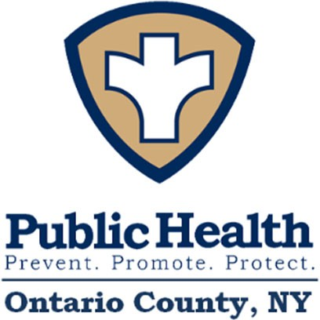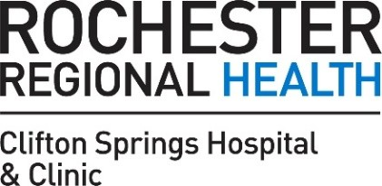



Table of Contents
Ontario County 2022-2024 Community Health Assessment (CHA), Community Service Plan (CSP) and Community Health Improvement Plan (CHIP) 1
Table of Contents 2
Introduction 3
Executive Summary 4
County Chapter – Ontario County 6
Community Assets and Resources to be Mobilized 29
Community Health Improvement Plan/Community Service Plan 31
Dissemination 32
Appendix 1 33
List of Maps 33
List of Figures 33
List of Tables 33
Appendix 2 34
Ontario County CHIP/CSP Chart 2022-2024: Ontario County Public Health in Partnership with Finger Lakes Health (GGH), Rochester Regional Health (CSHC), and UR Thompson Health 34

Introduction
The Prevention Agenda is New York State’s blueprint to help improve the health and well-being of its residents and promote health equity through state and local action. Every three years, New York State requests that local health departments and their local hospital systems work together to create a joint community health assessment and improvement plan using the Prevention Agenda guidelines. Local entities must choose two areas in which to focus community improvement efforts during the plan period. Local entities can choose from five priority areas:
- Prevent Chronic Diseases
- Promote a Healthy and Safe Environment
- Promote Healthy Women, Infants and Children
- Promote Well-Being and Prevent Mental and Substance Use Disorders
- Prevent Communicable Diseases
Throughout the cycle, public health and hospital systems value the input and engagement of key partners and community members, who are critical to help determine which priorities are most important to the community members, and what actions ought to be taken to improve the population’s health. The following report summarizes pertinent information relating to the above priority areas.
It is well known that residents live, work, and seek services beyond their county of residence. The health and well-being of residents in a neighboring county may impact the needs and services in other counties. In addition, collaborative practices such as shared messaging and lessons learned may help to expand reach and success of like-interventions. It is for this reason that the nine counties in the Finger Lakes Region have further collaborated to complete one comprehensive regional health assessment. Following the comprehensive assessment of the health of the entire region, this report contains a chapter specific to tOntario County. This focused chapter highlights specific needs, including additional demographic indicators, main health challenges and underlying behavioral, political, and built environmental factors contributing to the region’s overall health status for residents located in the county.

Executive Summary
From March of 2020 to March of 2022, local health departments were enmeshed in COVID-19 mitigation to the exclusion of all other programming. This significantly impacted the department and its partners’ ability to perform Community Health Improvement Plan (CHIP) activities, much less complete a CHA.
Nonetheless, Ontario County Public Health (OCPH) gathered stakeholders and with the help of Common Ground Health and Pivital Public Health Partnership, completed a CHA. After applying Results Based Accountability to our findings, in collaboration with UR Medicine Thompson Health, Clifton Springs Hospital and Clinic, and Finger Lakes Health, priority areas were chosen, and the 2022-2024 Community Health Improvement Plan was created. Chosen foci and disparity are noted in Table 1.
Table 1: Priorities Chosen using Results Based Accountability

Priority Areas & Disparity
Prevent Chronic Diseases

Overarching Goal: Reduce obesity and the risk of chronic disease Focus Area 1: Healthy eating and food security
Objective 1.2 Decrease the percentage of children with obesity

Disparity: Low socioeconomic population
Promote Well-Being and Prevent Mental and Substance Use Disorders

Focus Area 2: Prevent mental and substance use disorders
Goal 2.4 Reduce the prevalence of major depressive disorders
Objective 2.4.2 Reduce the past-year prevalence of major depressive episodes among adolescents aged 12-17 years.

Disparity: Low socioeconomic population

CHA and CHIP Development Process
The Ontario County Health Collaborative (OCHC), a group of diverse partners who span all sectors of the community, participated in the prioritization process and disparity and intervention identification. While a complete list of partners is available within the Ontario County Chapter under Community Health Improvement Plan/Community Service Plan, partners represented academia, not-for-profits and community organizations, businesses, the public, and local government. They included the Ontario County Public Health Department, UR Medicine Thompson Health, Rochester Regional Health/Clifton Springs Community Hospital, Finger Lakes Health/Geneva General Hospital, the Partnership for Ontario County, and Ontario County Mental Health.

Partners’ roles in the assessment were to review findings, use their expertise to provide anecdotal data (due to pandemic-related data gaps), and collaboratively select priority areas, objectives, interventions, and measurement parameters for the 2022-2024 CHIP. Members were asked to consult with other stakeholders at their organizations for additional input. Common Ground Health obtained, compiled, and provided regional and Ontario County specific data at OCHC meetings in 2022. A matrixed, online survey was used to help the group discern the magnitude of the problem identified by each priority area, its impact on other health outcomes, the impact of social determinants of health, and the capacity of partners to work on identified priorities. Results of the survey were reviewed, and the group found consensus, as noted in Table 1. At subsequent meetings Common Ground Health shared data targeted to chosen Focus Areas. This informed the group’s choice of goals, objectives, and interventions. The complete list of interventions and process measures is available in the CHIP Appendix.
Data sources included, but were not limited to, the US Census Bureau American Community Survey, the enhanced Behavioral Risk Factor Surveillance System, Vital Statistics, communicable disease and dental reports, data collected from Pivital Public Health Partnership (formerly known as S2AY Rural Health Network), Common Ground Health’s 2018 My Health Story, 211 Lifeline, and the Statewide Planning and Research Cooperative System (SPARCS). Additionally, a focus group of mental health professionals met twice in the summer of 2022 and provided observations, expertise, and anecdotal evidence of the effect of the COVID-19 pandemic on the mental health of children and adults in Ontario County and the Finger Lakes Region.
The pandemic necessitated a curtailed community health assessment. Public Health spearheads CHA/CHIP/CSP development and local health department employees and leadership were otherwise engaged during the months when this process should have started. A full community-based survey could not be completed. The Ontario County community had previously weighed in via Common Ground Health’s 2018 My Health Story survey. At this writing, the 2022 My Health Survey is circulating in the community. It will provide additional insight into residents’ opinions and experiences related to their health. This information will be analyzed and will inform potential additions to Ontario County’s CHIP in 2023.
The Ontario County Health Collaborative (OCHC), outside of CHA/CHIP development, meets monthly and will oversee progress on the Community Health Improvement Plan. Partners will provide quarterly updates about interventions and Public Health will monitor process measures and outcomes and share quarterly reports with group members. The need for mid-course corrections or changes in processes will be addressed by OCHC partners. Every quarter, mental health providers will meet with Public Health and hospital system partners in lieu of the regularly scheduled health collaborative meeting to review mental health CHIP/CSP interventions and process measures.

County Chapter – Ontario County

Demographic and Socioeconomic Health Indicators
Ontario County is located eight miles from the city of Rochester in the Finger Lakes Region of New York. The County includes two cities, 16 towns, nine villages, two colleges, and nine school districts. The cities of Canandaigua (the County seat) and Geneva are located at the northern ends of Canandaigua and Seneca Lakes, respectively, and contain approximately 21% of the County’s population. Honeoye and Canadice Lakes are in Ontario County, while Hemlock Lake forms a part of the County’s western border. Ontario is bordered in the north by Wayne and Monroe Counties, in the west by Monroe and Livingston Counties, in the south by Steuben and Yates Counties, and in the east by Seneca County.
Ontario County is home to 109,774 people³⁸. Canandaigua, Geneva, Victor, and Farmington are the most populous zip codes. All other zip codes in the county had populations of 6,000 or less residents. Map 1 shows the population distribution by zip code in Ontario County.
Map 1: Population by ZIP Code in Ontario County
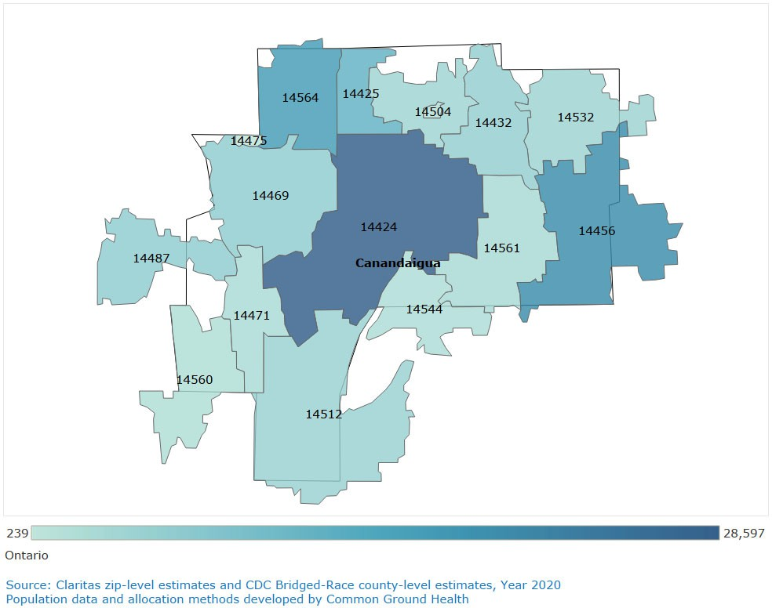

38 US Census Bureau, American Community Survey, 2020

Most residents in Ontario County are White Non-Hispanic (93%) followed by Hispanic (5%), African American (3%), Two or More Races (3%), Some Other Race (2%) and Asian (1%). The White, Black, Asian, and Hispanic populations in Ontario County have been stable over the past decade.
Map 2: Ontario County Black Non-Hispanic Map 3: Ontario County Hispanic
Population by Zip Code (Percent of Population Population by Zip Code (Percent of Population and Count) and Count)
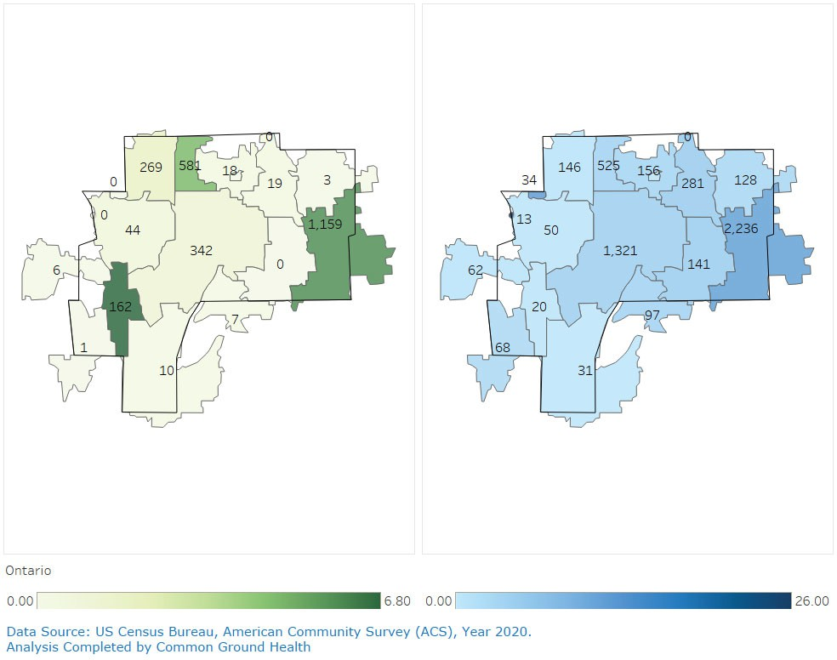

In addition to more typical minority populations, Ontario County is home to a growing Mennonite enclave. In recent years, many traditional, multigenerational farms have been sold to Mennonite families. It is difficult to ascertain the number of Mennonites in the county, but observationally, the population has increased significantly in the last twenty years. It’s not unusual to see horse-drawn buggies on busy roadways and community members in retail outlets (identifiable by attire). Mennonite owned produce and dry good stores are commonplace across the County. There are five Mennonite schools in Ontario County which conclude at grade eight. Teachers are often young, unmarried women with no formal training.

The health department reviews school vaccine coverage and has fostered relationships with church leaders and families. Many Mennonite children receive vaccines at the health department and health educators have been invited in to teach first aid and CPR to students. These relationships are essential as this population will undoubtedly continue to grow.
Farming requires farm workers. Ontario County attracts migrant farm workers who travel from community to community for planting and harvesting. The county is fortunate to have a Federally Qualified Healthcare Center (FQHC) with an active migrant health program. Dedicated, bi-lingual staff serve clients at farms and at a modern facility in Geneva.
Though considered rural, Ontario is the most urbanized of the counties in the Finger Lakes Region (not including Monroe). It is home to many lakes, farms, breweries, vineyards, tourist businesses, and vacation properties. The New York State Thruway travels through the northern part of the County east to west, with routes 96 and 5 and 20 running roughly parallel a few miles south. Major roadways are well maintained and well-traveled. They provide ready access to jobs and services in neighboring communities and ease of travel for tourists, of which there are many.
Unlike other Finger Lakes counties, it is predicted Ontario County’s population will grow by 3% over the next two decades. The Towns of Victor and Farmington on the northeast edge of the county continue to experience rapid growth as farmland is bought up by developers and converted into businesses and housing. Additionally, there has been an influx of individuals who work in Rochester (Monroe County) but prefer to live in a more rural area.
According to the US Census, “in less than two decades, the graying of America will be inescapable: Older adults are projected to outnumber kids for the first time in
U.S. history.”⁴⁰ Projections indicate that by the year 2035, there will be a larger population of older adults (age 65 and over) than children (under 18). Since 2017, the number of older adults in Ontario County has increased by ~2,000 while the number of children has decreased by ~500.⁴¹ Seniors are evenly distributed across the county, with a slightly higher concentration in the Canandaigua area where there are numerous living facilities for older adults.
The Ontario County Department of Economic Development reports that dairy farms, vineyards, orchards, and field crops cover approximately 40% of county land. The top ten employers encompass healthcare, technology, manufacturing, education, and tourism. Figure 1 shows the percentage of Ontario County residents employed by the top 5 employment sectors.

40 https://www.census.gov/library/stories/2018/03/graying-america.html
41 US Census Bureau, American Community Survey

Figure 1: Employment by Sector in Ontario County
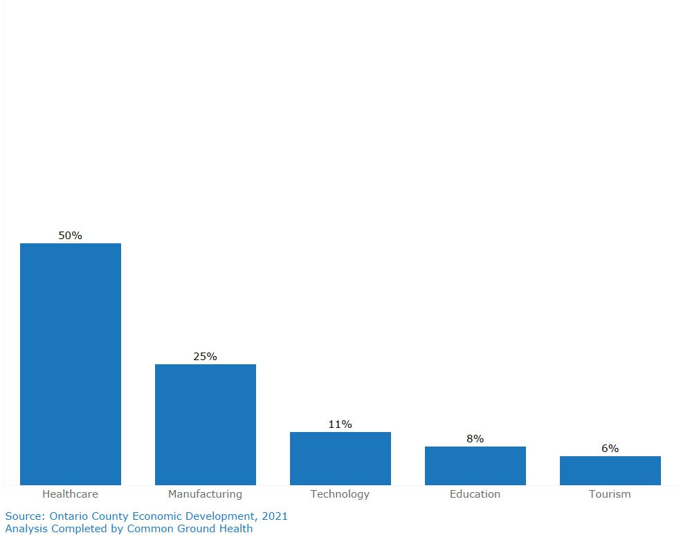

Social Determinants of Health
Social determinants of health are conditions in which people live, work and play that impact their overall health and well-being. This may include population dynamics, the natural and built environment, poverty, and more. These determinants were reviewed and considered as part of the prioritization process and are summarized below:
In 2020, 9% of Ontario County residents were living in poverty, the lowest county number in the region while being the 2nd largest county by population. While the rates are low for the entire county, there are some pockets of higher poverty, most notably within the zip code/census tracts on the eastern edge of the county (Geneva). In addition to place-based differences, there is a large disparity in poverty rates among those who did not graduate high school (22% impoverished) and those who graduated and/or have received higher education (3% impoverished). Map 4 shows the distribution of poverty in Ontario County by census tract. Poverty is concentrated within the City of Geneva with most of the tracts having poverty rates of 15% or higher and the only tract in the county with a poverty rate greater than 20%.

Map 4: Poverty by Census Tract
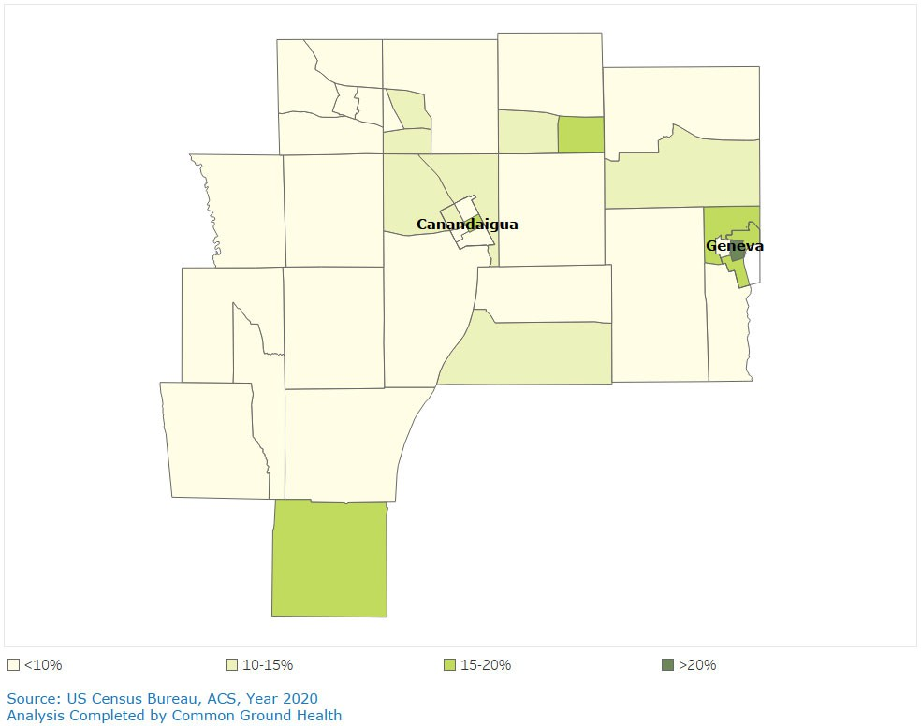

Related to poverty, another important factor the health of residents is their housing. Map 5 shows the distribution of owner-occupied residences in Ontario County. Home ownership is high in Ontario County, with 73% of residents owning their homes. Only 5 tracts (3 in Canandaigua and 2 in Geneva) have ownership rates lower than 50%.

Map 5: Owner Occupied Residents by Tract (Percent of Housing Units)
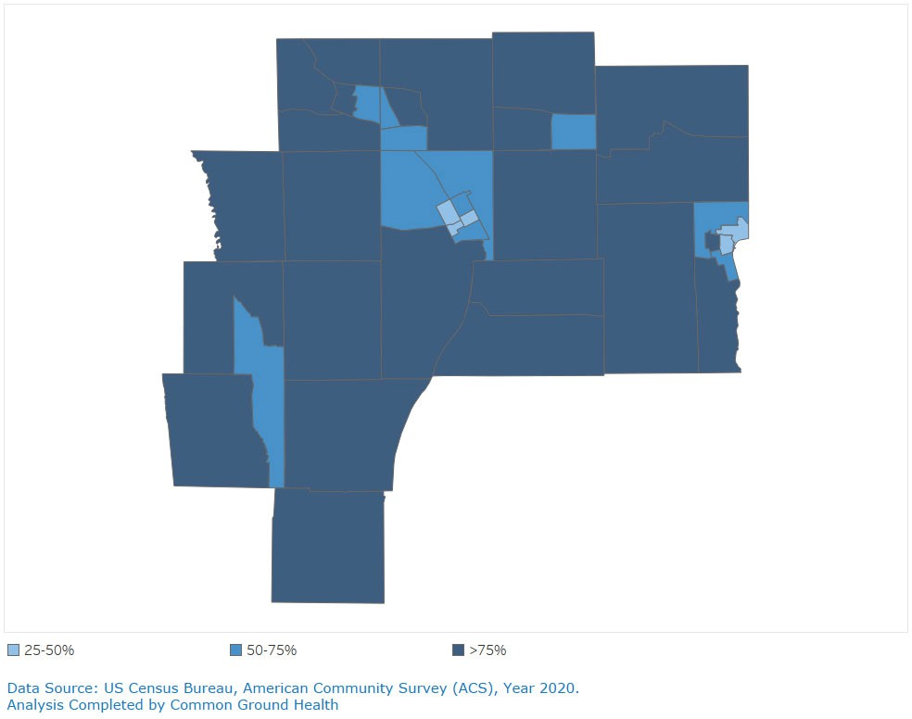

From 2011 to 2020, the median value of a home in Ontario County has risen ~22% from $134,000 to $163,000. Along with that, the cost of housing has gone up significantly since the beginning of the pandemic, with the median price for an American home up nearly 20 percent in a year.⁴⁵
Poverty impacts housing and both impact health. Though the county has many beautiful, expensive homes, it lacks affordable housing for residents at socioeconomic disadvantage. Median values are inflated by expensive new builds, multimillion dollar lake properties, and lack of inclusion of rental housing in the US Census Bureau data regarding this indicator. Old, poorly maintained rentals and a handful of apartment complexes remain the only options for many young, working families and residents on fixed or otherwise limited incomes.

45 https://www.nytimes.com/2022/01/20/upshot/home-prices-surging.html

According to the Census Bureau, there has been a decline in the percentage of families that pay 35% or more of their gross income on housing. However, individuals who rent are twice as likely to spend >35% of their earnings on housing than those who own (35% versus 15%).Unfortunately, the recent spike in home values and assessments has driven landlords to raise rents significantly on very short notice. A concerning observation reported by Ontario County Department of Social Services/Emergency Housing Unit, is a rise in homelessness among families.
Educational attainment impacts the socioeconomic status of Ontario County’s residents and socioeconomic status impacts educational opportunities. The number of individuals over the age of 25 who have a high school diploma or GED in Ontario County has been stable since 2015. The county enjoys an almost 90% mean high school graduation rate. The rate of residents attaining bachelor’s degrees, though stable since 2015, varies significantly by zip code. Victor zip codes reflect 60% of their residents have earned a Bachelor’s, while zip codes in Farmington, Manchester, and Gorham, only 15%.
Tied to educational attainment, and employment, is health insurance coverage. In Ontario County, over 95% of the population has insurance coverage. For most demographic factors available from the Census Bureau (age, sex, educational attainment), the 95% coverage rate holds. Disparity exists among foreign-born residents and minority groups with rates of coverage between 85-95%. As members of the growing Mennonite community seldom purchase health insurance, in the future it may appear that coverage rates in the county decline.

Main Health Challenges
The novel coronavirus was the main health challenge of the last two years. To pretend otherwise would be unwise. Pandemic mitigation has affected the ability of the health department to fully assess the community. Prevention Agenda data is outdated, some covering years prior to the last CHA/CHIP cycle. Little local data is available, excepting that related to COVID-19.
What we do know is that the pandemic has affected residents’ physical and mental health and access to preventive services. It has increased unemployment, decreased food security, and exacerbated lack of trust in the government, including Public Health. The healthcare community is understaffed, many medical providers are burnt out, and one in three public health workers are considering leaving their organization in the next year⁴⁶.
The public seems to be ready to move on, but local public health workers do not have that luxury. They are providing core public health programs, trying to maintain and hire staff, working to recoup funds expended on COVID mitigation, while planning and staffing mass vaccination clinics.
This is the backdrop of our CHA.
Throughout the winter and spring of 2022, members of the Ontario County Health Collaborative (OCHC) met monthly. Partners included the county’s three hospital systems, community-based organizations, clergy, community members, a college, and a Federally Qualified Healthcare Center. Representatives from Ontario County Public Health, the Pivital Public Health Partnership (previously the S2AY Rural Health Network) and Common Ground Health walked partners through the NY State Prevention Agenda Dashboard, reviewing Action Plans, Focus Areas, Goals, and potential interventions. Primary and secondary qualitative and quantitative data were presented, discussed, and analyzed.
Data were collected from a variety of sources in an effort to identify Ontario County’s main health challenges. These included, the American Community Survey, the Enhanced Behavioral Risk Factor Surveillance System (BRFSS), Vital Statistics, NYS Communicable Disease Electronic Surveillance System, Pivital Public Health Partnership, the NYS Department of Education, the US Census, 2-1-1 Lifeline, the Ontario County Community Survey and Risk and Protective Factor Survey and Common Ground Health’s My Health Story Survey, 2018.
In 2018, My Health Story Survey was administered in Ontario County. Its purpose was to gather primary qualitative and quantitative data from residents about health attitudes, behaviors, and challenges. OCPH and community partners ensured this

46 Smith, C. (2022, March 30). Public Health Employee Survey reveals a workforce crisis. Governing. Retrieved September 19, 2022, from https://www.governing.com/now/public-health-employee-survey-reveals-a-workforce-crisis

survey reached all corners of the county, including historically disparate populations. The survey was updated during the spring and summer of 2022 and began to be circulated in early August. Though too late to apply to this CHA, findings will be shared with stakeholders this fall and winter and will inform Ontario County’s CHIP/CSP activities moving forward.
After review and analysis of available data and discussion of social determinants of health, a matrixed survey was used to prompt group members to consider and rate the significance of identified health indicators and the feasibility of addressing them collaboratively. Results of the survey pointed group members to the NYS Prevention Agenda’s action plans for Preventing Chronic Diseases and Promoting Well-Being and Preventing Mental and Substance Use Disorders. A targeted review of county-specific data related to these two areas ensued as did discussion about the effects of the pandemic on food security, physical activity, employment, chronic disease, and mental health (See Appendix 3 for more info on this process).
Partners ultimately chose to collaborate on the NYS Prevention Agenda’s (PA) Prevent Chronic Disease Action Plan, Focus Area 1, Healthy Eating and Food Security with the overarching goal of reducing obesity and the risk of chronic disease. They agreed it was feasible to target efforts on Objective 1.2, Decrease the Percentage of Children with Obesity among Public School Students by providing school and daycare-based education about healthy eating and physical activity.
Though mental health and substance use disorders were identified as areas of immediate concern, data concerning the impact of COVID-19 pandemic was lacking. In May of 2022, Public Health enlisted the assistance of Ontario County’s Director of Mental Health in gathering mental health and substance use prevention providers together to discuss the impact of the COVID-19 pandemic on behavioral health.
This served as a focus group by proxy, as well as a work group to select goals and interventions around the NY State PA’s priority of Preventing Mental and Substance Use Disorders. The group met in June and July and through discussion and review of a root cause analysis, chose Goal 2.4, Objective 4.4.2 Reduce the Past-year Prevalence of Major Depressive Episodes among Adolescents aged 12-17-years.
This group will continue to meet quarterly to report progress and share outcomes.
Looking upstream and choosing to work with school-aged children in both of our chosen focus areas is intentional. Historically it has been difficult to engage schools in CHIP/CSP interventions. The COVID-19 pandemic solidified relationships and built trust and respect between schools and the health department. Maintaining this relationship will be invaluable to Ontario County Public Health and its partners.
As a result, the following areas were selected for the 2022-2024 Community Health Improvement Plan:

Priority Area: Prevent Chronic Diseases
Focus Area: Healthy Eating and Food Security

Priority Area: Promote Well-Being and Prevent Mental and Substance Use Disorders
Focus Area: Mental Health & Substance Use Disorders Prevention
Disparity: Low Income/SES

Risk and Protective Factors Contributing to Main Health Challenges Healthy Eating and Food Security
Substandard nutrition is directly related to the development and progression of chronic diseases. There are many behavioral and environmental risk factors that affect healthy eating and food security. One way to assess the nutritional health of a community is by exploring obesity rates of children via the Student Weight Status Category Reporting System. Though percentages of obese and overweight children have been stable for the last twenty years, older students are more likely to be classified as overweight or obese, than younger counterparts. Figure 2 shows the percentage of students with obesity in Ontario County schools by grade level (Elementary vs. Middle/High School)
Figure 2: Percent of Students with Obesity in Ontario County Schools
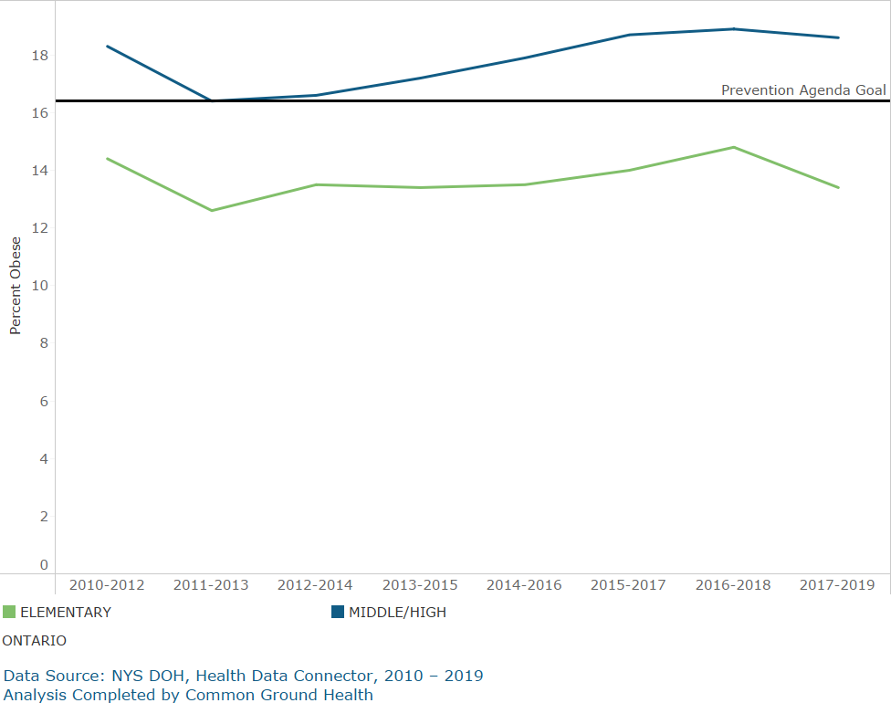

Upon further analysis, it is obvious that children in some school districts are heavier than others. In Ontario County, there are higher percentages of obese and overweight middle and high school students in districts with higher percentages of

children at economic disadvantage (see Figure 3). The difference between the most affluent community and least, is remarkable (24% for the former; 46% the latter). This inequity leaves these children at risk for the development of chronic diseases. Additionally, obesity is often an indicator of lack of access to healthy foods (food insecurity). Food insecurity may adversely affect a child’s growth and development and general health. It may increase asthma risk and contribute to behavioral problems at home and school. When looking at the correlation between overweight/obesity and economic disadvantage at the elementary level, there does not appear to be the same correlation as with the older students (Figure 4).
Figure 3: % Overweight/Obese Students vs. % Economically Disadvantaged Students - Middle/High School in Ontario County Districts
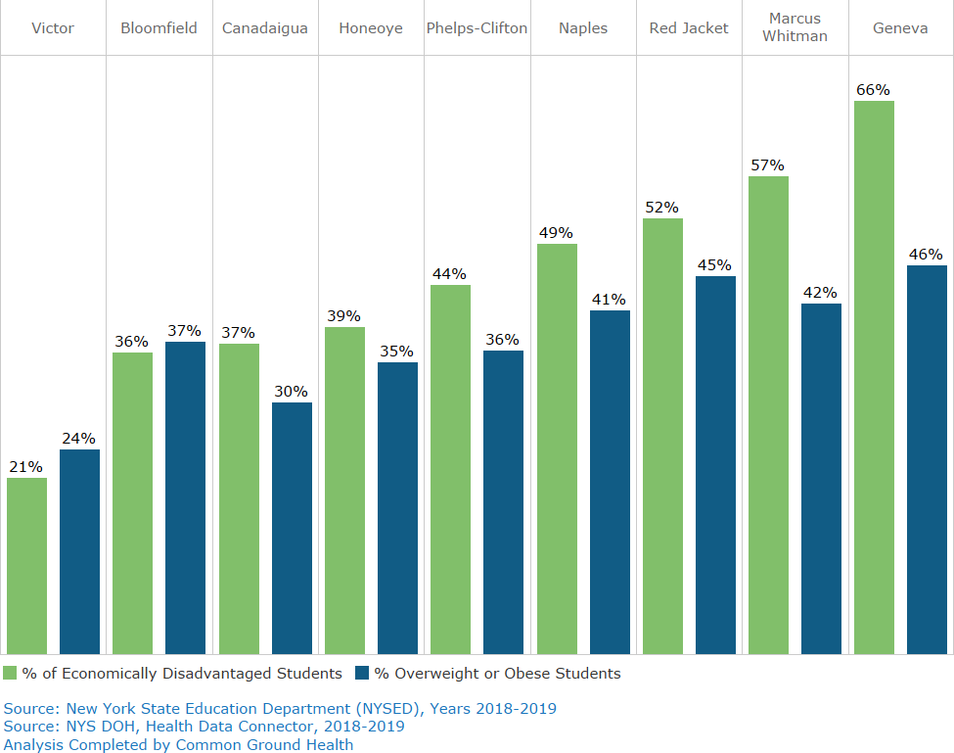

Figure 4: % Overweight/Obese Students vs. % Economically Disadvantaged Students - Elementary School in Ontario County Districts
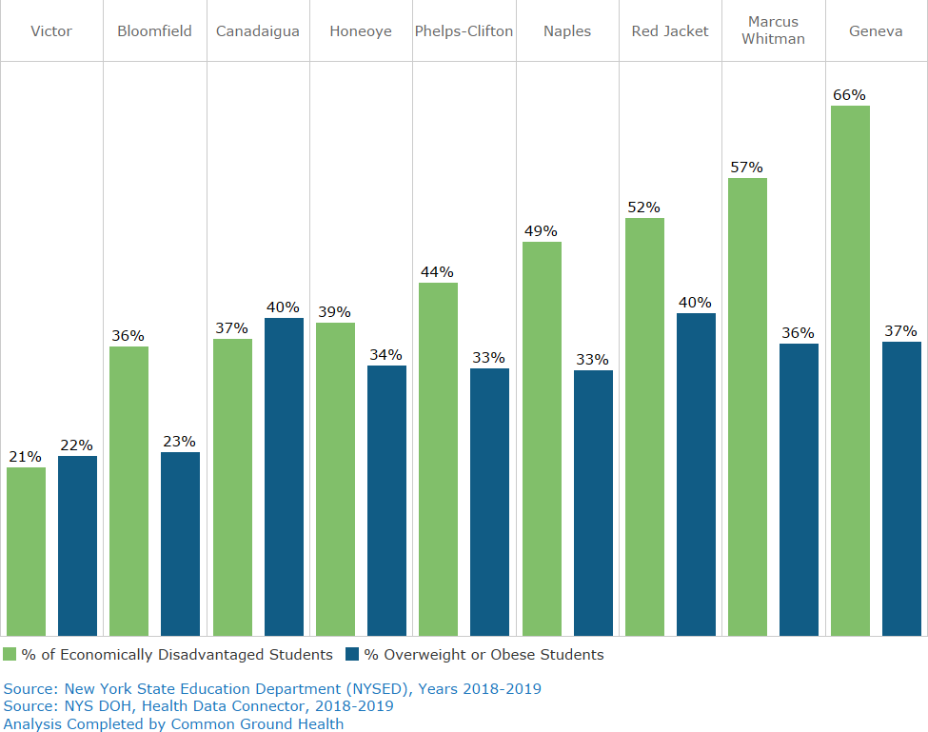

Elementary schools may provide environments that level the nutritional/physical activity playing field between children of varying economic status. Younger children’s days are more scripted and may include opportunities for physical exercise (recess). Many children attend regulated afterschool programs where snacks are nutritious, and exercise is encouraged. Additionally, young children are less likely to feel embarrassed about receiving reduced or free breakfasts and lunches at school. Conversely, adolescents have less opportunities for physical activity during the school day. They may forego free meals to avoid stigma and resort to filling up on fast or convenience foods before and after school. Many return to empty homes at the end of the school day without adult supervision of screen time and snacking. Finally, hormonal fluctuations and changes in sleep patterns may contribute to weight gain as children go through puberty.
The differences between elementary school children and their older counterparts noted above do not tell the whole story of childhood obesity. Mental health affects

obesity and obesity affects mental health. Studies suggest that multiple adverse childhood experiences (ACEs) may increase the likelihood of obesity in children, 2-5 years later⁴⁷. In the 2021 Youth Risk and Protective Factor Survey of 5 rural school districts in Ontario County, the percent of children who had experienced >2 ACES, was twice as high for 12th graders as it was for 6th graders (43% and 19%, respectively), which seems to correlate higher ACE scores with increased obesity.
There is growing research that demonstrates the need to address childhood obesity and psychosocial problems simultaneously. An integrated public health approach is needed and should include policy makers, healthcare providers, educators, and organizations that interface with children, teens, and families⁴⁸. Ontario County Public Health and its partners believe that this can be done by encouraging early childhood education and modeling (school/daycare gardens, Eating the Rainbow, Coordinated Approach to Child Health, etc.), providing nutrition and parenting support to caregivers (Positive Parenting Program), standardizing food insecurity and mental health screening tools in pediatric practices, and equipping educators and Student Resource Officers to respond to mental health crises during the school day.
Over the course of the two previous CHIPs, Ontario County Public Health has collaborated with school cafeteria managers and community partners to increase the number of fresh fruits and vegetables available during the school day.
Additionally, sugar sweetened beverages have been removed from most schools’ vending machines. Schools that have actively pursued “farm-to-table” initiatives, continue to do so, but not all districts have embraced this model.
Ontario County is home to a thriving farming community. It would seem everyone has access to fresh, healthy foods during the summer and fall when roads are littered with fruit and vegetable stands. Additionally, farmers’ markets are usual weekend occurrences in the cities of Canandaigua and Geneva and other communities. These are important assets, but access remains a problem for some residents.
In the previous CHIP, members of the Ontario County Health Collaborative partnered with the Regional Transit System (RTS) to provide grocery store targeted bus routes to individuals living in Geneva’s food desert, as well as for seniors residing in adult care facilities. Unfortunately, the COVID-19 pandemic curtailed this intervention, considerably. Public transportation is less well developed in rural areas. County residents who do not drive, are at the mercy of busy family

47 https://doi.org/10.1111/obr.13204, Schroeder, K., Schuler, B. R., Kobulsky, J. M., & Sarwer, D. B. (2021). The association between adverse childhood experiences and childhood obesity: A systematic review. Obesity Reviews, 22(7), e13204.
48 Small L, Aplasca A. Child Obesity and Mental Health: A Complex Interaction. Child Adolesc Psychiatr Clin N Am. 2016 Apr;25(2):269-82. doi: 10.1016/j.chc.2015.11.008. Epub 2016 Jan 22. PMID: 26980129.

members, infrequent bus routes, and private taxi services. Map 6 shows the census tracts in Ontario County have access issues for children and persons/families receiving SNAP benefits.
Map 6: Percentage of Children Age 0-17 Map 7: Percentage of Housing Units receiving SNAP more than 1 mile from a Supermarket benefits more than 1 mile from a Supermarket
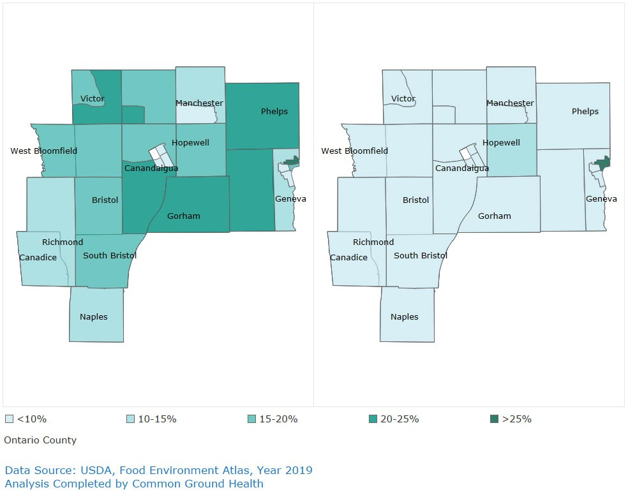

Anecdotal data points to significantly decreased food access and security during the COVID-19 pandemic (March 2020-March 2022). Children who previously received two meals a day at school, were now home with parents who were trying to juggle work, sick family members, remote learning, childcare, and tighter budgets. School districts, churches, civic organizations, the United Way, and local food pantries became a lifeline to tens of thousands of Ontario County residents. In one year, alone (7/2021-6/2022), Foodlink Inc. served about 3,600 households a month in Ontario County.
The Boys and Girls Club of Geneva, estimates they provided 200,000 meals to residents of Geneva during the pandemic with assistance from state funding, the Geneva City School District, and Hobart and William Smith Colleges. During the

lockdown (Mar-Aug 2020), 350 breakfasts and 480 dinners were distributed five days a week. From September 2020 to June of 2021, 150 dinners were provided every school day. At this writing, the Boys and Girls Club continues to distribute groceries to 450 families twice a month (1,800 individuals). Of these, 90 are delivered to those unable to attend a drive-thru.
The first year of the upcoming CHIP will focus on assessing the full impact of the pandemic on food access and security in Ontario County and using these findings to forge new partnerships and develop future programming.

Mental Health & Substance Use Disorders Prevention
The NY State Prevention Agenda Dashboard provides data about depression in adults and adolescents from the National Survey on Drug Use and Health (NSDUH). In the most recent report (2020) the percentage of adolescents who had experienced a depressive episode in the preceding 12 months rose from 4% in 2004-2007, to 8% in 2016-2019. Forty-three percent of youth who experienced depression received treatment. Though this is similar to national trends, it remains unacceptable.⁵¹
The lack of treatment available to depressed adolescents came as no surprise when Mental Health providers met as a subcommittee of OCHC in June and July of 2022. What was surprising was the lack of awareness group members (hospitals and health department included) had about programs other than their own. This lack of knowledge applied also to New York State as their Office of Mental Health’s Program Finder website noted only four outpatient clinics in Ontario County. Though there is a lack of service providers, this is an obvious under representation.
Every two to three years, the Partnership for Ontario County administers the Evalumetrics Youth Survey (EYS) to adolescents during the school day. The EYS is based on the Risk and Protective Factor Model developed at the University of Washington by J. David Hawkins, Richard Catalano, and Janet Miller. Students are queried about depression, substance use, violence, suicidal ideation, family and community attachment, social emotional distress, and adverse childhood events. Self-injurious behaviors and bullying are also included in the survey.
Students from five school districts participated in the 2021 EYS: Bloomfield, Honeoye, Gorham-Middlesex (Marcus Whitman), Midlakes (HS), and Naples. These districts are rural with student censuses between 569 and 1,549, K-12. Of particular concern in the most recent survey were responses surrounding depression, trauma (Adverse Childhood Experiences), and suicidal ideations and attempts.
Of sixth graders, 37% reported feeling sad or depressed most days in the year prior. This jumped to >43% among seniors. Across all grades 40-50% reported their lives “lacked purpose.” Undoubtedly, the COVID-19 pandemic contributed to these findings. Though the pandemic was temporary, the effects of isolation, food insecurity, fear/anxiety related to family finances or illness, and lack of reprieve from abusive caregivers could affect this cohort for many years. Additionally, the survey showed many children had experienced more than 2 adverse childhood

51 Khesht-Masjedi MF, Shokrgozar S, Abdollahi E, Habibi B, Asghari T, Ofoghi RS, Pazhooman S. The relationship between gender, age, anxiety, depression, and academic achievement among teenagers. J Family Med Prim Care. 2019 Mar;8(3):799-804. doi: 10.4103/jfmpc.jfmpc_103_18. PMID: 31041204; PMCID: PMC6482750.

events (ACEs) in their lifetime. By senior year over 40% reported at least 2 ACEs. Figure 5 shows this data.
Figure 5: Ontario County Adolescents Reporting > 2 ACEs
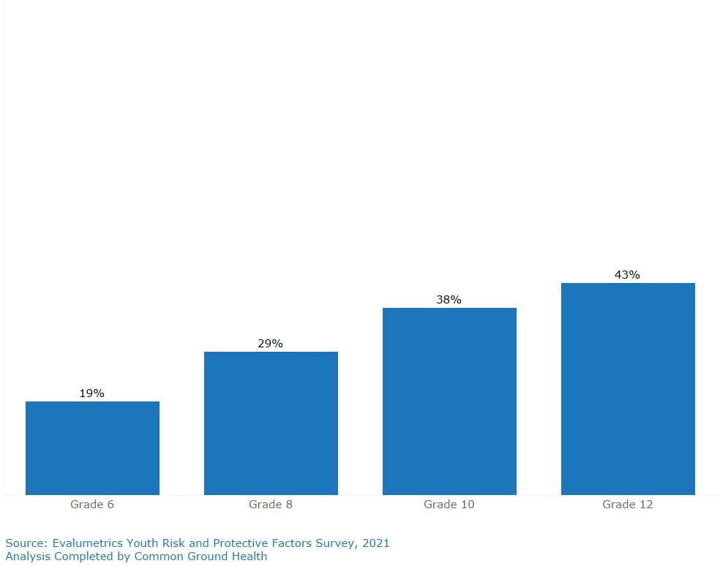

Poor mental health can affect concentration and energy levels which can hinder academic performance. Research suggests depressed children have lower GPA’s and higher dropout rates which may affect pursuit of advanced degrees or trades, employability, and future earning potential. Additionally, adolescents with a history of two or more ACE’s are at increased risk for behavioral issues which may result in frequent absences and suspensions⁵³. Ontario County is home to nine school districts, with a mean graduation rate of 89.5%. High school graduation rates

53 Agnafors, S., Barmark, M., Sydsio, G. Mental Health and Academic Performance: A Study on selection and causation effects from childhood to early adulthood. Social psychiatry and psychiatric epidemiology. Retrieved September 19, 2022, from https://pubmed.ncbi.nlm.nih.gov/32813024/

decrease as incomes fall moving west to east across the county. Map 8 shows this data.
Map 8: High School Graduation Rates, Ontario County Districts
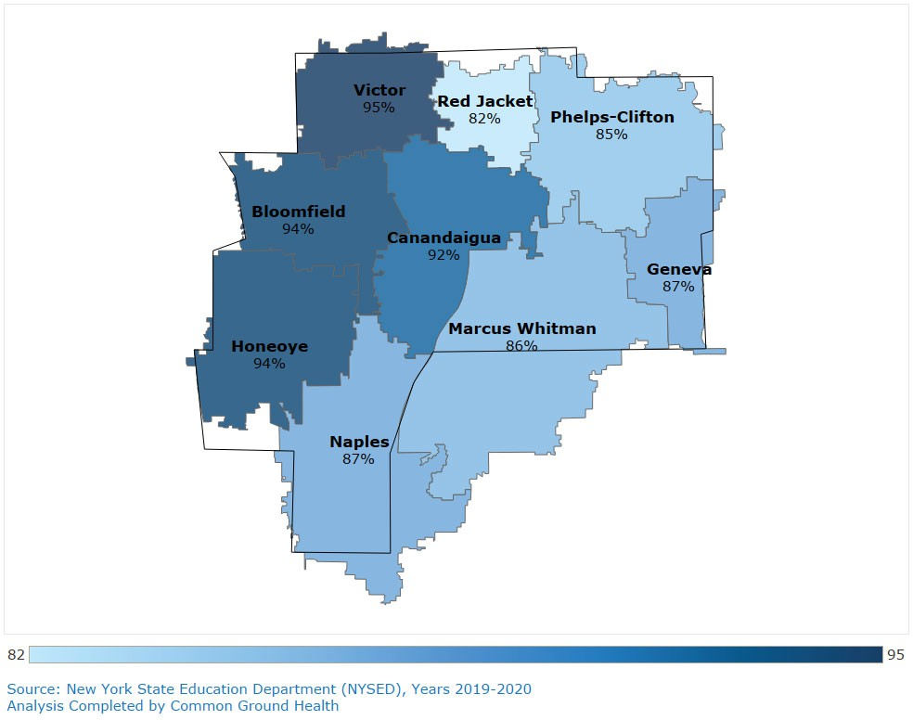

As stated throughout this report, the impact of poverty is widespread on one’s health and ability to achieve. Looking at the data for Ontario County, we see that reflected in the graduation rate. Figure 6 shows the correlation between the percent of students who are economically disadvantaged and the district on time graduation rate (students graduating in June of their cohort year).
In addition to fewer students graduating, more students are serving suspensions on any given day in districts with higher rates of economically disadvantaged students. As well as being counter-productive to a child’s education, time out of the classroom is isolating and stigmatizing. If the family relies on free breakfasts and lunches, the child may not eat. Parents may be forced to decide between missing work or leaving their child unsupervised and abusive family members from whom the child is free during the school day, may be present in the home if the child is suspended.

Figure 6: Graduation Rate vs. % of Economically Disadvantaged Students
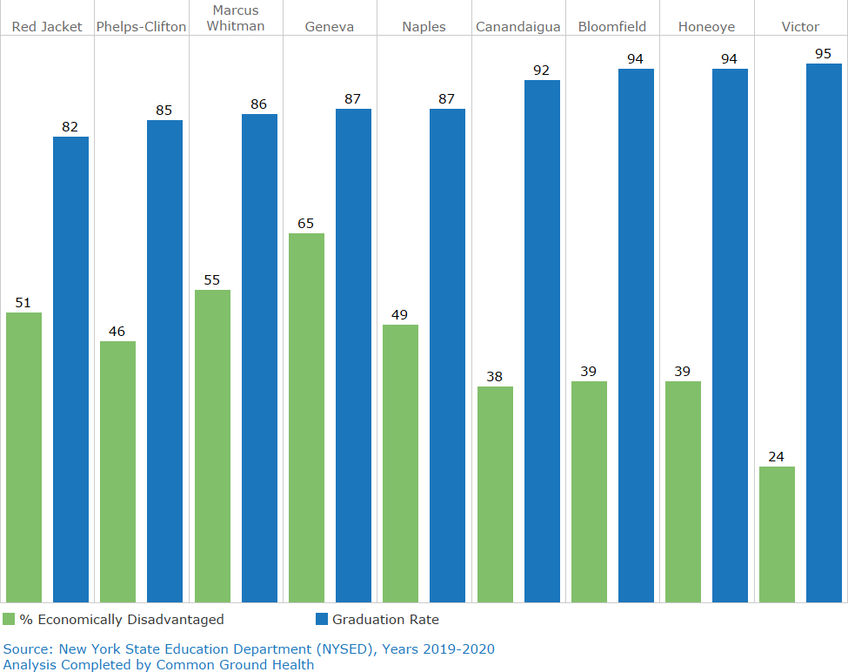

Figure 7: Suspension Rate vs. % of Economically Disadvantaged Students
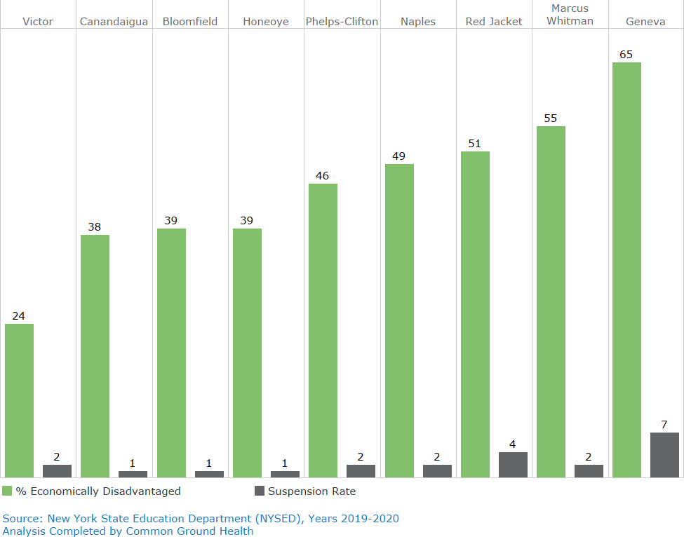

Research has shown that children living in poverty have worse academic achievement, higher school dropout rates, and are at elevated risk for unemployment as adults. They are also more apt to have contact with the criminal justice system than children who never experienced poverty firsthand.⁵⁴
Lack of success in school is a predictor of future low socioeconomic status, higher rates of inadequate housing or homelessness, poor nutrition, lack of access to healthcare, and increased incidence of chronic disease. Poor mental health contributes to lack of success in school with a significant negative correlation between academic achievement and anxiety and depression.⁵⁵
Perhaps the most disturbing data collected by the EYS was regarding suicide. More than 5% of sixth graders and 8% of 8th, 10th and 12th graders reported having a plan in place for taking their own lives (Figure 8). This represents 50-77 Ontario County children from these five, small schools. Additionally, 4.6-6.5% of students in these grade levels had attempted suicide in the previous 12 months.
Figure 8: Suicidal Ideation and Attempts by Grade Level
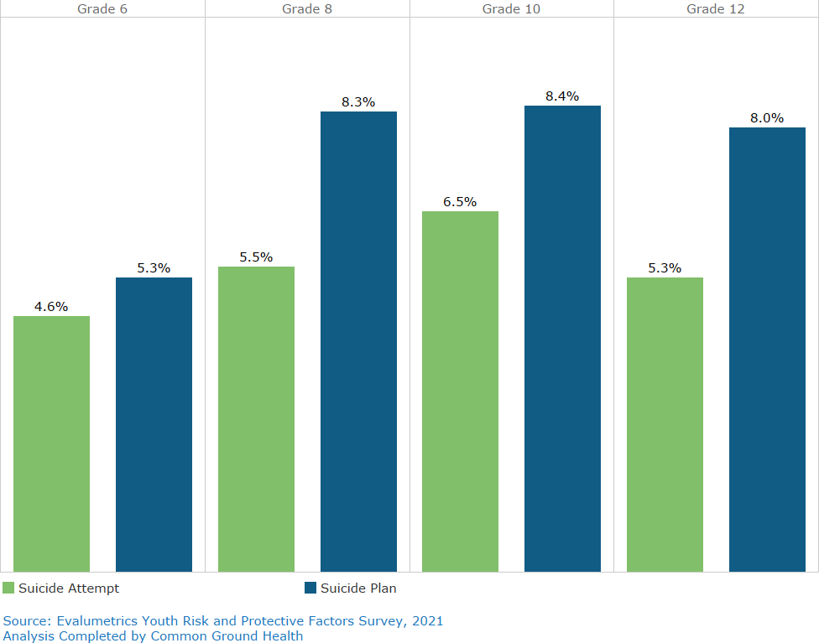

54 The State of America’s Children, 2020 Child Poverty
55 Khesht-Masjedi MF, Shokrgozar S, Abdollahi E, Habibi B, Asghari T, Ofoghi RS, Pazhooman S. The relationship between gender, age, anxiety, depression, and academic achievement among teenagers. J Family Med Prim Care. 2019 Mar;8(3):799-804. doi: 10.4103/jfmpc.jfmpc_103_18. PMID: 31041204; PMCID: PMC6482750.

In efforts to understand capacity of schools to address mental health issues with students, Common Ground Health compared the number of mental health “support” positions (social workers and counselors) in Ontario County’s nine school districts to the number of students enrolled. A Support Staff Ratio metric was created and reflects what a typical caseload would be for these staff members; a lower number being preferable.
From 2018-2020, there is a promising trend, but potential caseloads remain very large particularly as these same staff members often shoulder the responsibility of completing and maintaining student individualized education programs (IEPs) for their district. Formally trained individuals working for the school cannot meet the mental health needs of all students. Figure 9 shows this data.
Figure 9: Support Staff Ratio for Ontario County
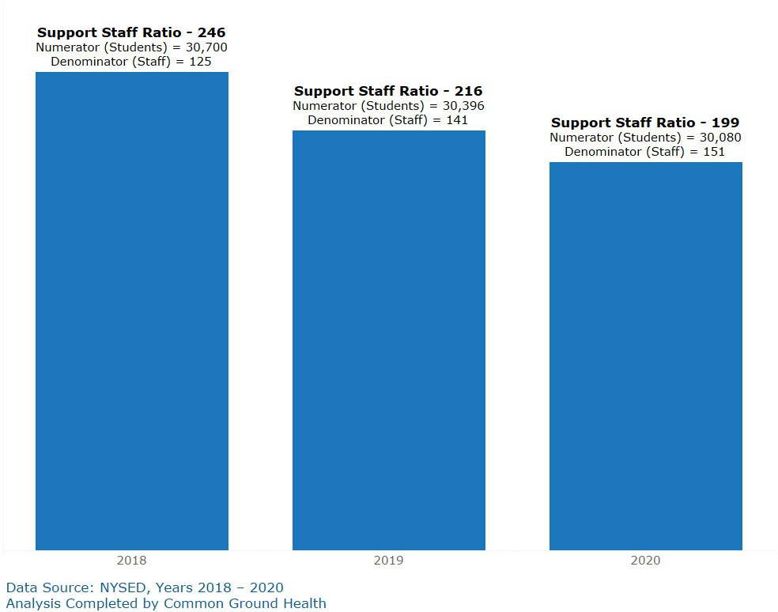

New financial streams are available to place trained social workers in schools to provide counseling to students and families. Ontario County Mental Health has hired and placed professionals in one of nine school districts with success. Unfortunately,

there are not enough qualified providers in the region to expand this program to other schools. Increasing capacity of schools to address mental health requires a school wide approach that involves teachers, administrators, school resource officers (SRO’s), and others.
Why are our children depressed; why do they feel hopeless? When mental health providers met the summer of 2022, they asked themselves this question as part of a root cause analysis. Social factors (lack of community connectedness, social pressures, acceptance by peers, societal norms, standards of beauty, social media, etc.) and family factors (lack of family attachment, blending of families, divorce, poor parenting, family mental health, etc.) were identified as two leading contributors, with lack of availability of services and personal factors ranking third and fourth, respectively. The need is great, mental health services are limited, and waiting lists are long. It is vital to increase capacity of schools to identify and assist children at risk for depression, anxiety, and other mental illnesses.
A community cannot address mental health or chronic disease without first considering the social determinants of health that affect its population. When this is done, the relationships between socioeconomic status, mental health, obesity, and chronic disease become obvious. After completing Ontario County’s 2022 Community Health Assessment, partners knew it was imperative to focus interventions upstream: on children and adolescents and their families.

Community Assets and Resources to be Mobilized
The Finger Lakes Region has two designated agencies that promote and facilitate collaboration: Pivital Public Health Partnership (previously the S2AY Rural Health Network) and Common Ground Health. Pivital is a partnership of eight rural health departments in the Finger Lakes Region. The network’s focus is on improving the health and well-being of Finger Lakes residents. Common Ground Health covers the same geographic footprint, with the addition of Monroe County, and focuses on bringing together leaders from all sectors – hospitals, insurers, universities, business, nonprofit, faith communities and residents – to collaborate on strategies for improving health in the region. Both agencies support efforts of the local health department to improve the health of Ontario County residents.
As already noted, the Ontario County Health Collaborative meets monthly with community partners. During brainstorming sessions between May and August of 2022 partners identified assets and resources within Ontario County that could be mobilized toward selected objectives and interventions. These include relationships and experience with previous CHIP partners, schools, Cornell Cooperative Extension, Boys and Girls Clubs, Youth Club Houses, churches, food pantries and many others.
There is good mental health work being done in the county. OCHC meetings included mental health providers and it is clear there is a vibrant community of concerned and knowledgeable individuals focusing on this work. The programming already in place and the buy-in from this group of professionals places the County in a good position to address the mental health of adolescents in a concerted fashion.
Ontario County has three, small hospitals which is unusual for a rural county. Residents can tap into unique services offered by each facility and receive care locally rather than travelling to large medical centers in surrounding urban counties. Additionally, inpatient mental health and addictions treatment are available and situated across the street from each other in Clifton Springs. Unfortunately, there are no psychiatric inpatient pediatric beds in the county.
COVID-19 brought obvious challenges, but with it came some opportunities. The local health department (LHD) helped schools, daycares, and the community navigate the pandemic. Many relationships were forged and strengthened. Schools relied heavily on the LHD and grew to trust the judgment of its members. Health department staff became intimately familiar with school nurses, superintendents, principals, coaches, and social workers. These will be important allies as we address obesity and mental health in school-aged children. Additionally, the LHD’s social media page has a much larger readership than pre-pandemic. There is increased community awareness of the department’s roles, responsibilities, and contributions.

Ontario County is scenic and boasts walking trails, lakes, parks, and playgrounds. Most villages and towns maintain their sidewalks and most residents report feeling safe in their community. From a bird’s eye view, Ontario County appears affluent and well-situated. Unemployment is relatively low, most people own their own home, schools perform well on average, healthcare is accessible, and unlike most other NY counties, Ontario County is growing. Additionally, community leaders and municipalities are supportive of the work of the health department which is fully staffed and high functioning. The devil, of course, is in the details; our pockets of poverty and food insecurity, inferior rental properties, childhood obesity, depression among our teens.
Over the course of the next three years, we’ll work together as a community to mitigate our challenges, address our disparities, and leverage our resources as we implement our CHIP/CSP.

Community Health Improvement Plan/Community Service Plan
As previously noted in Main Health Challenges, group discussion and consensus were used to select priority areas for Ontario County’s Community Health Improvement Plan/Community Services Plan. Once priority areas were chosen, additional targeted data were acquired and presented to partners as they delineated objectives, identified disparities, and considered interventions. During OCHC meetings, partners were asked to identify interventions already in place as well as those that would be feasible to initiate, sustain, and measure. Input was compiled and summarized by LHD staff and a list of interventions, contributing partners, and family of measures was presented to partners on 9/8/2022. This first draft of the CHIP was accepted by group members with minimal additions. Health department staff will make necessary adjustments and finalize this document after which time hospital partners will present it to their boards.
A full description of objectives, interventions, process measures, partner roles and resources are available in the Appendix 2. All interventions selected are evidence based or evidence-informed and strive to achieve health equity by targeting residents of low socioeconomic status.
OCHC is a diverse array of people who meet together monthly. . Some are professionals who work in the community, some represent community-based organizations, and some are community members who have hearts for public health. Each partner provides a unique voice that resonates from their experiences with the populations they serve.
Our three hospitals keep partners abreast of the status of healthcare delivery and education in the county. Food Justice of Geneva, Inc. provides fresh fruits and vegetables to low-income individuals via neighborhood food boxes, churches, and food pantries. They provide perspective on the Geneva community and the food desert that exists there. Office for the Aging helps group members understand the unique struggles of older residents on fixed incomes. College health center staff remind us that community college students are often adult learners juggling jobs, families, and finances. They may be having to choose between tuition and groceries. Family Promise provides emergency housing for families and offers a glimpse into the changing face of homelessness. Community members and clergy who provide emergency food tell us that food insecurity is common, even in a community where most people own their own home. Agra Business Child Development reminds partners that Ontario County is a farming community, and we need to take care of those who plant, tend, and harvest our fruits and vegetables. Mental Health practitioners help us understand how mental illness affects everything: relationships, education, employability, homelessness, drug and alcohol use, physical health, etc. Without these partners and others, it would be impossible to undertake a CHA, create a CHIP/CSP, and identify our most vulnerable residents who might otherwise being overlooked.

In addition to providing expertise, perspective, and representation, CHIP/CSP partners provide quarterly updates on interventions and outcomes. The LHD organizes this information and provides a report to OCHC partners quarterly, and to New York State, annually. Over the course of the next three years, group members will undertake interventions via their own organizations, support OCHC partners’ programming through expertise and advertising, assess each other’s progress, celebrate successes, and adjust the CHIP/CSP, as needed.
The following organizations were engaged in Ontario County’s planning and prioritization process:

ONTARIO COUNTY PLANNING AND PRIORITIZATION AGENCIES
Agri Business Child | ARC of Ontario | Canandaigua Churches in
Development |  | Action
Cancer Services Partnership | Clifton Springs Behavioral | Regional Health Clifton
 | Health Rochester | Springs Community Hospital
Common Ground Health | Cornell Cooperative | Council on Alcoholism and
 | Extension | Addiction of the Finger
 |  | Lakes (CAAFL)
Family Promise | Finger Lakes Community | Finger Lakes Community
 | College | Health
Geneva General Hospital | Finger Lakes WIC | FL Area Counseling and
and Soldiers and Sailors |  | Recovery Agency (FLACRA)
Memorial Hospital (Finger
Lakes Health)
Food Justice of Geneva, Inc. | Helio Health | Lifespan
Lions Club | Ontario County Office of the | Ontario County Mental
 | Aging | Health
Ontario County Public | Ontario County Youth | SNAP Ed
Health | Bureau
Partnership for Ontario | Pivital Public Health | SPOA
County | Partnership
UR Medicine Center for | UR Medicine Thompson | UR Medicine Wilmot Cancer
Community Health & | Health | Center
Prevention
Tobacco Action Coalition of
the Finger Lakes
Dissemination
On behalf of the Ontario County Health Collaborative, Ontario County Public Health will share the Community Health Assessment and the CHIP/CSP documents with Ontario County’s governing body (Board of Supervisors via Health and Human Services Standing Committee) and with the community via its website and social media platforms:
- Website: https://ontariocountyny.gov/904/Community-Health-Improvement-Plan
- Facebook: https://www.facebook.com/OCPHealth

List of Maps
Map 1: Population by ZIP Code in Ontario County 6
Map 2: Ontario County Black Non-Hispanic ...... Map 3: Ontario County Hispanic
7
Map 4: Poverty by Census Tract 10
Map 5: Owner Occupied Residents by Tract (Percent of Housing Units) 11
Map 6: Percentage of Children Age 0-17 Map 7: Percentage of Housing Units
receiving SNAP 20
Map 8: High School Graduation Rates, Ontario County Districts 24

List of Figures
Figure 1: Employment by Sector in Ontario County 9
Figure 2: Percent of Students with Obesity in Ontario County Schools 16
Figure 3: % Overweight/Obese Students vs. % Economically Disadvantaged Students - Middle/High School in Ontario County Districts 17
Figure 4: % Overweight/Obese Students vs. % Economically Disadvantaged Students - Elementary School in Ontario County Districts 18
Figure 5: Ontario County Adolescents Reporting > 2 ACEs 23
Figure 6: Graduation Rate vs. % of Economically Disadvantaged Students 25
Figure 7: Suspension Rate vs. % of Economically Disadvantaged Students 25
Figure 8: Suicidal Ideation and Attempts by Grade Level 26
Figure 9: Support Staff Ratio for Ontario County 27

List of Tables
Table 1: Priorities Chosen using Results Based Accountability 4

Ontario County CHIP/CSP Chart 2022-2024: Ontario County Public Health in Partnership with Finger Lakes Health (GGH), Rochester Regional Health (CSHC), and UR Thompson Health

The following tables are the list of interventions, measures, and partner for the focus areas and goals.
Priority Areas: Prevent Chronic Disease
Focus Area 1: Healthy eating and food security
Goal 1.0: Reduce obesity and the risk of chronic disease
Overarching Objective 1.0.1: By December 31, 2024, decrease the percentage of children with obesity (among public school students in NYS exclusive of New York City)
Disparity: Low Socioeconomic Status - Partnering with childcare centers and public schools ensures children and families of all SES will be included in CHIP interventions.

Interventions | Family of Measures | By December 2023 | Partner
URMC FF Thompson  - Evidence-based program childhood educational programs  - Get Up Fuel Up  - PreK-K Puppet shows and take-home activity books for children to complete with parents  - Determine feasibility of using a standardized tool for assessing food security in offices of affiliated medical providers. | - Childhood education measures  - # of sessions  - # of participants  - Assess for learning post intervention  - GUFU-Pre/Post Test  - Puppet Show- Verbal check for understanding  - # or % of provider offices utilizing standardized screening tool  - Baseline # or % of patients who report food insecurity  - % decrease in food insecure families over time  - Student weights-NYS ED School District Weight Survey | - Complete two educational sessions at elementary and preschool levels.  - Earn buy-in from affiliated practices to use standardized food insecurity assessment tool.  - Establish baselines for food insecurity among patients at affiliated practices. | Hospital
Jim Dooley Childcare Center affiliated with Finger Lakes Health system  - Use nutritionist-developed menus to provide breakfast, lunch, and snacks.  - Model family style eating  - Provide weekly farmer’s markets | - Rate your Plate, Eat the Rainbow  - # of sessions  - # of participants  - Assess for learning post intervention  - # farmers markets held  - # parent newsletters providing nutrition/exercise education | - Complete two educational sessions using Rate Your Plate.  - Host 2 farmer's markets.  - Include nutrition/exercise messaging to parents in 2 newsletters. | Community Based Organization (affiliated with hospital)

- Provide healthy tips and nutrition information to parents via center’s newsletter
- Utilize "Rate your Plate, Eat the Rainbow” evidence-based curriculum.
- Use raised garden beds to provide farm to table education for ages 3-12.
Finger Lakes Health System (FLH)  Determine feasibility of using a standardized tool for assessing food security in offices of affiliated medical providers. | - # or % of provider offices utilizing standardized screening tool  - Baseline # or % of patients who report food insecurity  - % decrease in food insecure families over time  - Student weights-NYS ED School District Weight Survey | - Earn buy-in from affiliated practices to use standardized food insecurity assessment tool.  - Establish baselines for food insecurity among patients at affiliated practices. | Hospital
Agri-Business Childcare Development Center (ABCD)  - Nutritional meals per Child and Adult Care Food Program (CACFP)  - Ready Rosie App Based curriculum program  Parent education healthy eating and movement | - Ready Rosie  - # of sessions  - # participants  - assess for learning post intervention  - BMI at the beginning and end of enrollment (Child Plus data) | - Provide two Ready Rosie sessions.  - Provide two parent educational events (newsletters, tip sheets, in -person, etc.).  - Establish BMI baselines. | Community-based organization
Ontario County Public Health (OCPH)  - Assess nutrition programing in Ontario County daycares.  - Recommend and pursue unified approach to early childhood nutrition programming in Ontario County.  - Collect, analyze, and manage data and establish baseline rates for student weights.  - Partner with hospitals to determine feasibility of creating a standardized process and screening tool to assess for food insecurity during visits to healthcare providers in Ontario  County. | - # of daycare centers approached re nutrition programming.  - # of childcare centers providing nutrition education/programming.  - Percent decrease in student weights by school survey  - # of medical providers utilizing standardized food insecurity screening tool.  - Baseline # or % of patients who report food insecurity.  - % decrease in food insecure families over time. | - Compile a list of childcare centers in Ontario County.  - Assess current nutrition education/programming provided at childcare centers.  - Create a sample policy for childcare centers delineating key educational messages.  - Advertise and promote participation in CATCH to school leaders.  - Promote and support programming in schools and childcare centers by providing educators and curriculum, as needed.  - Create a sample policy/tool for medical providers to assess food security at routine visits.  - Support hospital partners as they promote standardized | Local health department

5. Report out progress to partners and the community. |  | screening tool to affiliated practices.  8. Create, publish, and distribute a list of resources for patients for use with food insecurity screening tool.
SNAP-ED NY (Cornell Cooperative Extension)  - Engage eligible schools re CATCH program.  - Provide CATCH program at eligible schools. | - # schools engaged  - # of sessions held in schools  - # students reached  - % eligible schools trained in CATCH | - Engage the three Ontario County schools that qualify for the CATCH program.  - Complete the CATCH program in three schools. | Community-based organization
Clifton Springs Hospital (CSH-Rochester Regional Health)  - Implement food insecurity screening at well-child visits-Geneva Pediatrics. | - # of families screened for food Insecurity  - # or % of families reporting food insecurity  - % decrease in food insecure families over time | - Determine the feasibility of using a 2-question food insecurity survey at time of child’s visit to gather data about food insecurity among residents, ascertain need for referral to DSS (SNAP),  WIC, and provide food distribution site list. | Hospital

Priority Area: Promote Well-Being and Prevent Mental and Substance Use Disorders Focus Area 2: Prevent Mental and Substance User Disorders
Goal 2.4: Reduce the prevalence of major depressive disorders
Overarching Objective 2.4.2: Reduce the past-year prevalence of major depressive episodes among adolescents aged 12-17 years by 10% to no more than 10.4%
Disparity: Low SES-by partnering with schools, we will reach children and families of all socioeconomic status.

Interventions | Family of Measures | By December 2023 | Partner
Council on Alcoholism and Addiction of the Finger Lakes  Deliver Triple P, an evidence-based program from OASAS. Consists of 1-5 individual or group sessions for parents of children and adolescents.  Goals: build and strengthen, structure and consistency in family units. | - # of Sessions  - # of attendees  - Pre/post survey re confidence in parenting skills | - Engage 3 Ontario County schools to support Triple P programming.  Provide Triple P programming in at least 2 schools. | Community-based organization
University of Rochester Medical Center (URMC)/ Extension for Community Healthcare Outcomes (ECHO)  - Partner with LHD and Ontario County School districts to increase capacity of schools to identify mental health issues in middle/high school students and refer to appropriate services, by:  - Creation of School Mental Health Teams who will receive training.  - Create resource guide of mental health services in Ontario County.  - Provide Mental Health Frist Aide (YMHFA) train-the-trainer for school personnel, LHD, and SRO’s.  - Provide referral services for schools (URMC’s READY  and START programs). | - # of schools participating  - % of staff trained in YMHFA (10% trained after year 1;  15% after year2).  - # of referrals to URMC mental health programming.  - # or % of adolescents who successfully complete READY or START program (discharged with goals met).  - # of referrals to Psychotherapy Emergency Program (CPEP) by participating school districts. | - Educate administrators from 9 school districts about ECHO project.  - Engage 5 schools in ECHO program.  - Train 2 LHD staff in delivery of YMHFA.  - Establish comprehensive data base of mental health services in Ontario County.  - Collect data and share with LHD. | Hospital

Clifton Springs Hospital (CSH-Rochester Regional Health): CPEP  - Provide data regarding adolescents served by CPEP and those referred by schools/providers for 12-17-year-olds.  - Suicide Safer Care (SSC) training for pediatricians and family practice providers in Ontario County.  Track and provide # acute referrals to CSHC Behavioral Health (potential hospitalizations) for Ontario County children (by zip code). | - # of CPEP services provided to adolescents (decrease by 2.5%)  - # of school referrals to CPEP (decrease by 2.5%).  - # of providers trained in SSC.  - # of acute referrals to CSHC. | Obtain historical data and established baselines; monitor data points throughout year. | Hospital
Ontario County Public Health  - Engage and sustain relationships with mental health providers in Ontario County. Use expertise of mental health providers to inform future CHIP efforts.  - Act as liaison between ECHO program and school districts. Promote ECHO program to school superintendents.  - Supplement school-based ECHO workgroups with LHD staff.  - Assist schools with creation of policies re training of staff in YMHFA or other mental health programming.  - Manage data provided by CSHC Behavioral Health and CPEP and report back to partners.  - Advertise and promote Triple P program.  - Provide mental health and suicide prevention education to adolescents during the school day  - It’s Real  - Talk Saves Lives | - # of mental health partners.  - # of meetings held.  - # of schools participating in ECHO.  - # of schools engaged in Triple P.  - # of LHD staff supporting school efforts.  - % of school personnel and SROs trained in YMHFA or other mental health programming.  - % of Ontario County schools with policies regarding training of staff and SRO’s in YMHFA or other mental health programming.  - % change in referrals of children to CPEP or inpatient care.  - # of schools offered mental health and suicide prevention education for students.  - # of school districts allowing mental health and suicide prevention education for students.  - # students who have received mental health and suicide prevention education during the school day.  - % change in students experiencing depressive episodes, feelings of hopelessness, thoughts of suicide, and suicide attempts (per the Partnership for Ontario County’s Youth Risk and Protective Factor Survey). | - 6 meetings annually with Mental Health partners.  - Promote ECHO program in 9 school districts.  - Provide 2 staff members to support schools with ECHO project.  - Train 2 LHD staff in delivery of YMHFA (train the trainer).  - Promote and advertise Triple P Program in 9 school districts.  - Approach school  administrators in 9 districts to discuss the feasibility of creation of a school-wide policy for requiring staff members and SROs to receive training in YMHFA and/or other mental health interventions (ASIST, Talk Saves Lives, etc.).  - Analyze and share data from the Youth Risk and Protective Factor Survey.  - Gain permission from 4 school districts to provide “It’s Real” and/or “Talk Saves Lives” to adolescents during the school day. | Local health department

The Partnership for Ontario County  - Deliver the Youth Risk and Protective Factor Survey.  Share results with LHD. | - % of school districts allowing students to participate.  - # of students surveyed.  - % of children surveyed with depressive episodes, feelings of hopelessness, thoughts of suicide, and suicide attempts. | - Deliver Youth Risk and Protective Factor Survey  - Compile results.  - Share results with LHD. | Community-based Organization
Ontario County School Districts  - Participate in ECHO program  - Refer to Triple P program  - Adopt policy to include mental health training in required curriculum for employees. | - # or % of schools participating in ECHO.  - # or % of schools referring to Triple P.  - # or % of schools adopting policy. | - Completion of ECHO program by at least 5 districts.  - 10 referrals to Triple P originating from schools.  - Discussion between LHD and school administrators regarding policy for mental health training of staff. | Schools

