Comprehensive Regional Community
Health Assessment
PREPARED FOR: Chemung, Livingston, Ontario, Schuyler, Seneca, Steuben, Wayne, and Yates Counties
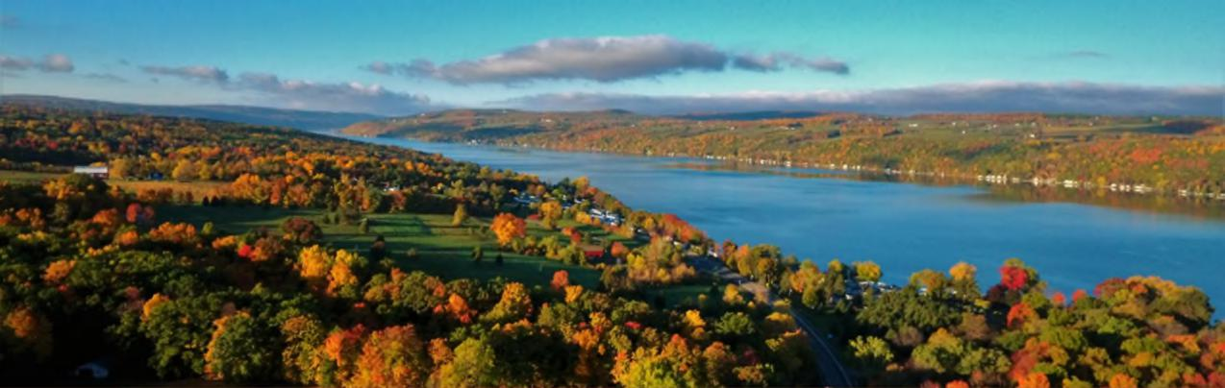
Courtesy of Finger Lakes Tourism Alliance: Joe Carroll
PREPARED BY: Pivital Public Health Partnership | December 2025

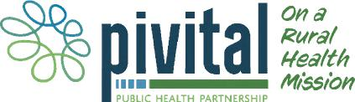

Comprehensive Regional Community Health Assessment
Executive Summary 4
Table of Contents
County Specific Priority Areas 10
Steering Committee 11
New York State 2025-2030 Prevention Agenda 12
Data Method and Processes (Methodology) 14
Comprehensive Regional Community Health Assessment 21
Demographics 21
New York State 2025-2030 Prevention Agenda Domains and Priorities 37
List of Tables:
Table 1: County-Specific Priority Areas 10
Table 2: NYSDOH Prevention Agenda Domains, Priorities and Targets 13
Table 3: Farms and Farm Workers in the Finger Lakes Region 24
Table 4: Foreign Born and Citizenship 26
Table 5: Life Expectancy 32
Table 6: Leading Causes of Death 2022 33
Table 7: Leading Causes of Premature Death 35
Table 8: County Health Rankings 36
Table 9: Poverty Rates in the Finger Lakes Region 39
Table 10: Food Environment Index in the Finger Lakes Region 41
Table 11: Housing Cost Burden and Area Deprivation Index in the Finger Lakes 42
Region
Table 12: Rate of Depressive Disorders and Percentage of Adults Reporting 44 14 or more days of Poor Mental Health in a Month
Table 13: Overdose Deaths 45
Table 14: Healthy Eating 47
Table 15: Injuries and Violence 51
Table 16: Provider Access in the Finger Lakes Region 58
Table 17: Preventive Services 59
Table 18: Oral Care 60
Table 19: Emergency Department Visits and Preventable Hospitalizations 61
Table 20: Education-related Socio-economic Factors 65
Table 21: Education Indicators 65
List of Maps:
Map 1: The Finger Lakes Region of New York State 21
Map 2: Households without a Vehicle by Zip Code 31
Map 3: Life Expectancy by Zip Code, Finger Lakes Region 32
Map 4: Age-Adjusted Death Rate for Heart Disease Rate per 100,000 34
Map 5: Age-adjusted Death Rate for Cancer Rate per 100,000 34
Map 6: Overall Poverty in the Finger Lakes Region 37
Map 7: Poverty rates by Zip Code for those Over 65 Years of Age 38
Map 8: Poverty Rate by Zip Code for those Under 18 Years of Age 38
Map 9: Food Insecurity Rate by Zip Code 40
Map 10: Area Deprivation Index by Area 42

Page 2 Regional Community Health Assessment

Comprehensive Regional Community Health Assessment
Map 11: Frequent Mental Distress Among Adults (Mental Health Not Good 43 for 14+ of past 30 days)
Map 12: Percentage of the population of those 65 years and older living 50
alone by zip code
Map 13: Percentage of births with late (3rd trimester) or no prenatal care 52
Map 14: Premature birth rates by Zip Code 55
Map 15: Percentage of Premature Births with 32 - < 37 Weeks Gestation 55
Map 16: Percentage Low Birth Weight (<2.5 kg) Singleton Births 55
Map 17: Potentially Preventable Hospitalizations 61
Map 18: ED Visits for Cancer by Zip Code 61
Map 19: ED Visits Related to Heart Disease by Zip Code 62
Map 20: ED Visits for Hypertension by Zip Code 62
Map 21: ED Visits for Depressive Disorders by Zip Code 62
Map 22: ED Visits for Anxiety and Panic Disorders by Zip Code 62
List of Figures:
Figure 1: Social Determinants of Health 12
Figure 2: MAPP 2.0 Roadmap to Health Equity 14
Figure 3: MAPP 2.0 Phases 15
Figure 4: Data Triangulation Process 18
Figure 5: Fishbone Diagram 18
Figure 6: Percent Change in Population from 2020- 2040 22
Figure 7: Population Projections by Age Group, Finger Lakes Region 23
Figure 8: Race/Ethnicity Finger Lakes Region 23
Figure 9: Percent of Households Speaking a Language Other than English 27
Figure 10: Disability Rate by County 28
Figure 11: Veteran Population by Percent of Total Population 28
Figure 12: Percentage of Population Uninsured 2020 29
Figure 13: Residents with Medicaid Coverage 30
Figure 14: Broadband Connection vs Broadband Access in each County 30
Figure 15: Percent of Households with No Vehicle Access 31
Figure 16: Suicide Rates 44
Figure 17: Smoking and Binge Drinking 46
Figure 18: Adverse Childhood Experiences 46
Figure 19: Access to Locations for Physical Activity 48
Figure 20: Walkability Index 49
Figure 21: Social Vulnerability Index 49
Figure 22: Alcohol Abstinence in Pregnancy 53
Figure 23: Smoking Abstinence in Pregnancy 53
Figure 24: Illegal Drug Abstinence in Pregnancy 54
Figure 25: Percentage of Preterm Births in the Region from 2018-2024 54
Figure 26: Infant Mortality Rate per 1,000 (2022) 56
Figure 27: Maternal and Child Mortality Rates per 100,000 (2022) 56
Figure 28: Number of Births in the Finger Lakes Region 57
Figure 29: Blood Lead Level Screenings 63
Figure 30: Immunization Rates 64

Page 3 Regional Community Health Assessment


Photo: Watkins Glen State Park courtesy of Schuyler County
Comprehensive Regional Community Health Assessment
Executive Summary
Introduction
The New York State Department of Health (NYSDOH) Prevention Agenda 2025-2030 serves as a roadmap for county health departments, hospitals and other health care systems and partners to develop strategic priorities to ensure the health and well-being of New York State residents. Every six years, New York State requests that local health departments and their local hospital systems work together to create a joint community health assessment and improvement plan. Both should align with the NYSDOH Prevention Agenda and with priorities and requirements detailed by the Public Health Accreditation Board (PHAB).
Local health departments and hospitals must choose at least three areas from the Prevention Agenda on which to focus their community health improvement efforts. Local entities may choose from five domains and 23 priorities within those domains. The five domains are:
- Economic Stability
- Social and Community Context
- Neighborhood and Built Environment
- Health Care Access and Quality
- Education Access and Quality
Throughout the Community Health Assessment cycle, public health and hospital systems value the input
and engagement of key partners and community members who are critical in helping determine which priorities are most important to the community, and what actions ought to be taken to improve the population’s health. The following report summarizes the pertinent information relating to the above priority areas. Residents live, work, and seek services beyond their county of residence. The health and well-being of residents in a neighboring county may impact the needs and services in other counties. In addition, collaborative practices such as shared messaging and lessons learned may expand the reach and success of like-minded interventions. Following the comprehensive assessment of the health of the entire region, this report contains a county-specific chapter from the region. Each county’s chapter highlights specific needs, including additional demographic indicators, main health challenges, and underlying behavioral, political, and built environmental factors contributing to the county’s overall health status.
Page 4 Regional Community Health Assessment

Comprehensive Regional Community Health Assessment
Key Findings
The health of residents of the Finger Lakes region has been challenged by a variety of factors and circumstances ranging from demographic changes to public health crises. Addressing these challenges requires creative thinking, careful planning, and coordinated action, all of which are described in this community health assessment (CHA).
Although the region’s overall population is projected to shrink, the region will experience an increase in the number of older adults over the next several years. This will result in the need to increase the capacity of healthcare and social service agencies. The expected increase in older adults and retirees, paired with a predicted decline in the number of working-age adults, will further exacerbate workforce demands.
Despite the long-standing existence of several unique populations in the region, including migrant farm workers, Amish and Mennonite, Native American and Alaska Natives, researchers have been challenged to collect and interpret data related to their unique health needs. In addition to these populations, there are other demographic and cultural factors which may impact health outcomes and status in a particular county including race, ethnicity, age, income, education, and the infrastructure that makes up the built environment. The 2025–2030 New York State Prevention Agenda organizes these conditions into five domains of social determinants of health: Economic Stability; Social and Community Context; Neighborhood and Built Environment; Health Care Access and Quality; and Education Access and Quality. The data shared below corresponds to the five domain areas of the Prevention Agenda and provides a summary of findings. For more detailed information, please refer to the specific Prevention Agenda sections in this CHA.
Economic Stability
Economic stability refers to socioeconomic disparities, unemployment and underemployment, access to affordable, nutritious food, and housing security. All are closely linked to poor health, affecting physical, mental, and educational outcomes. Children and older adults are especially vulnerable.
Socioeconomic conditions strongly shape community health. Higher poverty levels are associated with more chronic disease, mental health challenges, and limited access to essential resources such as food, housing, education, healthcare, and employment. Poverty also creates wider societal burdens, including homelessness, crime, and higher healthcare costs. Data across counties show notable variation in poverty rates, with several counties exceeding the New York State average. Poverty among older adults is rising in every county, which is concerning given the expected growth of the 65+ population. While household incomes have increased, they are not keeping pace with the living wage needed to meet basic costs.
Access to healthy foods is another key concern. The Food Environment Index (FEI), which reflects food insecurity and distance to grocery stores, indicates that many counties in the region face greater food access challenges than the state overall. High food insecurity rates and large numbers of residents with incomes below the SNAP threshold highlight ongoing economic strain, particularly in rural areas. Limited access to nutritious food contributes to elevated rates of obesity, diabetes, and premature death.
Page 5 Regional Community Health Assessment

Comprehensive Regional Community Health Assessment
Housing stability also plays an important role in health. When housing is unaffordable or poor in quality, it can create stress, contribute to chronic illness, and limit access to other necessities. The Area Deprivation Index (ADI), which measures socioeconomic disadvantage, shows substantial variation across the region, with some communities experiencing significantly higher levels of deprivation and associated health risks.
Children and older adults are especially vulnerable, as poverty, food insecurity, and unstable housing can disrupt healthy development, worsen chronic conditions, and compound disadvantages over time.
Social and Community Context
Social and community context encompasses the relationships, environments, and local systems that shape people’s health and well-being. Strong social connections, a sense of belonging, and access to community resources support positive health outcomes, while factors such as discrimination, isolation, and inequities in the surrounding environment can undermine health.
Mental health concerns are rising across the Finger Lakes region, with increasing rates of depressive disorders and adults reporting frequent poor mental health. Factors such as economic strain, chronic illness, political polarization, and adverse childhood experiences contribute to anxiety and stress, while access to mental health providers remains a challenge. Suicide rates among adults are climbing in most counties, and youth suicide trends vary, with some counties reporting decreases and others showing significant increases.
Drug-related deaths, including opioid overdoses, have escalated sharply in many counties, surpassing statewide averages. Community focus groups also identified growing substance use as a major concern, prompting new local partnerships aimed at addressing addiction.
While smoking has declined across the region, binge drinking has increased, and both behaviors occur at rates higher than the New York State average. Adverse childhood experiences remain a significant issue, with many adults reporting two or more ACEs, which can affect long-term health.
Healthy eating patterns remain a concern across the region. Fewer than half of adults in most counties eat fruit daily, though this is improving, and daily vegetable consumption is declining. Sugary drink consumption is below the state average in most counties yet remains an important target for prevention given its link to obesity and chronic disease. Focus group participants consistently emphasized the importance of healthy eating but noted that affordability and limited grocery access make it difficult to sustain healthy eating habits.
Neighborhood and Built Environment
Neighborhood and built environment depend on clean air and water, safe and affordable housing, well-maintained streets and sidewalks, adequate lighting, low violence, and accessible parks and trails. Although physical activity is essential for preventing chronic disease, many focus group participants reported feeling unsafe on local roads and sidewalks, and residents with mobility limitations often struggle to navigate their surroundings, safely.
Several counties have expanded access to physical activity resources but rising injuries and violence across the region undermine residents’ sense of safety. Regionally, violent crime has risen in recent
Page 6 Regional Community Health Assessment

Comprehensive Regional Community Health Assessment
years, especially since 2020, and is currently at its highest level since 2013. Most counties now exceed the state average in unintentional injury deaths.
Transportation barriers in rural areas further limit access to food and healthcare, as many residents live far from essential services and grocery stores. Low walkability and high social vulnerability scores reflect these challenges. Perceived increases in community violence, regardless of the cause, also discourage community engagement.
Despite these concerns, respondents to the 2024 Regional Access to Care Survey highlighted strong community assets, including volunteers, local non-profit organizations, and hospitals, which help offset shortcomings in the built environment.
Health Care Access and Quality
Health care access and quality play a critical role in preventing disease, supporting healthy development, and reducing inequities. Early and consistent prenatal care lowers risks for mothers and infants, while regular screenings, immunizations, and management of chronic conditions help prevent serious illness and death. Oral health, often tied to socioeconomic status, is another key component of overall wellbeing. Despite the benefits of these services, many residents face barriers, including transportation challenges, inequitable access, and mistrust, that limit their ability to receive timely, high-quality care.
Access to early prenatal care and abstinence from alcohol, tobacco, and illicit drugs during pregnancy are critical in ensuring healthy starts for our youngest residents. While only a small share of births in the region receive late (third trimester) or no prenatal care, some counties have rates that are more than twice those of the best performing counties, underscoring ongoing geographic disparities in timely access. The use of harmful substances during pregnancy has decreased in the region, as have the incidences of preterm births and low birth weights. This is encouraging as the eight counties represented in this regional CHA continue to work collaboratively on maternal child health indicators, interventions, and unified messaging.
Access to primary care and dental care is problematic in rural counties, particularly for low-income and Medicaid-eligible residents. Provider shortages, cost, transportation barriers, and scheduling difficulties hinder timely care. Though mammography rates are high, colorectal cancer and diabetes screenings lag. Dental care, particularly for individuals with Medicaid, remains limited due to a lack of participating providers.
High emergency department use, preventable hospitalizations, and increased behavioral-health visits reflect gaps in primary and specialty care. Public health activities such as TB screening and treatment, blood lead testing, childhood vaccination clinics, and STI testing and treatment remain important stop gaps for individuals who otherwise would lack access to these services. Future improvements may come from telehealth expansion, better broadband, urgent care expansion, and social care networks, though the advent of concierge medicine may worsen inequities.
A 2024 regional survey of more than 1,700 residents confirmed persistent barriers to care (for more detail, please see Regional Access to Care Report section of this CHA). Findings included:
- Shortages of medical, dental, and mental health providers
- Transportation difficulties, especially in rural areas
Page 7 Regional Community Health Assessment

Comprehensive Regional Community Health Assessment
- Insurance-related challenges for uninsured and Medicaid patients
- Greater access barriers for non-White, rural, and Plain community residents
- Strong community assets, including local organizations and hospitals
Emerging issues include workforce shortages—particularly in behavioral health—limited broadband for
telehealth, policy changes affecting Medicaid and SNAP, difficulties integrating new care models, ongoing equity gaps, and the potential benefits of expanding Social Care Networks and urgent care services.
Education Access and Quality
Education is a major determinant of health. People with higher levels of schooling tend to live longer, experience fewer chronic conditions, and enjoy greater economic security. Student absenteeism can stem from a range of issues, including physical and mental health concerns, substance use, unsafe school environments, and low physical fitness. Beyond high school, additional education offers significant advantages: adults with a bachelor’s degree typically have higher earnings, lower unemployment, and improved health and living conditions compared to those with only a high school diploma. However, cost and disparities in access continue to limit these opportunities for many.
Education opportunities are reflected in high school graduation rates, per-student spending, and graduation rates among economically disadvantaged students. Most counties surpass the state average for adults with a high school diploma, suggesting that educational attainment may support greater economic stability.
Regional Assets and Resources to be Mobilized
In the Finger Lakes Region, there is a long history of collaboration and coordination among local health departments (LHDs) and community partners. The counties work together on programming, policy development, and unified messaging and have inter-municipal agreements for emergency response. Six of the counties worked together to become nationally accredited in 2020 and are now pursuing multi-jurisdictional reaccreditation. Additionally, LHDs work collaboratively with hospital partners in emergency preparedness, community health priorities, at co-sponsored events, during communicable disease outbreaks, and on boards and coalitions. Each county maintains a group of hospital and community stakeholders with which they complete the CHA and the CHIP. In addition to these relationships, eight Finger Lakes counties are members of the Pivital Public Health Partnership and collaborate with Common Ground Health and the Forward Leading IPA (FLIPA).
Pivital Public Health Partnership
Pivital Public Health Partnership is a collaboration of eight local health departments including Chemung, Livingston, Ontario, Schuyler, Seneca, Steuben, Wayne, and Yates Counties. The network focuses on improving the health and well-being of Finger Lakes residents by promoting health equity in populations who experience disparities. The Pivital board is made up of community members, medical professionals, and public health directors from member counties. Directors meet monthly to strategize and coordinate efforts to improve the health and wellbeing of Finger Lakes residents.
Page 8 Regional Community Health Assessment

Comprehensive Regional Community Health Assessment
Common Ground Health
Common Ground Health covers the same geographic area as Pivital, with the addition of Monroe County, which has both urban and rural populations. The agency brings together leaders from healthcare, business, education and other sectors to find common ground on health challenges and bring attention to health inequities based on geography, socio-economic status, race and ethnicity. Members meet quarterly at Regional Leadership meetings to discuss challenges in health outcomes and available resources.
Forward Leading IPA (FLIPA)
FLIPA’s mission is to strengthen healthcare through meaningful connections by creating opportunities for member organizations to collaborate, build relationships, and share best practices to support the health and wellbeing of communities across upstate New York. The executive director of Pivital represents the eight Pivital counties on the FLIPA board of directors. Current work is centered on the 1115 waiver and creation of a social care network.
These agencies support the work of the CHA and the eventual execution of the CHIP and continually strive toward highlighting alignment, leveraging shared resources, and creating opportunities for shared learning. With facilitation and coordination by each agency, local leaders are able to regularly meet to discuss health challenges and issues as a team and devise plans toward improving the health of all Finger Lakes residents.
In addition to the resources available through Pivital, Common Ground Health, and FLIPA, LHD’s are active in regional workgroups and local nonprofit organizations. For a list of partners in each county, please see the specific County chapter.
Page 9 Regional Community Health Assessment
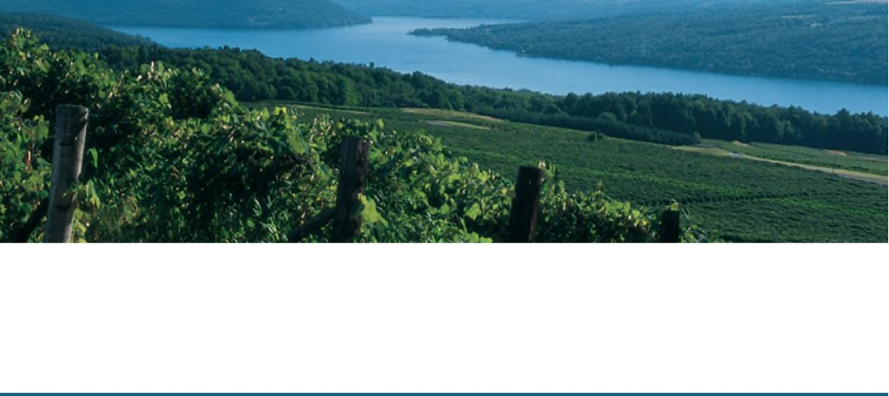
Keuka Lake, Source: Steuben County

Comprehensive Regional Community Health Assessment
The eight counties of the Finger Lakes region each chose three or four priority areas on which to focus their Community Health Improvement Plans as shown in Table 1.
County-Specific Priority Areas
Table 1: County-Specific Priority Areas
County | Prevention Agenda Domain |  |  | Priority Area
Chemung |  | Economic Stability | • | Poverty
 |  | Health Care Access and | • | Housing Stability and Affordability
 |  | Quality  Neighborhood and Built | •  • | Preventive Services – Lead Screening  Access to Community Support Services
 |  | Environment
Livingston |  | Economic Stability | • | Nutrition Security
 |  | Social and Community | • | Depression
 |  | Context  Health Care Access and | • | Oral Health Care
 |  | Quality
Ontario |  | Economic Stability | • | Poverty
 |  | Health Care Access and | • | Preventive Services for Chronic Disease Prevention and
 |  | Quality  Social and Community | • | Control  Depression
 |  | Context
Schuyler |  | Health Care Access and  Quality  Social and Community | •  • | Preventive Services for Chronic Disease Prevention and  Control  Primary Prevention, Substance Misuse and Overdose
 |  | Context  Economic Stability | • | Prevention  Poverty
Seneca |  | Health Care Access and  Quality  Social and Community | •  • | Healthy Children/Preventive Services  Primary Prevention, Substance Misuse and Overdose  Prevention
 |  | Context  Economic Stability | • | Nutrition Security
Steuben |  | Economic Stability | • | Housing Stability and Affordability
 |  | Social and Community | • | Poverty
 |  | Context | • | Primary Prevention, Substance Misuse, and Overdose Prevention
Wayne |  | Social and Community  Context  Economic Stability | •  •  • | Anxiety and Stress  Nutrition Security  Housing Stability and Affordability

Page 10 Regional Community Health Assessment

Comprehensive Regional Community Health Assessment
Yates |  | Economic Stability | • | Housing Stability and Affordability
 |  | Health Care Access and | • | Preventive Services for Chronic Disease Prevention and
 |  | Quality  Social and Community | • | Control  Anxiety and Stress
 |  | Context

Regional Community Health Assessment Structure and Approach
Steering Committee
The regional Community Health Assessment (CHA) effort was led by the Pivital Public Health Partnership, a non-profit affiliation of eight county Public Health Departments in the Finger Lakes region of New York State. Regional CHA partners included: County-level public health departments from Chemung, Livingston, Ontario, Schuyler, Seneca, Steuben, Wayne, Yates; Pivital Public Health Partnership; Common Ground Health; local steering committees; and diverse sectoral organizations. See also County Chapters for specific partners.
Pivital provided county staff with targeted education on the Mobilizing for Action through Planning and Partnership (MAPP) 2.0 Framework; a tool created by the National Association of County and City Health Officials. Additionally, they attended stakeholder meetings and facilitated monthly meetings with health department staff assigned to CHA/CHIP activities. Pivital also provided technical assistance and data support by collecting and entering county-level Community Status Assessment (CSA) data into the Clear Impact performance management scorecard. This ultimately created a regional CSA scorecard to identify shared regional health issues and challenges. County-level teams customized the processes for their local needs and priorities (see specific County Chapters for detailed information.)
While planning was coordinated regionally, each county designated a chairperson who facilitated the CHA process at the local level. Each local health department formed a steering committee best suited to its local needs in order to implement each step of the MAPP 2.0 framework. This adaptive approach allowed each county to follow recognized best practices for collaborative health improvement, while ensuring that local priorities and resources shaped their process.
To enhance data analysis and promote equity, Pivital partnered with Common Ground Health, a health research and planning organization based in Rochester, NY. Common Ground Health supports the nine Finger Lakes counties (the eight represented in this CHA and Monroe County) and is recognized for maintaining the region’s most comprehensive health and health care data resources. Their expertise enabled deeper investigation of health trends and identification of health inequities by geography, socioeconomic status, race, and ethnicity.
During the Community Context Assessment (CCA), the eight counties worked together regionally to identify key unified questions for focus groups. Each local health department was given the opportunity to customize and enrich CCA questions to meet local needs but agreed to use a minimum set of questions decided upon by regional consensus, ensuring consistency and comparability across the region.
Page 11 Regional Community Health Assessment

Comprehensive Regional Community Health Assessment
The NYSDOH Prevention Agenda 2025-2030 serves as a roadmap for county health departments, hospitals and other health care systems and partners to develop strategic priorities to ensure the health and well-being of New York State residents. It guides communities to set priorities, address health disparities, and improve the health and well-being of all New Yorkers. The NYSDOH Prevention Agenda is closely tied to Social Determinants of Health. These determinants are everyday life conditions, such as where people live, work, learn, and play, that affect health, well-being, and opportunities to thrive. (Figure 1)
New York State 2025-2030 Prevention Agenda
Figure 1 Social Determinants of Health
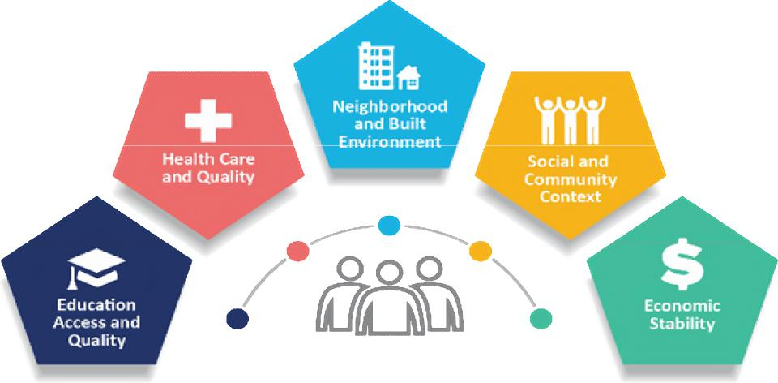
Source: CDC
Local health departments, hospitals and partners used the Prevention Agenda to align their CHA and
CHIP with statewide goals, ensuring that efforts are data-driven and focused on advancing health equity.
The Prevention Agenda outlines five domains with their associated priority areas as detailed in Table 2. Each domain is a Social Determinant of Health.
Page 12 Regional Community Health Assessment

Comprehensive Regional Community Health Assessment
Table 2: NYSDOH Prevention Agenda Domains, Priorities and Targets
 | Domain | Priorities
 | Economic Stability | Poverty
 | Economic Stability | Unemployment
 | Economic Stability | Nutrition Security
 | Economic Stability | Housing Stability and Affordability
 | Social and Community Context | Anxiety and Stress
 | Social and Community Context | Suicide
 | Social and Community Context | Depression
 | Social and Community Context | Primary Prevention, Substance Misuse, and Overdose Protection
 | Social and Community Context | Tobacco/E-cigarefte Use
 | Social and Community Context | Alcohol Use
 | Social and Community Context | Adverse Childhood Experiences
 | Social and Community Context | Healthy Eating
 | Neighborhood and Built Environment | Opportunities for Active Transportation and Physical Activity
 | Neighborhood and Built Environment | Access to Community Services and Support
 | Neighborhood and Built Environment | Injuries and Violence
 | Health Care Access and Quality | Access to and Use of Prenatal Care
 | Health Care Access and Quality | Prevention of Infant and Maternal Mortality
 | Health Care Access and Quality | Preventive Services for Chronic Disease Prevention and Control
 | Health Care Access and Quality | Oral Health Care
 | Health Care Access and Quality | Preventive Services
 | Health Care Access and Quality | Early Intervention
 | Health Care Access and Quality | Childhood Behavioral Health
 | Education Access and Quality | Health and Wellness Promoting Schools
 | Education Access and Quality | Opportunities for Continued Education

Source: NYSDOH Prevention Agenda 2025-2030
Page 13 Regional Community Health Assessment

Comprehensive Regional Community Health Assessment
The CHA provides a comprehensive picture of a community’s current health status, including factors that contribute to health risks and challenges. It also identifies priority health needs by analyzing local data and community input.
The eight counties in the Finger Lakes region of New York State represented in this CHA adopted the NACCHO MAPP 2.0 Framework for community improvement in developing this regional CHA. (Figure 2). This broad framework allowed the counties to work as one collective unit while also enabling them to customize the assessments to best suit the needs and abilities of their individual counties.
Figure 2 MAPP 2.0 Roadmap to Health Equity
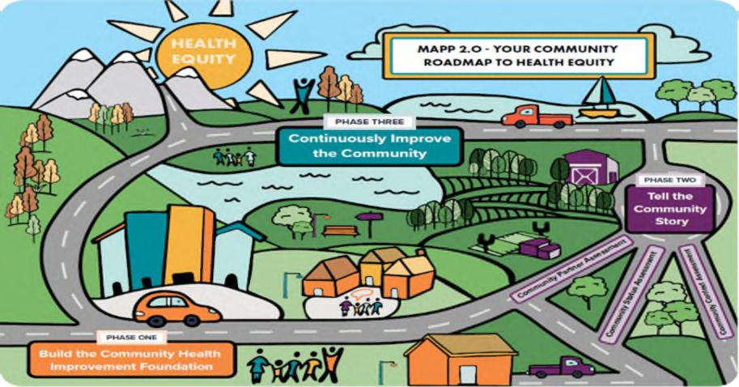
Source: NACCHO
Data Method and Process (Methodology)
Page 14 Regional Community Health Assessment

Comprehensive Regional Community Health Assessment
The process implemented by each county followed a three-phased approach noted in Figure 3.
Phase 1: Build the Community Health Improvement Foundation.
This phase focuses on creating the leadership, partnerships, and shared commitment necessary to guide the MAPP process. It involves forming or strengthening a community health coalition, establishing clear roles and responsibilities, and developing a shared vision for a healthier community. During this
step, partners build trust, set expectations, and ensure that diverse voices are represented, including
residents, community organizations, health systems, and local government.
Phase 2: Tell the Community Story
This phase focuses on gathering and analyzing data to create a comprehensive picture of the community’s health using three coordinated assessments: the Community Partner Assessment (CPA), Community Status Assessment (CSA), and Community Context Assessment (CCA). Together, these tools integrate quantitative data with qualitative input from residents and stakeholders to identify key health issues, strengths, and challenges, aligned with the Prevention Agenda social determinants of health domains and equity goals. Partners gain a shared understanding of health needs, disparities, and resources, which provides the evidence base for setting priorities and developing strategies for improvement.
Community Partner Assessment (CPA)
The CPA helps community organizations examine both their own internal processes and abilities, as well as their shared capacity as a community network to tackle health inequities. It is designed to guide partners in determining what actions are needed to address inequities at the individual, system, and structural levels. The CPA is intended to address the following questions:
- What are the capabilities, skills and strengths each participating organization possesses that will contribute to improving community health and advancing MAPP goals?
- Who is currently involved in the MAPP process? Who else needs to be involved?¹
¹ NACCHO Community Partner Assessment Tool, www.naccho.org
Figure 3 MAPP 2.0 phases
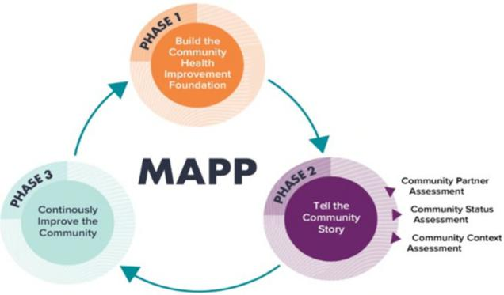
Source: NACCHO
Page 15 Regional Community Health Assessment

Comprehensive Regional Community Health Assessment
Each county developed and administered a survey and/or convened focus groups as part of its CPA. Details of the survey development and distribution and focus group administration for each county are noted in the specific county section of this CHA. Responses were then organized qualitatively and quantitatively in an effort to identify strengths, weaknesses, opportunities, and threats as identified by respondents.
Community Status Assessment (CSA)
The CSA provides quantitative information about the community, such as population characteristics, health conditions, and disparities. Its purpose is to help communities understand inequities that go beyond individual behaviors or health outcomes, including how these issues connect to social determinants of health and broader systems of power and privilege. Ultimately, the CSA is a community-centered effort intended to capture and convey the community’s narrative. The CSA is intended to address the following questions:
- What does the status of the community look like, including key health, socioeconomic, environmental, and quality-of-life outcomes?
- What populations are experiencing inequities across health, socioeconomic, environmental, and quality-of-life outcomes?
- How do systems influence outcomes?²
Data for each county was collected and compiled using Clear Impact performance management software. Data sources included:
- United States Census Bureau (census.gov) and the American Community Survey (5-year estimates)
- New York State Prevention Agenda Dashboard
- New York State Community Health Indicator Dashboard
- County Health Rankings
- Centers for Disease Control and Prevention (CDC)
- Behavioral Risk Factor Surveillance System
- NYSDOH Vital Records (Vital Statistics); New York State Department of Health
- New York State’s Statewide Planning and Research Cooperative System (SPARCS)
- Graduation Rate Data, 4-year outcomes; New York State Education Department (NYSED)
- NYS Perinatal Data Profile; Statewide Perinatal Data System
- Healthy People 2020; US Dept of Health and Human Services
- Environmental Protection Agency (EPA) Office of Community Revitalization
- The Neighborhood Atlas | Center for Health Disparities Research
- Local area unemployment Statistics (LAUS); U.S. Bureau of Labor Statistics, Office of Employment and Unemployment Statistics
- Evalumetrics Youth Survey (EYS) Reports
- Wilmot Cancer Institute, Cancer in Focus State Cancer Profiles; National Vital Statistics System | SEER
² NACCHO Community Status Assessment Tool, www.naccho.org
Page 16 Regional Community Health Assessment

Comprehensive Regional Community Health Assessment
- NYSIIS Performance Report; New York State Immunization Information System
- Immunization Action Plan (IAP) Baseline Reports
Community Context Assessment (CCA)
The Community Context Assessment is a qualitative and quantitative tool used to assess a community’s strengths, weaknesses, assets, and challenges specific to each community. It is based on three areas: Community Strengths and Assets, Built Environment, and Forces of Change. The MAPP 2.0 Framework CCA guiding questions were developed collaboratively by participating health departments to ensure continuity in data collection and analysis. Each county had the option of adding additional questions, but all counties asked the following seven questions:
- Which health issues have the biggest impact on you and/or your community?
- What does our community have that helps everyone, no matter their income, background, or language, have a fair chance to be healthy and feel welcome?
- How do the streets, buildings, and sidewalks in different parts of our community help support the health of people, especially those with low incomes, people of color, limited English speakers, people with different genders or sexual orientations, or those with disabilities?
- Where in our community is it easier or harder to be healthy, and why?
- What has occurred recently that may affect the health of our community?
- What may occur in the future?
- Based on the above – do these things affect some groups more than others?³
Data collected during the Community Context Assessments added residents’ voices and care was taken to engage often underrepresented populations, including migrant farm workers, members of the LGBTQ community, males, and low-income individuals. Data enhanced understanding of the unique needs of each community and aided in establishing the priority areas chosen by each county.
For a description of each county’s activities during the CCA, see county-specific chapters in the document.

³ NACCHO Community Context Assessment Tool, www.naccho.org

Page 17 Regional Community Health Assessment

Comprehensive Regional Community Health Assessment
Data Triangulation
Counties collaborated with Pivital, Common Ground Health, and their county-specific partners and stakeholders to complete the CPA, CSA and CCA.
After each county completed the three assessments, Pivital triangulated the data to develop and propose cross-cuffing themes for each county (Figure 4).
Figure 4 Data Triangulation Process
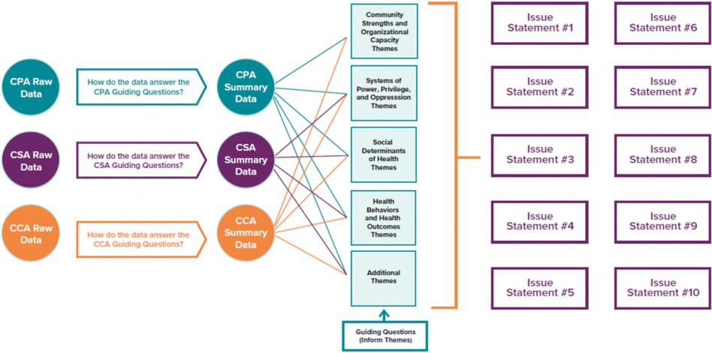
Source: NACCHO

After data was triangulated, counties used Fishbone Diagrams to examine the cause and effect of each identified community issue – Figure 5. Using the Five Whys - identifying an issue and asking “why” at least five times to get to the root cause - counties were able to narrow the list of priorities and identify upstream root causes on which to focus. Each county then reviewed findings with their stakeholders and community partners and conducted a Health Assessment Prioritization using a prioritization matrix to rank each theme based on five criteria: | 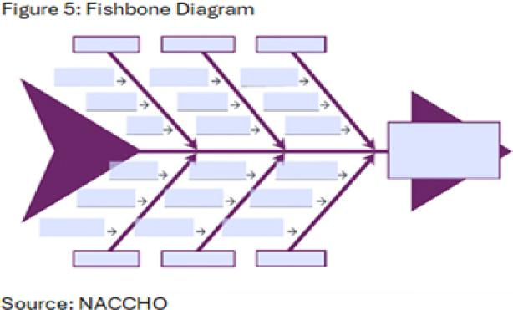

- Relevance of the issue to community members.
- Magnitude/severity of the issue.
- Impact of the issue on communities impacted by inequities.
Page 18 Regional Community Health Assessment

Comprehensive Regional Community Health Assessment
- Availability and feasibility of solutions and strategies to address the issue.
- Availability of resources (time, funding, staffing, equipment) to address the issue.
Each county then identified at least three Prevention Agenda Priorities to address in its CHIP.
Phase 3: Continuously Improve the Community
This phase focuses on using assessment findings and selected priorities to develop, implement, and monitor a Community Health Improvement Plan (CHIP). This phase emphasizes ongoing collaboration, use of evidence-based strategies, and continuous quality improvement to advance health equity and strengthen community conditions over time. After the selection of focused Prevention Agenda priorities to be included in the CHIP, local health departments and community partners will identify evidence-based and promising practices that address the root causes and key drivers of each priority area. Local county committees will then select strategies that are realistic and feasible for implementation, taking into account local capacity, existing and potential partners, and available resources. Following the selection of strategies, partners will identify clear performance measures and selected Prevention Agenda objectives to monitor implementation, track progress, and assess impact over time, supporting a continuous quality improvement approach to community health.
Partner Engagement
Community partners played a key role throughout the CHA and during the development of the CHIP. Each partner completed the Community Partner Assessment (CPA), providing valuable organizational data and insights. They also helped identify and engage community members and organizations for focus groups as part of the Community Context Assessment (CCA), ensuring diverse perspectives were included.
Throughout the process, each county’s stakeholders and partners participated in regular meetings where findings from all three assessments were presented. These sessions encouraged questions, feedback, and shared interpretation of the data. These work groups collaboratively reviewed and discussed the triangulated results, allowing partners to validate findings and contribute to identifying key themes.
Finally, partners participated in the prioritization process, ensuring that shared priorities reflected both data and community voice.
Regional Access to Care Report
In addition to the MAPP 2.0 Framework process, Pivital Public Health Partnership, in collaboration with the eight local health departments, administered the Access to Care Survey⁴ between July and November 2024 to obtain primary, population-based data on access and barriers to care across the region. The survey, offered in multiple formats and languages, included questions on having a usual source of care, use of routine and preventive services, delays in care due to cost or transportation, experiences with behavioral health care, insurance status, and key demographic characteristics, and yielded more than 1,700 completed responses from residents of the eight counties.
⁴ Source: Access to Care in the Finger Lakes Region, Collaborative Assessment Report, 2025
https://pivitalphp.org/reports/access-to-care/
Page 19 Regional Community Health Assessment

Comprehensive Regional Community Health Assessment
Survey data were cleaned, weighted to reflect the regional population using Census-based distributions, and analyzed using descriptive statistics to characterize access indicators and chi-square tests and logistic regression models to examine differences and disparities by factors such as race, insurance type, geography, and Plain Community status. Findings from this analysis were integrated with MAPP 2.0 assessments and qualitative input from focus groups to identify populations facing the greatest barriers, and were used to inform health issue prioritization.
Key findings from the Survey showed that people in the eight counties still face problems when trying to get health care:
- Not enough providers: It is difficult for many people to find a doctor, dentist or mental health provider, especially in rural areas.
- Transportation issues: Many people do not have reliable ways to get to appointments, especially if they do not own a car or if they live far away from care.
- Insurance problems: People without insurance and those who have Medicaid often have a harder time getting care. They may have to wait longer or travel farther.
- Unequal access: Non-White, rural and Plain community (Amish/Mennonite) members face compounded barriers, with reduced routine/preventive care and higher rates of appointment access challenges.
- Community strength: People also shared many positive things, like strong local groups, caring volunteers, helpful nonprofit organizations, and local hospitals.
The report also identified emerging issues within the Finger Lakes region:
- Health care workforce shortages: Behavioral health, in particular, along with other health care workers are in demand. Rural communities have a difficult time attracting talent because of aging infrastructure and rate of pay.
- Telehealth expansion: While telehealth may be expanding in many areas of the country, limited broadband access makes its dissemination problematic in rural areas.
- Insurance policy changes: Impending cuts to Medicaid may impact access to care and increase out-of-pocket costs.
- Supplemental Nutrition Assistance Program (SNAP): Expected changes to eligibility may mean residents are forced to choose between food and medical care, including prescriptions.
- Integration of care: New models of care are being piloted in many areas but face funding and coordination challenges in the Finger Lakes region.
- Equity gaps: Mortality rates among minority populations are higher than other groups. Additionally, higher Medicaid-dependence is linked with higher food insecurity issues which impact overall health.
- Innovative care models: Social Care Networks and Urgent Care expansion will help to alleviate some rural health concerns and issues.
Page 20 Regional Community Health Assessment

Comprehensive Regional Community Health Assessment
Comprehensive Regional Community Health Assessment
Community Description: The Finger Lakes Region
Demographics
The Finger Lakes get their name from the series of 11 lakes in central and western New York that resemble the fingers on a hand. Native American lore explains that the lakes were formed when the Great Spirit laid his hand down on the region. The lakes were formed as an impression of his hand blessing the landscape.⁵ Scientifically speaking, the lakes were formed by receding glaciers over two million years ago.⁶ The area now serves as an idyllic recreational spot with abundant outdoor activities, award-winning wineries, historic and quaint towns, and vast agricultural farmland. While smaller urban areas do exist within the counties, this mostly rural region of New York State shares the health-related issues and illnesses of many rural areas in New York and the United States.
Though the Finger Lakes Region encompasses a larger swath of the state, the eight Finger Lakes counties represented in this Community Health Assessment, include: Chemung, Livingston, Ontario, Schuyler, Seneca, Steuben, Wayne, and Yates. (Map 1)
Map 1: The Finger Lakes Region of New York State
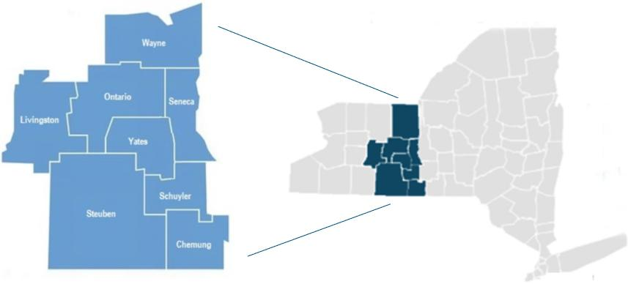
⁵ Source: FingerLakesTravelNY.com: History of the Finger Lakes
⁶ "Ithaca is Gorges: A Guide to the Geology of the Ithaca Area, Fourth Edition" by Warren D. Allmon and Robert M. Ross, published in 2007 by the Paleontological Research Institution
Page 21 Regional Community Health Assessment

Comprehensive Regional Community Health Assessment
Population Estimates
Overall Population Estimates
There are 515,563 people living in the 8-county Finger Lakes Region. Estimates projecting into the year 2040 demonstrate a slight decrease in the population for most counties, with the exceptions of Livingston and Ontario. Stratified by county (Figure 6) are the projected population differences over the next 20 years. Some of the largest changes are expected in Chemung, Steuben and Wayne Counties.
Figure 6: Percent Change in Population from 2020- 2040
Source: County Health Rankings, Census Population Estimates, Cornell Program on Applied Demographics
Age Group Projections
Over the next five years (2025–2030), the population of residents aged 65 and older is projected to increase in all Finger Lakes counties, while younger age groups (under 18, 18–39, and 40–64) are expected to decline in most counties. Exceptions include: Ontario County, which is projected to see a slight increase in the under-18 population; Seneca County, which is expected to gain residents aged 40– 64; and Yates County, which is projected to experience growth in the 18–39 age group. The overall growth in the older adult population will likely increase demand for geriatric care and chronic disease management across the region. Figure 7 illustrates the projected percent change in each age group by county.
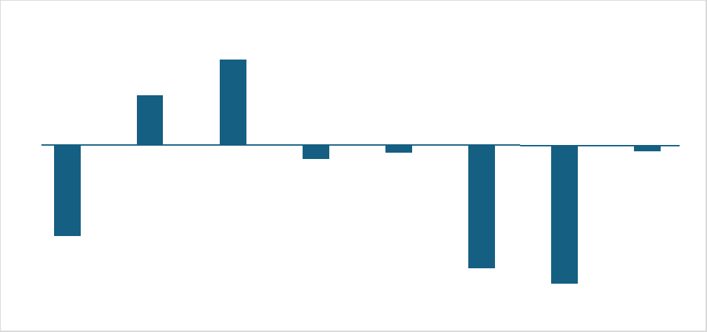
Steuben
-7.00%
Wayne
2.50%
Livingston Ontario
-4.60%
Chemung
4.30%
-0.70% -0.40% -0.30%
Schuyler Seneca Yates
-6.20%
Page 22 Regional Community Health Assessment

Comprehensive Regional Community Health Assessment
Figure 7: Population Projections by Age Group, Finger Lakes Region
Population Projections 2025-2030
(Percent Change)
-15.00 -10.00 -5.00 0.00 5.00 10.00 15.00
Chemung Livingston Ontario Schuyler Seneca Steuben Wayne Yates |  | 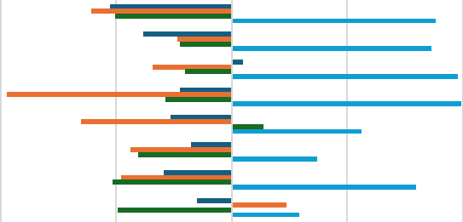
Percent change (under 18) Percent change (18-39) Percent change (40-64) Percent change (65+)
Source: Cornell University Program on Applied Demographics, 2025-2030
Race/Ethnicity
More than 90% of the Finger Lakes Region population is White/Non-Hispanic. Chemung County has the largest non-white population with 5.9% Black, 3.6 % Hispanic, 0.3% American Indian/Alaska Native. (Figure 8).
Figure 8: Race/Ethnicity Finger Lakes Region
Source: An Ecosystem of Minority Health and Health Disparities Resources. National Institute on Minority Health and Health Disparities
Race/Ethnicity Finger Lakes Region (2020)
7
6
6 | 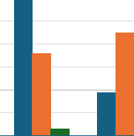
5 4 3 2 1  0 |  |  |  |  |  |  | 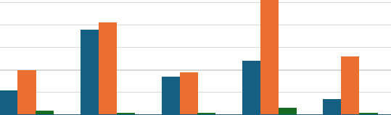
Chemung Livingston Ontario Schuyler Seneca Steuben Wayne Yates
Black Hispanic American Indian/Alaska Native
Page 23 Regional Community Health Assessment

Comprehensive Regional Community Health Assessment
Migrant Farm Workers
The 2022 Census of Agriculture reported that there were 22,000 workers on farms in the Finger Lakes region. Just less than one quarter (5,340) were unpaid and probably represented family members or coop workers. The vast majority (16,600) were paid workers, but not necessarily in full-time or permanent positions. Wayne County had the highest number of migrant workers (3,034) of the eight counties.
Almost 25% of the region’s farms contracted with migrant farm workers. Because migrant farm workers move from job to job depending on the season, a single migrant worker may be counted by multiple
farms, therefore the total number of migrant workers is potentially an over count of individuals (Table 3).
County | Number of  Farms with  Hired  Workers  (2022) | Number of  Farms with  Migrant  Workers  (2022) | Hired Farm Labor* |  | Number of  Migrant  Workers**  (2022) | Number of  Unpaid  Workers***  (2022)
County | Number of  Farms with  Hired  Workers  (2022) | Number of  Farms with  Migrant  Workers  (2022) | Total  Workers  (2022) | Number of  Workers  Who  Worked  <150 days  (2022) | Number of  Migrant  Workers**  (2022) | Number of  Unpaid  Workers***  (2022)
Chemung | 48 | 2 | 171 | 90 | (D)^ | 381
Livingston | 142 | 16 | 998 | 354 | 68 | 477
Ontario | 229 | 32 | 1,547 | 718 | 307 | 801
Schuyler | 108 | 25 | 943 | 547 | 119 | 333
Seneca | 146 | 39 | 1,653 | 1,212 | 493 | 429
Steuben | 297 | 21 | 1,344 | 690 | 66 | 1,370
Wayne | 259 | 141 | 3,902 | 2,590 | 3,034 | 677
Yates | 250 | 80 | 1,625 | 1,111 | 390 | 872
Total Finger Lakes  Region | 1,479 | 356 | 12,183 | 7,312 | 4,477 | 5,340

Table 3: Farms and Farm Workers in the Finger Lakes Region
*Hired farm labor does not include contract/migrant workers.
**Migrant farm workers are workers whose employment requires travel that prevents the worker from returning to his or her
permanent place of residence the same day.
***Unpaid workers include agricultural workers not on the payroll who performed activities or work on a farm or ranch.
^Suppressed to avoid disclosing data for individual farms.
Source: US Department of Agriculture, 2022 Census of Agriculture
Migratory and seasonal agricultural workers and their families face distinct barriers that contribute to significant health disparities. Factors such as hazardous working conditions, poverty, inadequate housing, limited clean water, lack of insurance, language and cultural barriers, and fear and mistrust related to immigration status all limit access to consistent, quality care. These challenges increase the risk of serious health issues including diabetes, malnutrition, depression, substance use, infectious diseases, pesticide exposure, and work-related injuries. Migration further heightens these problems by creating isolation and disrupting continuity of care, making it harder to maintain treatment and health records.⁷
⁷ Source: Rural Health Information Hub, 2025: hftps://www.ruralhealthinfo.org/topics/migrant-health
Page 24 Regional Community Health Assessment

Comprehensive Regional Community Health Assessment
A healthy migrant community is essential to the farming industry in the eight-county region and
therefore essential to the livelihood of farmers and the economy of the region. Without them, fields may go unplanted, fruit unpicked, and crops unharvested.
Amish/Mennonite
The Plain Community - Amish and Mennonite - is an important part of the Finger Lakes region, contributing substantially to the agricultural sector in many areas. Obtaining reliable, current information about their population size and health outcomes is difficult, particularly at the county level, because these groups typically do not participate in surveys like those run by the U.S. Census Bureau.
Elizabethtown College’s Young Center for Amish Studies provides annual population estimates that help fill this gap. According to their data, New York State has 60 Amish settlements and 188 districts, totaling roughly 25,220 individuals.⁸ Within the Finger Lakes, specifically Livingston, Seneca, Steuben, and Wayne Counties, there are 16 districts with an estimated 3,770 Amish residents.⁹ These numbers do not include Mennonite populations. The Young Center also compiles information on various Mennonite groups, often organized by church conference. In New York, the Groffdale Conference Mennonites are estimated at 3,856 people, the Midwest Mennonite Conference at 971, and the Stauffer Mennonite Conference at around 476.¹⁰
When reviewing data or planning public health efforts, it is important to account for Amish and Mennonite cultural practices. Decision-making about health care is typically influenced by church leaders’ guidance. Many families rely on natural or homeopathic health approaches, which can delay lifesaving medical care and affect decisions about family planning, preventive care, dental care, and vaccinations. Home births and delayed prenatal care are relatively common as is breast feeding. Children generally attend school through eighth grade before focusing on farming or learning a trade, increasing exposure to potential injuries. Travel by bicycle or horse-drawn buggy also creates traffic-safety concerns on rural roads shared with faster-moving motor vehicles.
These cultural factors combined with expected population growth are important considerations for public health professionals in the region. Research suggests that when health information is offered by trusted sources and services are easily accessible, Plain families are often receptive to interventions, including certain immunizations. Building cultural understanding and maintaining flexible, consistent outreach can support strong participation in recommended health practices.¹¹
⁸ “Amish Population Profile, 2025.” Young Center for Anabaptist and Pietist Studies, Elizabethtown College. https://groups.etown.edu/amishstudies/statistics/amish-population-profile-2025.
⁹ Statistics compiled by Edsel Burdge Jr., Young Center for Anabaptist and Pietist Studies, Elizabethtown College, in cooperation with Joseph F. Donnermeyer, School of Environment and Natural Resources, The Ohio State University, and with assistance from Adam Hershberger, Ohio Amish Library, Millersburg, Ohio.
¹⁰ Compiled from the most recent directories by Edsel Burdge Jr., Young Center for Anabaptist and Pietist Studies, Elizabethtown College, 1 Alpha Drive, Elizabethtown, PA 17022 Updated October 2025
¹¹ Baillie, K. U. (2018, July 13). With free vaccinations, ChildProtect program helps Amish communities stay healthy. Penn Today. University of Pennsylvania. https://penntoday.upenn.edu/news/free-vaccinations-childprotect-program-helps-amish-communities-stay-healthy
Page 25 Regional Community Health Assessment

Comprehensive Regional Community Health Assessment
American Indian and Alaska Native Population
In 2022, 1,408 residents of the Finger Lakes region identified themselves as American Indian and Alaska Native alone. However, it is important to note that this estimate does not include residents who identify as multiple races.¹²
The Centers for Disease Control and Prevention noted that as of 2023, the average life expectancy for American Indians and Alaska Natives is the lowest of all ethnic groups. American Indians and Alaska Natives can expect to live to 70.1 years as compared with the national estimate of 78.4 years. Further, they also report being in fair or poor health more often than all other racial groups (24.4%). The leading causes of death in this group are heart disease, cancer, unintentional injuries, chronic liver disease, and diabetes.¹³
These disparities exist for a number of reasons but largely correlate back to inadequate educational opportunities, disproportionate rates of poverty, discrimination in the delivery of health services, and the impact of historical intergenerational trauma including centuries of racial discrimination.¹⁴
Foreign Born Population
The majority of those who are foreign-born living in the Finger Lakes region have become naturalized US Citizens. The naturalization rate varies by county, from as low as 35 percent in Wayne County to 77.9 percent in Yates County (Table 4). Residents coming from other countries may face significant challenges in adapting to the United States’ disease prevention and treatment culture and, as such, should be cared for and tended to in a way that is respectful of and collaborative with the customs and beliefs of their heritage.
Table 4: Foreign Born and Citizenship
County | Percent of Population that is Foreign-born (2020) | Percent Naturalized U.S. Citizen (2020) | Percent Not a U.S.  Citizen (2020)
Chemung | 3.6 | 58.0 | 42.0
Livingston | 3.5 | 51.5 | 48.5
Ontario | 5.0 | 55.8 | 44.2
Schuyler | 1.9 | 51.8 | 48.2
Seneca | 2.9 | 54.4 | 45.6
Steuben | 3.3 | 38.4 | 61.6
Wayne | 5.0 | 35.0 | 65.0
Yates | 1.6 | 77.9 | 22.1
Source: U.S. Census Bureau, 2020 Census.
Public health professionals must keep cultural and linguistic differences in mind when collecting and exhibiting data, developing and providing programming, and evaluating the effectiveness of
¹² Source: U.S. Census Bureau Population Estimates Program. Methodology for the United States population estimates: Vintage 2022. 2022. hftps://www2.census.gov/programs-surveys/popest/technical-documentation/methodology/2020-2022/methods-statement-v2022.pdf
¹³ Source: CDC, hftps://minorityhealth.hhs.gov/american-indian-and-alaska-native-health
¹⁴ US Commission on Civil Rights, Broken Promises: Continuing Federal Funding Shortfall for Native Americans, 2018
Page 26 Regional Community Health Assessment

Comprehensive Regional Community Health Assessment
interventions. Demonstrating respect for an individual’s national and cultural background fosters trust and strengthens the practitioner–client relationship. Cultural responsiveness enhances the quality of care, supports better health outcomes, and reduces disparities.
Household Languages
While most people in the Finger Lakes region primarily use English, a smaller portion of the population speaks other languages at home. These include Spanish, various Asian and Pacific Island languages, and a range of other Indo-European languages (Figure 9). In Yates County, the notable share of Indo-European language speakers is likely influenced by the presence of Amish and Mennonite communities in which some families speak German dialects in the home. Small counties may have no bilingual staff members and few options for obtaining interpreters.
Figure 9: Percent of Households Speaking a Language Other than English
Source: U.S. Census Bureau, 2024 ACS 1or 5-year estimates
Disability
People with disabilities face a higher likelihood of developing chronic health issues such as obesity, heart disease, and diabetes. Reducing health disparities among this population involves fostering a community culture that supports inclusion and creating welcoming physical spaces free of conditions that might prohibit participation in healthy behaviors. Achieving this requires coordinated efforts across multiple disciplines, including policy, systems, and environments.
Percent of Households Speaking a Language Other than English
(2024)

18 16 14 12 10
8
6
4
2
0
18 16 14 12 10  8  6  4  2  0 | 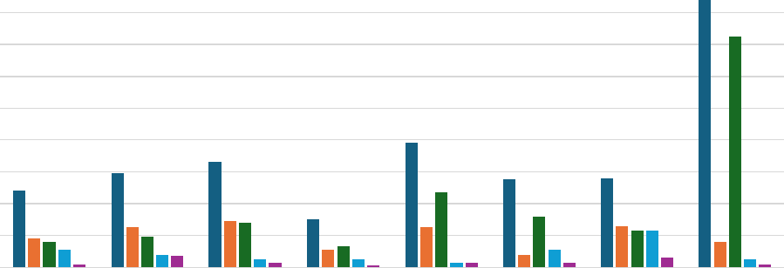
18 16 14 12 10  8  6  4  2  0 | Chemung Livingston Ontario Schuyler Seneca Steuben Wayne Yates
Overall Spanish Other Indo-European Languages Asian and Pacific Island Languages Other Languages
Page 27 Regional Community Health Assessment

Comprehensive Regional Community Health Assessment
Figure 10 shows the disability rate for each county in the Finger Lakes region. The most common disabilities in the region are cognitive, ambulatory and independent living.¹⁵
Figure 10: Disability Rate by County
Source: U.S. Census Bureau, 2020 Census
Veterans
The population of veterans in the eight counties of the Finger Lakes is higher than the NYS average of 3.5 percent. Veterans certainly have the same health care needs as others in the community, however, they may also require additional health care services related to mental health, physical health and issues related to environmental exposure during service.¹⁶ Figure 11 details the percentage of veterans in each county.
Figure 11: Veteran Population by Percent of Total Population
Source: U.S. Census, 2020 Census
¹⁵ Source: U.S. Census Bureau, 2020 Census
¹⁶ Source: Veterans Affairs, hftps://www.va.gov/health-care/health-needs-conditions/
Disabled Population by Percent of Total (2020)

20
20 | 18 | 18.3

15.9 15.1 |  |  |  |  |  |  |  |  |  | 15.6
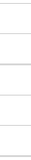 |  | 14.1 13.6
 |  |  |  |  |  |  |  |  |  |  |  |  |  | 11.1
 |  |  |  |  |  |  |  |  |  |  |  |  |  |  |  | 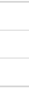
Chemung Livingston Ontario Schuyler Seneca Steuben Wayne Yates
18 16 14 12 10
8
6
4
2
0
Veteran Population by Percent of Total (2020)
10 8.9 8.7 8.6
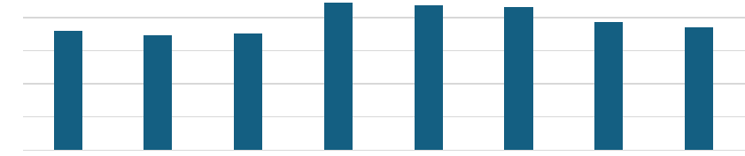
7.7 7.4
8 7.2 6.9 7
6
4
2
0
Chemung Livingston Ontario Schuyler Seneca Steuben Wayne Yates
Page 28 Regional Community Health Assessment

Comprehensive Regional Community Health Assessment
Health Insurance Status
Health insurance plays an important role in ensuring people can obtain necessary medical services. Like individuals with limited financial resources, those without insurance are less likely to seek routine or preventive care, often lack a consistent healthcare provider, and may rely more heavily on emergency departments for issues that could be managed in primary care. Figure 12 illustrates the share of residents in each county who are uninsured. The notably higher uninsured rate in Yates County is likely influenced by the sizable Amish and Mennonite communities living there.
Figure 12: Health Insurance Status
Source: U.S. Census Bureau, 2020 Census
In October of 2025, in New York, 6,812,160 residents were enrolled in Medicaid.¹⁷ Of these, 128,589 are residents of the eight county Finger Lakes Region. According to the NY State of Health, an estimated 11.5 million New Yorkers may lose Medicaid coverage in 2026 due to new federal requirements.¹⁸ Using this projection, between 18,774 and 28,290 Finger Lakes residents may lose coverage. Figure 13 highlights the number of residents with Medicaid coverage versus the overall population in each county.
¹⁷Source: Medicaid Enrollment Databook, October 2025 at
https://www.health.ny.gov/health_care/medicaid/enrollment/docs/by_resident_co/current_month.htm ¹⁸ Source: https://info.nystateofhealth.ny.gov/stay-connected
Health Insurance Status
25
19.6
20
15
10
20  15  10 |  |  |  |  |  |  |  |  |  |  |  |  |  |  |  | 
20  15  10 |  |  |  |  |  |  |  |  |  | 8.7
 |  |  |  |  |  |  |  |  |  |  |  |  |  | 6.1
 |  |  |  |  |  |  |  |  |  |  |  | 5 |  | 6.1
5 |  |  |  | 3.9 4.1  3.5 |  |  |  |  |  |  |  | 5
5 |  | 2.4
0

Chemung Livingston Ontario Schuyler Seneca Steuben Wayne Yates
Page 29 Regional Community Health Assessment

Comprehensive Regional Community Health Assessment
Figure 13: Residents with Medicaid Coverage
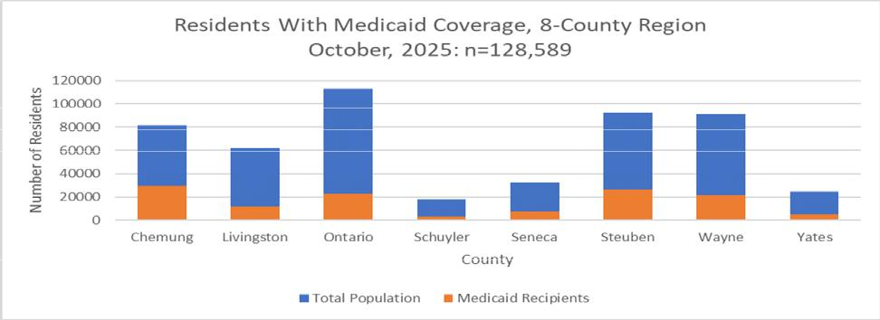
Source: Source: Medicaid Enrollment Databook
Broadband Access
Access to broadband services is considered a necessity. The Covid-19 pandemic elevated the need for broadband access to a new level with remote work and learning as well as accessible healthcare options. New York State as a whole has extensive broadband access (90%), but not every part of the state has the same access. Figure 14 notes the percentage of households with a broadband connection versus the percentage in the county who have no access to broadband services, meaning broadband service is not available to them to purchase or access.
Figure 14: Broadband Connection vs Broadband Access in each County
Source: Office of the State Comptroller, ACS, County Health Rankings
Broadband Connection vs. Access (2025)
0 10 20 30 40 50 60 70 80 90 100
Chemung Livingston Ontario Schuyler Seneca Steuben Wayne Yates | 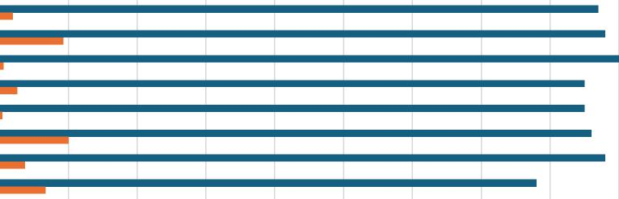
Households with Broadband Connection Households with no Access to Broadband Services
Page 30 Regional Community Health Assessment

Comprehensive Regional Community Health Assessment

Transportation  Rural residents lack equitable access to transportation. Low population density often makes public transportation implausible. Access to a personal vehicle can affect an individual’s health and wellness in many ways. Unreliable, inconsistent or inconvenient transportation can cause a strain on the ability to access health care services, purchase food and other items, and maintain a job. These can result in, poor health outcomes, and decreased economic stability.  Figure 15 shows the proportion of households in each Finger Lakes county that do not have access to a vehicle. Yates County’s higher percentage is largely due to the Amish and Mennonite communities, who typically use horse-and-buggy travel rather than motor vehicles. This is particularly evident in Map 2.  Figure 15: Percent of Households with No Vehicle Access | Map 2: Households without a Vehicle by Zip Code
 | 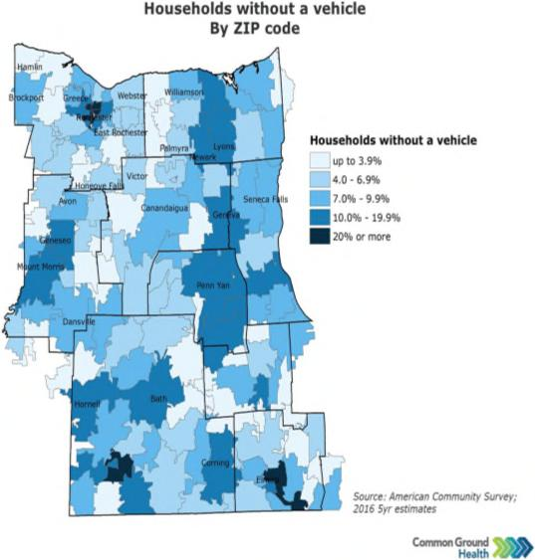

Source: U.S. Census Bureau 2023 5-year estimates

No Vehicle Access (2023)
14 13
Chemung Livingston Ontario Schuyler Seneca Steuben Wayne Yates
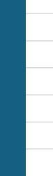
9.6
10
8 | 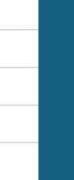
8 |  |  | 6.4  5.9 6.3
6
4
2
0
8.8_
12
9.9
7
Life Expectancy
Genetics are not the only indicator of an individual’s life expectancy. Social determinants of health impact life expectancy. Table 5 notes the life expectancy in each county in the Finger Lakes region along with the percent change from 2018. Life expectancy is decreasing in most counties and is below the New York State average.
Page 31 Regional Community Health Assessment

Comprehensive Regional Community Health Assessment
Table 5: Life Expectancy
County | Life Expectancy  (2022)  (NYS: 79.4) | Percent Change  from Baseline  (2018)
Chemung | 75.0 | -3%
Livingston | 79.4 | -1%
Ontario | 79.8 | No change
Schuyler | 76.5 | -2%
Seneca | 77.6 | No change
Steuben | 76.3 | -3%
Wayne | 77.2 | -2%
Yates | 78.1 | No change

Source: County Health Rankings, National Center for Health Statistics-Mortality Files
In addition, Map 3 further delineates life expectancy by Zip Code. Lower life expectancy by zip code corresponds with increased poverty rates (Maps 68), higher preventable hospitalizations (Map 13) and higher Emergency Department visits (Maps 14-18).  Leading Causes of Death  The top causes of death in the counties of the Finger Lakes region may be seen in Table 6 along with the number of deaths per 100,000 population. The top two leading causes of death in all eight counties are heart disease and cancer. All counties except Ontario have a higher death rate per 100,000 population than the New York State average. | Map 3 Life Expectancy by Zip Code, Finger Lakes Region
 | 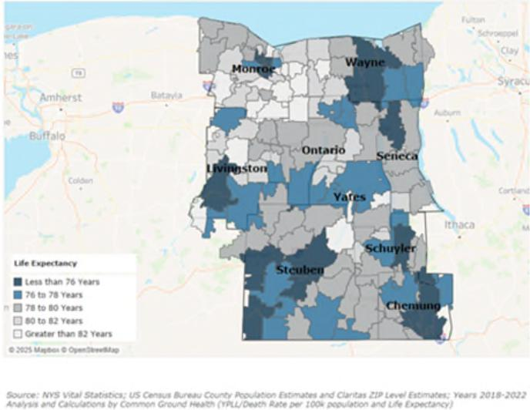

The rates shown for Alzheimer’s in this Courtesy Common Ground Health
table reflect a combined category of
“Alzheimer’s disease and other dementias” that was age–sex adjusted using local population estimates, whereas the state Vital Statistics tables report age adjusted rates for “Alzheimer’s disease” alone. As a result, counts for Alzheimer’s disease align with state data, but the inclusion of other dementias and the different adjustment method produce higher overall rates and allow this combined category to appear among the leading causes of death in several counties while still following a trend similar to the state’s Alzheimer's only rates.
Page 32 Regional Community Health Assessment

Comprehensive Regional Community Health Assessment
Across the region, the most commonly diagnosed cancers reflect patterns seen statewide, with female breast, prostate, and lung cancers appearing most frequently in many counties, alongside colorectal cancer in some areas. These cancers represent a substantial share of the overall cancer burden even when they are not always the leading causes of cancer death, underscoring the importance of continued emphasis on screening, early detection, and treatment.
Table 6: Leading Causes of Death 2022
County | First Cause | Second Cause | Third Cause | Death Rate/100,000  (NYS: 744.2/100,000)
Chemung | Heart Disease  235.6/100,000 | Cancer  184.7/100,000 | Alzheimer's and  Other Dementias  87.0 /100,000 | 1,014
Livingston | Cancer  145.1/100,000 | Heart Disease  122.1/100,000 | Alzheimer's and  Other Dementias  73.1/100,000 | 763.1
Ontario | Heart Disease  141.8/100,000 | Cancer  128.9/100,000 | Alzheimer's and  Other Dementias  69.8/100,000 | 716.9
Schuyler | Cancer  221.5/100,000 | Heart Disease  210.8/100,000 | Diabetes  63.6/100,000 | 974.3
Seneca | Heart Disease  167.6/100,000 | Cancer  155.8/100,000 | Alzheimer's and  Other Dementias  87.8 /100,000 | 812.9
Steuben | Heart Disease  204.7/100,000 | Cancer  187.8/100,000 | Alzheimer's and  Other Dementias  71.5/100,000 | 944.8
Wayne | Cancer  151.5/100,000 | Heart Disease  170.4/100,000 | Alzheimer's and  Other Dementias  78.3/100,000 | 828.0
Yates | Cancer  143.3/100,000 | Heart Disease  142.6/100,000 | Alzheimer's and  Other Dementias  88.4/100,000 | 839.3
Source: New York State Department of Health Vital Statistics, 2022
Page 33 Regional Community Health Assessment

Comprehensive Regional Community Health Assessment
Map 4 highlights the age-adjusted death rate for heart disease per 100,000 population and Map 5 details the age-adjusted death rate for cancer per 100,000 population in each of the counties of the Finger Lakes. Note that the highest death rates for both cancer and heart disease in both maps coincide with the highest poverty rates (Maps 6-8), and lowest life expectancy of the counties. It also coincides with higher preventable hospitalizations (Map 13) and higher Emergency Department visits (Maps 14-18).
Map 4: Age-Adjusted Death Rate for Heart Disease Rate per Map 5: Age-adjusted Death Rate for Cancer Rate per
100,000 100,000
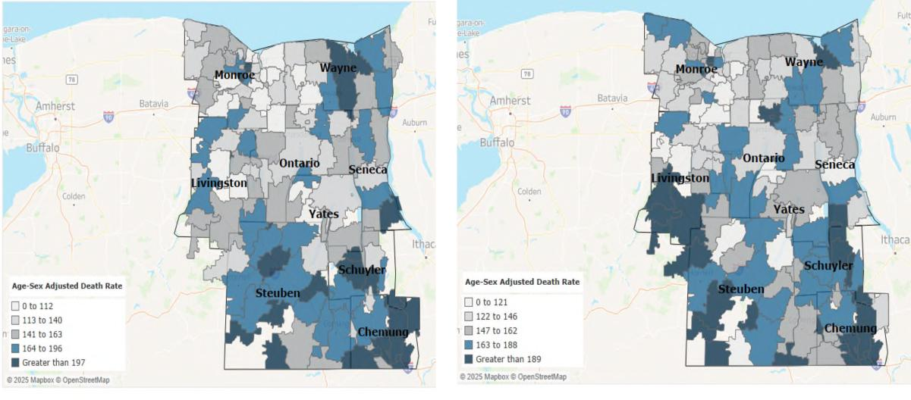
Courtesy: Common Ground Health Courtesy: Common Ground Health
Leading Causes of Premature Death
The top causes of premature death in the counties of the Finger Lakes region may be seen in Table 7 with the number of deaths per 100,000 population. Consistent across all eight counties, the top three causes of premature death (before age 75) are cancer, heart disease and unintentional injury. Most counties also exceed the New York State average rate for premature death.
Unintentional injury deaths in Yates County may be due in part to its Mennonite population. There are many family-owned farms on which children assist parents with chores. Transportation by horse and buggy and bicycle further increases the risks for injuries on roadways.
Page 34 Regional Community Health Assessment

Comprehensive Regional Community Health Assessment
Table 7: Leading Causes of Premature Death 2022
County | First Cause | Second Cause | Third Cause | Premature  Death Rate  (NYS:  326.8/100,000)
Chemung | Cancer  111.7/100,000 | Heart Disease  88.3/100,000 | Unintentional Injury  75.4/100,000 | 496.2
Livingston | Cancer  80.8/100,000 | Unintentional  Injury  43.6/100,000 | Heart Disease  33.4/100,000 | 324.1
Ontario | Cancer  60.5/100,000 | Heart Disease  60.7/100,000 | Unintentional Injury  38.1/100,000 | 304.6
Schuyler | Cancer  123.0/100,000 | Heart Disease  65.8/100,000 | Unintentional Injury  62.0/100,000 | 420.2
Seneca | Cancer  91.5/100,000 | Heart Disease  50.8/100,000 | Unintentional Injury  36.7/100,000) | 369.6
Steuben | Cancer  97.1/100,000 | Heart Disease  62.6/100,000 | Unintentional Injury  48.9/100,000 | 423.5
Wayne | Cancer  93.6/100,000 | Unintentional  Injury  58.1/100,000 | Heart Disease  65.6/100,000 | 398.4
Yates | Unintentional  Injury  63.4/100,000 | Cancer  61.4/100,000 | Heart Disease  46.0/100,000 | 334.4
Source: New York State Department of Health Vital Statistics, 2022
County Health Rankings
The University of Wisconsin Population Health Institute has created the County Health Rankings & Roadmaps, a program that works to improve health outcomes for all and to close the health disparities gap between those with the most and least opportunities for good health.¹⁹
As the county health rankings model has evolved, so have the measures. Table 8 demonstrates how each county in the Finger Lakes ranks compared with New York State and the nation as a whole. Two categories are referenced: Health and Well-being describes health as “more than being free from disease and pain; health is the ability to thrive. Well-being covers both quality of life and the ability of people
¹⁹ County Health Rankings, hftps://www.countyhealthrankings.org/about-us
Page 35 Regional Community Health Assessment

Comprehensive Regional Community Health Assessment
and communities to contribute to the world.”²⁰ Community Conditions refer to the social determinants of health. Generally, the Finger Lakes region is better than or equal to New York State and the nation in terms of health and well-being and community conditions.
Table 8: County Health Rankings (2025)
County | Health and Well-being |  | Community Conditions
County | New York State | U.S. | New York State | U.S.
Chemung | Worse | Better | Worse | About Equal To
Livingston | Better | Better | Better | Better
Ontario | Better | Better | Better | Better
Schuyler | About Equal To | Better | Worse | About Equal To
Seneca | Better | Better | Worse | About Equal To
Steuben | About Equal To | Better | About Equal To | Better
Wayne | About Equal To | Better | About Equal To | Better
Yates | Better | Better | Worse | About Equal To
Source: County Health Rankings
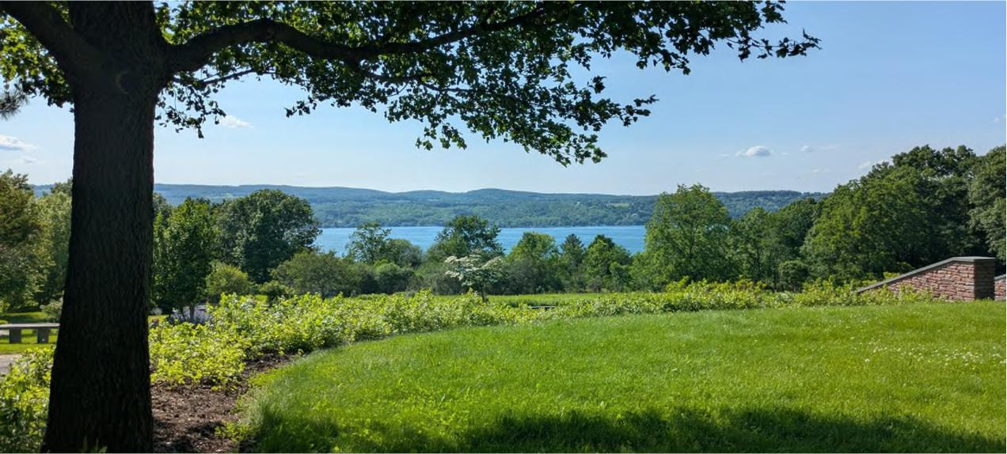
Courtesy Ontario County
²⁰ County Health Rankings, https://www.countyhealthrankings.org/health-data
Page 36 Regional Community Health Assessment

Comprehensive Regional Community Health Assessment
This section details the New York State Prevention Agenda domains and their associated priorities by exploring region-wide data.
Map 6 Overall Poverty in the Finger Lakes Region
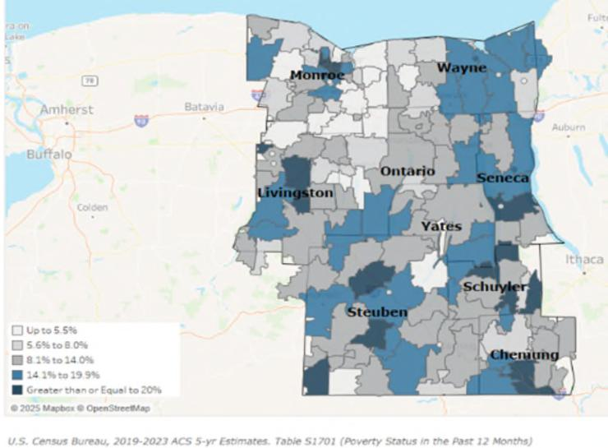
Courtesy Common Ground Health
New York State 2025-2030 Prevention Agenda Domains and Priorities
Economic Stability
Poverty and Unemployment
The socio-economic status of communities greatly impacts the health outcomes of the individuals residing there. Higher rates of poverty have been linked to increased anxiety and mental illness, higher mortality rates and increased risk of chronic disease. Additionally, communities with increased rates of poverty have more limited access to necessities such as food, shelter, healthcare, education, and employment. Rural poverty is often characterized by isolation and lack of access to resources rather than overcrowded housing and crime, which are more prevalent in urban communities. Map 6 notes poverty rates by zip code in the
Finger Lakes region.
The population of those 65 years of age and older is expected to increase through at least 2040. Map 7 shows the poverty rate by zip code in this age group. Older Americans living in poverty are at risk for experiencing earlier mortality, higher rates of disability, loneliness, depression and anxiety.²¹ These patterns indicate that poverty is not evenly distributed, with older adults in rural and higher-deprivation ZIP codes facing disproportionate financial and health burdens, which can widen existing health inequities.
²¹ Source: Thornton, M., Bowers, K., (January 31, 2024) "Poverty in Older Adulthood: A Health and Social Crisis" OJIN: The Online Journal of Issues in Nursing Vol. 29, No. 1, Manuscript 3
Page 37 Regional Community Health Assessment

Comprehensive Regional Community Health Assessment

Map 7: Poverty rates by Zip Code for those Over 65 Years of Age | Map 8 shows the poverty rate  by zip code in each county for  those under age 18.  According to the American  Psychological Association,²²  childhood poverty is  significant and can be long  lasting. It is associated with  subpar housing and  homelessness, poor nutrition  and hunger, less safe  neighborhoods, educational  lags, and substandard  childcare. All of these affect  the ability of children to be  successful and to be mentally  and physically healthy.  The societal costs of poverty  are significant, not just to
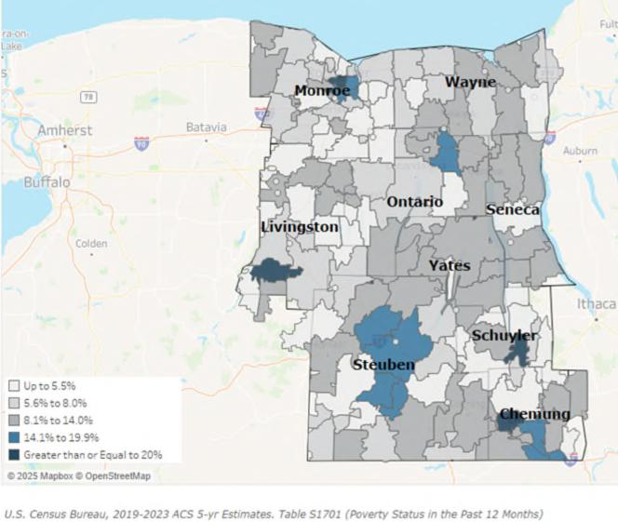

Courtesy Common Ground Health Map 8: Poverty Rate by Zip Code for those Under 18 Years of Age
individuals, but to the community at large. They include affordable housing shortages, increased homelessness, workforce shortages, increased crime, and more reliance on social sectors such as temporary housing, the justice system, food banks, Medicaid and SNAP. New York Counties share Medicaid and SNAP benefit costs with the federal government. When poverty rates increase, local contributions to these programs increase, as well, straining already strapped county budgets. | 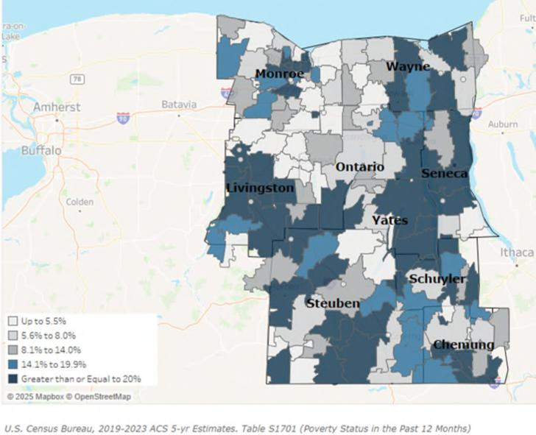
 | Courtesy Common Ground Health

²² Source: hftps://www.apa.org/topics/socioeconomic-status/poverty-hunger-homelessness-children
Page 38 Regional Community Health Assessment

Comprehensive Regional Community Health Assessment

Table 9 notes the poverty rates, median household income, living wage requirement, and unemployment rate for the eight counties compared with the NYS average and the prevention agenda (PA) target. The living wage requirement refers to the amount of money one person would need to earn to cover basic household expenses including taxes for one adult and two children. The percent change from the baseline year is also noted. For several counties, the poverty rate exceeds the NYS average and, in many cases, is increasing. The population of those over age 65 living in poverty, though it does not exceed the NYS average, is particularly alarming as it has increased in all counties. The average household income has increased, but it has not kept pace with the living wage requirement.
Table 9 Poverty Rates in the Finger Lakes Region
County | % Poverty  2023  NYS: 13.7  PA:12.5* | % Change  from 2018* | % Poverty  ages <18  2023  NYS: 19* | % Change  from 2018* | % Poverty  ages >65  2023  NYS: 12.7  PA=11* | % Change  from 2018*
Chemung | 15.8 | +7.0 | 22.0 | +10.0 | 10.1 | +15.0
Livingston | 11.6 | -14.0 | 12.0 | -14.0 | 6.9 | +17.0
Ontario | 9.2 | -4.0 | 10.0 | -9.0 | 7.6 | +27.0
Schuyler | 15.1 | +9.0 | 19.0 | -10.0 | 8.9 | +75.0
Seneca | 13.3 | +7.0 | 21.0 | +5.0 | 9.0 | +25.0
Steuben | 13.7 | -2.0 | 19.0 | 0.0 | 11.1 | +63.0
Wayne | 11.3 | 0.0 | 14.0 | -7.0 | 8.3 | +9.0
Yates | 14.1 | +24 | 18.0 | -14.0 | 12.5 | +51
 | Median  Household  Inc.  2023  NYS:  $82,100** | % Change  from 2019** | Living Wage  Required  2023  NYS:  $61.75*** | % Change  from 2021*** | %Unemployed  (January  2025)**** | % change  from January  2019****
Chemung | $60,500 | +4.0 | $50.73 | +30.0 | 4.4 | -2.2
Livingston | $70,200 | +16.0 | $51.12 | +29.0 | 4.6 | -9.8
Ontario | $79,400 | +19.0 | $56.94 | +37.0 | 6.1 | +29.8
Schuyler | $65,200 | +25.0 | $49.95 | +31.0 | 6.1 | -1.6
Seneca | $58,600 | +15.0 | $48.77 | +26.0 | 3.6 | -5.2
Steuben | $64,300 | +21.0 | $49.08 | +29.0 | 5.0 | +8.7
Wayne | $73,000 | +18.0 | $51.24 | +29.0 | 4.6 | -9.8
Yates | $66,200 | +9.0 | $51.14 | +33.0 | 4.5 | +4.7
Source: *Poverty Rates: American Community Survey (2018-2023)
**Average Household Income: Small Area Income and Poverty Estimates, U.S. Census (2019-2023)
***Living Wage Requirement: The Living Wage Calculator (2021-2024)
****Unemployment Rate: U.S. Department of Labor (2019-2025)

Page 39 Regional Community Health Assessment

Comprehensive Regional Community Health Assessment

Nutrition Security

Map 9: Food Insecurity Rate by Zip Code

The Food Environment Index (FEI) measures how easily residents can access healthy, affordable foods. The score is based on both the rate of food insecurity and the percentage of low-income residents who live far from a grocery store. Scores range from 0 (worst) to 10 (best). Lack of access to healthy foods is strongly associated with increased rates of obesity, chronic disease (such as diabetes and heart disease), and early death.
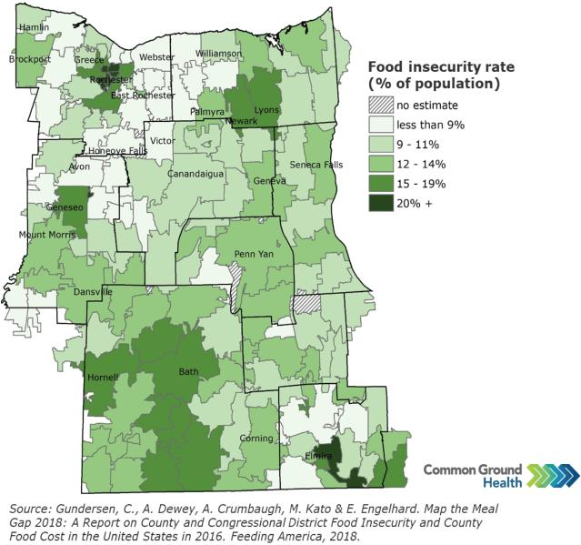
The Food Insecurity Rate highlights the economic disparities that may contribute to increases in poverty rates. The Food Insecurity Rate, expressed as a percentage of the total population, measures the share of households that lack consistent access to enough food for an active, healthy life. Map 9 shows the Food Insecurity Rate by Zip Code in the Finger Lakes region.

A strong food environment is important
because limited access to healthy food is linked to higher rates of chronic diseases (like obesity and diabetes), premature death, and poorer overall community health, especially in low-income and rural communities.
Over the past three years, cross-sectional community surveys conducted by the Pivital Public Health Partnership in Chemung, Livingston, Ontario, Schuyler, Seneca, Steuben, Wayne, and Yates counties show that food insecurity is both common and worsening. Using the validated two-item Hunger Vital Sign screener, the share of surveyed households reporting food insecurity increased from 26% in 2019– 2020 to 67% in 2023–2024, indicating that more than two in three responding households now experience concern about having enough food or difficulty affording balanced meals. During the same period, the proportion of respondents who reported knowing someone struggling with food insecurity rose from 45% to 65%, underscoring that food hardship is widely visible within residents’ social networks and community life.
A total of 1,289 responses were collected across the eight counties (Chemung 76, Livingston 209, Ontario 380, Schuyler 80, Seneca 164, Steuben 52, Wayne 126, and Yates 202), providing community input to inform assessment and planning. These survey findings complement secondary indicators such as FEI, food insecurity rate, and SNAP eligibility, reinforcing that many rural residents face both geographic and economic barriers to healthy food and that targeted strategies to improve nutrition security are needed
Page 40 Regional Community Health Assessment

Comprehensive Regional Community Health Assessment
across the region. Taken together, these findings show that food insecurity disproportionately affects residents in lower-income and more remote ZIP codes, contributing to avoidable gaps in diet-related health outcomes and reinforcing existing inequities.
Table 10 compares each county’s Food Environment Index (FEI) with its estimated food insecurity rate to illustrate ongoing challenges with nutrition security in the region. Counties with FEI scores below the New York State value of 8.7, such as Chemung, Schuyler, Seneca, and Steuben, face relatively greater barriers to healthy food access, including affordability and proximity to grocery stores. At the same time, food insecurity affects roughly one in eight to one in seven residents across the counties, with the highest rates generally observed in more rural areas, indicating that many households continue to struggle to afford enough nutritious food.
Table 10 Food Environment Index in the Finger Lakes Region
County | Food  Environment  Index  (2022)  (NYS: 8.7)* | % Change from  2018* | Food Insecurity  Rate  (2023)**
Chemung | 7.9 | 0.0 | 14.4
Livingston | 8.7 | +4.0 | 11.8
Ontario | 8.8 | +2.0 | 11.8
Schuyler | 8.4 | +2.0 | 13.9
Seneca | 8.4 | +2.0 | 14.0
Steuben | 8.1 | -1.0 | 13.6
Wayne | 8.7 | +4.0 | 11.9
Yates | 8.8 | -1.0 | 12.4
Source: *County Health Rankings, USDA, **Feeding America: Map the Meal

Seneca Harbor, Courtesy Seneca County
Page 41 Regional Community Health Assessment

Comprehensive Regional Community Health Assessment
Housing Stability and Affordability Map 10: Area Deprivation Index by Area
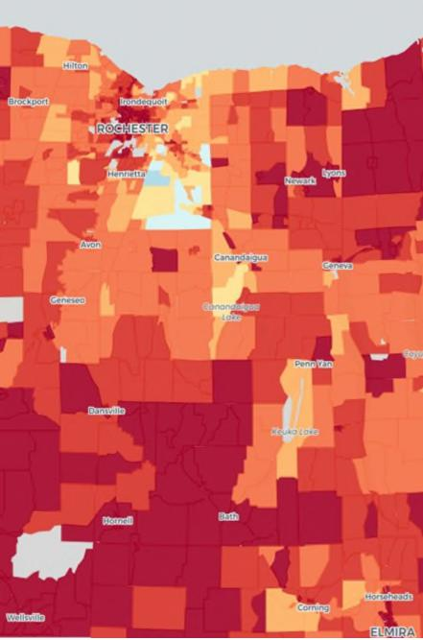
Source: University of Wisconsin School of Medicine and Public Health. Area Deprivation Index.
Poor housing conditions are closely linked to health risks, influencing everything from chronic disease rates to mental wellbeing. Access to safe, stable, and affordable housing remains a top priority for residents across the region. A high housing cost burden -when households spend a large share of their income on housing - can signal financial strain and potential housing instability, which in turn may affect health outcomes and access to other basic needs.
The Area Deprivation Index (ADI) provides additional context by measuring the level of socioeconomic disadvantage in a community based on factors such as income, education, employment, and housing quality. Higher ADI scores indicate greater disadvantages, which can often be associated with poorer housing conditions and elevated health risks. Map 10 notes the ADI by zip code in the Finger Lakes. The ADI is measured from 1 (blue - least deprived) to 10 (red - most deprived). Most deprived areas of the region also coincide with higher poverty rates as can be seen in Maps 6-8.
Table 11 compares both the housing cost burden and the Area Deprivation Index (ADI) across the counties of the Finger Lakes region, with New York State averages. The data suggest that, while housing cost burdens in most Finger Lakes counties fall below the state average of 19 percent, ADI scores are higher across all counties, indicating that many areas experience greater socioeconomic disadvantage than the state overall. This contrast
ftps/w _{g} oo
underscores the complex relationship between housing affordability, neighborhood conditions, and community health.
Table 11 Housing Cost Burden and Area Deprivation Index in the Finger Lakes Region
County | Housing Cost  Burden  (2023)  (NYS: 19%)* | % Change from  2015* | Area Deprivation Index  (ADI)  (2023)  (NYS: 5.5)** | % Change from  2019**
Chemung | 15% | +25 | 9.3 | +3
Livingston | 10% | -23 | 8.7 | 0
Ontario | 11% | +10 | 8.2 | -1
Schuyler | 11% | -8 | 8.9 | -2
Seneca | 12% | +9 | 9.0 | 0
Steuben | 11% | +10 | 9.4 | +1
Wayne | 11% | +10 | 9.0 | 0
Yates | 12% | -8 | 8.5 | +1
Source: *Housing Cost Burden: American Community Survey (2015-2023)
**ADI: Kind AJH, Buckingham W. Making Neighborhood Disadvantage Metrics Accessible: The Neighborhood Atlas. New
England Journal of Medicine, 2018. 378: 2456-2458. DOI: 10.1056/NEJMp1802313. PMCID: PMC6051533. (2019-2023)
Page 42 Regional Community Health Assessment

Comprehensive Regional Community Health Assessment
Social and Community Context
Anxiety and Stress Map 11: Frequent Mental Distress Among Adults (Mental Health Not Good for 14+ of past 30 days)
The rate of depressive disorders and the percentage of adults reporting 14 or more days of poor mental health in a month increased significantly across the counties of the Finger Lakes between 2018 and 2022. (Table 12). Map 11 highlights those reporting 14 or more days of poor mental health in the past 30 days by zip code in the Finger Lakes region. Because county estimates are based on survey samples, some of the larger percentage changes - especially in smaller counties - may reflect statistical variability and should be interpreted with caution rather than as exact
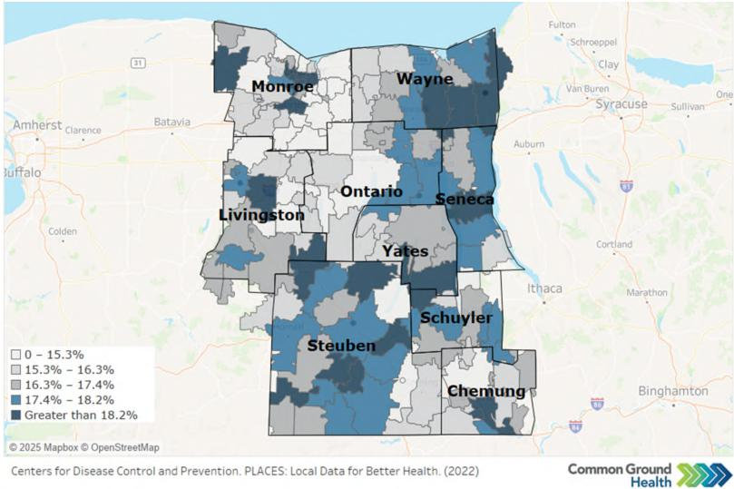
shifts in prevalence.
The map illustrates that frequent mental distress (14 or more days of poor mental health in the past month) is elevated in many ZIP codes across the region, reinforcing county-level survey data showing rising rates of depressive disorders and frequent poor mental health among adults.
In 2021, all eight counties reported higher percentages of adults with a depressive disorder than in 2016, with increases ranging from about 5% to more than 75%. Similarly, the share of adults reporting 14 or more days of poor mental health in the past month was higher than in 2018 in every county, indicating a broad rise in mental distress.
Many factors influence rates of anxiety and stress, including economic stability, chronic health
conditions, and adverse childhood experiences. Lack of access to mental health providers in rural areas is a factor that makes receiving treatment for anxiety and stress challenging.
Page 43 Regional Community Health Assessment

Comprehensive Regional Community Health Assessment
Table 12: Rate of Depressive Disorders and Percentage of Adults Reporting 14 or more days of Poor Mental Health in a Month
County | Percent of Adults  Reporting a  Depressive  Disorder (2021)  (NYS=18.7) | Percent Change  from 2018  Baseline | Percent of Adults  Reporting 14 or  more Days of  Poor Mental  Health Per Month  (2021) (NYS=16) | Percent Change  from 2018  Baseline
Chemung | 35.4 | +36 | 18 | +20
Livingston | 24.9 | -15 | 18 | +29
Ontario | 27.9 | +64 | 18 | +38
Schuyler | 24.1 | -18 | 20 | +33
Seneca | 18.3 | -16 | 18 | +20
Steuben | 29.5 | +7 | 19 | +27
Wayne | 20.3 | -23 | 18 | +20
Yates | 24.3 | +40 | 19 | +36
Source: New York Expanded Behavioral Risk Factor Surveillance System
Suicide Rate
Figure16: Suicide Rates for the Finger Lakes Region (age-adjusted)
Adult suicide mortality in the eight-county region has remained elevated over the past five years, increasing from 13.1 deaths per 100,000 residents in 2018 to a peak of 15.3 in 2020 and remaining above the 2018 baseline through 2022 at 14.4 per 100,000. These values represent age-adjusted rates based on 5-year County Health Rankings data (2014– 2018 for the 2018 baseline and 2018–2022 for the most recent point), demonstrating that suicide continues to be a persistent and significant cause of premature death across the region. Because these
Deaths due to Suicide per 100,000 Population
(Age-Adjusted)
15.3
15.5
15.0 |  |  |  |  |  | 15.0
14.5 |  |  |  |  |  |  |  | 14.4
14.0
13.5
 | 13.1 | 13.0
13.0
12.5
12.0
11.5
2018 2019 2020 2021 2022

Source: County Health Rankings; National Center for Health Statistics – Mortality Files
rates are calculated from very small numbers of deaths, even one additional death can cause large percentage changes, so trends should be interpreted cautiously.
Youth suicide rates for the region, drawn from the New York State Prevention Agenda dashboard for ages 10–19, are based on small numbers of deaths (fewer than 10 events per 5-year period) and are therefore considered statistically unstable. Because of this instability, youth suicide rates are flagged as unreliable in official reporting and should be interpreted with extreme caution, emphasizing the need for ongoing monitoring rather than firm conclusions about trends.
Overdose Deaths by Drugs
Page 44 Regional Community Health Assessment

Comprehensive Regional Community Health Assessment
Overdose deaths related to opioids and any drug show an alarming increase in most counties exceeding NYS averages. Overdose deaths may be indicative of substance use problems within a community. Table 13 presents regional overdose mortality rates for opioids and all drugs combined, alongside New York State averages and Prevention Agenda targets, to illustrate the extent to which the Finger Lakes Region is above desired levels. Because the regional rates draw on small numbers of deaths in some counties, relatively few additional deaths can result in large percentage changes over time, so trends should be interpreted with caution rather than as precise shifts in risk. Focus group participants in several counties noted the increase in drug use as problems within their counties. Several counties have developed partnerships with organizations that deal directly with drug use and misuse.
Table 13: Overdose Deaths
County | Age-Adjusted  Rate of Opioid  Overdose Deaths  per 100,000  (2022)  (NYS=27) | Percent Change  from 2013  Baseline | Age-Adjusted  Rate of Overdose  Deaths Involving  any Drug per  100,000 (2022)  (NYS=31.3  PA=22.6) | Percent Change  from 2013  Baseline
Chemung | 40.9 | +605 | 46.5 | +489
Livingston | 22.3 | +829 | 24.5 | +433
Ontario | 12 | +500 | 16 | +332
Schuyler | 21.4 | +2,040 | 39.8 | +3,880
Seneca | 14.4 | +700 | 24.6 | +779
Steuben | 30.7 | +708 | 31.3 | +341
Wayne | 29.8 | +645 | 35.2 | +314
Yates | 0 | 0 | 8.2 | +720
Source: NYS Opioid Data Dashboard
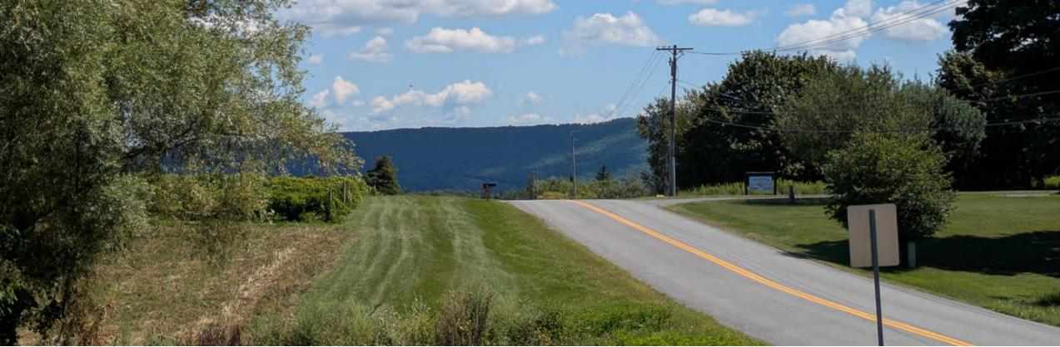
Source: Ontario County
Page 45 Regional Community Health Assessment

Comprehensive Regional Community Health Assessment
Smoking and Binge Drinking
Smoking rates have decreased in each county from 2018 to 2022, while the rates of reported binge
drinking have increased, with the exception of Schuyler which remained unchanged (Figure 17). All rates exceed the New York State averages of 12 percent for smoking and 20 percent for binge drinking.
Figure 17: Smoking and Binge Drinking
Source: Behavioral Risk Factor Surveillance System
Adverse Childhood Experiences
Adverse Childhood Experiences (ACEs) are those negative emotional and physical circumstances one experiences before age 18. They may include neglect, sexual abuse, parental divorce, mental illness and/or substance abuse in the home, and exposure to violence. ACEs impact individuals well into adulthood and may include physical and mental long-term health problems. The age-adjusted percentage of adults with two or more ACEs may be seen in Figure 18.
Figure 18: Adverse Childhood Experiences
Source: National Center for Health Statistics
Smoking and Binge Drinking (2022)
30
25
25 22 23 23 23 22 22 22
20
15
10
5
0
16
14
20
16
15
18
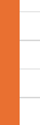
16
17

Chemung Livingston Ontario Schuyler Seneca Steuben Wayne Yates
Smoking Binge Drinking
Age-Adjusted Percentage of Adults who Report Two or
More Adverse Childhood Experiences (2021)
0 10 20 30 40 50 60
Chemung Livingston Ontario Schuyler Seneca Steuben Wayne Yates | 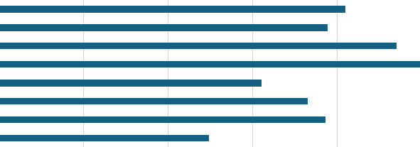
Page 46 Regional Community Health Assessment

Comprehensive Regional Community Health Assessment
Healthy Eafing
The Finger Lakes Region is largely rural with hundreds of farms and farm stands, during harvest season. Unfortunately, the number of people without access to a vehicle and/or who live far from a grocery store is substantial. The cost of healthy foods is also a factor in whether or not families are able to purchase fruits and vegetables.
The percentage of adults who eat fruits daily is under 50% for most of the counties but is trending upward, which is a promising sign. More people eat vegetables each day, but that percentage decreased for each county between 2016 and 2021. The number of people who drink one or more sugary drinks each day is below the NYS average in all but three counties (Livingston, Ontario, Schuyler). (Table 14)
Focus group respondents noted that though healthy eating is a priority, it is difficult for many to afford healthy foods. While dollar stores, convenience stores and fast-food restaurants are prolific across the region, grocery stores are less common in many communities.
Table 14: Healthy Eating
County | Percentage  of Adults  who Eat Fruit  Daily  (2021) | Percent  change from  2016  baseline | Percentage  of Adults  who Eat  Vegetables  Daily  (2021) | Percent  change from  2016  baseline | Percentage  of Adults  with an  Annual  Household  Income  <$25,000  who drink  one or more  sugary drinks  every day  (2021)  (NYS = 34.1) | Percent  change from  2016  baseline
Chemung | 41.7 | No change | 46.9 | -25 | 25.5 | -47
Livingston | 49 | -9 | 56.5 | -2 | 37.5 | -14
Ontario | 49 | -9 | 52.1 | -24 | 45.2 | +71
Schuyler | 45.6 | +17 | 60.3 | -3 | 42.4 | +18
Seneca | 57.3 | +13 | 71.3 | -6 | 28.1 | -25
Steuben | 44.7 | +9 | 52 | -21 | 20.5 | -42
Wayne | 42.3 | +20 | 57.2 | -7 | 20.3 | -40
Yates | 63.4 | +16 | 70.2 | -4 | 17.1 | +60
Source: Behavioral Risk Factor Surveillance System
Page 47 Regional Community Health Assessment

Comprehensive Regional Community Health Assessment
Neighborhood and Built Environment
Opportunities for Active Transportation and Physical Activity
While healthy eating is a major component of preventing and managing chronic diseases, so is physical activity and exercise. More than 50 percent of the population in several counties have access to locations for physical activity (Figure 19). Livingston, Steuben, and Wayne counties all increased the share of residents with access to physical activity resources between 2021 and 2024, with Steuben showing a particularly notable rise of 940 percent.
Figure 19: Access to Locations for Physical Activity.
Source: ArcGIS Business Analyst and Living Atlas of the World; YMCA; US Census TIGER/Line Shapefiles
The Walkability Index measures how walkable a county is on a scale from 1 (least walkable) to 20 (most walkable). Overall, the Finger Lakes counties included in this chart have relatively low walkability scores, ranging from about 4.5 to just over 9 on the 20-point scale. The 2019 Walkability Index scores are: Chemung 7.6, Livingston 9.12, Ontario 6.49, Schuyler 4.53, Seneca 6.11, Steuben 6.66, Wayne 6.16, and Yates 5.46 (Figure 20).
Walking or biking for exercise in rural upstate communities can be dangerous due to roads that often lack sidewalks, shoulders, and streetlights, especially outside village centers. Between October and April, roadways and any existing sidewalks may be icy or snow-covered, and higher speed limits on county and town roads can discourage walking and biking for recreation or transportation. Although there are YMCA facilities and other indoor exercise options in parts of the region, many residents face barriers such as membership costs, limited hours, and lack of reliable transportation, which can reduce access to safe places for physical activity.
Percentage of Population with Access to Locations for Physical
Activity (2024)
0 10 20 30 40 50 60 70 80 90 100
Chemung Livingston Ontario Schuyler Seneca Steuben Wayne Yates | 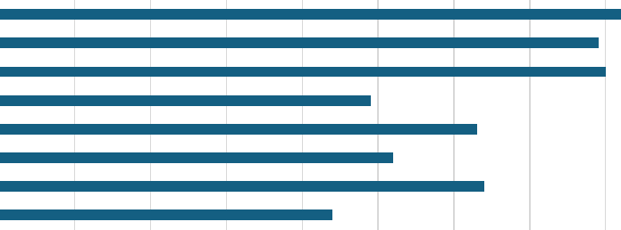
Page 48 Regional Community Health Assessment

Comprehensive Regional Community Health Assessment
Figure 20: Walkability Index
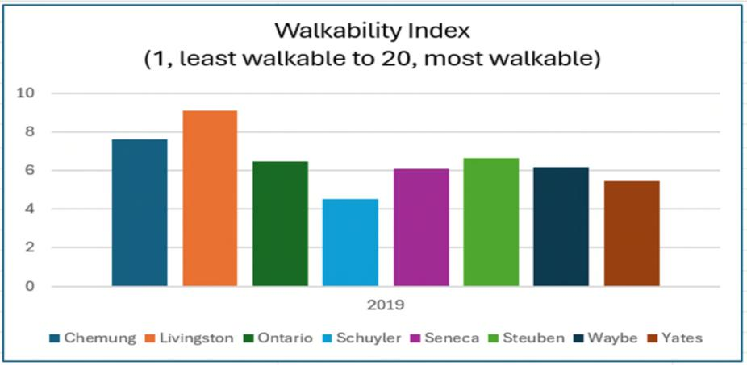
Source: EPA Office of Community Revitalization
Access to Community Services and Support
The Social Vulnerability Index was developed to measure the level of access to community services and support in the wake of emergencies. It is a useful tool for public health programming and outreach as it considers poverty, unemployment, income, high school graduation rate, single parent homes, individuals with disabilities, those over 65, minority status, spoken language, housing and transportation. It is measured on a scale from 0 (lowest vulnerability) to 1 (highest vulnerability). While no county is considered highest vulnerability, Chemung, Seneca, Steuben and Yates are above the 0.5 midpoint. (Figure 21)
Figure 21: Social Vulnerability Index
Source: Centers for Disease Control and Prevention/Agency for Toxic Substances and Disease Registry/Geospatial Research, Analysis, and Services Program. CDC/ATSDR Social Vulnerability Index Interactive
Social Vulnerability Index (2022)
0 0.1 0.2 0.3 0.4 0.5 0.6 0.7 0.8 0.9 1
Chemung Livingston Ontario Schuyler Seneca Steuben Wayne Yates | 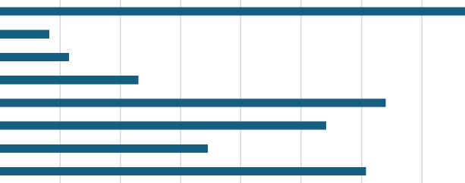

Page 49 Regional Community Health Assessment

Comprehensive Regional Community Health Assessment
The Finger Lakes Region is aging and people over the age of 65 who live alone may lack access to community services and support. Map 12 highlights the distribution of this population. Loneliness and social isolation among adults over 65 can create serious physical, mental, and social health challenges. Physical challenges include increased risk of chronic diseases, higher mortality risk, and poor nutrition and sleep. Mental health impacts include depression and anxiety, cognitive decline and lower resilience in coping with mental and physical challenges. Social isolation may make it difficult to access services and supports, particularly during emergencies like a fall. Social isolation may also cause a loss of purpose and can perpetuate elder abuse by allowing it to go undetected.²³
Map 12: Percentage of the population of those 65 years and older living alone by zip code
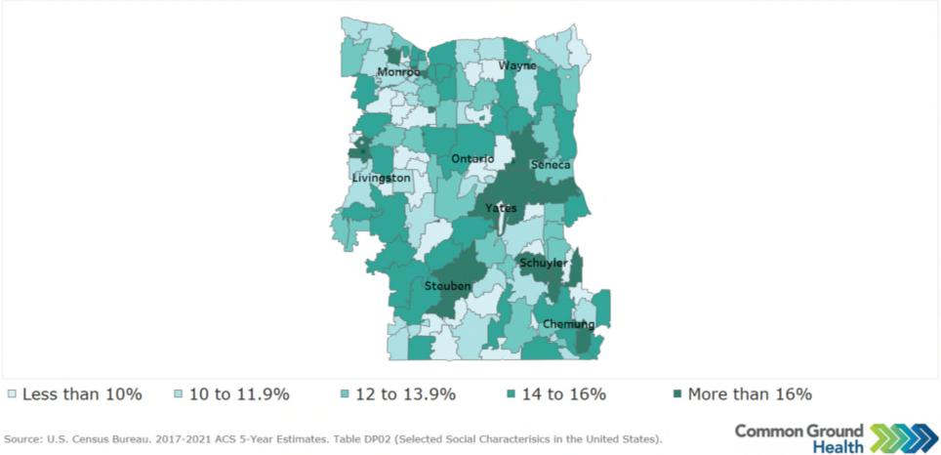
Injuries and Violence
Injuries and violence are a major and growing concern across the eight-county Finger Lakes region. Because “injuries and violence” in this assessment includes several distinct indicators (unintentional injury, violent crime, and firearm-related deaths), each measure uses a different baseline year based on data availability. For example, unintentional injury trends use a 2015 baseline, firearm-related deaths use 2018, and violent crime uses 2013. As a result, rates and trends should be interpreted within the context of each indicator’s specific baseline year rather than as a single combined trend for injuries and violence.
Unintentional injuries in NYS Vital Statistics include deaths from external causes that are not intentionally self-inflicted or due to assault, such as motor vehicle crashes, falls, drownings, fires and burns, accidental poisonings (including many drug overdoses coded as unintentional), and other accidental injuries.
²³ Perissinofto CM, Stijacic Cenzer I, Covinsky KE. Loneliness in older persons: a predictor of functional decline and death. Arch Intern Med. 2012 Jul 23;172(14):1078-83. doi: 10.1001/archinternmed.2012.1993. PMID: 22710744; PMCID: PMC4383762.
Page 50 Regional Community Health Assessment

Comprehensive Regional Community Health Assessment
Unintentional Injuries in the eight counties of the Finger Lakes region have increased since 2015 and, in many cases, alarmingly. The exception is Seneca County which decreased in age-adjusted death rate for unintentional injury in 2015 from 2022. Three counties are below the New York State average for age-adjusted death rate for unintentional injury. Conversely, five counties exceed the New York State average for age-adjusted death rate (death before age 75) for unintentional injury. All counties have increased in this indicator from baseline. (Table 15)
Table 15: Injuries and Violence
County | Age-Adjusted  Death Rate for  Unintentional  Injury per  100,000  (2022)  (NYS = 54.1) | Percent Change  from Baseline of  2015 | Age-Adjusted  Premature Death  Rate (Death  Before Age 75) for  Unintentional  Injury per  100,000  (2022)  (NYS = 46.9) | Percent Change  from Baseline of  2015
Chemung | 88.2 | +102 | 75.4 | +144
Livingston | 50.7 | +14 | 43.6 | +46
Ontario | 48.1 | +26 | 38.1 | +32
Schuyler | 66.3 | +46 | 62 | +57
Seneca | 43.5 | -2 | 36.7 | +27
Steuben | 58.6 | +99 | 48.9 | +136
Wayne | 64.3 | +60 | 58.1 | +61
Yates | 80.3 | +267 | 63.4 | +424
Source: New York State Department of Health - Office of Quality and Patient Safety - Division of Information and Statistics - Bureau of Health Informatics - Vital Statistics Unit
Violence related harms show similar concern in the region and require clear definitions. Violent crime refers to reported offenses of murder, rape, robbery, and aggravated assault, compiled from local law enforcement data by state and federal justice agencies and expressed as a rate per 100,000 residents. Firearm related deaths are measured as the number of deaths due to firearms per 100,000 population over a five year period, based on national mortality data and Census population estimates; this measure includes suicides, homicides, and other firearm fatalities defined by specific ICD10 codes, and values are suppressed for counties with fewer than 10 deaths. Because recent changes in population estimation methods affect the denominator for firearm fatality rates, comparisons across years should be made with caution. In the Finger Lakes region, the violent crime rate has risen from about 120.9 per 100,000 in 2013 to approximately 154.5 per 100,000 in 2022, and firearm related deaths have also increased since 2018 and now exceed the statewide rate, although they remain concentrated in specific communities. Together, these patterns indicate that many residents face elevated risks of both accidental and intentional injury, underscoring the need for coordinated prevention strategies focused on traffic safety, fall and poisoning prevention, firearm safety, and community violence reduction.
Page 51 Regional Community Health Assessment

Comprehensive Regional Community Health Assessment

Health Care Access and Quality  Access to and Use of Prenatal Care  Maternal and child health have been areas of focus for the Finger Lakes Region counties in several past Community Health Improvement Plans. According to Healthy People 2030, “improving the well-being of mothers, infants, and children is an important public health goal for the United States. Their well-being determines the health of the next generation and can impact future public health challenges for families, communities, and the health care system.”²⁴  Receiving early and adequate prenatal care is important for ensuring a healthy pregnancy. At prenatal visits, health care providers screen for diseases, provide vaccinations, and manage maternal chronic diseases that may be exacerbated by or have a negative impact on their pregnancy. In addition, health care providers educate pregnant persons about labor, delivery, postpartum depression, and early warning signs of complications. Ensuring timely prenatal care is obtained can lower the incidence of premature birth, low birth weight babies and infant mortality.¹⁸ | Map 13: Percentage of births with late (3rd trimester) or no prenatal care (2019-2021)
 | 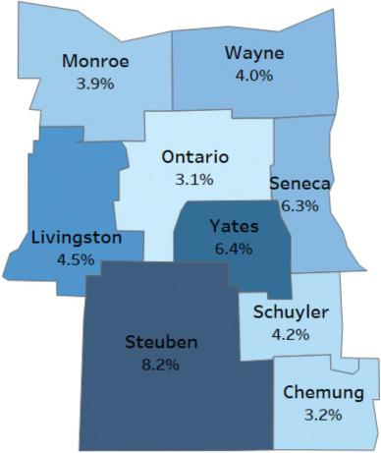
Despite regional efforts, some pregnant residents still Source: NYS Perinatal Data Profile 2019-2021
begin care late in pregnancy or receive no prenatal care at all. Map 13 shows that, while most births occur with timely prenatal care, a notable minority in several counties receive care in the third trimester or not at all, highlighting persistent geographic disparities in early access that can contribute to preterm birth, low birth weight, and higher infant and maternal risks.
Prenatal care may also be measured using three abstinence indicators – alcohol (Figure 22), smoking
(Figure 23), and illegal drugs (Figure 24). All counties have improved in each indicator from 2018 to 2024 with the exception of alcohol abstinence in Schuyler County.
²⁴ Source: Healthy People 2030 hftps://odphp.health.gov/healthypeople/about/workgroups/maternal-infant-and-child-health-workgroup
Page 52 Regional Community Health Assessment

Comprehensive Regional Community Health Assessment
Figure 22: Alcohol Abstinence in Pregnancy
Source: Healthy People 2020; US Department of Health and Human Services.
Figure 23: Smoking Abstinence in Pregnancy
Source: Healthy People 2020; US Department of Health and Human Services.
Alcohol Abstinence in Pregancy (2024)
86 88 90 92 94 96 98 100
Chemung Livingston Ontario Schuyler Seneca Steuben Wayne Yates
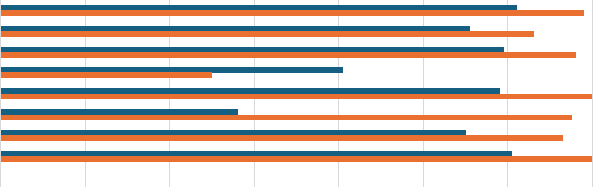
2018-Alcohol 2024-Alcohol
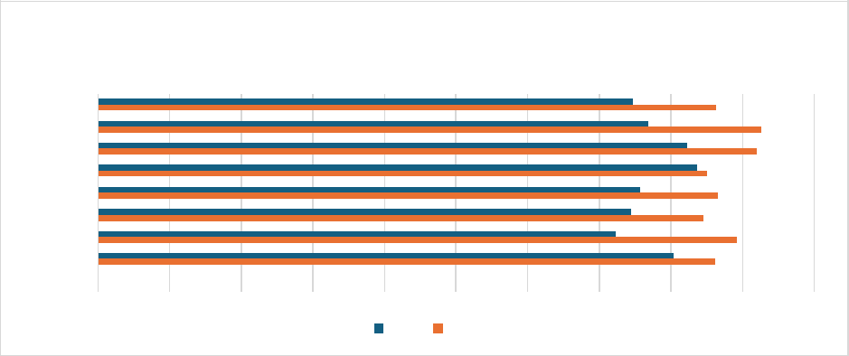
Chemung Livingston Ontario Schuyler Seneca Steuben Wayne Yates
0 10 20 30 40 50 60 70 80 90 100
Smoking Abstinence in Pregnancy (2024)
2018 2024
Page 53 Regional Community Health Assessment

Comprehensive Regional Community Health Assessment
Figure 24: Illegal Drug Abstinence in Pregnancy
Source: Healthy People 2020; US Department of Health and Human Services.
Additionally, lack of access to prenatal care may be manifested by low live birth weights (<2,500 grams or about 5 lbs., 8 oz.) and premature births (live births before 37 weeks) (Figure 25 and Maps 14, 15, 16).
Figure 25: Percentage of Preterm Births in the Region from 2018-2024
Source: National Center for Health Statistics
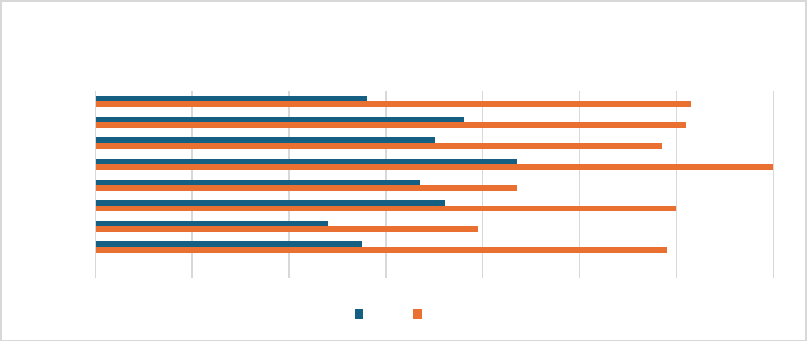
Chemung Livingston Ontario Schuyler Seneca Steuben Wayne Yates
86 88 90 92 94 96 98 100
Illegal Drug Use Abstinence During Pregnancy (2024)
2018 2024
Percentage of Preterm Births
80
70
 | 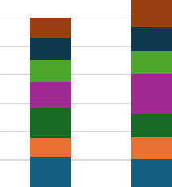 |  |  |  |  |  |  |  |  |  | 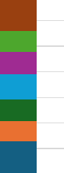
60
50
40
30
20
10
0
2018 2019 2020 2021 2022 2023 2024
Chemung Livingston Ontario Schuyler Seneca Steuben Wayne Yates
Page 54 Regional Community Health Assessment

Comprehensive Regional Community Health Assessment

Map 14: Premature birth Rates | A baby born prematurely is immediately at risk for complications including jaundice, anemia, feeding and airway issues, and apnea. The earlier in pregnancy a baby is delivered, the more likely it is that the baby will need to spend time in the neonatal intensive care unit (NICU). Long-term health complications associated with premature birth include vision and hearing deficits, neurological delays, delays in speech and language development and deficits in social and emotional regulation. Of note, premature birth is the primary cause of low birth weight.²⁵The percent of live births with low birth weight has remained relatively unchanged in the region from 2018 (6.4%) to 2023 (also 6.4%). A missing value is reported for counties with fewer than 10 low birthweight births in the time frame was the case in 2021.²⁶
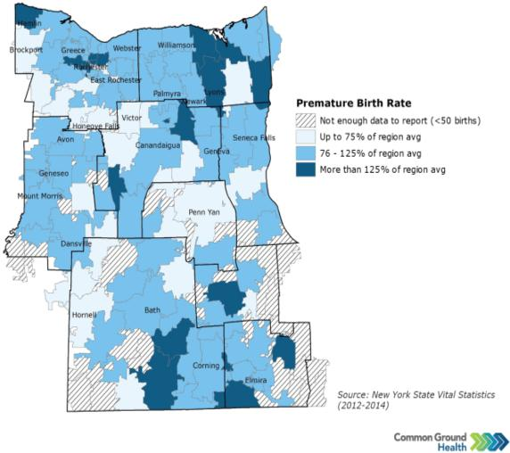

Map 15: Percentage of Premature Births with 32 - < 37 Weeks Map 16: Percentage Low Birth Weight (<2.5 kg) Singleton Births
Gestation (2019-2021) (2019-2021)
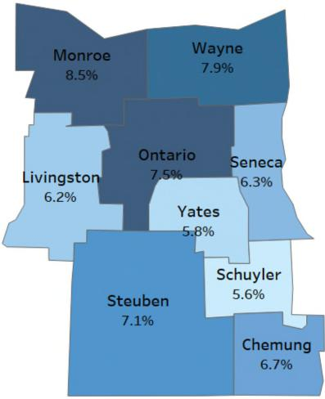 | 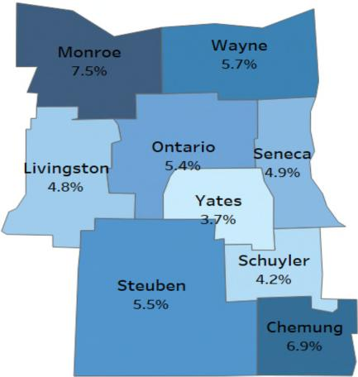
 | Source: NYS Perinatal Data Profile 2029-2021
Source: NYS Perinatal Data Profile 2019-2021
²⁵ Stanford Children’s Health, Low Birthweight
²⁶ Stanford Children’s Health, Low Birthweight
Page 55 Regional Community Health Assessment

Comprehensive Regional Community Health Assessment
Prevention of Infant and Maternal Mortality
Prematurity and its related conditions are the leading causes of infant mortality. Reducing rates of preterm births, therefore should decrease infant mortality. (Figure 26). Figure 27 shows maternal (per 100,000), child (per 100,000) mortality rates while Figure 26 shows infant (per 1,000) mortality rates in the Finger Lakes region. If data are expressed as 0, it may not indicate that there was no mortality. Data may not be available or the number may be too small as not to be reportable. The New York State average maternal mortality rate is 22 per 100,000. More than half of the counties exceed that rate. The New York State average for child mortality is 40. More than half of the counties are at or above that rate.
Figure 26: Infant Mortality Rate per 1,000 (2022)
Infant Mortality Rate per 1,000
0 2 4 6 8 10
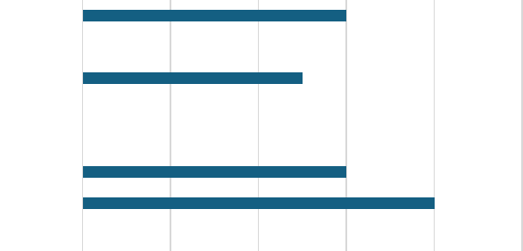
Chemung Livingston Ontario Schuyler Seneca Steuben Wayne Yates
6
0
5
0
0
6
8
0
Source: National Center for Health Statistics
Figure 27: Maternal and Child Mortality Rates per 100,000 (2022)
Source: National Center for Health Statistics
Maternal and Child Mortality Rates
(per 100,000)
250
200
150
100
50
0
Chemung Livingston Ontario Schuyler Seneca Steuben Wayne Yates
Maternal Mortality Child Mortality
Page 56 Regional Community Health Assessment

Comprehensive Regional Community Health Assessment
Total births in the Finger Lakes region have been on a steady decline until a precipitous drop in 2024 (Figure 28).
Figure 28: Number of Births in the Finger Lakes Region
Number of Births in the Finger Lakes Region
Source: Statewide Planning and Delivery System (SPDS)
Preventive Services for Chronic Disease Prevention and Control
Most chronic diseases are preventable and are closely tied to modifiable behaviors, including poor diet, limited physical activity, tobacco use, and heavy alcohol consumption. These conditions significantly drive up health care costs and place substantial pressure on the health care system. In New York State, chronic illnesses - such as heart disease, stroke, cancer, COPD, diabetes, and obesity - are the primary causes of disability and death. They create a considerable health burden and greatly diminish overall quality of life, contributing to six in ten deaths.²⁷
Many New Yorkers also experience multiple chronic conditions at the same time. Expanding early screening and detection, strengthening self-management skills, and improving access to health care providers and referral services can play a major role in reducing both the occurrence and severity of chronic diseases.²⁸
Access to care is a widespread barrier, especially for those on Medicaid or living in poverty. Even when primary care, dental care, and mental health care are available, access may be inequitable across. populations and places. Cost, insurance limitations, scheduling practices, and a lack of transportation continue to be barriers to access. These barriers may prevent people from seeking acute care, as well as preventive measures such as dental exams, yearly physicals, and cancer screenings.
²⁷ Source: NYS Prevention Agenda
²⁸ Source: NYS Prevention Agenda
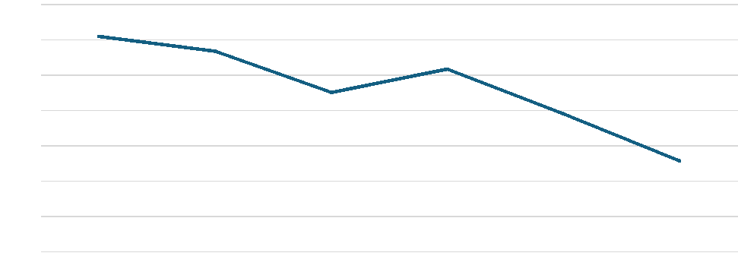
4314
5019
5000
4834
4800
4702
4581
4600
4400
4200
4000
3800
2018 2019 2020 2021 2022 2023
5200
4935
Page 57 Regional Community Health Assessment

Comprehensive Regional Community Health Assessment
A look at practitioner access in Table 16 provides insight into the problem of obtaining both acute and
preventive health care in the region as well as insights into the problem of chronic disease management.
Table 16 Provider Access in the Finger Lakes Region
County | Primary Care  Physicians –  Number of  residents to one  physician  (2021)  (NYS: 1,240) | Mental Health  Providers Number  of residents to one  provider  (2024)  (NYS: 260) | Dentists Number of  residents to one  dentist  (2022)  (NYS: 1,200) | Primary Care Providers Other than Physicians Number of residents to one provider  (2024)  (NYS: 610)
Chemung | 1,280 | 290 | 1,540 | 560
Livingston | 2,200 | 640 | 1,980 | 1,130
Ontario | 1,210 | 330 | 1,660 | 680
Schuyler | 1,610 | 430 | 3,530 | 1,590
Seneca | 3,740 | 410 | 3,290 | 1,120
Steuben | 1,790 | 400 | 2,810 | 930
Wayne | 4,300 | 800 | 2030 | 1,420
Yates | 2,050 | 840 | 2,220 | 1,220
Sources: County Health Rankings & Roadmaps, using data from the Area Health Resources Files (primary care physicians), CMS National Provider Identifier and NPPES files (mental health providers, dentists, and other primary care providers).
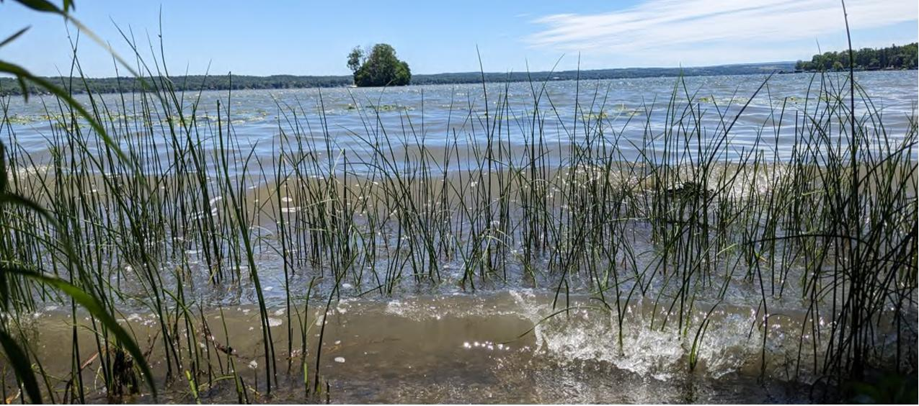
Courtesy Ontario County
Page 58 Regional Community Health Assessment

Comprehensive Regional Community Health Assessment
Access to and use of preventive services may also be measured by the percentage of residents who have undergone diagnostic testing such as mammograms and colorectal screenings. Additionally, those who have been tested for and diagnosed with high blood pressure or diabetes as detailed in Table 17. A large percentage of residents receive mammography services, and those on Medicare doing so exceed the New York State average.
Table 17: Preventive Services
County | Percentage of  those 50-74 years  who have gotten  a Mammogram  (2022) | Percentage of  those on  Medicare who  have gotten a  Mammogram  (NYS = 44%)  (2022) | Percentage of Those Receiving Colorectal Screening  (2022) | Percentage  of Those  who have  had a test  for High  Blood  Sugar/  Diabetes  Test  (2021) | Percentage  of those  with an  income <  $25,000  who have  had a test  for High  Blood  Sugar/  Diabetes  (2018)  (NYS =  62.2%) | Percentage  of those  Diagnosed  with High  Blood  Pressure  (18+)  (2021)
Chemung | 74.4 | 51 | 61.3 | 66.9 | 52.8 | 29.7
Livingston | 79 | 51 | 62 | 61.6 | 75.4 | 28.8
Ontario | 75.9 | 52 | 65.3 | 63.2 | 56.6 | 28.9
Schuyler | 73.7 | 50 | 61.4 | 62.9 | 63.4 | 28.8
Seneca | 73 | 47 | 61.3 | 63.3 | 64.3 | 31.9
Steuben | 76.9 | 50 | 59.9 | 59.4 | 49.5 | 29.8
Wayne | 79.6 | 43 | 62.3 | 65 | 51.4 | 29.1
Yates | 75.5 | 55 | 63.2 | 69.6 | 48.7 | 30.1
Sources: County Health Rankings, American Medical Association, National Provider Identifier, Healthy People 2020, NYS Prevention Agenda, Statewide Perinatal Data System, National Center for Health Statistics, CDC, Vital Records, Behavioral Risk Factor Surveillance System, NYS Medicaid Program, IAP Baseline Report, NYSIIS Performance Report, Child Health Plus.
Oral Care
Oral care is important to overall health. Lack of dental insurance, insufficient provider numbers, and lack of dentists willing to see Medicaid clients contribute to residents’ inability to access preventive and acute dental care. Table 17 describes the state of dental care in the region. All data points demonstrate room for improvement, particularly Medicaid preventive visits for those ages 2-20 as early preventive care prevents future chronic conditions. (Table 18)
Page 59 Regional Community Health Assessment

Comprehensive Regional Community Health Assessment

Table 18: Oral Care
County | Adult Dental  Visits (%)  (2019) | Medicaid Visits  (age 2-20) (%)  (2023) | Medicaid Visits  (%)  (2023) | Medicaid  Preventive Visit  (%)  (2023) | Medicaid  Preventive Visit  (age 2-20) (%)  (2023)
Chemung | 65.4 | 43.3 | 25.2 | 21.4 | 40.8
Livingston | 69.9 | 41.3 | 26.7 | 22.7 | 38.7
Ontario | 74.5 | 40 | 25 | 21.1 | 37.1
Schuyler | 58.4 | 43.6 | 24.3 | 20.6 | 40.5
Seneca | 69.1 | 34.8 | 21.6 | 17.4 | 30.9
Steuben | 59.5 | 41.1 | 23.9 | 20.2 | 38.5
Wayne | 66.6 | 39.4 | 25.1 | 20.6 | 36.2
Yates | 62.6 | 41.2 | 25.1 | 21.1 | 37.2
Sources: County Health Rankings, American Medical Association, National Provider Identifier, Healthy People 2020, NYS Prevention Agenda, Statewide Perinatal Data System, National Center for Health Statistics, CDC, Vital Records, Behavioral Risk Factor Surveillance System, NYS Medicaid Program, IAP Baseline Report, NYSIIS Performance Report, Child Health Plus.
Lack of access to dental care, the use of non-fluorinated well water by many rural residents, and an emerging trend of municipalities removing fluoride from public water systems leave Finger Lakes residents at risk for oral diseases and disorders.
Emergency Department Visits and Preventable Hospitalizations
Emergency Departments may serve as the source of primary care for those who are underinsured or lack health insurance. In addition, lack of provider access may contribute to increased reliance on emergency rooms and may cause preventable hospitalizations. Migrant populations fearing deportation may defer medical care until an emergency room visit and subsequent hospitalization is necessary. Mennonite community members often self-treat common maladies and wait until they are experiencing advanced illnesses which require the use of an emergency room.
Many Finger Lakes counties exceed New York State averages for emergency department visits and preventable hospitalizations. Four counties exceed the state rate for behavioral health ED visits; four exceed the state rate for all preventable hospitalizations; and all but one county exceeds the state rate for all emergency department visits. The number of emergency department visits related to behavioral (suicidal thoughts, substance use, psychiatric disorders), and mental health (depressive disorders) are areas that may be improved. (Table 19)

Page 60 Regional Community Health Assessment

Comprehensive Regional Community Health Assessment

Table 19: Emergency Department Visits and Preventable Hospitalizations
County | All Emergency  Department Visits  (2023)  (NYS = 29,809) | All Behavioral Health  Conditions ED Visits  (2023)  (NYS = 6,872) | All Mental  Health ED Visits  (2023)  (NYS = 3,370) | All Preventable  Hospitalizations  (2023)  (NYS = 808)
Chemung | 43,624 | 8,622 | 4,204 | 1,046
Livingston | 27,323 | 5,798 | 2,470 | 723
Ontario | 33,756 | 6,132 | 2,645 | 780
Schuyler | 52,967 | 7,108 | 3,523 | 954
Seneca | 38,723 | 6,873 | 3,014 | 885
Steuben | 44,043 | 8,215 | 3,292 | 720
Wayne | 31,387 | 8,617 | 3,423 | 1,072
Yates | 41,443 | 4,935 | 2,303 | 604
Source: SPARCS
Map 14 highlights the potentially preventable hospitalizations by zip code in the Finger Lakes region. This map corresponds with maps highlighting life expectancy as well as emergency department visits for heart disease, cancer, hypertension, depressive disorders, and anxiety and panic disorders (Maps 17-22) as well as poverty (Maps 6-8). Note that the concentrations of potentially preventable hospitalizations as well as the emergency department visits cluster in similar areas of the region. This corresponds with higher poverty rates as well as decreased life expectancy. Higher rates of emergency department use and preventable hospitalizations in certain counties and populations—especially people living in poverty, on Medicaid, or in rural areas—signal inequitable access to timely, high-quality outpatient care and contribute to widening health disparities.
Map 17: Potentially Preventable Hospitalizations Map 18: ED Visits for Cancer by Zip Code

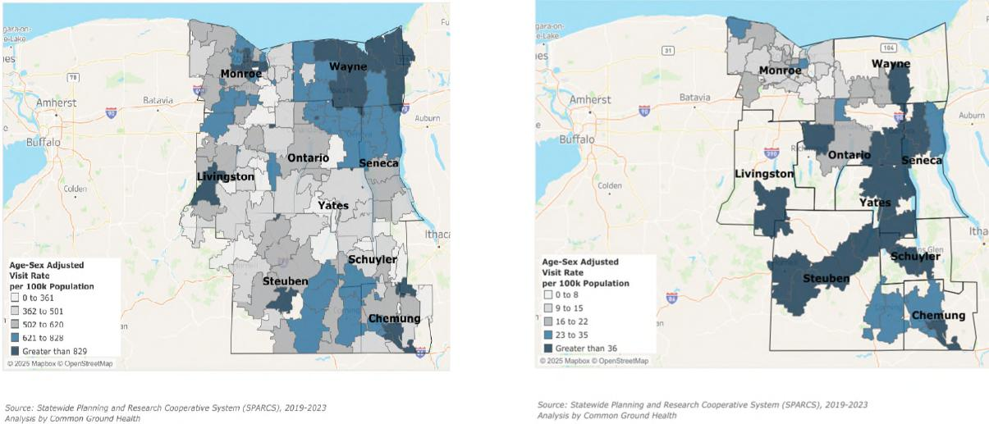

Page 61 Regional Community Health Assessment

Comprehensive Regional Community Health Assessment

Map 19: ED Visits Related to Heart Disease by Zip Code Map 20: ED Visits for Hypertension by Zip Code

Map 22: ED Visits for Anxiety and Panic Disorders by Zip Code
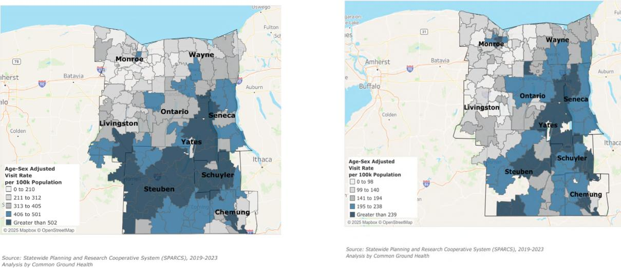
Map 21: ED Visits for Depressive Disorders by Zip Code

Page 62 Regional Community Health Assessment
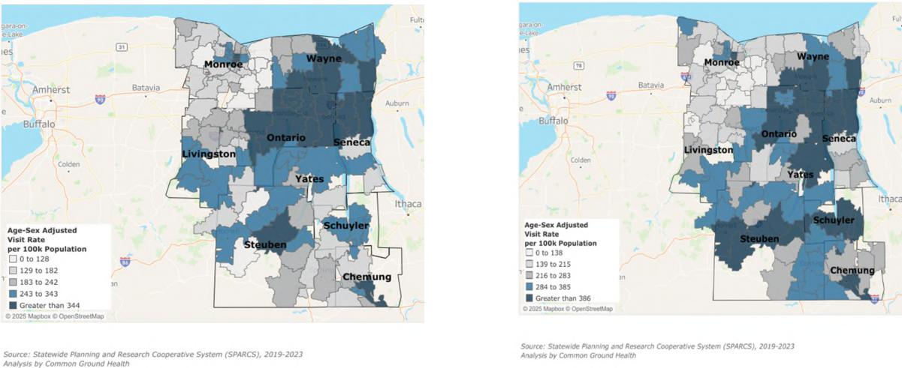

Comprehensive Regional Community Health Assessment
Blood Lead Level Screening and Vaccinations
One important screening that happens during well-child visits is a blood lead level test. “Asymptomatic lead poisoning has become more common in children. Blood lead levels of greater than 5 ug per dL are associated with impairments in neurocognitive and behavioral development that are irreversible.”²⁹ It is required that children to have at least two screenings in the first 36 months of life – one at age one and one at age 2. (Figure 29) In addition, the 4:3:1:3:1:4 (four doses of DTaP (Diphtheria, Tetanus, and Pertussis), three doses of polio (IPV), one dose of MMR ((Measles, Mumps, and Rubella)), three doses of Hib ((Haemophilus influenzae type b)), three doses of Hepatitis B, one dose of Varicella, and four doses of pneumococcal vaccine (PCV) ) childhood vaccination series are key to keeping not just children, but the overall population free of vaccine preventable diseases. (Figure 30)
Figure 29: Blood Lead Level Screening in the Finger Lakes Region
Source: NYSIIS Performance Report
²⁹ Mayans, L. (2019). Lead poisoning in children. American family physician, 100(1), 24-30.
Blood Lead Level Screening
70
 |  |  |  |  |  |  |  |  |  |  | 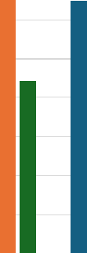
 |  |  |  |  |  |  |  |  |  |  |  |  |  |  |  |  |  |  |  |  |  |  | 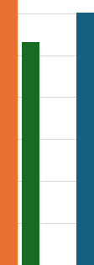
60
60 |  |  |  | 
50
40 |  |  |  |  |  |  |  |  |  |  |  |  |  |  |  |  |  |  |  |  |  |  |  |  |  |  |  |  | 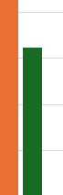
30
20
10
0
Chemung Livingston Ontario Schuyler Seneca Steuben Wayne Yates
Screening at 1 Year Screening at 2 Year At least Two Lead Screenings
Page 63 Regional Community Health Assessment

Comprehensive Regional Community Health Assessment
The Finger Lakes region shows persistent gaps in key pediatric and adolescent preventive services, despite relatively strong early-childhood immunization rates. Across the eight counties, completion of the 4:3:1:3:1:4 vaccine series consistently exceeds both lead screening by age two and adolescent HPV vaccination, indicating that standard early-childhood vaccines are delivered more reliably than other preventive services. HPV vaccination is the lowest measure in every county, and lead-screening completion remains only moderate, signaling missed opportunities for cancer prevention and early detection of environmental hazards affecting low-income and rural children.
Figure 30: Immunization Rates by County in the Finger Lakes
Source: NYSIIP
Education Access and Quality
Health and Wellness Promoting Schools
Health and wellness promoting schools refers to the non-academic factors that impact whether a student is set up for success. These may include the prevalence of healthy food choices and ability to participate in physical activity.
One important indicator of how well schools are supporting students is chronic absenteeism, defined as missing at least 10 percent of school days in a year. State-level data from the 2022–2023 school year show that nearly one in three New York students is chronically absent, with rates varying by region, race and ethnicity, and socioeconomic status. Chronic absenteeism has increased sharply in rural districts, reaching 13.4 percent in low-need rural areas, 25.2 percent in average-need rural areas, and 33.0 percent in high-need rural areas. Economically disadvantaged students, students with disabilities, and English language learners experience the highest absenteeism rates, highlighting the need for
Immunization Rates by County (2025)
90
80
70 |  |  |  |  |  |  |  |  |  | 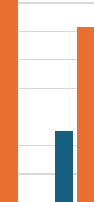
70 | 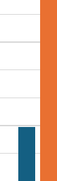 |  |  |  |  |  |  |  |  |  |  |  |  |  |  |  |  |  |  |  |  | 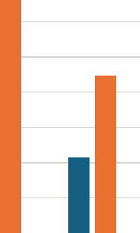
60
50
40
30
20
10
0
Chemung Livingston Ontario Schuyler Seneca Steuben Wayne Yates
HPV Vaccination 4:3:1:3:1:4 Vaccine Series
Page 64 Regional Community Health Assessment

Comprehensive Regional Community Health Assessment
school-based strategies that address health, transportation, and other non-academic barriers to attendance.³⁰
Additional indicators include the percentage of teens and young adults who were neither working nor in school (disconnected youth), the number of school age students eligible for free or reduced lunch and the number of childcare centers per 100,000 children under age 5 as highlighted in Table 20.
Table 20: Education-related Socio-economic factors
County | % teens and young  adults (age 16-19)  neither working nor in  school (2025)  (NYS: 7%) | % school age children  eligible for free or  reduced lunch (2025)  (NYS: 57%) | Number of childcare  centers per 1,000  children under age 5  (2025)  (NYC: 6)
Chemung | 11 | 53 | 6
Livingston | 5 | 44 | 7
Ontario | 5 | 43 | 6
Schuyler | Not available | 43 | 5
Seneca | 14 | 56 | 3
Steuben | 9 | 50 | 8
Wayne | 9 | 50 | 4
Yates | Not available | 55 | 3
Source: County Health Rankings
Three measures of opportunities for continued education are the high school graduation rate, the average spending per student, and the high school graduation rate of economically disadvantaged students. All counties except Seneca and Yates exceed the New York State average percent of adults over age 25 with a high school diploma or equivalent. A quality education may improve the economic prosperity of residents by allowing them to obtain better compensated employment which increases their economic stability. (Table 21)
Table 21: Education Indicators
County | Percent of adults over age 25 with a high school diploma or equivalent (2023)  (NYS = 88) | Average gap ($)  between actual and  required spending in  public school districts  (2022)  (NYS = $12,754) | Graduation rate of  economically  disadvantaged  students (2023)  (NYS = 82)
Chemung | 91 | 9,909 | 75
Livingston | 93 | 11,626 | 87
Ontario | 93 | 12,784 | 85
Schuyler | 91 | 11,955 | 80
Seneca | 85 | 13,399 | 80

³⁰ Source: New York’s Stubbornly High Rates of Chronic Absenteeism. October 2024.
https://www.osc.ny.gov/files/reports/pdf/missing-school-ny-chronic-absenteeism.pdf
Page 65 Regional Community Health Assessment

Comprehensive Regional Community Health Assessment

Steuben | 92 | 12,721 | 85
Wayne | 91 | 12,785 | 81
Yates | 84 | 9,915 | 81
Source: U.S. Census Bureau, ACS, NYSED
The findings in this Community Health Assessment show that health in the Finger Lakes region is shaped by intersecting social and economic conditions, including poverty, food and housing insecurity, transportation barriers, provider shortages, and educational opportunity. These challenges are not experienced equally: older adults, children, people living in rural and higher deprivation ZIP codes, and residents from historically marginalized groups often face higher risks and fewer resources, leading to persistent health inequities across the region. At the same time, strong community assets—including collaborative public health and health care systems, engaged community organizations, and dedicated residents—provide a foundation for collective action.
The accompanying county chapter build on this regional picture by highlighting the county’s specific strengths, challenges, and priority populations. Together, the regional and county -level assessment will guide the development of Community Health Improvement Plans that focus on advancing health equity, strengthening the conditions where people live, learn, work, and age, and improving health outcomes for all residents of the Finger Lakes region.
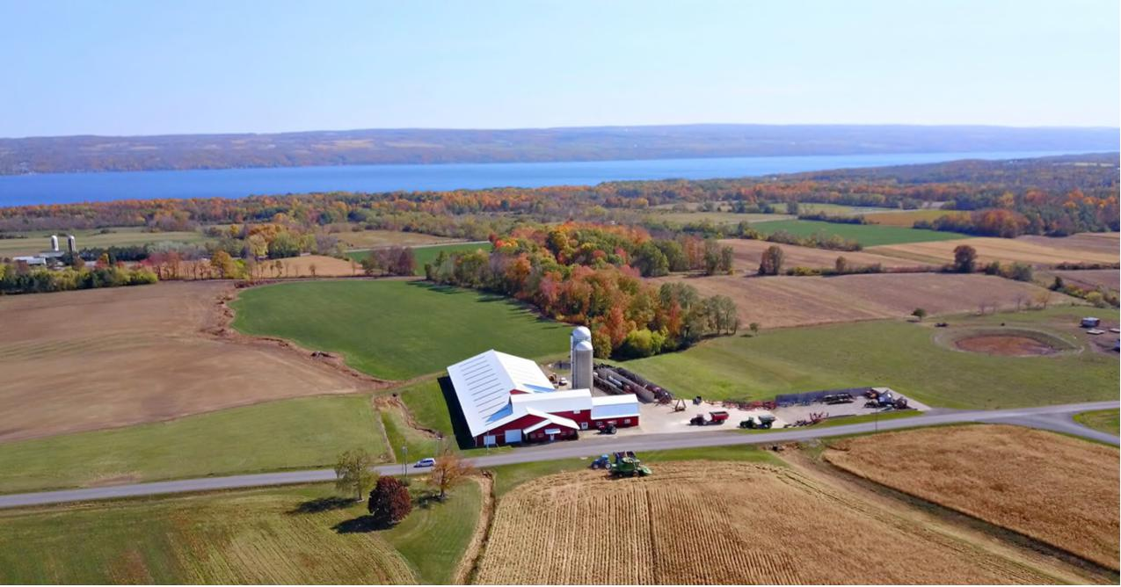
Farm overlooking Keuka Lake, Courtesy of Steuben County
Page 66 Regional Community Health Assessment

Courtesy of Yates County Chamber of Commerce
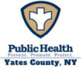 | Community Health Assessment – Yates County | 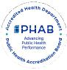

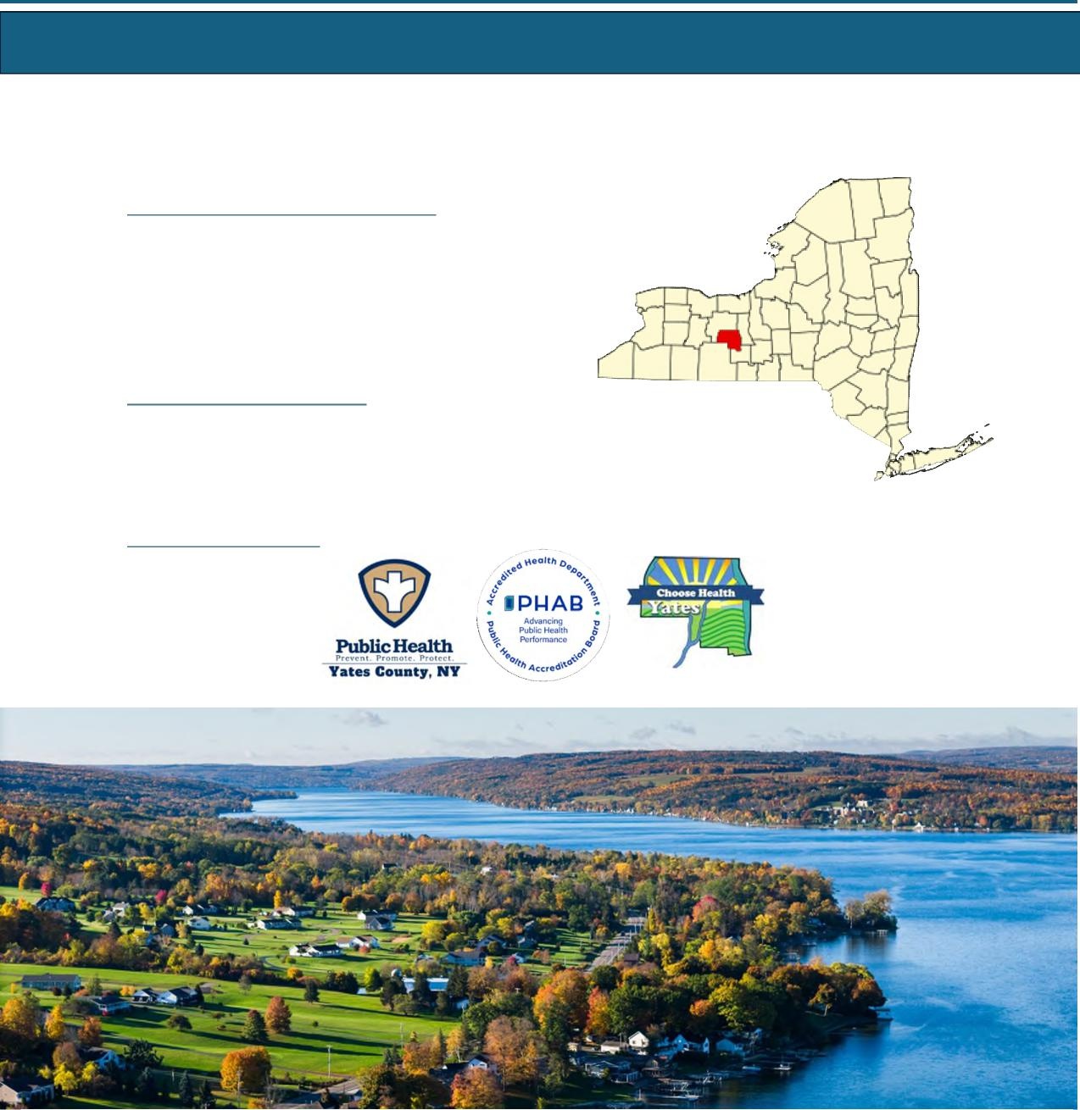
Yates County Public Health
Alyssa Broome-Quissimisse
Director of Public Health
Alyssa.Quissimisse@yatescountyny.gov
315-536-5160
UR Medicine Finger Lakes Health Soldiers and Sailors
Memorial Hospital
Kimberly Ilacqua
Vice President, Community Services
Executive Director, Finger Lakes Health Foundation
Kimberly.Ilacqua@flhealth.org
315-787-4053
Pivital Public Health Partnership Michele Foster
Executive Director MFoster@pivitalphp.org
Yates County
Page 67 Yates County

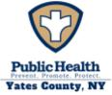 | Community Health Assessment – Yates County | 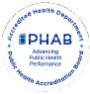
Table of Contents
Executive Summary 69
Community Description | 71
Service Area | 71
Demographic Summary | 71
Health Status Description | 76
Specific Methodology | 76
County Health Rankings | 78
NYS Prevention Agenda | 79
Priority Areas | 103
Community Assets and Resources | 104
Appendix 1: Participating Partners and Community Representation | 107
List of Tables:
Table Y1: Causes of Death | 75
Table Y2: NYS Prevention Agenda 2025-2030 Domains and Priorities | 79
Table Y3: Rates of Age-Adjusted Causes of Death | 93
Table Y4: Emergency Department Visits | 95
Table Y5: 4:3:1:3:3:1:4 Schedule | 99
Table Y6: Enrolled School-Age Population | 101
Table Y7: County Resources to Accomplish CHA/CHIP Goals | 105
List of Maps:
Map Y1: Population Density in Yates County | 72
Map Y2: Overall Poverty Rate in Yates County | 81
Map Y3: Food Insecurity Rate | 82
Map Y4: Poor Mental Health Days | 86
Map Y5: ED Visit Rate by Zip Code | 94
Map Y6: Preventable Hospitalizations by Zip Code | 94
List of Figures:
Figure Y1: Population Projections in Yates County | 72
Figure Y2: Population by Age and Sex | 73
Figure Y3: County Health Rankings Health and Well-Being | 78
Figure Y4: County Health Rankings Community Conditions/SDOH | 78
Figure Y5: Unemployment Rate | 81
Figure Y6: Residents to Healthcare Provider Ratio | 96
Figure Y7: Immunization Rates 2025 | 99
Figure Y8: Preventive Services – Lead Screening | 100

Page 68 Yates County

Yates County has identified three priority areas for this Community Health Assessment (CHA). They are:
 | Community Health Assessment – Yates County | 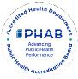
Executive Summary
- Housing Stability and Affordability
- Preventive Services for Chronic Disease Prevention and Control
- Anxiety and Stress
Data Sources
Yates County’s CHA incorporated a blend of quantitative and qualitative data sources, including secondary data from the New York State Behavioral Risk Factor Surveillance System, County Health Rankings and Roadmaps, the National Center for Health Statistics, the American Community Survey, the U.S. Census, the NYS Medicaid Program, and local performance reports.
Partners and Roles
The Choose Health Yates Committee was integral in the development of the CHA, along with the participating partners and community representation listed in Appendix 1. Yates County community members were invited to attend the Choose Health Yates meetings through local radio announcements and meeting dates published on the local health department’s website. During the CHA development, Choose Health Yates met regularly to develop and integrate information collected through use of the MAPP 2.0 framework.
Valuable organizational data and community insights were compiled to create a comprehensive county profile. Gathering this information was completed using three assessments: the Community Partner Assessment (CPA), Community Context Assessment (CCA), and Community Status Assessment (CSA). Throughout the process, partners and community members participated in regular Choose Health Yates meetings where findings from the assessments mentioned above were presented. These sessions encouraged questions, feedback, and shared interpretation of the data. The full committee collaboratively reviewed and discussed the triangulated results of all three assessments, allowing partners to validate findings and identify key health themes, leading to the selection of priorities.
Summary of Findings
Yates County faces a complex mix of social, economic, and health challenges that influence the overall well-being of its residents. Poverty has increased to 14.1%, with the highest concentrations in the southern part of the county, and older adults have experienced a particularly sharp rise in financial hardship. Median household income remains below the state average, and while unemployment is relatively low, wages are not keeping pace with the cost of living, creating economic stress for many families. Even though homeownership rates are high compared to NYS, households have experienced 1 of 4 housing problems (overcrowding, high housing costs, and/or lack of kitchen or plumbing facilities) at higher rates since 2020. Nutrition security appears stable, with most residents having access to healthy food, but gaps in physical activity opportunities, walkable spaces, and community amenities highlight barriers to healthy lifestyles.
Page 69 Yates County

 | Community Health Assessment – Yates County | 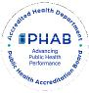

Mental health is a growing concern. Rates of adults reporting poor mental health and depression, along with elevated suicide rates, exceed state averages, signaling rising stress, anxiety, and unmet behavioral health needs. Substance use and overdose trends have decreased, along with the percentage of adults who are current smokers.
Access to healthcare is strained by provider shortages, geographic barriers, and declining insurance coverage for adults and children. Preventive care indicators, including screenings, dental care, immunizations, and lead testing, show lower completion rates among Medicaid enrollees and low-income populations.
High school completion and post-secondary enrollment lag state averages, and the four-year graduation rate is lower than the state average. School funding gaps have slightly worsened, limiting resources and programming that support student success. However, students who are economically disadvantaged have shown a promising upward trend in graduation rates. Civic engagement and social cohesion are moderate, with relatively strong organizational participation and voter turnout, but social vulnerability remains elevated, particularly for those facing economic, transportation, or housing barriers.
Interventions, Strategies, and Disparities
Yates County residents who are older adults, children, of low-income status, and live with a mental health and/or substance use disorder face the greatest health disparities. Yates County Public Health has chosen to submit the Community Health Improvement Plan (CHIP) for June 2026 where more information about specific health disparities will be included. Choose Health Yates and the local hospital, Soldiers and Sailors Memorial Hospital, will continue to work collaboratively in selecting the objectives and interventions for the chosen priorities.
Measures and Evaluation
Choose Health Yates continues to meet regularly to improve the health of Yates residents and to oversee CHIP implementation. Attendees at these meetings will routinely review the progress of the chosen priorities, objectives, and interventions. Once the interventions have been selected, group members will identify and implement mid-course corrections to interventions and processes. These meetings will serve as continued program evaluation and a means to keep the community and partners apprised of the CHIP progress.
Page 70 Yates County

 | Community Health Assessment – Yates County | 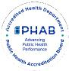
Community Description
Service Area
Yates County is a small, predominantly rural county located in the Finger Lakes region of New York State, covering approximately 376 square miles. The service area encompasses a mix of village centers, lakeside communities, and widely dispersed agricultural areas. With one of the smallest populations in the state, the county is characterized by low population density, limited public transportation, and long travel distances to healthcare and social services. The community includes a growing older-adult population, families living in or near poverty, and several culturally distinct groups, including a sizable Amish and Mennonite population whose health needs, access patterns, and service utilization differ from the general population.
Healthcare services within the county are provided primarily by a small number of clinics, primary care practices, and one critical access hospital, with many residents traveling outside the county for specialty care, behavioral health services, and advanced medical treatment. Economic conditions, geographic isolation, seasonal employment, and transportation barriers all shape the community’s health needs and influence how residents access care.
Overall, the Yates County service area reflects the unique challenges and strengths of a rural community—tight-knit and resourceful, yet facing persistent barriers related to access, affordability, and availability of healthcare and support services.
Demographic Summary
Demographic information is essential in public and community health as it identifies who lives in a community, how their needs differ, and where health disparities exist. By understanding factors such as age, race, income, education, and poverty, organizations can target resources, design effective programs, and allocate funding where it will have the greatest impact. Demographic data provides the foundation for equitable planning, informed decision-making, and improved health outcomes for all community members.
Page 71 Yates County

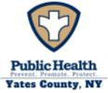 | Community Health Assessment – Yates County

Population
Yates County is in the heart of the Finger Lakes Region and is bordered by Steuben, Seneca, Ontario, and Schuyler counties. While Yates County includes parts of Canandaigua Lake and Seneca Lake, it is home to the popular Keuka Lake. The beautiful scenery, agriculture, and recreational water activities make it an ideal vacation spot for tourists from April to October. There are 24,774 residents across Yates County, with the densest population areas in Penn Yan and Dundee, as shown in Map Y1. The county is considered very rural, with 68.6% of residents living outside population-dense areas.³¹ The population of Yates County is expected to hold relatively steady over the next decade before increasing. (Figure Y1)
Figure Y1: Population Projections- Yates County
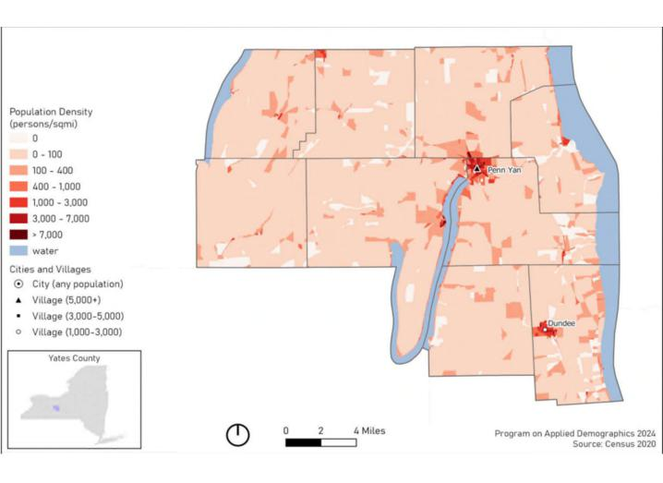
Map Y1: Population Density of Yates County
Source: Cornell Program on Applied Demographics 2024; US Census 2020
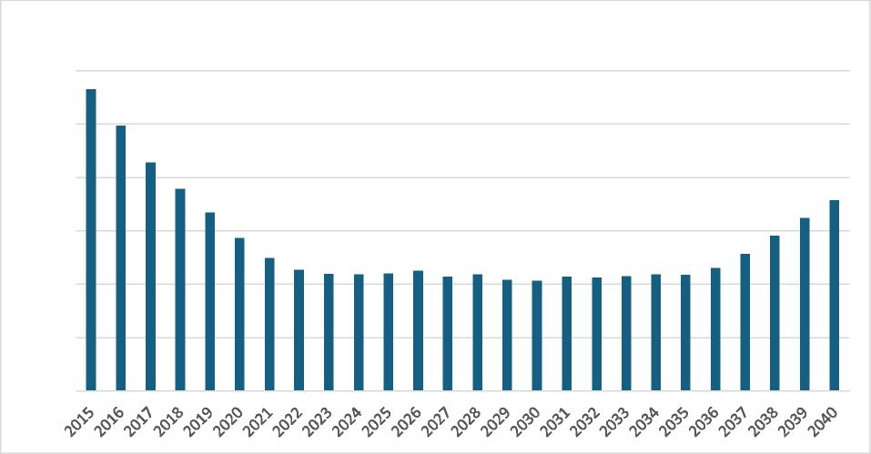
Population Projections - Yates County
25,100
25,000
24,900
24,800
24,700
24,600
24,500
Source: Cornell Program on Applied Demographics
³¹ Source: County Health Rankings, U.S. Census
Page 72 Yates County

Age and Sex
 | Community Health Assessment – Yates County | 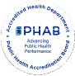

Figure Y2: Population by Age and Sex
To better understand health needs, it is important to know the sex and age make-up of a community. Figure Y2 shows the number of county residents by sex and age. The median age in Yates County is 41.6 years, with one larger population group aged 50-79. Sex is relatively evenly split, with females accounting for 50.7% of the population. Individuals identifying as LGBTQ+ account for 5.8% of the population.  Youth (below 18 years of age) represent 22.7% of the population. However, 21.9% of the population is 65 years of age or older, with the largest age group of the older population being 65 to 74 years old, representing 13.4% of the total population. Aging populations often require the utilization of more health services, adding further strain to health infrastructure.  Race and Ethnicity | 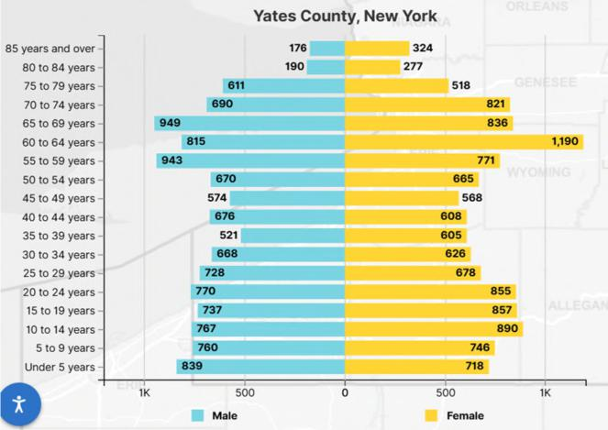
 | Source: U.S. Census 2020

Census data for Yates County indicate a largely white (93%) population followed by Hispanic or Latino (2.6%), Black or African American (0.7%), Asian (0.3%), and American Indian or Alaska Native (0.1%). The regional section of this CHA denotes additional population considerations, including Amish/Mennonite and migrant farmworkers.
There is a large Mennonite community who reside in Yates County. The Groffdale Mennonites, commonly known as Horse-and-Buggy Mennonites, settled in Yates County around 1974, coming from Lancaster County, Pennsylvania. The 2025 Old Groffdale and Midwest Horse and Buggy maps show that there are approximately 877 Mennonite households across Ontario, Schuyler, Steuben, and Yates Counties, with the largest number residing in Yates County. Since 2022, the number of horse-and-buggy households has increased by 97. However, since their settlement, Mennonites continued to diversify into Driving Mennonites, expanding households even further around the Finger Lakes Region.
Mennonites make a significant contribution to Yates County’s agriculture and economy. Additionally, it is important to note the cultural implications the population can have on local data, such as vaccination rates, uninsured rates, prenatal care, educational attainment, and unintentional injuries (e.g.., motor vehicle and farm accidents). The Mennonite community often resorts to homeopathic medicine and relies on experienced community members for health care. Community organizations and partners collaborate to host inclusive events that integrate Mennonite beliefs and values with evidence-based practices, providing the best opportunities for meaningful learning.
Page 73 Yates County

Community Health Assessment – Yates County

Veterans and People with Disabilities
Veterans often have distinct health needs, including higher rates of chronic conditions, mental health challenges, and service-related injuries. The Veteran population of Yates County accounts for 7.2% of the total population, which is higher than the NYS average (3.9%).³² Of that number 94% are male, and 6% are female.
People with disabilities may face heightened barriers to care, transportation, employment, housing, and healthy living. There are approximately 11.1% of the Yates County population who live with a disability. Comparatively, there is about 13.5% of the New York State population that lives with a disability. The most common disabilities are cognitive, independent living, and ambulatory difficulty.
Language Spoken at Home
In Yates County, according to the U.S. Census, 16.8% of people speak a language other than English at home. This includes: 1.6% who speak Spanish; 14.5% who speak Indo-European languages; 0.8% who speak Asian and Pacific Island languages; and 0.2% percent who speak other languages. The notable share of Indo-European language speakers is likely influenced by the presence of Amish and Mennonite communities. Providing language assistance in health care improves the quality of care for all populations with limited English proficiency, thereby optimizing overall health literacy.
Leading Cause of Death and Life Expectancy
The average number of years a person in Yates County may expect to live is 78.1³³, with variation throughout the county as seen in Map Y2. This number is lower than the state average of 80.4, but greater than the national average of 77.6.³³ Life expectancy in Yates County is greater than three of its contingent counties (Steuben 76.6, Seneca 77.5, and Schuyler 75.8) and lower than only the remaining contingent county of Ontario (79.6)^{33.} Life expectancy in Yates County has remained relatively stable since 2018.
Per NYSDOH 2025 data, the leading causes of death in Yates County are cancer, heart disease, and unintentional injury, respectively. The leading causes of cancer in the county include prostate, female breast, and lung cancers. At the state level, the leading causes of death are heart disease, cancer and COVID-19. The leading causes of premature death (before age 75) in Yates County are cancer, heart disease, and unintentional injury, reflecting state trends. The death rates for each indicator are noted in Tables Y1a and Y1b, along with NYS figures.
The total deaths per 100,000 Yates County residents exceed state rates for both overall death (839.3 vs 679.6 per 100,000) and premature death (334.4 vs 309.3 per 100,000). This is largely due to a substantial increase in unintentional injury deaths. At the state level, unintentional injury accounts for 50.6 per 100,000 deaths and is the fourth leading cause of death. In Yates County, this rises to 86.8 per 100,000 and is the third leading cause of death. Rates of premature death due to unintentional injury show a
³² Source: U.S. Census, 2023
³³ Source: University of Wisconsin Population Health Institute. (2025). Life expectancy: Yates County, New York. County Health Rankings & Roadmaps. www.countyhealthrankings.org/health‐data/population‐health‐and‐well‐being/length‐of‐life
Page 74 Yates County

Community Health Assessment – Yates County

similar trend. Statewide, unintentional injury accounts for 44.8 premature deaths per 100,000 while in Yates County this figure jumps to 70.4 per 100,000.
Table Y1a: Causes of Death (measured per 100,000 population)
Cause of Death | All Ages, Age-Sex Adjusted Yates  County | All Ages – NYS excluding NYC
Cancer | 142.6 | 129.23
Heart Disease | 141.1 | 159.82
Unintentional Injury | 86.8 | 50.6
Death Rate | 814.47 | 679.6
Source for Age-Sex Adjusted Leading Causes of Death: Source: NYS DOH Vital Statistics, 2022.Analysis by Common Ground Health
Table Y1b: Premature Causes of Death (Before age 75; measured per 100,000 population)
Cause of Death | Premature Death rate (Before age 75) Yates County | Premature Death rate (Before age 75) NYS excluding NYC
Cancer | 61.4 | 67.1
Heart Disease | 46.0 | 57.4
Unintentional Injury | 70.4 | 44.8
Death Rate | 334.4 | 309.3
Source for Premature Death Rates (before age 75): NYS Leading Causes of Death Dashboard.
Health Disparities
Health disparities are the preventable differences in health outcomes when compared to the overall population of an area. Yates County’s rural location presents significant challenges to health outcomes and access to care. With the densest populations near the villages of Penn Yan and Dundee³⁴, much of the county remains isolated, leaving many residents with limited access to physical and mental health care, inadequate health care infrastructure (e.g., provider shortages), low rates of physical activity, and restricted access to healthy food. Having limited availability to these resources can exacerbate chronic disease. Populations living in rural areas have a higher risk of developing chronic disease when compared to urban counterparts. The county also has a large aging population, lower socioeconomic status, and many uninsured individuals who face greater barriers to achieving optimal health.
³⁴ Source: Cornell University Population Density Maps for NYS Counties, February 2024.
Page 75 Yates County

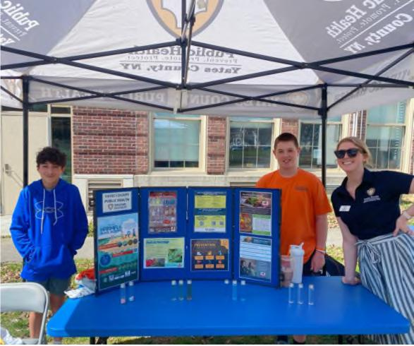
Penn Yan students, Wilson and Keegan, with Yates County Public Health Educator, Emily End, at the Future Farmers of America (FFA) field day event at the Penn Yan Middle School.
Community Health Assessment – Yates County
Health Status Description
Specific Methodology
The CHA provides a comprehensive picture of a community’s current health status, including factors that contribute to health risks and challenges, and identifies priority health needs by analyzing local data and community input. Community members and key stakeholders were invited to be part of the CHA by participating in the CHIP steering committee, known as Choose Health Yates. Choose Health Yates met monthly in 2025, except in January, May, July, and November.
Data Sources
Yates County’s CHA incorporated a blend of quantitative and qualitative data sources, including secondary data from the NYS Behavioral Risk Factor Surveillance System (BRFSS), County Health Rankings and Roadmaps, the National Center for Health Statistics, the American Community Survey, the U.S. Census, the NYS
Medicaid Program, and local performance reports.
Pivital Public Health Partnership assisted in the coordination, development, and distribution of the
assessments. The data collected from the assessments were used to tell the community’s story of overall
health and well-being.
Community partners played a key role throughout the development of the CHA by completing three assessments:
- Community Partner Assessment (CPA): An evaluation of collective community partner systems and capacities to identify partners working in the areas of health inequities.
- Community Status Assessment (CSA): A compilation of quantitative data from the state and local level to identify trends related to the social determinants of health and systems of power and privilege.
- Community Context Assessment (CCA): A collection of community voices and qualitative data to better understand the lived experience and priorities of those affected by inequities.
Community Engagement
Each assessment looked to gather different information by targeting different sectors of the community. The CPA was completed via an online survey platform and distributed to approximately 22 members of
Page 76 Yates County

Community Health Assessment – Yates County

the Choose Health Yates committee in February 2025. The response rate was approximately 46%, and the results were shared with the group to highlight partner strengths that could assist with the CHIP.
The second assessment, the CCA, was developed in March and conducted between April and May of 2025. During the CCA, a regional survey was developed and distributed to gather community feedback. The questions focused on the following categories provided by the MAPP 2.0 CCA assessment toolkit: overall health behaviors and outcomes, community strengths and assets, built environment, and forces of change. Choose Health Yates made it a priority to ensure disproportionately affected populations were included in qualitative data collection by choosing various engagement methods. Yates County Public Health, along with various other stakeholders, held focus groups, community dialogues, and interviews/discussions to collect qualitative data. A total of 11 engagement sessions were conducted throughout the CCA process. Yates County Public Health did attempt a PhotoVoice with the aging population, but due to low attendance, the session was cancelled.
Overall, the engagement methods were a great success, yielding rich insight from diverse target populations. Targeted populations included: aging population, low-income neighborhoods, youth, incarcerated individuals, faith-based groups, agricultural workers, and Mennonites. Choose Health Yates methodically identified where these populations were already meeting, and the agency conducting the CCA asked to be invited to the gathering to conduct the assessment. The groups provided extensive constructive feedback that painted a clear picture of community needs and existing strengths to build upon. Preliminary data from the CCA were shared at each monthly meeting with Choose Health Yates to gather input from committee members.
While the CCA was being conducted, Pivital Public Health Partnership completed the CSA. This was completed by compiling secondary data into scorecards stored in the performance management system, Clear Impact. The scorecards made data easily accessible and shareable among stakeholders and community members, helping review the overall health status of Yates County.
Throughout the assessments, the Choose Health Yates committee met regularly to present and discuss findings from all three assessments. These sessions encouraged questions, feedback, and shared interpretation of the data. The full committee collaboratively reviewed and discussed the triangulated results, allowing partners to validate findings and contribute to identifying several cross-cuffing themes. These themes included:
- Access to Care/Insurance Stability
- Opportunities for Active Transportation & Physical Activity
- Housing Stability & Affordability
- Mental Wellbeing & Substance Use
- Injuries & Violence
- Opportunities for Continued Education
The cross-cuffing themes were used to develop issue statements for each priority area. The issue statements were used to complete root cause analyses and create issue profiles for each health priority. Partners actively participated in analyzing and reviewing these issue profiles. The group then completed a prioritization matrix process to refine options further by systematically comparing identified issues through selection, weighing, and applying a ranking criterion. The ranking criteria included: relevance to the community, magnitude or severity, impact on communities affected by inequities, availability and
Page 77 Yates County

 | Community Health Assessment – Yates County | 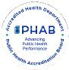

feasibility of solutions, and availability of resources. This process ensured that shared priorities reflected both data and community voice. Yates County Public Health shared its prioritization matrix process with the Choose Health Yates committee, which consisted of small group community members.
The final CHA will be made available to the public through several platforms including posting on the Yates County Public Health website, sharing infographics on social media (Facebook, Instagram), distribution to the Yates County Legislature and community partners, and discussion on local radio (WFLR).
County Health Rankings
The County Health Rankings & Roadmaps program highlights differences in community health within and across communities. This ranking system assesses several variables, including community conditions, population health and well-being, social and economic factors, and built environment.
Yates County is ranked above the national and state averages for health and well-being (Figure Y3). This measure reflects the overall quality of life and the ability to thrive within a community. Variables affecting physical, mental, spiritual, and social well-being are included in this measure. This ranking signals that Yates County is a community that supports its residents and provides the foundation for living, growing, and succeeding.
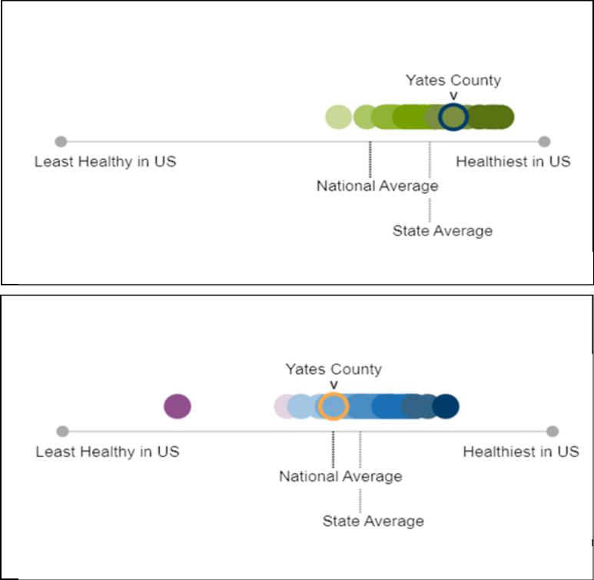
Figure Y3: Health and Well-Being (2025)
Source: County Health Rankings
Figure Y4: Community Condifions/SDOH (2025)
Source: County Health Rankings
However, rankings of community conditions and the Social Determinants of Health fall below the state average and are roughly comparable to the national average (Figure Y4). The Social Determinants of Health refer to the non-medical factors that influence individual and community health outcomes, including economic stability; access to and quality of education; access to and quality of healthcare; neighborhood and built environment; and social and community context. This ranking signifies that, despite the overall quality of life exceeding state and national averages, there is still work to be done to address underlying factors affecting community health outcomes.
Page 78 Yates County

Community Health Assessment – Yates County

New York State Prevention Agenda 2025-2030
Table Y2 identifies the New York State Department of Health (NYSDOH) Prevention Agenda domains and priorities (see Regional Chapter for further information). The “Community Partners” column shows the percentage of partners in the CPA who expressed that each domain is either very important or important to address, or who are unsure of its importance. Bolded priorities are those Yates County has chosen to prioritize during this CHA cycle.
Table Y2: NYS Prevention Agenda
Domain | Priorities | Community Partners
- Economic Stability | Poverty | 80% very important 10% important  10% unsure
- Economic Stability | Unemployment | 80% very important 10% important  10% unsure
- Economic Stability | Nutrition Security | 80% very important 10% important  10% unsure
- Economic Stability | Housing Stability and Affordability | 80% very important 10% important  10% unsure
- Social and Community Context | Anxiety and Stress | 40% very important 40% important 20% unsure
- Social and Community Context | Suicide | 40% very important 40% important 20% unsure
- Social and Community Context | Depression | 40% very important 40% important 20% unsure
- Social and Community Context | Primary Prevention, Substance Misuse, and Overdose Prevention | 40% very important 40% important 20% unsure
- Social and Community Context | Tobacco/ E-cigarette Use | 40% very important 40% important 20% unsure
- Social and Community Context | Alcohol Use | 40% very important 40% important 20% unsure
- Social and Community Context | Adverse Childhood Experiences | 40% very important 40% important 20% unsure
- Social and Community Context | Healthy Eating | 40% very important 40% important 20% unsure
- Neighborhood and Built Environment | Opportunities for Active Transportation and Physical Activity | 40% very important 40% important 20% unsure
- Neighborhood and Built Environment | Access to Community Services and Support | 40% very important 40% important 20% unsure
- Neighborhood and Built Environment | Injuries and Violence | 40% very important 40% important 20% unsure
- Health Care Access and Quality | Access to and Use of Prenatal Care | 50% very important 40% important  10% unsure
- Health Care Access and Quality | Prevention of Infant and Maternal Mortality | 50% very important 40% important  10% unsure
- Health Care Access and Quality | Preventive Services for Chronic Disease Prevention and Control | 50% very important 40% important  10% unsure
- Health Care Access and Quality | Oral Health Care | 50% very important 40% important  10% unsure
- Health Care Access and Quality | Preventive Services | 50% very important 40% important  10% unsure
- Health Care Access and Quality | Early Intervention | 50% very important 40% important  10% unsure
- Health Care Access and Quality | Childhood Behavioral Health | 50% very important 40% important  10% unsure
- Education Access and Quality | Health and Wellness Promoting Schools | 60% very important 30% important  10% unsure
- Education Access and Quality | Opportunities for Continued Education | 60% very important 30% important  10% unsure

Page 79 Yates County

Community Health Assessment – Yates County

Domain: Economic Stability
Economic stability is influenced by each of the priorities listed above: poverty, unemployment, nutrition security, and housing stability and affordability. Socioeconomic disparities are closely linked to poor health, affecting physical, mental, and educational outcomes. Children and older adults are especially vulnerable to these adverse effects.
Unemployment and underemployment contribute to major health inequities. Unemployed individuals face greater barriers to health care and experience worsening health as unemployment persists. Employment challenges stem from shifts in the labor market, wage stagnation, and weakening labor protections.
Food insecurity disproportionately affects low-income households, people with less education, and those who are unemployed. Access to affordable, nutritious food is vital for preventing chronic disease and supporting healthy development. Many communities, especially rural and low-income communities, lack full-service grocery stores and rely on costly convenience outlets with limited healthy options.
Housing insecurity further undermines health by increasing stress, reducing stability, and increasing exposure to unsafe and/or unhealthy environments. Low-income families and older adults face the greatest housing burdens and associated health risks.
Priority: Poverty
Poverty can strain nearly every aspect of community life, from housing stability to healthcare access,
transportation, and nutritious food. Families facing financial hardship often struggle to meet basic needs, and limited resources can make it difficult for them to find sustainable pathways out of poverty.
Map Y2 shows the distribution of poverty across Yates County³⁵. An estimated 14.1% of residents live in poverty, with the highest concentrations located in the southern part of the county, particularly around Dundee, Himrod, and Dresden. Poverty levels in Yates County have been rising steadily since 2018, and by 2022, the county’s rate exceeded the statewide average. Among children under 18, 23% live in
poverty, which is above the New York State average of 19% but an improvement from 26% in 2019. For adults age 65 and older, 12.5% live in poverty, just under the state average of 12.7%. However, the poverty rate for older adults has increased significantly - up 51% since 2018.
³⁵ Source: Common Ground Health, 2024. https://commongroundhealth.org/insights/county‐health‐statistics
Page 80 Yates County

 | Community Health Assessment – Yates County | 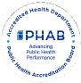

Map Y2: Overall Poverty Rate in Yates County
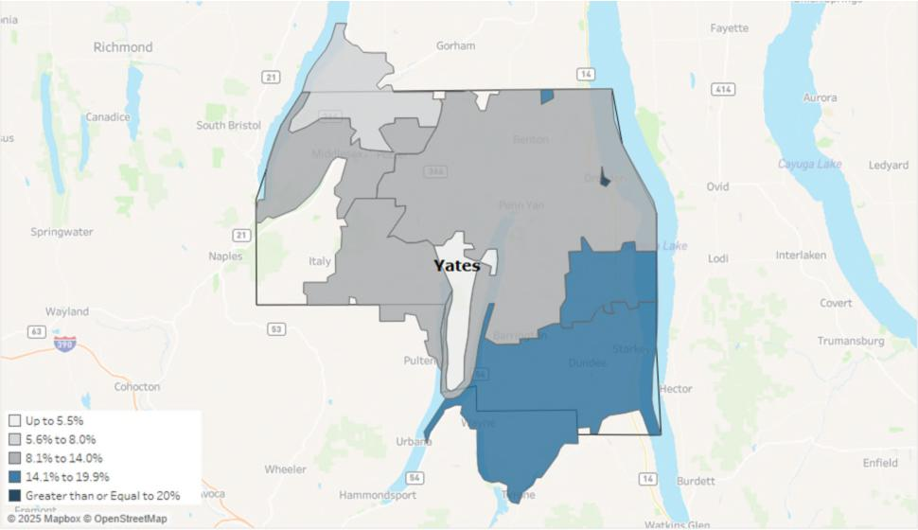
Priority: Unemployment
The unemployment rate in Yates County was 4.5% in April 2025. Figure Y5 notes the trend in unemployment rates recorded each January from 2019 to present. According to US Census data from 2023, the top three employment sectors in Yates County are (1) educational services, health care and social assistance (24.7%); (2) manufacturing (14.5%); and (3) retail trade (11.9%).
Source: Bureau of Labor Statistics
Figure Y5: Unemployment Rate in Yates County as reported in January of each year
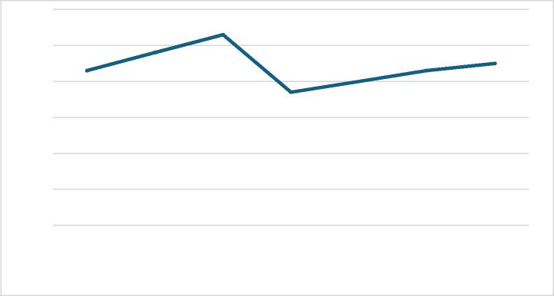
6.00%
5.30%
4.80%
4.30%
4.50%
4.30%
4.00%
3.70%
3.00%
2.00%
1.00%
0.00%
2019 2020 2021 2022 2023 2024 2025
5.00%
4.00%
2023 U.S Census data indicate that the median household income in Yates County is $67,521, lower than the state median of $85,820. The gross hourly wage needed for a family of one adult and two children to cover household expenses gradually increased from $38.36 in 2021 to $51.14 in 2024. This figure
Page 81 Yates County

remains lower than the 2024 state value of $61.75 but higher than those of neighboring counties, Seneca, Steuben, and Schuyler.
Community Health Assessment – Yates County

Priority: Nutrition Security
It is important to note the definitional difference between nutrition and food security for data relevance. The New York State Prevention Agenda defines food security as having access to enough food. When a person reports they are food insecure, they recognize they have limited or uncertain access to food due to limited economic resources. Map Y3 shows the food insecurity rates of Yates and contiguous counties. On the other hand, nutrition security looks not only at food access, but also at consistent and equitable access to healthy, safe, affordable food. New York State has transitioned to focus on nutrition insecurity data, but food insecurity data remains relevant to ensure equitable access of food exists across all parts of the state.
Nutrition and food insecurity can lead to higher rates of chronic disease, poor child development, and overall diminished health and well-being. When families lack consistent access to affordable and nutritious food as well as community systems, such as healthcare and schools, they may feel the strain of long-term inequities, resulting in poorer health outcomes.
Approximately one in four adults (24.9%) in New York State experience food insecurity. Having access to affordable, healthy food helps reduce hunger and prevent chronic disease. Food and nutrition security rates may be influenced by several factors, including income, employment, race/ethnicity, and disability.³⁶ Areas with higher poverty rates (Dundee, Himrod, and Dresden) will likely face greater challenges in accessing healthy, safe, and affordable food.  Additionally, children are disproportionately impacted by food insecurity. Feeding America closely monitors annual food insecurity and food costs using real-time data. In Yates County, approximately 950 children are food-insecure, | Map Y3: Food Insecurity Rate
 | 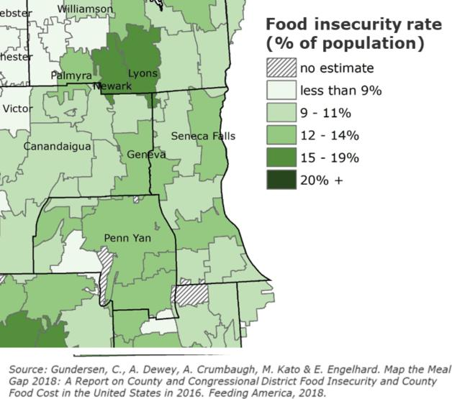

³⁶ Source: Healthy People 2030, 2025
Page 82 Yates County

and the overall food insecurity rate for children is 16.9%, which is lower than the New York State rate of 19.0%.³⁷
 | Community Health Assessment – Yates County | 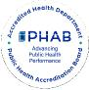

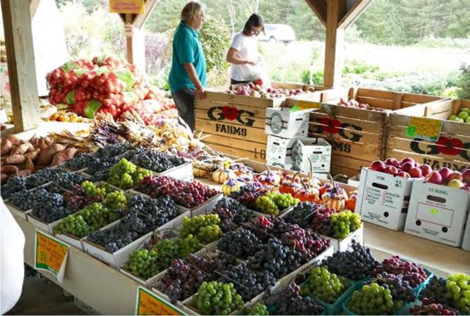 | The Food Environment Index of the  USDA Food Environment Atlas  measures how easy it is for residents to  access healthy, affordable  food, combining rates of food insecurity  and the percentage of low-income  people living far from a grocery store.  Scores range from 0 (worst) to 10  (best). Yates County’s score decreased  from 8.9 in 2018 to 8.8 in 2022 and  is nearly equal to the state average of  8.7. This indicates that, on average,  residents face barriers to healthy food  access similar to those elsewhere in the  state.
Picture courtesy of Yates Chambers of Commerce of Windy Acres Farm Market
Priority: Housing Stability and Affordability

Housing was identified as a top priority affecting community stability, access to basic needs, and overall health and well-being in Yates County. Housing instability and a lack of affordable options can leave families struggling to meet basic needs, often forcing them to choose between housing costs, food, and healthcare. When stable housing is out of reach, communities experience higher rates of homelessness, overcrowding, and financial stress, which can undermine overall health, safety, and economic growth.
In 2021, 13% of households in Yates County experienced at least one of the following major housing problems: overcrowding, high housing costs, and/or lack of kitchen or plumbing facilities. This is well below the state average of 23% and reflects a 13% improvement since 2017. Severe housing cost burden has remained stable since 2021, with only 12% of households spending half or more of their income on housing, compared to 19% statewide. This represents an 8% improvement since 2019, when 13% of households were spending half or more of their income on housing. However, this progress is still concerning given that 14% of the population lives in poverty, leaving many households with very limited resources to meet basic needs beyond housing.³⁸
A recurring issue raised by focus groups was the increasing use of rental properties for tourism, which drives up costs and reduces availability for residents. Homeownership rates in the county have decreased from 80% in 2019 to 77% in 2023, indicating that fewer residents live in owner-occupied residences.³⁹ According to data from the 2023 American Community Survey 5-Year Estimates, Yates County has a total of 13,143 housing units, of which 4,048 units are vacant. Vacant housing includes
³⁷ Source: Feeding America, 2023: https://map.feedingamerica.org/county/2023/child/new-york/county/yates
³⁸ Source: U.S. Census Bureau, 2025
³⁹ Source: County Health Rankings & Roadmaps, 2025
Page 83 Yates County

 | Community Health Assessment – Yates County | 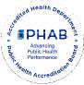

units with no occupants at the time of the census, temporarily occupied residences such as short-term rentals and vacation homes, and new units not yet occupied. As of 2025, Yates County has 615 short-term rental properties (i.e., residences available for rent up to 30 days) registered with the Department of Finance. ⁴⁰
According to the American Community Survey 5-year Estimates, the 2023 vacancy rates (defined differently from the census) indicated the housing inventory available for long-term rent or sale were 2% for rental-occupied units and 1% for homeowner-occupied units. Concerns over a shortage of affordable middle-income housing and reasonably priced rental properties were also discussed in focus groups. Approximately 26% of renter-occupied households contribute more than 35% of their household's gross income towards rent, indicating a significant cost burden for many residents. Furthermore, the average rent in Yates County was $802 in 2023, which was lower than in neighboring counties. However, through discussions of lived experiences with focus groups, the cost of rent in 2025 is significantly higher than that of 2023.
Residents also raised the issue of lack of local senior housing and assisted living options that support aging in place. According to the Pro Action Office for the Aging, Yates County is home to six independent living homes and three higher-level care facilities for older adults. Admission to these facilities often involves strict eligibility requirements and higher costs for individuals and families. The ALICE Household Monthly Survival Budget estimates that a single senior needs $2,770/month to cover basic needs. New York State reports that the average cost of long-term care is between $5,500 and $13,000 per month, a significant contrast to what most older adults can afford.⁴¹ As a result, many local seniors are compelled to relocate to more suitable living arrangements elsewhere.
Focus group participants expressed a strong connection to their community and a desire to remain in Yates County as they age. However, barriers such as lack of in-home assistance, high costs, and transportation challenges were noted as reasons older adults often seek alternative living accommodations. Aging in place is associated with individual and community benefits, including improved life satisfaction and increased volunteerism.⁴² With nearly a quarter of the population aged 65 and older, concerns about the availability of aging in place options are likely to grow in the coming years.
Economic Stability Domain Summary: The percent of people living in poverty in Yates County has shown a steady increase since 2018, rising from 11.4% (2018) to 14.1% (2023). This same upward trend in poverty rates can also be seen among populations who are 65 and older in Yates County. Employment indicators are strong, with lower unemployment, however, the gross hourly wage needed to sustain a family of four remains below the median household income. Nutrition security has improved, and the county’s overall food environment now aligns with the state average. Homeownership rates have declined, and significant cost burdens persist, especially for vulnerable populations like the aging and low-income residents.
⁴⁰ Source: Yates County Document Center: https://www.yatescountyny.gov/DocumentCenter/View/8733/Yates-County-Registered-STR-Properties?bidId=
⁴¹ Source: New York State Department of Financial Services, 2023
⁴² Source: Rural Health Information Hub, 2019
Page 84 Yates County

 | Community Health Assessment – Yates County | 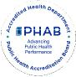

Domain: Social and Community Context
Good mental health is essential for daily functioning, healthy relationships, and resilience. Stress and
anxiety can harm the body, contribute to conditions like depression and substance misuse, and increase the risk of early death.
Nationally, suicide remains a major public health concern. Many high school students report suicidal thoughts or attempts, and death by suicide is still a leading cause of death among young people nationally.
Depression affects more than one in five New Yorkers each year and significantly disrupts daily life.
Certain groups face higher risks due to chronic stress, trauma, and systemic inequities. Many people still struggle to access or seek treatment because of stigma or limited services.
Substance use and overdose deaths continue to pose serious challenges in the state. Early alcohol and drug use, high availability of substances, and social norms contribute to risk.
Commercial tobacco use remains a leading cause of preventable illness and death, with significant disparities driven by targeted marketing, especially in low-income and minority communities. Excessive alcohol use is common and leads to thousands of deaths and billions of dollars in economic costs for New York State each year. Availability, low pricing, and targeted marketing contribute to unequal burdens among certain populations.
Adverse childhood experiences (ACEs) are events in childhood, such as abuse or neglect, that negatively impact long-term health. These experiences significantly increase the risk of chronic disease, mental health problems, and substance misuse later in life.
Healthy eating is vital for preventing chronic disease, yet many New Yorkers fall short of fulfilling the recommended intake of fruits, vegetables, and other nutrients.
Priority: Anxiety and Stress
Data from the BRFSS indicates that the percentage of adults reporting 14 or more days of poor mental health per month (age-adjusted) increased from 14% in 2018 to 19% in 2022, above the NYS average of 16%. Experiencing 14 or more days of poor mental health in a month is strongly linked to worse overall health outcomes. When this percentage rises, as it has in Yates County, it can signal increasing stress, depression, or anxiety in the community, which may lead to higher rates of chronic disease, substance use, reduced productivity, and greater demand for mental health and medical services.
When comparing Yates County to New York State as a whole and other counties, Yates residents reportedly experience poor mental health at a greater rate (see Map Y4). According to County Health Rankings and Roadmaps, Yates County residents, on average, report 6.1 poor mental health days out of the last 30 days. Comparatively, surrounding counties report only 5.7 poor mental health days out of the last 30. This elevated rate suggests that residents may struggle more with daily functioning, decision-
Page 85 Yates County

 | Community Health Assessment – Yates County | 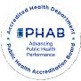

making, and maintaining healthy behaviors, ultimately affecting both individual well-being and community health.⁴³
Map Y4. Poor Mental Health Days in New York
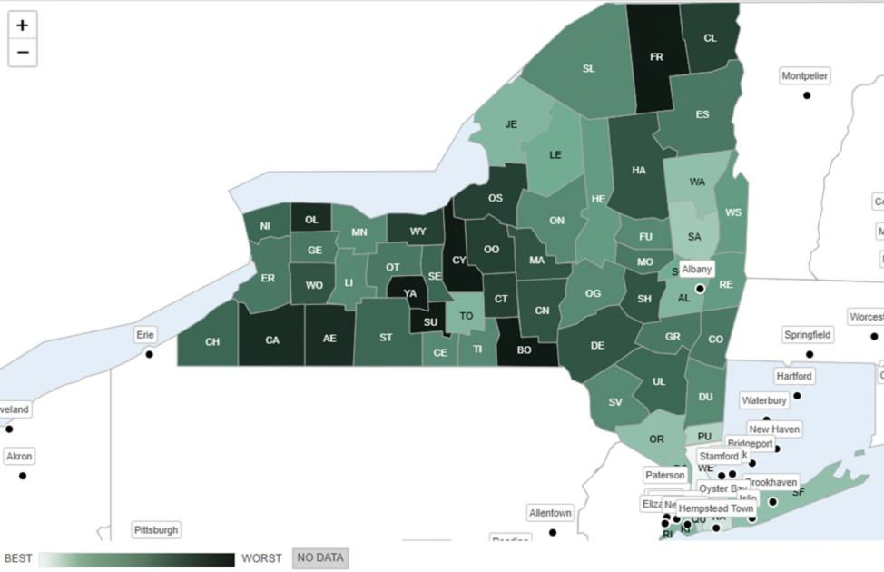
Source County Health Rankings and Roadmaps
Mental health was a common concern across all ages and backgrounds, with many focus group respondents citing a range of compounding factors. Youth cited bullying and cyberbullying as key contributors, while older adults noted the rural community and social isolation as important factors. A shortage of mental health providers and ongoing barriers to seeking help, especially for marginalized groups such as older adults and the LGBTQ+ community, were cited as cause for concern. Other suggested root causes include an increased focus on social media and technology, stigma around receiving mental health care, and the effect of the high cost of living on quality of life.
Residents value organizations that facilitate social and personal connections, such as Pro Action Office for the Aging, community centers, health organizations, churches, libraries, and The Living Well. Many focus group participants commented on the wide range of community supports available and expressed gratitude for their work in the community. Volunteerism and peer support are seen as vital for
⁴³ Source: Strine TW, Balluz L, Chapman DP, Moriarty DG, Owens M, Mokdad AH. Risk behaviors and healthcare coverage among adults by frequent mental distress status, 2001. Am J Prev Med. 2004 Apr;26(3):213-6. doi: 10.1016/j.amepre.2003.11.002. PMID: 15026100.
Page 86 Yates County

Community Health Assessment – Yates County

community outreach and engagement, with many residents expressing a desire for more opportunities to connect with the various populations of Yates County.
Despite recognizing opportunities and a desire to grow community connections, isolation remains a frequent theme, particularly in the aging community. Beyond social connections, residents request more chances for mentorship and regular information sharing. There is a desire for more educational programming on topics such as chronic disease prevention and resource awareness. Community members feel that implementing such programs may assist in bringing together the community and removing the sense of isolation to better support and improve the overall quality of life in the community.
Priority: Suicide
The National Center for Health Statistics notes that in 2022 the suicide rate in the county was 15.0 per 100,000 people, nearly double the NYS average of 8 per 100,000 people. This represents a 36% increase in deaths due to suicide since 2018. In contrast, the suicide rate among youth (15-19 years of age) was 0.0 per 100,000 people in 2022, which is lower than the NYS average of 5.6 and has remained unchanged since 2015. The rate of youth suicide remains a bright spot, suggesting strong protective factors and support systems for adolescents in the county. However, the substantial increase in deaths due to suicide among adults indicates that expanded mental health resources are needed to better support this population.
Rising suicide rates signal worsening mental health and increasing levels of stress, trauma, or unmet behavioral health needs in the community. When the county’s overall suicide rate exceeds the state average, it suggests that residents may face greater barriers to timely mental health care, social support, or crisis intervention. Higher suicide rates also have wide-reaching impacts, causing strain to families, schools, healthcare systems, and communities. It also potentially indicates deeper issues such as isolation, substance use, economic stress, or limited access to mental-health services.⁴⁴
Priority: Depression
In Yates County, the age-adjusted percentage of adults reporting a depressive disorder in 2021 was 24.3%. This is greater than the NYS rate of 18.7% in the same year and has increased 40% since 2016. Elevated rates of depression are associated with increased risk of chronic diseases, substance use, social isolation, and suicide, as well as greater demand for mental health services. When the county rate is both higher than the state's average and rising, it indicates that many residents may not be receiving adequate treatment or support, contributing to long-term health disparities and strain on local healthcare and social services.⁴⁵
Focus groups identified several root causes of high depression rates in the area. Insights suggested that decreased resiliency, increased reliance on social media and technology, and the lingering mental health impacts of the pandemic have all played significant roles. Participants also identified broader societal influences, such as the stigma around receiving care, the high cost of living, and career burnout, as
⁴⁴ Source: https://www.cdc.gov/suicide/facts/index.html
⁴⁵Source: National Institute of Mental Health: https://www.nimh.nih.gov/health/publications/chronic-illness-
mental-health?utm_source=chatgpt.com
Page 87 Yates County

Community Health Assessment – Yates County

additional influences on mental health. Focus groups did recognize that the screening process for mental health concerns has greatly improved, potentially identifying a higher number of cases compared to the past. However, it was consistently noted that the infrastructure of mental health care is lacking in the area, contributing to difficulty in receiving care when needed.
The community emphasized that expanding opportunities for social support and community engagement would improve mental health across the county. It is also understood that geographic factors, such as the rural landscape of Yates County, can increase the risk of social isolation and contribute to depression rates. Considering this, participants stressed the importance of pursuing creative solutions that build on community strengths to better support those experiencing mental distress.
Priority: Primary Prevention, Substance Misuse, and Overdose Prevention
Since 2021, there has been a sharp decrease in overdose deaths involving any drug in Yates County, decreasing from a crude rate of 20 deaths per 100,000 population in 2021 to 8.2 deaths per 100,000 in 2022. Yates County also has a lower overdose death rate compared to the Finger Lakes Region as a whole. Opioids, opioid pain relievers, and synthetic opioids other than methadone saw a dramatic decline in overdose deaths. However, overdoses involving cocaine in Yates County have increased from a zero crude rate per 100,000 population in 2020 to 8.2 in 2022. This data supports anecdotal information from the community regarding a recent shift to increased use of cocaine and methamphetamine.
Focus groups expressed concern about the connection between mental health and substance use, remarking that poor access to mental health providers in the area may affect substance use rates. Individuals with lived experience noted the effect that social isolation has on substance use and mental health, adding that disciplinary actions such as revoking driver’s licenses intensify feelings of isolation. Yates County has one mental health provider for every 840 residents, more than three times the NYS ratio (260:1), indicating that Yates County has roughly two-thirds fewer available providers than the state. According to the Substance Abuse and Mental Health Administration (SAMHSA), a diagnosis such as anxiety or depression increases an individual’s risk for substance use. With limited access to mental health support, Yates residents with existing mental health concerns may be at a higher risk of substance use than those in surrounding counties.⁴⁶
The community recognized Yates County’s efforts to address the opioid epidemic and the resulting progress. Since 2023, the county has recorded 269 Naloxone training sessions, 798 individuals trained in Naloxone distribution, and 495 Naloxone kits distributed. Despite the shifting trends in substance use, maintaining these initiatives is vital to prevent opioid-related deaths. Furthermore, the growing use of stimulants presents continued risks as these substances may be contaminated with high-risk drugs such as fentanyl. People who use substances consequently remain vulnerable to opioid-related injury or death, regardless of the type of substance being used. Ongoing community education about overdose prevention and substance use risks is critical in continuing the positive trends currently being experienced.
⁴⁶ Source: Substance Abuse and Mental Health Administration (SAMHSA)
Page 88 Yates County

Community Health Assessment – Yates County

Priority: Tobacco/E-cigarefte and Alcohol Use
According to data from the BRFSS, the percentage of adults who are current smokers (age-adjusted) has declined slightly since 2018 from 19% to 18% in 2022, which still remains above the New York State average of 12%. In contrast, the percentage of adults reporting binge or heavy drinking quickly rose from 16% (2021) to 22% (2022), higher than the state average of 20%. Data on e-cigarefte use among adults in the county are not available, but rates of vaping by middle and high school students are available. In 2022, 3.9% of middle school students reported vaping within the last 30 days, and 5.3% of high school students reported that they vaped within the last 30 days.⁴⁷
Both smoking and excessive alcohol use are major risk factors for chronic diseases, including heart disease, cancer, liver disease, and respiratory illnesses. Higher rates of these behaviors in the community increase the burden on healthcare systems, contribute to preventable morbidity and mortality, and can reduce quality of life. Persistent smoking above the state average and rising binge or heavy drinking indicate that residents may face elevated long-term health risks and that targeted prevention and intervention efforts are needed.⁴⁸
Priority: Adverse Childhood Experiences
Adverse Childhood Experiences (ACEs) are the emotional and physical circumstances one experiences before age 18. These may include neglect, sexual abuse, parental divorce, mental illness, and/or substance abuse in the home, and exposure to violence. ACEs impact individuals well into adulthood and may result in long-term physical and mental health problems. The age-adjusted percentage of adults with two or more adverse childhood experiences decreased from 29.4% in 2016 to 24.8% in 2021, below the current NYS average of 40.5%.
ACEs have long-lasting effects on physical, mental, and behavioral health. Experiencing two or more ACEs increases the risk of chronic diseases, mental health disorders, substance use, and social challenges well into adulthood. Even though the county’s rate of adults with two or more ACEs has decreased to 24.8%, this still represents a substantial portion of the population at higher risk for long-term health problems and increased healthcare and social service needs.⁴⁹
Priority: Healthy Eating
From 2016 to 2021, the percentage of adults who eat fruits daily (63.4%) increased by 16%, and those who eat vegetables daily (70.2%) decreased by 4%.⁵⁰ An interesting dichotomy arose in focus groups where some individuals stated it was difficult to incorporate healthy eating into their routines, while others said it was very easy. Approximately 1 in 5 NYS adults consume at least one sugar-sweetened
⁴⁷ Source: Yates County Evalumetric Youth Survey Report, 2022
⁴⁸ Source: Kim Y. The effects of smoking, alcohol consumption, obesity, and physical inactivity on healthcare costs: a longitudinal cohort study. BMC Public Health. 2025 Mar 5;25(1):873. doi: 10.1186/s12889-025-22133-4. PMID: 40045251; PMCID: PMC11881326.
⁴⁹ Source: hftps://www.cdc.gov/aces/about/index.html
⁵⁰ Source: Behavior Risk Factor Surveillance System (BRFSS), 2021
Page 89 Yates County

Community Health Assessment – Yates County

beverage daily.⁵¹ In Yates County, the percentage of adults with annual incomes below $25,000 who drink one or more sugar-sweetened beverages has increased from 10.7% in 2016 to 17.1% in 2018.
Low consumption of fruits and vegetables and high intake of sugary drinks contribute to poor nutrition, obesity, diabetes, heart disease, and other chronic conditions. Addressing sugar-sweetened beverage consumption is important because studies have found that frequently drinking these beverages is linked to weight gain, tooth decay and cavities, heart disease, stroke, and type 2 diabetes in adults.⁵² When access to healthy foods is limited, especially for lower-income populations, residents are more likely to develop diet-related illnesses, increasing healthcare costs and reducing overall community health and quality of life.⁵³
Social and Community Context Domain Summary: Yates County is experiencing significant mental and behavioral health challenges. Rates of poor mental health, depression, and suicide all exceed state averages, signaling rising stress, untreated mental health needs, and growing demand for services. Substance use concerns are also increasing, with sharp rises in overdose deaths involving non-opioid drugs, despite overall rates remaining below the New York State average. Risk behaviors such as smoking and heavy drinking continue to contribute to preventable health problems, while mixed trends in healthy eating and persistent impacts of adverse childhood experiences further underscore ongoing vulnerabilities. Together, these indicators highlight mental health, substance use, and related social factors as critical priorities for improving community well-being.
Domain: Neighborhood and Built Environment
Regular physical activity offers wide-ranging benefits at every age. It lowers the risk of major chronic diseases, including heart disease, stroke, type 2 diabetes, and several cancers, and supports stronger bones and muscles, better sleep, improved mental health, and longer life expectancy.
Access to physical activity is not equal. Structural barriers such as unsafe neighborhoods, limited accessible facilities, or environments not designed for diverse needs shape how people can be active. Social factors like income, education, community support, and cultural attitudes also influence activity levels. Physical environment features, including parks, safe sidewalks, bike lanes, and walkable neighborhood layouts, also play a major role.
Active transportation, such as walking or biking, to reach daily destinations can help integrate physical activity into everyday routines, but it requires safe, well-connected routes and nearby destinations.
Injuries are a leading cause of premature death. Motor vehicle crashes, falls, and overdoses are major contributors, with disparities affecting racial and ethnic minorities, older adults, and workers in high-risk occupations.
Priority: Opportunities for Active Transportation and Physical Activity
Focus groups report mixed experiences related to community amenities and social infrastructure
supporting health. As of 2024, the percentage of the population with adequate access to physical activity
⁵¹ Source: Behavior Risk Factor Surveillance System (BRFSS), 2021
⁵² Source: Behavior Risk Factor Surveillance System (BRFSS), 2021
⁵³ Source: https://www.cdc.gov/nutrition/php/about/index.html
Page 90 Yates County

Community Health Assessment – Yates County

locations is 44%. This has remained stable since 2022 but is well below the NYS average of 93%. Some residents praise the available nature trails and recreational spaces for opportunities to maintain health, while others cite a lack of such opportunities in more rural areas. Many focus group respondents note that the Village of Penn Yan has adequate access to amenities that promote health, such as the Yates Community Center. Participants also observed that agencies such as Yates County Public Health and the Yates Office for the Aging (OFA), administered by Pro Action of Steuben and Yates, Inc., provide ample support to the community as a whole.
However, these positive experiences are not shared equally throughout the county. Many respondents comment on a lack of health-supporting community amenities and social opportunities. One focus group participant noted that “if you live in Dundee...there is nothing to access inside where people can have a social network”. Several other community members supported the notion that maintaining health outside of larger villages and towns is difficult, particularly in areas such as Branchport and Potter, which “need more resources for health”. This is reflected in data from 2022, when 27% of adults reported no leisure-time physical activity. This is slightly higher than the NYS average of 25% and an increase of 23% from 2021.⁵⁴ A frequently expressed suggestion across multiple focus groups was the need for a community pool to help address gaps in health-promoting amenities. The disparity between more populated areas and their more rural counterparts emphasizes an opportunity to support recreation, social connection, and safety measures in less populated communities.
In addition to concerns about health-supporting community amenities, focus group members repeatedly noted a need for improvements to county-wide built infrastructure. ⁵⁵ Many neighborhoods lack accessible sidewalks, causing pedestrians to walk in the streets. This is reflected in a poor Walkability Index (3.67 out of 20).⁵⁶The National Walkability Index accounts for the built environment’s effect on the probability that a person will walk as a mode of transportation and reflects street intersection density, proximity to transit stops, and land-use diversity.⁵⁷ The low walkability index in Yates County raises concern for the 13% of residents without access to a vehicle, who may face transportation challenges. Residents recognized improvements made, specifically in Dundee, but would like to see these projects continued.
Other concerns, such as speeding, poor signage, and unsafe roads, especially near playgrounds and schools, are widely noted. Road and sidewalk safety are compounded by increased traffic during the tourist season and horse-and-buggy use from the large Mennonite community. Many residents express the need for an allotted bike and/or horse and buggy lane to improve safety for all when traveling. Overall, residents express a strong desire for traffic calming, better signage, and safer pedestrian environments.
Accessibility for those with mobility differences and the need for assistive devices was raised as a concern. Residents noted accessibility is limited by a lack of ramps and safe infrastructure. Several anecdotes were shared about experiences with limited accessibility, especially in downtown Penn Yan. Limited accessibility is compounded by poor lighting, poorly maintained sidewalks and roads, and a lack
⁵⁴ Sources: U.S. Census, County Health Rankings, EPA Office of Community Revitalization
⁵⁵ Source: EPA Office of Community Revitalization, 2021
⁵⁶ Source: National Walkability Index Methodology and User Guide
⁵⁷ Source: EPA Office of Community Revitalization, 2021
Page 91 Yates County

Community Health Assessment – Yates County

of accessibility buttons for doors. Residents collectively express a desire for safer, more inclusive, and better lit areas for activity. Access to safe spaces for physical activity, transportation options, and walkable environments directly affects residents’ ability to maintain regular exercise. Low physical activity is linked to higher risks of obesity, heart disease, diabetes, mental health issues, and overall premature mortality. Limited walkability and inadequate access to activity locations or transportation can create barriers to healthy lifestyles, contributing to long-term health disparities in the community.⁵⁸
Priority: Access to Community Services and Support
The Social Vulnerability Index (SVI) is a composite measure reflecting factors such as poverty, unemployment, housing, disability, minority status, and access to transportation. It is used to identify communities that may need additional support during emergencies or public health interventions. SVI is measured from 0 to 1, with values closer to zero indicating less vulnerability. Yates County’s SVI was 0.6066 as measured in 2022, indicating moderate social vulnerability. This is an improvement from an SVI of 0.7377 in 2014, but a poorer score than the 2018 score of 0.4918. This fluctuation represents changes in the community, with recent progress in addressing underlying risk factors.
Civic engagement and strong community networks, such as high voter participation and membership in organizations, help build social cohesion, improve disaster preparedness, and support collective action during crises. Civic engagement may be measured as voting, volunteering, and participating in community events. The percentage of the voting-age population who voted in the 2020 presidential election was 56.2%. Per the National County Health Rankings, Yates County has 11.9 membership organizations per 10,000 people, representing civic, political, religious, sports, and professional organizations.¹³
Examining the SVI and civic engagement together can help us predict how the community might respond to challenges, such as a disaster or emergency. A community with a higher SVI may face a greater risk of harm and slower recovery, while a community with strong civic engagement may have more community support to respond to the challenges. Yates County’s relatively low SVI and strong civic involvement suggest it has a solid foundation to respond to community challenges, though vulnerabilities still exist for certain populations.⁵⁹
Priority: Injuries and Violence
Unintentional injury death is the third leading cause of death in Yates County. Death resulting from firearms and motor vehicle crashes are above state rates and increasing. Overall, injury and violence-related deaths are a growing threat to community health and safety. Table Y3 details age-adjusted injury and violence death rates per 100,000 population.
⁵⁸ Source: https://www.who.int/news-room/fact-sheets/detail/physical-activity
⁵⁹ Source: County Health Rankings.
Page 92 Yates County

Community Health Assessment – Yates County

Table Y3. Rates of Age-Adjusted Cause of Death (measured per 100,000 population)
Incidence % change from Definition
Rate (2022) 2018
Unintentional Injury Death | 80.3 | +267% | Injury resulting in death that are unplanned and  often  preventable (i.e., poisonings, vehicle accidents,  drowning, fires, farm equipment, falls, etc.)
Death due to Firearms | 9 | No baseline data  available | Death caused by gunshot wound or penetrating  injury from weapon that uses gun powder
Intentional Injury | 79 | +18% | Death caused by physical harm that was  inflicted purposefully
Deaths by suicide (Age- adjusted) | 15 | + 36% | Death caused by injuring oneself with the  intent to die
Death due to Motor vehicle crash | 13 | +44% | Death resulting from car accident upon impact  or death occurs within 30 days of accident

Rates above state averages and increasing trends indicate rising risk factors, such as unsafe environments, mental health challenges, substance use, and lack of safety interventions. High injury and violence-related death rates also strain healthcare systems, emergency services, and social support networks, highlighting the need for targeted prevention, education, and community safety initiatives.⁶⁰
Neighborhood and Built Environment Domain Summary: Residents in Yates County face limited access to physical activity spaces, low walkability, and moderate social vulnerability, creating additional barriers to healthy living. Although some indicators, such as reduced ACEs and stable youth suicide rates, show progress, the overall pattern highlights significant and growing needs across mental health, substance use, injury prevention, and community support systems.
Domain: Health Care Access and Quality
Health care access and quality are critical aspects of community health. Positive health outcomes are
influenced by access to health promotion and therapeutic interventions, which are often limited in rural areas. This includes access to primary care, specialists, and dental care.
Access to prenatal care and health of parents creates the foundation for positive health outcomes throughout life. Care is most effective when initiated early and maintained throughout pregnancy. Prenatal care reduces risks such as preterm birth, low birth weight, and maternal and infant mortality.
Routine immunizations and screenings help children stay healthy, yet access and uptake remain uneven due to systemic inequities, transportation barriers, and historical mistrust. In addition, poor oral health impacts nutrition, speech, social development, and overall well-being. Vulnerable populations, including low-income communities, face higher rates of untreated dental disease.
⁶⁰ Source: https://www.cdc.gov/injury/index.html
Page 93 Yates County

Community Health Assessment – Yates County

Emergency Department Visits and Potentially Preventable Hospitalizations
Maps Y5 and Y6 detail emergency department (ED) visits and preventable hospitalizations (hospital admissions that could have been potentially avoided with timely and effective outpatient care or disease management) by zip code in Yates County. Table Y4 highlights the difference in ED visits in Yates County compared with NYS.
Map Y5: ED Visit Rate by Zip Code
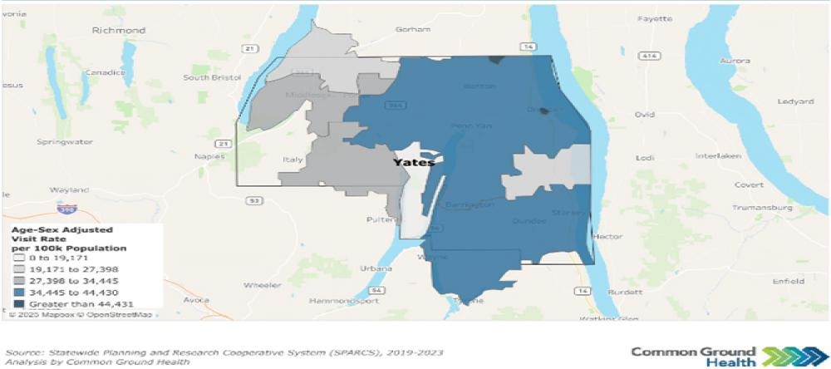
Map Y6: Preventable Hospitalizations by Zip Code
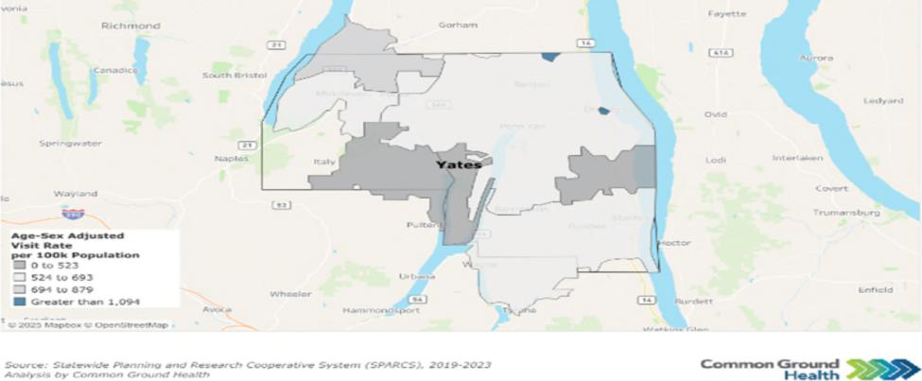
Page 94 Yates County

Community Health Assessment – Yates County

Table Y4: Emergency Department Visits
Yates County Rate NYS Rate Per
Issue % Change
Per 100,000 100,000 (from 2017)
(2023) (2023)
All ED Visits | 41,443 | 29,809 | +10%
Substance Use Disorder ED  Visits | 1,076 | 1,646 | -34%
Intentional Self Harm ED Visits | 359 | 343 | +2%
Preventable Hospitalizations (Overall) | 604 | 808 | -30%
Diabetes  Preventable Hospitalizations | 75 | 181 | -6%
Source: SPARCS
2023 data indicate mixed trends in healthcare utilization in Yates County as compared to 2017. ED visits increased by 10%, suggesting a reduced usage of primary care providers and a growing demand for urgent care services. In contrast, ED visits related to substance use disorders decreased by 34%, while visits for intentional self-harm rose slightly by 2%. Preventable hospitalizations declined by 30%, including a small 6% decrease in diabetes-related hospitalizations, which may reflect improvements in disease management, though ongoing attention to chronic disease prevention remains important.
Priority: Access to and Use of Prenatal Care
Receiving early and adequate prenatal care is important for ensuring a healthy pregnancy. Abstinence from smoking, alcohol, and illegal drug use are important indicators of appropriate prenatal care. Since 2018, Yates County has improved in all three indicators. In 2024, the percentage of birthing persons who abstained from alcohol was 100%, an increase of 2%.⁶¹ Abstinence from smoking was 86.1%, an increase of 7%, and abstinence from illegal drug use was 97.8%, an increase of 7%.⁶²
Prenatal care may be additionally measured by low live birth weights (<2,500 grams or about 5 lbs., 8 oz.) and premature births (live births before 37 weeks). Vital Records data indicate that 12.2% of births (2022 data) were preterm, an increase of 36% from 2013. Live births with low birth weights were 4% (2023 data), a decrease of 20% from 2018 and below the NYS average of 8%.
Breasffeeding infants ensures optimal nutrition and provides health benefits to both the breasffeeding parent and the child. The percentage of infants fed breast milk only or both breast milk and formula at the time of hospital discharge (2024 data) was 91.9%, an increase of 11.4% from 2019. Those who were
⁶¹ Source: National Survey on Drug Use and Health, 2024
⁶² Source: U.S. Department of Health and Human Services, Healthy People 2020, National Center for Health Statistics
Page 95 Yates County

Community Health Assessment – Yates County

fed exclusively breast milk in the hospital were 77.4%, a decrease of 1% from 2019, though greater than the NYS average of 46.7%.⁶³ This indicator has shown an upward trend, increasing since 2020.
Priority: Prevention of Infant and Maternal Mortality
Prematurity and its related conditions are the leading causes of infant mortality. In 2024, the percentage of preterm births in Yates County was 12.2%, exceeding the NYS target of 9.4% or below. Reducing premature birth rates may directly affect infant mortality rates. Data for this measure in Yates County is unavailable, likely due to the small number of infant deaths in the county.⁶⁴
Encouraging healthy habits during pregnancy can lead to healthier pregnancies and better outcomes for the child. Yates County has seen continuously improved rates in abstinence from alcohol and smoking during pregnancy. Smoking abstinence has improved from 82.5% in 2020 to 86.1% in 2024. Alcohol abstinence in pregnancy has held steady between 99% to 100% since 2020.⁶⁵
For Yates County, the maternal mortality rate has remained 0 since the 2013-2015 reporting period, until the most recent reporting period between 2020-2022, where there was one death reported. This caused a severe increase in the maternal mortality rate, rising to 102.6 per 100,000 live births.
Priority: Preventive Services for Chronic Disease Prevention and Control
Yates County, like many rural counties, faces unique challenges in health care access and support. Fewer primary care physicians, dentists, mental health providers, and non-physician health care providers pose significant barriers to care. Figure Y6 depicts the ratios of health care providers to one resident in Yates County. These ratios indicate a critical need for improved healthcare access across all sectors in Yates County.
Figure Y6: Resident to Healthcare Provider Ratio
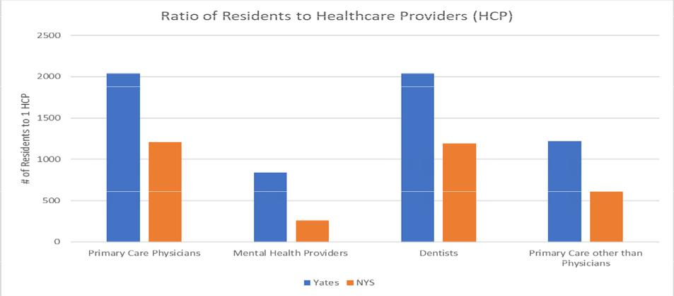
Source: County Health Rankings, Area Health Resource File/American Medical Association
⁶³ Source: NYS Prevention Agenda, Vital Records
⁶⁴ Source: NYS Prevention Agenda, Statewide Perinatal Data System, Vital Records
⁶⁵ Source: Healthy People 2030
Page 96 Yates County

Community Health Assessment – Yates County

Those who are under- or uninsured face additional obstacles to accessing care. The uninsured rate for Yates County is 10% of the population under age 65 (up 25% since 2018) and 8% of children under 19 (up 33% since 2018).⁶⁶ Yates County has a higher percentage of uninsured residents compared to NYS. It is important to note that in Yates County, the Mennonite population often chooses not to have health insurance.
The combination of high population-to-provider ratios and a sizable uninsured population creates a significant barrier to preventative care. Consequently, these individuals may not seek preventive health care services and instead present to the Emergency Department with potentially preventable conditions. Yates County residents seek care at the Emergency Department 39% more than the NYS average.⁶⁷ This may further result in increased health care costs and lost workdays, reinforcing the cycle of poverty.
Focus group participants consistently expressed concerns about high health care costs and difficulty
navigating insurance. They noted that the cost of even basic health care is unaffordable for many families and the insurance systems are difficult to navigate.
Limited transportation and its effect on access to care were common concerns among focus groups. This concern is particularly true for specialty care services such as cancer and cardiac care - two of the leading causes of death in Yates County.⁶⁸ Many individuals report struggling to get to appointments due to unreliable public transportation or a lack of personal vehicles. Moreover, many focus group members noted the need to travel an hour or more to access certain specialties. This again results in additional time loss at work and increased personal expenses for the individual.
Despite a nationwide proliferation of telehealth and telemedicine services, access to and use of broadband services in Yates County is limited. High-speed, quality internet connection enables residents to access essential services such as telehealth, online health information, appointment scheduling, and remote monitoring - tools that are vital for rural communities and those with limited transportation. Reliable internet also supports health education, emergency communication, social connection, and access to benefits and resources, helping reduce disparities and improve overall community well-being. Broadband access in Yates County, as measured in the 2025 County Health Rankings, is 78%, while NYS is 90%. The percentage of the population with no access to broadband services, meaning broadband is simply not available in their area, is 6.7% in Yates, compared to just 1.3% in NYS as a whole.⁶⁹ This creates an additional barrier to accessing alternative means of care in an already underserved area.
In lieu of access challenges, chronic disease prevention emerges as a central concern for the county. Preventing chronic diseases is essential to supporting a community’s overall health and well-being. In Yates County, conditions such as diabetes and obesity affect a significant portion of residents, including both adults and children. In 2022, the prevalence of adults over age 20 with diagnosed diabetes is 10%; in 2021, the percentage of adults with obesity was 31.8%; and in 2023, the percentage of children and adolescents with obesity was 27.9%. Each of these measures has increased steadily over the past 7–9 years, except for adult obesity, which declined slightly in 2018 before rising again in 2021.
⁶⁶ Source: County Health Rankings & Roadmaps, 2025
⁶⁷ Source: New York State Department of Health Statewide Planning and Research Collaborative, 2023
⁶⁸ Source: Vital Statistics Data, 2024
⁶⁹ Source: County Health Rankings & Roadmaps, 2025
Page 97 Yates County

Community Health Assessment – Yates County

Monitoring and managing risk factors such as high blood sugar and blood pressure is critical for addressing chronic disease trends in Yates County. The percentage of adults aged 45+ who had a test for high blood sugar or diabetes within the past three years increased from 54.96% (2018) to 69.6% (2021), exceeding the state average of 63.8%. Among adults aged 45+ with a household income below $25,000, the percentage who had the same tests decreased from 58.9% in 2016 to 48.7% in 2018.⁷⁰ The prevalence of high blood pressure in adults 18+ increased 4% from 2017 to 30.1% in 2021.⁷¹ These patterns underscore the importance of expanding access to preventative screening for chronic disease risk factors, particularly for low-income adults who are less likely to receive regular screening.
Mammograms and colorectal cancer screenings have also been shown to be effective preventative care measures. The completion of preventive services shows mixed trends based on 2022 data. Mammogram rates among women ages 50–74 have steadily increased from 73% in 2018 and 74.1% in 2020, to 75.5% currently. The percentage of female Medicare enrollees who receive a mammogram screening has also improved since 2018, increasing from 52% to 55% in 2022. However, the prevalence of colorectal cancer screening among Yates County residents has decreased by 13% from 2020 to 2022, dropping from 72.3% to 63.2%.⁷¹ These trends highlight the need for targeted interventions to promote completion of preventative measures and reduce long-term health risks.
Priority: Oral Health Care
According to County Health Rankings, Yates County has a dentist-to-population ratio of 2,220 to 1. In 2019, 62.6% of adults had a dental visit in the past year, a 5% decrease since 2014 and below the New York State average of 71.3%.
Access to oral health care is even more limited for Medicaid enrollees. The only Medicaid-accepting dental provider in Yates County is Finger Lakes Community Health, with clinics in Penn Yan and Dundee. The percentage of Medicaid-enrolled adults with at least one dental visit remained above 30% between 2014 and 2019. However, in 2020, this percentage dropped to 25.9%, a 23% difference from the year prior. Since 2020, the percentage of dental visits for adult Medicaid enrollees has continued to fall below the state average of 31.1%, underscoring concerns about oral health care availability.
Access to dental care for children is similarly limited. In 2023, Finger Lakes Community Health opened a school-based dental clinic in Penn Yan, providing preventive dental care. Trends for Medicaid enrollees aged 2-20 years who had at least one dental visit within the last year are similar to those of adults. Between 2015 and 2017, this percentage remained above state average, with 49% of Yates County Medicaid enrollees ages 2-20 completing at least one dental visit in 2018. The rates dropped rapidly in 2020, reaching 36.3%, before slowly increasing to 41.2% in 2023.⁷²
Priority: Preventive Services – Immunizations and Lead
Yates County is classified as high risk for disease outbreak due to low vaccination rates. The completion
rate target value of 4:3:1:3:3:1:4 series (Table Y4) is 80% in NYS. However, in Yates County the percentage of children who have received this immunization series by two years of age is 44.8% in 2025, an increase
⁷⁰ Source: Behavior Risk Factor Surveillance System (BRFSS), 2022
⁷¹ Source: Centers for Disease Control and Prevention (CDC), 2022
⁷³ Source: U.S. Census and 2023 American Community Survey
Page 98 Yates County

Community Health Assessment – Yates County

of 15% from 2016. The rate of immunization completion remained relatively stable between 2019 and 2025, increasing by only 0.22%.
Table Y5. 4:3:1:3:3:1:4 Schedule
Vaccine Type | Number of Doses
Diphtheria, Tetanus, and Pertussis (DTaP) | 4
Polio (IPV) | 3
Measles, Mumps, Rubella (MMR) | 1
Hepatitis B | 3
Haemophilus infuenzae type B (Hib) | 3
Varicella | 1
Pneumococcal Conjugate Vaccine (PCV) | 4

As of January 1, 2025, Yates County’s MMR (Measles, Mumps, Rubella) vaccination rate is the worst in the state with only 55.8% of residence receiving one MMR dose by 2 years of age, compared to the state average of 81.2% and below the 95% threshold to achieve herd immunity. The recommended childhood vaccination schedule indicates that the first dose of the MMR vaccine be administered between 12 and 15 months and their second dosage between 4 to 6 years, prior to starting Kindergarten.
Similarly, the number of children who completed the Human Papillomavirus (HPV) vaccine series increased from 15% in 2016 to 21.5% in 2025, but the overall change since 2017 is only 0.5%. HPV immunization rates fall below the NYS average of 63.6% and well below the state target value of 80% (Figure Y7).
Figure Y7: Immunization Rates (2025)
Source: NYSIIP Performance Reports, IAP Baseline Report
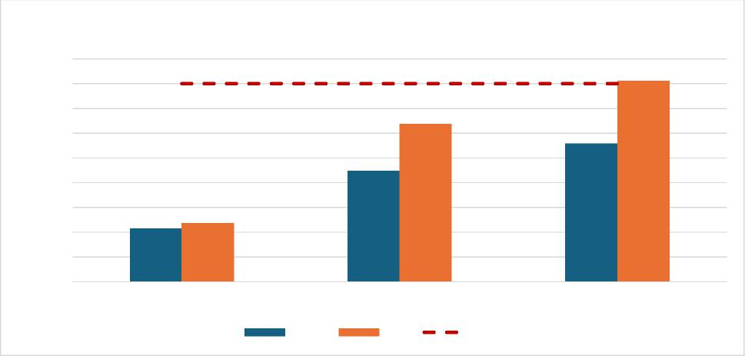
Immunization Rates
90
HPV 4:3:1:3:3:1:4 MMR
Yates NYS Target
Completion Rate (%)
40
80
70
60
50
30
20
10
0
Page 99 Yates County

Community Health Assessment – Yates County

Yates County’s low Immunization rates are likely affected by the large Mennonite population in the community. It is common practice for the Mennonite community to remain unvaccinated and seek alternative, holistic measures of care. Of note, though, is that Mennonite office visits for immunizations at Yates County Public Health increased by 57% since 2024, indicating a growing interest in this practice. Nonetheless, targeted, culturally competent education is key to understanding the importance and effectiveness of vaccination and ultimately improving rates of immunization.
Testing for blood levels of lead is essential in young children as no level of lead in the blood is safe. The CDC indicates that lead poisoning may lead to slowed growth and development, learning and behavior problems, and other long-term health effects. Young children may not show signs and symptoms of lead in the blood and body but can quickly be negatively impacted. Individuals that live or spend time in buildings built before 1978 or are from low-income households are especially vulnerable. With 18% of children under age 18 living in poverty, it is essential to prioritize efforts to improve access to and completion of lead screening to safeguard long-term health in the county.
Lead screening data from 2024 (Figure Y8) indicate that the percentage of children aged one year who received one lead screening is 40.5%. The percentage of children aged two years who received at least one lead screening was 42.7%. Those who received at least two lead screenings by three years of age were 32.4%. Overall trends are showing a decline in all measures of lead testing.
Figure Y8: Preventive Services – Lead Screening (2024)
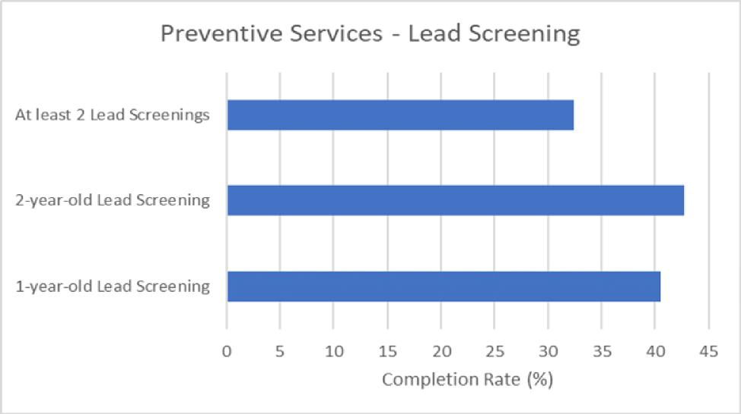
Source: NYSIIP Performance Reports, IAP Baseline Report
Health Care Access and Quality Domain Summary: Yates County shows progress in several maternal and child health indicators, including increased abstinence from smoking, alcohol, and drug use during pregnancy, lower rates of low birthweight, and high breasffeeding rates. However, challenges remain. Preventive care access is strained by provider shortages, declining insurance coverage, transportation
Page 100 Yates County

Community Health Assessment – Yates County

barriers, and lower preventive screening rates among low-income residents. Dental care access, particularly for Medicaid enrollees, has also declined. Immunization and lead-screening rates have declined since 2019. Overall, significant gaps in access to preventive, oral, and specialty care continue to affect community health outcomes.
Domain: Education Access and Quality
Education strongly influences health. Individuals with more schooling live longer, have fewer chronic diseases, and experience greater economic stability. Chronic absenteeism, defined by the U.S. Department of Education as missing at least 10% of the school year for any reason, can interfere with educational attainment. Several factors contribute to absenteeism, such as physical and mental health challenges, substance use, unsafe school environments, and low fitness levels.
Chronic absenteeism rose sharply in New York State after the COVID-19 pandemic. In 2022–2023, 26.4% of all students and 34.1% of high school students were chronically absent, far above the pre-pandemic rate of 15.5%. Chronic absenteeism is associated with lower academic achievement, social disengagement, higher dropout risk, and poorer long-term health and economic outcomes. The percentage of students who start ninth grade and graduate in four years was 80% in 2023, lower than the NYS average of 87% and unchanged from the baseline in 2018. The graduation rate for students classified as economically disadvantaged was 81% in 2023 versus 82% for NYS, an increase of 6.6% from baseline in 2019.
In Yates County, 73.5% of the school-age population is enrolled in kindergarten through 12th grade, with 32.7% in private schools and 67.3% in public schools. The number of students enrolled in school between grades 5 to 8 and grades 9 to 12 drops by approximately 586 students⁷³ (Table Y6). This is likely due to the Mennonite educational structure which discontinues schooling after 8th grade.
Table Y6: Enrolled School-Age Population

Grade Level Total Estimate Percent Estimate in Percent Estimate in Private
Public School School
Kindergarten | 210 | 74.3% | 25.7%
Elementary: grade 1 to grade 4 | 1216 | 55.6% | 44.4%
Elementary: grade 5 to grade 8 | 1395 | 64.1% | 35.9%
High School: grade 9 to grade 12 | 809 | 88.8% | 11.2%
Source: 2023 American Community Survey 5-Year Data
The average gap in dollars between actual and required spending per pupil among public school districts was $9,915 in 2022, compared with $12,745 on average in NYS; an increase of 4.4% from baseline in 2019. The gap between what schools need and what they actually spend is growing. A widening funding gap can strain school resources, limit access to educational programs and support services, and make it
⁷³ Source: U.S. Census and 2023 American Community Survey
Page 101 Yates County

Community Health Assessment – Yates County

harder for districts to meet student needs. Over time, this can contribute to disparities in academic achievement, staffing challenges, and fewer opportunities for students, especially in communities already facing economic or social disadvantages.
Post-secondary education also brings substantial benefits. Adults with a bachelor’s degree have higher incomes, are less likely to be unemployed, and have better health and safer working and living conditions than those with only a high school diploma. However, affordability and unequal access to educational opportunities remain challenges. The percentage of adults ages 25 and over in Yates County with a high school diploma or equivalent was 84% in 2023, lower than the NYS average of 88% and a decrease of 2% from the baseline in 2019. The percentage of adults aged 25-44 with some postsecondary education was 42% in 2023, lower than the NYS average of 71% and a decrease of 22% from the baseline in 2019.
Education Access and Quality Domain Summary: Educational attainment remains a priority concern: rates of high school completion, post-secondary education, and on-time graduation all fall below state averages. Additionally, the per-pupil spending gap has widened, signaling increasing strain on school resources and the potential for growing inequities in academic opportunities and student support.
Page 102 Yates County

Community Health Assessment – Yates County
Priority Areas
Yates County identified three priority areas for this CHA. They are:
- Housing Stability and Affordability
- Preventive Services for Chronic Disease Prevention and Control
- Anxiety and Stress
These priority areas were selected in December 2025 using a ranking systematic survey to select the above priorities, in addition to using secondary data and community feedback.
Housing Stability and Affordability
Although housing cost burden is lower than the state average, community partners and focus groups consistently identify housing quality, availability, and affordability as urgent concerns. Homeownership rates are declining in Yates County while the cost of living continues to rise.
"People of low income will always be affected the most...as those with adequate funds have choices - where to live, work, spend their money, and where to get their healthcare."
- YCC Focus Group Participant
Focus groups in Yates County highlighted significant concerns about local housing, noting a shortage of safe and functional homes. Older housing, particularly pre-1950s structures, often lacks inspections for lead and mold, increasing risks for respiratory illnesses, developmental issues, and chronic conditions, as well as injuries from falls in poorly maintained homes.
Further housing assessments are needed in Yates County to better understand the resources available to help the community.
Preventive Services for Chronic Disease Prevention and Control
Yates County is seeing increased rates of
obesity, cancer, diabetes, and heart disease
and the county’s top two leading causes of
death are associated with chronic disease.
Prevention, early detection, and disease
management are important to improving
overall quality of life.
"I feel that we have to be our own advocate when it comes to healthcare...if I was to mention health issues between family and friends, there would be too many to state."
- YCC Focus Group Participant
However, access to care in Yates County is a
widespread barrier, especially for elderly and low-income populations. There is limited access to primary care locally, and residents are also forced to travel long distances for specialty care. Additional barriers
Page 103 Yates County

include high medical costs, insurance limitations, scheduling difficulties, lack of transportation, and poor broadband access.
Community Health Assessment – Yates County

Increasing access to care through creative community solutions and partnerships can reduce the burden of chronic disease in the community.
Anxiety and Stress "Older people still have skills to be useful and want to be"
Mental health was noted as a major issue across all focus groups. Youth cited bullying and cyberbullying as factors influencing mental health while older adults noted isolation as a key contributor. A shortage of
-YCC Focus Group Participant
mental health providers and ongoing barriers to seeking help, especially for marginalized groups, was
cited as cause for concern.
Declining mental health can signal underlying concerns around rising stress, depression, or anxiety in the community. This may lead to higher rates of chronic disease, substance use, reduced productivity, and greater demand for mental health and medical services.
Building community support systems focused on resilience-building strategies and social connections can improve community well-being.
Existing and needed community assets and resources supporting health were identified throughout the Community Health Assessment process. The community partners listed in Appendix 1 provide valuable resources to support positive health outcomes for Yates County residents.
Community Assets and Resources
Pivital Public Health Partnership and Common Ground Health are two agencies that promote and facilitate regional collaboration. Pivital is a partnership of eight rural health departments in the Finger Lakes Region, focusing on improving the health and well-being of Finger Lakes residents. Common Ground Health covers the same geographic footprint, with the addition of Monroe County, and focuses on bringing together leaders from all sectors to collaborate on strategies for improving health in the region. Both agencies provide support, collaboration and resources to improve the health of Yates County residents.
Yates County has broad engagement from nonprofits, healthcare systems, school districts, grassroots groups, and faith-based communities. Agencies like Finger Lakes Area Counseling & Recovery Agency (FLACRA), Cornell Cooperative Extension, UR Medicine Finger Lakes Health, Pro Action provide mental health, substance use, medical, social, and educational services. Individuals of all ages and backgrounds—including low-income populations, older adults, those living with disabilities, LGBTQIA+ community members, immigrants, and racial minorities— are engaged through support groups, advisory boards, social media, and multilingual support. Partners actively work on policy and advocacy, adapt through regular evaluation , and use innovative tools and leadership opportunities to build resilience and local capacity.
Page 104 Yates County

Community Health Assessment – Yates County

There is also a strong emphasis on community within the county as exemplified by committed staff, volunteers, and resource sharing (spaces, technology, event support). Social hubs such as libraries, community centers, churches, and schools anchor programming and promote referrals across health/wellness, social, and preventive services.
While partnerships and organizations exist to foster collaboration in the community, gaps still exist that may inhibit growth. Several partners discussed the need to expand community engagement for youth inclusion. Engagement must go beyond social media to include more one-to-one interaction. Many populations, especially the older population, expressed the desire to mentor youth and foster relationships.
Additionally, community partners and businesses must continue to address organizational awareness of structural determinants of health. In doing so, creating more inventive, comfortable, and accessible meeting and engagement spaces are needed.
Through implementation of the Community Health Improvement Plan (CHIP), Yates County and its community partners will work to leverage existing relationships, knowledge, and resources. The Yates County CHIP workplan will include a full description of interventions and partner roles that will be used to address chosen priorities and objectives.
Table Y7 highlights the specific county partners associated with each priority area and how they may support Yates County in achieving its goals.
Table Y7: County Resources to Accomplish CHA/CHIP Goals
Priority Area | Sample Assets & Collaborafi ve Resources | How They Support  Community Health & Well-  being
Housing Stability & | Yates County DSS; Keuka | Ensure basic needs for residents are
Affordability | Housing Council; Cornell | met (housing, food, safe drinking
 | Cooperative Extension (CCE); | water, clothing, heat etc.);
 | Yates County Soil and Water; | educational resources to residents
 | Geneva District Office for | who face environmental hazards
 | Environmental Health; LAW of | within their house; informing
 | NYS; Housing Consortium | residents of their rights as a homeowner; community and governmental collaboration can help maintain neighborhoods at affordable prices for residents who live and work in the area

Page 105 Yates County

Community Health Assessment – Yates County

Preventive Services of Chronic Disease Prevention & Control
Anxiety & Stress
Cornell Cooperative Extension (CCE); ProAction of Steuben and Yates; Tobacco Action Coalition of the Finger Lakes; Finger Lakes Community Health; Penn Yan Central School District (PYCSD); Dundee Central School District (DCSD); UR Medicine Finger Lakes Health; Dundee Food Pantry-Baptist Church; The Living Well; Dundee Fresh Grocery, Our Town Rocks; Medical Reserve Corps (MRC); Rochester Regional Health
Penn Yan Public Library; Yates County Office of Emergency Services; ProAction of Steuben and Yates; Finger Lakes Area Counseling and Referral Agency (FLACRA); Finger Lakes Community Health; Yates County Sheriff’s Office (YCSO); Lakeview Health Services; Yates County Correctional Facility; UR Medicine Finger Lakes Health; The Living Well; Yates County Community Services; Our Town Rocks; Yates Prevention Coalition
Providing educational resources around general health and well-being, nutrition, and prevention/management of chronic disease; primary, emergency, and specialty health care providers; food and nutrition security; school systems providing primary prevention education, healthy food options, and educational opportunities around health and well-being; organizations offering community support groups and connection to resources
Mental health support and care; emergency response to mental health crises; resources for mental health and general well-being; educational resources for residents who experience mental health concerns; population-specific resources and community support; social connection opportunities
Page 106 Yates County

Appendix 1
 | Community Health Assessment – Yates County | 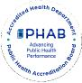

A diverse coalition of organizations and community members participated in the Yates County Community Health Assessment process to ensure broad stakeholder input and representation from populations experiencing health disparities. Known as Choose Health Yates, this group serves as the Community Health Improvement Plan (CHIP) steering committee for Yates County. The following partners are active members of the Choose Health Yates Committee:
Participating Partners and Community Representation
Organization | Sector | Population
Penn Yan Public Library | Non-profit organization | All populations, LGBTQ+
Pivital Public Health  Partnership | Non-profit organization | Finger Lakes region
Chamber of Commerce | Local tourism agency | Yates County residents
Yates County Office of Emergency Services | Local government | Yates County residents
Yates County Cornell  Cooperative Extension | Nonprofit educational system | Agricultural workers, low-income, veterans
ProAction of Steuben and Yates | Nonprofit agency | Aging population, low-income
Yates County Department of Social Services | Local government | Marginalized populations- low socioeconomic status
Finger Lakes Area Counseling and Referral Agency (FLACRA) | Mental and behavioral health organization | People who use drugs (PWUD), marginalized populations
Tobacco Action Coalition of the Finger Lakes | Nonprofit organization | Finger Lakes region
Finger Lakes Community Health | Federally Qualified Health Center (FQHC ) | Marginalized communities-migrant/agriculture workers, LGBTQ+, low-income, Medicaid recipients, LEP
Penn Yan Central School District (PYCSD) | Academics | Youth
Yates County Sheriff’s Office (YCSO) | Local government | Yates County residents
Lakeview Health Services | Mental and behavioral health services | Finger Lakes Region

Page 107 Yates County

Yates County Correctional Facility | Local government | Marginalized populations-incarcerated individuals
University of Rochester Medical Center- Soldiers & Sailors Memorial Hospital | Hospital | All populations
Dundee Food Pantry- Baptist Church | Faith based organization | Low-income, aging population
The Living Well | Non-profit | Low-income, aging population
Yates County Community Services | Local government | Yates County Residents
Dundee Fresh Grocery | Business | All populations
Our Town Rocks | Nonprofit community organization | All populations
Retired Physicians | Community members

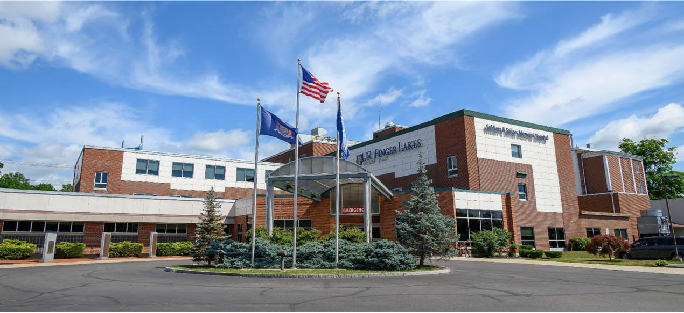
Soldiers and Sailors Memorial Hospital Courtesy of UR Medicine Finger Lakes Health
Courtesy of UR Medicine- Soldiers and Sailors Memorial Hospital
 | Community Health Assessment – Yates County | 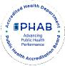

Page 108 Yates County

