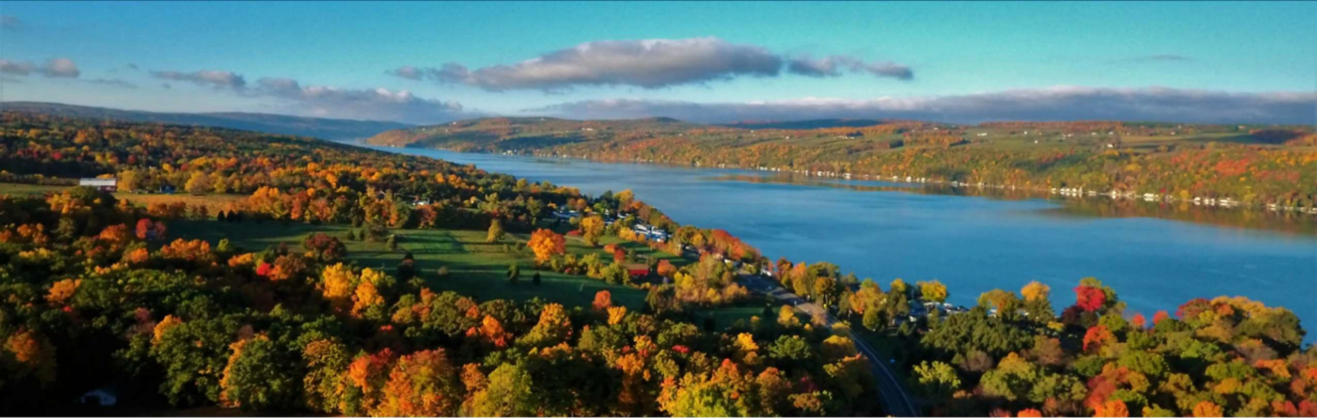
Comprehensive Regional Community

Health Assessment
PREPARED FOR: Chemung, Livingston, Ontario, Schuyler, Seneca, Steuben, Wayne, and Yates Counties

Courtesy of Finger Lakes Tourism Alliance: Joe Carroll
PREPARED BY: Pivital Public Health Partnership | December 2025
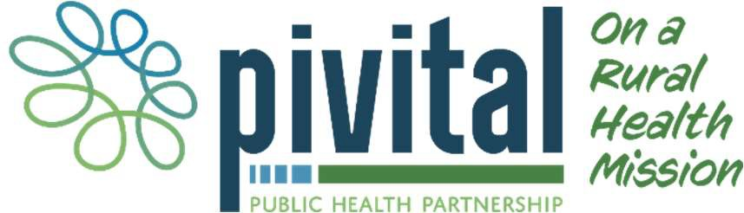

Table of Contents

Executive Summary | 4
County Speciﬁc Priority Areas | 10
Steering Committee | 11
New York State 2025-2030 Prevention Agenda | 12
Data Method and Processes (Methodology) | 13
Comprehensive Regional Community Health Assessment | 20
Demographics | 20
New York State 2025-2030 Prevention Agenda Domains and Priorities | 37
List of Tables:
Table 1: County-Speciﬁc Priority Areas | 10
Table 2: NYSDOH Prevention Agenda Domains, Priorities and Targets | 13
Table 3: Farms and Farm Workers in the Finger Lakes Region | 24
Table 4: Foreign Born and Citizenship | 26
Table 5: Life Expectancy | 32
Table 6: Leading Causes of Death 2022 | 33
Table 7: Leading Causes of Premature Death | 35
Table 8: County Health Rankings | 36
Table 9 Poverty Rates in the Finger Lakes Region | 39
Table 10 Food Environment Index in the Finger Lakes Region | 41
Table 11 Housing Cost Burden and Area Deprivation Index in the Finger Lakes  Region | 42
Table 12: Rate of Depressive Disorders and Percentage of Adults Reporting | 44
14 or more days of Poor Mental Health in a Month
Table 13: Overdose Deaths 45
Table 14: Healthy Eating 47
Table 15: Injuries and Violence 52
Table 16 Provider Access in the Finger Lakes Region 59
Table 17: Preventive Services 60
Table 18: Oral Care 61
Table 19: Emergency Department Visits and Preventable Hospitalizations 62
Table 20: Education-related Socio-economic factors 66
List of Maps:
66
Table 21: Education Indicators
Map 1: The Finger Lakes Region of New York State 21
Map 2: Households without a Vehicle by Zip Code 31
Map 3 Life Expectancy by Zip Code, Finger Lakes Region 32
Map 4: Age-Adjusted Death Rate for Heart Disease Rate per 100,000 34
Map 5: Age-adjusted Death Rate for Cancer Rate per 100,000 34
Map 6 Overall Poverty in the Finger Lakes Region 37
Map 7: Poverty rates by Zip Code for those Over 65 Years of Age 38
Map 8: Poverty Rate by Zip Code for those Under 18 Years of Age 38
Map 9: Food Insecurity Rate by Zip Code 40
Map 10: Area Deprivation Index by Area 42

Map 11: Frequent Mental Distress Among Adults (Mental Health Not Good 43
for 14+ of past 30 days)
Map 12: Percentage of the population of those 65 years and older living
alone by zip code
51
Map 13: Percentage of births with late (3rd trimester) or no prenatal care 53
Map 14: Premature birth rates by Zip Code 55
Map 15: Percentage of Premature Births with 32 - < 37 Weeks Gestation 55
Map 16: Percentage Low Birth Weight (<2.5 kg) Singleton Births 56
Map 17: Potentially Preventable Hospitalizations 62
Map 18: ED Visits for Cancer by Zip Code 62
Map 19: ED Visits Related to Heart Disease by Zip Code 63
Map 20: ED Visits for Hypertension by Zip Code 63
Map 21: ED Visits for Depressive Disorders by Zip Code 63
List of Figures:
63
Map 22: ED Visits for Anxiety and Panic Disorders by Zip Code
Figure 1 Social Determinants of Health 12
Figure 2 MAPP 2.0 Roadmap to Health Equity 14
Figure 3 MAPP 2.0 phases 14
Figure 4 Data Triangulation Process 17
Figure 5: Fishbone Diagram 18
Figure 6: Percent Change in Population from 2020- 2040 21
Figure 7: Population Projections by Age Group, Finger Lakes Region 22
Figure 8: Race/Ethnicity Finger Lakes Region 23
Figure 9: Percent of Households Speaking a Language Other than English 27
Figure 10: Disability Rate by County 28
Figure 11: Veteran Population by Percent of Total Population 28
Figure 12: Health Insurance Status 29
Figure 13: Residents with Medicaid Coverage 30
Figure 14: Broadband Connection vs Broadband Access in each County 30
Figure 15: Percent of Households with No Vehicle Access 31
Figure 16: Suicide Rates 44
Figure 17: Smoking and Binge Drinking 46
Figure 18: Adverse Childhood Experiences 46
Figure 19: Access to Locations for Physical Activity 48
Figure 20: Walkability Index 49
Figure 21: Social Vulnerability Index 50
Figure 22: Alcohol Abstinence in Pregnancy 54
Figure 23: Smoking Abstinence in Pregnancy 54
Figure 24: Illegal Drug Abstinence in Pregnancy 55
Figure 25: Percentage of Preterm Births in the Region from 2018-2024 56
Figure 26: Infant Mortality Rate per 1,000 (2022) 57
Figure 27: Maternal and Child Mortality Rates per 100,000 (2022) 57
Figure 28: Number of Births in the Finger Lakes Region 58
Figure 29: Blood Lead Level Screenings 64
Figure 30: Immunization Rates 65

Executive Summary


Introduction
Photo: Watkins Glen State Park courtesy of Schuyler County
The New York State Department of Health (NYSDOH) Prevention Agenda 2025-2030 serves as a roadmap for county health departments, hospitals and other health care systems and partners to develop strategic priorities to ensure the health and well-being of New York State residents. Every six years, New York State requires health departments and their local hospital systems work together to create a joint community health assessment (CHA) and a community health improvement plan. Both should align with the NYSDOH Prevention Agenda and with priorities and requirements detailed by the Public Health Accreditation Board (PHAB).
Local health departments and hospitals must choose at least three areas from the New York State Prevention Agenda on which to focus their community health improvement eﬀorts. Local entities may choose from ﬁve domains and 23 priorities within those domains. The ﬁve domains are:
- Economic Stability
- Social and Community Context
- Neighborhood and Built Environment
- Health Care Access and Quality
- Education Access and Quality
Throughout the Community Health Assessment cycle,
public health and hospital systems beneﬁted from input and engagement of key partners and community members who are critical in helping determine which priorities are most important to the community, and what actions ought to be taken to improve the population’s health. The following report summarizes the pertinent information relating to the above priority areas. Residents live, work, and seek services beyond their county of residence. The health and well-being of residents in a neighboring county may impact the needs and services in other counties. In addition, collaborative practices such as shared messaging and lessons learned may expand the reach and success of like-minded interventions. Following the comprehensive assessment of the health of the entire region, this report contains a county-speciﬁc chapter from the region. Each county’s chapter highlights speciﬁc needs, including additional demographic indicators, main health challenges, and underlying behavioral, political, and built environmental factors contributing to the county’s overall health status.

Key Findings
The health of residents of the Finger Lakes region has been challenged by a variety of factors and circumstances ranging from demographic changes to public health crises. Addressing these challenges requires creative thinking, careful planning, and coordinated action, all of which are described in this community health assessment (CHA).
Although the region’s overall population is projected to shrink, the region will experience an increase in the number of older adults over the next several years. This will result in the need to increase the capacity of healthcare and social service agencies. The expected increase in older adults and retirees, paired with a predicted decline in the number of working-age adults, will further exacerbate workforce demands.
Despite the long-standing existence of several unique populations in the region, including migrant farm workers, Amish and Mennonite, Native American and Alaska Natives, researchers have been challenged to collect and interpret data related to their unique health needs. In addition to these populations, there are other demographic and cultural factors which may impact health outcomes and status in a particular county including race, ethnicity, age, income, education, and the infrastructure that makes up the built environment. The 2025–2030 New York State Prevention Agenda organizes these conditions into ﬁve domains of social determinants of health: Economic Stability; Social and Community Context; Neighborhood and Built Environment; Health Care Access and Quality; and Education Access and Quality. The data shared below corresponds to the ﬁve domain areas of the Prevention Agenda and provides a summary of ﬁndings. For more detailed information, please refer to the speciﬁc Prevention Agenda sections in this CHA.

Economic Stability
Economic stability refers to socioeconomic disparities, unemployment and underemployment, access to aﬀordable, nutritious food, and housing security. All are closely linked to poor health, aﬀecting physical, mental, and educational outcomes. Children and older adults are especially vulnerable.
Socioeconomic conditions strongly shape community health. Higher poverty levels are associated with more chronic disease, mental health challenges, and limited access to essential resources such as food, housing, education, healthcare, and employment. Poverty also creates wider societal burdens, including homelessness, crime, and higher healthcare costs. Data across counties show notable variation in poverty rates, with several counties exceeding the New York State average. Poverty among older adults is rising in every county, which is concerning given the expected growth of the 65+ population. While household incomes have increased, they are not keeping pace with the living wage needed to meet basic costs.
Access to healthy foods is another key concern. The Food Environment Index (FEI), which reﬂects food insecurity and distance to grocery stores, indicates that many counties in the region face greater food access challenges than the state overall. High food insecurity rates and large numbers of residents with incomes below the SNAP threshold highlight ongoing economic strain, particularly in rural areas. Limited access to nutritious food contributes to elevated rates of obesity, diabetes, and premature death.

Housing stability also plays an important role in health. When housing is unaﬀordable or poor in quality, it can create stress, contribute to chronic illness, and limit access to other necessities. The Area Deprivation Index (ADI), which measures socioeconomic disadvantage, shows substantial variation across the region, with some communities experiencing signiﬁcantly higher levels of deprivation and associated health risks.
Children and older adults are especially vulnerable, as poverty, food insecurity, and unstable housing can disrupt healthy development, worsen chronic conditions, and compound disadvantages over time.

Social and Community Context
Social and community context encompasses the relationships, environments, and local systems that shape people’s health and well-being. Strong social connections, a sense of belonging, and access to community resources support positive health outcomes, while factors such as discrimination, isolation, and inequities in the surrounding environment can undermine health.
Mental health concerns are rising across the Finger Lakes region, with increasing rates of depressive disorders and adults reporting frequent poor mental health. Factors such as economic strain, chronic illness, political polarization, and adverse childhood experiences contribute to anxiety and stress, while access to mental health providers remains a challenge. Suicide rates among adults are climbing in most counties, and youth suicide trends vary, with some counties reporting decreases and others showing signiﬁcant increases.
Drug-related deaths, including opioid overdoses, have escalated sharply in many counties, surpassing statewide averages. Community focus groups also identiﬁed growing substance use as a major concern, prompting new local partnerships aimed at addressing addiction.
While smoking has declined across the region, binge drinking has increased, and both behaviors occur at rates higher than the New York State average. Adverse childhood experiences remain a signiﬁcant issue, with many adults reporting two or more ACEs, which can aﬀect long-term health.
Healthy eating patterns remain a concern across the region. Fewer than half of adults in most counties eat fruit daily, though this is improving, and daily vegetable consumption is declining. Sugary drink consumption is below the state average in most counties yet remains an important target for prevention given its link to obesity and chronic disease. Focus group participants consistently emphasized the importance of healthy eating but noted that aﬀordability and limited grocery access make it diﬃcult to sustain healthy eating habits.

Neighborhood and Built Environment
Neighborhood and built environment depend on clean air and water, safe and aﬀordable housing, well-maintained streets and sidewalks, adequate lighting, low violence, and accessible parks and trails.
Although physical activity is essential for preventing chronic disease, many focus group participants reported feeling unsafe on local roads and sidewalks, and residents with mobility limitations often struggle to navigate their surroundings, safely.
Several counties have expanded access to physical activity resources but rising injuries and violence across the region undermine residents’ sense of safety. Regionally, violent crime has risen in recent

years, especially since 2020, and is currently at its highest level since 2013. Most counties now exceed the state average in unintentional injury deaths.
Transportation barriers in rural areas further limit access to food and healthcare, as many residents live far from essential services and grocery stores. Low walkability and high social vulnerability scores reﬂect these challenges. Additionally, regional increases in depressive disorders may impact residents’ ability to engage with their communities.
Despite these concerns, respondents to the 2024 Regional Access to Care Survey highlighted strong community assets, including volunteers, local non-proﬁt organizations, and hospitals, which help oﬀset shortcomings in the built environment.

Health Care Access and Quality
Health care access and quality play a critical role in preventing disease, supporting healthy development, and reducing inequities. Early and consistent prenatal care lowers risks for mothers and infants, while regular screenings, immunizations, and management of chronic conditions help prevent serious illness and death. Oral health, often tied to socioeconomic status, is another key component of overall well-being. Despite the beneﬁts of these services, many residents face barriers, including transportation challenges, inequitable access, and mistrust, that limit their ability to receive timely, high-quality care.
Access to early prenatal care and abstinence from alcohol, tobacco, and illicit drugs during pregnancy are critical in ensuring healthy starts the region’s youngest residents. While only a small percentage of pregnant persons in the region receives late (third trimester) or no prenatal care, some counties have rates that are more than twice those of the best performing counties, underscoring ongoing geographic disparities in timely access. The use of harmful substances during pregnancy has decreased in the region, as have the incidences of preterm births and low birth weights. This is encouraging as the eight counties represented in this regional CHA continue to work collaboratively on maternal child health indicators, interventions, and uniﬁed messaging.
Access to primary care and dental care is problematic in rural counties, particularly for low-income and Medicaid-eligible residents. Provider shortages, cost, transportation barriers, and scheduling diﬃculties hinder timely care. Though mammography rates are high, colorectal cancer and diabetes screenings lag. Dental care, particularly for individuals with Medicaid, remains limited due to a lack of participating providers.
High emergency department use, preventable hospitalizations, and increased behavioral-health visits reﬂect gaps in primary and specialty care. Public health activities such as TB screening and treatment, blood lead testing, childhood vaccination clinics, and STI testing and treatment remain important stop gaps for individuals who otherwise would lack access to these services. Future improvements may come from telehealth expansion, improved broadband access, urgent care expansion, and utilization of social care networks, while the advent of concierge medicine may worsen inequities.
A 2024 regional survey of more than 1,700 residents conﬁrmed persistent barriers to care (for more detail, please see Regional Access to Care Report section of this CHA). Findings included:
- Shortages of medical, dental, and mental health providers
- Transportation diﬃculties, especially in rural areas

- Insurance-related challenges for uninsured and Medicaid patients
- Greater access barriers for non-White, rural, and Plain community residents
- Strong community assets, including local organizations and hospitals
Emerging issues include workforce shortages—particularly in behavioral health—limited broadband for telehealth, policy changes aﬀecting Medicaid and SNAP, diﬃculties integrating new care models, ongoing equity gaps, and the potential beneﬁts of expanding Social Care Networks and urgent care services.

Education Access and Quality
Education is a major determinant of health, as research suggests that educational attainment may support greater economic stability. People with higher levels of schooling tend to live longer, experience fewer chronic conditions, and enjoy greater economic security. Student absenteeism can stem from a range of issues, including physical and mental health concerns, substance use, unsafe school environments, and low physical ﬁtness. Beyond high school, additional education oﬀers signiﬁcant advantages: adults with a bachelor’s degree typically have higher earnings, lower unemployment, and improved health and living conditions compared to those with only high school diplomas. However, cost and disparities in access continue to limit these opportunities for many.
Educational opportunities are reﬂected in high school graduation rates, per-student spending, and graduation rates among economically disadvantaged students. Most counties in the region surpass the state average for adults with a high school diploma.

Regional Assets and Resources to be Mobilized
In the Finger Lakes Region, there is a long history of collaboration and coordination among local health departments (LHDs) and community partners. The counties work together on programming, policy development, and uniﬁed messaging and have inter-municipal agreements for emergency response. Six of the counties worked together to become nationally accredited in 2020 and are now pursuing multi-jurisdictional reaccreditation. Additionally, LHDs work collaboratively with hospital partners in emergency preparedness, community health priorities, at co-sponsored events, during communicable disease outbreaks, and on boards and coalitions. Each county maintains a group of hospital and community stakeholders with which they complete the CHA and the CHIP. In addition to these relationships, eight Finger Lakes counties are members of the Pivital Public Health Partnership and collaborate with Common Ground Health and the Forward Leading IPA (FLIPA).

Pivital Public Health Partnership
Pivital Public Health Partnership is a collaboration of eight local health departments including Chemung, Livingston, Ontario, Schuyler, Seneca, Steuben, Wayne, and Yates Counties. The network focuses on improving the health and well-being of Finger Lakes residents by promoting health equity in populations who experience disparities. The Pivital board is made up of community members, medical professionals, and public health directors from member counties. Directors meet monthly to strategize and coordinate eﬀorts to improve the health and wellbeing of Finger Lakes residents.

Common Ground Health

Common Ground Health covers the same geographic area as Pivital, with the addition of Monroe County, which has both urban and rural populations. The agency brings together leaders from healthcare, business, education and other sectors to ﬁnd common ground on health challenges and bring attention to health inequities based on geography, socio-economic status, race and ethnicity. Members meet quarterly at Regional Leadership meetings to discuss challenges in health outcomes and available resources.

Forward Leading IPA (FLIPA)
FLIPA’s mission is to strengthen healthcare through meaningful connections by creating opportunities for member organizations to collaborate, build relationships, and share best practices to support the health and wellbeing of communities across upstate New York. The executive director of Pivital represents the eight Pivital counties on the FLIPA board of directors. Current work is centered on the 1115 waiver and creation of a social care network.
These agencies support the work of the CHA and the eventual execution of the CHIP while ensuring alignment, leveraging shared resources, and creating opportunities for shared learning. With facilitation and coordination by each agency, local leaders meet regularly to discuss health challenges and social issues as a team and devise plans to improve the health of all Finger Lakes residents.
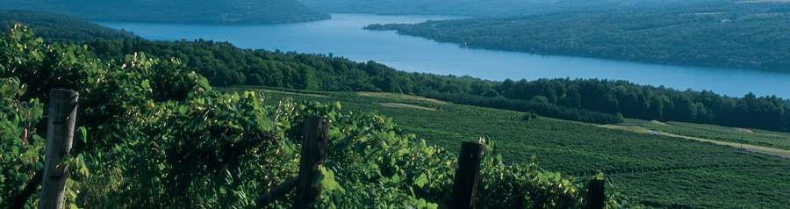
In addition to the resources available through Pivital, Common Ground Health, and FLIPA, LHD’s are active in regional workgroups and local nonproﬁt organizations. For a list of partners in each county, please see the speciﬁc County chapter.
Keuka Lake, Source: Steuben County

County-Speciﬁc Priority Areas

Each Finger Lakes county chose two or three domains on which to focus their CHIPs. Priority areas for each are bulleted and appear to the right of the corresponding domain in Table 1.
Table 1: County-Speciﬁc Priority Areas

County | Prevention Agenda Domain | Priority Area
Chemung | - Economic Stability  - Health Care Access and Quality  - Neighborhood and Built  Environment | - Poverty  - Housing Stability and Aﬀordability  - Preventive Services – Lead Screening  - Access to Community Support Services
Livingston | - Economic Stability  - Social and Community Context  - Health Care Access and Quality | - Nutrition Security  - Depression  - Oral Health Care
Ontario | - Economic Stability  - Health Care Access and Quality  - Social and Community Context | - Poverty  - Preventive Services for Chronic Disease  - Depression
Schuyler | - Health Care Access and Quality  - Social and Community Context  - Economic Stability | - Preventive Services for Chronic Disease  - Primary Prevention, Substance Misuse and Overdose Prevention  - Poverty
Seneca | - Health Care Access and Quality  - Social and Community Context  - Economic Stability | - Healthy Children/Preventive Services  - Primary Prevention, Substance Misuse and Overdose Prevention  - Nutrition Security
Steuben | - Economic Stability  - Social and Community Context | - Housing Stability and Aﬀordability  - Poverty  - Primary Prevention, Substance Misuse, and Overdose Prevention
Wayne | - Social and Community Context  - Economic Stability | - Anxiety and Stress  - Nutrition Security  - Housing Stability and Aﬀordability
Yates | - Economic Stability  - Health Care Access and Quality  - Social and Community Context | - Housing Stability and Aﬀordability  - Preventive Services for Chronic Disease  - Anxiety and Stress

Steering Committee

Regional Community Health Assessment Structure and Approach
The regional Community Health Assessment (CHA) eﬀort was led by the Pivital Public Health Partnership, a non-proﬁt aﬃliation of eight county Public Health Departments in the Finger Lakes region of New York State. Regional CHA partners included: County-level public health departments from Chemung, Livingston, Ontario, Schuyler, Seneca, Steuben, Wayne, Yates; Pivital Public Health Partnership; Common Ground Health; local steering committees; and diverse sectoral organizations. See County Chapters for speciﬁc partners.
Pivital provided county staﬀ with targeted education on the Mobilizing for Action through Planning and Partnership (MAPP) 2.0 Framework; a tool created by the National Association of County and City Health Oﬃcials (NACCHO). Additionally, they attended stakeholder meetings and facilitated monthly meetings with health department staﬀ assigned to CHA/CHIP activities. Pivital also provided technical assistance and data support by collecting and entering county-level Community Status Assessment (CSA) data into the Clear Impact performance management scorecard. This ultimately created a regional CSA scorecard to identify shared regional health issues and challenges. County-level teams customized the processes for their local needs and priorities (see speciﬁc County Chapters for detailed information.)
While planning was coordinated regionally, each county designated a chairperson who facilitated the CHA process at the local level. Each local health department formed a steering committee best suited to its local needs in order to implement each step of the MAPP 2.0 framework. This adaptive approach allowed each county to follow recognized best practices for collaborative health improvement, while ensuring that local priorities and resources shaped their process.
To enhance data analysis and promote equity, Pivital partnered with Common Ground Health, a health research and planning organization based in Rochester, NY. Common Ground Health supports the nine Finger Lakes counties (the eight represented in this CHA and Monroe County) and is recognized for maintaining the region’s most comprehensive health and health care data resources. Their expertise enabled deeper investigation of health trends and identiﬁcation of health inequities by geography, socio-economic status, race, and ethnicity.
During the Community Context Assessment (CCA), the eight counties worked together regionally to identify key uniﬁed questions for focus groups. Each local health department was given the opportunity to customize and enrich CCA questions to meet local needs but agreed to use a minimum set of questions decided upon by regional consensus, ensuring consistency and comparability across the region.

New York State 2025-2030 Prevention Agenda

The NYSDOH Prevention Agenda 2025-2030 serves as a roadmap for county health departments, hospitals and other health care systems and partners to develop strategic priorities to ensure the health and well-being of New York State residents. It guides communities to set priorities, address health disparities, and improve the health and well-being of all New Yorkers. The NYSDOH Prevention Agenda is

closely tied to Social Determinants of Health. These determinants are everyday life conditions, such as where people live, work, learn, and play, that aﬀect health, well-being, and opportunities to thrive. (Figure 1)
Local health departments, hospitals and partners used the Prevention Agenda to align their CHA and CHIP with statewide goals, ensuring that eﬀorts are data-driven and focused on advancing health equity.
The Prevention Agenda outlines ﬁve domains with their associated priority areas as detailed in Table 2. Each domain is a Social Determinant of Health.
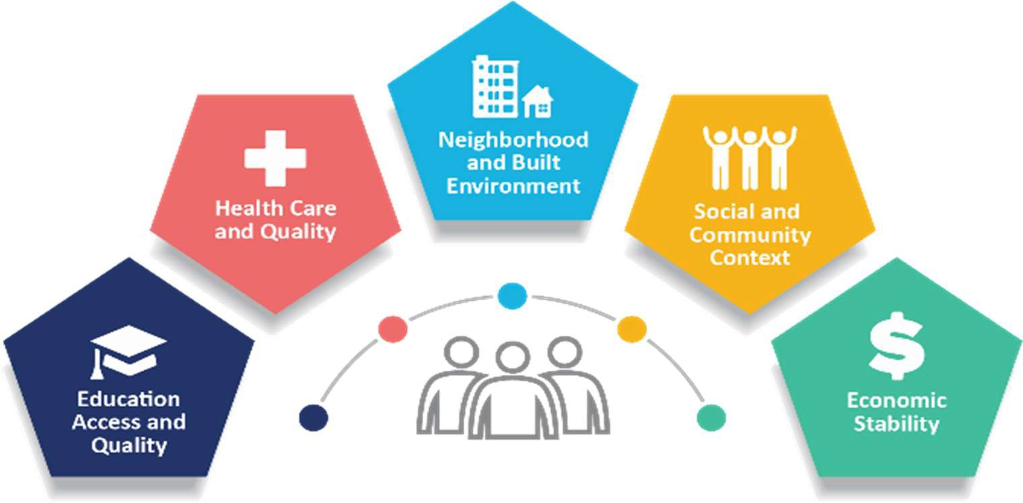
Figure 1 Social Determinants of Health
Source: CDC

Table 2: NYSDOH Prevention Agenda Domains, Priorities and Targets

Domain | Priorities
1. Economic Stability | Poverty
1. Economic Stability | Unemployment
1. Economic Stability | Nutrition Security
1. Economic Stability | Housing Stability and Aﬀordability
2. Social and Community Context | Anxiety and Stress
2. Social and Community Context | Suicide
2. Social and Community Context | Depression
2. Social and Community Context | Primary Prevention, Substance Misuse, and Overdose Protection
2. Social and Community Context | Tobacco/E-cigarette Use
2. Social and Community Context | Alcohol Use
2. Social and Community Context | Adverse Childhood Experiences
2. Social and Community Context | Healthy Eating
3. Neighborhood and Built Environment | Opportunities for Active Transportation and Physical Activity
3. Neighborhood and Built Environment | Access to Community Services and Support

 | Injuries and Violence
4. Health Care Access and Quality | Access to and Use of Prenatal Care
4. Health Care Access and Quality | Prevention of Infant and Maternal Mortality
4. Health Care Access and Quality | Preventive Services for Chronic Disease Prevention and Control
4. Health Care Access and Quality | Oral Health Care
4. Health Care Access and Quality | Preventive Services
4. Health Care Access and Quality | Early Intervention
4. Health Care Access and Quality | Childhood Behavioral Health
5. Education Access and Quality | Health and Wellness Promoting Schools
5. Education Access and Quality | Opportunities for Continued Education

Source: NYSDOH Prevention Agenda 2025-2030

Data Method and Process (Methodology)

The CHA provides a comprehensive picture of a community’s current health status, including factors that contribute to health risks and challenges. It also identiﬁes priority health needs by analyzing local data and community input.
The eight counties represented in this CHA adopted the NACCHO MAPP 2.0 Framework for community improvement in developing this regional CHA. (Figure 2). This broad framework allowed the counties to work as one collective unit while also enabling them to customize the assessments to best suit the needs and abilities of their individual counties.
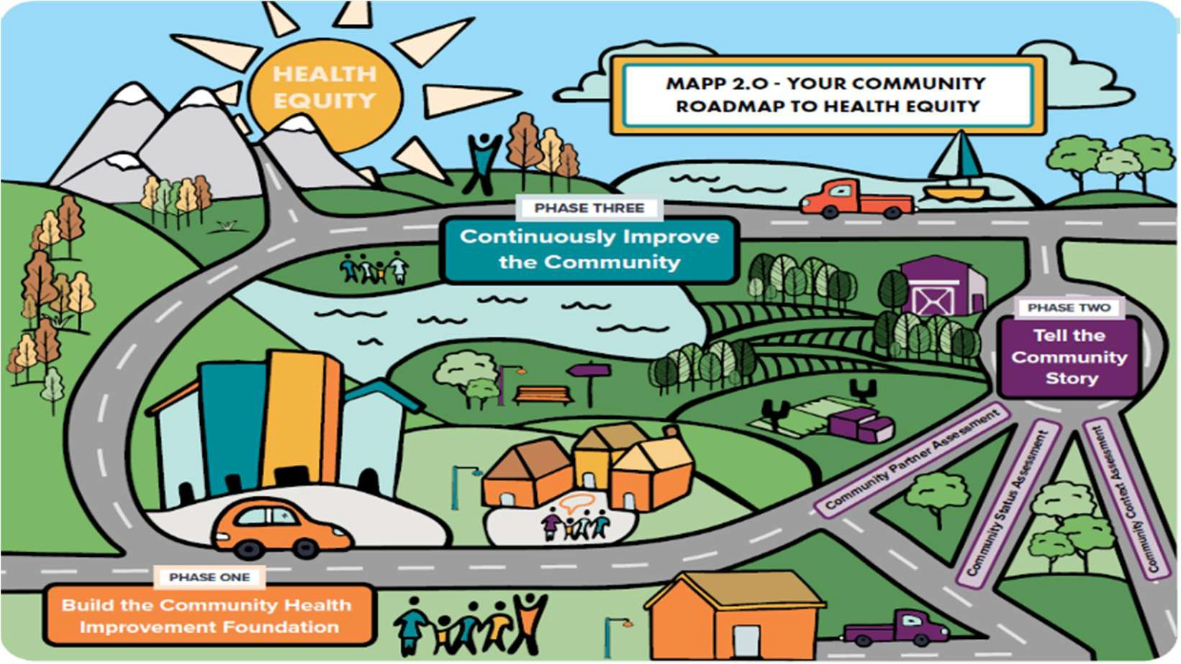
Figure 2 MAPP 2.0 Roadmap to Health Equity
Source: NACCHO

The process implemented by each county followed a three-phased approach noted in Figure 3.

Figure 3 MAPP 2.0 phases
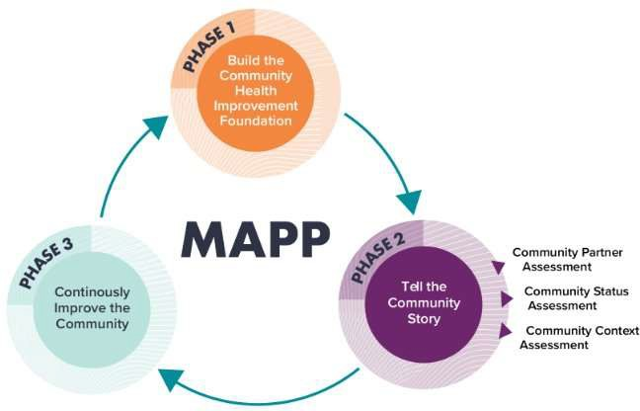
Source: NACCHO

Phase 1: Build the Community Health Improvement Foundation.
The focus of phase 1 is creating the leadership, partnerships, and shared commitment necessary to guide the MAPP process. It involves forming or strengthening a community health coalition, establishing clear roles and responsibilities, and developing a shared vision for a healthier community. During this step, partners build trust, set expectations, and ensure that diverse voices are represented, including residents, community organizations, health systems, and local government.
Phase 2: Tell the Community Story
In this phase data is gathered and analyzed to create a comprehensive picture of the community’s health using three coordinated assessments: the Community Partner Assessment (CPA), Community Status Assessment (CSA), and Community Context Assessment (CCA). Together, these assessments integrate quantitative health indicator data with qualitative stakeholder and resident data. Key health issues, strengths, and challenges are identiﬁed and aligned with the NY State Prevention Agenda’s domains and priorities. Partners gain a shared understanding of community health needs, disparities, and resources, which provides the evidence base for setting priorities and developing strategies for improvement.

Community Partner Assessment (CPA)
The CPA lets community organizations examine both their own internal processes and abilities, as well as their shared capacity to tackle health inequities. The assessment is designed to guide partners in determining what actions are needed to address inequities at individual, system, and structural levels.
The CPA is intended to address the following questions:
- What are the capabilities, skills and strengths each participating organization possesses that will contribute to improving community health and advancing MAPP goals?

- Who is currently involved in the MAPP process? Who else needs to be involved?¹
Each county developed and administered a survey and/or convened focus groups as part of its CPA. Details of the survey development and distribution and focus group administration for each county are noted in the speciﬁc county section of this CHA. Responses were then organized qualitatively and quantitatively in an eﬀort to identify strengths, weaknesses, opportunities, and threats (SWOT) as identiﬁed by respondents.

Community Status Assessment (CSA)
The CSA provides quantitative information about the community, such as population characteristics, health conditions, and disparities. Its purpose is to help communities understand inequities that go beyond individual behaviors or health outcomes, including how these issues connect to social determinants of health and broader systems of power and privilege. Ultimately, the CSA is a community-centered eﬀort intended to capture and convey the community’s narrative. The CSA is intended to address the following questions:
- What does the status of the community look like, including key health, socioeconomic, environmental, and quality-of-life outcomes?
- What populations are experiencing inequities across health, socioeconomic, environmental, and quality-of-life outcomes?
- How do systems inﬂuence outcomes?²
Data for each county was collected and compiled using Clear Impact performance management software. Data sources included:
- United States Census Bureau (census.gov) and the American Community Survey (5-year estimates)
- New York State Prevention Agenda Dashboard
- New York State Community Health Indicator Dashboard
- County Health Rankings
- Centers for Disease Control and Prevention (CDC)
- Behavioral Risk Factor Surveillance System
- NYSDOH Vital Records (Vital Statistics); New York State Department of Health
- New York State’s Statewide Planning and Research Cooperative System (SPARCS)
- Graduation Rate Data, 4-year outcomes; New York State Education Department (NYSED)
- NYS Perinatal Data Proﬁle; Statewide Perinatal Data System
- Healthy People 2020; US Dept of Health and Human Services
- Environmental Protection Agency (EPA) Oﬃce of Community Revitalization
- The Neighborhood Atlas | Center for Health Disparities Research
- Local area unemployment Statistics (LAUS); U.S. Bureau of Labor Statistics, Oﬃce of Employment and Unemployment Statistics

¹ NACCHO Community Partner Assessment Tool, www.naccho.org
² NACCHO Community Status Assessment Tool, www.naccho.org

- Evalumetrics Youth Survey (EYS) Reports
- Wilmot Cancer Institute, Cancer in Focus State Cancer Proﬁles; National Vital Statistics System | SEER
- NYSIIS Performance Report; New York State Immunization Information System
- Immunization Action Plan (IAP) Baseline Reports

Community Context Assessment (CCA)
The Community Context Assessment is a qualitative and quantitative tool used to assess a community’s strengths, weaknesses, assets, and challenges. It is based on three areas: Community Strengths and Assets, Built Environment, and Forces of Change. The CCA guiding questions were developed collaboratively by participating health departments to ensure continuity in data collection and analysis. Each county had the option of adding additional questions, but all counties asked the following seven questions:
- Which health issues have the biggest impact on you and/or your community?
- What does our community have that helps everyone, no matter their income, background, or language, have a fair chance to be healthy and feel welcome?
- How do the streets, buildings, and sidewalks in different parts of our community help support the health of people, especially those with low incomes, people of color, limited English speakers, people with different genders or sexual orientations, or those with disabilities?
- Where in our community is it easier or harder to be healthy, and why?
- What has occurred recently that may affect the health of our community?
- What may occur in the future?
- Based on the above – do these things affect some groups more than others?³
Data collected during the Community Context Assessments added residents’ voices and care was taken to engage often underrepresented populations, including migrant farm workers, members of the LGBTQ+ community, males, and low-income individuals. Data enhanced understanding of the unique needs of each community and aided in establishing the priority areas chosen by each county.
For a description of each county’s activities during the CCA, see county-speciﬁc chapters in the document.

Data Triangulation
After each county completed the CPA, CSA and CCA, Pivital triangulated the accumulated data to identify cross-cutting themes. The data triangualtion process is outlined in Figure 4.

³ NACCHO Community Context Assessment Tool, www.naccho.org

Figure 4 Data Triangulation Process

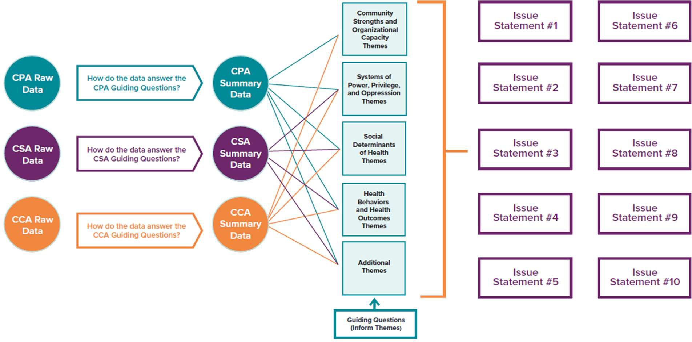
Source: NACCHO
After data was triangulated, counties used Fishbone Diagrams to examine the cause and eﬀect of each identiﬁed community issue – Figure 5. Using the Five Whys - identifying an issue and asking “why” at least ﬁve times to get to the root cause - counties were able to narrow the list of priorities and identify upstream root causes on which to focus.
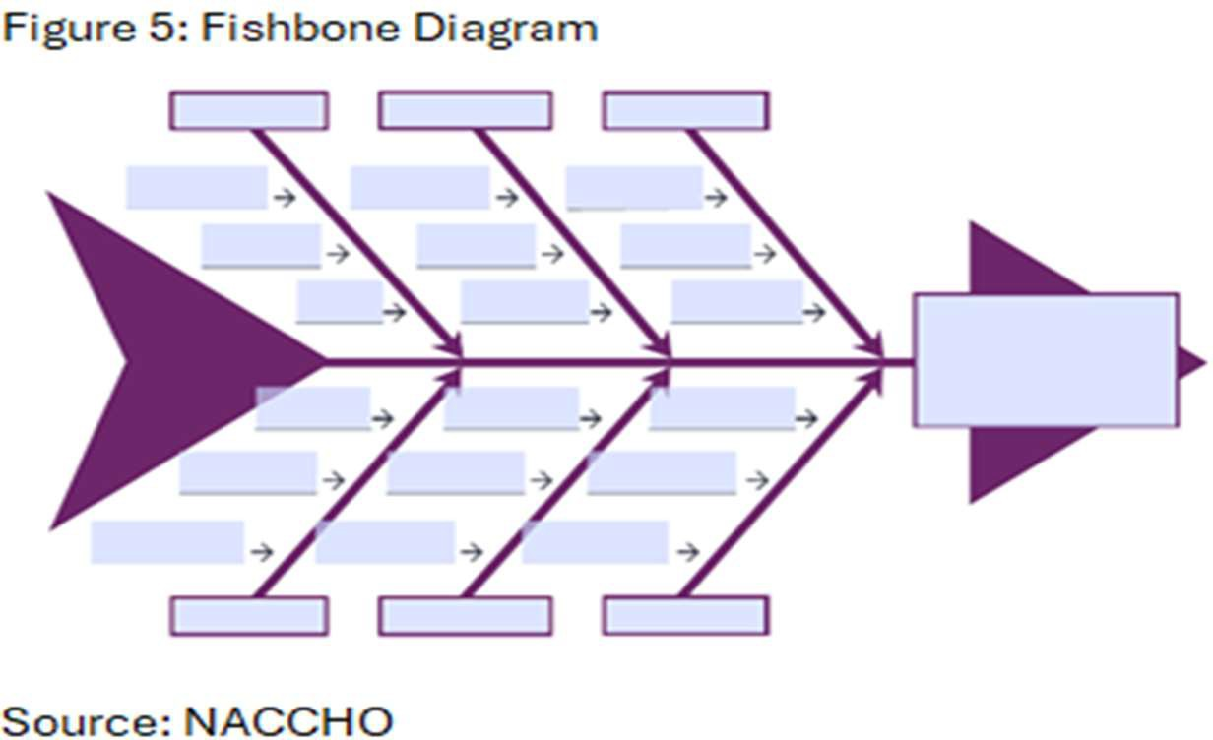

Each county then reviewed ﬁndings with their stakeholders and community partners and conducted a Health Assessment Prioritization using a prioritization matrix to rank each theme based on ﬁve criteria:
- Relevance of the issue to community members.
- Magnitude/severity of the issue.
- Impact of the issue on communities impacted by inequities.

- Availability and feasibility of solutions and strategies to address the issue.
- Availability of resources (time, funding, staﬃng, equipment) to address the issue.
Using prioritization results, each county identiﬁed at least three Prevention Agenda Priorities to address in its CHIP.
Phase 3: Continuously Improve the Community
In phase 3, assessment ﬁndings and selected priorities are used to develop, implement, and monitor a Community Health Improvement Plan (CHIP). This phase emphasizes ongoing collaboration, use of evidence-based strategies, and continuous quality improvement to advance health equity and strengthen community conditions over time. After the selection of focused Prevention Agenda priorities to be included in the CHIP, local health departments and community partners will identify
evidence-based and promising practices that address the root causes and key drivers of each priority area. Local county committees will then select strategies that are realistic and feasible for implementation, taking into account local capacity, existing and potential partners, and available resources. Following the selection of strategies, partners will identify clear performance measures and selected Prevention Agenda objectives to monitor implementation, track progress, and assess impact over time, supporting a continuous quality improvement approach to community health.
Because of lags in the development and release of the NY State Prevention Agenda in 2025, an extension for submission of the CHIP was granted to local health departments. The CHA is due in December of 2025, while the comprehensive CHIP is due in June of 2026. See individual county chapters for additional information.

Partner Engagement
Community partners played a key role throughout the CHA process and during the development of the CHIP. Each partner completed the Community Partner Assessment (CPA), providing valuable organizational data and insights. They also helped identify and engage community members and organizations for focus groups as part of the Community Context Assessment (CCA), ensuring diverse perspectives were included.
Throughout the process, each county’s stakeholders and partners participated in regular meetings where ﬁndings from all three assessments were presented. These sessions encouraged questions, feedback, and shared interpretation of the data. These work groups collaboratively reviewed and discussed the triangulated results, allowing partners to validate ﬁndings and contribute to identifying key themes.
Finally, partners participated in the prioritization process, ensuring that shared priorities reﬂected both data and community voice.

Regional Access to Care Report
In addition to the MAPP 2.0 Framework process, Pivital Public Health Partnership, in collaboration with the eight local health departments, administered the Access to Care Survey⁴ between July and November 2024 to obtain primary, population-based data on access and barriers to care across the

⁴ Source: Access to Care in the Finger Lakes Region, Collaborative Assessment Report, 2025 https://pivitalphp.org/reports/access-to-care/

region. The survey, oﬀered in multiple formats and languages, included questions on having a usual source of care, use of routine and preventive services, delays in care due to cost or transportation, experiences with behavioral health care, insurance status, and key demographic characteristics, and yielded more than 1,700 completed responses from residents of the eight counties.
Survey data were cleaned, weighted to reﬂect the regional population using Census-based distributions, and analyzed using descriptive statistics to characterize access indicators and chi-square tests and logistic regression models to examine diﬀerences and disparities by factors such as race, insurance type, geography, and Plain Community status. Findings from this analysis were integrated with MAPP 2.0 assessments and qualitative input from focus groups to identify populations facing the greatest barriers, and were used to inform health issue prioritization.
Key ﬁndings from the survey showed that people in the eight-county region continue to face barriers when trying to access health care:
- Not enough providers: It is diﬃcult for many people to ﬁnd a doctor, dentist or mental health provider, especially in rural areas.
- Transportation issues: Many people do not have reliable ways to get to appointments, especially if they do not own a car or if they live far away from care.
- Insurance problems: People without insurance and those who have Medicaid often have a harder time getting care. They may have to wait longer or travel farther.
- Unequal access: Non-White, rural and Plain community (Amish/Mennonite) members face compounded barriers, with reduced routine/preventive care and higher rates of appointment access challenges.
- Community strength: People also shared many positive things, like strong local groups, caring volunteers, helpful nonproﬁt organizations, and local hospitals.
The report also identiﬁed emerging issues within the Finger Lakes region:
- Health care workforce shortages: Behavioral health, in particular, along with other health care workers are in demand. Rural communities have a diﬃcult time attracting talent because of aging infrastructure and rate of pay.
- Telehealth expansion: While telehealth may be expanding in many areas of the country, limited broadband access makes its dissemination problematic in rural areas.
- Insurance policy changes: Impending cuts to Medicaid may impact access to care and increase out-of-pocket costs.
- Supplemental Nutrition Assistance Program (SNAP): Expected changes to eligibility may mean residents are forced to choose between food and medical care, including prescriptions.
- Integration of care: New models of care are being piloted in many areas but face funding and coordination challenges in the Finger Lakes region.
- Equity gaps: Mortality rates among minority populations are higher than other groups. Additionally, higher Medicaid-dependence is linked with higher food insecurity issues which impact overall health.
- Innovative care models: Social Care Networks and Urgent Care expansion will help to alleviate some rural health concerns and issues.

Comprehensive Regional Community Health Assessment

The following narrative describes life, health and disparities in the Finger Lakes Region using qualitative and quantitative data.

Demographics

Community Description: The Finger Lakes Region
The Finger Lakes get their name from the series of 11 lakes in central and western New York that resemble the ﬁngers on a hand. Native American lore explains that the lakes were formed when the Great Spirit laid his hand down on the region. The lakes were formed as an impression of his hand blessing the landscape.⁵ Scientiﬁcally speaking, the lakes were formed by receding glaciers over two million years ago.⁶ The area now serves as an idyllic recreational spot with abundant outdoor activities, award-winning wineries, historic and quaint towns, and vast agricultural farmland. While smaller urban areas do exist within the counties, this mostly rural region of New York State shares the health-related issues and illnesses of many rural areas in New York and the United States.
Though the Finger Lakes Region encompasses a larger swath of the state, the eight Finger Lakes counties represented in this Community Health Assessment, include: Chemung, Livingston, Ontario, Schuyler, Seneca, Steuben, Wayne, and Yates. (Map 1)
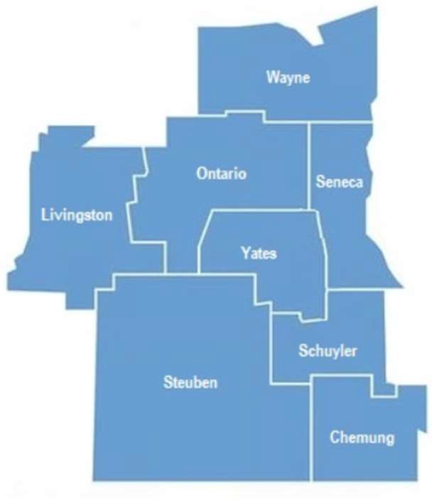
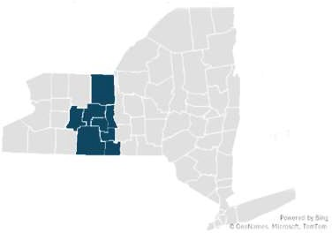
Map 1: The Finger Lakes Region of New York State

⁵ Source: FingerLakesTravelNY.com: History of the Finger Lakes
⁶ "Ithaca is Gorges: A Guide to the Geology of the Ithaca Area, Fourth Edition" by Warren D. Allmon and Robert M. Ross, published in 2007 by the Paleontological Research Institution

Population Estimates, Projections, and Characteristics
Population Estimates




Figure 6: Anticipated Percent Change in Population from 2020- 2040
4.30%
2.50%
Livingston
Ontario
-0.70%
Schuyler
-0.40%
Seneca
-0.30%
Yates
-4.60%
Chemung
-6.20%
Steuben
-7.00%
Wayne

Source: County Health Rankings, Census Population Estimates, Cornell Program on Applied Demographics

There are 515,563 people living in the 8-county Finger Lakes Region. Estimates projecting into the year 2040 demonstrate a slight decrease in the population for most counties, with the exceptions of Livingston and Ontario. The largest decreases are expected in Chemung, Steuben and Wayne Counties.
Age Group Projections
Over the next ﬁve years (2025–2030), the population of residents aged 65 and older is projected to increase in all Finger Lakes counties, while younger age groups (under 18, 18–39, and 40–64) are expected to decline in most counties. Exceptions include: Ontario County, which is projected to see a slight increase in the under-18 population; Seneca County, which is expected to gain residents aged 40–64; and Yates County, which is projected to experience growth in the 18–39 age group. The overall growth in the older adult population will likely increase demand for geriatric care and chronic disease management across the region. Figure 7 illustrates the projected percent change in each age group by county.

Figure 7: Population Projections by Age Group, Finger Lakes Region

Population Projections 2025-2030 (Percent Change)
-15.00 -10.00 -5.00 0.00 5.00
10.00
15.00
Chemung
Livingston Ontario Schuyler Seneca Steuben Wayne Yates

Percent change (under 18) Percent change (18-39) Percent change (40-64) Percent change (65+)
Source: Cornell University Program on Applied Demographics, 2025-2030
Race/Ethnicity
More than 90% of the Finger Lakes Region population is White/Non-Hispanic. Chemung County has the largest non-white population with 5.9% Black, 3.6 % Hispanic, 0.3% American Indian/Alaska Native. (Figure 8)
Race/Ethnicity Finger Lakes Region (2020)
7
6
5
4
3
2
1
0
Chemung Livingston
Ontario
Schuyler
Seneca
Steuben
Wayne
Yates
Black Hispanic American Indian/Alaska Native
Figure 8: Race/Ethnicity Finger Lakes Region
Source: An Ecosystem of Minority Health and Health Disparities Resources. National Institute on Minority Health and Health Disparities

Migrant Farm Workers

The 2022 Census of Agriculture reported that there were 22,000 farm workers in the Finger Lakes region. Just less than one quarter (5,340) were unpaid and probably represented family members or co-op workers. The vast majority (16,600) were paid workers, but not necessarily in full-time or permanent positions. Wayne County had the highest number of migrant workers (3,034) of the eight counties.
An estimated 25% of the region’s farms contract with migrant farm workers. Because migrant farm workers move from job to job depending on the season, a single migrant worker may be counted by multiple farms, therefore the total number of migrant workers is potentially an over count of individuals (Table 3).
Table 3: Farms and Farm Workers in the Finger Lakes Region

County | Number of Farms with Hired Workers (2022) | Number of Farms with Migrant Workers (2022) | Hired Farm Labor* |  | Number of Migrant Workers** (2022) | Number of Unpaid Workers*** (2022)
County | Number of Farms with Hired Workers (2022) | Number of Farms with Migrant Workers (2022) | Total Workers (2022) | Number of Workers Who Worked  <150 days  (2022) | Number of Migrant Workers** (2022) | Number of Unpaid Workers*** (2022)
Chemung | 48 | 2 | 171 | 90 | (D)^ | 381
Livingston | 142 | 16 | 998 | 354 | 68 | 477
Ontario | 229 | 32 | 1,547 | 718 | 307 | 801
Schuyler | 108 | 25 | 943 | 547 | 119 | 333
Seneca | 146 | 39 | 1,653 | 1,212 | 493 | 429
Steuben | 297 | 21 | 1,344 | 690 | 66 | 1,370
Wayne | 259 | 141 | 3,902 | 2,590 | 3,034 | 677
Yates | 250 | 80 | 1,625 | 1,111 | 390 | 872
Total Finger Lakes  Region | 1,479 | 356 | 12,183 | 7,312 | 4,477 | 5,340

*Hired farm labor does not include contract/migrant workers.
**Migrant farm workers are workers whose employment requires travel that prevents the worker from returning to his or her permanent place of residence the same day.
***Unpaid workers include agricultural workers not on the payroll who performed activities or work on a farm or ranch.
^Suppressed to avoid disclosing data for individual farms.
Source: US Department of Agriculture, 2022 Census of Agriculture
Migratory and seasonal agricultural workers and their families face distinct barriers that contribute to signiﬁcant health disparities. Factors such as hazardous working conditions, poverty, inadequate housing, limited clean water, lack of insurance, language and cultural barriers, and fear and mistrust related to immigration status limit access to consistent, quality care. These challenges increase the risk of serious health issues including diabetes, malnutrition, depression, substance use, infectious diseases, pesticide exposure, and work-related injuries. Migration further heightens these problems by creating isolation and disrupting continuity of care, making it harder to maintain treatment and health records.⁷

⁷ Source: Rural Health Information Hub, 2025: https://www.ruralhealthinfo.org/topics/migrant-health

A healthy migrant community is essential to the farming industry in the eight-county region and therefore essential to the livelihood of farmers and the economy of the region. Without them, ﬁelds may go unplanted, fruit unpicked, and crops unharvested.
Amish/Mennonite
The Plain Community - Amish and Mennonite - is an important part of the Finger Lakes region, contributing substantially to the agricultural sector in many areas. Obtaining reliable, current information about their population size and health outcomes is diﬃcult, particularly at the county level, because these groups typically do not participate in U.S. Census Bureau surveys.
Elizabethtown College’s Young Center for Amish Studies provides annual population estimates that help ﬁll this gap. According to their data, New York State has 60 Amish settlements and 188 districts, totaling roughly 25,220 individuals.⁸ Within the Finger Lakes, speciﬁcally Livingston, Seneca, Steuben, and Wayne Counties, there are 16 districts with an estimated 3,770 Amish residents.⁹ These numbers do not include Mennonite populations. The Young Center also compiles information on various Mennonite groups, often organized by church conference. In New York, the Groﬀdale Conference Mennonites are estimated at 3,856 people, the Midwest Mennonite Conference at 971, and the Stauﬀer Mennonite Conference at around 476.¹⁰
When reviewing data or planning public health eﬀorts, it is important to account for Amish and Mennonite cultural practices. Decision-making about health care is typically inﬂuenced by church leaders’ guidance. Many families rely on natural or homeopathic health approaches, which can delay lifesaving medical care and aﬀect decisions about family planning, preventive care, dental care, and vaccinations. Home births and delayed prenatal care are relatively common as is breast feeding. Children generally attend school through eighth grade before focusing on farming or learning a trade, increasing exposure to potential injuries. Travel by bicycle or horse-drawn buggy also creates traﬃc-safety concerns on rural roads shared with faster-moving motor vehicles.
These cultural factors combined with expected population growth are important considerations for public health professionals in the region. Research suggests that when health information is oﬀered by trusted sources and services are easily accessible, Plain families are often receptive to interventions, including certain immunizations. Building cultural understanding and maintaining ﬂexible, consistent outreach can support strong participation in recommended health practices.¹¹
American Indian and Alaska Native Population

⁸ “Amish Population Proﬁle, 2025.” Young Center for Anabaptist and Pietist Studies, Elizabethtown College. https://groups.etown.edu/amishstudies/statistics/amish-population-proﬁle-2025.
⁹ Statistics compiled by Edsel Burdge Jr., Young Center for Anabaptist and Pietist Studies, Elizabethtown College, in cooperation with Joseph F. Donnermeyer, School of Environment and Natural Resources, The Ohio State University, and with assistance from Adam Hershberger, Ohio Amish Library, Millersburg, Ohio.
¹⁰ Compiled from the most recent directories by Edsel Burdge Jr., Young Center for Anabaptist and Pietist Studies, Elizabethtown College, 1 Alpha Drive, Elizabethtown, PA 17022 Updated October 2025
¹¹ Baillie, K. U. (2018, July 13). With free vaccinations, ChildProtect program helps Amish communities stay healthy. Penn Today. University of Pennsylvania. https://penntoday.upenn.edu/news/free-vaccinations-childprotect-program-helps-amish-communities-stay-healthy

In 2022, 1,408 residents of the Finger Lakes region identiﬁed themselves as American Indian and Alaska Native alone. However, it is important to note that this estimate does not include residents who identify as multiple races.¹²
The Centers for Disease Control and Prevention noted that as of 2023, the average life expectancy for American Indians and Alaska Natives is the lowest of all ethnic groups. American Indians and Alaska Natives can expect to live to 70.1 years as compared with the national estimate of 78.4 years. Further, they also report being in fair or poor health more often than all other racial groups (24.4%). The leading causes of death in this group are heart disease, cancer, unintentional injuries, chronic liver disease, and diabetes.¹³
These disparities exist for a number of reasons but largely correlate back to inadequate educational opportunities, disproportionate rates of poverty, discrimination in the delivery of health services, and the impact of historical intergenerational trauma including centuries of racial discrimination.¹⁴
Foreign Born Population
The majority of those who are foreign-born living in the Finger Lakes region have become naturalized US Citizens. The naturalization rate varies by county, from as low as 35 percent in Wayne County to 77.9 percent in Yates County (Table 4). Residents coming from other countries may face significant challenges in adapting to the United States’ disease prevention and treatment culture and, as such, should be cared for and tended to in a way that is respectful of and collaborative with the customs and beliefs of their heritage.
Table 4: Foreign Born and Citizenship

County | Percent of Population that is Foreign-born  (2020) | Percent Naturalized  U.S. Citizen (2020) | Percent Not a U.S. Citizen (2020)
Chemung | 3.6 | 58.0 | 42.0
Livingston | 3.5 | 51.5 | 48.5
Ontario | 5.0 | 55.8 | 44.2
Schuyler | 1.9 | 51.8 | 48.2
Seneca | 2.9 | 54.4 | 45.6
Steuben | 3.3 | 38.4 | 61.6
Wayne | 5.0 | 35.0 | 65.0
Yates | 1.6 | 77.9 | 22.1
Source: U.S. Census Bureau, 2020 Census.
Public health professionals must keep cultural and linguistic diﬀerences in mind when collecting and exhibiting data, developing and providing programming, and evaluating the eﬀectiveness of interventions. Demonstrating respect for an individual’s national and cultural background fosters trust

¹² Source: U.S. Census Bureau Population Estimates Program. Methodology for the United States population estimates: Vintage 2022. 2022. https://www2.census.gov/programs-surveys/popest/technical-documentation/methodology/2020-2022/methods-statement-v2022.pdf
¹³ Source: CDC, https://minorityhealth.hhs.gov/american-indian-and-alaska-native-health
¹⁴ US Commission on Civil Rights, Broken Promises: Continuing Federal Funding Shortfall for Native Americans, 2018

and strengthens the practitioner–client relationship. Cultural responsiveness enhances the quality of care, supports better health outcomes, and reduces disparities.
Household Languages
While most people in the Finger Lakes region primarily use English, a smaller portion of the population speaks other languages at home. These include Spanish, various Asian and Paciﬁc Island languages, and a range of other Indo-European languages (Figure 9). In Yates County, the notable share of Indo-European language speakers is inﬂuenced by the presence of Amish and Mennonite communities in which some families speak German dialects in the home. Small counties may have no bilingual staﬀ members and few options for obtaining interpreters.
Figure 9: Percent of Households Speaking a Language Other than English
Percent of Households Speaking a Language Other than English
(2024)
18
16
14
12
10
8
6
4
2
0
Chemung Livingston
Ontario
Schuyler
Seneca
Steuben
Wayne
Yates
Overall Spanish Other Indo-European Languages Asian and Pacific Island Languages Other Languages
Source: U.S. Census Bureau, 2024 ACS 1or 5-year estimates

Disability
People with disabilities face a higher likelihood of developing chronic health issues such as obesity, heart disease, and diabetes. Reducing health disparities among this population involves fostering a community culture that supports inclusion and creating welcoming physical spaces free of conditions that might prohibit participation in healthy behaviors. Achieving this requires coordinated eﬀorts across multiple disciplines, including policy, systems, and environments.
Figure 10 shows the disability rate for each county in the Finger Lakes region. The most common disabilities in the region are cognitive, ambulatory and independent living.¹⁵

¹⁵ Source: U.S. Census Bureau, 2020 Census

Figure 10: Disability Rate by County
Disabled Population by Percent of Total (2020)
20
18
18.3
18
15.9
16
15.1
15.6
14.1
14
12
13.6
11.1
10
8
6
4
2
0
Chemung Livingston
Ontario
Schuyler
Seneca
Steuben
Wayne
Yates
Source: U.S. Census, 2020 Census
Veterans
The population of veterans in the eight counties of the Finger Lakes is higher than the NYS average of 3.5 percent. Veterans certainly have the same health care needs as others in the community, however, they may also require additional health care services related to mental health, physical health and issues related to environmental exposure during service.¹⁶ Figure 11 details the percentage of veterans in each county.
Figure 11: Veteran Population by Percent of Total Population
Veteran Population by Percent of Total (2020)
10
8.9
8.7
8.6
8
7.2
7.7
6.9
7
7.4
6

4

2

0
Chemung Livingston Ontario
Schuyler
Seneca
Steuben
Wayne
Yates
Source: U.S. Census, 2020 Census

¹⁶ Source: Veterans Aﬀairs, https://www.va.gov/health-care/health-needs-conditions/

Health Insurance Status
Health insurance plays an important role in ensuring people can obtain necessary medical services. Like individuals with limited ﬁnancial resources, those without insurance are less likely to seek routine or preventive care, often lack a consistent healthcare provider, and may rely more heavily on emergency departments for issues that could be managed in primary care. Figure 12 illustrates the share of residents in each county who are uninsured. The notably higher uninsured rate in Yates County is likely inﬂuenced by the sizable Amish and Mennonite communities living there.
Percentage of Population Uninsured (2020)
25
20
19.6
15
10
8.7
6.1
5
5
3.9
3.5
4.1
2.4
0
Chemung Livingston
Ontario
Schuyler
Seneca
Steuben
Wayne
Yates
Figure 12: Health Insurance Status
Source: U.S. Census Bureau, 2020 Census

In October of 2025, in New York, 6,812,160 residents were enrolled in Medicaid.¹⁷ Of these, 128,589 are residents of the eight county Finger Lakes Region. According to the NY State of Health, an estimated 1-
1.5 million New Yorkers may lose Medicaid coverage in 2026 due to new federal requirements.¹⁸ Using this projection, between 18,774 and 28,290 Finger Lakes residents may lose coverage. Figure 13 highlights the number of residents with Medicaid coverage versus the overall population in each county.

¹⁷Source: Medicaid Enrollment Databook, October 2025 at https://www.health.ny.gov/health_care/medicaid/enrollment/docs/by_resident_co/current_month.htm ¹⁸ Source: https://info.nystateofhealth.ny.gov/stay-connected

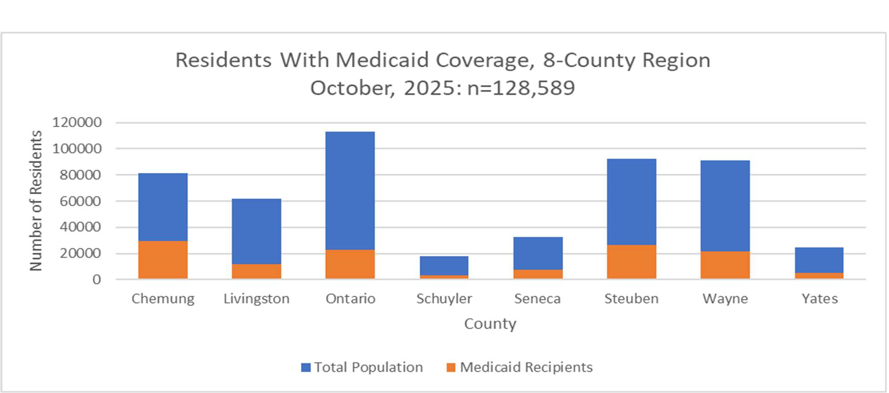
Figure 13: Residents with Medicaid Coverage

Source: Source: Medicaid Enrollment Databook

Broadband Access
Access to broadband services has become a necessity. The Covid-19 pandemic elevated the need for broadband access to participate in work and school and to acquire healthcare. New York State as a whole has extensive broadband access (90%), but not every part of the state has the same access. Figure 14 notes the percentage of households with a broadband connection versus the percentage in the county who have no access to broadband services, meaning broadband service is not available to them to purchase or access.
Broadband Connection vs. Access (2025)
0
10
20
30
40
50
60
70
80
90
100
Chemung
Livingston Ontario Schuyler Seneca Steuben Wayne Yates
Households with Broadband Connection
Households with no Access to Broadband Services
Figure 14: Broadband Connection vs Broadband Access in each County
Source: Oﬃce of the State Comptroller, ACS, County Health Rankings

Transportation

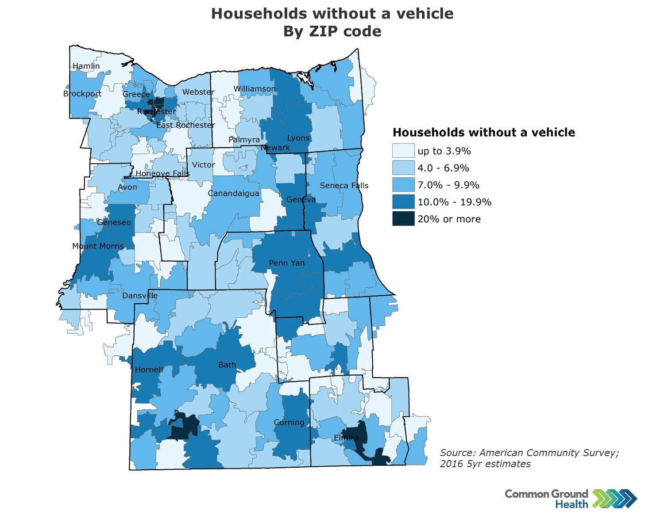
Rural residents lack equitable access to transportation. Low population density often makes public transportation implausible. Access to a personal vehicle can aﬀect an individual’s health and wellness in many ways. Unreliable, inconsistent or inconvenient transportation can cause a strain on the ability to access health care services, purchase food and other items, and maintain a job. These can result in, poor health outcomes, and decreased economic stability.
Figure 15 shows the proportion of households in each Finger Lakes county that do not have access to a vehicle. Yates County’s higher percentage is largely due to the Amish and Mennonite communities, who typically use horse-and-buggy travel rather than motor vehicles. This is particularly evident in Map 2.
Map 2: Households without a Vehicle by Zip Code

Figure 15: Percent of Households with No Vehicle Access
No Vehicle Access (2023)
14
13
12
10
9.6
9.9
8.8
8
5.9
6.4
6.3
7
6
4
2
0
Chemung Livingston
Ontario
Schuyler
Seneca
Steuben
Wayne
Yates
Source: U.S. Census Bureau 2023 5-year estimates

Life Expectancy
Genetics are not the only indicator of an individual’s life expectancy. Social determinants of health play an important role. Table 5 notes the life expectancy in each county in the Finger Lakes region along with the percent change from 2018. Life expectancy is decreasing in most counties and is below the New York State average.
Table 5: Life Expectancy

County | Life Expectancy (2022)  (NYS: 79.4) | Percent Change from Baseline  (2018)
Chemung | 75.0 | -3%
Livingston | 79.4 | -1%
Ontario | 79.8 | No change
Schuyler | 76.5 | -2%
Seneca | 77.6 | No change
Steuben | 76.3 | -3%
Wayne | 77.2 | -2%
Yates | 78.1 | No change

Source: County Health Rankings, National Center for Health Statistics-Mortality Files
In addition, Map 3 further delineates life expectancy by Zip Code. Lower life expectancy by zip code corresponds with increased poverty rates (Maps 6-8), higher preventable hospitalizations (Map 17) and higher Emergency Department visits (Maps 18-22).
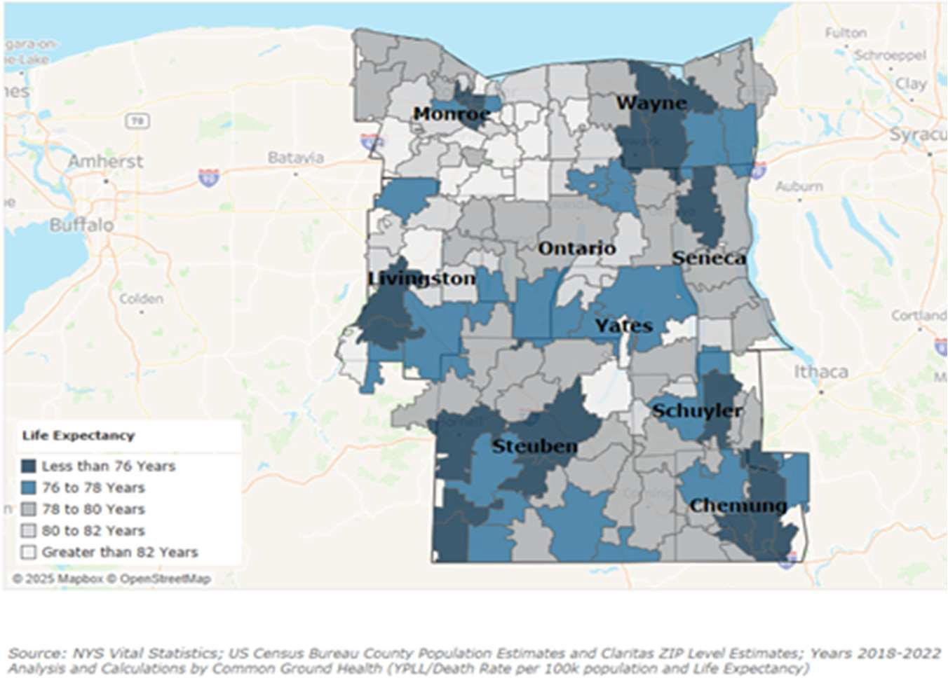
Map 3 Life Expectancy by Zip Code, Finger Lakes Region
Courtesy Common Ground Health

Leading Causes of Death in the Finger Lakes
The most common causes of death and incidence per 100,00 are noted in Table 6. The top two leading causes of death in all eight counties are heart disease and cancer. All counties except Ontario have a higher death rate per 100,000 population than the NY State average.
The rates shown for Alzheimer’s in this table reﬂect a combined category of “Alzheimer’s disease and other dementias” that was age–sex adjusted using local population estimates, whereas the state Vital Statistics tables report age adjusted rates for “Alzheimer’s disease” alone. As a result, counts for Alzheimer’s disease align with state data, but the inclusion of other dementias and diﬀerent adjustment methods inﬂate rates and allow this combined category to appear among the leading causes of death in several counties while still following a trend similar to the state’s Alzheimer's only rates.
Across the region, the most commonly diagnosed cancers reﬂect patterns seen statewide, with breast (female), prostate, and lung cancers appearing most frequently in many counties, alongside colorectal cancer in some areas. These cancers represent a substantial share of the overall cancer burden even when they are not always the leading causes of cancer death, underscoring the importance of continued emphasis on screening, detection, and early treatment.
Table 6: Leading Causes of Death 2022

County | First Cause | Second Cause | Third Cause | Death Rate/100,000  (NYS: 744.2/100,000)
Chemung | Heart Disease  235.6/100,000 | Cancer  184.7/100,000 | Alzheimer's and Other Dementias  87.0 /100,000 | 1,014
Livingston | Cancer  145.1/100,000 | Heart Disease  122.1/100,000 | Alzheimer's and Other Dementias  73.1/100,000 | 763.1
Ontario | Heart Disease  141.8/100,000 | Cancer  128.9/100,000 | Alzheimer's and Other Dementias  69.8/100,000 | 716.9
Schuyler | Cancer  221.5/100,000 | Heart Disease  210.8/100,000 | Diabetes  63.6/100,000 | 974.3
Seneca | Heart Disease  167.6/100,000 | Cancer  155.8/100,000 | Alzheimer's and Other Dementias  87.8 /100,000 | 812.9
Steuben | Heart Disease  204.7/100,000 | Cancer  187.8/100,000 | Alzheimer's and Other Dementias 71.5/100,000 | 944.8
Wayne | Cancer  151.5/100,000 | Heart Disease  170.4/100,000 | Alzheimer's and Other Dementias 78.3/100,000 | 828.0

Yates | Cancer  143.3/100,000 | Heart Disease  142.6/100,000 | Alzheimer's and Other Dementias 88.4/100,000 | 839.3
Source: New York State Department of Health Vital Statistics, 2022
Map 4 highlights the age-adjusted death rate for heart disease per 100,000 population and Map 5 details the age-adjusted death rate for cancer per 100,000 population in each of the counties of the Finger Lakes. Note that the highest death rates for both cancer and heart disease in both maps coincide with the highest poverty rates (Maps 6-8), and lowest life expectancy of the counties. It also coincides with higher preventable hospitalizations (Map 17) and higher Emergency Department visits (Maps 18-22).
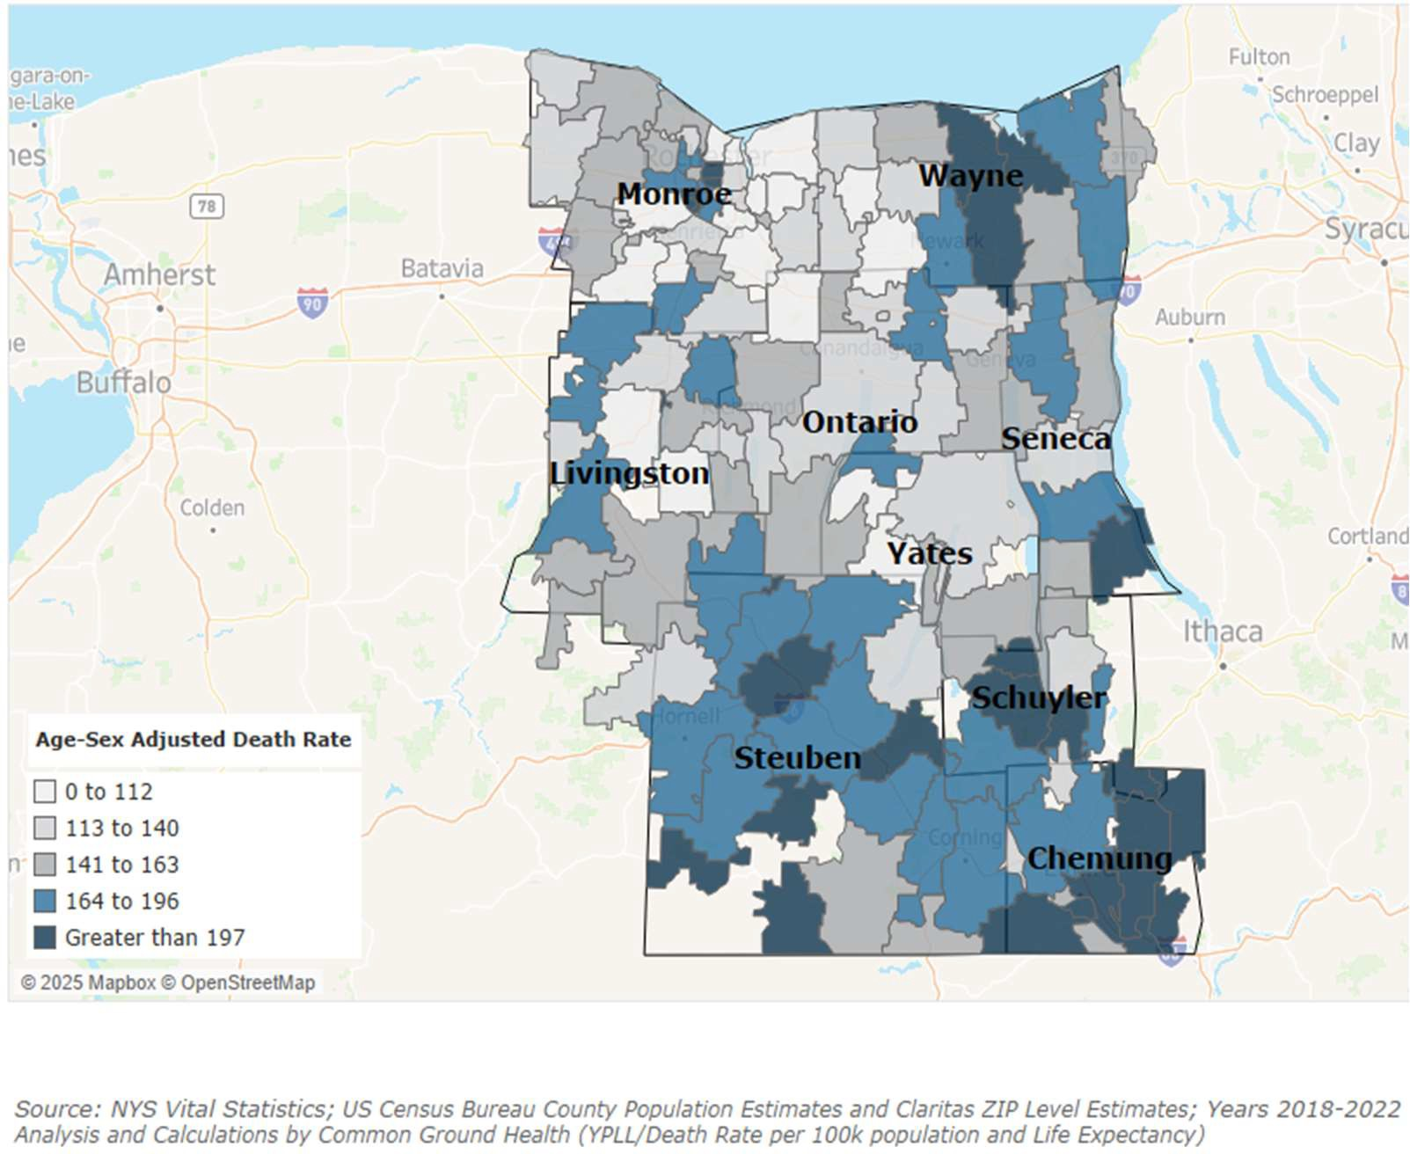
Map 4: Age-Adjusted Death Rate for Heart Disease Rate per 100,000
Courtesy: Common Ground Health

Map 5: Age-adjusted Death Rate for Cancer Rate per 100,000
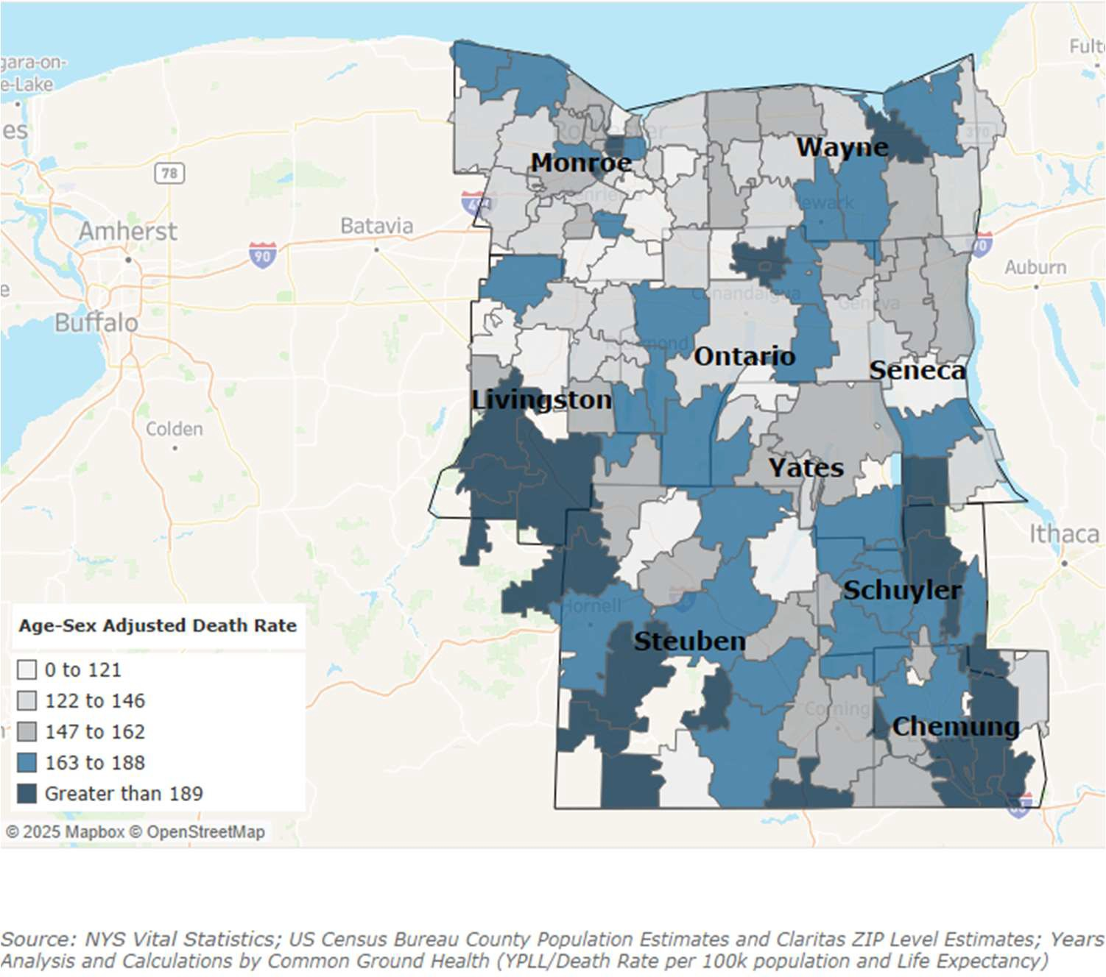
Courtesy: Common Ground Health

Leading Causes of Premature Death
The top causes of premature death and incidence per 100,000 are noted in Table 7. Consistent across all eight counties, the top three causes of premature death (before age 75) are cancer, heart disease and unintentional injury. Most counties also exceed the New York State average rate for premature death.
Unintentional injury deaths in Yates County may be due in part to its Mennonite and farming communities. There are many family-owned farms on which children assist parents with chores and among Mennonites, children are taught trades while still very young. Transportation by horse and buggy and bicycle increase the risks for injuries on roadways.

Table 7: Leading Causes of Premature Death 2022

County | First Cause | Second Cause | Third Cause | Premature Death Rate (NYS:  326.8/100,000)
Chemung | Cancer  111.7/100,000 | Heart Disease  88.3/100,000 | Unintentional Injury  75.4/100,000 | 496.2
Livingston | Cancer  80.8/100,000 | Unintentional Injury 43.6/100,000 | Heart Disease  33.4/100,000 | 324.1
Ontario | Cancer  60.5/100,000 | Heart Disease  60.7/100,000 | Unintentional Injury  38.1/100,000 | 304.6
Schuyler | Cancer  123.0/100,000 | Heart Disease  65.8/100,000 | Unintentional Injury  62.0/100,000 | 420.2
Seneca | Cancer  91.5/100,000 | Heart Disease  50.8/100,000 | Unintentional Injury  36.7/100,000) | 369.6
Steuben | Cancer  97.1/100,000 | Heart Disease  62.6/100,000 | Unintentional Injury  48.9/100,000 | 423.5
Wayne | Cancer  93.6/100,000 | Unintentional Injury 58.1/100,000 | Heart Disease  65.6/100,000 | 398.4
Yates | Unintentional Injury 63.4/100,000 | Cancer  61.4/100,000 | Heart Disease  46.0/100,000 | 334.4
Source: New York State Department of Health Vital Statistics, 2022
County Health Rankings
The University of Wisconsin Population Health Institute created County Health Rankings & Roadmaps; a program that seeks to improve health outcomes and close gaps in health disparities.¹⁹
As the county health rankings model has evolved, so have the measures. Table 8 demonstrates how each county in the Finger Lakes ranks compared with New York State and the nation as a whole. Two categories are referenced: Health and Well-being describes health as “more than being free from disease and pain; health is the ability to thrive. Well-being covers both quality of life and the ability of people

¹⁹ County Health Rankings, https://www.countyhealthrankings.org/about-us

and communities to contribute to the world.”²⁰ Community Conditions refer to the social determinants of health. Generally, the Finger Lakes region is better than or equal to New York State and the nation in terms of health and well-being and community conditions.
Table 8: County Health Rankings (2025)

County | Health and Well-being |  | Community Conditions
County | New York State | U.S. | New York State | U.S.
Chemung | Worse | Better | Worse | About Equal To
Livingston | Better | Better | Better | Better
Ontario | Better | Better | Better | Better
Schuyler | About Equal To | Better | Worse | About Equal To
Seneca | Better | Better | Worse | About Equal To
Steuben | About Equal To | Better | About Equal To | Better
Wayne | About Equal To | Better | About Equal To | Better
Yates | Better | Better | Worse | About Equal To
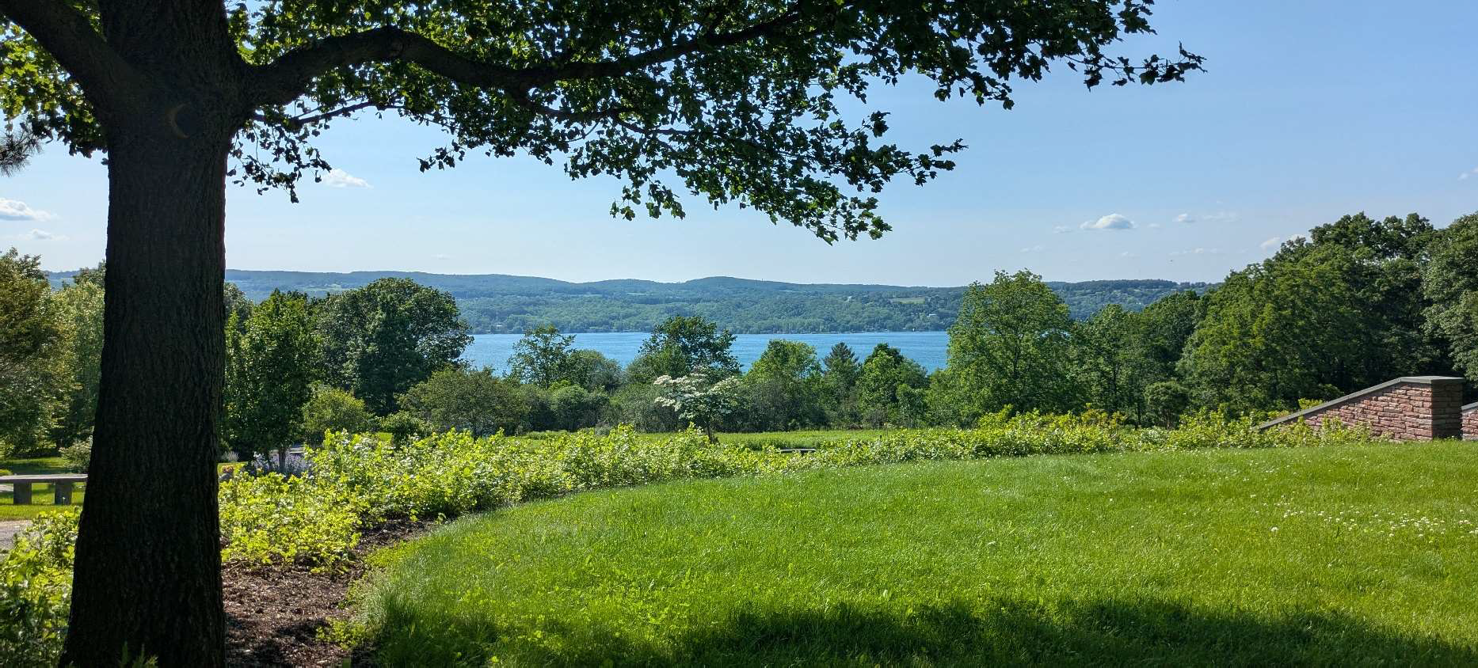
Source: County Health Rankings

Courtesy Ontario County

²⁰ County Health Rankings, https://www.countyhealthrankings.org/health-data

New York State 2025-2030 Prevention Agenda Domains and Priorities

This section details the New York State Prevention Agenda domains and their associated priorities by exploring region-wide data.

Domain 1: Economic Stability

Poverty and Unemployment
The socio-economic status of communities greatly impacts the health outcomes of the individuals residing there. Higher rates of poverty have been linked to increased anxiety and mental illness, higher mortality rates and increased risk of chronic disease. Additionally, communities with increased rates of poverty have more limited access to necessities such as food, shelter, healthcare, education, and employment. Rural poverty is often characterized by isolation and lack of access to resources rather than overcrowded housing and crime, which are more prevalent in urban communities. Map 6 notes poverty rates by zip code in the Finger Lakes region.
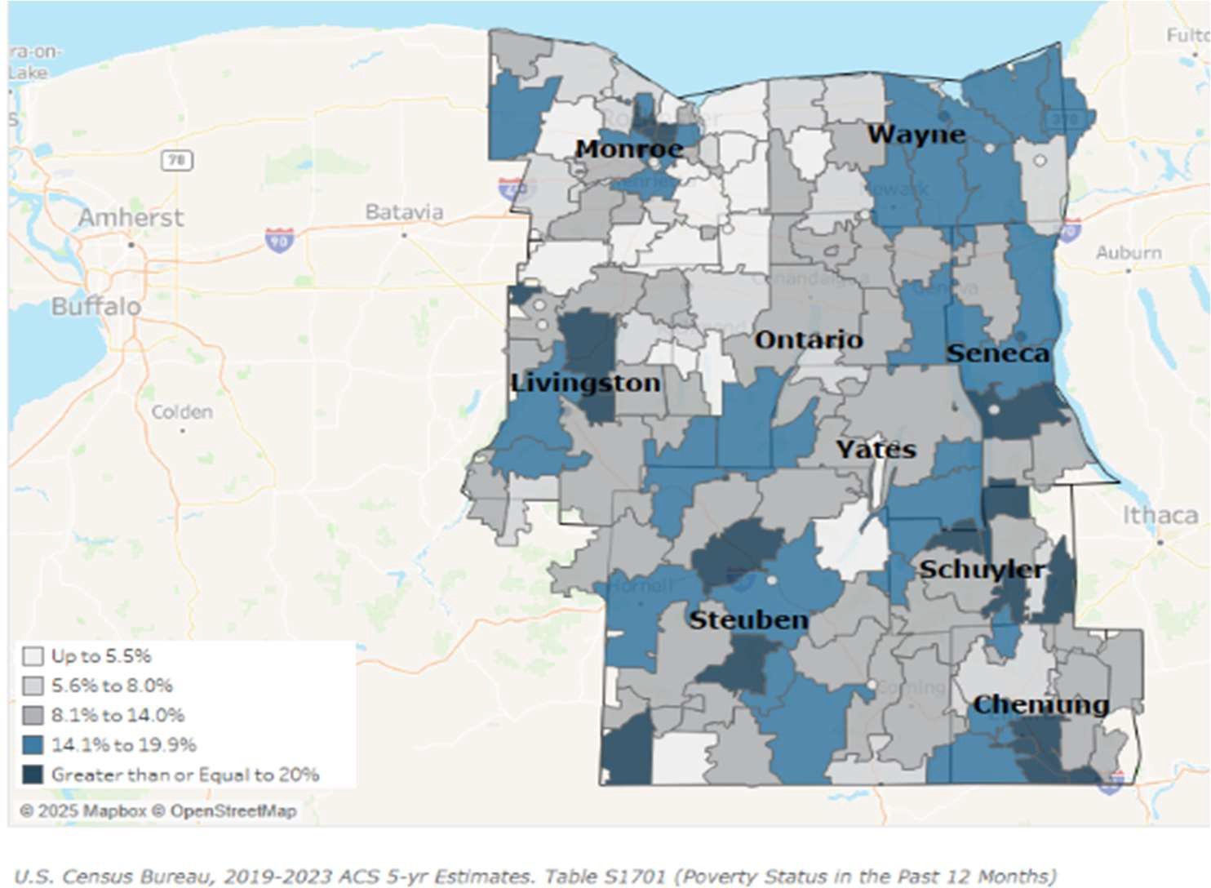
Map 6 Overall Poverty in the Finger Lakes Region
Courtesy Common Ground Health

The population of those 65 years of age and older is expected to increase through at least 2040. Map 7 shows the poverty rate by zip code in this age group. Older Americans living in poverty are at risk for

experiencing earlier mortality, higher rates of disability, loneliness, depression and anxiety.²¹ These patterns indicate that poverty is not evenly distributed, with older adults in rural and higher-deprivation ZIP codes facing disproportionate ﬁnancial and health burdens, which can widen existing health inequities.
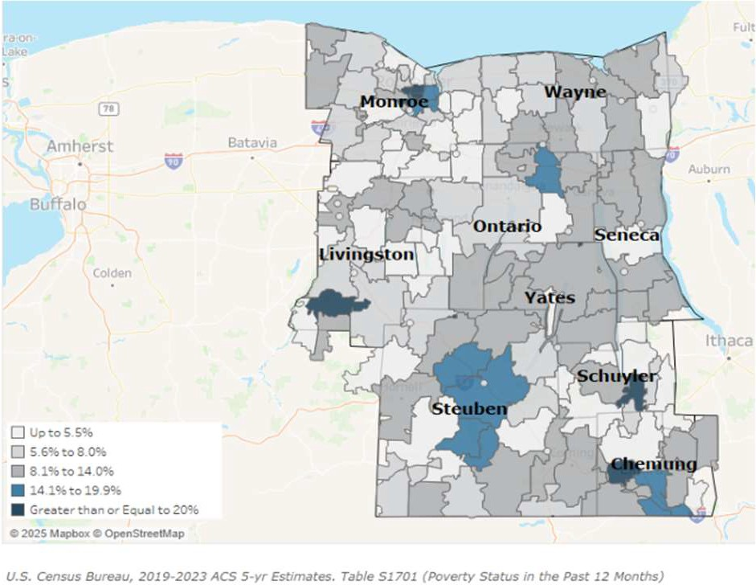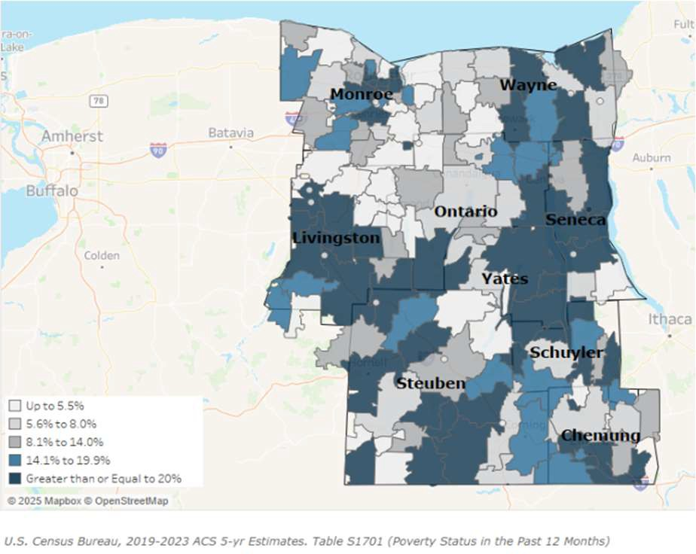
Map 7: Poverty rates by Zip Code for those Over 65
Courtesy Common Ground Health
Map 8: Poverty Rate by Zip Code for those Under 18
Courtesy Common Ground Health
Map 8 shows the poverty rate by zip code in each county for those under age 18. According to the American Psychological Association,²² childhood poverty is signiﬁcant and can be long lasting. It is associated with subpar housing and homelessness, poor nutrition and hunger, less safe neighborhoods, educational lags, and substandard childcare. All of these aﬀect the ability of children to be successful and to be mentally and physically healthy.
The societal costs of poverty are signiﬁcant, not just to individuals, but to the community at large. They include aﬀordable housing shortages, increased homelessness, workforce shortages, increased crime, and more reliance on social sectors such as temporary housing, the justice system, food banks, Medicaid and SNAP. New York Counties share Medicaid and SNAP beneﬁt costs with the federal government.
When poverty rates increase, local contributions to these programs increase, as well, straining already strapped county budgets.
Table 9 notes the poverty rates, median household income, living wage requirement, and unemployment rate for the eight counties compared with the NYS average and the prevention agenda (PA) target. The living wage requirement refers to the amount of money one person would need to earn to cover basic household expenses including taxes for one adult and two children. The percent change from the baseline year is also noted. For several counties, the poverty rate exceeds the NYS average and, in many cases, is increasing. The population of those over age 65 living in poverty, though it does not exceed the NYS average, is particularly alarming as it has increased in all counties. The average household income has increased, but it has not kept pace with the living wage requirement.

²¹ Source: Thornton, M., Bowers, K., (January 31, 2024) "Poverty in Older Adulthood: A Health and Social Crisis" OJIN: The Online Journal of Issues in Nursing Vol. 29, No. 1, Manuscript 3
²² Source: https://www.apa.org/topics/socioeconomic-status/poverty-hunger-homelessness-children

Table 9 Poverty Rates in the Finger Lakes Region

County | % Poverty 2023  NYS: 13.7 PA:12.5* | % Change from 2018* | % Poverty ages <18  2023  NYS: 19* | % Change from 2018* | % Poverty ages >65  2023  NYS: 12.7 PA=11* | % Change from 2018*
Chemung | 15.8 | +7.0 | 22.0 | +10.0 | 10.1 | +15.0
Livingston | 11.6 | -14.0 | 12.0 | -14.0 | 6.9 | +17.0
Ontario | 9.2 | -4.0 | 10.0 | -9.0 | 7.6 | +27.0
Schuyler | 15.1 | +9.0 | 19.0 | -10.0 | 8.9 | +75.0
Seneca | 13.3 | +7.0 | 21.0 | +5.0 | 9.0 | +25.0
Steuben | 13.7 | -2.0 | 19.0 | 0.0 | 11.1 | +63.0
Wayne | 11.3 | 0.0 | 14.0 | -7.0 | 8.3 | +9.0
Yates | 14.1 | +24 | 18.0 | -14.0 | 12.5 | +51
 | Med. House- | % Change | Living Wage | % Change | %Unemployed | % change
 | hold Income  2023 | from 2019** | Required  2023 | from 2021*** | (January  2025)**** | from January  2019****
 | NYS: |  | NYS:
 | $82,100** |  | $61.75***
Chemung | $60,500 | +4.0 | $50.73 | +30.0 | 4.4 | -2.2
Livingston | $70,200 | +16.0 | $51.12 | +29.0 | 4.6 | -9.8
Ontario | $79,400 | +19.0 | $56.94 | +37.0 | 6.1 | +29.8
Schuyler | $65,200 | +25.0 | $49.95 | +31.0 | 6.1 | -1.6
Seneca | $58,600 | +15.0 | $48.77 | +26.0 | 3.6 | -5.2
Steuben | $64,300 | +21.0 | $49.08 | +29.0 | 5.0 | +8.7
Wayne | $73,000 | +18.0 | $51.24 | +29.0 | 4.6 | -9.8
Yates | $66,200 | +9.0 | $51.14 | +33.0 | 4.5 | +4.7
Source: *Poverty Rates: American Community Survey (2018-2023)
**Average Household Income: Small Area Income and Poverty Estimates, U.S. Census (2019-2023)
***Living Wage Requirement: The Living Wage Calculator (2021-2024)
****Unemployment Rate: U.S. Department of Labor (2019-2025)

Nutrition Security
The Food Environment Index (FEI) measures how easily residents can access healthy, aﬀordable foods. The score is based on both the rate of food insecurity and the percentage of low-income residents who live far from a grocery store. Scores range from 0 (worst) to 10 (best). Lack of access to healthy foods is strongly associated with increased rates of obesity, chronic disease (such as diabetes and heart disease), and early death.
The Food Insecurity Rate highlights the economic disparities that may contribute to increases in poverty rates. The Food Insecurity Rate, expressed as a percentage of the total population, measures the share of households that lack consistent access to enough food for an active, healthy life. Map 9 shows the Food Insecurity Rate by Zip Code in the Finger Lakes region.

Map 9: Food Insecurity Rate by Zip Code
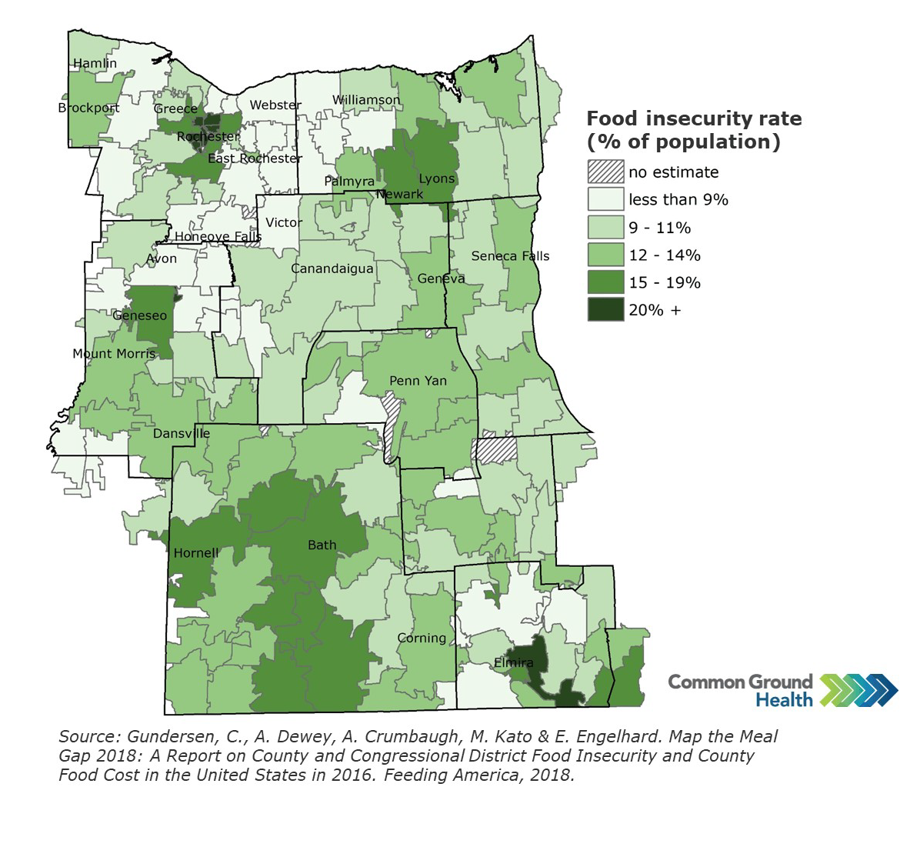
A strong food environment is important because limited access to healthy food is linked to higher rates of chronic diseases (like obesity and diabetes), premature death, and poorer overall community health, especially in low-income and rural communities.
Over the past three years, cross-sectional community surveys conducted by the Pivital Public Health Partnership in Chemung, Livingston, Ontario, Schuyler, Seneca, Steuben, Wayne, and Yates counties show that food insecurity is both common and worsening. Using the validated two-item Hunger Vital Sign screener, the share of surveyed households reporting food insecurity increased from 26% in 2019–2020 to 67% in 2023–2024, indicating that more than two in three responding households now experience concern about having enough food or diﬃculty aﬀording balanced meals. During the same period, the proportion of respondents who reported knowing someone struggling with food insecurity rose from 45% to 65%, underscoring that food hardship is widely visible within residents’ social networks and community life.
A total of 1,289 responses were collected across the eight counties (Chemung 76, Livingston 209, Ontario 380, Schuyler 80, Seneca 164, Steuben 52, Wayne 126, and Yates 202), providing community input to inform assessment and planning. These survey ﬁndings complement secondary indicators such as FEI, food insecurity rate, and SNAP eligibility, reinforcing that many rural residents face both geographic and economic barriers to healthy food and that targeted strategies to improve nutrition security are needed across the region. Taken together, these ﬁndings show that food insecurity disproportionately aﬀects

residents in lower-income and more remote ZIP codes, contributing to avoidable gaps in diet-related health outcomes and reinforcing existing inequities.
Table 10 compares each county’s Food Environment Index (FEI) with its estimated food insecurity rate to illustrate ongoing challenges with nutrition security in the region. Counties with FEI scores below the New York State value of 8.7, such as Chemung, Schuyler, Seneca, and Steuben, face relatively greater barriers to healthy food access, including aﬀordability and proximity to grocery stores. At the same time, food insecurity aﬀects roughly one in eight to one in seven residents across the counties, with the highest rates generally observed in more rural areas, indicating that many households continue to struggle to aﬀord enough nutritious food.
Table 10 Food Environment Index in the Finger Lakes Region

County | Food Environment Index  (2022)  (NYS: 8.7)* | % Change from 2018* | Food Insecurity Rate  (2023)**
Chemung | 7.9 | 0.0 | 14.4
Livingston | 8.7 | +4.0 | 11.8
Ontario | 8.8 | +2.0 | 11.8
Schuyler | 8.4 | +2.0 | 13.9
Seneca | 8.4 | +2.0 | 14.0
Steuben | 8.1 | -1.0 | 13.6
Wayne | 8.7 | +4.0 | 11.9
Yates | 8.8 | -1.0 | 12.4

Source: *County Health Rankings, USDA, **Feeding America: Map the Meal
Seneca Harbor, Courtesy Seneca County

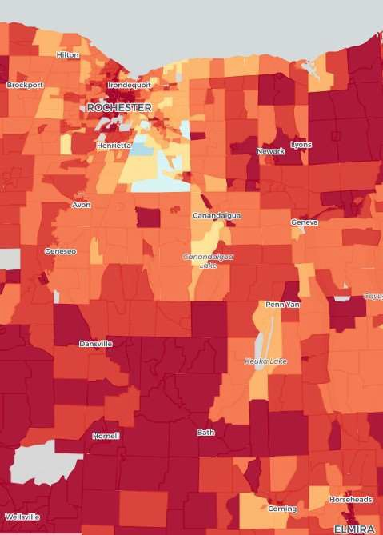

Housing Stability and Aﬀordability
Map 10: Area Deprivation Index by
Source: University of Wisconsin School of
Medicine and Public Health. ADI www.neighborhoodatlas.medicine.wisc.edu
Poor housing conditions are closely linked to health risks, inﬂuencing everything from chronic disease rates to mental well-being. Access to safe, stable, and aﬀordable housing remains a top priority for residents across the region. A high housing cost burden -when households spend a large share of their income on housing - can signal ﬁnancial strain and potential housing instability, which in turn may aﬀect health outcomes and access to other basic needs.
The Area Deprivation Index (ADI) provides additional context by measuring the level of socioeconomic disadvantage in a community based on factors such as income, education, employment, and housing quality. Higher ADI scores indicate greater disadvantages, which can often be associated with poorer housing conditions and elevated health risks. Map 10 notes the ADI by zip code in the Finger Lakes. The ADI is measured from 1 (blue - least deprived) to 10 (red - most deprived). Most deprived areas of the region also coincide with higher poverty rates as can be seen in Maps 6-8.
Table 11 compares both the housing cost burden and the Area Deprivation Index (ADI) across the counties of the Finger Lakes
region, with New York State averages. The data suggest that, while housing cost burdens in most Finger Lakes counties fall below the state average of 19 percent, ADI scores are higher across all counties, indicating that many areas experience greater socioeconomic disadvantage than the state overall. This contrast underscores the complex relationship between housing aﬀordability, neighborhood conditions and community health.
Table 11 Housing Cost Burden and Area Deprivation Index in the Finger Lakes Region

County | Housing Cost Burden (2023)  (NYS: 19%)* | % Change from 2015* | Area Deprivation Index (ADI)  (2023)  (NYS: 5.5)** | % Change from 2019**
Chemung | 15% | +25 | 9.3 | +3
Livingston | 10% | -23 | 8.7 | 0
Ontario | 11% | +10 | 8.2 | -1
Schuyler | 11% | -8 | 8.9 | -2
Seneca | 12% | +9 | 9.0 | 0
Steuben | 11% | +10 | 9.4 | +1
Wayne | 11% | +10 | 9.0 | 0
Yates | 12% | -8 | 8.5 | +1
Source: *Housing Cost Burden: American Community Survey (2015-2023)
**ADI: Kind AJH, Buckingham W. Making Neighborhood Disadvantage Metrics Accessible: The Neighborhood Atlas. New England Journal of Medicine, 2018. 378: 2456-2458. DOI: 10.1056/NEJMp1802313. PMCID: PMC6051533. (2019-2023)

Domain 2: Social and Community Context

Anxiety and Stress
The rate of depressive disorders and the percentage of adults reporting 14 or more days of poor mental health in a month increased signiﬁcantly across the counties of the Finger Lakes between 2018 and 2022. (Table 12). Map 11 highlights those reporting 14 or more days of poor mental health in the past 30 days by zip code in the Finger Lakes region. Because county estimates are based on survey samples, some of the larger percentage changes - especially in smaller counties - may reﬂect statistical variability and should be interpreted with caution rather than as exact shifts in prevalence.
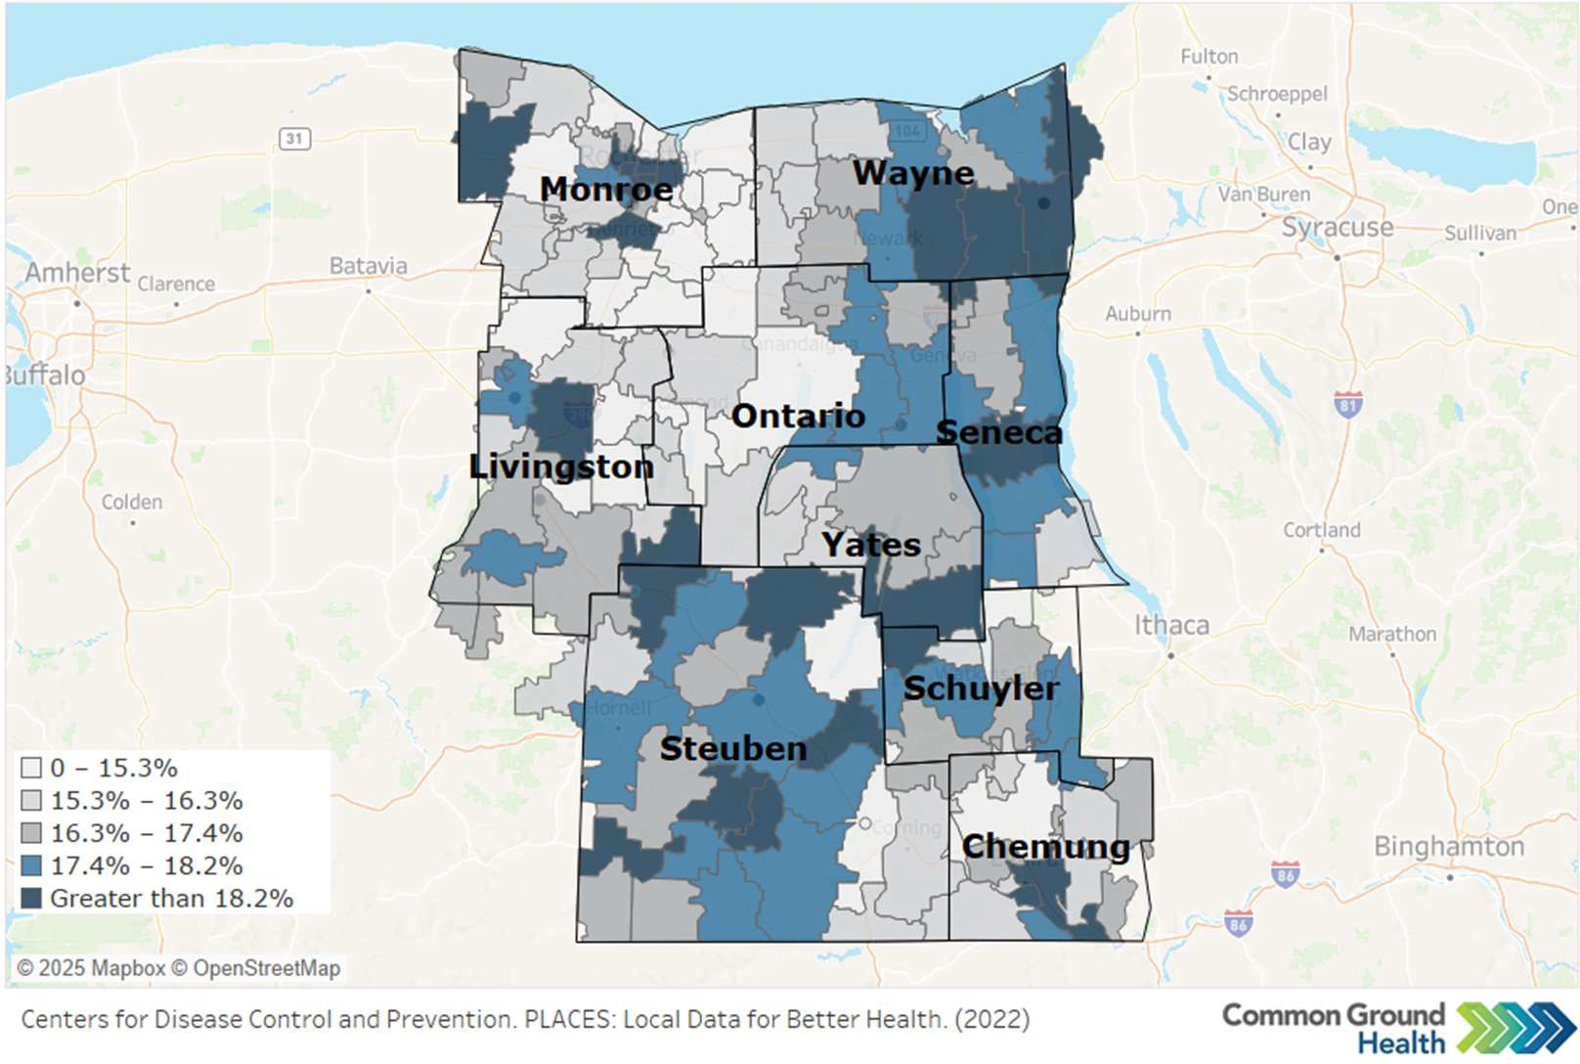
Map 11: Frequent Mental Distress Among Adults (Mental Health Not Good for 14+ of past 30 days)
The map illustrates that frequent mental distress (14 or more days of poor mental health in the past month) is elevated in many ZIP codes across the region, reinforcing county-level survey data showing rising rates of depressive disorders and frequent poor mental health among adults.
In 2021, all eight counties reported higher percentages of adults with a depressive disorder than in 2016, with increases ranging from about 5% to more than 75%. Similarly, the share of adults reporting 14 or more days of poor mental health in the past month was higher than in 2018 in every county, indicating a broad rise in mental distress.
Many factors inﬂuence rates of anxiety and stress, including economic stability, chronic health conditions, and adverse childhood experiences. Lack of access to mental health providers in rural areas is a factor that makes receiving treatment for anxiety and stress challenging.

Table 12: Rate of Depressive Disorders and Percentage of Adults Reporting 14 or more days of Poor Mental Health in a Month

County | Percent of Adults Reporting a Depressive Disorder (2021) (NYS=18.7) | Percent Change from 2018 Baseline | Percent of Adults Reporting 14 or more Days of Poor Mental Health Per Month  (2021) (NYS=16) | Percent Change from 2018 Baseline
Chemung | 35.4 | +36 | 18 | +20
Livingston | 24.9 | -15 | 18 | +29
Ontario | 27.9 | +64 | 18 | +38
Schuyler | 24.1 | -18 | 20 | +33
Seneca | 18.3 | -16 | 18 | +20
Steuben | 29.5 | +7 | 19 | +27
Wayne | 20.3 | -23 | 18 | +20
Yates | 24.3 | +40 | 19 | +36
Source: New York Expanded Behavioral Risk Factor Surveillance System

Suicide Rate
Adult suicide mortality in the eight-county region has increased over the past ﬁve years. The rate per 100,000 peaked in 2020 at 15.3 and remained above the 2018 baseline through 2022. These values represent age-adjusted rates based on 5-year County Health Rankings data (2014–2018 for the 2018 baseline and 2018–2022 for the most recent point), demonstrating that suicide continues to be a persistent and signiﬁcant cause of premature death across the region. Because these rates are calculated from very small numbers of deaths, even one additional death can cause large percentage changes, so trends should be interpreted cautiously.
2022
2021
2020
2019
2018
14.0
13.5
13.0
12.5
12.0
11.5
Deaths due to Suicide per 100,000 Population
(Age-Adjusted)
15.3
15.0
15.5
15.0
14.5
Figure16 Suicide Rates for the Finger Lakes Region (age-adjusted)

14.4
13.1 13.0

Source: County Health Rankings; National Center for Health Statistics – Mortality Files

Youth suicide rates for the region, drawn from the New York State Prevention Agenda dashboard for ages 10–19, are based on small numbers of deaths (fewer than 10 events per 5-year period) and are therefore considered statistically unstable. Because of this instability, youth suicide rates are ﬂagged as unreliable in oﬃcial reporting and should be interpreted with extreme caution, emphasizing the need for ongoing monitoring rather than ﬁrm conclusions about trends.

Overdose Deaths by Drugs
Overdose deaths related to opioids and any drug show an alarming increase in most counties, exceeding NYS averages. Overdose deaths are indicative of substance use problems within a community. Table 13 presents regional overdose mortality rates for opioids and all drugs combined, alongside New York State averages and Prevention Agenda targets, to illustrate the extent to which the Finger Lakes Region is above desired levels. Because the regional rates draw on small numbers of deaths in some counties, relatively few additional deaths can result in large percentage changes over time, so trends should be interpreted with caution rather than as precise shifts in risk. Focus group participants in several counties noted the increase in drug use as problems within their counties. Several counties have developed partnerships with organizations that deal directly with drug use and misuse.
Table 13: Overdose Deaths

County | Age-Adjusted Rate of Opioid Overdose Deaths per 100,000  (2022) (NYS=27) | Percent Change from 2013 Baseline | Age-Adjusted Rate of Overdose Deaths Involving any Drug per 100,000 (2022) (NYS=31.3  PA=22.6) | Percent Change from 2013 Baseline
Chemung | 40.9 | +605 | 46.5 | +489
Livingston | 22.3 | +829 | 24.5 | +433
Ontario | 12 | +500 | 16 | +332
Schuyler | 21.4 | +2,040 | 39.8 | +3,880
Seneca | 14.4 | +700 | 24.6 | +779
Steuben | 30.7 | +708 | 31.3 | +341
Wayne | 29.8 | +645 | 35.2 | +314
Yates | 0 | 0 | 8.2 | +720
Source: NYS Opioid Data Dashboard

Smoking and Binge Drinking
Smoking rates decreased in each county between 2018 and 2022, while the rates (percentage) of reported binge drinking have increased, with the exception of Schuyler which remained unchanged (Figure 17). All rates exceed the New York State averages of 12 percent for smoking and 20 percent for binge drinking.

Smoking and Binge Drinking (2022)
30
25
25
22
23
23
23
22
22
22
20
20
18
16
16
16
17
15
15
14
10
5
0
Chemung Livingston
Ontario
Schuyler
Seneca
Steuben
Wayne
Yates
Smoking Binge Drinking
Figure 17: Percent of Population Reporting Smoking and Binge Drinking
Source: Behavioral Risk Factor Surveillance System

Adverse Childhood Experiences
Adverse Childhood Experiences (ACEs) are those negative emotional and physical circumstances one experiences before age 18. They may include neglect, sexual abuse, parental divorce, mental illness and/or substance abuse in the home, and exposure to violence. ACEs impact individuals well into adulthood and may include physical and mental long-term health problems. The age-adjusted percentage of adults with two or more ACEs may be seen in Figure 18.
Figure 18: Adverse Childhood Experiences
Age-Adjusted Percentage of Adults who Report Two or More
Adverse Childhood Experiences (2021)
0
10
20
30
40
50
60
Chemung
Livingston Ontario Schuyler Seneca Steuben Wayne
Yates
Source: National Center for Health Statistics

Healthy Eating
The Finger Lakes Region is largely rural with hundreds of farms and farm stands, during harvest season. Unfortunately, the number of people without access to a vehicle and/or who live far from a grocery store is substantial. The cost of healthy foods is also a factor in whether or not families are able to purchase fruits and vegetables.
The percentage of adults who eat fruits daily is under 50% for most of the counties but is trending upward, which is a promising sign. More people eat vegetables each day, but that percentage decreased for each county between 2016 and 2021. The number of people who drink one or more sugary drinks each day is below the NYS average in all but three counties (Livingston, Ontario, Schuyler). (Table 14)
Focus group respondents noted that though healthy eating is a priority, it is diﬃcult for many to aﬀord healthy foods. While dollar stores, convenience stores and fast-food restaurants are proliﬁc across the region, grocery stores are less common in many communities.
Table 14: Healthy Eating

County | Percentage of Adults who Eat Fruit Daily  (2021) | Percent change from 2016  baseline | Percentage of Adults who Eat Vegetables Daily (2021) | Percent change from 2016  baseline | % of Adults earning  <$25K  annually who drink > 1 sugary drink daily (2021)  (NYS = 34.1) | Percent change from 2016  baseline
Chemung | 41.7 | No change | 46.9 | -25 | 25.5 | -47
Livingston | 49 | -9 | 56.5 | -2 | 37.5 | -14
Ontario | 49 | -9 | 52.1 | -24 | 45.2 | +71
Schuyler | 45.6 | +17 | 60.3 | -3 | 42.4 | +18
Seneca | 57.3 | +13 | 71.3 | -6 | 28.1 | -25
Steuben | 44.7 | +9 | 52 | -21 | 20.5 | -42
Wayne | 42.3 | +20 | 57.2 | -7 | 20.3 | -40
Yates | 63.4 | +16 | 70.2 | -4 | 17.1 | +60
Source: Behavioral Risk Factor Surveillance System

Domain 3: Neighborhood and Built Environment

Opportunities for Active Transportation and Physical Activity
While healthy eating is a major component of preventing and managing chronic diseases, so is physical activity and exercise. More than 50 percent of the population in several counties have access to locations for physical activity (Figure 19). Livingston, Steuben, and Wayne counties all increased the share of residents with access to physical activity resources between 2021 and 2024, with Steuben showing a particularly notable rise of 940 percent.
Percentage of Population with Access to Locations for Physical
Activity (2024)
0
10
20
30
40
50
60
70
80
90
100
Chemung
Livingston Ontario Schuyler Seneca Steuben Wayne
Yates
Figure 19: Access to Locations for Physical Activity.
Source: ArcGIS Business Analyst and Living Atlas of the World; YMCA; US Census TIGER/Line Shapeﬁles
The Walkability Index measures how walkable a county is on a scale from 1 (least walkable) to 20 (most walkable). Overall, the Finger Lakes counties have relatively low walkability scores, ranging from about
4.5 to just over 9 on the 20-point scale. The 2019 Walkability Index scores are found in Figure 20.
Walking or biking for exercise in rural upstate communities can be dangerous due to roads that often lack sidewalks, shoulders, and streetlights, especially outside village and city centers. Between October and April, roadways and any existing sidewalks may be icy or snow-covered, and higher speed limits on county and town roads can discourage walking and biking for recreation or transportation. Although there are YMCA facilities and other indoor exercise options in parts of the region, many residents face barriers such as membership costs, limited hours, and lack of reliable transportation, which can reduce access to safe places for physical activity. An emerging issue is the growing popularity of e-bikes and their accompanying safety concerns.

Figure 20: Walkability Index
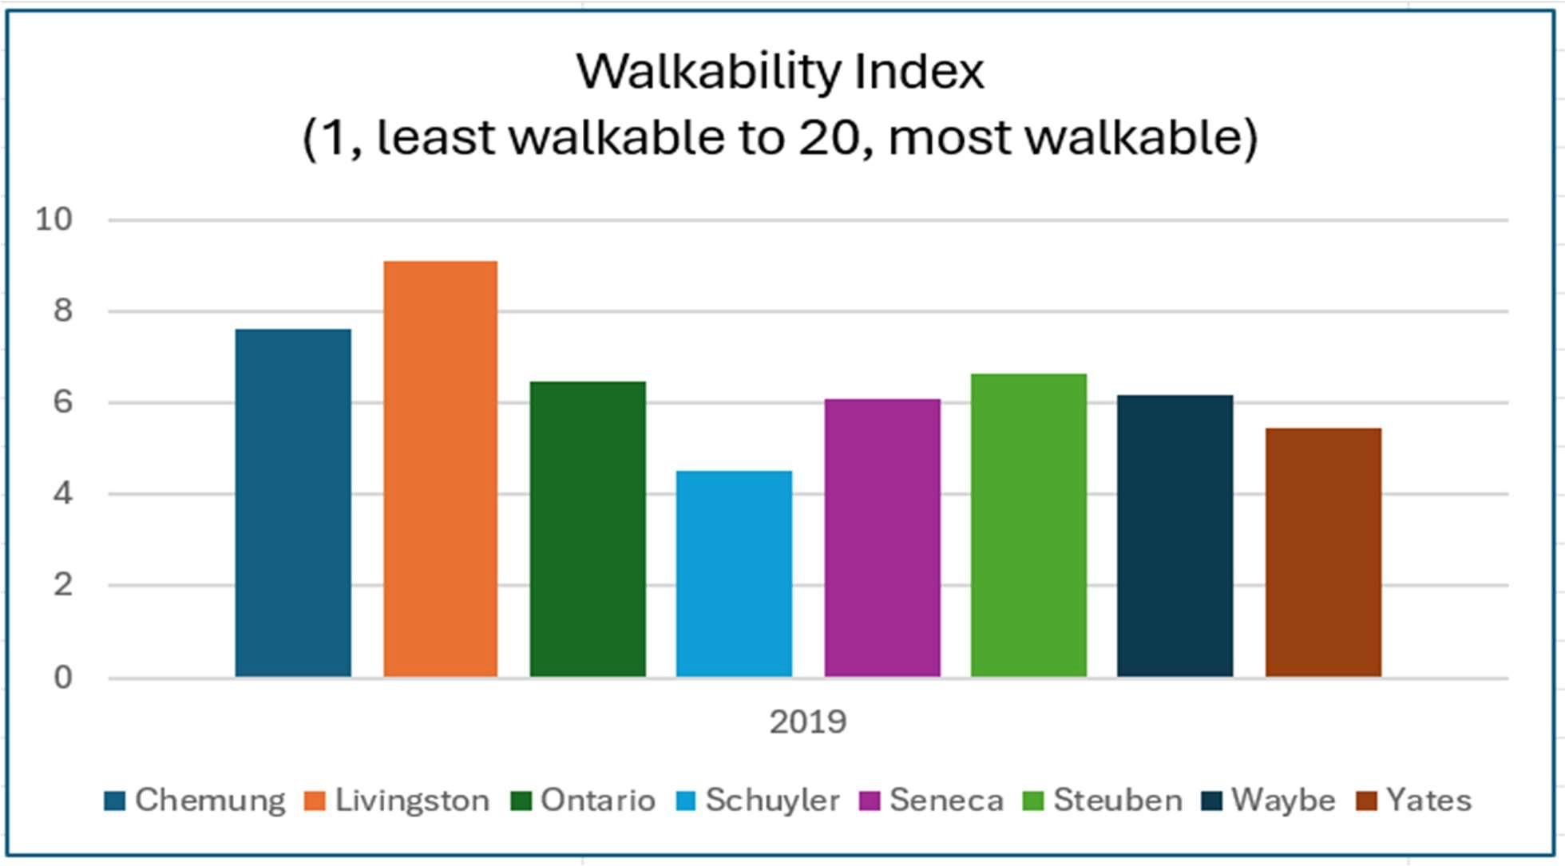
Source: EPA Oﬃce of Community Revitalization

Access to Community Services and Support
The Social Vulnerability Index was developed to measure the level of access to community services and support in the wake of emergencies. It is a useful tool for public health programming and outreach as it considers poverty, unemployment, income, high school graduation rate, single parent homes, individuals with disabilities, those over 65, minority status, spoken language, housing and transportation. It is measured on a scale from 0 (lowest vulnerability) to 1 (highest vulnerability). While no county is considered highest vulnerability, Chemung, Seneca, Steuben and Yates are above the 0.5 midpoint. (Figure 21)

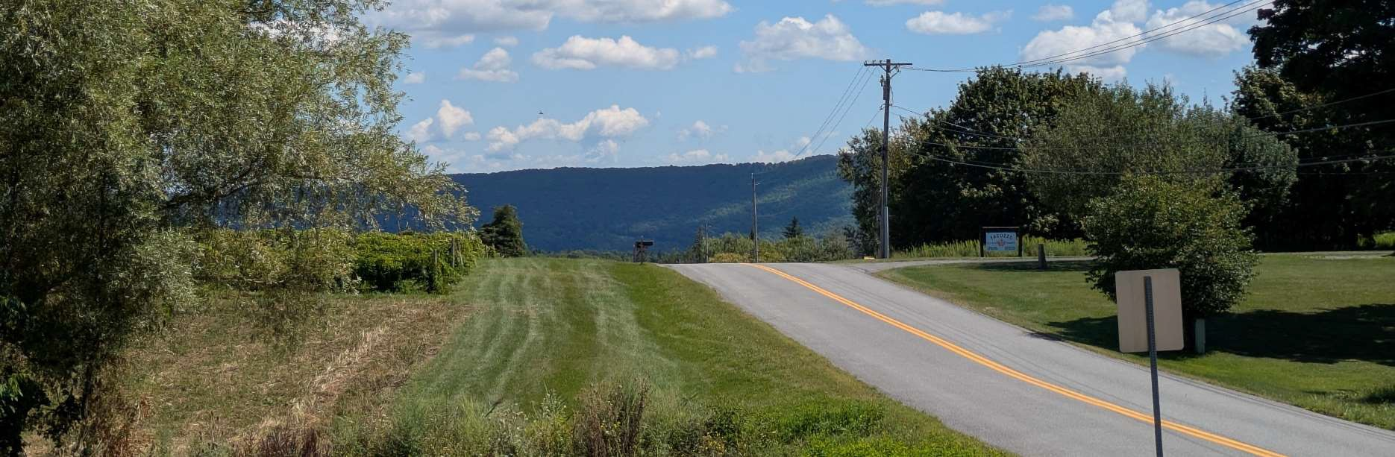
Figure 21: Social Vulnerability Index
Social Vulnerability Index (2022)
0
0.1
0.2
0.3
0.4
0.5
0.6
0.7
0.8
0.9
1
Chemung
Livingston Ontario Schuyler Seneca Steuben Wayne Yates

Source: Centers for Disease Control and Prevention/Agency for Toxic Substances and Disease Registry/Geospatial Research, Analysis, and Services Program. CDC/ATSDR Social Vulnerability Index Interactive

Source: Ontario County
The Finger Lakes Region is aging and people over the age of 65 who live alone may lack access to community services and support. Map 12 highlights the distribution of this population. Loneliness and social isolation among adults over 65 can create serious physical, mental, and social health challenges. Physical challenges include increased risk of chronic diseases, falls, higher mortality risk, and poor nutrition and sleep. Mental health impacts include depression and anxiety, cognitive decline and lower resilience in coping with mental and physical challenges. Social isolation may make it diﬃcult to access

services and supports, particularly during emergencies like a fall. Social isolation may also cause a loss of purpose and can perpetuate elder abuse by allowing it to go undetected.²³
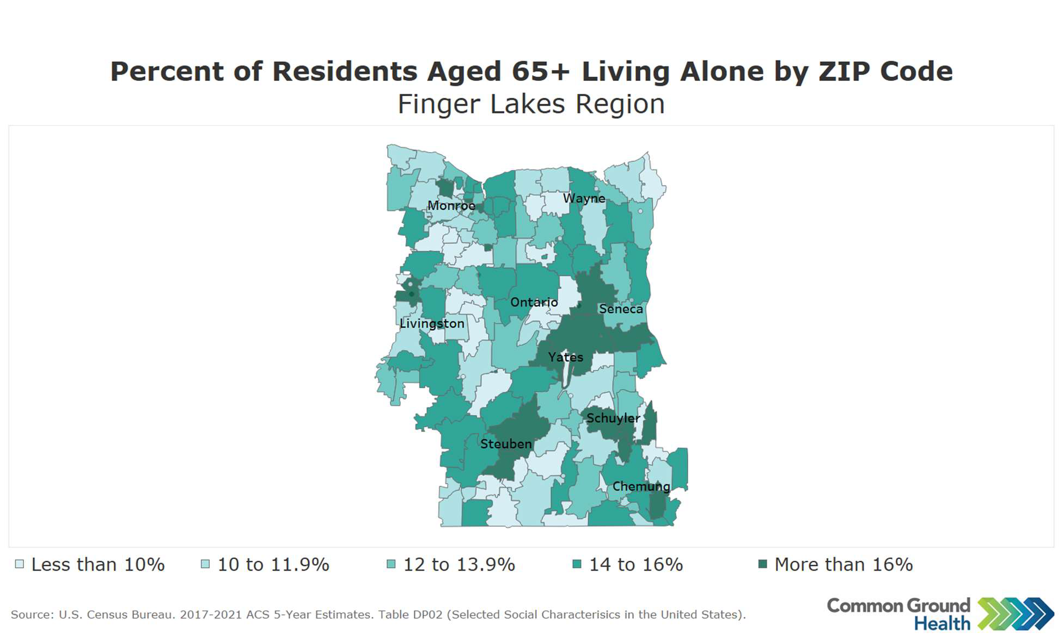
Map 12: Percentage of the population of those 65 years and older living alone by zip code

Injuries and Violence
Injuries and violence are a major and growing concern across the eight-county Finger Lakes region. Because “injuries and violence” in this assessment includes several distinct indicators (unintentional injury, violent crime, and ﬁrearm-related deaths), each measure uses a diﬀerent baseline year based on data availability. For example, unintentional injury trends use a 2015 baseline, ﬁrearm-related deaths use 2018, and violent crime uses 2013. As a result, rates and trends should be interpreted within the context of each indicator’s speciﬁc baseline year rather than as a single combined trend for injuries and violence.
Unintentional injuries in NYS Vital Statistics include deaths from external causes that are not intentionally self-inﬂicted or due to assault, such as motor vehicle crashes, falls, drownings, ﬁres and burns, accidental poisonings (including many drug overdoses coded as unintentional), and other accidental injuries.
Unintentional Injuries in the eight counties of the Finger Lakes region have increased since 2015 and in many cases, alarmingly. The exception is Seneca County which decreased in age-adjusted death rate for unintentional injury in 2015 from 2022. Three counties are below the New York State average for age-adjusted death rate for unintentional injury. Conversely, ﬁve counties exceed the New York State average

²³ Perissinotto CM, Stijacic Cenzer I, Covinsky KE. Loneliness in older persons: a predictor of functional decline and death. Arch Intern Med. 2012 Jul 23;172(14):1078-83. doi: 10.1001/archinternmed.2012.1993. PMID: 22710744; PMCID: PMC4383762.

for age-adjusted death rate (death before age 75) for unintentional injury. All counties have increased in this indicator from baseline. (Table 15)
Table 15: Injuries and Violence

County | Age-Adjusted Death Rate for Unintentional Injury per 100,000; 2022  (NYS = 54.1) | Percent Change from Baseline of 2015 | Age-Adjusted Premature Death Rate (Before Age 75)-Unintentional Injury per 100,000; 2022  (NYS = 46.9) | Percent Change from Baseline of 2015
Chemung | 88.2 | +102 | 75.4 | +144
Livingston | 50.7 | +14 | 43.6 | +46
Ontario | 48.1 | +26 | 38.1 | +32
Schuyler | 66.3 | +46 | 62 | +57
Seneca | 43.5 | -2 | 36.7 | +27
Steuben | 58.6 | +99 | 48.9 | +136
Wayne | 64.3 | +60 | 58.1 | +61
Yates | 80.3 | +267 | 63.4 | +424
Source: New York State Department of Health - Oﬃce of Quality and Patient Safety - Division of Information and Statistics - Bureau of Health Informatics - Vital Statistics Unit
Violence related harm in the region is concerning and requires careful consideration. Violent crime refers to reported oﬀenses of murder, rape, robbery, and aggravated assault, compiled from local law enforcement data by state and federal justice agencies and expressed as a rate per 100,000 residents.
Firearm related deaths are measured as the number of deaths due to ﬁrearms per 100,000 population over a ﬁve-year period, based on national mortality data and Census population estimates; this measure includes suicides, homicides, and other ﬁrearm fatalities deﬁned by speciﬁc ICD10 codes, and values are suppressed for counties with fewer than 10 deaths. Because recent changes in population estimation methods aﬀect the denominator for ﬁrearm fatality rates, comparisons across years should be made with caution. In the Finger Lakes region, the violent crime rate has risen from about 120.9 per 100,000 in 2013 to approximately 154.5 per 100,000 in 2022, and ﬁrearm related deaths have also increased since 2018 and now exceed the statewide rate, although they remain concentrated in speciﬁc communities.
Together, these patterns indicate that many residents face elevated risks of both accidental and intentional injury, underscoring the need for coordinated prevention strategies focused on traﬃc safety, fall and poisoning prevention, ﬁrearm safety, and community violence reduction.

Domain 4: Health Care Access and Quality

Access to and Use of Prenatal Care
Maternal and child health have been areas of focus for the Finger Lakes Region counties in several past Community Health Improvement Plans. According to Healthy People 2030, “improving the well-being of mothers, infants, and children is an important public health goal for the United States. Their well-being

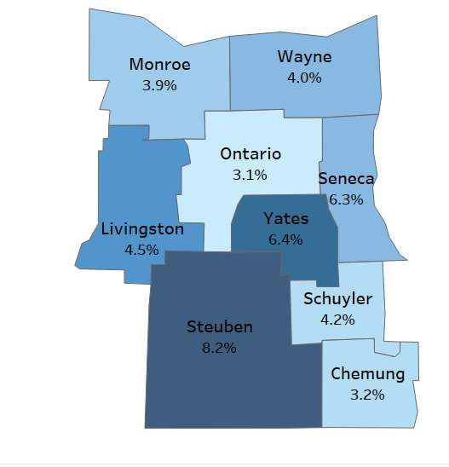

determines the health of the next generation and can impact future public health challenges for families, communities, and the health care system.”²⁴
Map 13: Percentage of births with late (3rd trimester) or no prenatal care (2019-2021)
Receiving early and adequate prenatal care is important for ensuring a healthy pregnancy. At prenatal visits, health care providers screen for diseases, provide vaccinations, and manage maternal chronic diseases that may be exacerbated by or have a negative impact on their pregnancy. In addition, health care providers educate pregnant persons about labor, delivery, postpartum depression, and early warning signs of complications. Ensuring timely prenatal care is obtained can lower the incidence of premature birth, low birth weight babies and infant mortality.¹⁸
Despite regional eﬀorts, some pregnant residents still begin care late in pregnancy or receive no prenatal care at all. Map 13 shows that, while most births occur with timely prenatal care, a notable minority in several counties receive care in the third trimester or not at all, highlighting persistent geographic disparities in early
Source: NYS Perinatal Data Proﬁle 2019-2021
access that can contribute to preterm birth, low birth weight, and higher infant and maternal risks.
Prenatal care may also be measured using three abstinence indicators – alcohol (Figure 22), smoking (Figure 23), and illegal drugs (Figure 24). All counties have improved in each indicator from 2018 to 2024 with the exception of alcohol abstinence in Schuyler County.
Figure 22: Alcohol Abstinence in Pregnancy
Alcohol Abstinence in Pregancy (2024)
86
88
90
92
94
96
98
100
Chemung
Livingston Ontario Schuyler Seneca Steuben Wayne Yates
2018-Alcohol 2024-Alcohol
Source: Healthy People 2020; US Department of Health and Human Services.

²⁴ Source: Healthy People 2030 https://odphp.health.gov/healthypeople/about/workgroups/maternal-infant-and-child-health-workgroup

Figure 23: Smoking Abstinence in Pregnancy
Smoking Abstinence in Pregnancy (2024)
0
10
20
30
40
50
60
70
80
90
100
Chemung
Livingston Ontario Schuyler Seneca Steuben Wayne Yates
2018 2024

Source: Healthy People 2020; US Department of Health and Human Services.

Figure 24: Illegal Drug Abstinence in Pregnancy
Illegal Drug Use Abstinence During Pregnancy (2024)
86
88
90
92
94
96
98
100
Chemung
Livingston Ontario Schuyler Seneca Steuben Wayne Yates
2018 2024

Source: Healthy People 2020; US Department of Health and Human Services.

Additionally, lack of access to prenatal care may be manifested by low live birth weights (<2,500 grams or about 5 lbs., 8 oz.) and premature births (live births before 37 weeks) (Figure 25 and Maps 14, 15, 16).

Figure 25: Percentage of Preterm Births in the Region, 2018-2024; missing data is indicative suppression due to low numbers
Map 14: Premature birth Rates
Percentage of Preterm Births, Finger Lakes Counties
9.5
6.9 8
8
8.8
8.3
8.3
10.7
6.5
8.2
7.6
8.9
8.1
8.1
8.6
7.4
6.4
8.9
8.7
8.7
8
8
6.5
5 8.8
7.5
9.7
12.2
11.2
7.6
7.9
8.9
14.1
11.1
9.7
10.4
7.7
9
7.9
8.5
8
11.2
10.3
14.5
11.8
13
12.2
12.8
2018 2019 2020 2021 2022 2023 2024
Chemung Livingston Ontario Schuyler Seneca Steuben Wayne Yates
Source: National Center for Health Statistics

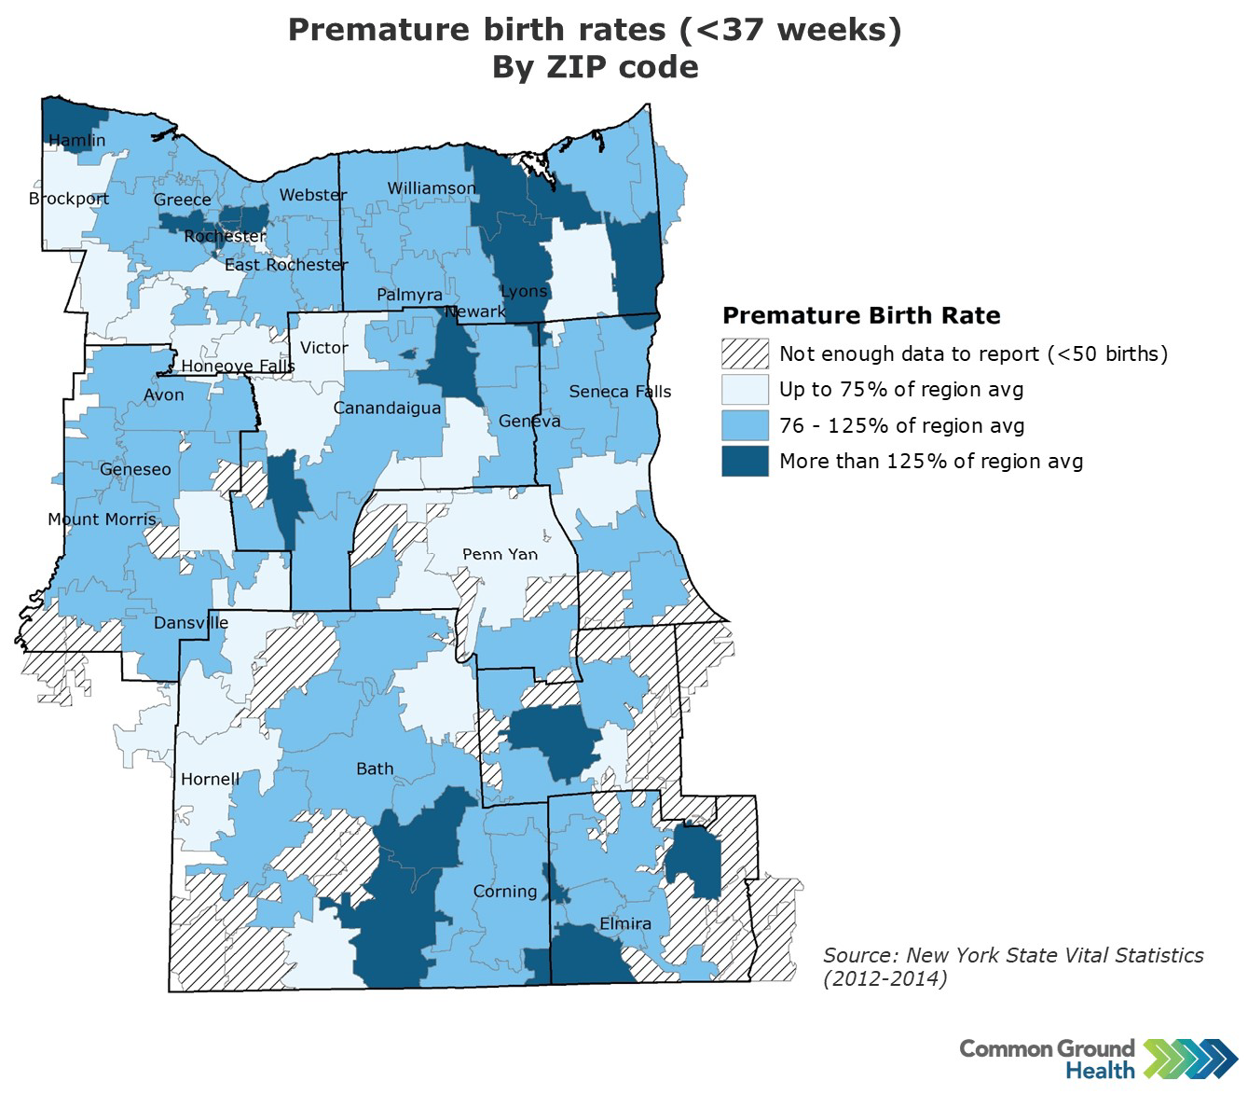
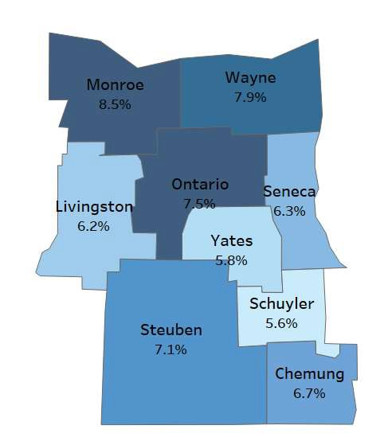


Map 15: Percentage of Premature Births with 32 - < 37 Weeks
Gestation (2019-2021)
Source: NYS Perinatal Data Proﬁle 2019-2021

F
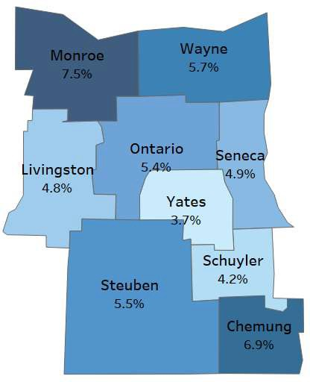

A baby born prematurely is immediately at risk for complications including jaundice, anemia, feeding issues, and apnea. The earlier in pregnancy a baby is delivered, the more likely it is that the baby will need to spend time in the neonatal intensive care unit (NICU). Long-term health complications associated with premature birth include vision and hearing deﬁcits, neurological delays, delays in speech and language development and deﬁcits in social and emotional regulation.
Map 16: Percentage Low Birth Weight (<2.5 kg) Singleton Births (2019-2021)
Of note, premature birth is the primary cause of low birth weight.²⁵The percent of live births with low birth weight has remained relatively unchanged in the region from 2018 (6.4%) to 2023 (also 6.4%).
Prevention of Infant and Maternal Mortality Prematurity and its related conditions are the leading causes of infant mortality. Reducing rates of preterm births, therefore should decrease infant mortality. Figure 26 includes infant mortality per 1,000 while Figure 27 includes maternal and child mortality rate per 100,000 births. If data are expressed as “0”, it may indicate numbers were low and suppressed or that there were no deaths that year.
Figure 26: Infant Mortality Rate per 1,000 (2022)

Infant Mortality Rates per 1,000: Finger Lakes Counties, 2022
Chemung
6
Livingston 0
Ontario 5
Source: NYS Perinatal Data Proﬁle 2029-2021

Schuyler | 0
Seneca | 0
Steuben |  | 6
Wayne |  |  | 8
Yates | 0
Source: National Center for Health Statistics

²⁵ Stanford Children’s Health, Low Birthweight

The New York State average maternal mortality rate is 22 per 100,000. More than half of the eight counties exceed that rate. The New York State average for child mortality is 40. More than half of the counties are at or above that rate.
Maternal and Child Mortality Rates per 100,000: Finger Lakes
Counties, 2022
250

200

150

100

50

0
Chemung Livingston Ontario Schuyler
Seneca
Steuben
Wayne
Yates
Maternal Mortality Child Mortality
Figure 27: Maternal and Child Mortality Rates per 100,000 (2022)
Source: National Center for Health Statistics
Similar to trends across New York, total births in the Finger Lakes region have been on a steady decline since 2018 (Figure 28).

Number of Births in the Finger Lakes Region
5200
5019
5000
4935
4834
4800
4702
4581
4600
4400
4314
4200
4000
3800
2018
2019
2020
2021
2022
2023
Figure 28: Number of Births in the Finger Lakes Region
Source: Statewide Planning and Delivery System (SPDS)

Preventive Services for Chronic Disease Prevention and Control
Most chronic diseases are preventable and are closely tied to modiﬁable behaviors, including poor diet, limited physical activity, tobacco use, and heavy alcohol consumption. These conditions signiﬁcantly drive health care costs and place substantial pressure on the health care system. In New York State, chronic illnesses - such as heart disease, stroke, cancer, COPD, diabetes, and obesity - are the primary causes of disability and death. They create a considerable health burden and greatly diminish overall quality of life, contributing to six in ten deaths.²⁶
Many New Yorkers experience multiple chronic conditions at the same time. Expanding early screening and detection, strengthening self-management skills, and improving access to health care providers and referral services can play a major role in reducing both the occurrence and severity of chronic diseases.²⁷
As previously discussed, access to care is a widespread barrier, especially for those on Medicaid or living in poverty. Even when primary care, dental care, and mental health care are available, access may be inequitable across. populations and places. Cost, insurance limitations, scheduling practices, and a lack of transportation continue to be barriers to access. These barriers may prevent people from seeking acute care, as well as preventive measures such as dental exams, yearly physicals, and cancer screenings.
A look at practitioner access in Table 16 provides insight into the problem of obtaining both acute and preventive health care in the region as well as insights into the problem of chronic disease management.
Table 16 Provider Access in the Finger Lakes Region

County | Primary Care Physicians – Resident to Provider Ratio, 2021 (NYS: 1,240) | Mental Health Providers – Resident to Provider Ratio, 2024  (NYS: 260) | Dentists - Resident to Dentist Ratio, 2022  (NYS: 1,200) | Non-physician PCPs – Resident to Provider Ratio, 2024  (NYS: 610)
Chemung | 1,280 | 290 | 1,540 | 560
Livingston | 2,200 | 640 | 1,980 | 1,130
Ontario | 1,210 | 330 | 1,660 | 680
Schuyler | 1,610 | 430 | 3,530 | 1,590
Seneca | 3,740 | 410 | 3,290 | 1,120
Steuben | 1,790 | 400 | 2,810 | 930
Wayne | 4,300 | 800 | 2030 | 1,420
Yates | 2,050 | 840 | 2,220 | 1,220
Sources: County Health Rankings & Roadmaps, using data from the Area Health Resources Files (primary care physicians), CMS National Provider Identiﬁer and NPPES ﬁles (mental health providers, dentists, and other primary care providers).

²⁶ Source: NYS Prevention Agenda
²⁷ Source: NYS Prevention Agenda

Courtesy Ontario County
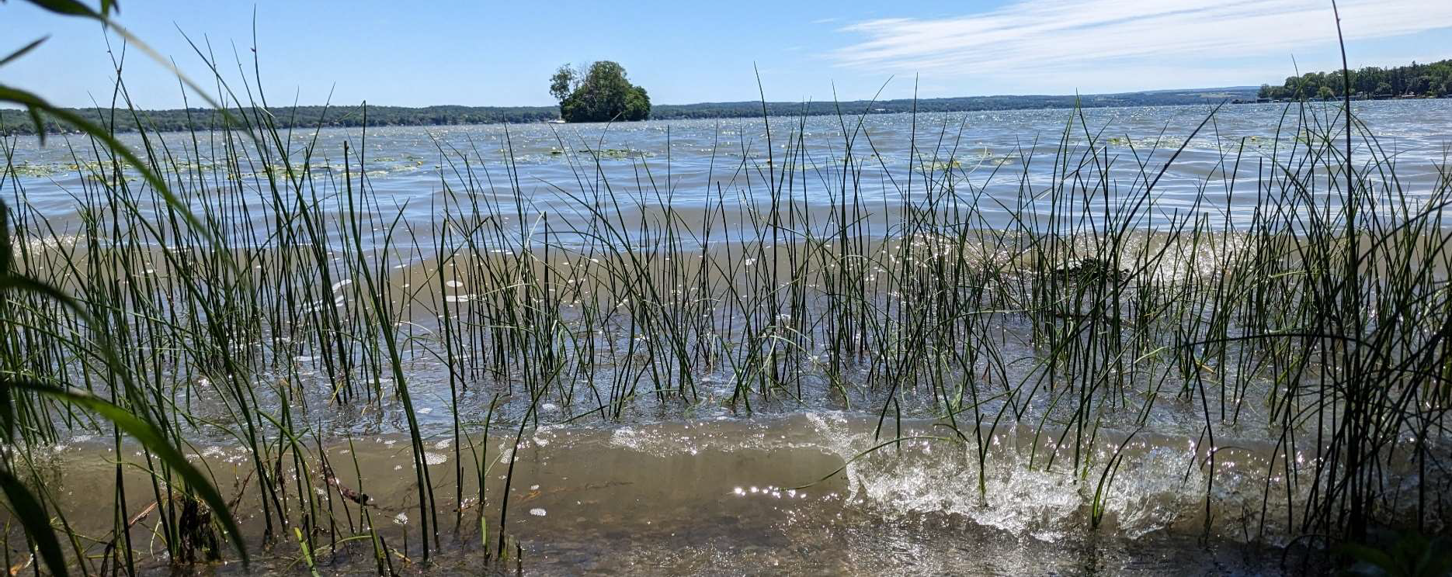
An indicator for access to preventive services is the percentage of residents who have had breast and colorectal screenings. Additionally, the percentage of individuals tested for - or diagnosed with - diabetes and high blood provides evidence of access to preventive medical care. Table 17 provides these indicators. A large percentage of Finger Lakes residents receive access mammography services; those on Medicare doing so at a higher rate than the rest of the state.
Table 17: Preventive Services

County | % Age 50-74  years who had a Mammogram 2022 | % On Medicare who had a Mammogram 2022  (NYS = 44%) | % Received colorectal screening 2022 | % Tested for diabetes 2021 | % Earning  < $25,000  tested for diabetes 2018  (NYS = 62%) | % Age 18+  diagnosed with high blood pressure 2021
Chemung | 74.4 | 51 | 61.3 | 66.9 | 52.8 | 29.7
Livingston | 79 | 51 | 62 | 61.6 | 75.4 | 28.8
Ontario | 75.9 | 52 | 65.3 | 63.2 | 56.6 | 28.9
Schuyler | 73.7 | 50 | 61.4 | 62.9 | 63.4 | 28.8
Seneca | 73 | 47 | 61.3 | 63.3 | 64.3 | 31.9
Steuben | 76.9 | 50 | 59.9 | 59.4 | 49.5 | 29.8
Wayne | 79.6 | 43 | 62.3 | 65 | 51.4 | 29.1
Yates | 75.5 | 55 | 63.2 | 69.6 | 48.7 | 30.1
Sources: County Health Rankings, American Medical Association, National Provider Identiﬁer, Healthy People 2020, NYS Prevention Agenda, Statewide Perinatal Data System, National Center for Health Statistics, CDC, Vital Records, Behavioral Risk Factor Surveillance System, NYS Medicaid Program, IAP Baseline Report, NYSIIS Performance Report, Child Health Plus.

Oral Care
Oral care is important to overall health. Early preventive care prevents future chronic conditions. Lack of dental insurance, insuﬃcient provider numbers, and lack of dentists willing to see Medicaid clients contribute to residents’ inability to access preventive and acute dental care in the region. Table 18 describes the state of dental care in the region. All data points demonstrate room for improvement, particularly Medicaid preventive visits for those ages 2-20.
Table 18: Oral Care

County | Adult Dental Visits (%) 2019 | Medicaid Visits, age 2-20 ((%)  2023 | Medicaid Visits (%)  2023 | Medicaid Preventive Visit (%)  2023 | Medicaid Preventive Visit, age 2-20 (%)  2023
Chemung | 65.4 | 43.3 | 25.2 | 21.4 | 40.8
Livingston | 69.9 | 41.3 | 26.7 | 22.7 | 38.7
Ontario | 74.5 | 40 | 25 | 21.1 | 37.1
Schuyler | 58.4 | 43.6 | 24.3 | 20.6 | 40.5
Seneca | 69.1 | 34.8 | 21.6 | 17.4 | 30.9
Steuben | 59.5 | 41.1 | 23.9 | 20.2 | 38.5
Wayne | 66.6 | 39.4 | 25.1 | 20.6 | 36.2
Yates | 62.6 | 41.2 | 25.1 | 21.1 | 37.2
Sources: County Health Rankings, American Medical Association, National Provider Identiﬁer, Healthy People 2020, NYS Prevention Agenda, Statewide Perinatal Data System, National Center for Health Statistics, CDC, Vital Records, Behavioral Risk Factor Surveillance System, NYS Medicaid Program, IAP Baseline Report, NYSIIS Performance Report, Child Health Plus.
Lack of access to dental care, the use of non-ﬂuorinated well water by many rural residents, and an emerging trend of municipalities removing ﬂuoride from public water systems leave Finger Lakes residents at risk for oral diseases and disorders.

Emergency Department Visits and Preventable Hospitalizations
For many residents, emergency departments may serve as the primary source of care for those who are underinsured or lack health insurance. In addition, lack of provider access may contribute to increased reliance on emergency rooms and may cause preventable hospitalizations. Migrant populations fearing deportation may defer medical care until an emergency room visit and subsequent hospitalization is necessary. Mennonite community members often self-treat common maladies and wait until they are experiencing advanced illnesses which require the use of an emergency room.
Many Finger Lakes counties exceed New York State averages for emergency department visits and preventable hospitalizations. Four counties exceed the state rate for behavioral health ED visits; four exceed the state rate for all preventable hospitalizations; and all but one county exceeds the state rate for all emergency department visits. The number of emergency department visits for behavioral and mental health disorders (suicidal thoughts, substance use, depression, etc.) is an area in need of improvement (Table 19).

Table 19: Emergency Department Visits and Preventable Hospitalizations

County | All Emergency Department Visits 2023  (NYS = 29,809) | All Behavioral Health Conditions ED Visits 2023  (NYS = 6,872) | All Mental Health ED Visits 2023  (NYS = 3,370) | All Preventable Hospitalizations 2023  (NYS = 808)
Chemung | 43,624 | 8,622 | 4,204 | 1,046
Livingston | 27,323 | 5,798 | 2,470 | 723
Ontario | 33,756 | 6,132 | 2,645 | 780
Schuyler | 52,967 | 7,108 | 3,523 | 954
Seneca | 38,723 | 6,873 | 3,014 | 885
Steuben | 44,043 | 8,215 | 3,292 | 720
Wayne | 31,387 | 8,617 | 3,423 | 1,072
Yates | 41,443 | 4,935 | 2,303 | 604
Source: SPARCS
Map 17 highlights potentially preventable hospitalizations by zip code in the Finger Lakes region. This map corresponds with maps highlighting life expectancy as well as emergency department visits for heart disease, cancer, hypertension, depressive disorders, and anxiety and panic disorders (Maps 17-22) as well as poverty (Maps 6-8). Note that the concentrations of potentially preventable hospitalizations as well as the emergency department visits cluster in similar areas of the region. This corresponds with higher poverty rates as well as decreased life expectancy. Higher rates of emergency department use and preventable hospitalizations in certain counties and populations—especially people living in poverty, on Medicaid, or in rural areas—signal inequitable access to timely, high-quality outpatient care and contribute to widening health disparities.
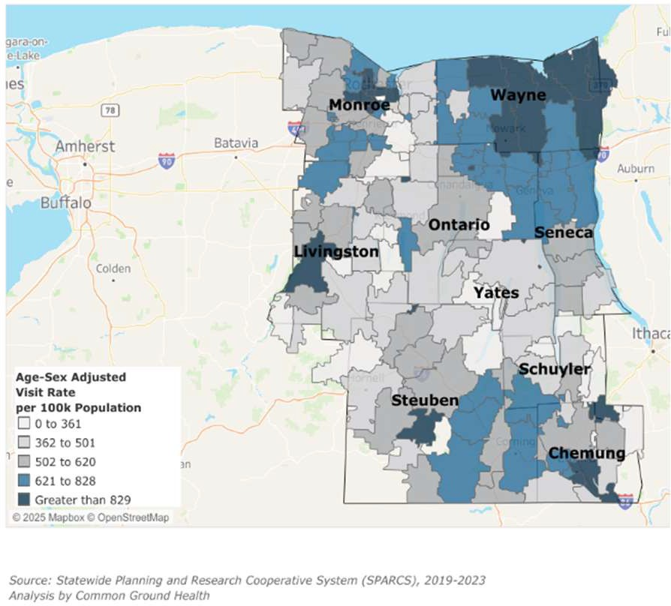
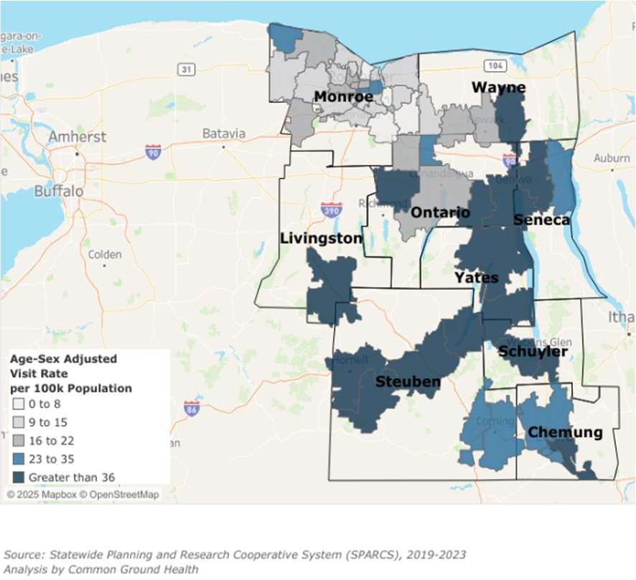
Map 17: Potentially Preventable Hospitalizations
Map 18: ED Visits for Cancer by Zip Code

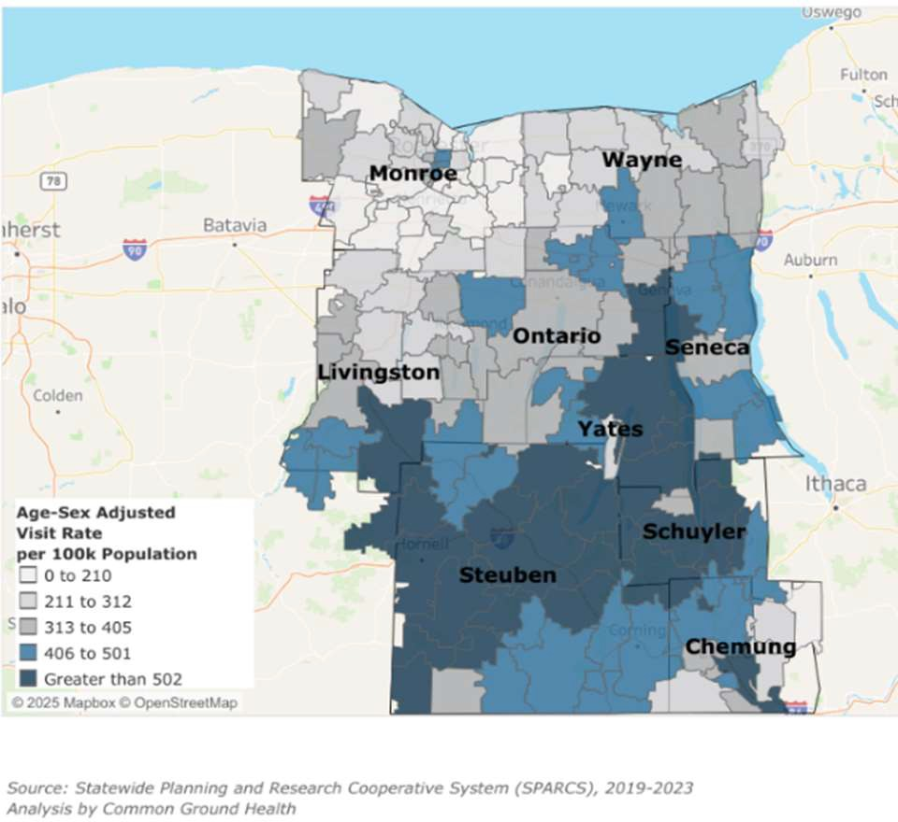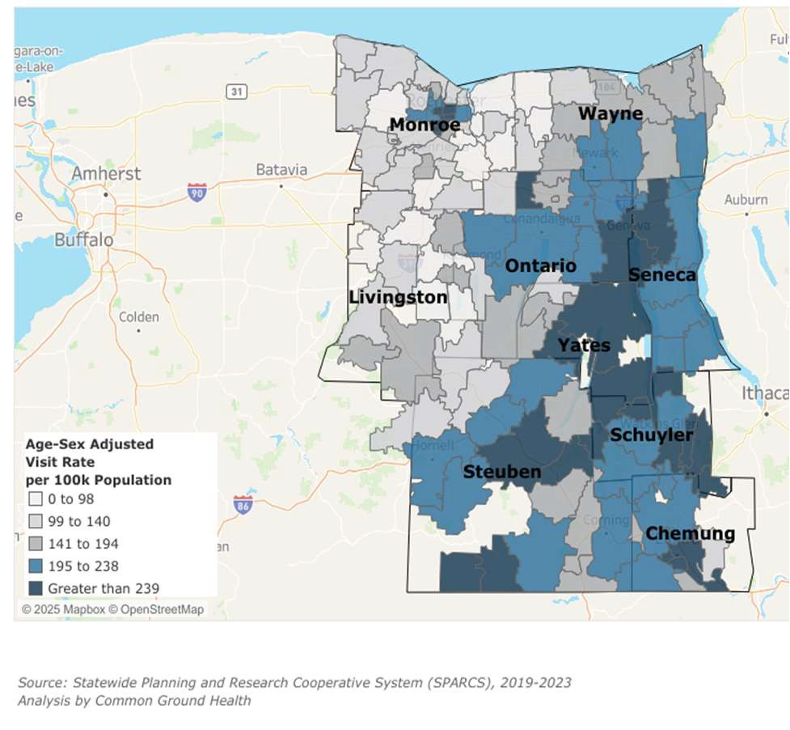
Map 19: ED Visits Related to Heart Disease by Zip Code
Map 20: ED Visits for Hypertension by Zip Code

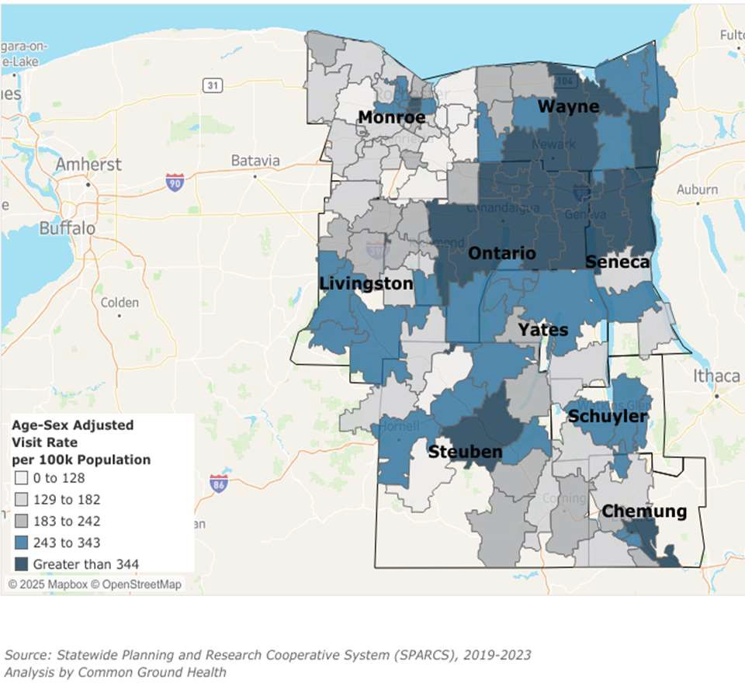
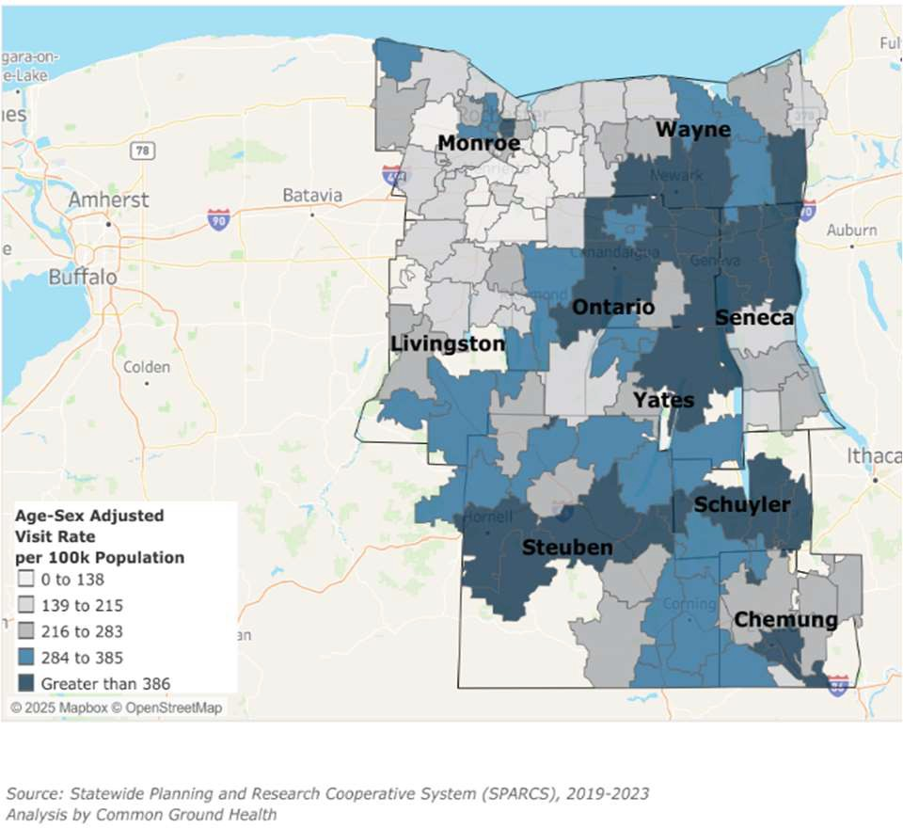
Map 21: ED Visits for Depressive Disorders by Zip Code
Map 22: ED Visits for Anxiety and Panic Disorders by Zip Code

Blood Lead Level Screening and Vaccinations
Lead Screening: “Asymptomatic lead poisoning has become more common in children. Blood lead levels of greater than 5 ug per dL are associated with impairments in neurocognitive and behavioral development that are irreversible.”²⁸ New York State requires pediatricians to order at least two lead screenings in the ﬁrst 36 months of life – one at age one and one at age 2. Physicians provide orders to parents at routine well-child visits, but cannot force them to take their child to a lab to have blood drawn. Figure 29 describes how the region is doing with recommended childhood lead testing.
Figure 29: Blood Lead Level Screening in the Finger Lakes Region
Blood Lead Level Screening
70

60

50

40

30

20

10

0
Chemung
Livingston
Ontario
Schuyler
Seneca
Steuben
Wayne
Yates
Screening at 1 Year
Screening at 2 Year
At least Two Lead Screenings
Source: NYSIIS Performance Report

Immunizations: Recommended vaccines for children include the following.
- 4 doses of DTaP (Diphtheria, Tetanus, and Pertussis),
- 3 doses of polio (IPV)
- 1 of MMR ((Measles, Mumps, and Rubella))
- 3 doses of Hib (Haemophilus inﬂuenzae Type B)
- 3 doses of Hepatitis B
- 1 dose of Varicella
- 4 doses of pneumococcal vaccine (PCV)
The routine vaccination schedule is referred to as the 4:3:1:3:1:4 schedule and the rate of uptake is used to assess vaccine coverage among children.
Figure 30 describes immunization rates by county for routine childhood vaccines, including HPV vaccine.

²⁸ Mayans, L. (2019). Lead poisoning in children. American family physician, 100(1), 24-30.

Immunization Rates by County (2025)
90
80
70
60
50
40
30
20
10
0
Chemung Livingston Ontario
Schuyler
Seneca
Steuben
Wayne
Yates
HPV Vaccination
4:3:1:3:1:4 Vaccine Series
Figure 30: Immunization Rates by County in the Finger Lakes

Source: NYSIIP
The Finger Lakes region shows persistent gaps in key pediatric and adolescent preventive measures. Many gaps are parent-driven. Physicians advise parents of the need for lead testing and provide lab orders, but it is contingent on parents to take their children to the lab to be tested. Across the eight counties, completion of the 4:3:1:3:1:4 vaccine series - required for school admission - well-exceeds that of HPV vaccination which is not required for school attendance.
These gaps need to be continually addressed to ensure children are protected from the physical and neurological eﬀects of lead poisoning, and can avoid vaccine-preventable diseases that leave them susceptible to illness, injury, and future cancers. In 2025, changes in staﬃng and operations at the Centers for Disease Control and Prevention, the Advisory Committee on Immunization Practice, and the Food and Drug Administration may aﬀect future vaccination rates in the Finger Lakes Region.

Domain 5: Education Access and Quality

Health and Wellness Promoting Schools
Schools that promote health and wellness are ones that provide opportunities for balanced nutrition, exercise and mental wellbeing during the school day.
Rates of chronic absenteeism – missing at least 10% of schools days – is an indicator of how well children are being supported during the school day. State-level data from the 2022–2023 school year show that nearly one in three New York students is chronically absent, with rates varying by region, race and ethnicity, and socioeconomic status. Chronic absenteeism has increased sharply in rural districts,

reaching 13.4% in low-need rural areas, 25.2% in average-need rural areas, and 33.0% in high-need areas. Economically disadvantaged students, students with disabilities, and English language learners experience the highest absenteeism rates, highlighting the need for school-based strategies that address health, transportation, and other non-academic barriers to attendance.²⁹
Additional indicators for educational access and quality include the percentage of teens and young adults who were neither working nor in school (disconnected youth), the number of school age students eligible for free or reduced lunch and the number of childcare centers per 100,000 children under age 5 as highlighted in Table 20.
Table 20: Education-related Socio-economic factors

County | % teens and young adults (age 16-19) neither working nor in school, 2025  (NYS: 7%) | % school age children eligible for free or reduced lunch, 2025  (NYS: 57%) | Childcare centers per 1,000 children under  age 5 2025  (NYC: 6)
Chemung | 11 | 53 | 6
Livingston | 5 | 44 | 7
Ontario | 5 | 43 | 6
Schuyler | Suppressed for low #’s | 43 | 5
Seneca | 14 | 56 | 3
Steuben | 9 | 50 | 8
Wayne | 9 | 50 | 4
Yates | Suppressed for low #’s | 55 | 3
Source: County Health Rankings
Three measures of opportunities for continued education are the high school graduation rate, the average spending per student, and the high school graduation rate of economically disadvantaged students. (Table 21) All counties except Seneca and Yates exceed the New York State average percent of adults over age 25 with a high school diploma or equivalent. A quality education may improve the economic prosperity of residents by allowing them to obtain better compensated employment which increases their economic and housing stability.
Table 21: Education Indicators

County | % adults over age 25 with a high school diploma or equivalent 2023  (NYS = 88) | Average gap ($) between actual and required spending in public school districts 2022  (NYS = $12,754) | Graduation rate of economically disadvantaged students 2023  (NYS = 82)
Chemung | 91 | 9,909 | 75
Livingston | 93 | 11,626 | 87

²⁹ Source: New York’s Stubbornly High Rates of Chronic Absenteeism. October 2024. https://www.osc.ny.gov/ﬁles/reports/pdf/missing-school-ny-chronic-absenteeism.pdf

Ontario | 93 | 12,784 | 85
Schuyler | 91 | 11,955 | 80
Seneca | 85 | 13,399 | 80
Steuben | 92 | 12,721 | 85
Wayne | 91 | 12,785 | 81
Yates | 84 | 9,915 | 81
Source: U.S. Census Bureau, ACS, NYSED
Conclusion: The ﬁndings in this Regional Community Health Assessment demonstrate that health in the Finger Lakes is shaped by intersecting social and economic conditions, including poverty, food and housing insecurity, transportation barriers, provider shortages, and educational opportunities.
These challenges are not experienced equally: older adults, children, people living in rural and higher deprivation ZIP codes, and residents from historically marginalized groups face more challenges and are able to access fewer resources. This perpetuates health inequities in the eight-county region. At the same time, strong community assets—including collaborative public health and health care systems, engaged community organizations, and dedicated residents—provide a foundation for collective action.
The accompanying county chapter builds on this regional picture by highlighting county-speciﬁc strengths, challenges, and priorities. Together, the regional and county assessment will guide the development of a targeted CHIP that will focus on providing opportunities for all residents - regardless of age, socioeconomic factors, race, ethnicity or gender – to participate in their communities, to feel safe, and to pursue personal and community health.

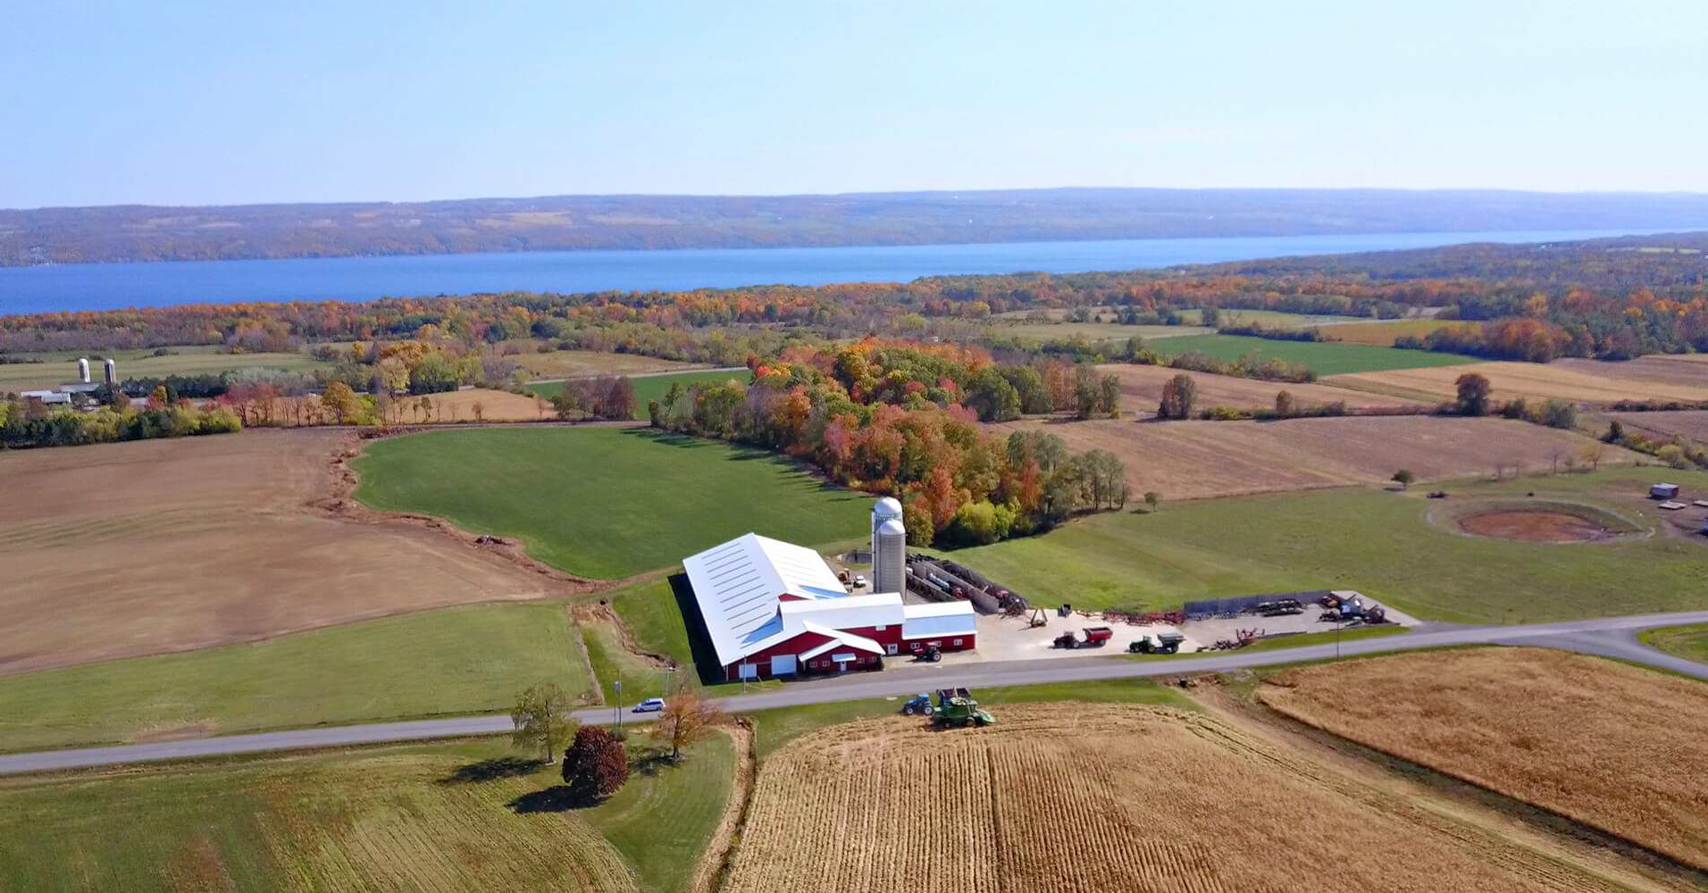
Farm overlooking Keuka Lake, Courtesy of Steuben County

