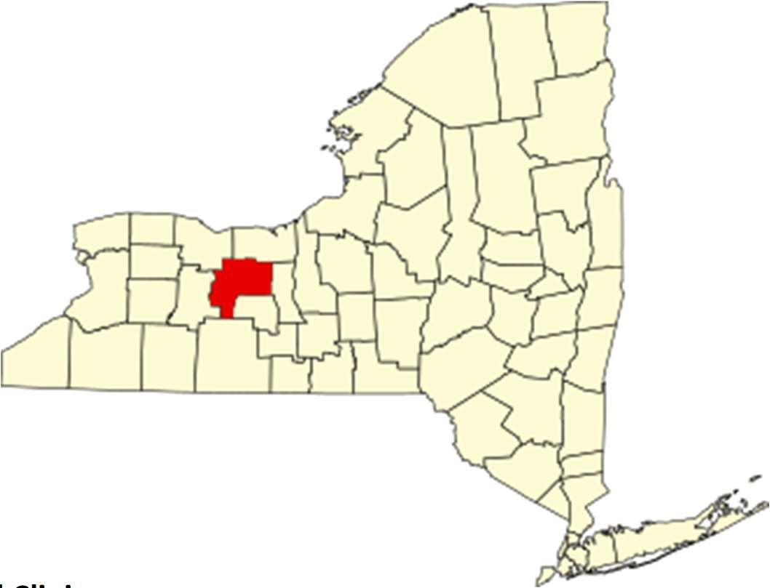
Ontario County Public Health
Ontario County Joint Assessment
Kate Ott, RN, MPH Public Health Director
kate.ott@ontariocountyny.gov 585-396-4343

UR Medicine Thompson Health
Amanda Reynolds, BS Amanda_Reynolds@URMC.Rochester.edu Wellness Coordinator
585-396-6589

Rochester Regional Health Clifton Springs Hospital and Clinic Hannah Smith, MBA, RD, CDN Hannah.Smith@rochesterregional.org
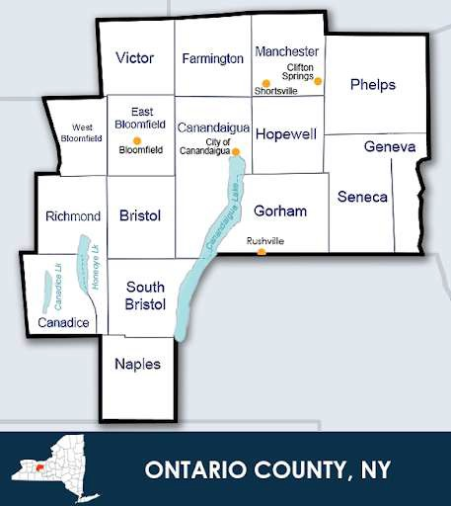
Associate Chief Operating Oﬃcer 315-462-9561

UR Medicine Finger Lakes Health Kimberly Ilacqua, MS, BS Kimberly_Ilacqua@URMC.Rochester.edu Vice President, Community Services
315-787-4053

Pivital Public Health Partnership
Michele Foster, MPA Executive Director MFoster@pivitalphp.org

Table of Contents

Page
4
6
Acknowledgements
Participating Partners 5
Community Representation
Executive Summary 7
Community Description
Service Area 13
Demographics
Speciﬁc Methodology 19
23
New York State Prevention Agenda 2025-2030
13
13
Health Status Description 24
Health Challenges and Associated Risk Factors
61
Health Priorities 65
Poverty
Depression 66
Preventive Services for Chronic Disease Prevention and Control
Community Assets and Resources 69
List of Tables:
Table O1: Selected Health Priorities And Disparities Being Addressed | 7
Table O2: Community Partner Survey Results | 21
Table O3: NYS Prevention Agenda 2025–2030 Domains and Priorities | 23
Table O4: ALICE Household Survival Incomes | 27
Table O5: Asset Limited, Income Constrained, Employed (ALICE) Households | 27
Table O6: Food Insecurity Rate | 29
Table O7: Food Insecurity Reported by Ontario County Youth | 29
Table O8: Social and Community Context | 32
Table O9: Trends in Suicide-Related Behaviors reported by Ontario County Students | 34
Table O10: Student Social and Community Context | 35
Table O11: Tobacco/E-cigarette and Alcohol Use | 38
Table O12: ACES among Students | 39
Table O13: Injury and Violence | 43
Table O14: Pregnancy Behaviors and Outcomes | 45
Table O15: Comparison of Leading Causes of Death and Premature Death in Ontario | 57
County and NYS
Table O16: Emergency Department Visits | 59
Table O17: Resources to Accomplish CHA/CHIP goals | 71
List of Maps:
Map O1: Town, Cities, Villages and Counties Surrounding Ontario County | 13
Map O2: Population Density in Ontario County 14
67
65
Map O3: Poverty Rates in Ontario County by Zip Code 25
Map O4: Life Expectancy by Zip Code 57
Map O5: ED Visit Rate by Zip Code 58
Map O6: Preventable Hospitalizations by Zip Code 59
Page 2 Ontario County

Figure O1: Ontario County Health Collaborative Process 7
Figure O2: Population Projections in Ontario County 15
List of Figures:
Figure O3: Population Pyramid 16
Figure O4: Community Partner Network Across Prevention Levels 20
Figure O5: Poverty Amongst Primary School Children 26
Figure O6: Households below the Poverty Level and ALICE Households 26
Figure O7: Unemployment Rates in January of Each Year 28
Figure O8: Suicide Rates in Ontario County 33
Figure O9: Opioid Deaths per 100,000 in Ontario County 36
Figure O10: Overdose Deaths in Ontario County Compared with NYS Average 37
Figure O11: First Trimester Prenatal Care 45
Figure O12: Prenatal Care and Birth Outcomes by Race/Ethnicity 46
Figure O13: Maternal Mortality 47
Figure O14: Provider Access 49
Figure O15: Percentage of Medicaid Enrollees Reporting a Dental Visit in the Past 51
Year (2014-2023)
Figure O16: Dental Visit Status Among Medicaid Recipients (Ages 2-20) 52
Figure O17: Routine Vaccination Rate Among Children 54
Figure O18: HPV Vaccination Series by Age 13 54
Figure O19: Childhood Lead Testing 55
Figure O20: Chronic Absenteeism 55
Figure O21: Postsecondary Education 56
Figure O22: Health and Well-Being 60
Figure O23: Community Conditions 60
Appendix A. Community Voices Included in the Community Health Assessment 72
Appendices

Acknowledgements

We thank community members whose knowledge and lived experience form the foundation of this report. The input they generously shared has focused the scope of this work, strengthened its quality, and led us toward a more accurate understanding of local health needs.
We thank community partners, Ontario County Health Collaborative members, and organizations that contributed to this assessment by providing data, outreach support, expertise, and ongoing collaboration. These partnerships grounded the assessment in local context and ensured it reﬂects the realities of Ontario County.
The Public Health Director would like to thank the director and staﬀ at the Pivital Public Health Partnership for providing guidance, expertise and support during the community health assessment (CHA), as well as, Pauline Hoﬀman, Ph.D. for assisting with the CHA narrative. A special thanks to Kassandra Doyle, MS who assembled community partners, led them through the MAPP 2.0 process, provided vision, and contributed signiﬁcantly to the creation of this document.

Community Partners

A diverse coalition of organizations and residents participated in the Ontario County Community Health Assessment process to ensure broad stakeholder input and representation from organizations that serve people in our community experiencing health disparities. The following partner organizations, organized by sector, contributed to planning and assessment activities:

Community Agencies

- American Lung Association / Tobacco Action
Coalition of the Finger Lakes
- ARC of Ontario
- Brightstart Connect
- Cabrini Health Foundation
- Cancer Support Community at Gilda's Club Rochester
- Common Ground Health
- Cornell Cooperative Extension of Ontario County
- Council for Alcoholism and Addiction of the Finger Lakes (CAAFL)
- Eaglestar Housing
- Finger Lakes Area Counseling & Recovery
Agency (FLACRA)
- Forward Leading IPA
- Pivital Public Health Partnership
- SNAP-Ed NY
- Society for the Protection and Care of Children (Finger Lakes WIC)
- The Arc Ontario
- Ontario Cares-formerly the Partnership for Ontario County
- United Way of Greater Rochester and the Finger Lakes
- YWCA Rochester

H  - UR Medicine FF Thompson Health | ealth Care  - Rochester Regional Health Clifton Springs
- UR Medicine Finger Lakes Health | Hospital and Clinic
- Finger Lakes Community Health
Education
  - Finger Lakes Community College • Wayne/Finger Lakes BOCES
  - Hobart & William Smith Colleges
Govern  - Ontario County Social Services Department | ment  - Ontario County Public Health
- Ontario County Mental Health | - Ontario County Oﬃce for the Aging
- Ontario County Youth Bureau  Transpo | rtation
  - RTS (Regional Transit Service)

Partner organizations facilitated connections to Ontario County residents who are often missed by traditional outreach methods. The following list, organized by social identity, describes groups reached through outreach activities:
Community Representation
Rural Geography
  - Rural homeschool families • Dairy farm workers
  - Rural caregivers • Residents in small towns
Income and Economic Stability
  - Low-income families • Frontline helping professionals
  - Older adults on ﬁxed incomes
Disability and Ability
  - Adults with disabilities • Parents of children with complex medical
  - Older adults with disabilities needs
Language and Immigration
  - Spanish-speaking community program • Spanish-speaking migrant farm workers participants
Justice System Involvement
  - People on probation • Incarcerated men and women
Health and Behavioral Health
  - People with lived experience of substance • Individuals with mental health needs misuse and recovery
Sexual Orientation and Gender Identity
  - LGBTQIA+ adults across age groups • LGBTQIA+ frontline workers
Racial and Ethnic Identity
- Indigenous community members living in the • Black and Hispanic residents were included Finger Lakes region across engagement activities rather than
through outreach based on race or ethnicity

Background
Executive Summary
Throughout 2025, Ontario County Public Health collaborated with UR Medicine Thompson Health, UR Medicine Finger Lakes Health, and RRH Clifton Springs Hospital and Clinic, and community partners to complete a Community Health Assessment (CHA), begin a joint Community Health Improvement Plan (CHIP), and develop a Community Services Plan (CSP). Eﬀorts were stymied by a signiﬁcant delay in the release of the 2025 to 2030 NYS Prevention Agenda documents and guidance. Prevention Agenda materials were received by health departments approximately ﬁve months prior to the CHA/CHIP/CSP due date. While a six-month extension was granted for completion of the Community Health Improvement Plan (CHIP), the deadline for hospital partners to submit their Community Service Plans (CSPs) remained 12/31/2025.

This CHA and CHIP/CSP will be submitted by Ontario County Public Health on behalf of the three participating hospital systems in December of 2025 to comply with IRS requirements. Public Health and other stakeholders will take advantage of the six-month extension and will submit a combined, comprehensive CHIP to NY State by June of 2026. The ﬁnal version will include contributions from all partners.

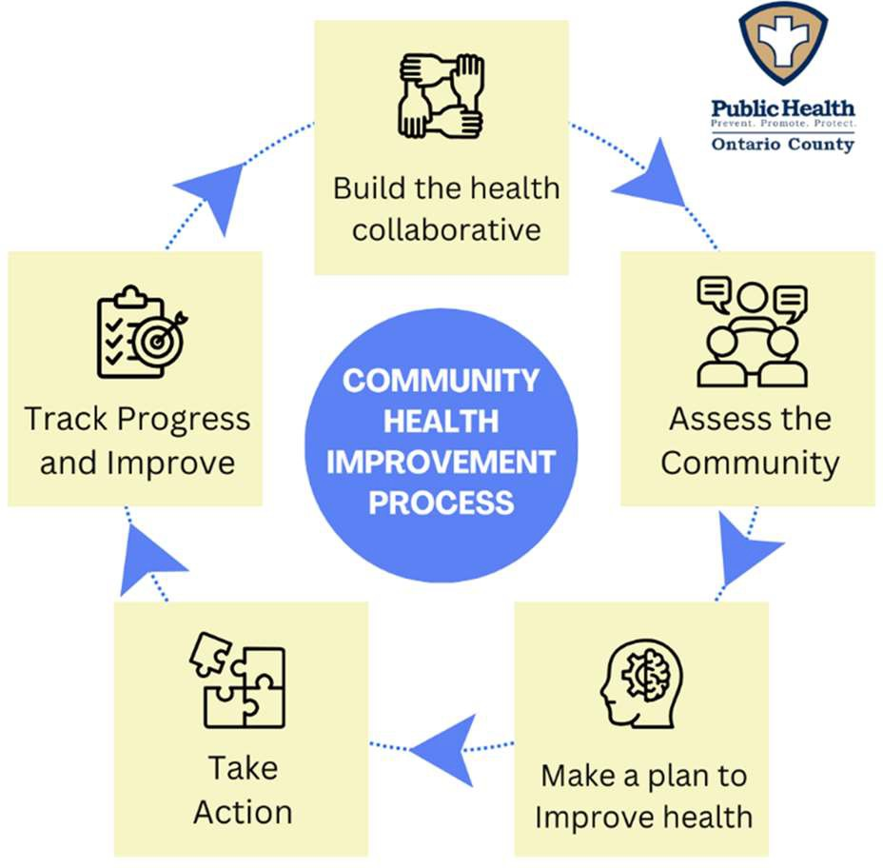
Community Health Improvement and Community Service Plan Development
In the fall of 2025, after the comprehensive CHA and using the 2025-2030 NYS Prevention Agenda,
health issues were identiﬁed and prioritized, and groups experiencing unequal health outcomes were considered. Goals and objectives were selected, indicators were chosen, and realistic targets were set (Table O1).
Progress toward health improvement goals will be monitored quarterly and presented to stakeholders at meetings of the Ontario County Health Collaborative (Figure O1). The plan will be updated as needed to respond to changing community needs, stakeholder capacity, and emerging issues.

Looking ahead, New York State will require local health departments work with hospital partners to complete a mid-cycle CHA and CSP, due in December
Figure O1: Ontario County Health Collaborative Process, Courtesy of Ontario County Public Health
2028. This ensures hospitals meet their IRS community beneﬁt obligation, which is required for maintaining non-proﬁt status. A full CHA will follow in 2030.

Table O1: Selected Health Priorities And Disparities Being Addressed

Poverty
Goal | Identify, promote, and implement programs that address poverty
Objective | Reduce the percentage of people living in poverty
Disparity to Address | People with low-income: Higher risk of food insecurity and unmet social needs
Depression
Goal | Increase screening and treatment for depression
Objective | Maintain or reduce the percentage of adults experiencing frequent poor mental health
Disparities to Address | Rural residents: Health care access barriers Young people: Higher rates of depression
Preventive Services for Chronic Disease Prevention and Control
Goal | Reduce disparities in access and quality of evidence-based preventive and diagnostic services for chronic diseases
Objective 1 | Increase the percentage of adults aged 45 to 75 who are up to date on colorectal cancer screening
Objective 2 | Increase the percentage of adults with hypertension who are taking blood pressure medication
Disparities to Address | Rural residents: Health care access barriers  People from racial and ethnic groups: Lower rates of hypertension

Health Disparities
Health disparities in Ontario County are primarily linked to age, income, and socioeconomic status, with additional challenges for rural residents, youth, and racial/ethnic minorities. Children in high-poverty areas, such as Geneva, face developmental, health, and mental health risks, often relying on school-based supports to overcome these factors. Older adults and low-income or Medicaid populations encounter barriers to primary, preventive, and specialty care due to cost, limited local providers and lack of transportation. Rural families, farmworkers, LGBTQ+ individuals, and people in recovery also experience gaps in health care access. These overlapping challenges in poverty, mental health, chronic disease, and service access highlight the need for coordinated interventions to improve equity and outcomes.

Data Sources
The Regional and Ontario County-speciﬁc CHA incorporated both quantitative and qualitative data sources, including secondary data from the Behavioral Risk Factor Surveillance System, County Health Rankings, National Center for Health Statistics, American Community Survey, U.S. Census, and NYS Medicaid Program.

Key ﬁndings pulled from local qualitative and quantitative data form the backbone of this assessment. Ontario County-speciﬁc data sources included:
- Evalumetrics Youth Survey of Students
- Ontario County 2023 Housing Study
- United Way’s ALICE (Asset Limited, Income Constrained, Employed) Measurements
- Pivital Public Health Partnership Food Security Survey
- Pivital Public Health Partnership Access to Care Survey
- Ontario Cares’ Pathways to Stability and Resilience Report
- Focus groups and interviews conducted across Ontario County (see appendix A)
Ontario County used the MAPP 2.0 framework for its Community Health Assessment, combining quantitative data, organizational input, and community voices. Focus groups and interviews engaged underserved populations, revealing key issues like mental health, chronic disease, poverty, and service gaps. Findings were integrated with partner assessments to identify community strengths and challenges. A structured prioritization process then guided the selection of ﬁnal health improvement priorities for the Community Health Improvement Plan.

Partners and Roles
Partners are listed in the Community Partners section. Key facilitators for this assessment included Ontario County Public Health, UR Medicine Thompson Health, Rochester Regional Health Clifton Springs Hospital and Clinic, UR Medicine Finger Lakes Health, Common Ground Health, Ontario Cares, and the Pivital Public Health Partnership. These partners promoted and circulated surveys, organized and led focus groups, conducted outreach to underrepresented groups, and attended monthly meetings of the Ontario County Health Collaborative where they participated in the MAPP 2.0 planning and assessment process (see Methodology section). This included review and interpretation of data, prioritization exercises, root cause and intervention analyses and ultimately the creation of the CHIP/CSP.

Summary of Findings
Located in the western portion of New York’s Finger Lakes region, Ontario County has seen modest improvements in economic stability including declining poverty and low unemployment. However, older adults and families living in certain parts of the county remain ﬁnancially vulnerable. Housing may be more aﬀordable than statewide averages but rising costs without commensurate increases in salaries have created challenges for ﬁrst-time buyers, older adults, and low-income families. Unlike most counties across New York, Ontario County’s population is increasing. A 2023 housing study conducted by Urban Partners found over the course of the next few years, Ontario County needs 1,600 new homes to match population growth, with older adults driving most of that demand. There are sharp divides in wealth among residents; some living in multimillion dollar lake-side homes while the county’s most vulnerable populations live in substandard rentals.
Health outcomes reﬂect this ﬁnancial diversity. Though county-wide rates of chronic disease are below state averages and life expectancy is high (79.8 years), health outcomes for residents are dependent on their ZIP code, school district, race, and ethnicity. Most children poisoned by lead live in poorly maintained rentals built prior to the 1978 lead paint ban. Mental health and behavioral challenges aﬀect some schools more than others. There are growing concerns about substance use and overdose deaths among certain populations. Placement of convenient and dollar stores in low-income neighborhoods

provide easy access to tobacco and vapes and aﬀect eating habits, including inadequate fruit and vegetable intake, binge drinking, and high sugary beverage consumption.

Access to preventive and specialty care is limited in some areas of the county due to provider shortages, transportation barriers, and high out-of-pocket costs, particularly aﬀecting low-income households, rural residents, and individuals on Medicaid. Though immunizations, prenatal care, and breastfeeding rates are generally encouraging, rates of pre-term birth and infant mortality remain concerning.
Dental care access is signiﬁcantly limited, especially for Medicaid enrollees.

Ontario County exhibits generally supportive social and educational environments. Educational attainment is high, with strong high school and post-secondary completion rates, and civic engagement is relatively robust. Access to physical activity is moderate, with most

Kershaw Park on Canandaigua Lake, Courtesy of Ontario County Public Health

residents having vehicle access but limited choices for walkability and locations at which to exercise in the winter. Injury and violence-related deaths, including farming accidents, motor vehicle accidents, suicide and ﬁrearm incidents, remain elevated.
Community engagement and collaboration are key strengths. Partnerships across health care, public health, social services, and community organizations, as well as informal peer networks and volunteer support, provide essential resources for residents. Programs addressing food access, substance use prevention, chronic disease, mental health, and early childhood health ﬁll gaps where formal systems fall short. Regional coalition work between the eight Finger Lakes Counties, is spearheaded by the Pivital Public Health Partnership.
Overall, Ontario County demonstrates strong community assets, a relatively high quality of life, and eﬀective collaboration among partners. At the same time, ongoing challenges, particularly in mental health, substance use, obesity, housing aﬀordability, and health care access, highlight areas for targeted interventions through the Community Health Improvement Plan.

Interventions and Measures
The Joint CHIP/CSP submitted in December 2025 captures the planned activities of hospital partners. This information is included here to meet IRS requirements for non-proﬁt hospitals by the December 31, 2025 deadline. The comprehensive CHIP will be ﬁnalized by June of 2026 and will be addended to this report. It will incorporate the activities of our community partners in addition to those of the hospitals.
Domain: Economic Stability Priority: Poverty
Planned Interventions | Implementation Partner
Conduct regular screenings of patients for social determinants of health factors  Measure(s):  - Number of screenings performed  - Positivity rate  - Number of reports received by LHD | - UR Medicine FF Thompson Health  - Rochester Regional Health Clifton Springs Hospital and Clinic  - UR Medicine Finger Lakes Health
Create healthy food pantries in hospitals to ensure food security and access to healthy food  Measure(s):  - Number of people served by pantry | UR Medicine FF Thompson Health

Domain: Health Care Access & Quality
Priority: Preventive Services for Chronic Disease Prevention and Control
Planned Intervention | Implementation Partner
Encourage the use of client reminders by providers to increase cancer screening per Community Guide national guidelines.  Measure(s):  - Number of practices that use client reminders | Rochester Regional Health Clifton Springs Hospital and Clinic
Provide evidence-based stroke prevention education in communities that are disproportionately aﬀected by a high prevalence of undiagnosed and/or uncontrolled hypertension.  Measure(s):  - Number of education/outreach events | UR Medicine Finger Lakes Health
Provide evidence-based education on stroke recognition and the use of emergent Emergency Medical Services (EMS) care in communities disproportionately aﬀected by stroke hospitalizations.  Measure(s):  - Number of people reached through stroke education and trainings  - Number of stroke support group sessions held  - Number of stroke incidents | UR Medicine FF Thompson Health

Domain: Social & Community Context Priority: Depression
Planned Intervention | Implementation Partner
Implement and promote Mental Health First Aid training in communities and health care settings  Measure(s):  - Number of trainings  - Number of participants | UR Medicine FF Thompson Health
Conduct standardized depression screenings during patient visits  Measure(s):  - Number of screenings  - Positivity rates | UR Medicine Finger Lakes Health
Track utilization of Comprehensive Psychiatric Emergency Program  Measure(s):  - Number of admissions  - Number of adolescents admitted | Rochester Regional Health Clifton Springs Hospital and Clinic

Evaluation and Accountability
Ontario County Public Health, hospital partners, and community stakeholders will track progress throughout the prevention agenda cycle to make sure the Community Health Improvement Plan remains useful, feasible, and accurate. Data that informed the strategies for each priority will be updated as new information becomes available. Partners will report on their Community Service Plan Activities quarterly and the Ontario County Public Health Department will communicate updates during monthly coalition meetings.
Evaluation will focus on tracking key indicators for each health priority and monitoring performance measures for selected strategies. The community will be monitored for changing conditions, emerging issues, and new disparities. Additionally, existing and future partners will provide perspective and expertise over the course of the next six years. This process will allow for mid-course corrections during the health improvement cycle and will ensure the plan is aligned with the needs of the community and the capacity of partners.

Dissemination
The ﬁndings of the CHA and the plan for community health improvement (CHIP) will be shared widely. The full report will be available on the Ontario County Public Health website and hospital partners will share the document with their boards and as directed by IRS requirements. Partner organizations will receive electronic copies to share within their networks. Hard copies will be provided to libraries. Key messages will be shared through community meetings, newsletters, and through social and traditional media to help the community understand the health improvement process and the goals of the CHIP. This approach will ensure that residents, service providers, and stakeholders have easy access to information about the health status of their community and are included in the evolving plan to address

community’s needs. The Public Health Director will share the CHA/CSP with county leadership and the legislative body to ensure county oﬃcials understand the role of public health in data collection and analysis, convening of stakeholders, and program development and to ensure alignment with the county’s mission, vision, and values.

Service Area
Community Description
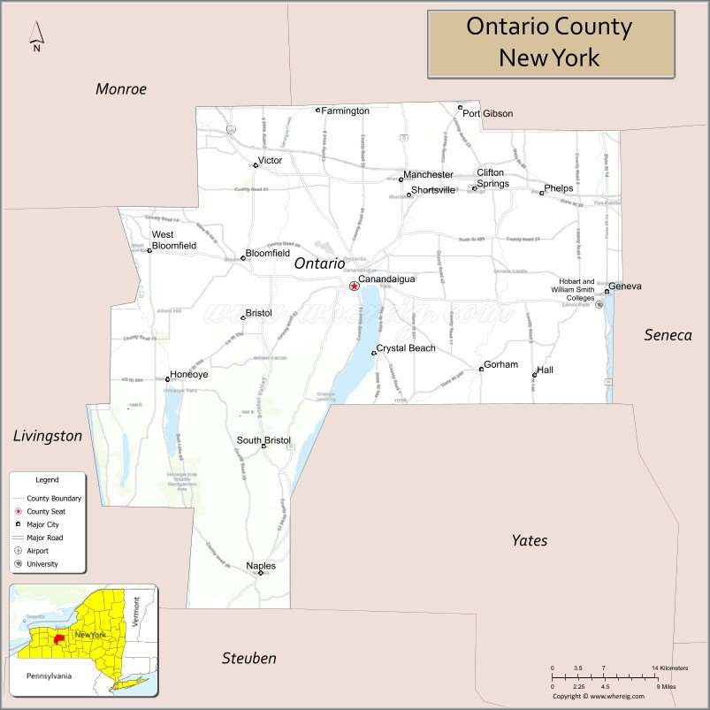
Ontario County covers a total area of about 663 square miles. The county lies in the middle of the Finger Lakes Region of western New York and is the home to two small cities (Canandaigua and Geneva), 16 towns, and 8 villages. Canadice and Honeoye Lakes are located within county borders while Hemlock, Canandaigua, and Seneca and Lakes border contiguous counties (Map O1).
Ontario borders Monroe County, home to the City of Rochester, on the west and smaller more rural counties to the north, south, and east. The New York State throughway runs east-west in the northern part of the county and creates easy commutes for residents who work in the greater Rochester or Syracuse areas.

Ontario County is served by nine school districts. These districts vary in size and community characteristics, from large suburban schools in Victor and Canandaigua, to rural, small-town

Map O1: Town, Cities, Villages, and Counties Surrounding Ontario County.

districts in Honeoye and Naples. Higher education providers in Ontario County include Hobart and William Smith Colleges, Finger Lakes Community College, and the Marion S. Whelan School of Practical Nursing.

Demographics
Demographic information is essential to public health practice. It identiﬁes who lives in a community, how their needs diﬀer, and where health disparities exist. By understanding factors such as age, race, place, education, and poverty, health departments can design programs and target resources where they will have the greatest impact. In short, demographic data provides the foundation for equitable planning, informed decision-making, and improved health outcomes for community members.

Population
Ontario County is home to about 112,500 residents and has a population density of 175 individuals per square mile. Though largely rural, recent population growth in towns and villages, particularly on the western edge of the county, make some areas resemble nearby suburban communities. The most populous areas of the county are the Town of Victor (15,908 residents) and the cities of Geneva and Canandaigua (County Seat) both with approximately 12,500 residents. (Map O2) As noted in the Executive Summary, Ontario County is growing.¹ Population estimates through 2040 are noted in Figure O2.
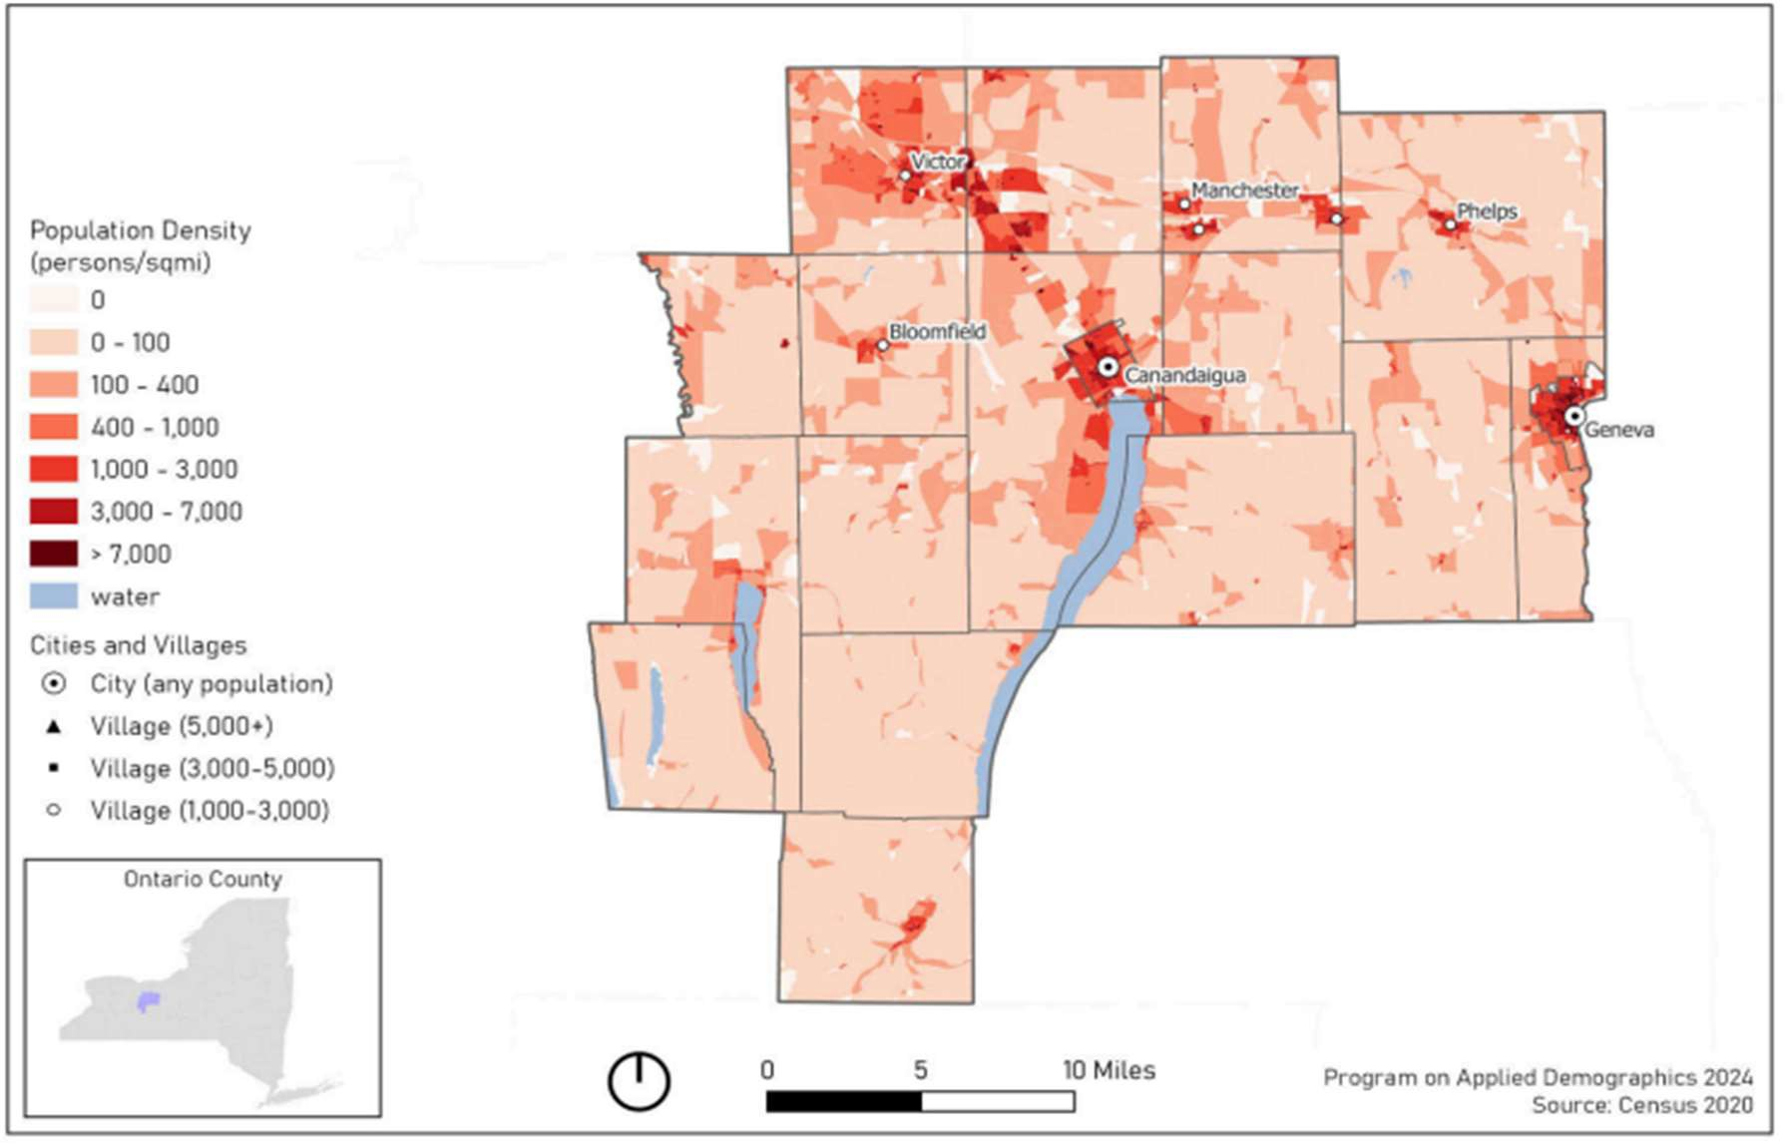
Map O2: Population Density in Ontario County

¹ Source: U.S. Census Bureau (2023). American Community Survey 1-year estimates. Retrieved from Census Reporter Proﬁle page for Ontario County, NY http://censusreporter.org/proﬁles/05000US36069-ontario-county-ny

Population Projections Ontario County
116,000
115,000
114,000
113,000
112,000
111,000
110,000
109,000
108,000
107,000
106,000
2015 2017 2019 2021 2023 2025 2027 2029 2031 2033 2035 2037 2039
Figure O2: Population Projections in Ontario County

Source: Cornell Program on Applied Demographics

Age and Gender
To understand the health needs of a community, it is necessary to consider age and gender. This data is presented in Figure O3. Those identifying as female or male are nearly equally distributed, while 5.8% of the population identify as LGBTQ+. The median age of residents is 43.9 years. Women continue to outlive men. Figure O3 overlays generational cohorts onto the current age structure of Ontario County residents to show the relative size of the Silent Generation, Baby Boomers, Generation X, Millennials, Generation Z, and young children often referred to as Generation Alpha, a term that may evolve as the cohort ages. The ﬁgure also incorporates images representing the dominant form of communication commonly used when each cohort came of age. This analysis informs the design and delivery of public health outreach and supports the use of communication methods that are aligned with generational preferences. The population trends shown within Figure O3 are largely stable with overall decline reﬂecting an aging Baby Boomer population, a shrinking Millennial labor force, fewer school-aged children, and lower birth and death rates.

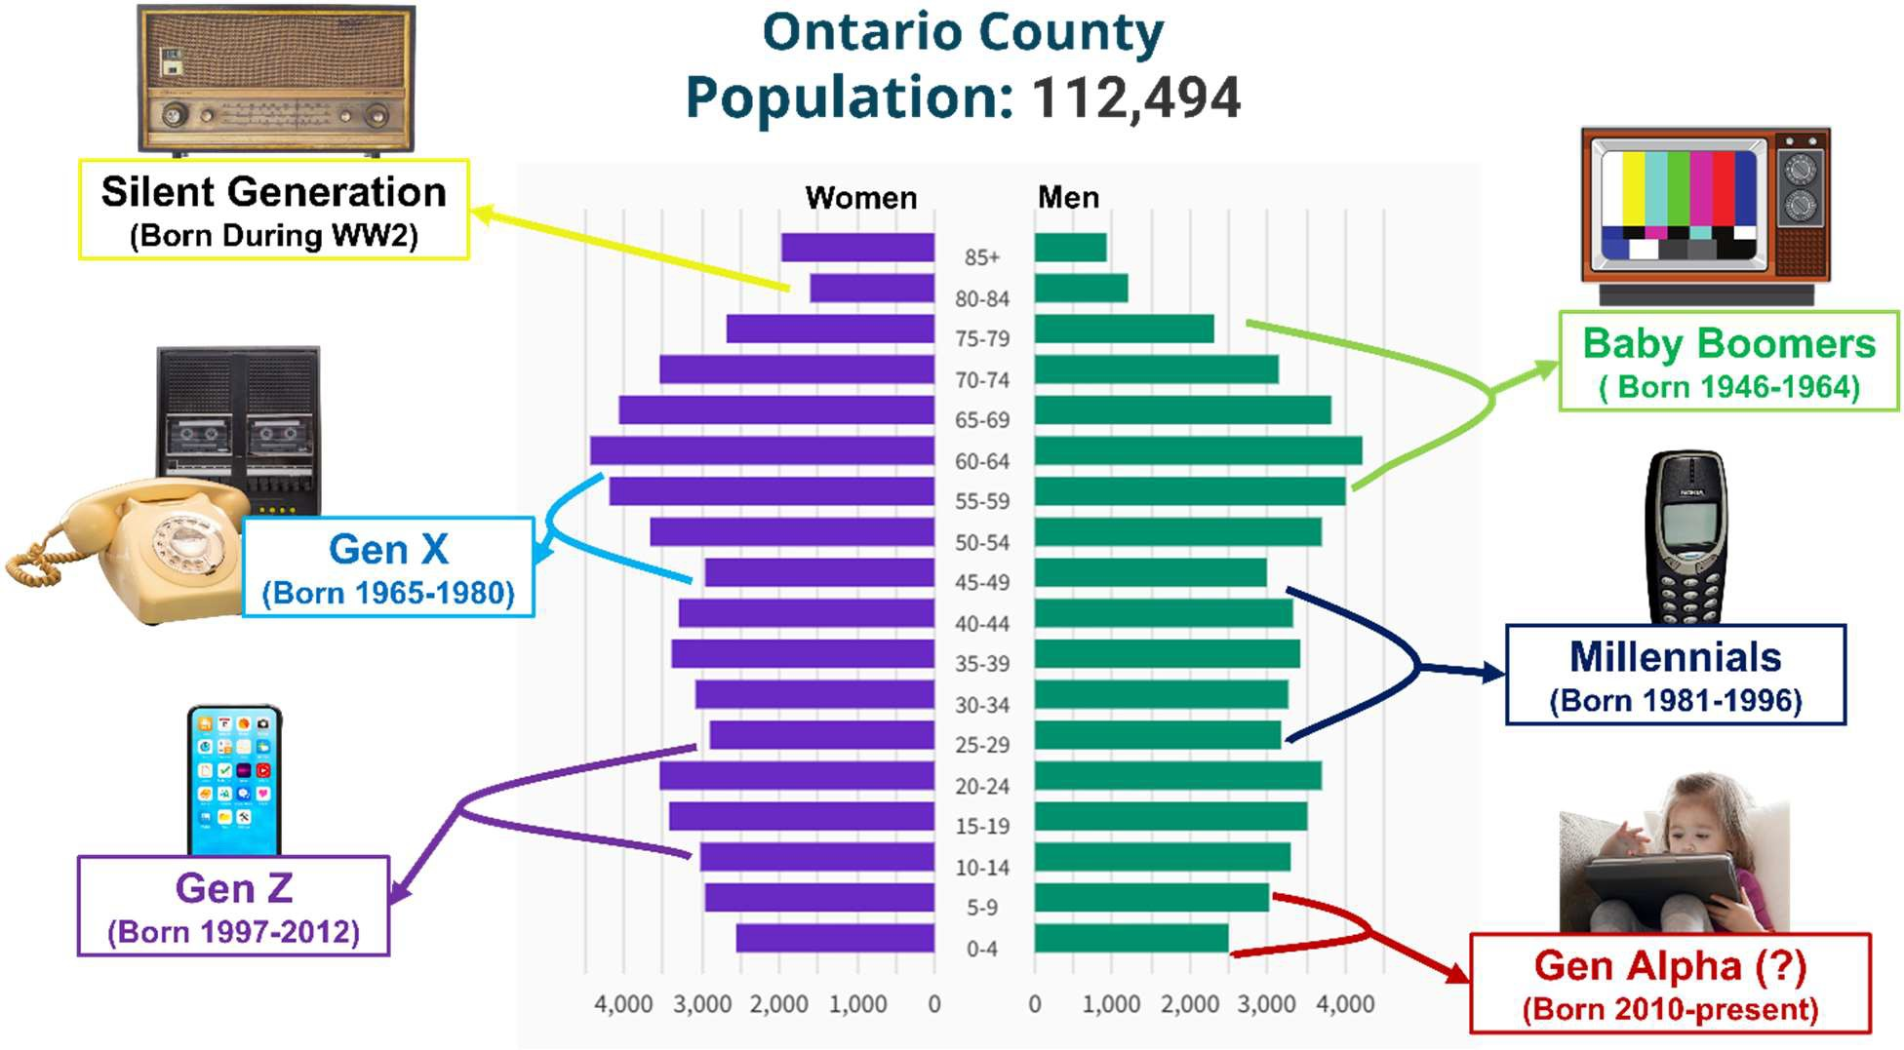
Figure O3: Population pyramid by age, sex, and generation. Sources: 2020 Census, U.S.A. Facts, Canva Pro Image Library

Race and Ethnicity
Census data for Ontario County indicate the population is predominantly White (86.6%), followed by Hispanic or Latino (5.4%), Black or African American (2.2%), Asian (1.2%) and American Indian or Alaska Native (0.2%). The City of Geneva on the eastern edge of the county enjoys the most racial and ethnic diversity in the county. According to the American Community Survey,² in 2023, Geneva’s population included:
- White (Non-Hispanic): 67.9%
- Black or African American (Non-Hispanic): 7.24%
- White (Hispanic): 6.78%
- Other (Hispanic): 4.64%)
- Two Races Including Other (Hispanic): 4.18%
In addition to more typical minority populations, Ontario County is home to a growing Plain (Mennonite and Amish) population. In recent decades, many traditionally multigenerational farms have been sold to Mennonite families moving north from Pennsylvania and Yates County. Though it is challenging to ascertain the number of plain families, observationally, the population has grown signiﬁcantly in the last decade. Horse-drawn buggies are commonplace on county roads and Mennonite-owned businesses

² Source: U.S. Census Bureau (2023). American Community Survey 1-year estimates. Retrieved from Census Reporter Proﬁle page for Ontario County, NY http://censusreporter.org/proﬁles/05000US36069-ontario-county-ny

appear to be thriving. There are ﬁve Mennonite schools in the county. Typically, children attend through eighth grade, taught by previous graduates with no formal training in education. Some Mennonite families seek out vaccines in the health department’s clinic, but school vaccination surveys conducted by NY State and Public Health staﬀ reveal low rates of vaccination for measles and other communicable diseases. Ontario County also includes a population of members of the Church of Jesus Christ of Latter-day Saints. Hill Cumorah is located within the county and holds religious and cultural signiﬁcance for members of the Church.
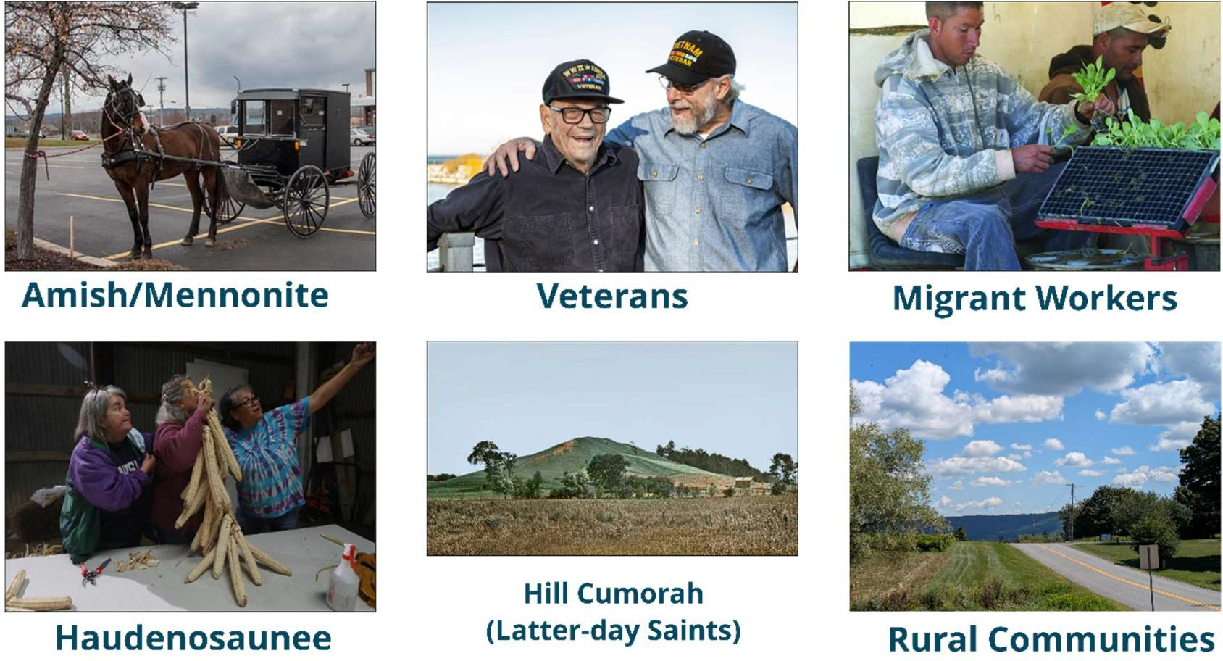

Special Populations in Ontario County
This county is located on the ancestral lands of the Haudenosaunee Confederacy, including the Seneca, Cayuga, Onondaga, Oneida, Mohawk, and Tuscarora Nations. Ganondagan State Historic Site remains an important cultural gathering place that reﬂects the continued presence of Indigenous people in the Finger Lakes Region.³
As a farming community, Ontario County attracts migrant farm workers who travel from community to community for planting and harvesting. Local farmers rely heavily on these individuals for their livelihoods. The county is fortunate to have a Federally Qualiﬁed Health care Center (FQHC) operated by Finger Lakes Community Health with an active migrant health program in Geneva. With the 2025 increase in frequency of U.S. immigration enforcement raids, the health department has learned from key stakeholders and migrant and seasonal workers themselves that fear is discouraging workers from leaving their farms for any reason, including to obtain health care.

³ Source: U.S. Census Bureau (2023). American Community Survey 1-year estimates. Retrieved from Census Reporter Proﬁle page for Ontario County, NY http://censusreporter.org/proﬁles/05000US36069-ontario-county-ny

Veterans and Disability
Veterans often have distinct health needs, including higher rates of chronic conditions, mental health challenges, and service-related injuries. There are over 7,000 veterans living in Ontario County representing between six and seven percent of the population. ⁴ This is more than twice the rate in NY, and 25% higher than the U.S. rate. The county is home to a VA Medical Center, where many local veterans receive health care, including mental health and substance misuse services. Ontario Cares, a community-based not for proﬁt, leads a Veterans’ Coalition; the ﬁrst of its kind in New York State.
Disabled persons have higher risks of chronic disease and may face heightened barriers to care, transportation, employment, and housing. According to data provided by Disability Statistics,⁵ 14.5% of Ontario County residents experience a disability.

Languages Spoken at Home
English language proﬁciency is one factor that ensures residents are able to communicate their needs and understand their options, particularly related to health care. Public Health relies on partners for written translation, an interpreter phone line, and Instant Language Assistant (ILA) for phone and in person encounters.
Languages spoken by Ontario County residents who have Limited English Proﬁciency (LEP)⁶:
- Spanish: 36.3%
- Dutch: 15%
- Pennsylvania German: 14.4%
- Italian: 6.7%
- German: 4.8%
- 23 other languages: 0.3% to 2.5%

Broadband Access
Broadband access supports health by enabling residents to use telehealth services, access health information, schedule appointments, and engage in remote health and wellness monitoring. These tools are especially vital for rural residents and people with limited transportation options. Reliable internet access also supports health education, emergency communication, social connection, and access to beneﬁts and community resources. This access helps reduce disparities and improve overall community well-being. Broadband access is considered a basic necessity and is tracked as an indicator measured by County Health Rankings and Roadmaps. While New York State as a whole has extensive broadband access, with 90% of people connected, gaps remain in Ontario County. An estimated 0.6% of the population, about 670 individuals, currently lack access to reliable broadband service.

⁴ Source: U.S. Census Reporter: https://censusreporter.org/proﬁle
⁵ Source: Disability Statistics: https://disabilitystatistics.org/acs-census?indStat=1
⁶ Source: NY State Language Dashboard at https://ogs.ny.gov/language-dashboard

Ontario County used the MAPP 2.0 framework to guide their Community Health Assessment. The process included:
Speciﬁc Methodology
- Starting Point Assessment
- Community Partner Assessment (CPA)
- Community Status Assessment (CSA)
- Community Context Assessment (CCA)
- Structured prioritization process

Starting Point Assessment
The CHA process began with a review of the previous county-wide health assessment to identify strengths, gaps, and opportunities for improvement. Partners reﬂected on what worked well, what did not go as planned, and which groups were missing from both community input and data sources. The Starting Point Assessment also helped establish goals for communication, data use, and community engagement during the new cycle. This review highlighted the need emerged to strengthen community engagement with underserved and rural populations. Based on these ﬁndings, and previous experiences with sample bias inherent in community-wide surveys, the Ontario County Health Collaborative decided to use focus groups and interviews as the primary method of gathering community input instead of relying on a county-wide questionnaire.

Community Partner Assessment (CPA)
The Community Partner Assessment helped the Collaborative understand local organizational strengths, capacities, and challenges. Partners placed local assets and resources along an upstream-midstream-downstream continuum to identify where prevention eﬀorts were concentrated and where gaps existed (Figure O4).

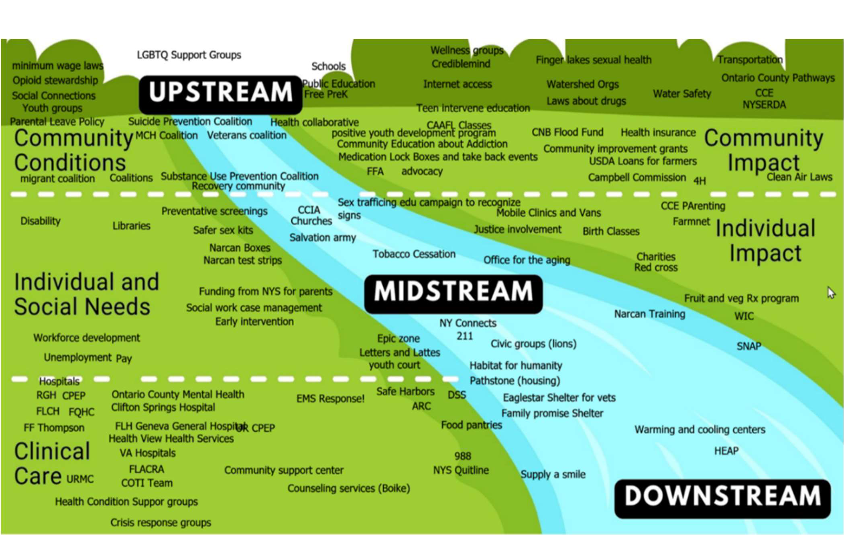
Figure O4: Community Partner Network Across Prevention Levels

A complementary survey revealed strong commitment from partners, substantial capacity in areas like outreach and education, and limitations in funding, data analysis, and staﬀ continuity (Table O2). The CPA also surfaced themes around structural barriers, inequities, and the ways systems of power and privilege shape access to care. This assessment guided the Collaborative in determining which partners should be involved at each stage of the CHA, where additional outreach was needed, and how power-sharing could support more equitable data collection.

Table O2: Community Partner Survey Results
Domain | Partners Active in Domain (n 16)
Domain | Partner Areas of Activity | Number |  | %
Economic Stability | Economic security | 4 | 25
Economic Stability | Jobs and labor | 5 | 31
Economic Stability | Wages and income | 5 | 31
Social and Community Context | Community conditions | 16 | 100
Social and Community Context | Connections to communities with lived experience | 11 | 67
Social and Community Context | Family well-being | 13 | 81
Social and Community Context | Violence prevention | 8 | 50
Social and Community Context | Youth development | 8 | 50
Neighborhood and Built Environment | Public safety | 7 | 44
Neighborhood and Built Environment | Housing | 6 | 38
Neighborhood and Built Environment | Transportation | 5 | 31
Neighborhood and Built Environment | Land use | 2 | 13
Health Care Access and Quality | Health care access and utilization | 11 | 69
Health Care Access and Quality | Needs assessments & data sharing | 10 | 63
Education Access and Quality | Youth development and leadership | 8 | 50
Education Access and Quality | Family well-being | 13 | 81
Education Access and Quality | Public health | 13 | 81
Education Access and Quality | Early childhood education and K-12 | 10 | 63

Community Status Assessment (CSA)
The CSA involved reviewing existing quantitative data to understand the health status of Ontario County residents. Partners examined demographic trends, health outcomes, social determinants of health, and system-level factors. The Clear Impact Scorecard platform was used to compile data from sources such as BRFSS, census data, hospital utilization data, and other public health surveillance systems. These data highlighted key concerns, including mental health, chronic disease, poverty, transportation barriers, and rising adverse childhood experiences. The CSA also identiﬁed gaps in existing datasets and areas where local data were limited, informing the focus of outreach for the Community Context Assessment which would involve targeted focus groups and interviews.

Community Context Assessment (CCA)
The Community Context Assessment focused on gathering lived experience and community voice. To expand reach and increase equity, partners participated in virtual training to facilitate focus groups and then helped host, co-facilitate, or take notes for groups across the county. Empowering partners to collect data directly allowed the collaborative to engage groups and individuals who typically face barriers to participation. These included migrant farmworkers, parents of children with complex medical needs, Spanish-speaking residents, and rural families. A total of 18 focus groups and multiple interviews were completed. Themes included stigma, transportation, cost of living, service gaps, mistrust, discrimination, housing instability, and strong reliance on peer support and informal networks. Findings

from these discussions were paired with results from the CPA and CSA to paint a more complete picture of community strengths and challenges.

Prioritization
During the prioritization process, partners ensured that shared priorities reﬂected both data and community voice. Proﬁles of the top ten identiﬁed health issues were shared with the Ontario County Health Collaborative. Coalition members reviewed issue proﬁles, asked questions, oﬀered feedback, and reﬂected on how these issues appeared in the populations they work with and represent. To support participation and informed voting, priority issues and issue proﬁles were made available in multiple formats including printed copies and electronic links. Coalition members voted on priorities independently and results informed the selection of the ﬁnal CHIP priorities.
Several priorities from the NYS Prevention Agenda framework were not presented to the CHA Committee for prioritization including Early Intervention, Health and Wellness Promoting Schools, and Opportunities for Continued Education. At the time of prioritization, local partners lacked the capacity to implement prevention agenda strategies related to early intervention program or school-based approaches due to staﬃng shortages and increased service demands. Additionally, Child Behavioral Health was not included in the initial version of the NY State Prevention Agenda framework used by Ontario County Stakeholders during prioritization.

In 2025, New York State aligned its 2025-2030 Prevention Agenda with CDC’s Healthy People 2030 and as noted previously, there was a signiﬁcant lag in this information being made available to local health departments and their CHA/CHIP partners. Table O3 identiﬁes the NYSDOH Prevention Agenda Domains and Priorities. Those domains and priorities shown in bold were selected by Ontario County Public Health and its partners.
New York State Prevention Agenda 2025-2030
Table O3: NYS Prevention Agenda 2025-2030 Domains and Priorities

Domain | Priority Area | Priorities
Economic Stability | Economic Wellbeing | - Poverty  - Unemployment  - Nutrition Security  - Housing Stability and Affordability
Social and Community Context | Mental Wellbeing | - Anxiety and Stress  - Suicide  - Depression  - Primary Prevention, Substance Misuse, and Overdose Prevention  - Tobacco/E-cigarette Use  - Alcohol Use  - Adverse Childhood Experiences  - Healthy Eating
Neighborhood and Built Environment | Safe and Healthy Communities | - Opportunities for Active Transportation and Physical Activity  - Access to Community Services and Supports  - Injuries and violence
Health Care Access and Quality | Health Insurance Coverage and Access to Care | - Access To And Use of Prenatal Care  - Prevention of Infant and Maternal Mortality  - Preventive Services for Chronic Disease Prevention and Control  - Oral Health Care
Health Care Access and Quality | Healthy Children | - Preventive Services  - Early Intervention*  - Child Behavioral Health*
Education Access and Quality | PreK-12 Student Success and Educational Attainment | - Health and Wellness Promoting Schools*  - Opportunities for Continued Education*
* Priority not presented to CHA Committee for prioritization

The following section details Ontario County’s health status related to the Prevention Agenda domains and priorities.
Health Status Description

Domain: Economic Stability
Economic stability allows residents to have the assets they need to live healthy lives. Factors that contribute to economic stability include:
- Job availability
- Earning a living wage
- Having sick time and health insurance coverage
- Aﬀordable housing
- Aﬀordable childcare
- Transportation
- Employment programs and career counseling
- Aﬀordable options for continuing education
External factors that aﬀect an individual’s economic stability include:
- Disabilities and injuries
- Unemployment rate
- Inﬂation and interest rates
- Housing market
- Local, State and Federal priorities, laws and funding
Individuals who lack economic stability are at risk for chronic health conditions and premature mortality. Though Ontario County has seen modest improvements in poverty and unemployment, older adults and young residents alike face uncertainty in regard to aﬀordable housing on retirement and entry-level salaries, respectively.
Residents who are under or unemployed face signiﬁcant barriers to health care access; as do those with large, unrealistic insurance deductibles. Addressing these issues requires cross-sector collaboration and integration of workforce well-being into public health and economic strategies. Promoting equitable employment opportunities will support long-term economic stability and allow Ontario County families to access education, health care, nutritious foods, and stable housing.

Priority: Poverty
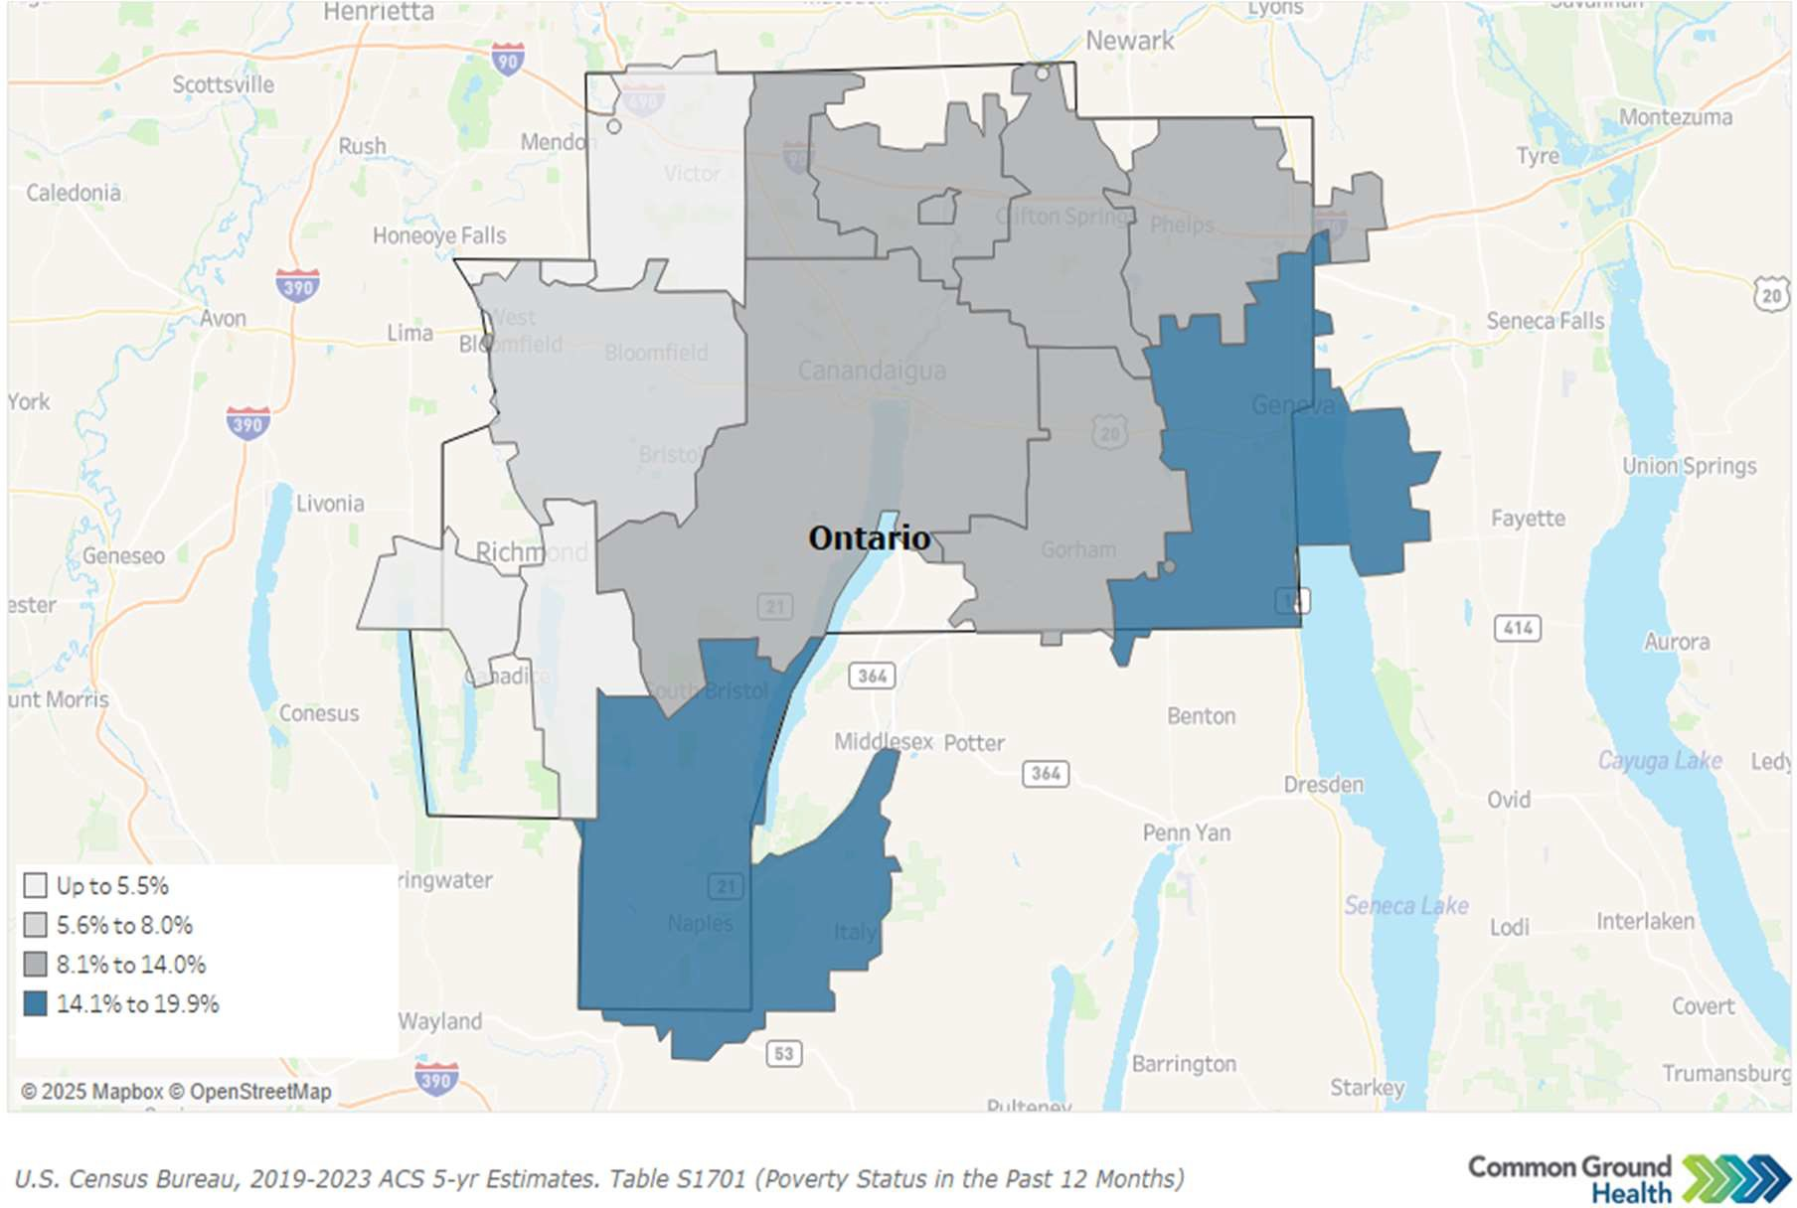
Map O3: Poverty Rates Ontario County by Zip Code

Families facing ﬁnancial hardship often struggle to meet basic needs and limited local resources make it harder to navigate out of poverty. Overall, Ontario County’s poverty rate has remained fairly stable at 9.2% of all individuals, compared to 9.6% in 2018, and remains well below the state average of 13.7%.
Among children under 18, poverty aﬀects 10% of the population, which is lower than the state average of 19% but represents a slight increase from 9.0% in 2018. Poverty among adults over age 65 has increased to 7.6% from 6% in 2018. While this remains lower than the state average for older adults (27%), the population of older adults in Ontario County is projected to grow signiﬁcantly over the next decade, increasing the risk that more residents may experience poverty in the future. Geographic disparities are also evident. Map O3 shows poverty by zip code, with the highest rates found in and around Naples (16.9%) and Geneva (18.3%).

Figure O5 demonstrates poverty rates in diﬀerent school systems within Ontario County. Geneva City School District has the highest poverty rate of the county.

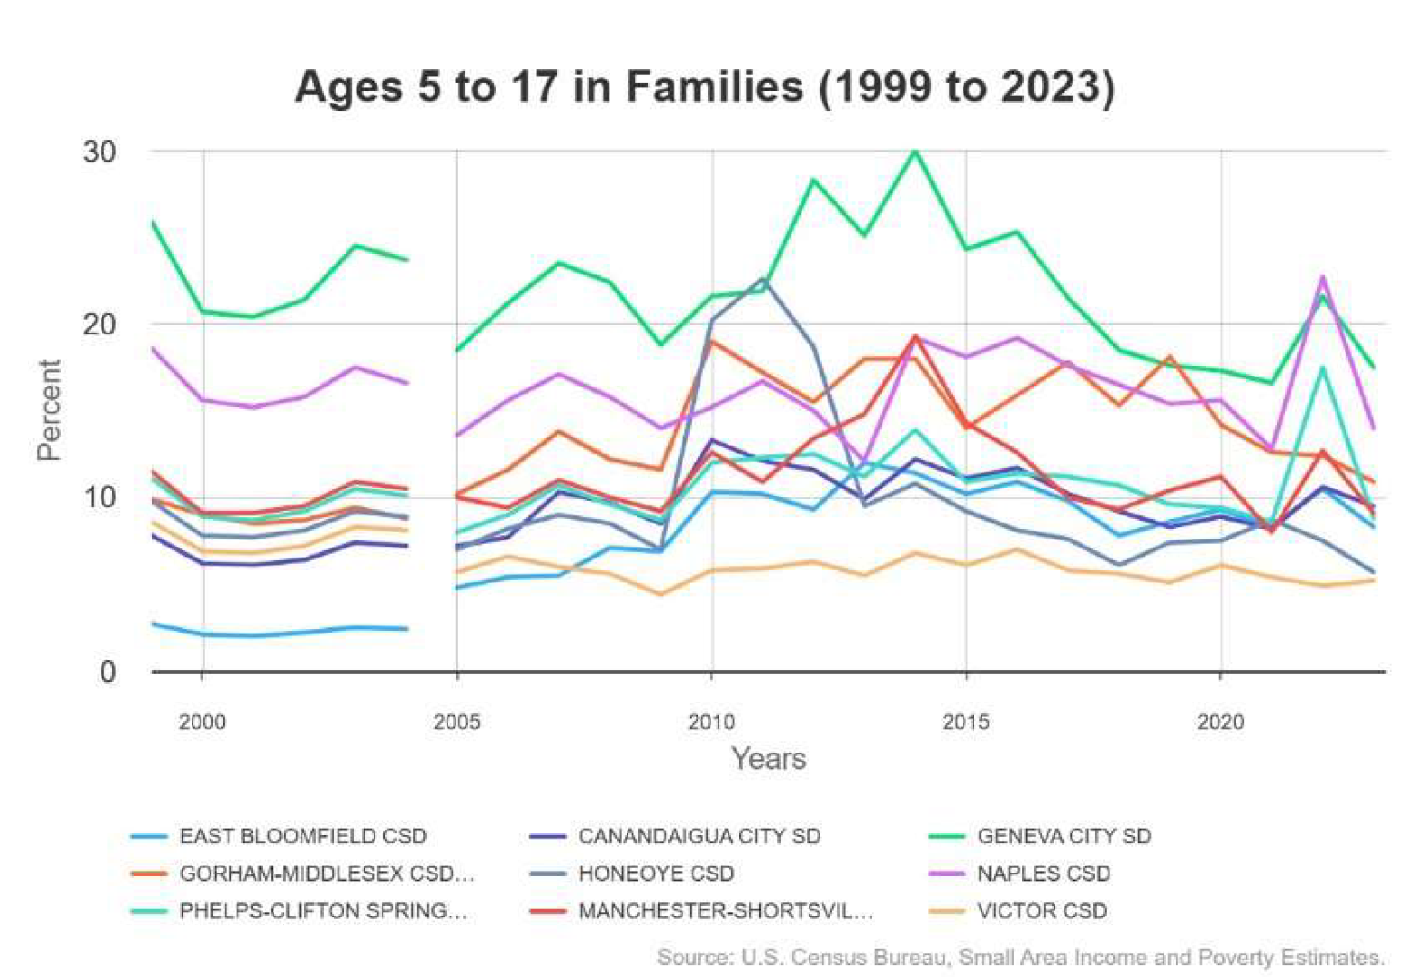
Poverty rates do not tell the complete story of ﬁnancial hardship in the county. Many residents, though employed and living above the federal poverty level, are unable to aﬀord basic necessities of housing, child care, food, transportation, health care, and technology. United for ALICE (Asset Limited, Income Constrained, Employed) provides data to health departments and community partners to quantify the number of households ﬁnancially struggling. ALICE data reﬂect residents living near the edge of ﬁnancial catastrophe. In 2023, the United Way reported 29% of households in Ontario County were ALICE families (Figure O6).
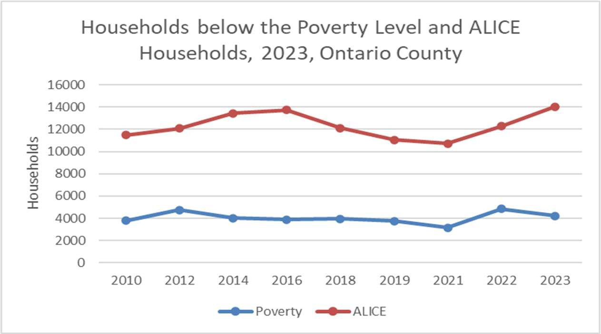
Figure O6: Households below the Poverty Level and ALICE Households
Source: United Way ALICE

23% of Ontario County households (10,700 households) earn less than the household survival budgets noted in Table O4. ALICE Household Survival Budget estimates show the minimum income required for households in Ontario County to meet basic needs. This amount is substantially higher than federal poverty guidelines.

Table O4: ALICE Household Survival Incomes
ALICE and Poverty Household Survival Incomes and Federal Poverty Guidelines, 2021
Household Size | ALICE | Poverty
Single Adult | $29,160 | $12,880
2 Adults | $43,500 | $17,420
2 Adults, 2 School Aged Children | $60,444 | $26,500
2 Adults, 2 Preschool Children | $76,260 | $26,500
Single Senior | $33,648 | $12,880
2 Seniors | $53,688 | $17,420
Source: United Way ALICE

Table O5 provides ALICE data by Ontario County town and city.
Table O5: Asset Limited, Income Constrained, Employed (ALICE) Households

Name | Percent Below ALICE 2021 | Percent Below ALICE 2023
Bristol Town | 32% | 34%
Canadice Town | 28% | 37%
Canandaigua City | 49% | 48%
Canandaigua Town | 26% | 30%
East Bloomfield Town | 23% | 29%
Farmington Town | 31% | 30%
Geneva City | 47% | 42%
Geneva Town | 27% | 32%
Gorham Town | 34% | 41%
Hopewell Town | 39% | 37%
Manchester Town | 37% | 42%
Naples Town | 47% | 47%
Phelps Town | 32% | 42%
Richmond Town | 23% | 29%
Seneca Town | 36% | 39%
South Bristol Town | 28% | 32%
Victor Town | 23% | 26%
West Bloomfield Town | 44% | 49%
Source: United Way ALICE

Priority: Unemployment
In Ontario County, the primary employment sectors are health care and social assistance followed by educational services, and manufacturing.
Unemployment can lead to ﬁnancial instability for families and reduced economic vitality for the broader community. High unemployment rates strain social services, limit consumer spending, and can contribute to long-term challenges such as housing insecurity, poor health outcomes, and decreased quality of life. Figure O7 notes the unemployment rates in January of each year from 2019 to the present. In April of 2025, Ontario County’s unemployment rate was very low, at 3.3%.⁷ See the regional CHA’s Economic Stability section for median household income, living wage and other employment indicators.
Figure O7: Unemployment Rates in January of Each Year
8.00%
7.00%
6.10%
6.00%
4.90%
5.00%
4.70%
4.00%
3.70%
3.90%
4.10%
3.00%
2.00%
1.00%
0.00%
2019
2020
2021
2022
2023
2024
2025

Unemployment Rate as it Stood in January of Each Year
10.00%
9.00% | 8.60%

Source: US Bureau of Labor Statistics

Priority: Food (Nutrition) Security
When residents lack access to enough food to support an active and healthy life, they are considered food insecure. Food insecurity can lead to higher rates of chronic disease, obesity, and diﬃculty learning, and can aﬀect the ability to ﬁght oﬀ or recover from illnesses. In Ontario County, when families lack consistent access to aﬀordable, nutritious food, the health care system, schools, municipalities, Oﬃce for the Aging, SNAP, WIC, Foodlink, and other community-based organizations (food pantries, churches, etc.) provide a safety net, which can become stressed.
When SNAP beneﬁts were paused in November 2025 due to a federal government shutdown, the county, community-based organizations, and the public stepped up to ensure the county’s approximately

⁷ ‘Source: U.S. Bureau of Labor Statistics via FRED®-https://fred.stlouisfed.org/series/NYONTA5URN

9,000 residents on SNAP were able to access the food they needed. With pending new federal regulations and requirements surrounding SNAP and Medicaid in 2026, it is expected community agencies and non-proﬁts will be required to play a larger role in food acquisition in the county.
To understand food access and nutrition security in Ontario County, data from a variety of sources must be considered. According to the Behavioral Risk Factor Surveillance System (BRFSS), nearly three in ten adult New Yorkers (28.9%) reported worrying about having enough money to obtain nutritious foods, while 71.1% reported they did not. Food insecurity was highest among members of racial minorities (40%-50%), women (32%), people with annual incomes under $25,000 (58%), people without a high school diploma (52%) and unemployed individuals (46%). Between 2019 and 2023, food insecurity in New York edged up each year, increasing from 19.4% in 2019 to 28.9% in 2023.⁸
A 2023 study conducted by Foodlink produced a food insecurity rate of 11.8% and punctuated that residents of color are disproportionately aﬀected by food insecurity in Ontario County.⁹ (Table O6)
Table O6: Food Insecurity Rate
Food Insecurity, Ontario County
All residents | 11.8% (13,216 residents)
Black residents | 23.0%
Latino residents | 27.0%
White residents | 9.0%
Source: Feeding America
Table O7: Food Insecurity Reported by Ontario County Youth

Food Insecurity among Ontario County Youth
Year | Grade 6 | Grade 8 | Grade 10 | Grade 12
2023 | 10.9% (26/237) | 9.9% (58/589) | 10.8% (55/508) | 9.9% (21/215)
2025 | 22.1% (61/276) | 18.4% (51/278) | 16.7% (37/220) | 15.9% (35/222)
Trend | Increasing* | Increasing* | Increasing* | Increasing
* Statistically signiﬁcant change based on two proportion z-test (p<.05)
Source: Evalumetrics Youth Survey
There is a marked discrepancy in local food insecurity data between surveys completed at health care visits, schools, and voluntarily in the community. The Pivital Public Health Partnership’s Food Insecurity Survey completed in community settings showed more than half of respondents in 2023 and 2024 reported worrying about running out of food. In contrast, data collected by hospital partners for the 2022 to 2024 showed much lower rates of food insecurity during clinical screenings with small numbers of patients screening positive at UR Medicine FF Thompson Health (<1%) and UR Medicine Finger Lakes Health (<1%) and higher, but still low, numbers at Clifton Springs Hospital pediatrics practice (11%).
Student responses showed a diﬀerent pattern. Self-reported food insecurity increased across all grade levels between 2023 and 2025 (Table O7) with about one in six students reported food insecurity. These

⁸ Source: Food Security, New York State Adults 2023. BRFSS Brief, No. 2025-17. Albany, NY:
New York State Department of Health, Division of Nutrition, Evaluation, Research and Surveillance Unit, May 2025. ⁹ Source: Feeding America: https://map.feedingamerica.org/county/2023/overall/new-york/organization/foodlink-inc

diﬀerences likely reﬂect that people share food needs diﬀerently depending on the setting, the questions asked, and how comfortable they feel during screening.
The Food Environment Index of the USDA Food Environment Atlas provides an additional lens for assessing food security. It measures the ease at which residents are able to access healthy, aﬀordable food, by considering rates of food insecurity and the percentage of low-income people living far from grocery stores. Scores can range from 0 (worst) to 10 (best). Ontario County’s score in 2022 was 8.8 (NYS: 8.7).¹⁰ It is estimated that three percent of low-income Ontario County residents do not live close to a grocery store (NYS: 2%). This suggests that overall food access in Ontario County is similar to the state as a whole. However, county-wide scores can mask important local diﬀerences. Food access is distributed unevenly across the landscape of Ontario County. Rural travel distances, transportation barriers, and distance from community-based food resources like food pantries mean that some residents face greater challenges to obtain healthy, aﬀordable foods than the Food Environment Index suggests.

Priority: Housing Stability and Aﬀordability
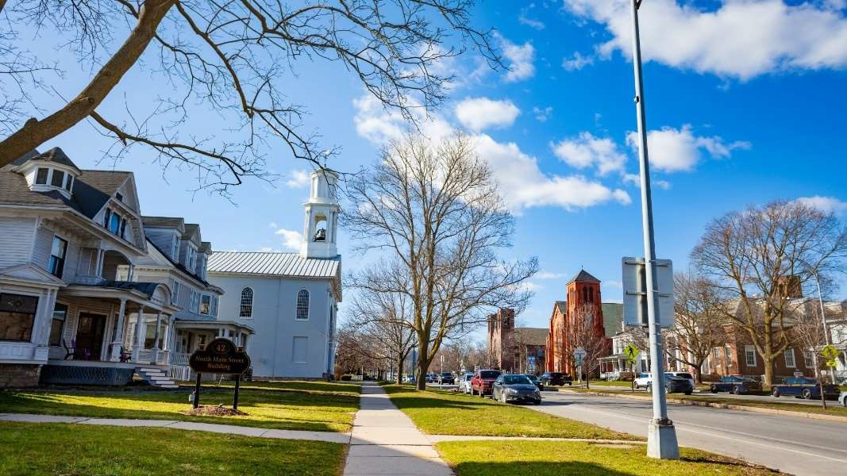
Housing instability and a lack of aﬀordable options can leave families struggling to meet basic needs, often forcing them to choose between rent, food, health care and other necessities. When stable housing is out of reach, communities experience higher rates of homelessness, overcrowding, and ﬁnancial stress, which can undermine overall health, safety, and economic growth. County Health Rankings and Roadmaps reports show that in 2021, 11% of households in Ontario County faced at least one housing problem such as overcrowding, high costs, lack of kitchen facilities, or lack of plumbing facilities.
Houses in the City of Canandaigua, Source Canva Pro Image Library

¹⁰ Source: USDA Food Environment Atlas; Map the Meal Gap from Feeding America

Housing costs place a signiﬁcant ﬁnancial strain on many households. In 2023, the American Community Survey indicated that 73% of occupied housing units in the county were owned. This is higher than the state average of 54% and may reﬂect zoning practices common in rural communities and a limited supply of multi-unit dwellings. Though home ownership is robust, many residents ﬁnd themselves spending large portions of their family’s budget on housing. Once housing costs consume more than 30% of a family’s income, the U.S. Census Bureau considers the household “cost-burdened.” When housing costs exceed 50% of a family’s income, they are considered to be “extremely cost-burdened.” In 2019, 16.5% of households (5,465) fell into the cost-burdened category and an additional 6.5% (2,170 households) were extremely cost-burdened.¹¹ These high housing costs crowd out spending on necessities like food, health care, and savings.
According to the 2023 Ontario County Housing Assessment, uneven growth across the county is impacting housing aﬀordability. The towns of Victor, Canandaigua, and Farmington are growing rapidly while the rest of the county is stagnant or slightly declining. Newly built homes are growing larger and more costly, creating challenges for ﬁrst-time home buyers and putting homeownership out of reach for many. New and existing homes on the market are not aﬀordable given the median income of county residents. Land use, zoning policies, and insuﬃcient energy infrastructure restrict development in some areas. Additionally, there are not enough homes for the growing aging population in Ontario County.

Domain: Social and Community Context
Families, schools, workplaces, and neighborhoods shape how people connect with one another and participate in community life. These social ties inﬂuence health behaviors and reﬂect how connected people feel to their communities.¹² Table O8 highlights challenges community members face in this area. Although cigarette smoking has decreased, between 7% and 11% of adults in Ontario County reported using vape products in 2021.¹³

¹¹ Source: Housing Needs Assessment, 2023: Urban Partners Presentation: https://www.ontariocountyny.gov/DocumentCenter/View/40640/Ontario-County-Housing-Final-Report-Presentation-PDF
¹² Source: Fajobi, O. Hunter, L. Peluso, C. BRFSS Brief: Electronic Cigarette Use, New York State Adults, 2021. No. 2023-14. Albany, NY: New York State Department of Health, Division of Chronic Disease Prevention, Bureau of Chronic Disease Evaluation and Research, December 2023.
¹³ Source: Online BRFSS Database: Centers for Disease Control and Prevention (CDC). Behavioral Risk Factor Surveillance System Survey Data. Atlanta, Georgia: U.S. Department of Health and Human Services, Centers for Disease Control and Prevention, 2023.

Table O8: Social and Community Context
Adults | 2018 | 2021
Frequent Poor Mental Health | 12.8% | 15.1%
3 or more Adverse Childhood Experiences (ACES) | 24.2% | 25.6%
Binge Drinking | 16.7% | 23.4%
Cigarette Smoking | 17.4% | 14.1%
Other Social Indicators
Suicides | 2019-2021:  14.3/100,000 | 2020-2022:  12.4/100,000
Unique Individuals Admitted to Treatment  Programs due to Opioids | 2022: 450/100,000 | 2023: 408/100,000
Source: Behavioral Risk Factor Surveillance System

Priority: Anxiety and Stress
Mental health is essential for daily functioning, healthy relationships, and resilience. Stress and anxiety can increase the impact of chronic diseases, contribute to depression and substance misuse, and increase the risk of early death or suicide.
The number of adults reporting frequent poor mental health increased between 2018 and 2021 as reported by the Behavioral Risk Factor Surveillance System (Table O8). Experiencing 14 or more days of poor mental health in a month is linked to poor health outcomes. Residents that regularly experience stress, depression or anxiety are at risk for chronic diseases, substance use, missed work and decreased productivity, and more contact with the health care system. They may also struggle with decision-making and maintaining healthy relationships and behaviors, ultimately aﬀecting both individual well-being and the health of the community.¹⁴

Priority: Suicide
The National Center for Health Statistics notes the suicide rate in the county was 15 per 100,000 people in 2022, an increase of 15% as shown in Figure O8; higher than the NYS average of 9.7. The suicide rate among youth (15-19 years-of-age) per 100,000 is 9.4 which is higher than the NYS average of 5.6 but a decrease of 31% as shown in Figure O8. Rising suicide rates signal worsening mental health and increasing levels of stress, trauma, or unmet behavioral-health needs in the community. When the county’s overall suicide rate, and especially its youth suicide rate, exceeds the state average, it suggests that residents may face greater barriers to timely mental-health care, social support, or crisis intervention. Higher suicide rates also have wide-reaching impacts that ripple through families, schools, health care systems, and communities, and often indicate underlying issues such as isolation, substance use, economic stress, lack of LGBTQ+ support, or limited access to mental-health services.¹⁵

¹⁴ Source: Strine TW, Balluz L, Chapman DP, Moriarty DG, Owens M, Mokdad AH. Risk behaviors and health care coverage among adults by frequent mental distress status, 2001. Am J Prev Med. 2004 Apr;26(3):213-6. doi: 10.1016/j.amepre.2003.11.002. PMID: 15026100.
¹⁵ Source: https://www.cdc.gov/suicide/facts/index.html

Suicide Rates in Ontario County per 100,000 Population
(Overall and Youth)
16.0
15.0
13.9 14.0 14.0
14.0
13.0
13.0
12.0
10.0
9.3
9.3
9.4
8.0
6.0
4.7
4.0
2.0
0.0
2018
2019
2020
2021
2022
Ontario County Rate
Rate Among Ontario County Youth
Figure O8: Suicide Rates in Ontario County
Per 100,000

Source: County Health Rankings, National Center for Health Statistics
Trends in suicide-related behaviors among students show meaningful improvements over time (Table O9). Rates of suicide planning and suicide attempts decreased across grade levels between 2021 and 2025 with the largest reductions taking place in high school. The Evalumetrics Youth Survey is completed every two years and includes self-reported responses from Ontario County students in grades 6, 8, 10, and 12 from 2021 through 2025. It is possible to look at how groups of students may change as they move through school. While the survey does not track the same individual students or school districts, the grade patterns allow a pseudo-cohort that helps show how suicide-related risks might shift as students grow. When longitudinal student-level data are not available, this method provides a useful approximation of the way risk changes with age.

Table O9: Trends in Suicide-Related Behaviors reported by Ontario County Students
Made a Suicide Plan | Year  2021  2023  2025 | Grade 6  5.3%^{A}  5.9%  5.8% | Grade 8  8.3%^{B}  7.3%^{A}  7.1% | Grade 10  8.4%  7.6%^{B}  4.5%^{A} | Grade 12  8.0%  3.4%  5.2%^{B}
Trend |  | Decrease | Decrease | Decrease | Decrease
Suicide Attempts  Trend | 2021  2023  2025 | 4.6%^{A}  3.6%  2.9%  Decrease | 5.5%^{B}  5.8%^{A}  5.3%  Decrease | 6.5%  5.3%^{B}  4.5%^{A}  Decrease | 5.3%  2.2%  2.0%^{B}  Decrease
* Signiﬁcant trend based on two proportion z-test (2021-2025) and Cochran-Armitage test across 2021-2025
^{A} Cohort A: Born approximately 2009-2010 (Grade 6 in 2021, Grade 8 in 2023, Grade 10 in 2025)
^{B} Cohort B: Born approximately 2007-2008 (Grade 8 in 2021, Grade 10 in 2023, Grade 12 in 2025)
Source: Evalumetrics Youth Survey
Cohort A, born approximately 2009 to 2010 began in 6th grade in 2021, appears again in 8th grade in 2023, and again in 10th grade in 2025. This cohort shows an early rise in suicide planning and attempts in 8th grade followed by a non-signiﬁcant decline in 10th grade. Cohort B was born approximately 2007 to 2008, begin 8th grade in 2021, appear again in 10th grade in 2023, and in 12th grade in 2025. This older cohort shows a non-signiﬁcant decrease in suicide risk behaviors across all survey years. These patterns suggest that suicide-related risk among youth may peak in early adolescence, notably in the 8th grade, and improve as students move through high school years. This reinforces the importance of implementing suicide prevention and mental health support strategies in middle school.

Priority: Depression
Depression aﬀects more than one in ﬁve New Yorkers. In Ontario County, the age-adjusted rate of adults reporting a depressive disorder is 27.9%, well above the NYS rate of 18.7% and an increase of 8% from 2016 per the Behavioral Risk Factor Surveillance System.
Depression aﬀects an individual’s ability to work, parent, socialize and participate in their community. Certain groups face a higher risk of depression due to chronic stress, trauma, and systemic inequities. Many struggle to access or seek treatment due to cost or persistent stigma surrounding mental health treatment. Additionally, in rural parts of the county, they may not be able to ﬁnd a mental health provider close to home. In response to these barriers, Ontario County Public Health partnered with the Department of Mental Health and the Oﬃce for the Aging in 2024 to oﬀer access to an online platform for mental health resources (CredibleMind). Usage during the ﬁrst year has been highest among 13-17-year-olds.

Table O10 reﬂects the percentage of students at the designated grade levels who feel sad or depressed most days and report that life lacks meaning or purpose. The 2022-2024 CHIP included interventions to address these concerning ﬁndings, including training school personnel in Youth Mental Health First Aid. While in most cases, the trend is decreasing, it remains a considerable percentage and will continue to be addressed.
Elevated rates of depression are associated with increased risk of chronic diseases, substance use, social isolation, and suicide, as well as greater demand for mental health services. The county’s rate is both higher than the state average and rising. This indicates residents may not be receiving adequate treatment or support, contributing to long-term health disparities and strain on local health care and social services.¹⁶
Table O10: Student Social and Community Context (Source: Evalumetrics Youth Survey)

Sad or | Year  2021 | Grade 6  37.1% | Grade 8  31.5% | Grade 10  39.3% | Grade 12  43.4%
Depressed | 2023 | 31.0% | 35.9% | 35.7% | 31.0%
Most Days | 2025 | 29.6% | 34.4% | 33.1% | 30.3%
Trend |  | Decrease* | Increase | Decrease | Decrease*
Life Lacks Purpose  Trend | 2021  2023  2025 | 40.3%  27.6%  26.4%  Decrease* | 49.7%  33.1%  32.0%  Decrease * | 47.6%  32.6%  31.8%  Decrease* | 44.7%  27.8%  27.1%  Decrease*
* Signiﬁcant trend based on two proportion z-test (2021-2025) and Cochran-Armitage test across 2021-2025

¹⁶ Source: https://www.nimh.nih.gov/health/publications/chronic-illness-mental-health

Priority: Primary Prevention, Substance Misuse, and Overdose Prevention
Deaths from opioid overdose in Ontario County declined between 2016 and 2022, but rose sharply in 2023. This increase coincided with a growing presence of fentanyl in the local drug supply (Figure O9). Prior to this increase, the number of people dying from opioid overdose remained below the NYS Prevention Agenda’s 2030 goal. While ﬁnal numbers for 2024 are not yet available, preliminary information from County Coroners suggests that the rate of deaths may be trending downward again. Together, these data highlight the variability in overdose risk faced by Ontario County residents and the inﬂuence of increasingly potent and unpredictable illicit substances circulating in NYS and the Finger Lakes Region. The spike in 2023 shows how quickly progress can be reversed even after years of decline. Ongoing surveillance of local data provides critical information for detecting emerging health threats and planning eﬀective community responses.
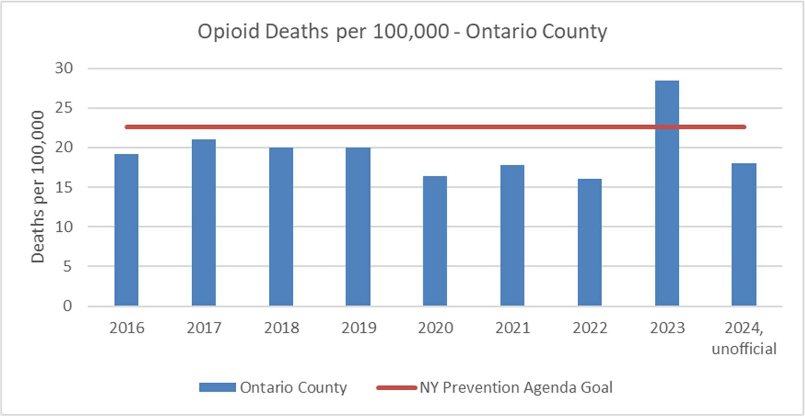
Figure O9: Opioid Deaths per 100,000 in Ontario County
Source: National Center for Health Statistics

Figure O10 compares overdose deaths per 100,000 people at the state (trend lines) and county level (bars). County overdose deaths are below state averages and trends are dissimilar, with the exception of heroin-related deaths for which both NY State and Ontario County have seen decreases since 2019. The state, however, saw increased deaths with “any drug”, opioids and pain relievers while the County rate for “any drug” declined modestly and opioid and pain relievers have been relatively stable since 2019.

Figure O10: Overdose Deaths in Ontario County Compared with NYS Average
Overdose Deaths Ontario County
35
30
25
20
15
10
5
0
2014
2015
2016
2017
2018
2019
2020
2021
2022
Any opioids
Any Drug
Heroin
Pain Relievers
NYS Opioid Avg NYS Any Drug Avg NYS Heroin Avg NYS Pain Reliever Avg
Source: Source: National Center for Health Statistics

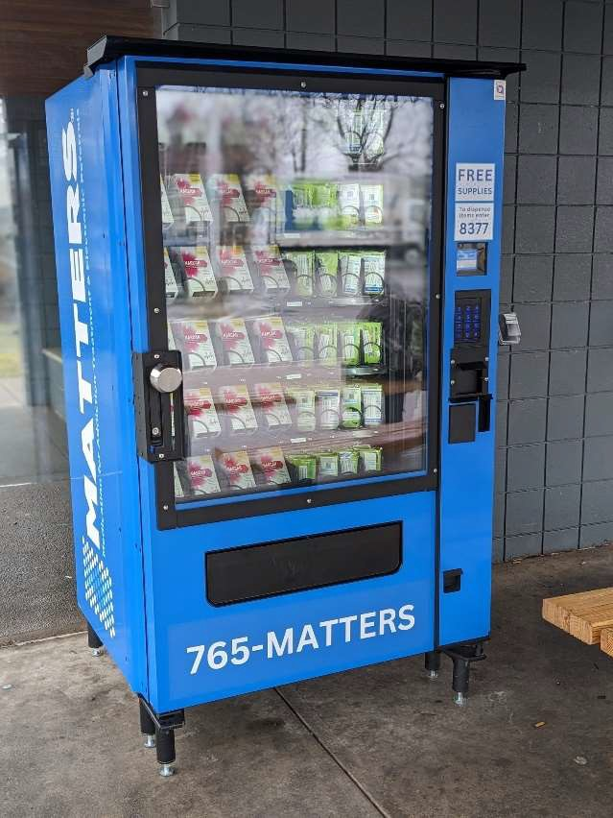

Overdose deaths remain a signiﬁcant concern in Ontario County. However, mortality data alone does not capture the full impact of substance misuse. Long before and long after a death from overdose, individuals, families, and communities absorb substantial harm. These impacts include injection-site infections, persistent health complications from anoxia (lack of oxygen to the brain), and a long trail of social and economic disadvantages.
Even though the county’s rates are usually below state averages, the persistence and severity of this problem strains emergency services, health care systems, and families, and indicates a need for targeted prevention, treatment, and harm-reduction strategies.¹⁷ In response, the Public Health Department and community partners continue to provide naloxone and overdose prevention trainings to school staﬀ, emergency responders, and the community members.

¹⁷ Source: https://www.cdc.gov/overdose-prevention/about/

Priority: Tobacco/E-cigarette and Alcohol Use
Table O11: Tobacco/E-cigarette and Alcohol Use
Ontario County Adults | 2018 | 2021
Binge Drinking | 16.7% | 23.4%
Cigarette Smoking | 17.4% | 14.1%
Source BRFSS
The Behavioral Risk Factor Surveillance System reports the percentage of adults who are current smokers (age-adjusted) decreased 22% since 2018. It remains higher than the NYS average of 12%. Binge drinking has increased and remains above the NYS average. Comparative data on e-cigarette use among adults in the county are not available, but in 2021, 7-11% of adults in Ontario County reported using vape products (BRFSS, 2023).
Both smoking and excessive alcohol use are major risk factors for chronic diseases, including heart disease, cancer, liver disease, and respiratory illnesses. Higher rates of these behaviors in the community increase the burden on health care systems, contribute to preventable morbidity and mortality, and reduce quality of life. A persistently elevated smoking rate and an increase in heavy drinking indicate that residents may face elevated long-term health risks and that targeted prevention and intervention eﬀorts are needed.¹⁸

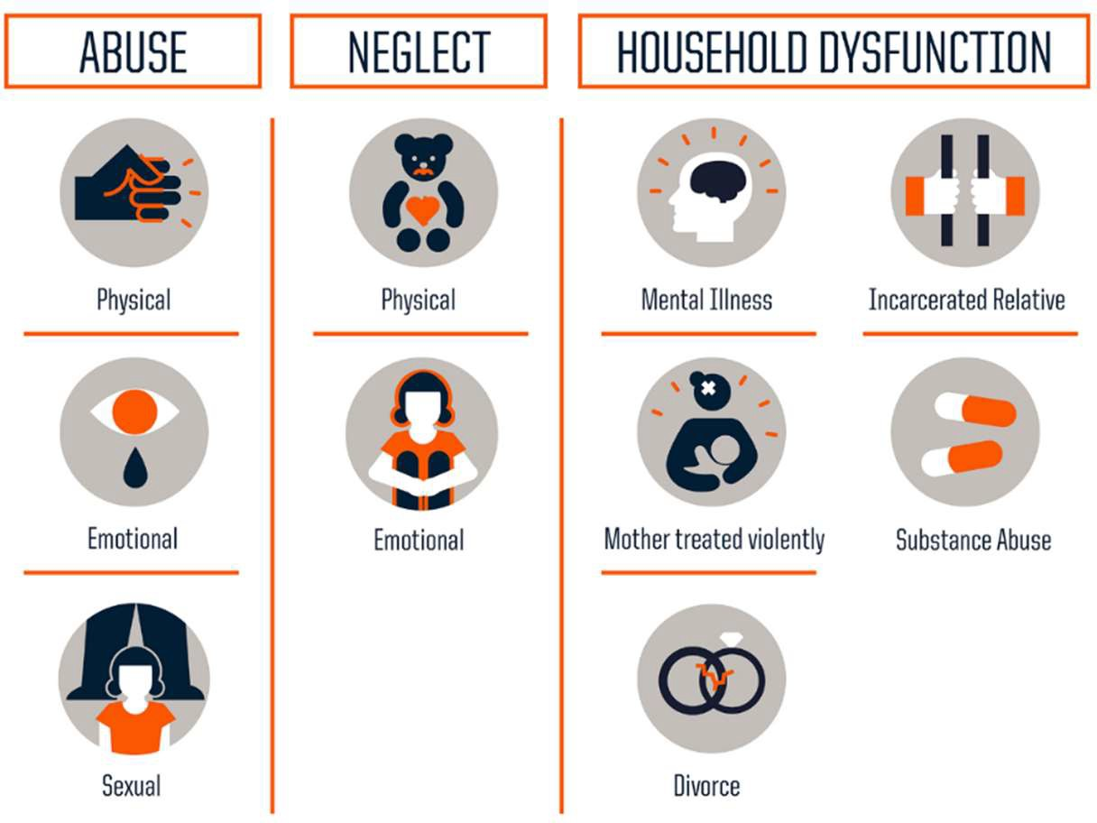
Priority: Adverse Childhood Experiences (ACES)

Adverse Childhood Experiences are those emotional and physical circumstances one experiences before age 18. They may include neglect, sexual abuse, parental divorce, exposure to violence, and mental illness and/or substance abuse in the home. ACEs impact individuals well into adulthood and may include physical and mental long-term health problems.
Approximately one in four Ontario County adults has a history of three or more ACES, leaving them vulnerable to long-term physical and mental health problems and increased health care and social service needs.¹⁹¹

Categories of Adverse Childhood Experiences which are linked to long-term physical and mental health impacts. Source: Robert Wood Johnson Foundation, rwjf.org/aces

¹⁸ Source: Kim Y. The eﬀects of smoking, alcohol consumption, obesity, and physical inactivity on health care costs: a longitudinal cohort study. BMC Public Health. 2025 Mar 5;25(1):873. doi: 10.1186/s12889-025-22133-4. PMID: 40045251; PMCID: PMC11881326.
¹⁹ Source: https://www.cdc.gov/aces/about/index.html

In 2021 per BRFSS, 25.6% of Ontario County adults reported a history of three or more ACES; very similar to 24.2% in 2018. Trends in ACEs among students show a pattern of accumulating adversity over time.
ACE 2+ rates rise steadily across grade levels. A large share of high school students continues to report multiple forms of trauma. Improvement in recent youth rates may reﬂect the eﬀects of protective eﬀorts in Ontario County schools and communities, including after school programs and youth club houses.
Table O12: ACES among Students
Year Grade 6 Grade 8 Grade 10 Grade 12

Two or More ACEs | 2021  2023 | 19.4% (55/283)  23.2% (58/251) | 28.7% (52/181)  35.2% (220/625) | 38.2% (105/275)  34.9% (181/519) | 42.9% (97/226)  38.1% (80/210)
 | 2025 | 16.7% (52/311) | 25.2% (85/337) | 31.0% (76/245) | 33.5% (84/251)
Trend |  | N/A | Decrease* | N/A | Decrease*
* Significant trend based on two proportion z-test (2021-2025)
²⁰ Evalumetrics Youth Survey

Priority: Healthy Eating


Food security and healthy eating are closely connected and were discussed in detail under the Poverty section on of this document.

Grapes from Ontario County, Source VisitFingerLakes.com
In NYS, approximately 19% adults consume at least one sugar-sweetened beverage (SSB) each day. Increased consumption is more common among adults under 35 years (27.2%), men (22.8%), and individuals living with a disability (24.4%). Daily consumption is also more prevalent in residents with annual household incomes below $25,000 (27.5%) and residents who did not graduate from high school (29.3%). About 23% of Hispanic and Black residents reporting consuming at least one SSB a day.²¹
In Ontario County, a signiﬁcant percentage of residents do not eat fruits and vegetables regularly. In 2018, BRFSS data indicated that 29.8% of residents ate fewer than one fruit and

²¹ Source: Sugar-Sweetened Beverages, New York State Adults 2021. BRFSS Brief, No. 2023-08. Albany, NY: New York State Department of Health, Division of Chronic Disease Prevention, Bureau of Chronic Disease Evaluation and Research, 2023.

one vegetable a day; by 2021, this proportion rose to 31.9%. Introducing fruits and vegetables early in life is an eﬀective strategy to promote healthy eating. However, this requires consistent access to aﬀordable fresh foods and may not be a viable option for people living far from grocery stores as well as people living closer to fast food or convenience stores. Low consumption of fruits and vegetables and high intake of sugary-sweetened beverages contribute to poor nutrition, dental caries, obesity, diabetes, heart disease, and other chronic conditions. When access to healthy foods is limited, especially for lower-income populations, residents are more likely to develop diet-related illnesses, increasing health care costs, and reducing overall community health and quality of life.²²

Domain: Neighborhood and Built Environment
According to BRFSS, in 2021, 79.2% of Ontario County adults reported being physically active; a modest increase from 77.8% in 2018. Regular physical activity oﬀers wide-ranging beneﬁts at every age. It lowers the risk of major chronic diseases, including heart disease, stroke, type 2 diabetes, and several cancers. Exercise also supports stronger bones and muscles, better sleep, improved mental health, and longer life expectancy.
Access to physical activity is not distributed equitably across Ontario County. Limited walkability and inadequate access to spaces for recreation or transportation can create barriers to healthy lifestyles, contributing to long-term health disparities in the community.²³ Structural barriers, such as unsafe neighborhoods, limited access to facilities, or environments not designed for diverse needs, inﬂuence whether people can be active. Social factors like income, education, community support, and cultural attitudes also inﬂuence the likelihood that an individual will be physically active. Physical features of a built environment, such as safe parks, well-maintained sidewalks, bike lanes, crosswalks, and walkable neighborhood layouts, play major roles as well.
In 2024, Public Health began cross-sector collaborations with local towns to improve walkability. Ontario County Public Health worked with towns to conduct a walkability assessment using the CDC’s Active Communities Tool in the Town of Manchester and began the same process in the Town of East Bloomﬁeld. Survey results from Manchester showed that while most respondents reported walking in their neighborhood, many raised concerns about traﬃc safety, and the condition and connectivity of sidewalks. Residents expressed support for expanding trails, improving pedestrian safety, and building more connections between everyday destinations. Both towns are actively seeking funding to expand walking trails and improve pedestrian infrastructure based, in part, on these ﬁndings.

²² Source: https://www.cdc.gov/nutrition/php/about/index.html
²³ Source: https://www.who.int/news-room/fact-sheets/detail/physical-activity

Priority: Opportunities for Active Transportation and Physical Activity
Active transportation, such as walking or biking to reach daily destinations, can integrate physical activity into everyday routines, but it depends on safe, well-connected routes and nearby destinations. Much of Ontario County is rural, and communities are connected by miles of state and county roads that often lack sidewalks. Walking on the shoulder of the road increases the risk of injury and death, particularly in snow and ice conditions. Ontario County’s walkability index is 4.5 out of 20, where 20 represents the most walkable communities.²⁴
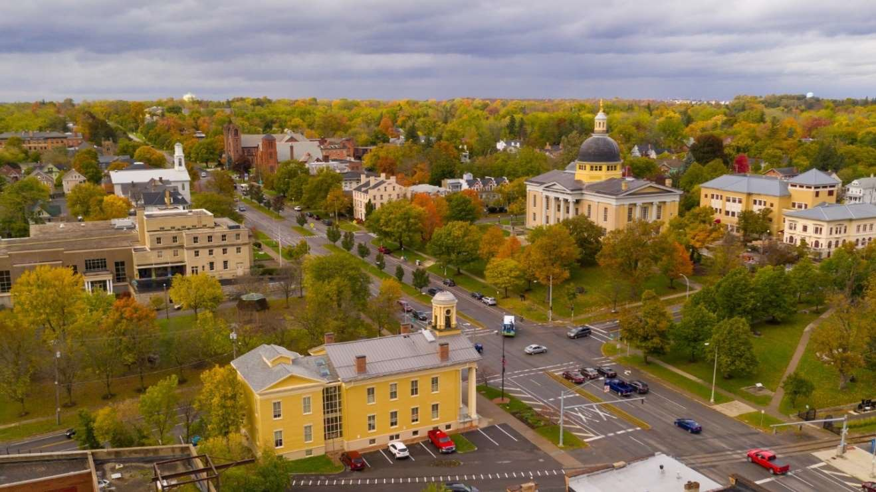

Aerial photo of the City of Canandaigua, Source: Canva Pro Image Library
About 80% of Ontario County residents have adequate access to locations where they can be physically active, which is lower than the NYS average of 93%. Most residents rely on cars for work and other activities. Businesses and employers are concentrated in county’s largest municipalities (the Cities of Geneva and Canandaigua and the Towns of Victor and Farmington) and in neighboring counties. This limits the opportunities for walking or biking as a part of daily travel. As a result, very few residents are able to walk to work or to complete errands on foot or by bike.
In recent years, some residents are relying on electric bicycles as an alternative form of transportation, particularly among those who do not have a driver’s license due to age or impaired driving convictions. While having an alternate form of transportation is a lifeline for many, it is not without risk. E-bikes can reach speeds of up to 30 miles per hour, helmet use is inconsistent, and navigating snow and ice can be dangerous.

Priority: Access to Community Services/Civic Participation
The Social Vulnerability Index (SVI) describes the degree to which a community’s social conditions, such as poverty, overcrowded housing, and lack of transportation infrastructure, may aﬀect the ability to

²⁴ Source: EPA Oﬃce of Community Revitalization, 2021

prevent human suﬀering and ﬁnancial loss when an emergency arises.²⁵ A high SVI indicates that some residents may face greater risk of harm and slower recovery. SVIs are scaled from 0-1, with 1 representing the highest vulnerability. In Ontario County, the SVI is 0.1148, indicating relatively low overall vulnerability. This low SVI suggests the community has a strong baseline capacity to respond to challenges, though vulnerabilities still exist for certain populations and neighborhoods.²⁶

Civic engagement, as reported in the County Health Rankings and Roadmaps (CHR&R), reﬂects participation in civic life through activities such as voting, volunteering, and participation in community events. In Ontario County, 69.8% of voting-age residents participated in the 2020 presidential election, exceeding the national estimate of 66% (Pew Institute). Additionally, the county is home to a broad network of civic and community organizations including political committees, fraternal organizations, chambers of commerce,

Presentation to kids at Antique Wireless Association, Photo courtesy of VisitFingerLakes.com
volunteer ﬁre and EMS departments, non-proﬁt and community-based organizations, community centers, and two after-school youth clubhouses. Ontario County is home to 9 membership organizations per 10,000 residents, higher than the NYS rate of 7.9 per 10,000 (CHR&R). This higher density in Ontario County suggests relatively strong community infrastructure across civic, political, religious, sports and professional organizations.
Community connectedness fosters a sense of belonging
and shared identity that plays an important role in preventing loneliness and promoting physical and mental health. Strong social networks help build resilient communities that are better equipped to respond to emergencies, adapt to change, and address challenges in equitable, productive ways.

Priority: Injuries and Violence
Unintentional and intentional injury deaths, including those from ﬁrearms, motor vehicle crashes, and suicide, directly contribute to premature death and long-term physical, emotional, and economic consequences for individuals, families, and communities. Injury and violence-related deaths and

²⁵ Centers for Disease Control and Prevention/Agency for Toxic Substances and Disease Registry/Geospatial Research, Analysis, and Services Program. CDC/ATSDR Social Vulnerability Index Interactive
²⁶ Source: County Health Rankings.

hospitalizations place strain on health care systems, emergency responders, and social support networks, highlighting the need for targeted prevention, education, and community safety initiatives.²⁷
Injury and violence-related deaths remain ongoing threats to community health and safety in Ontario County. Table O13 presents violence and injury indicators by race and ethnicity for the years 2020 to 2022, highlighting disparities in injury-related mortality and hospitalization rates among population groups.


Injury risk patterns in Ontario County are shaped by the county’s rural setting and seasonal recreation activities that draw residents and visitors outdoors. This community is home to many families that hunt, both with bows and guns. While hunter education and safety courses are widely available, hunting-related injuries still occur. The lakes in the county draw thousands of people and watercraft to their shores every summer. Boating accidents, though relatively uncommon, can be catastrophic. In summer months, the Finger Lakes Region attracts increased bicycle, motorcycle and e-bike riders. As a result, roadway-related injuries are a persistent concern.

Table O13: Injury and Violence
Boathouses on Canandaigua Pier, Source Canva Pro Image Library

Indicators | Age adjusted Rates
Indicators | White | Black | Hispanic
Motor vehicle-related mortality per 100,000 | 9.4 | Suppressed due to  low # | 5.9
Unintentional injury mortality per 100,000 | 43.6 | 86.9 | 38.2
Unintentional injury hospitalizations per 10,000 | 84.9 | 105.5 | 84.8
Fall hospitalizations >age 65, per 10,000 | 171.2 | 110.6 | 109.5
Poisoning hospitalizations per 10,000 | 8.3 | 26.2 | 12.5
Suicide mortality per 100,000 | 12.4 | Suppressed due to  low # | Suppressed due to  low #
Overdose by opioid and non-fatal opioid  hospital events per 100,000 | 114.7 | 462.6 | 159.9
Source: NYSDOH, 2024 at https://www.health.ny.gov/community/health_equity/reports/county/ontario.htm
Emergency department visits for assault-related injuries remain stable at 21.9 per 10,000 residents; a rate substantially lower than the NYS rate of 30.5 per 10,000 residents.²⁸ Table O13 illustrates age-

²⁷ Source: https://www.cdc.gov/injury/index.html
²⁸ Source: New York State Department of Health. (2025). SPARCS Outpatient Data Dictionary.

adjusted injury and violent death rates per 100,000 residents, providing additional context for injury-related deaths in Ontario County.

Domain: Health Care Access and Quality
The Ontario County health care system consists of a network of hospitals, private providers, veterans’ health services, and complementary care options. The county is served by three nonproﬁt community hospitals and their associated urgent care centers and provider oﬃces:
- UR Medicine Finger Lakes Health in Geneva, NY
- UR Medicine FF Thompson Health in Canandaigua, NY
- Rochester Regional Health Clifton Springs Hospital and Clinic in Clifton Springs, NY

Partner Hospitals Serving Ontario County
Additional health care resources include the Canandaigua Veterans Administration Medical Center, privately owned medical and chiropractic oﬃces, and complementary services like acupuncture and massage therapy. All three community hospitals are aﬃliated with tertiary care centers in nearby Rochester, New York. When specialty care is not available inside the county, residents are referred to providers located in Monroe County. Routine cancer screening, surgical services, maternity care, and rehabilitation are available at each of the three hospitals though the scope of services varies by facility. Ontario County also has several privately owned skilled nursing and senior living facilities as well as a midwifery practice that serves residents from Mennonite and Amish communities.
Though this network suggests easy access to high-quality health care, barriers remain. Several nearby counties do not have hospital systems, and residents of those areas often receive care in Ontario County. As noted in the regional portion of this CHA, the region faces a shortage of health care providers which results in long wait times for appointments. Additionally, local hospitals do not have pediatric medical units, mental health units, or surgical centers capable of catering to children. When a child is in need of complex emergency care or admission, they are transported to pediatric centers in Monroe County. This creates a signiﬁcant burden on already stressed families, especially those without access to transportation.

Priority: Access To and Use of Prenatal Care
A baby’s ﬁrst connection to the health care system often begins before birth through prenatal care. Risk assessment, health promotion, and therapeutic interventions, are important steps to ensure a healthy

pregnancy for the pregnant person and the growing baby. Early and regular prenatal care reduces risks of preterm birth, low birth weight, and maternal and infant mortality. Despite these beneﬁts, the percent of pregnant persons receiving ﬁrst trimester prenatal care has declined from 2020 to 2022.
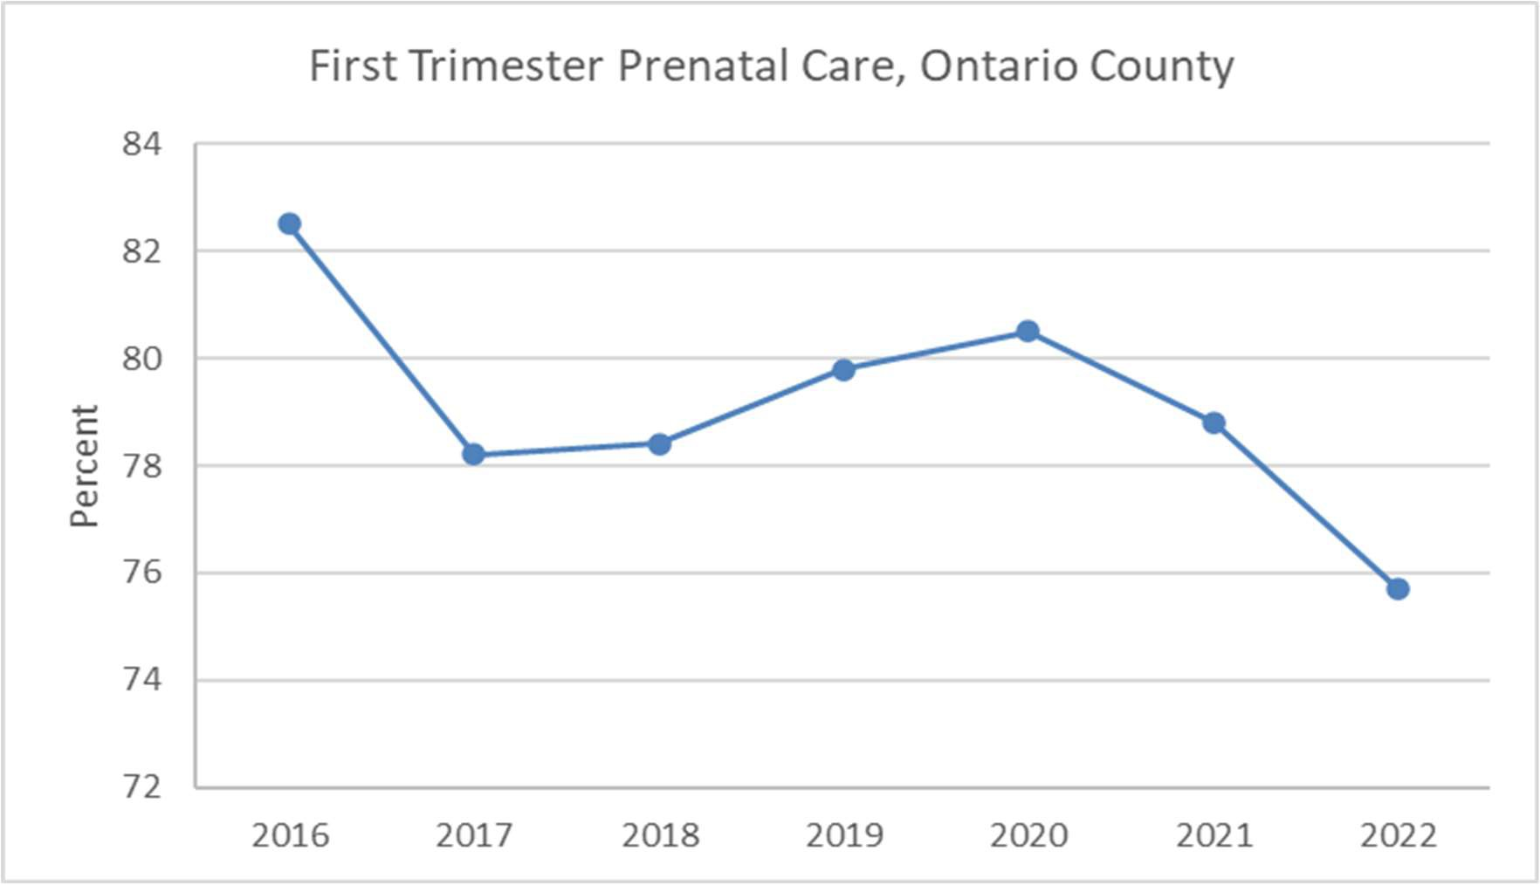
Figure O11: First Trimester Prenatal Care

Source: NYS Vital Records, Data as of May 2024
The county has multiple obstetrical practices, but only one hospital that provides birthing services at UR Medicine Thompson Health in Canandaigua. Many residents of the Finger Lakes region deliver in Ontario County, while some utilize facilities in neighboring counties. High risk pregnancies and signiﬁcantly pre-term deliveries are transferred to tertiary care centers in Monroe County. These referral patterns present signiﬁcant barriers for residents who lack reliable transportation or have low-incomes.
Abstinence from smoking, alcohol and illegal drugs are important indicators of appropriate prenatal care. According to the National Survey on Drug Use and Health, Ontario County improved or remained unchanged in all three indicators from 2018 to 2024.
Table O14: Pregnancy Behaviors and Outcomes

Ontario County Pregnancy Behaviors 2018 2024
Behavior | 2024 | Change since 2018 (higher is better)
Abstinence from smoking | 91.9% | Increase of 12%
Abstinence from drugs | 97.7% | Increase of 5%
Abstinence from alcohol | 98.1% | Unchanged
Source: 2024 Data from the National Survey on Drug Use and Health29

²⁹ Source: U.S. Department of Health and Human Services, Healthy People 2020, National Center for Health Statistics

Ontario County Pregnancy Outcomes
Indicator and Year | Rate | Change (lower is better)
Preterm Birth Rate, 2022 | 8.7% | Increase of 11% since 2013
Low Birth Weight, 2023 | 7% | Unchanged since 2018
Any Breast Milk at Hospital, 2024 | 88.8% | Increase of 23% since 2015
Source: County Health Rankings Natality Files30
Birth outcomes provide another lens for understanding access to and use of prenatal care. Common measures include rates of low live birth weight infants (<2,500 grams or about 5 lbs., 8 oz.) and premature births (prior to 37 weeks). Vital Records data for Ontario County indicate that in 2022, 8.7% of births were preterm, an increase of 11% from 2013. In 2023, 7% of babies born were of low birth weight; unchanged from 2018 and just below the NYS average of 8%. These county-wide averages mask important disparities across racial and ethnic groups (Figure O12). Black residents are less likely to access early prenatal care and have signiﬁcantly higher rates of preterm births and low birthweight babies. In 2024, Ontario County Public Health’s Maternal and Child Health Team began providing free childbirth, breastfeeding, and newborn education in the community to address these disparities. High breastfeeding rates may reﬂect those parents have received positive messages, education, reinforcement, and support about how to feed their newborn. In 2024, the percentage of infants fed any
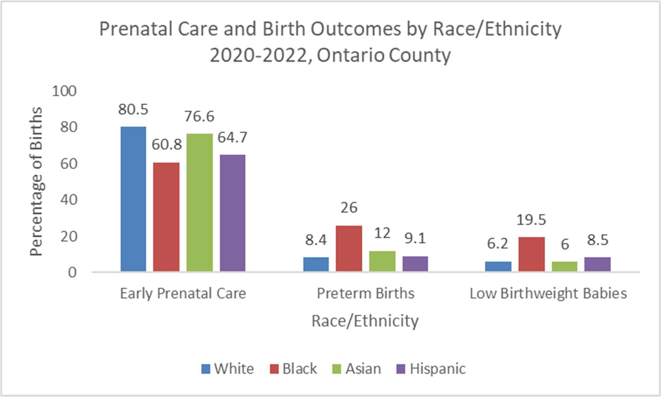
Figure O12: Prenatal Care and Birth Outcomes by Race/Ethnicity
Source: NYS, Ontario County Health Indicators by Race and Ethnicity, 2020-2022 at https://www.health.ny.gov/community/health_equity/reports/county/ontario.html

³⁰ Source: County Health Rankings, Natality Files; NYS Prevention Agenda Vital Health Records

breast milk at the time of hospital discharge was 88.8%, an increase of 23% since 2015. The percentage of infants exclusively fed breast milk prior to hospital discharge was 60.7%, a decrease of 5% since 2013, but well above the NYS average of 46.7%. This pattern suggests that many families are receiving eﬀective prenatal and perinatal education and support, even if sustaining exclusive breastfeeding remains challenging for some. Health educators from counties in the Finger Lakes, including Ontario, work collaboratively through the Maternal Child Health/Breastfeeding Coalition to increase access to breastfeeding education and support beginning during pregnancy.

Priority: Prevention of Infant and Maternal Mortality
Prematurity and its related conditions are the leading causes of infant mortality. Reducing rates of preterm births can therefore have a direct impact on infant mortality. In Ontario County, the most recent data from 2022 indicate a rate of 5 deaths per 1,000 live births, a 25% increase since 2018 and higher than the NYS rate of 4 per 1,000. Maternal mortality data is measured per 100,000 population and most recent data available cover the 2019-2021 period (Figure O13). Ontario County has a maternal mortality rate that exceeds the NYS rate of 22 per 100,000; however, these data are considered unstable and should be interpreted cautiously due to small sample size. Together, these data highlight the importance of preventing preterm birth and supporting maternal health across the full continuum of maternal and infant care from prenatal care through delivery and postpartum support.
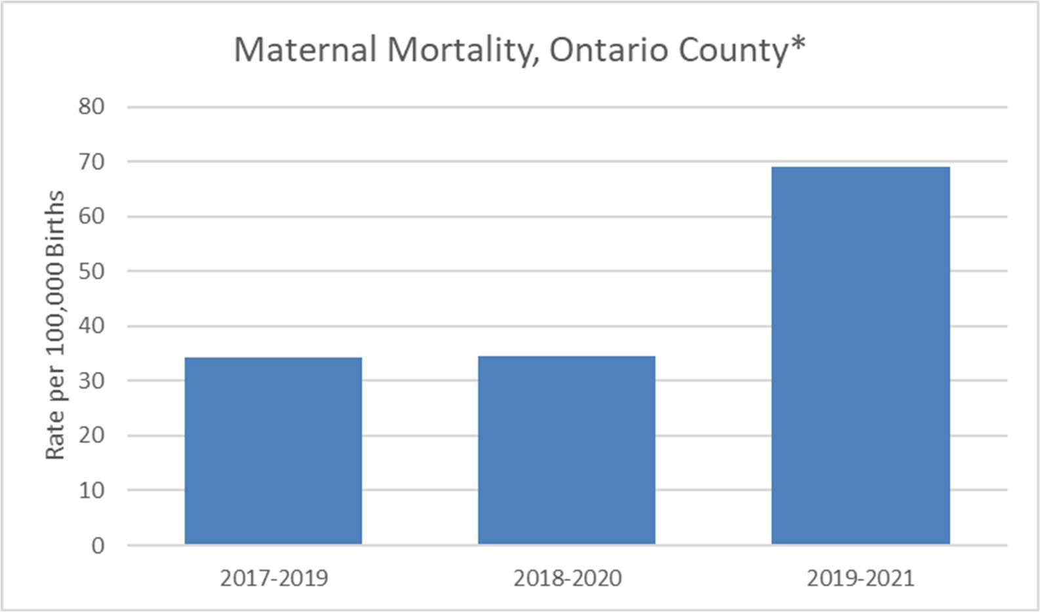
Figure O13: Maternal Mortality
Source: NYS Vital Records, March 2025 *Unstable estimates due to low numbers



Canandaigua Lake in Ontario County, Courtesy of Kassandra Doyle

Priority: Preventive Services for Chronic Disease Prevention and Control
Chronic disease prevention is key in helping communities maintain and improve health outcomes and well-being. Many chronic diseases impact the community. The prevalence of adults over age 20 with diagnosed diabetes in 2022 was 8%, a decrease of 27% from 2017 and lower than the NYS average of 10%. As compared to 2017, in 2021 the percentage of adults presenting as obese increased 13% making it higher than the NYS average. In 2018, 16.2% of Ontario County children and adolescents were considered obese which was a stable ﬁnding compared to 2013 and lower than the NYS rate of 20.6%. The percentage of obese children ages 2-4 years enrolled in SNAP and WIC decreased between 2010 and 2017, at which time it was 15.2%. This was higher than the NYS rate of 13.9%.³¹
Many factors impact access to care for community members. Provider shortages, insurance coverage and economic and geographic challenges all pose barriers to accessing care in Ontario County. As noted in the regional CHA, the ratios of physicians, mental health providers, and dentists per resident are high and exceed state averages, which can make accessing preventive services challenging. These barriers are particularly severe for low income, retired, rural residents with limited access to transportation.
In 2021, 92.6% of Ontario County residents reported having a “regular health care provider.” This represents a signiﬁcant increase from 82.2% in 2018. ³²

³¹ Source: Behavioral Risk Factor Surveillance System.

³² Source: Source: Online BRFSS Database: Centers for Disease Control and Prevention (CDC). Behavioral Risk Factor Surveillance System Survey Data. Atlanta, Georgia: U.S. Department of Health and Human Services, Centers for Disease Control and Prevention, 2025.

Figure O14: Provider Access
Provider Access
1800
1600
1400
1200
1000
800
600
400
200
0
Primary Care
Physicians
Mental Health
Providers
Dentists
Primary Care other
then Physicians
Ontario NYS
Source: County Health Rankings, Area Health Resource File/American Medical Association

Ontario County’s ratio of primary care physician per resident is 1:1,200 which is similar to NY State (1,240) and the highest ratio in the region. This tells only part of the story as residents from counties with less providers, particularly those without hospital systems, often seek care in Ontario County. The county has the highest ratio for non-physician PCPs (1:680), suggesting midlevel providers signiﬁcantly contribute to medical care in the county.
Most Ontario County residents have health insurance. The percentage of adults under age 65 without health insurance has remained stable at 4% and is lower than the New York State rate of 6%. This rate represents a substantial decrease from a high of 20% in 2018³³ due to expanded coverage under the Aﬀordable Care Act and NY State’s Essential Plan. Likewise, the percentage of children under 19 without health insurance (2%) is stable and lower than the state rate (3%). Though rates of health care insurance coverage are encouraging, these include high-deductible plans which may require high out of pocket contributions.
When an individual does not have health insurance, accessing preventive services becomes more diﬃcult. The NYS Department of Health’s Vaccine for Adults (VFA) and Vaccine for Children (VFC) programs provide vaccines to local health departments for uninsured adults and uninsured and Medicaid-eligible children. New York State also administers the Cancer Services Program in Ontario County which provides breast and colorectal cancer screening at no cost to eligible residents.

³³ Source: County Health Rankings, Small Area Health Insurance Estimates

There are 22,667 Ontario County residents enrolled in Medicaid and, 26,892 residents were Medicare eligible in 2021.^{34,35} Medicaid and Medicare provide reimbursement for a range of preventive screenings, and some Medicare Advantage plans provide additional beneﬁts such as gym memberships.
Preventive screening rates in Ontario county show mixed progress.
- Breast Cancer Screening: In 2022, 75.9% of women ages 50-74 received a mammogram, a 3% increase since 2018. Among Medicare enrollees, 52% received screening, unchanged from 2018 but higher than the state average of 44%.
- Colorectal Cancer Screening: In 2022, 65.3% of age-eligible adults were screened; an 8% decrease from 2018. While colorectal cancer incidence in young adults remains low, rates have been increasing. This is in contrast with declining rates in older adults who undergo routine screening.³⁶ Ensuring all age-eligible residents are aware of screening recommendations and have access to this screening services remains critical.
- Diabetes Screening: Among adults 45 and older 63.2%, underwent screening; a 4% increase from 2016 and similar to the state average. Screening rates were lower among residents who have low-income (household income under $25,000) at 56.6%, unchanged from 2016 and below the state average of 62.2%.
- Hypertension: High blood pressure remains common among adults in Ontario County, though prevalence dropped slightly to 28.9% in 2021.³⁷ That same year, 83.9% of adults with high blood pressure reported taking medication to manage the condition.³⁸

Priority: Oral Health Care
Access to oral health care is essential because dental health is closely linked to overall health. Poor oral health aﬀects nutrition and increases risk for local and systemic infections and chronic disease. When people cannot obtain regular dental care, preventable issues like tooth decay and gum disease can develop and worsen, leading to pain, infection, and higher long-term health care costs.
The most recent data from 2019 show that 74.5% of adults had a dental visit in the past year, 3% decrease since 2014, but still above the New York State average of 71.3%. Access and utilization of oral health care are signiﬁcantly lower among Medicaid enrollees. In 2023, only 40% of Medicaid-covered children and adolescents (ages 2-20) had at least one dental visit in the past year, an 8% decrease since 2014 and below the state average of 48.6%. Preventive visits were similarly low, with 37.1% receiving

³⁴ Source: NYS Medicaid Enrollment Databook by Month: Sugar-Sweetened Beverages, New York State Adults 2021. BRFSS Brief, No. 2023-08. Albany, NY: New York State Department of Health, Division of Chronic Disease Prevention, Bureau of Chronic Disease Evaluation and Research, 2023.
³⁵ Source: University of Iowa Medicare Eligible Updates: https://rupri.public-health.uiowa.edu/maupdates/statetables/march2021/NY.pdf
³⁶ Source: Singh KE, Taylor TH, Pan CG, Stamos MJ, Zell JA. Colorectal Cancer Incidence Among Young Adults in California. J Adolesc Young Adult Oncol. 2014 Dec 1;3(4):176-184. doi: 10.1089/jayao.2014.0006. PMID: 25538862; PMCID: PMC4270106.
³⁷ Source: CDC, Local Data for Better Health; County Health Rankings: Mapping Medicare Disparities Tool; Behavioral Risk Factor Surveillance System
³⁸ Source: Behavioral Risk Factor Surveillance System June 2025. at https://apps.health.ny.gov/public/tabvis/PHIG_Public/pa/reports/#county

one in the past year, a 9% decrease and below the state average of 45.2%. Among all Medicaid enrollees, 25% had at least one dental visit in the past year, down 18% from 2014, and 21.1% had a preventive visit, down 22%, both below statewide averages.³⁹
Preventive dental care is underutilized in Ontario County. There is one dentist for every 1,660 residents. For Medicaid recipients, the rate of dental care has decreased steadily over time. Most dental providers in the county will not serve Medicaid clients.
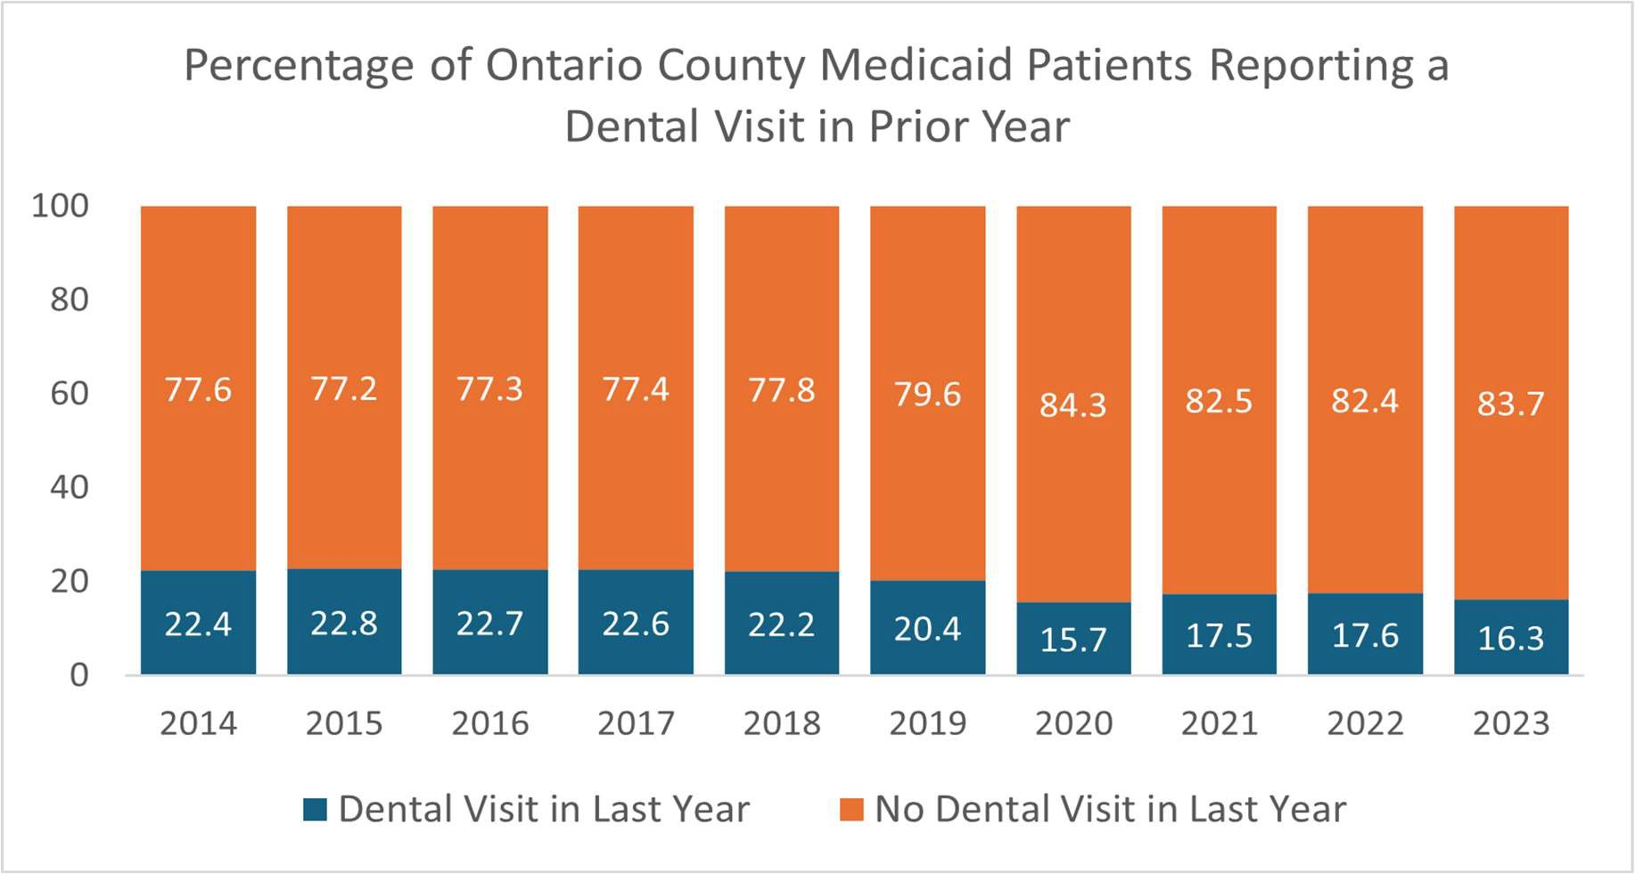
Figure O15: Percentage of Ontario County Medicaid Enrollees Reporting a Dental Visit in the Past Year (2014-2023)
Source: NY State Medicaid Program, 2025

³⁹ Source: Behavioral Risk Factor Surveillance System, NYS Medicaid Program, NYS Prevention Agenda

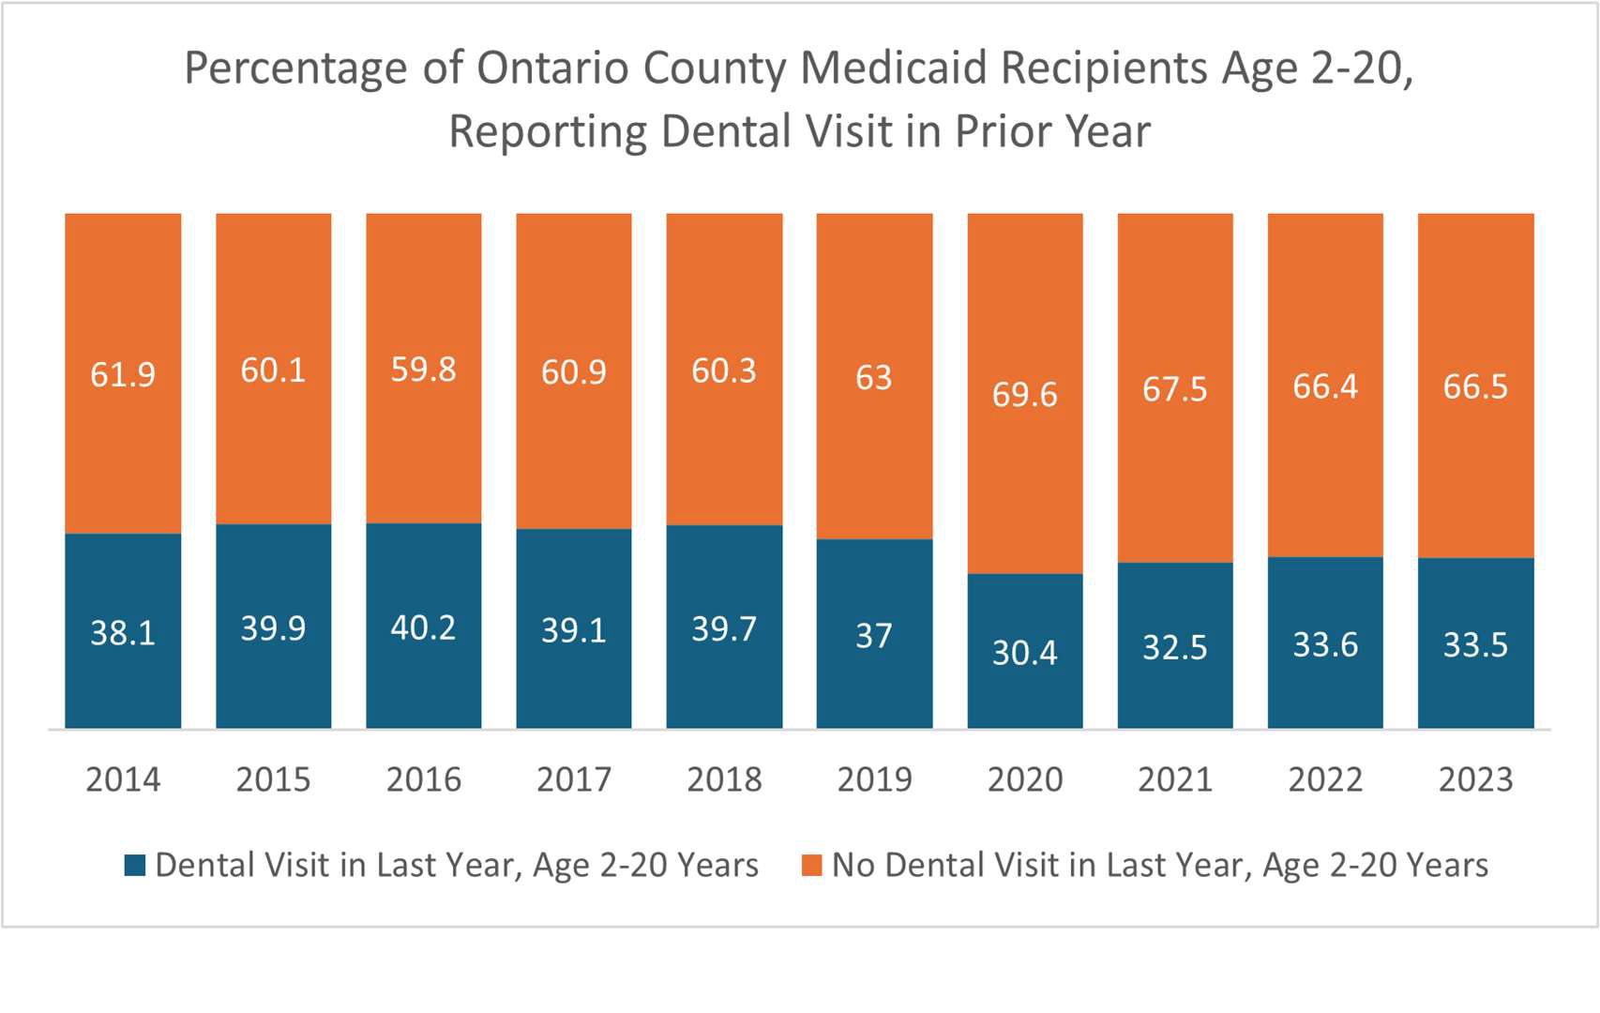
Figure O16: Dental Visit Status Among Ontario County Medicaid Recipients (Ages 2 to 20)
Source: NY State Medicaid Program, 2025
In summer months, public health staﬀ assist at Supply-a-Smile, a grassroots, church-sponsored dental services program for uninsured adults. However, this program reaches only a small portion of residents with unmet dental care needs. Signiﬁcant gaps in access to dental care remain, particularly for underserved populations such as residents without private insurance. Closing these gaps will require coordinated eﬀorts among partners and a focus on system-level and policy actions to expand oral health care access in Ontario County.


Priority: Preventive Services - Immunizations and Lead (Healthy Children) Immunizations
Recommended vaccines for children include the following:
- 4 doses of DTaP (Diphtheria, Tetanus, and Pertussis),
- 3 doses of polio (IPV)
- 1 of MMR ((Measles, Mumps, and Rubella))
- 3 doses of Hib (Haemophilus inﬂuenzae Type B)
- 3 doses of Hepatitis B
- 1 dose of Varicella
- 4 doses of pneumococcal vaccine (PCV)

The routine vaccination schedule is referred to as the 4:3:1:3:1:4 schedule and the rate of uptake is used to assess vaccine coverage among children. Rates dropped oﬀ slightly in 2024, which hopefully will not be a continuing trend⁴⁰ (Figure O17). The percent of children

Source VisitFingerLakes.com

who received the Human Papilloma Virus (HPV) vaccine increased until 2023, but as with routine childhood vaccines, decreased slightly in 2024. HPV vaccine protects against the viruses that cause cervical, vaginal, anal, oral and throat cancers.
In 2025, the immunization coordinator and department leadership dealt with many families questioning the NYS Vaccination Schedule for School Admission. Anecdotally, public health staﬀ have observed an increase in skepticism toward vaccines among parents and more are adamantly opposed to vaccinating their children. Federal actions involving the removal of vaccine experts from the CDC, the Advisory on Immunization Practices (ACIP), and the Food and Drug Administration (FDA), have public health practitioners on edge. The future of vaccine research, development, licensing and recommendations is in the hands of individuals without formal training or expertise in immunology. Future childhood vaccination rates may be adversely aﬀected and preventable childhood diseases may reappear and perpetuate.

⁴⁰ Source: New York State Immunization Information System Citywide Immunization Registry, Jan. 2025

Ontario County Routine Vaccination Rate among Children
24-35 Months of Age
100%
80%
34%
28%
28%
27%
23%
29%
60%
40%
66%
72%
72%
74%
77%
71%
20%
0%
2019
2020
2021
2022
2023
2024
24 -35 Month Old's Did Not Receive 4:3:1:3:3:1:4
24 -35 Month Old's Received 4:3:1:3:3:1:4
Figure O17: Routine Vaccination Rate Among Children
Percent

Source: NYSIIS Performance Report, IAP Baseline Report
Figure O18: HPV Vaccination

Source: NYSIIS Performance Report, IAP Baseline Report
HPV Vaccination Series by Age 13, Ontario County
100
90
80
70
60
50
40
30
20
10
0
28.8
29.2
32
34.4
34.4
31.9
2019 2020 2021 2022 2023 2024
Percent Received 3-dose Series

Lead Poisoning Prevention
Lead screening 2024 data indicate that the percentage of children aged one year who received one lead screening is 59.7%, an increase of 6% from 2015. The percentage of children aged two years who received at least one lead screening was 65.1%, an increase of 2% from 2015. Those who received at least two lead screenings by two years of age was 44.2%, a decrease of 2% from 2015. (Figure O19)

Figure O19 Childhood Lead Testing
Childhood Lead Testing, Ontario County 2024
% of children meeting the "Two tests by age 3"
indicator
44.23%
% of children tested for lead at age 2
65.42%
% of children tested for lead at age 1
59.61%
Source: NYSIIS Performance Report, IAP Baseline Report

Domain: Education Access and Quality

Priority: Health and Wellness Promoting Schools
Education strongly inﬂuences health. Individuals with more schooling live longer, have fewer chronic diseases, and experience greater economic stability.
Chronic absenteeism, deﬁned by the U.S. Department of Education as missing at least 10% of the school year for any reason, rose sharply in New York State and Ontario County after the COVID-19 pandemic (Figure O20). Chronic absenteeism is more prevalent in economically disadvantaged students and is associated with lower academic achievement, social disengagement, higher dropout risk, and poorer long-term health and economic outcomes.
Figure O20: Chronic Absenteeism
Chronic Absence Rates, Ontario County, K-8th Grade
30
25.7
24.4
25
23.7
20
16.3
15.4
15
13.9 14 13.5
10
7.6
8
5
0
2017/2018
2018/2019
2020/2021
2021/2022
2022/2023
School Year, excluding Pandemic Lock Down, 2019-2020
All Students
Economically Disadvantaged Students
Percent

Source: NYS Prevention Agenda Dashboard

Several factors may contribute to chronic absenteeism including physical health, mental health, behavioral factors, home environments, economic disadvantage, disability, and substance misuse.
Postsecondary education also brings substantial beneﬁts. Adults with a bachelor’s degree earn signiﬁcantly more, are less likely to be unemployed, and have better health and safer working and living conditions than those with only a high school diploma. However, aﬀordability and unequal access remain challenges. Data on high school seniors, with and without economic disadvantage, pursuing postsecondary education after graduation are reﬂected in Figure O21.
Figure O21: Postsecondary Education, Ontario County
Percent of High School Seniors Attending a 2-4 Year College
within 5 Years of Graduation, Ontario County
68.8
72.5
54.6
56
2022
2023
All High School Seniors
Economically Disadvantaged Seniors
Source: NYS Prevention Agenda Dashboard
Additional indicators under this priority include the percentage of teens and young adults neither working nor in school (disconnected youth) which in Ontario County is ﬁve percent; the percent of school age students eligible for free or reduced lunch (43%); and the number of child care centers per 1,000 children under age 5 (6/1,000),⁴¹ which is similar to NY State (6/1,000) and national data (7/1,000).

Priority: Opportunities for Continued Education
The percentage of adults ages 25 and over with a high school diploma or equivalent is 93%, higher than the NYS average of 88% and an increase of 1% from 2019. The percentage of adults aged 25-44 with some post-secondary education is 74%, higher than the NYS average of 71% and a decrease of 21% from 2019. The percentage of ninth grade cohort that graduates in 4 years is 93%, higher than the NYS average of 87% and an increase of 2% from 2019. The average gap in dollars between actual and required spending per pupil among public school districts is $12,784 compared with $12,745 on average in NYS; no change from 2019. The percentage of economically disadvantaged graduation rate is 85% vs. 82% for NYS; an increase of 10% from 2019.⁴²

⁴¹ Source: County Health Rankings
⁴² Source: American Community Survey

Priority: Education Access and Quality
Ontario County school absenteeism is lower than NY State averages and other indicators show generally supportive school and youth environments. The county reports low rates of disconnected youth (5%), moderate eligibility for free or reduced lunch (43%), and limited child care center availability for young children. Educational outcomes are strong. High school completion, four-year graduation rates, and post-secondary participation all exceed state averages, and graduation rates for economically disadvantaged students have improved. Despite these strengths, the gap between actual and required school spending remains unchanged and similar to the statewide average.

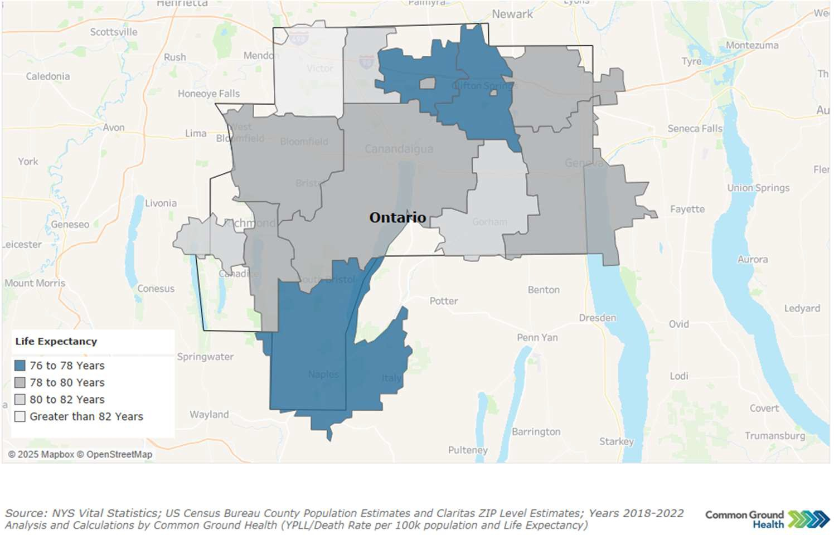
Leading Cause of Death and Life Expectancy
Map O4: Life Expectancy by Zip Code
The average life expectancy in Ontario County is 79.8 years, similar to the NYS life expectancy of 79.4 years. Life expectancy varies throughout the county as seen in Map O4. Those areas of the county with lower life expectancy mirror those counties with higher rates of poverty.
The leading causes of death and causes of premature death (before Age 75) in Ontario County are compared to NY State numbers in Table O15.
Table O15: Comparison of Leading Causes of Death and Premature Death in Ontario County and NYS

Leading Causes of Death per 100,000/year  (All Ages) |  |  | Leading Causes of Premature Death per 100,000/year  (Before Age 75)
Cause | Ontario  County | NY State | Cause | Ontario  County | NY State
Heart Disease | 141.8 | 166.4 | Cancer | 60.5 | 73.1
Cancer* | 128.9 | 137 | Heart Disease | 60.7 | 55.2
Alzheimer’s | 65.4 | 61.7 | Unintentional Injury | 38.1 | 46.9
All Causes | 716.9 | 744.2 | All Causes | 304.6 | 326.8
*Most common: lung, colorectal, female breast Source: NYS Vital Statistics, 2022

Emergency Department Visits and Potentially Preventable Hospitalizations
Overuse of the Emergency Department may signal gaps in care and access to outpatient, primary or preventive care. Individuals who have diﬃculty managing their chronic diseases, may overuse emergency rooms because they lack the necessary skills, cannot aﬀord medications, or are simply unable to see a medical provider on a regular basis due to expense, mobility, work schedule, transportation, etc. An increase in the number of substance use disorder ED visits is indicative of a worsening substance use crisis and a medical community that cannot meet the demand for outpatient treatment options.
Maps O5 and O6 detail the ED Visits and Preventable Hospitalizations by zip code in Ontario County. It should be noted that the areas of the county with increased ED visit rates and preventable hospitalizations are similar to those areas of the county with higher poverty rates and lower life expectancy. Table O16 highlights ED visits in Ontario County compared with NYS.

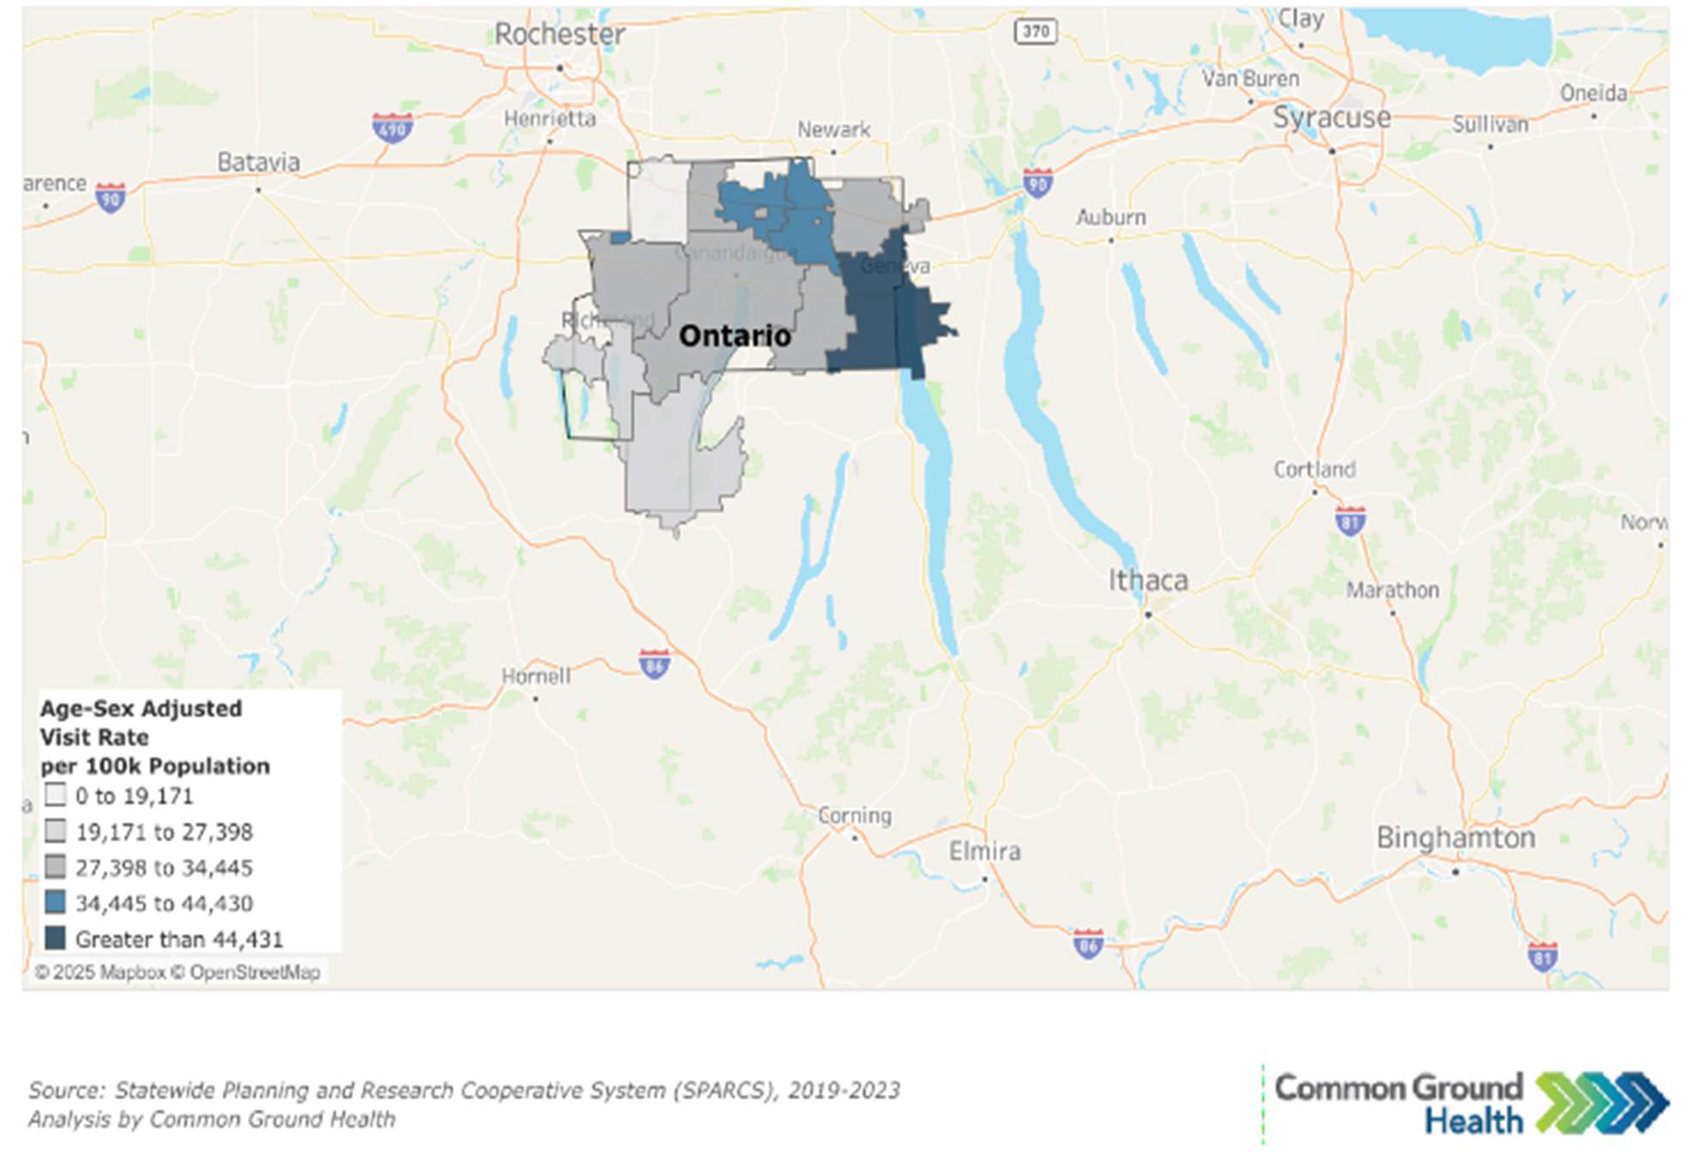
Map O5: ED Visit Rate by Zip Code

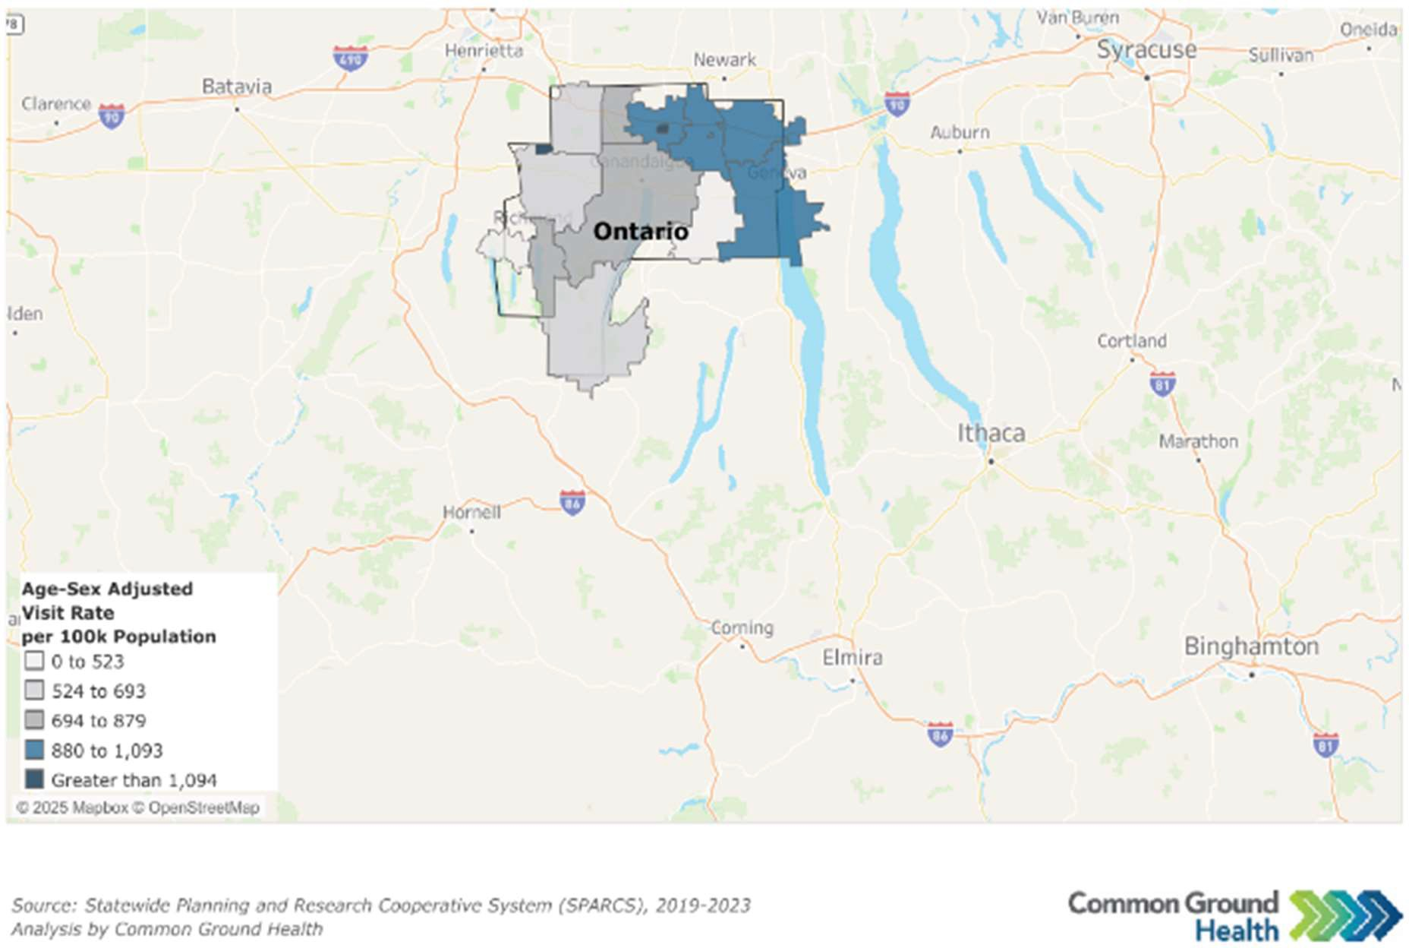
Map O6: Preventable Hospitalizations by Zip Code
Table O16: Emergency Department Visits

Issue | Ontario County  Rate Per 100,000 | NYS Rate Per  100,000 | % Change  (from 2017)
All ED Visits | 33,756 | 29,809 | 0%
Substance Use Disorder ED Visits | 1,435 | 1,646 | +255%
All Mental Health Visits | 2,645 | 3,370 | -32%
Intentional Self Harm ED Visits | 304 | 343 | +41%
Preventable Hospitalizations (Overall) | 780 | 808 | -20%
Diabetes Preventable Hospitalizations | 174 | 181 | +28%
Source: SPARCS

County Health Rankings
From a bird’s-eye view, Ontario County ranks above both the state and national averages for health and well-being (Figure O22) and community conditions (Figure O23), meaning residents generally experience better physical and mental health, higher quality of life, and a stronger ability to participate in their communities. The county also beneﬁts from favorable social and economic conditions, including better access to education, housing, transportation, and resources that support overall health.

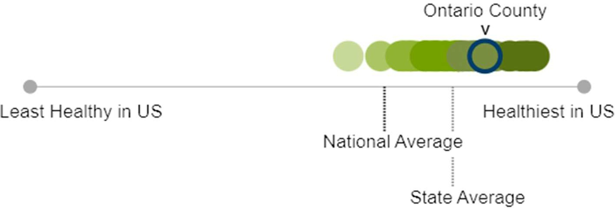

Figure O22: Health and Well-Being

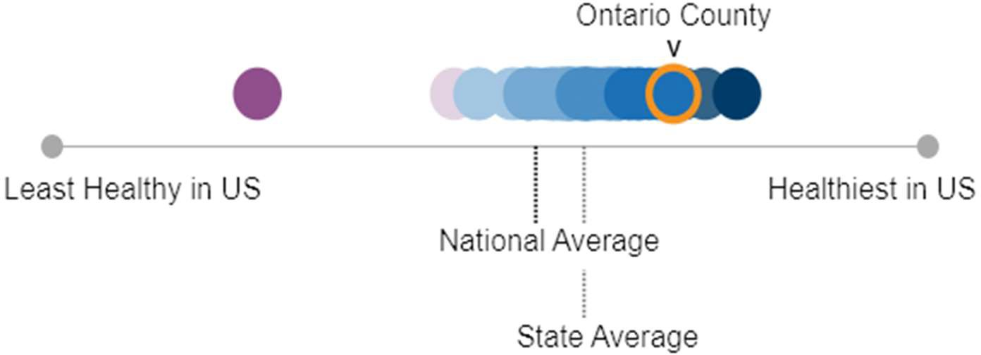

Figure O23: Community Conditions

Health Challenges and Associated Risk Factors
The following themes describe the health challenges and associated risk factors that were identiﬁed during qualitative data collection and analysis. Appendix A provides a list of groups that provided input.

High Cost of Living
Many residents described daily struggles to aﬀord food, housing, transportation, and basic health care. Families in rural areas said fresh food and exercise opportunities cost too much. Parents of disabled children talked about paying out of pocket for therapies when local Medicaid providers are not available. Older adults living on ﬁxed incomes spoke about food insecurity, long waitlists for specialty care, and the burden of managing prescriptions by mail.

High Cost of Health Care
Cost came up often as a barrier to care. Rural families said they avoid doctor visits because of high out-of-pocket costs. Farmworkers said they do not go to the doctor unless it is covered by workers’ compensation. LGBTQ+ frontline workers and people in recovery talked about losing health insurance due to paperwork issues or job changes, leaving them unable to pay for needed care. Some older adults living on ﬁxed incomes said they rely on mail-order prescriptions because there are no local pharmacies.

Health Care Provider Shortages
Many people said it is hard to ﬁnd primary care providers accepting new patients. Women and families in the city and rural areas described long waits for appointments or no local options, which pushes people to travel far for basic care. Parents of disabled children talked about shortages in local occupational, physical, and speech therapy services. Veterans praised the local VA but noted that people with complex conditions sometimes fall through the cracks.

Lack of Access to Specialty and Preventive Care
Specialty care, dental care, and vision care were named as hard to get, especially for low-income families and children with complex needs. Parents said they have to leave Ontario county and arrange to drive to Monroe County for some therapies or dental work because few local providers accept Medicaid. School nurses described relying on community closets, food pantries, and public programs to help students and families ﬁll basic health gaps when formal care is out of reach.

Low Wages and Job Insecurity
Low pay, high stress, and lack of beneﬁts were common points across groups. Frontline workers described moral injury from low-wage jobs that come with high risk and emotional toll. Many said helping professions are undervalued despite being essential to community functioning. Veterans and farm workers noted that missing work for health care is too expensive when paychecks do not cover basic bill

Housing Aﬀordability and Stability
High housing costs and lack of safe, stable options came up in nearly every discussion. Participants in recovery, people exiting jail, and low-income families described motels as last-resort housing that

exposes them to unsafe conditions and easy access to drugs. Veterans said aﬀordable sober housing is rare and that some emergency shelters feel unsafe or chaotic, which worsens stress.

Transportation Barriers
People across communities linked a lack of reliable transportation to lost wages and extra costs. Rural families pay more in time and gas to reach healthy food or medical care. Some said missed medical rides or late buses mean missed shifts or extra childcare costs. Farmworkers rely on employers or friends for rides, which adds to daily uncertainty and stress.

Financial Stress Inﬂuencing Mental Health
Economic strain was described as a constant source of worry that aﬀects mental health and daily choices. Many people said they know what to do to stay healthy but cannot aﬀord to do it. Parents talked about young adults forced to live at home because housing is unaﬀordable, adding stress for families. Several groups linked debt, student loans, and the rising cost of living to worsening anxiety and family conﬂict.

Social Isolation and Discrimination
Several participants talked about feeling isolated or left out of community life. Homeschool families described stigma and social exclusion because they do not use public schools but still pay school taxes without access to services. Older adults and people living with disabilities spoke about how mobility issues, lack of transport, and unsafe sidewalks can cut them oﬀ from friends and services. People in recovery or reentry said stigma keeps them from feeling fully part of their community.

Experiences of discrimination aﬀect how safe people feel where they live, work, and gather. LGBTQ+ participants spoke about being judged in health care settings and public spaces. Farmworkers and families with mixed immigration status described avoiding parks and churches out of fear of immigration enforcement. Indigenous respondents said they often feel looked down on or avoided in public spaces Parents talked about politics and divisiveness increasing conﬂict and fear within communities.

Trust and Social Support
Peer networks were highlighted as trusted sources of support and information. Veterans said they rely on other veterans for referrals and help. Parents of disabled children described how social media groups and informal word-of-mouth help them ﬁnd resources they cannot get through local systems. People in recovery emphasized the importance of safe spaces where they feel understood and not judged.

Social Stress and Discrimination
Community members described how conﬂict, fear of violence, and political division weaken social ties. Several participants said people feel less able to trust neighbors or speak up about problems because


they fear backlash or judgment. Rising costs and economic pressure add stress within families and communities, straining social bonds.

Environmental Concerns
Community members spoke about local environmental risks that shape neighborhood health. Rural families worried about pesticide spraying and ﬂooding that causes mold. Indigenous participants raised concerns about industry near reservations that they believe exposes residents to toxins and higher cancer rates. People in small towns pointed to poor drainage, broken sidewalks, and poor lighting as local issues that limit outdoor activity.

Emergency and Crisis Services Community members praised the Mobile Crisis Response Team and walk-in mental health support but said more is needed. People talked about how emergency rooms are sometimes the only option when basic care is missing, but stigma or fear of judgment or arrest can keep people from going until problems become severe.
Seneca Lake, Courtesy of Kassandra Doyle

Behavioral Risk Factors and Health Disparities
Ontario County’s behavioral health challenges are closely intertwined with the social and economic conditions in which residents live. Mental health concerns are rising, especially among youth, with increasing reports of sadness, depression, and suicidal thoughts. School nurses note growing demand for mental health support that exceeds school capacity, highlighting gaps in early intervention and access to behavioral health services. Substance use, particularly opioid-related overdose deaths, continues to escalate and now surpasses state rates, placing additional strain on families and emergency services.

These behavioral risks are ampliﬁed by persistent socioeconomic disparities. Poverty is concentrated in certain communities, most notably within the Geneva City School District, where children and families face chronic ﬁnancial instability, housing challenges, food insecurity, and higher exposure to toxic stress. Such conditions increase the likelihood of developmental delays, chronic illness, and behavioral health problems. Older adults on ﬁxed incomes also struggle to aﬀord medical and dental care, leaving many without timely preventive services.

Access to care remains a signiﬁcant barrier for several groups. Low-income families, migrant farmworkers, LGBTQ+ individuals, rural residents, and people with disabilities often encounter high out-of-pocket costs, limited transportation, reduced insurance continuity, and shortages of specialty, dental, and vision providers-particularly those who accept Medicaid. These barriers contribute to delays in treatment and increased reliance on emergency departments for conditions that could have been prevented or managed earlier.
Together, these patterns show how behavioral risks, such as substance misuse, poor mental health, tobacco and alcohol use, and limited physical activity, are shaped and worsened by inequities in income, geography, transportation, and access to care. As a result, residents in high-poverty neighborhoods, rural areas, and Medicaid-enrolled populations experience higher rates of chronic disease, injury, preventable hospitalizations, and premature mortality. Improving outcomes will require strengthening access to aﬀordable care, expanding supports for youth and families, and addressing the broader social determinants that drive health disparities across Ontario County.

Ontario County identiﬁed three health priorities to focus on for the 2025 to 2030 Community Health Improvement Plan and Community Service Plan.
Health Priorities
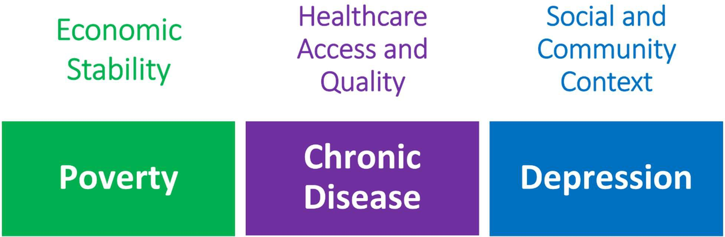
Prioritized Health Issues and their Domains within the NYS Prevention Agenda 2025-2030

Poverty

Issue Statement:
Persistent ﬁnancial strain contributes to delayed care, housing instability, and health inequities, especially for people living below the ALICE and poverty thresholds. Families, children, and older adults on ﬁxed incomes are most aﬀected. Systemic inequities, a high cost of living, and low wages drive ongoing cycles of poverty.
Both quantitative data and qualitative community input demonstrate that economic hardship continues to aﬀect health outcomes even when county-wide indicators appear relatively strong. While the county’s overall poverty rate remains below state averages, ﬁnancial strain is ongoing and unevenly distributed, with certain communities carrying a much greater burden.

Rates of poverty are one piece of the puzzle in understanding residents’ economic opportunities and needs. According to the United Way, nearly one-third of the county’s 112,000 residents (almost 32,500 individuals) earn above the federal poverty level but cannot make ends meet. These are our Asset Limited, Income Constrained, Employed (ALICE) families. Individuals in ALICE households may work multiple jobs, but still cannot meet basic needs like housing, daycare, food, gas, and health care.
These economic pressures shape daily life in ways that directly aﬀect health. Poverty intersects with food insecurity, housing instability, substance misuse, and chronic disease risk, making it a central driver of many health issues and a key opportunity for improving multiple health outcomes. Root cause analysis highlighted several contributing factors, including income instability, wages that have not kept pace with the cost of living, limited access to aﬀordable housing, childcare and transportation barriers, and

geographic diﬀerences in access to employment and services. Community members and partners described challenges in navigating available supports, particularly during times of transition or crisis.
The impact of ﬁnancial hardship begins early and can persist over time. Childhood poverty is associated with developmental delays, toxic stress, and chronic illness, increasing the likelihood of lasting health impacts and reinforcing cycles of disadvantage across generations. Addressing the conditions that contribute to poverty in children creates opportunities to improve health outcomes across the lifespan while reducing disparities.
Poverty branches into nearly every aspect of daily life and is at the root of many health disparities and inequities observed in Ontario County. It is unrealistic to believe partners can “solve” poverty and thereby improve health outcomes. CHIP partners can, however, continue to work upstream to address societal drivers of poverty, consider the relationship between policy and poverty, and knit a stronger safety net for the county’s most vulnerable residents. Advancing this priority will require public health to expand its sphere of inﬂuence and deepen partnerships across human services, housing, planning, workforce development, and other community sectors.

Depression

Depression was identiﬁed as a priority due to persistent and growing mental health needs across Ontario County with youth and residents of rural communities being particularly aﬀected. Youth mental health was also identiﬁed as a priority in the 2022 to 2024 CHIP. While some indicators show recent improvement, levels of sadness, hopelessness, and suicide-related behaviors remain high enough to warrant continued attention,
Issue Statement:
Depression is a widespread and growing concern aﬀecting residents across age groups, with a disproportionate impact on young people, low-income families, and marginalized populations. Limited access to timely, aﬀordable, and culturally relevant care compounds this burden, while stigma often prevents individuals from seeking help.

especially given the harm experienced by individuals, families, and communities.

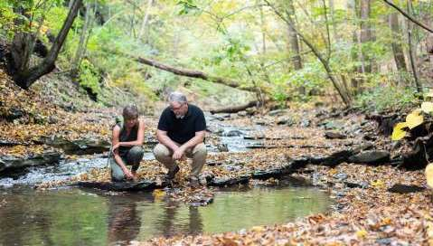
Root cause analysis suggests that depression in Ontario County is shaped by an overlapping of social, economic, and systemic factors. These include ﬁnancial strain, housing instability, social isolation, and limited access to timely, aﬀordable, and culturally relevant mental health care.
Stigma surrounding mental health continues to discourage seeking help and service capacity in the area often falls short of community need.

Couple by the water in a Finger Lakes Forest Immersion session. Photo Courtesy of VisitFingerLakes.com

School-based staﬀ described increasing mental health concerns among students, while facing challenges in meeting demand with available resources.

Depression is closely linked to substance use, mental health crises, suicide risk, educational outcomes, and overall well-being and it has emerged as a foundational issue aﬀecting health across the lifespan. Older adults expressed discomfort talking about mental health or asking for help, especially among peers who were raised in environments where mental illness was not openly discussed. This stigma makes it harder for people to accept mental health treatment until problems become severe.
Addressing these underlying community conditions that contribute to frequent mental distress creates opportunities to strengthen protective factors and improve outcomes, particularly for young people, older adults, and rural families. This priority will guide the development of targeted, collaborative strategies developed with community partners that emphasize prevention and community resilience in the face of limited health care resources.

Preventive Services for Chronic Disease Prevention and Control

Access to prevention services for chronic disease prevention and control continues to be a signiﬁcant challenge in Ontario County, particularly for residents with low incomes, Medicaid coverage, and those living in rural areas. Aﬀordability, inadequate insurance coverage, and lack of transportation remain persistent barriers that limit residents’ ability to obtain routine and preventive health care.
When residents are unable to access preventive care and recommended screenings, chronic conditions such as cancer, diabetes, and hypertension may

Issue Statement:
Chronic diseases such as heart disease, diabetes, and cancer are the leading causes of illness and death in Ontario County. These conditions are strongly shaped by social and economic factors, including food insecurity, housing costs, and access to care.
When chronic diseases are not detected or managed early, people experience delayed or preventable hospitalizations, with disproportionate impacts on families with low-income, older adults, and rural communities.

go undetected or unmanaged until they become severe enough to require emergency department visits or hospital admissions. These outcomes can contribute to lost workdays and medical debt, perpetuating cycles of ﬁnancial strain. More signiﬁcantly, delayed or foregone care increases the risk of long-term illness, disability, and reduced life expectancy.
Cost was cited frequently as a barrier to preventive care across multiple data sources, including the 2024 Regional Access to Care Survey and targeted focus groups in 2025. Rural residents described avoiding non-acute doctor visits due to high out-of-pocket expenses. Farmworkers shared that they often do not seek care unless it is covered by workers’ compensation. Frontline workers and people in recovery described losing health insurance during job changes or due to paperwork issues, leaving them unable to aﬀord needed care. In addition, pharmacy closures in recent years have led some residents to rely on mail-order services to access medications. This reduces residents’ opportunities to speak directly with pharmacists when questions arise.

Community members and service providers also identiﬁed specialty care, dental care, and vision care as particularly diﬃcult to access, especially for low-income families and children with complex needs.
Parents described traveling to Monroe County for therapies or dental services because few local providers accept Medicaid.
Addressing barriers to preventive services creates opportunities to improve early detection, support chronic disease management, and reduce avoidable health care utilization. This priority will guide the development of coordinated strategies with health care and community partners that improve access to preventive care before health conditions become crises.

Community Assets and Resources

Ontario County Public Health has a long-standing reputation of collaboration and coordination with partners in the health care system, other county departments, and the community. The department is also well-connected regionally, via the Pivital Public Health Partnership and Common Ground Health. Pivital is a rural health network of eight health departments in the Finger Lakes Region. Common Ground Health covers the same geographic footprint, with the addition of Monroe County, and focuses on bringing together leaders from all sectors to collaborate on strategies for improving health. Both agencies provide support, collaboration and resources to amplify public health priorities and expand programming. See the Finger Lakes Regional Community Health Assessment for additional details about these partners.
During focus groups, residents pointed to food pantries, free community programs, and informal mutual aid as lifelines when incomes fall short. Libraries, churches, and grassroots and community-based organizations were noted as valued assets to stretch limited incomes. It was noted by participants, however, that community safety nets cannot meet all needs and are not a replacement for stable jobs, aﬀordable housing, health insurance and a living wage.
Networks of peers were identiﬁed as trusted sources of support and information across focus groups. Veterans said they rely on other veterans for referrals and support. Parents of disabled children described how social media groups and informal word-of-mouth help them ﬁnd resources they cannot get through local systems. People in recovery emphasized the importance of safe spaces where they feel understood and not judged.

Community members agreed that neighbors, volunteers, and faith-based groups are the backbone of local support.
Participants spoke with pride about neighbors helping neighbors, church groups providing meals, and volunteers keeping food pantries stocked. Many see this informal help as proof of the community’s


Canandaigua Lake from Onanda Park, Image Courtesy of Kassandra Doyle

willingness to look out for each other, even when systems fall short.
Residents see well-maintained parks, safe sidewalks, and good lighting as signs that neighborhoods care for people’s health and safety. Inclusive playgrounds and community gardens were described as helping people connect and stay active. People across groups said they want more spaces that feel clean, safe, and easy to use for people of all ages and abilities.

Additionally, in Ontario County there are broad partnerships among the health care system, addictions treatment, public health, social services, mental health, oﬃce for the aging, law enforcement, the judicial system, educators, and community-based organizations. There are community coalitions that address substance use, mental health, suicide, and injury prevention. The Public Health Department participates in targeted coalitions regarding maternal child health, immunization, and lead poisoning prevention.

Other community resources include miles of walking and biking trails; county, town and city parks; public gyms; inclusive and accessible playgrounds; and lakes and beaches. ADA-compliant facilities provide an outlet for exercise and access to outdoor areas.
These assets are the foundation for our community’s capacity to address the health priorities identiﬁed using this CHA. As the CHIP commences, Public Health and its partners will leverage these connections and relationships to provide meaningful programming in the community and to augment its asset inventory.
Table O17 highlights the roles the county’s three hospitals will play in the CHIP. Roles and interventions of the health department and other partners and stakeholders will be detailed in the ﬁnal CHIP document to be submitted June 2026.

Table O17: Resources to Accomplish CHA/CHIP goals

Priority Area | Assets and Collaborative Resources | How they Support Community  Health and Well-being
Poverty | - Hospital social work teams  - Electronic medical record social determinant of health screening workﬂows  - Hospital-based food pantry  - Staﬀ and volunteers who maintain the pantry  - Community resource directories  - Partnerships with local food access  organizations | - Identify patients at risk for food insecurity  - Connect patients to local resources for food, housing, and ﬁnancial assistance  - Reduce food insecurity by oﬀering healthy food pantry in the hospital
Preventive Services for Chronic Disease Prevention and Control | - Clinical educators across hospital systems  - Stroke and high blood pressure prevention programs  - Community spaces that host education sessions  - Partners who support and share stroke recognition messages  - Electronic medical record cancer screening workﬂows and client reminders  - Partnerships with local cancer  support organizations | - Education for high risk communities to prevent stroke and improve management of high blood pressure  - Improve recognition of stroke symptoms  - Reduce preventable hospitalizations  - Expand access to cancer screening
Depression | - Mental health ﬁrst aid instructors and training program  - Health care settings and community spaces that host education sessions  - Electronic medical record depression screening workﬂow  - Psychiatric emergency program data-tracking systems  - Psychiatric emergency program staﬀ  and social work teams | - Increase community capacity to recognize and respond to mental health challenges  - Expand routine depression screening  - Improve understanding of how the community uses emergency psychiatric care

Appendix A. Community Voices Included in the Community Health Assessment
Appendix
- People who live in rural areas
- People who are in religious minorities
- Parents of children with disabilities
- People who homeschool their children, including caregivers and those who live in rural areas
- People who are on probation
- School-based health care providers
- Women across age groups utilizing public community programs (English and Spanish-speaking)
- People who are members of the Indigenous community living in the Finger Lakes region
- People with lived experience of substance misuse and recovery
- Men who are incarcerated
- Women who are incarcerated
- People who have served in the military
- People working on a dairy farm who speak Spanish as a ﬁrst language
- Parents of disabled children with complex medical needs
- Adults with disabilities
- Older adults living on ﬁxed incomes including people with disabilities
- People in frontline helping professions who identify as LGBTQ+
- Older adults who identify as LGBTQ+

