Seneca County

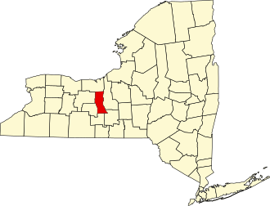
Seneca County Health Department
Scott King, MPH Director of Public Health sking@co.seneca.ny.us 315-539-1951

UR Medicine - Finger Lakes Health (Geneva General Hospital
Kim Ilacqua
Executive Director, Finger Lakes Health Foundation Kimberly-Ilacqua@URMC.Rochester.edu
315-787-4053

Pivital Public Health Partnership
Michele Foster Executive Director MFoster@pivitalphp.org


Courtesy, Hudson Valley Post

Table of Contents – Seneca County

Participating Partners and Community Representation | 3
Executive Summary | 4
Community Description | 6
Service Area | 6
Demographic Summary | 6
Health Status Description | 9
Speciﬁc Methodology | 9
NYS Prevention Agenda | 9
Chronic Disease | 26
County Health Rankings | 29
Health Challenges and Associated Risk Factors | 29
Community Assets and Resources | 31
Priority Areas | 32
List of Tables:
Table S1: NYS Prevention Agenda 2025-2030 Domains and Priorities | 10
Table S2: Causes of Death | 27
Table S3: Emergency Department Visits | 28
List of Maps:
Map S1: Population Density in Seneca County | 8
Map S2: Overall Poverty Rate in Seneca County | 11
Map S3: Life Expectancy | 27
Map S4: ED Visit Rate by Zip Code | 28
Map S5: Preventable Hospitalizations by Zip Code | 28
List of Figures:
Figure S1: Population Projections in Seneca County | 7
Figure S2: Population by Age and Sex | 8
Figure S3: Unemployment Rate | 12
Figure S4: Suicide Rate | 15
Figure S5: Overdose Deaths | 16
Figure S6: Injuries and Violence | 20
Figure S7: Provider Access | 23
Figure S8: Preventive Services – Immunizations and Lead | 24
Figure S9: County Health Rankings Health and Well-Being | 29
Figure S10: County Health Rankings Community Conditions/SDOH | 29

Participating Partners and Community Representation

A diverse coalition of organizations and community members participated in the Seneca County Community Health Assessment (CHA) process to ensure broad stakeholder input and representation from populations experiencing health disparities. The following partners contributed:

Organization | Sector | Population
UR Medical – Finger Lakes Health | Hospital | All
TACFL – Tobacco Action Coalition  of the Finger Lakes | Community Advocates
North Seneca/South Seneca  Ambulance | Ambulance | All
Alzheimer’s Association | Not For Proﬁt Organization | Aging Populations
Seneca County Board of Health | Other | All
Finger Lakes Community Health | FQHC | All
Seneca County Community  Counseling Center | Behavioral Health providers | Historically excluded or  marginalized population groups
South Towns Engaging People for  Solutions (STEPS) | Not For Proﬁt  Organization/Civic Group | All – Southern Towns
Office for the Aging (OFA) | Community Organization | Aging Populations
United Way of Seneca County | Civic Group | Historically excluded or marginalized population groups,  with a youth priority
Child and Family Resources | Civic Group | Children and Families, historically excluded or  marginalized population groups
Cornell Cooperative Extension | Community Organization | All
Finger Lakes Area Counseling and  Recovery Agency (FLACRA) | Behavioral Health Provider | Historically excluded or  marginalized population groups
Seneca County Planning  Department | Community Organization | All
Seneca County Department of Social Services | Community Organization | Children and Families, historically excluded or  marginalized population groups
Law Enforcement (Local PD,  Sheriff, State Police) | Community Organization | All
School Districts (Waterloo, Seneca Falls, Romulus, South  Seneca) | School | Children ages 4- 18

Women’s Leadership Council | Community Advocates | Historically excluded or  marginalized population groups
Northeast College of Health  Sciences | Higher Education | Young Adults
SPCC – Society for Protection and  Care of Children | Civic Group | Children and Families
WIC | Community Organization | Mothers with children

Executive Summary

Seneca County has identiﬁed three priority areas for this Community Health Assessment. They are:
- Healthy Children Preventive Services
- Primary Prevention, Substance Misuse, and Overdose Prevention
- Nutrition Security

Disparity Groups
Speciﬁc disparity groups include older adults and children living in poverty, Medicaid-enrolled children and adults with low preventive dental use, and residents with low socioeconomic status who have difficulty obtaining affordable dental care and other essential services.

Data Sources
Seneca County’s CHA incorporated a blend of quantitative and qualitative data sources, including secondary data from the Behavioral Risk Factor Surveillance System, County Health Rankings, National Center for Health Statistics, American Community Survey, U.S. Census, NYS Medicaid Program, and local performance reports. The CHA also used primary data collected through a structured questionnaire used to guide focus groups as part of the Community Context Assessment (CCA). Further, forces of change and asset mapping assessments were undertaken with community partners as part of the Community Partner Assessment (CPA) to triangulate ﬁndings and shape the selection of priority areas.

Partners and Roles
A diverse coalition of organizations and community stakeholders participated throughout the Seneca County CHA process beginning in early 2025. A total of ﬁve meetings were held and key partners included the Seneca County Health Department, UR Medicine - Finger Lakes Health (Geneva General Hospital), Pivital Public Health Partnership and local agencies. Five focus groups were held during the months of April, May, and June of 2025 to engage the broader community.
Partners contributed by participating in regular CHA committee meetings where they reviewed and interpreted data, completed prioritization surveys, and helped identify the health priorities to be addressed within Seneca County’s Community Health Improvement Plan.

Summary of Findings
Seneca County faces a wide range of health and social challenges that are closely tied to economic conditions, access to services, and long-term community well-being. Poverty has increased among both children and older adults, contributing to ﬁnancial strain, food insecurity, housing instability, and limited access to transportation and healthcare. Although unemployment remains low, median household income lags behind the state, and residents continue to experience barriers to affordable, nutritious food - challenges likely exacerbated by the recent loss of a key grocery store in the southern end of the county.
Housing and mental health indicators show mixed trends. While major housing problems remain below state averages, the number of cost-burdened households is rising. Reports of poor mental health have increased, and although suicide rates have declined overall, they remain above the state average. Although rates remain lower than New York State (NYS), substance use remains a signiﬁcant concern, with a sharp increase in drug-related overdose occurring in 2022. Tobacco use has decreased, but smoking and heavy alcohol use still exceed state averages.
Fruit and vegetable intake remains inconsistent, sugary-drink consumption has improved, and access to physical activity opportunities has declined for Seneca County residents. Adult obesity has increased, and childhood obesity remains signiﬁcantly higher than statewide levels. Preventive services show mixed outcomes as childhood immunization rates are improving but still below the NYS average. Lead-screening rates among one- and two-year-olds have slowly improved since 2020; however, continued efforts toward increasing the percentage of children receiving at least two lead screenings by the age of three are needed due to the drop in numbers. Adult screening for diabetes and colorectal cancer has declined. Access to dental care, especially among Medicaid enrollees, remains a persistent challenge.
Education and youth-related indicators further illustrate community needs. Disconnected youth rates are high, childcare availability is extremely limited, and school districts face a growing gap between required and actual per-pupil spending. While high school graduation rates are improving, post-secondary educational attainment continues to trail behind the state.
Despite these challenges, Seneca County has notable strengths. Life expectancy is stable, prenatal health behaviors have improved, breast-feeding rates are strong. The preventable hospitalization rate decreases substantially from 2017 to 2021; however, has trended upward in the last few years. Civic engagement and community participation remain solid, helping to buffer the effects of rising social vulnerability.
Overall, Seneca County exhibits resilience and progress in several health domains, but economic instability, limited access to care, rising injury and mental-health burdens, and preventable chronic disease risks continue to pose substantial challenges. These ﬁndings highlight a need for strengthened preventive services, improved access to healthcare and nutritious food, expanded mental-health and substance-use supports, and targeted efforts to address the social and economic conditions that shape long-term health.

In early 2026, the CHA/CHIP committee will meet to discuss and ﬁnalize interventions and strategies that will be incorporated into Seneca County’s Community Health Improvement Plan (CHIP) based on priorities identiﬁed during the CHA process. Simultaneously, speciﬁc measures will also be determined to track progress for each for each of the interventions. Preliminary CHA ﬁndings have been discussed with health department staff, Health Advisory Committee and the Board of Health members and periodic updates will be provided throughout the 2025-2030 cycle. The CHA/CHIP will be made available for public view on our health department website: www.senecacountyhealthny.gov

Community Description

Service Area
Seneca County is located in New York State’s Finger Lakes region and includes a mix of small towns and villages. Bounded by Seneca Lake to the west and Cayuga Lake to the east, the county covers roughly 390 square miles in total, of which about 324 square miles is land and around 66–67 square miles (roughly 17%) is water.
Because services are centralized and social service agencies are concentrated in the northern part of the county, residents in southern or more remote areas may face challenges, such as longer travel distances, limited transportation, and geographic isolation, to access care, especially for uninsured, Medicaid, or elderly populations.

Demographics
Demographic information is essential in public health because it helps identify which populations are most affected by speciﬁc health issues and where resources are needed most. By understanding factors such as age, income, race, and geography, public health professionals can design targeted interventions, reduce health disparities, and plan services that effectively meet a community’s needs.

Population
Seneca County’s population of 32,349 is slowly decreasing and this trend is expected to continue through 2040 as shown in Figure S1. Municipalities with the greatest population density are found in the northern portion of the county as illustrated in Map S1 with 57.9% of residents living in a rural area. The unequal distribution of populations along with geographical isolation contributes to resource deserts for many rural residents in the southern portion of the county.
Figure S1: Population Projections Seneca County
Population Projections Seneca County
35,000
34,800
34,600
34,400
34,200
34,000
33,800
33,600
33,400
33,200
Source: Cornell Program on Applied Demographics
Figure S2 shows the number of county residents by sex and age. The county has two larger population groups; 30-34 years of age and 60-64 years of age. Both an aging and a young population present unique health care challenges. The median age in Seneca County is 42.8, while the percentage of the population that is female is 48.7% and those identifying as LGBTQ+ is 5.8%.
Census data for Seneca County indicate the population is predominantly White (88.1%) followed by Hispanic or Latino (4.11%), Black or African American (3.6%), Asian (0.7%) and American Indian or Alaska Native (0.01%). The regional section of this CHA denotes additional population considerations including Amish/Mennonite and farmworkers.

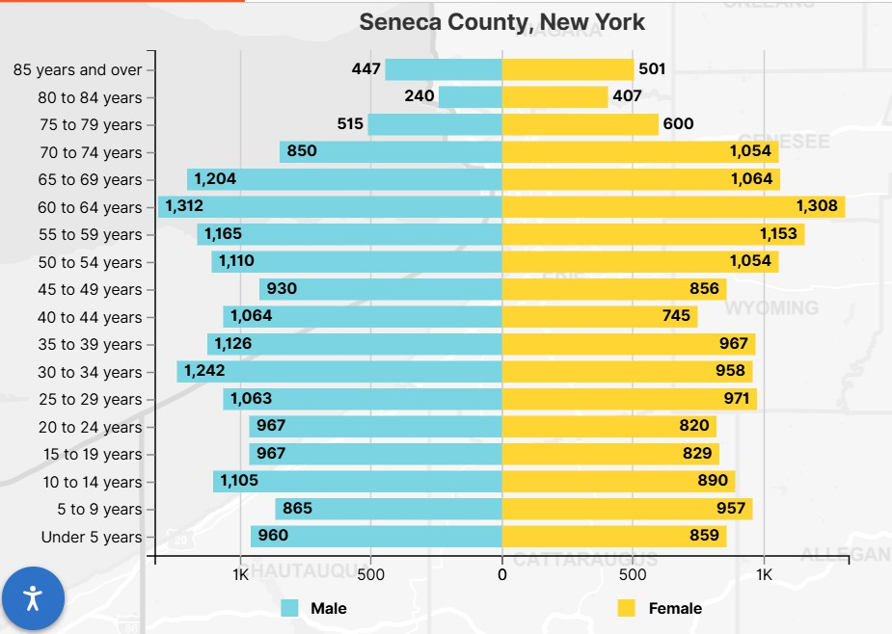
Map S1 Population Density Seneca County
Figure S2: Population by Age and Sex

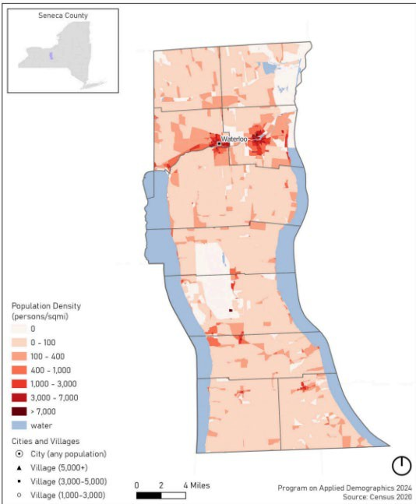
Veterans and Disability
Veterans often have distinct health needs, including higher rates of chronic conditions, mental health challenges, and service-related injuries. 2023 Census ﬁgures indicate the veteran population in Seneca County accounts for 8.7%, well above the state average of 3.9%. Of that number, 93% are male and 7% are female.
Disabled persons may face heightened barriers to care, transportation, employment, housing, and healthy living. The disabled population in Seneca County is 18% compared with 13.5% in New York State. The most common disabilities are cognitive, independent living and ambulatory difficulty.

Language Spoken at Home
In Seneca County, per the U.S. Census, the percentage of people who speak a language other than English at home is 7.8% which include Spanish, Indo-European, and Asian and Paciﬁc Island.
English language proﬁciency is one factor in ensuring residents are able to communicate their needs and understand their options, particularly related to health care. Those speaking Indo-European languages may represent a larger Amish/Mennonite population in the county.

Broadband Access
Broadband access is important because it enables residents to use essential services such as telehealth, online health information, appointment scheduling, and remote monitoring, tools that are especially vital for rural communities and those with limited transportation. Reliable internet also supports health education, emergency communication, social connection, and access to beneﬁts and resources, helping reduce disparities and improve overall community well-being.

Broadband access in Seneca County, as measured in the 2025 County Health Rankings, is 85% as compared to New York State broadband services at 90%. The percentage of the population with no access to broadband services, meaning broadband is simply not available in their area, is 0.4% in Seneca County.

Health Status Description

Speciﬁc Methodology
The CHA provides a comprehensive picture of a community’s current health status, including factors that contribute to health risks and challenges, and identiﬁes priority health needs by analyzing local data and community input. Community partners played a key role throughout the development of the CHA. Each partner completed the Community Partner Assessment (CPA), providing valuable organizational data and insights and participated in regular meetings where key cross-cutting themes from the CPA, CCA and CSA were presented. Based on cross-cutting themes, a ﬁshbone diagram was created for each to help narrow down the potential cause and effects of each of the issues. These sessions encouraged questions, feedback, and shared interpretation of the data. All partners were provided the opportunity to then participate in the prioritization process used to identify which health priorities would be addressed in Seneca County, ensuring that these priorities reﬂected both data and community voice.
The prioritization process involved a matrix with drop-down menus numbered 1 to 5 (one being most important; 5 being least important) to rank each identiﬁed issue based on ﬁve criteria to determine which three issues would be chosen as priority areas for this CHA.
The ﬁve criteria used to prioritize issues were:
- Relevance of the issue to community members
- Magnitude/severity of the issue
- Impact of the issue on communities impacted by inequalities
- Availability and feasibility of solutions and strategies to address the issue
- Availability of resources (time, funding, staffing, equipment) to address the issue

New York State Prevention Agenda 2025-2030
Table S1 reveals the NYS Prevention Agenda Domains and Priorities. Local health departments are tasked by NYS, based on data collected during the CHA process, to choose at least three priority areas under one or more domains to address within their respective communities. The domains and priorities in bold will be the focus areas for Seneca County’s Community Health Improvement Plan (CHIP). The Community Partners column reﬂects the percentage of partners who feel they either have the capacity to address some aspects of the speciﬁc priority area or routinely work with clients who are impacted by those priorities.

Table S1: NYS Prevention Agenda

Domain | Priorities | Community  Partners
1. Economic Stability | Poverty | 63%
1. Economic Stability | Unemployment | 50%
1. Economic Stability | Nutrition Security | 75%
1. Economic Stability | Housing Stability and Affordability | 75%
2. Social and Community Context | Anxiety and Stress | 75%
2. Social and Community Context | Suicide | 38%
2. Social and Community Context | Depression | 75%
2. Social and Community Context | Primary Prevention, Substance  Misuse, and Overdose Prevention | 63%
2. Social and Community Context | Tobacco/ E-cigarette Use | 50%
2. Social and Community Context | Alcohol Use | 50%
2. Social and Community Context | Adverse Childhood Experiences | 75%
2. Social and Community Context | Healthy Eating | 75%
3. Neighborhood and Built Environment | Opportunities For Active Transportation and  Physical Activity | 13%
3. Neighborhood and Built Environment | Access to Community Services and Support | 75%
3. Neighborhood and Built Environment | Injuries and Violence | 25%
4. Health Care Access and Quality | Access to and Use of Prenatal Care | 38%
4. Health Care Access and Quality | Prevention of Infant and Maternal Mortality | 38%
4. Health Care Access and Quality | Preventive Services for Chronic Disease  Prevention and Control | 75%
4. Health Care Access and Quality | Oral Health Care | 0%
4. Health Care Access and Quality | Preventive Services Healthy  Children | 75%
4. Health Care Access and Quality | Early Intervention | 63%
4. Health Care Access and Quality | Childhood Behavioral Health | 25%
5. Education Access and  Quality | Health and Wellness Promoting Schools | 50%
5. Education Access and  Quality | Opportunities for Continued Education | 38%

The following section details Seneca County’s health status related to the Prevention Agenda domains and priorities.

Domain: Economic Stability
Socioeconomic disparities are closely linked to poor health in Seneca County, affecting physical, mental, and educational outcomes, with children and older adults being especially vulnerable. The county prioritizes addressing these social determinants of health, including unemployment, food insecurity, and housing instability.
Unemployment and underemployment: Contributes to major health inequities in Seneca County. Individuals who are unemployed face greater barriers to health care and experience worsening health the longer unemployment persists. Employment challenges in the region stem from shifts in the labor market, wage stagnation, and other economic factors. Addressing these issues requires cross-sector collaboration and integrating workforce well-being of public health and economic strategies.
Nutrition Security: Access to affordable, nutritious food is vital for preventing chronic disease and supporting healthy development. Food insecurity disproportionately affects low-income households, people with less education, and those who are unemployed.
Lack of transportation is a primary barrier to accessing full-service grocery stores throughout the rural and low-income communities within the county.
Housing Stability and Affordability: Housing insecurity further undermines health, with low-income families and older adults facing the greatest housing burdens.

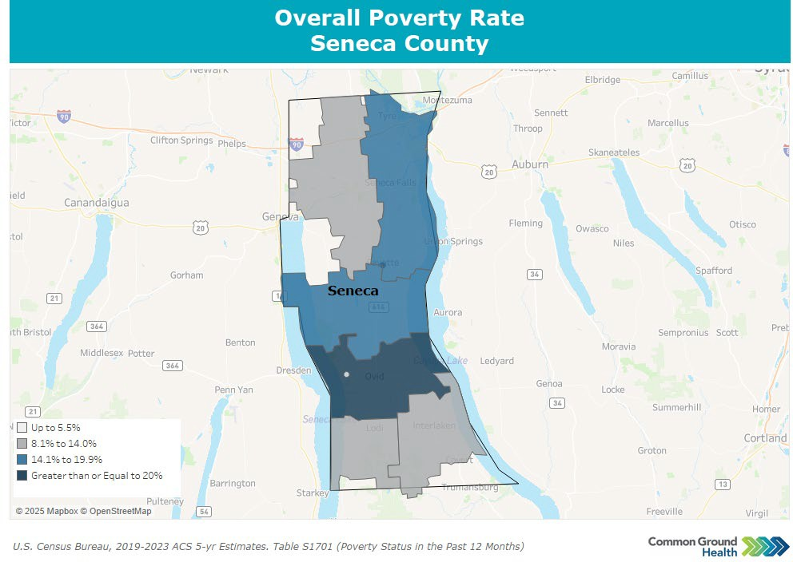
Priority: Poverty
Map S2: Poverty Rate
Poverty can strain nearly every aspect of community life, from housing stability to access to healthcare, transportation, and nutritious food. Families facing ﬁnancial hardship often struggle to meet basic needs, and limited local resources can make it difficult for them to ﬁnd sustainable pathways out of poverty.
Seneca County’s overall population poverty rate increased from 11.9% in 2021 to13.3% in 2023 (below the state average of 13.7%). The percentage of children under 18

years-of-age living in poverty increased slightly from 19% in 2022 to 21% in 2023 (above the state average of 19%). Additionally, the percentage of the population over 65 years-of-age living in poverty increased from 8.6% in 2022 to 9.0% in 2023, however, lower than the NYS average of 12.7%. Map S2 notes the percentage of those living in poverty in different areas of the county.

Priority: Unemployment
Unemployment can lead to ﬁnancial instability for families and reduced economic vitality for the community. High unemployment often strains social services, limits consumer spending, and can contribute to long-term challenges such as housing insecurity, poor health outcomes, and decreased quality of life.
The unemployment rate was 3.6% in January 2025 which is lower than the 4.7% it was in January of 2024. Both rates are also below the county's long-term average of 5.4%. In 2023, the median household income in the county is $58,600 (vs NYS $82,100). Figure S3 notes the unemployment rate as it stood in January of each year from 2019 to the present.
The primary employment sectors are health care and social assistance followed by educational services, manufacturing and others.

Figure S3: Unemployment Rate
9.00%
8.00%
7.00%
6.00%
Unemployment Rate as it Stood in January of Each Year
8.20%
5.00%
4.00%
3.00%
2.00%
1.00%
0.00%
4.70%
4.70%
3.80%
3.20%
3.50%
3.60%
2019
2020
2021
2022
2023
2024
2025
Source: U.S. Bureau of Labor Statistics

Priority: Nutrition Security
Nutrition insecurity can lead to higher rates of chronic disease, poor child development, and overall diminished health and well-being. When families lack consistent access to affordable, nutritious food, community systems from healthcare to schools feel the strain, and long-term inequities in health outcomes increase.
The percentage of the population who are low income and do not live close to a grocery store is 2% which is equal to the NYS average. This number is likely to be affected by a ﬁre in January 2025 that

destroyed the Ovid Big M grocery store which many in the county relied on for groceries and nutrition security. At present, we do not have data to reﬂect this change or the impact this has had on the southern part of the county. Based on the most recent data available from 2016, nearly half (47.2%) of adults with an annual household income less than $25,000 report food insecurity.
The Food Environment Index measures how easy it is for residents to access healthy, affordable food, combining rates of food insecurity and the percentage of low-income people living far from a grocery store. Scores range from 0 (worst) to 10 (best). Seneca County’s score was 8.4 in 2022 and is below the New York State average of 8.7, indicating that residents face more barriers to healthy food access than most New Yorkers.

Priority: Housing Stability and Affordability
Housing instability and a lack of affordable options can leave families struggling to meet basic needs, often forcing them to choose between rent, food, and healthcare. When stable housing is out of reach, communities experience higher rates of homelessness, overcrowding, and ﬁnancial stress, which can undermine overall health, safety, and economic growth.
The County Health Rankings report that in 2021, 12% of households experienced at least one major housing problem, such as overcrowding, high housing costs, or lack of kitchen or plumbing facilities. While this number is up 9% from 2017, Seneca County remains well below the New York State average of 23%. According to the American Community Survey, 72% of occupied housing units were owner-occupied in 2023, higher than the statewide rate of 54%, though this represents a 3% decline since 2019. Additionally, 12% of households spent half or more of their income on housing, an increase of 9% since 2019 but still below the state average of 19%.
Economic Stability Domain Summary: Seneca County faces growing economic strain, with overall poverty rising to 13.3% and child poverty reaching 21%, higher than the state average. Although unemployment has improved in 2025 and remains below long-term trends, median household income is still far lower than the New York State average. Nutrition security remains a concern, particularly for low-income households, and may worsen following the 2025 Ovid ﬁre that destroyed the only grocery store in the southern part of the county. Housing stability indicators show relatively fewer severe housing problems compared to the state, yet cost burden has increased, and owner-occupancy rates are gradually declining. Together, these trends highlight widening economic vulnerability and ongoing challenges in ensuring access to food, stable housing, and essential resources.

Domain: Social and Community Context
The Social and Community Context domain within the New York State (NYS) Prevention Agenda 2025-2030 recognizes that an individual's relationships, interactions, and community environment signiﬁcantly inﬂuence their overall health and well-being. This domain aims to strengthen communities to promote health, connection, and equity across New York.

The overarching vision is that every New Yorker can attain their highest level of health, free from the limitations of social or economic conditions. Key public health areas addressed in this domain include:
- Strengthening Mental Health and Promoting Well-being: The agenda focuses on promoting overall mental well-being and reducing frequent mental distress in populations most in need. This includes addressing conditions such as depression disorders, which affect over one in ﬁve New Yorkers annually. Efforts also focus on expanding access to culturally responsive mental health care and social support services, while reducing treatment barriers such as stigma and limited provider options.
- Suicide Prevention: Reducing suicide mortality remains a high-priority goal within Seneca County and the Prevention Agenda. Use of interventions to decrease suicide deaths by increasing access to mental health care and reducing access to lethal means.
- Reducing Substance Use Disorders and Overdose Deaths: New York State prioritizes preventing opioid and other substance misuse, reducing underage drinking, and addressing excessive alcohol consumption by adults. Goals include increasing access to harm reduction services, such as naloxone, medication, and assisted treatment.
- Preventing Adverse Childhood Experiences (ACEs): A key goal is to prevent and address the impact of childhood trauma, as ACEs signiﬁcantly increase the risk of chronic disease, mental health problems, and substance misuse later in life. Strategies emphasize creating safe and nurturing environments and ensuring children have supportive adults in their lives.
- Fostering Social Connection: Encouraging community participation, and strong social networks is a core strategy to combat the negative health effects of social isolation.
- Addressing Chronic Disease Drivers: Priorities such as controlling commercial tobacco use, preventing youth e-cigarette use, smoking cessation and promoting healthy nutrition by improving fruit and vegetable consumption, are integrated across all domains, recognizing the role of community context and targeted marketing in health disparities.
This comprehensive approach addresses the root causes of health issues within the community, leveraging partnerships and evidence-based strategies to improve outcomes for all New Yorkers.

Priority: Anxiety and Stress
The percentage of adults reporting 14 or more days of poor mental health per month (age-adjusted) was 18% in 2021. This represents a 20% increase from 2018 and is above the NYS average of 16% per the Behavioral Risk Factor Surveillance System. Experiencing 14 or more days of poor mental health in a month is strongly linked to worse overall health outcomes. When this percentage rises, as it has in Seneca County, residents experience increased levels of stress, depression, or anxiety, which may lead to higher rates of chronic disease, substance use, reduced productivity, and greater demand for mental health and medical services. An elevated rate also suggests that residents may

struggle more with daily functioning, decision-making, and maintaining healthy behaviors,
ultimately affecting both individual well-being and community health.1

Priority: Suicide
The suicide rate in the county was 12 per 100,000 in 2022, a decrease of 14% as shown in Figure S4; but still higher than the NYS average of 9.7 per 100,000. Rising suicide rates signal worsening mental health and increasing levels of stress, trauma, or unmet behavioral-health needs in the community. When the county’s overall suicide rate exceeds the state average, it suggests that residents may face greater barriers to timely mental-health care, social support, or crisis intervention. Higher suicide rates also have wide-reaching impacts: they strain families, schools, healthcare systems, and communities, and often indicate deeper issues such as isolation, substance use, economic stress, or limited access to mental-health services.2

Figure S4: Suicide Rate
Suicide Rate per 100,000 Population (Overall and Youth)
60
50
40
30
20
10
0
51.5
34.5
14
12
15
17.3
15
12
0
0
2018 2019 2020 2021 2022
Overall Youth
Source: National Vital Statistics

Priority: Depression
Across New York State, approximately one in ﬁve adults reported symptoms of depression and/or anxiety in 2024, a ﬁgure that has been gradually decreasing since 2021. The Seneca County age-adjusted rate of adults reporting a depressive disorder is 18.3%, about even with the NYS average of 18.7% and an increase of 63% from 2016 per the Behavioral Risk Factor Surveillance System. This is a signiﬁcant public health concern because a high prevalence of depressive disorders in the community can lead to widespread impacts on physical health, productivity, and overall well-being. Elevated rates of depression are associated with increased risk of chronic diseases, substance use,

1 Source: Strine TW, Balluz L, Chapman DP, Moriarty DG, Owens M, Mokdad AH. Risk behaviors and healthcare coverage among adults by frequent mental distress status, 2001. Am J Prev Med. 2004 Apr;26(3):213-6. doi: 10.1016/j.amepre.2003.11.002. PMID: 15026100.
2 Source: https://www.cdc.gov/suicide/facts/index.html

social isolation, and suicide, as well as greater demand for mental health services. The county’s increasing rate of adults reporting a depressive disorder indicates that many residents may not be receiving adequate treatment or support, contributing to long-term health disparities and strain on local healthcare and social services.3

Priority: Primary Prevention, Substance Misuse, and Overdose Prevention
Overdose deaths, as reported in 2022, continue to trend upward from 2021 apart from heroin as noted in Figure S5. Age-adjusted overdose deaths involving any opioids increased from 8.9 in 2021 to 14.4 in 2022. Overdose deaths involving any drug increased from 15.1 in 2021 to 24.6. In 2022, the rate of overdose deaths involving opioid pain relievers (including illicitly produced opioids such as fentanyl) was at 18.4, which climbed from 9.0 in 2021. All overdose deaths are below state averages and are measured per 100,000 population.
The opioid epidemic is a serious public health problem because rising overdose rates reﬂect increasing substance use and related harm in the community, which can lead to preventable deaths, long-term health complications, and social and economic consequences. Even though the county’s rates are below state averages, the sharp increases signal a growing crisis that strains emergency services, healthcare systems, and families, and indicates a need for targeted prevention, treatment, and harm-reduction strategies.4

Figure S5: Overdose Deaths
Overdose Deaths Seneca County
35
30
25
20
15
10
5
0
2014
2015
2016
2017
2018
Any Drug
NYS Opioid Avg
2019
2020
Heroin
2021
2022
Any opioids
Pain Relievers NYS Herion Avg
NYS Any Drug Avg
NYS Pain Reliever Avg
Source: National Center for Health Statistics

3 Source: https://www.nimh.nih.gov/health/publications/chronic-illness-mental-health
4 Source: https://www.cdc.gov/overdose-prevention/about/

Priority: Tobacco/E-cigarette and Alcohol Use
According to 2022 data in the Behavioral Risk Factor Surveillance System the percentage of adults who are current smokers (age-adjusted) decreased from 24% in 2018 to 16% in 2022, however, slightly higher than the NYS average of 12%. The percentage of adults reporting binge or heavy drinking increased from 18% in 2021 to 22% in 2022 as compared to the NYS average of 20%. Data on e-cigarette use among adults in the county are not available. There is, however, data from 2022 regarding middle school students who reported vaping in the last 30 days (2.7%) and high school students who did the same (12%). Both smoking and excessive alcohol use are major risk factors for chronic diseases, including heart disease, cancer, liver disease, and respiratory illnesses.
Higher rates of these behaviors in the community increase the burden on healthcare systems, contribute to preventable morbidity and mortality, and can reduce quality of life. Persistent smoking above the state average and rising binge or heavy drinking indicate that residents may face elevated long-term health risks and that targeted prevention and intervention efforts are needed.5

Priority: Adverse Childhood Experiences
Adverse Childhood Experiences (ACEs) are those emotional and physical circumstances and individual experiences before age 18. They may include neglect, sexual abuse, parental divorce, mental illness and/or substance abuse, and exposure to violence in the home. ACEs impact individuals into adulthood and may include physical and mental long-term health problems.
Behavioral Risk Factor Surveillance System data through 2021 shows the age-adjusted percentage of adults with two or more ACEs decreased 6% from 2016 to 31%, below the NYS average of 40.5%.
ACEs have long-lasting effects on physical, mental, and behavioral health. Individuals experiencing two or more ACEs increases their risk of chronic diseases, mental health disorders, substance use, and social challenges well into adulthood. Even though the county’s rate of adults with two or more ACEs has decreased, this still represents a substantial portion of the population at higher risk for long-term health problems and increased healthcare and social service needs.6

Priority: Healthy Eating
The percentage of adults who eat fruits (57.3%, an increase of 13%) and vegetables (71.3%, a decrease of 6% from 2016) daily may be tied to the availability of fresh produce and the convenience of a nearby grocery store. These percentages will likely change given the recent ﬁre that destroyed the Ovid Big M grocery store, depended on by many in the county. According to the Behavioral Risk Factor Surveillance System, the percentage of adults, in 2021, with an annual household income of less than $25,000 who drink one or more sugary drinks every day decreased 25% to 28.1%, lower than the NYS average of 34.1%.
Low consumption of fruits and vegetables and high intake of sugary drinks contribute to poor nutrition, obesity, diabetes, heart disease, and other chronic conditions. When access to healthy

5 Source: Kim Y. The effects of smoking, alcohol consumption, obesity, and physical inactivity on healthcare costs: a longitudinal cohort study. BMC Public Health. 2025 Mar 5;25(1):873. doi: 10.1186/s12889-025-22133-4. PMID: 40045251; PMCID: PMC11881326.
6 Source: https://www.cdc.gov/aces/about/index.html

foods is limited, especially for lower-income populations, residents are more likely to develop diet-related illnesses, increasing healthcare costs and reducing overall community health and quality of life.7
Social and Community Context Domain Summary: Seneca County is experiencing worsening mental and behavioral health challenges, with more adults reporting frequent poor mental health days, rising depressive disorders, and a suicide rate that remains above the statewide average.
Substance use concerns are also growing; overdose deaths have increased sharply since 2014, even though rates remain below state levels, indicating a need for expanded prevention and treatment services. Risk behaviors such as smoking and heavy drinking continue to exceed New York State averages, while youth vaping persists as an emerging concern. At the same time, nutrition-related risk, including inconsistent fruit and vegetable intake and the recent loss of a key grocery store, may further affect community health. Although ACEs have declined and remain below the state average, a signiﬁcant number of residents still face long-term ACE impacts, contributing to continued disparities in health and well-being.

Domain: Neighborhood and Built Environment
Neighborhood and Built Environment is directly tied to advancing health equity by modifying community environments and implementing supportive policies. Our aim is to create conditions where all residents can thrive, reducing disparities driven by income, education, or location. The following areas identiﬁed for action are:
- Promoting Physical Activity and Active Transportation: Regular physical activity is vital for health at every age, lowering the risk of major chronic diseases (heart disease, stroke, type 2 diabetes, certain cancers) and supporting better mental health and longevity. However, access is unequal due to structural barriers and social factors.
- Environmental Features: Access to physical activity is not equal. Structural barriers such as unsafe neighborhoods, limited accessible facilities, or environments not designed for diverse needs shape whether people can be active. Social factors like income, education, community support, and cultural attitudes also inﬂuence activity levels. Physical environmental features, including parks, safe sidewalks, bike lanes, and walkable neighborhood layouts, play a major role as well.
- Active Transportation: A key objective is to increase access to and the use of active transportation (walking or biking) for daily destinations by developing safe, well-connected routes and ensuring nearby amenities. There is a county wide need to make physical activity an integrated, default part of daily routines.
- Health Equity Focus: Strategies speciﬁcally target overcoming structural barriers, such as unsafe neighborhoods and limited accessible facilities, which disproportionately affect diverse communities.

7 Source: https://www.cdc.gov/nutrition/php/about/index.html

- Injury and Violence Prevention: Injuries, both intentional and unintentional, are a leading cause of premature death. Motor vehicle crashes, falls, and overdoses are major contributors, with disparities affecting racial and ethnic minorities, older adults, and workers in high-risk occupations.

Priority: Opportunities for Active Transportation and Physical Activity
In 2024, 63% of residents had adequate access to places for physical activity, a 7% decline since 2019 and well below the New York State average of 93%. The percentage of households without a vehicle was 8.8% in 2023 but remains far lower than the state average of 29%. The county’s walkability index, which depends upon characteristics of the built environment that inﬂuence the likelihood of walking being used as a mode of travel, continues to be low at 4.83 out of 20 since 2019. Meanwhile, 25% of adults report no leisure-time physical activity, matching the state average and representing a 14% improvement since 2019.
Seneca County residents struggle to maintain regular exercise due to limited access to safe spaces for physical activity, transportation options, and walkable environments. Low physical activity is linked to higher risks of obesity, heart disease, diabetes, mental health issues, and overall premature mortality. Limited walkability and inadequate access to activity locations or transportation creates barriers to healthy lifestyles, contributing to long-term health disparities in the community.8

Priority: Access to Community Services/Civic Participation
“The degree to which a community exhibits certain social conditions, including high poverty, low percentage of vehicle access, or crowded households, among others, may affect that community’s ability to prevent human suffering and ﬁnancial loss in the event of a disaster” deﬁne its Social Vulnerability Index (SVI). In Seneca County, the SVI, as measured in 2022, is 0.6393 (1 is the highest vulnerability), an increase from 0.5574 in 2020.9
Civic engagement may be measured as voting, volunteering, and participating in community events. 58% of eligible voters in the county cast a ballot in the 2020 presidential election based on data from the County Health Rankings.
Per the 2025 National County Health Rankings, Seneca County had 10.3 membership organizations per 10,000 people. These include civic, political, religious, sports and professional organizations.
Social vulnerability reﬂects how well a community can withstand and recover from disasters or emergencies. A higher Social Vulnerability Index (SVI) indicates that residents, particularly those in poverty, without transportation, or living in crowded households, may face greater risk of harm and slower recovery. Civic engagement and strong community networks, such as high voter participation and membership in organizations, help build social cohesion, improve disaster preparedness, and support collective action during crises. Seneca County’s relatively low SVI and

8 Source: https://www.who.int/news-room/fact-sheets/detail/physical-activity
9 Centers for Disease Control and Prevention/Agency for Toxic Substances and Disease Registry/Geospatial Research, Analysis, and Services Program. CDC/ATSDR Social Vulnerability Index Interactive

strong civic involvement suggest it has a solid foundation to respond to community challenges, though vulnerabilities still exist for certain populations.10

Priority: Injuries and Violence
The age-adjusted unintentional injury death rate was 43.5 per 100,000 in 2022, below the New York State average of 54.1. However, the premature death rate (before age 75) from unintentional injuries is 36.7 per 100,000, lower than the state average of 46.9.
Other injury-related outcomes for 2022 include: ﬁrearm deaths at 7 per 100,000 (compared to the state average of 5); overall injury deaths at 75 per 100,000 (above the state average of 60) suicide deaths at 12 per 100,000 (higher than the NYS average of 8) and motor vehicle crash deaths at 8 per 100,000 (above the NYS average of 6).
Latest data from County Health Rankings reveals the Seneca County juvenile delinquency rate dropped 60% to 4 cases per 1,000 youth in 2021. In contrast, the violent crime rate rose from 201 cases 2021 to 255 cases in 2022 (per 100,000), higher than the state average of 206.6. Data from 2018-2022 demonstrates that alcohol was involved in 25% of driving deaths, and slightly above the NY rate of 22%.
Unintentional and intentional injury deaths, such as those from ﬁrearms, motor vehicle crashes, and suicide, directly contribute to premature mortality and long-term physical, emotional, and economic consequences for families and communities. Rates ranking above state averages and increasing trends indicate rising risk factors, such as unsafe environments, mental health challenges, substance use, and lack of safety interventions. High injury and violence-related death

Figure S6: Injuries and Violence
Injuries and Violence
Age-Adjusted Death Rate per 100,000
90
80
70
60
50
40
30
20
10
0
Unintentional Injury
Firearms
Injury
Suicide
Youth Suicide Vehicle Crashes
2018 2019 2020 2021 2022
Death rate per 100,000

Source: County Health Rankings, National Center for Health Statistics

10 Source: County Health Rankings.

rates also strain healthcare systems, emergency services, and social support networks, highlighting the need for targeted prevention, education, and community safety initiatives.11 (Figure S6)
Neighborhood and Built Environment Domain Summary: Access to physical activity resources in the county has declined, with fewer residents living near places to be active, low walkability, and a growing share of households without a vehicle. While adult physical inactivity has improved since 2019, environmental and transportation barriers still limit opportunities for regular exercise and contribute to long-term health risks. The county’s Social Vulnerability Index has increased, indicating greater difficulty for some residents to prepare for or recover from emergencies, though civic engagement remains a stabilizing strength.
Injury trends show mixed progress: unintentional injury deaths have fallen, and several injury-related indicators have improved, yet premature injury deaths, ﬁrearm and suicide-related deaths, and motor vehicle fatalities remain concerns. Violent crime rates have risen above state averages, even as juvenile delinquency and alcohol-related driving deaths have decreased. These patterns underscore the need for continued focus on community safety, mental health, and targeted prevention efforts.

Domain: Health Care Access and Quality
The overarching goal for Health Care Access and Quality in the 2025-2030 Prevention Agenda is to eliminate health inequities by ensuring equitable access to care and addressing the root causes of health disparities. The agenda promotes collaborative efforts among healthcare providers, community organizations, and local health departments to implement effective, evidence-based interventions. The core areas include:
- Maternal and Infant Health: Emphasizes early and continuous prenatal and postpartum care to reduce risks like preterm birth, low birth weight, and maternal and infant mortality.
- Chronic Disease Prevention: Aims to prevent leading causes of death in NYS, including heart disease, stroke, cancer, diabetes, and obesity. The focus is on creating environments that support healthy lifestyles, such as promoting healthy food options and accessible physical activity opportunities.
- Oral Health: Focuses on reducing disparities in accessing preventive dental services. Poor oral health impacts nutrition, speech, social development, and overall well-being. Vulnerable populations, including low-income communities, face higher rates of untreated dental disease.
- Child Health, Immunizations, and Early Intervention: Routine immunizations and screenings help children stay healthy, yet access and uptake remain uneven due to systemic inequities, transportation barriers, and historical mistrust. Early Intervention

11 Source: https://www.cdc.gov/injury/index.html

Programs provide timely services and interventions to support infants and toddlers with developmental delays, particularly for Black, non-Hispanic children.

Priority: Access to and Use of Prenatal Care
Receiving early and adequate prenatal care is important for ensuring a healthy pregnancy. Abstaining from smoking, alcohol use, and illegal drug use are important indicators of appropriate prenatal care. According to data from the National Survey on Drug Use and Health, the percentage of pregnant people who abstained from smoking improved from 86.5% in 2024 as compared to 83% in 2021. Healthy People 2020 reports that the percentage of pregnant people abstaining from alcohol use rose from 98.6% in 2022 to 100% in 2024. Additionally, those with child who abstained from illegal drug use dropped slightly from 95.5% in 2023 to 94.7% in 2024.12
In addition, prenatal care may be measured using low live birth weights (<2,500 grams or about 5 lbs., 8 oz.) and premature births (live births before 37 weeks). Vital Records data indicate that 7.6% of births in 2022 were preterm, a slight increase from 6.2% in 2021. Live births with low birth weights in 2023 were 6%, unchanged from 2018 and better than the NYS average of 8%.
Breastfeeding infants is important to ensure optimal nutrition. The percentage of infants fed breast milk only or both breast milk and formula at the time of hospital discharge in 2024 was 86.8%, an increase from 79.7% in 2023. In 2022, 69.2% were fed exclusively breast milk in the hospital, higher than the NYS average of 46.7%.13

Priority: Prevention of Infant and Maternal Mortality
Prematurity and its related conditions are the leading causes of infant mortality. Reducing rates of premature births may have a direct impact on rates of infant mortality. Data for infant mortality is measured in deaths per 1,000 individuals. Data for this measure in Seneca County is unavailable. This may be due to the small number, if any, of infant deaths in the county.
Maternal mortality is measured per 100,000 population. Seneca County has had zero maternal mortality per 100,000 population. That does not necessarily mean there were no maternal deaths, but the number may be so low as to not be reportable.

12 Source: U.S. Department of Health and Human Services, Healthy People 2020, National Center for Health Statistics
13 Source: NYS Prevention Agenda, Vital Records

Priority: Access to Care
Many factors impact access to care for the community. Provider shortages, insurance coverage and economic and geographic challenges all pose as barriers to access to care in Seneca County.
As illustrated in Figure S7, there are fewer primary care physicians (3,740:1), mental
health providers (410:1),
dentists (3,230:1), and primary care providers other than physicians (1,120:1) per county resident compared to state averages. This is

Figure S7: Provider Access
Provider Access
4000
3500
3000
2500
2000
1500
1000
500
0
Primary Care Physicians
Mental Health Providers
Seneca
Dentists
Primary Care other then Physicians
NYS
Source: County Health Rankings, Area Health Resources/American Medical Association

especially challenging for rural residents and those with limited transportation. Low-income households and rural communities face additional barriers to accessing preventive and specialty care as many residents struggle with transportation, cost, and availability of services.
From 2020-2022, the percentage of adults under age 65 without health insurance remained steady at 7%. Also remaining steady is the percentage of children under age 19 without health insurance at 4% between 2020 and 2022.
Other indicators of preventive care based on 2022 data show mixed trends. Mammography rates among women ages 50–74 increased to 73%, up 3% since 2018. However, only 47% of Medicare enrollees received a mammogram, a 10% decline from 2018, though slightly above the NYS average of 44%. Colorectal cancer screening decreased to 61.3%, down 6% from 2018.
Screening for high blood sugar or diabetes among adults age 45+ dropped to 63.3%, a 9% decrease since 2016 and just below the state average of 63.8%. Among adults with annual household incomes under $25,000, diabetes testing held steady at 64.3%, slightly above the NYS average of 62.8%. Meanwhile, the prevalence of high blood pressure among adults rose to 31.9% in 2021, a 7% increase since 2017. 14

Oral Health Care
According to the 2025 County Health Rankings, Seneca County has a dentist-to-resident ratio of 1:3,230. The most recent data from 2019 show that 69.1% of adults had a dental visit in the past year, but still below the New York State average of 71.3%. Dental care access is signiﬁcantly lower among Medicaid enrollees. In 2023, only 34.8% of Medicaid-insured children and adolescents ages

14 Source: CDC, Local Data for Better Health; County Health Rankings: Mapping Medicare Disparities Tool; Behavioral Risk Factor Surveillance System

2–20 had at least one dental visit, which is well below the state average of 48.6%. Preventive dental visits were even less common, with just 30.9% receiving one in the past year, a 20% decrease and below the state average of 45.2%. Among all Medicaid enrollees, only 21.6% had a dental visit in the past year, which demonstrates a drop of 23% since 2020 and just 17.4% received a preventive visit, which is below the state average of 26.0%.15

Healthy Children-Preventive Services

Figure S8: Immunizations and Lead Screenings
Preventive Services - Immunizations and Lead Screenings
At least two lead screenings 2-year-old lead screening 1-year-old lead screening
HPV
4:3:1:3:1:4 Series
39.7
55.8
59
23.9
63.6
0
10
20
30
40
50
60
70
Source: NYSIIS Performance Report

Data from 2024 indicate the percentage of children who have received the 4:3:1:3:1:4 (four doses of DTaP (Diphtheria, Tetanus, and Pertussis), three doses of polio (IPV), one dose of MMR (Measles, Mumps, and Rubella), three doses of Hib (Haemophilus inﬂuenzae type b), three doses of Hepatitis B, one dose of Varicella, and four doses of pneumococcal vaccine (PVC) increased from 60.5% in 2023 to 63.6% in 2025, lower than the New York State target at 70.5%.The percentage of 13 year old adolescents with a complete HPV vaccine series in 2025 was 23.9%, close to NYS data at 23.5%.
Lead screening 2024 data indicate that the percentage of children aged one year who received one lead screening was 59%, as compared to 58.1% in 2023. The percentage of children aged two years who received at least one lead screening was 55.8% in 2024, an increase from 53.4% in 2023.
Those who received at least two lead screenings by three years of age in 2024 was 39.7%, a drop from 43.5% in 2021 with the NYS Prevention Agenda 2030 target at 70 % (Figure S8).
Health Care Access and Quality Domain Summary: Seneca County has shown improvements in prenatal care, with higher rates of abstinence from smoking and alcohol use among pregnant people. Preterm births have decreased, and low birth weight rates remain slightly below the state average. Breastfeeding rates are strong, particularly for exclusive breastfeeding, exceeding the New York State average. Maternal and infant mortality data are limited, but reported maternal mortality is effectively zero.

15 Source: Behavioral Risk Factor Surveillance System, NYS Medicaid Program, NYS Prevention Agenda

Access to care remains a challenge due to provider shortages, geographic barriers, and economic constraints, especially for rural residents and low-income households. Health insurance coverage rates have remained stable. Preventive services show mixed trends: mammography rates have improved, while colorectal cancer screening, diabetes testing, and dental care—especially among Medicaid enrollees—have declined.
Preventive services for children such as 4:3:1:3:1:4 vaccination series and lead screening rates demonstrate room for improvement and HPV vaccination rates remain somewhat consistent with the NYS rate. Additionally, gaps in adult preventive care and oral health access highlight ongoing challenges for the county’s healthcare system.

Domain: Education Access and Quality
Education Access and Quality represents the connection between an individual’s educational opportunities and their long-term health and well-being. Areas considered under this domain include:
- Chronic Absenteeism: Deﬁned as missing at least 10% of the school year for any reason (excused or unexcused). Chronic absenteeism is associated with lower academic achievement, social disengagement, higher dropout risk, and poorer long-term health and economic outcomes. Factors contributing to absenteeism locally include health challenges (physical and mental), lack of reliable transportation, family issues, food insecurity, and safety concerns, such as bullying.
- Educational Attainment and Postsecondary Access: Individuals with more schooling generally live longer, have fewer chronic diseases, and experience greater economic stability. Post-secondary education also brings substantial beneﬁts. Compared to those with a high school diploma, adults who have earned a bachelor’s degree earn signiﬁcantly more, are less likely to be unemployed, have better health and have safer working and living conditions. Despite these differences, affordability and unequal access remain challenges for all.
Priority: Health and Wellness Promoting Schools
According to the Office of the New York State Comptroller, in the 2022-2023 school year, the chronic absenteeism rate for all students in Seneca County was 26.8%, more than double the pre-pandemic rate of 12.3% in 2017-2018. Additional indicators to explain Seneca County’s health and wellness promoting schools may include 2025 data from the County Health Rankings. The percentage of teens and young adults who were neither working nor in school (disconnected youth) was 14% and the number of school age students who are eligible for free or reduced lunch was 56%. Additionally, the number of childcare centers per 1,000 children under age 5 is 3. 16

16 Source: County Health Rankings

Priority: Opportunities for Continued Education
In 2023, 85% of Seneca County adults aged 25 and over had a high school diploma or equivalent which is slightly below the NYS average of 88%. Of Seneca County residents aged 25-44, 56% reported some post-secondary education also below the statewide average of 71%. The four- year graduation rate for ninth grade cohorts reached 86% in 2023 compared to an NYS rate of 87%, up 6% from 2019. The average gap in dollars between actual and required spending per pupil among public school districts is $13,399 in 2022 compared with $12,745 on average in NYS; an increase of 16% from 2019. The percentage of economically disadvantaged graduation rate is 80% in 2023 vs. 82% for NYS; an increase of 5% from 2019. 17
Educational attainment trends show modest improvement: high school graduation (86%) and adult post-secondary education (56%) have both increased since 2019, though they remain below state averages. Meanwhile, the gap between actual and required school spending continues to grow, emphasizing ongoing resource constraints that may affect long-term student success and community opportunity.

Chronic Disease
Chronic disease prevention is key in helping communities maintain and improve health outcomes and well-being. Many chronic diseases impact the community. The percentage of adults over age 20 with diagnosed diabetes decreased to 9% in 2022, a 31% drop since 2017 and is now slightly below the statewide average of 10%. Adult obesity has also decreased, falling 19% since 2017 to 36.5% in 2021, although it remains higher than the statewide rate of 31.6%. Unfortunately, childhood obesity continues to increase. The most recent data shows that among children and adolescents, the rate of obesity rose to 33.6% in 2018), reaching 33.6% far surpassing the NYS average of 20.6%.

17 Source: American Community Survey

Leading Cause of death and Life Expectancy
In 2022, the life expectancy in Seneca County was 77.6 years, which has remained consistent since 2018. Map S3 highlights the area of the county with the lowest life expectancy in the northern part of the county.
As outlined in Table S2, the leading causes of death and causes of premature death (before Age 75) are generally higher than the NYS average.

Table S2: Causes of Death
Map S3: Life Expectancy
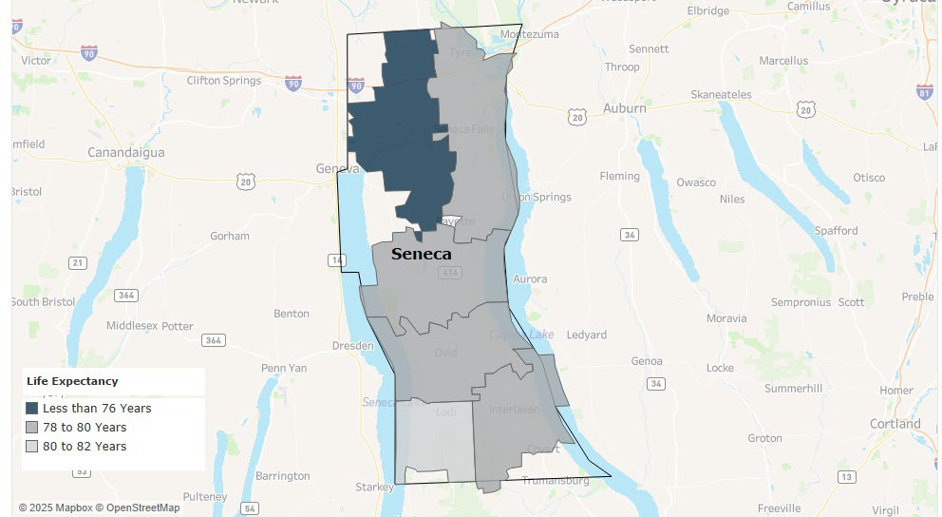
Source: NYS Vital Statistics; US Census Bureau County Population Estimates and Claritas ZIP Level Estimates; Years 2018-2022 Analysis and Calculations by Common Ground Helth (YPLLDeath Rate per 100k population and Life Expectancy

Leading Causes of Death (All Ages) | Leading Causes of Premature Death  (Before Age 75)
Heart Disease  (167.6/100,000 vs NYS 166.4)  Cancer  (155.8/100,000 vs NYS 137)  Top Cancers: Female Breast, Prostate, Lung  Alzheimer’s  (87.8 /100,000 vs NYS 61.65)  Death Rate:  (812.9/100,000 vs 744.2) | Cancer  (91.5/100,000 vs NYS 73.1)  Heart Disease  (50.8/100,000 vs 55.2)  Unintentional Injury  (36.7/100,000 vs NYS 46.9)  Premature Death Rate:  (369.6/100,000 vs NYS 326.8)
Source: NYS Vital Statistics

Emergency Department Visits and Potentially Preventable Hospitalizations
Increased numbers of visits to the Emergency Department (ED) can highlight shortfalls in access to outpatient, primary or preventive care, or in management of and education on chronic diseases.
Overall, ED visit rates continue to be higher in Seneca County compared with the NYS average, driven in part by rates of substance-use-related visits, while mental health related ED visits remain lower than the statewide average.

Maps S4 and S5 detail ED visits and preventable hospitalizations by zip code in Seneca County. Both indicate concentrations in the northern and southern areas of the county. Seneca County does not have a hospital in which residents may seek care. This may certainly impact how and when residents seek care for chronic and other conditions.

Map S4: ED Visit Rate by Zip Code
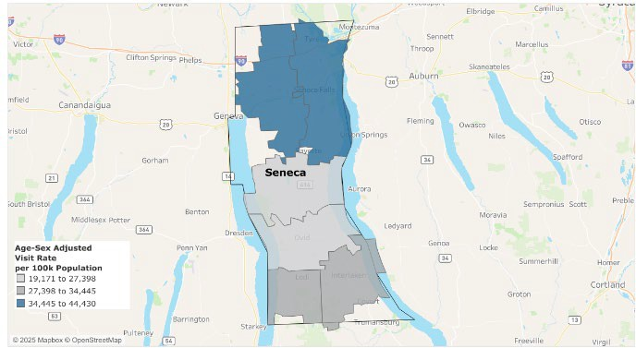
Source: SPARCS 2019-2023; Analysis by Common Ground Health
Map S5: Preventable Hospitalizations by Zip Code
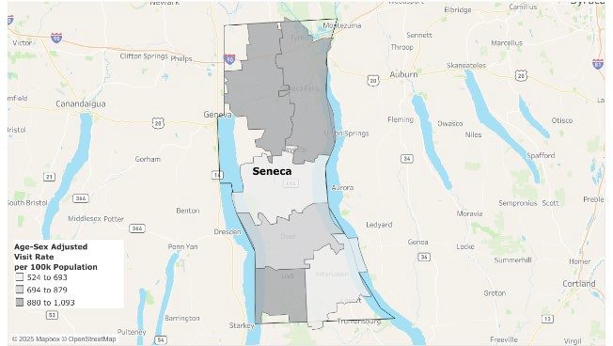
Source: SPARCS 2019-2023; Analysis by Common Ground Health

Table S3 highlights 2023 ED visits made by Seneca County residents compared to visits made by residents throughout NYS for speciﬁc conditions. Seneca County performs better than the NYS average in preventable hospitalizations for hypertension (64% lower) and the circulatory composite (9% lower). Although, several areas remain above the state averages: acute composite (10% higher), overall composite (9% higher), chronic composite (8% higher), respiratory composite (38% higher), and diabetes composite (6% higher).
Table S3: 2023 Emergency Department Visits and Preventable Hospitalizations

Issue | Seneca County Rate Per  100,000 | NYS Rate Per 100,000
All ED Visits | 38,723 | 29,809
Substance Use Disorder ED  Visits | 2,073 | 1,646
Intentional Self Harm ED Visits | 511 | 343
Preventable Hospitalizations  (Overall) | 885 | 808
Diabetes Composite | 193 | 181
Circulatory Composite | 286 | 312
Hypertension | 28 | 46
Acute Composite | 223 | 201
Chronic Composite | 662 | 607

Respiratory Composite | 183 | 114
Source: SPARCS 2023

County Health Rankings
Seneca County performs relatively well in terms of health and well-being, scoring higher than the national average and slightly higher than New York State average. Generally, this suggests that residents experience a better overall quality of life, including physical and mental health, day-to-day functioning, and the ability to participate in community life. Factors such as lower rates of poor physical or mental health days, stronger social support, or better self-reported health status may be contributing to this higher performance. (Figure S9)
However, when looking at community conditions and the Social Determinants of Health (Figure S10), the economic, social, and environmental factors that shape opportunities for health, the county scores are only slightly below the state average and align closely with national trends. This indicates that while residents report relatively strong well-being, some underlying structural conditions such as housing affordability, economic stability, transportation access, education levels, or neighborhood characteristics may be less favorable compared to other parts of New York State.

Figure S9: Health and Well-Being
Figure S10: Community Conditions

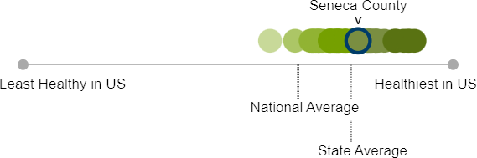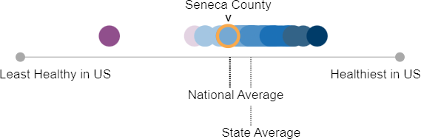

Health Challenges and Associated Risk Factors
Seneca County, like many rural areas in New York and across the U.S., faces unique challenges in health care access and support. The limited availability of primary care physicians, dentists, mental health providers, and other health services, can make it difficult for residents- especially those living in poverty to obtain timely care. Individuals who are underinsured or uninsured often delay preventive care and instead rely on the Emergency Department, contributing to higher health care costs and lost workdays, and a cycle that further reinforces economic hardship.
The absence of a hospital within the county further limits access to care. Long wait times, a shortage of providers, and limited awareness of available screenings, particularly among low-income or those with low-health-literacy, create additional barriers to care. Geographic distance

and minimal public transportation compound these challenges. Even insured residents may forgo care due to copays and deductibles, and older adults and lower-income residents are less likely to receive recommended screenings, contributing to higher rates of late-stage disease.
Residents continue to face challenges in securing safe, affordable housing and consistent access to healthy food. Supports like food pantries and mutual aid networks are valuable but not enough to overcome systemic barriers. While local, quality, affordable housing is limited, rising costs make it difficult for many families and individuals to remain in the community.
Residents report growing mental health concerns, driven by social isolation, economic stress, and limited access to providers. Youth face increased behavioral health risks linked to adverse childhood experiences, lack of mental health support and exposure to substance use. The cost of mental health appointments is a barrier and the impact of these challenges extend across the community including schools, families and workplaces. Mental health challenges are tied to environmental and economic strain. Although the county beneﬁts from valued assets like faith-based supports, school counselors, libraries, and 24/7 crisis response services, long-term mental health care remains limited, difficult to access, and fragmented.
Poorly maintained or hazardous sidewalks, along with unclear responsibility for repairs, contribute to falls/injuries, particularly for seniors and residents with disabilities. Some outdoor spaces are perceived as unsafe due to substance use, insufficient supervision and poor lighting. Uneven infrastructure also limits access to exercise and recreation. Concerns include the unsafe operation of motorized mobility chairs on roadways instead of designated pathways.
Low-income families, seniors, the disabled, young people, individuals without reliable transportation, and with limited access to healthy foods, or affordable housing face compounding barriers. These economic, geographic and systemic challenges continue to restrict their ability to achieve and maintain optimal health.

Behavioral Risk Factors and Health Disparities
Seneca County faces a range of interconnected health challenges shaped by social, economic, environmental, and healthcare access factors. While many indicators show progress, persistent gaps continue to affect residents’ ability to achieve and maintain optimal health.
Economic instability remains a signiﬁcant barrier for many households, especially those with children and household incomes well below the state average. Limited economic opportunity contributes to ongoing barriers such as housing instability, transportation challenges and nutrition insecurity, all of which directly affect health outcomes.
Access to healthcare is another major concern. The county has far fewer primary care physicians, dentists, and mental health providers than state averages, making it difficult for residents to receive timely preventive care. Screening rates for several chronic conditions have declined, and hypertension prevalence has increased. Oral health disparities are especially stark among Medicaid enrollees, where dental and preventive visit rates have fallen sharply.

Maternal and child health indicators show mixed results. Prenatal risk behaviors -such as smoking and alcohol use have improved. Immunization and leading rates among children highlight room for improvement and access to pediatric dental care remains limited.
Physical activity and transportation barriers also contribute to health risks. Access to recreation facilities has declined, walkability remains low, and nearly one-quarter of adults report no leisure-time physical activity. Limited vehicle access and long travel distances, particularly in rural areas, further restrict residents’ ability to reach healthcare services, grocery stores, safe activity spaces, and community resources.
Injuries and violence remain important areas of concern in Seneca County. While unintentional injury deaths have decreased overall, ﬁrearm-related deaths, suicide rates, and violent crime rates exceed state averages. Alcohol-related driving deaths, though improved, remain slightly above the state rate.
Nutrition and food access continue to challenge community well-being. Although the Food Environment Index has improved over time, the loss of a local grocery store combined with ongoing rural access issues has increased risks for worsening nutrition security across the county.
Finally, broader community conditions and social determinants of health, such as housing instability, transportation barriers, concentrated poverty, and pockets of high social vulnerability, continue to inﬂuence health inequities. Seneca County’s Social Vulnerability Index has risen, indicating greater risk during emergencies or periods of community stress.

Community Assets and Resources

Seneca County has a long-standing reputation of collaboration and coordination among its many and varied partners. The county also engages with two agencies that promote and facilitate collaboration: Pivital Public Health Partnership and Common Ground Health. Pivital is a partnership of eight rural health departments in the Finger Lakes Region that focuses on improving the health and well-being of Finger Lakes residents. Common Ground Health covers the same geographic footprint, with the addition of Monroe County, and works to bring leaders from all sectors together to collaborate on strategies for improving health in the region. Both agencies provide support, collaboration opportunities, and resources to improve the health of Seneca County residents.
Up to 72% of partners can dedicate staff to cross-organization initiatives and health improvement activities. 86% of partners provide services meeting immediate health or social needs, such as, food distribution, transportation and case management. Meeting/physical spaces, trusted sites like libraries, schools, churches and parks are widely used by partners for service delivery and outreach and all partners use social media to share information. Most partners employ diverse communication channels (external/internal newsletters, media, in-person education) to share information and support the community in addressing health concerns. 72% of partners cite

collaboration as a top priority for maximizing impact and reducing program duplication and many have long-standing relationships with communities most impacted by poverty, health inequity, and social isolation.

Priority Areas
To collaboratively address the three priority areas that will be outlined within the Community Health Improvement Plan (CHIP), existing and needed resources have been identiﬁed.
To address Nutrition Security, Seneca County will leverage the existing relationships with the following community partners: Women's Leadership Council, United Way of Seneca County, UR Medicine Finger Lakes Health, Seneca County School Districts, Seneca County Department of Social Services (DSS), STEPS, OFA, Pivital Public Health Partnership, Northeast College, Cornell Cooperative Extension, WIC / Society for Protection and Care of Children (SPCC). Additional community resources that can assist were identiﬁed are Food Pantries, Foodlink, Libraries, Faith Based Communities/Churches, Community Gardens and Farmers Markets.
To address Primary Prevention, Substance Misuse, and Overdose Prevention, Seneca County can leverage the existing relationships with the following partners: Tobacco Action Coalition of the Finger Lakes (TACFL), Women's Leadership Council, United Way of Seneca County, UR Medicine Finger Lakes Health, Seneca County School Districts, Seneca County Community Counseling Center, Seneca County Workforce/Youth Bureau, Seneca County Department of Social Services (DSS), STEPS, OFA, Pivital, Northeast College, Cornell Cooperative Extension, FLACRA, Law Enforcement, North Seneca/South Seneca Ambulance, Child and Family Resources, and WIC. Other identiﬁed community resources to assist with this priority area are Wayne Finger Lakes Boces/Health Center, Libraries, Regional Transit Service (RTS), Safe Harbours, and the Alzheimer’s Association.
To address Healthy Children Preventive Services, Seneca County can mobilize resources through the following partners: United Way of Seneca County, UR Medicine Finger Lakes Health, STEPS, Pivital Public Health Partnership, Seneca County Workforce/Youth Bureau, Cornell Cooperative Extension, Seneca County School Districts, Board of Health, Finger Lakes Community
Health, Children and Family Resources and WIC. Noted resources that can be leveraged under this priority area are Seneca County Code Enforcement, Libraries, Child Care Centers/Head Start and Community Centers.

