Yates County

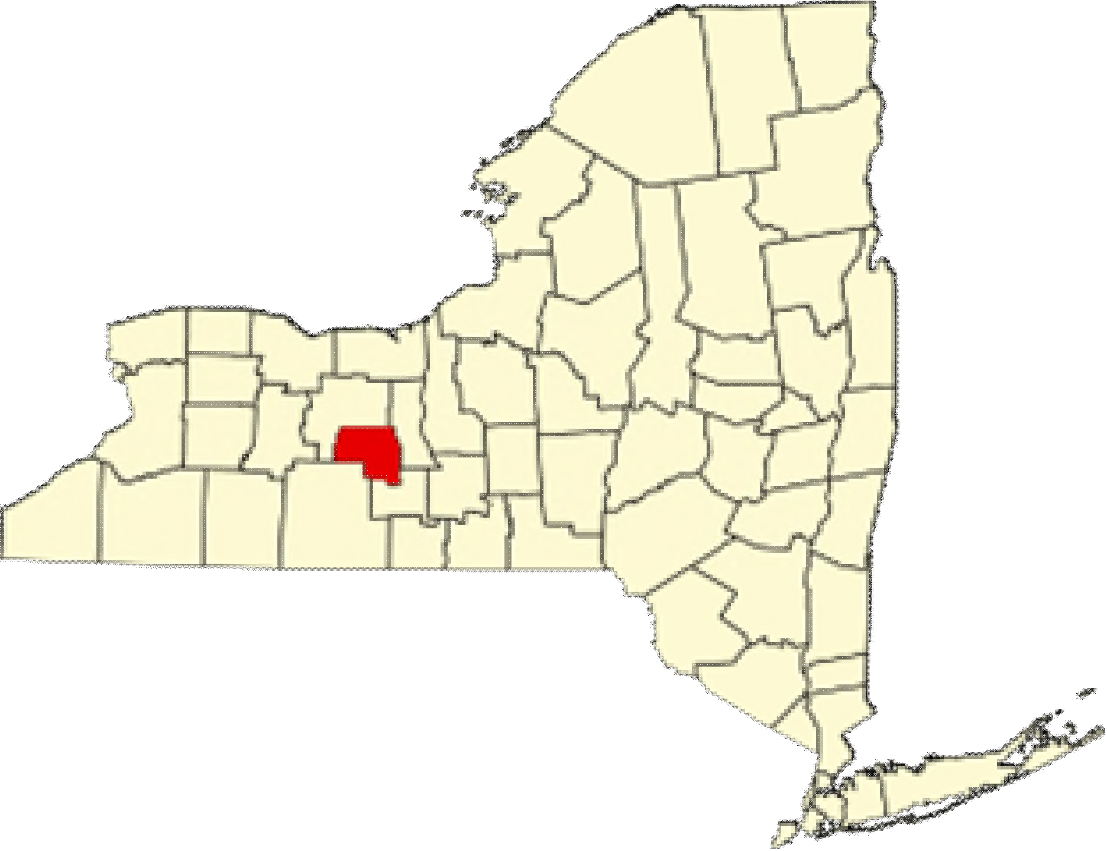
Yates County Public Health Alyssa Broome-Quissimisse Director of Public Health
Alyssa.Quissimisse@yatescountyny.gov 315-536-5160

UR Medicine Finger Lakes Health Soldiers and Sailors Memorial Hospital
Kimberly Ilacqua
Vice President, Community Services
Execufive Director, Finger Lakes Health Foundafion
Kimberly.Ilacqua@ﬂhealth.org
315-787-4053

Pivital Public Health Partnership
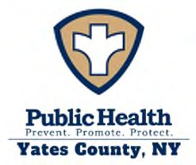
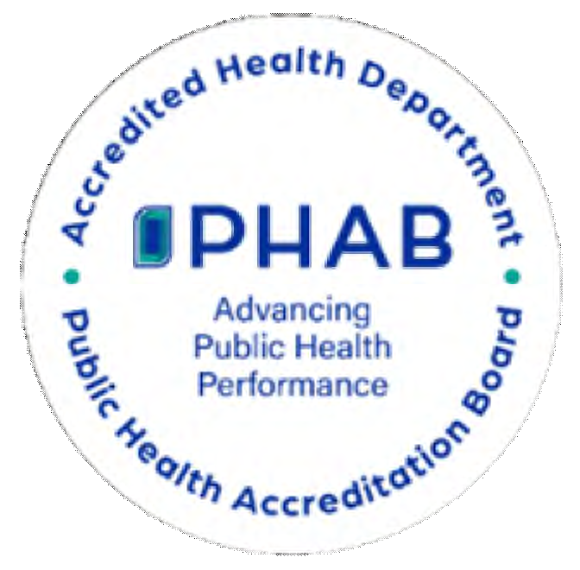
Michele Foster Execufive Director MFoster@pivitalphp.org
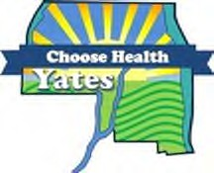
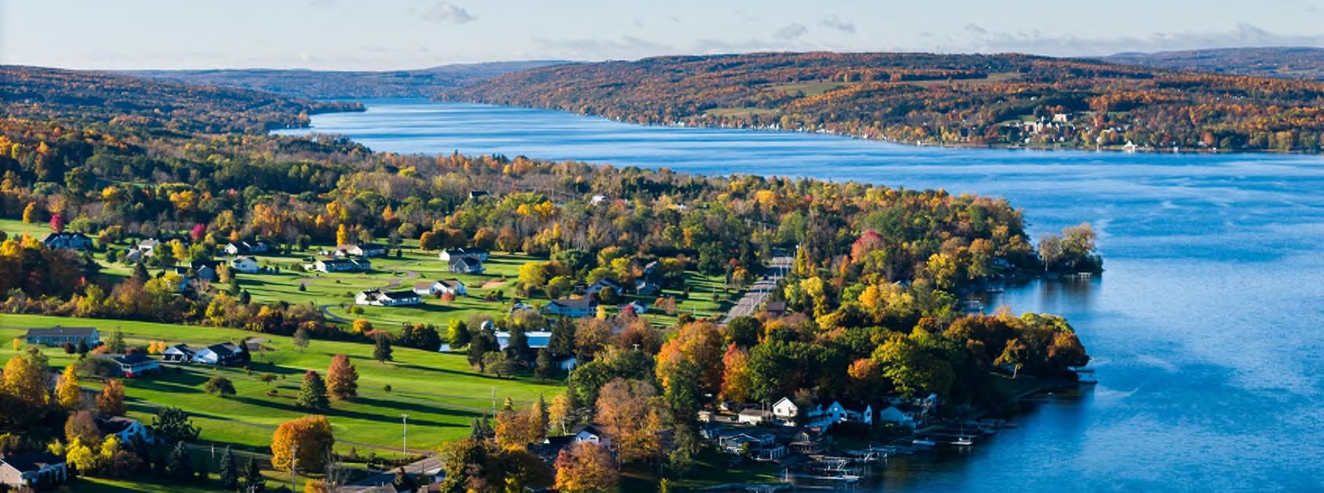

Courtesy of Yates County Chamber of Commerce

Table of Contents

Execufive Summary 69
Community Descripfion | 71
Service Area | 71
Demographic Summary | 71
Health Status Descripfion | 76
Speciﬁc Methodology | 76
County Health Rankings | 78
NYS Prevenfion Agenda | 79
Priority Areas | 103
Community Assets and Resources | 104
Appendix 1: Parficipafing Partners and Community Representafion | 107
List of Tables:
Table Y1: Causes of Death | 75
Table Y2: NYS Prevenfion Agenda 2025-2030 Domains and Priorifies | 79
Table Y3: Rates of Age-Adjusted Causes of Death | 93
Table Y4: Emergency Department Visits | 95
Table Y5: 4:3:1:3:3:1:4 Schedule | 99
Table Y6: Enrolled School-Age Populafion | 101
Table Y7: County Resources to Accomplish CHA/CHIP Goals | 105
List of Maps:
Map Y1: Populafion Density in Yates County | 72
Map Y2: Overall Poverty Rate in Yates County | 81
Map Y3: Food Insecurity Rate | 82
Map Y4: Poor Mental Health Days | 86
Map Y5: ED Visit Rate by Zip Code | 94
Map Y6: Preventable Hospitalizafions by Zip Code | 94
List of Figures:
Figure Y1: Populafion Projecfions in Yates County | 72
Figure Y2: Populafion by Age and Sex | 73
Figure Y3: County Health Rankings Health and Well-Being | 78
Figure Y4: County Health Rankings Community Condifions/SDOH | 78
Figure Y5: Unemployment Rate | 81
Figure Y6: Residents to Healthcare Provider Rafio | 96
Figure Y7: Immunizafion Rates 2025 | 99
Figure Y8: Prevenfive Services – Lead Screening | 100

Execufive Summary

Yates County has idenfiﬁed three priority areas for this Community Health Assessment (CHA). They are:
- Housing Stability and Aﬀordability
- Prevenfive Services for Chronic Disease Prevenfion and Control
- Anxiety and Stress

Data Sources
Yates County’s CHA incorporated a blend of quanfitafive and qualitafive data sources, including secondary data from the New York State Behavioral Risk Factor Surveillance System, County Health Rankings and Roadmaps, the Nafional Center for Health Stafisfics, the American Community Survey, the
U.S. Census, the NYS Medicaid Program, and local performance reports.

Partners and Roles
The Choose Health Yates Commiftee was integral in the development of the CHA, along with the parficipafing partners and community representafion listed in Appendix 1. Yates County community members were invited to aftend the Choose Health Yates meefings through local radio announcements and meefing dates published on the local health department’s website. During the CHA development, Choose Health Yates met regularly to develop and integrate informafion collected through use of the MAPP 2.0 framework.
Valuable organizafional data and community insights were compiled to create a comprehensive county proﬁle. Gathering this informafion was completed using three assessments: the Community Partner Assessment (CPA), Community Context Assessment (CCA), and Community Status Assessment (CSA).
Throughout the process, partners and community members parficipated in regular Choose Health Yates meefings where ﬁndings from the assessments menfioned above were presented. These sessions encouraged quesfions, feedback, and shared interpretafion of the data. The full commiftee collaborafively reviewed and discussed the triangulated results of all three assessments, allowing partners to validate ﬁndings and idenfify key health themes, leading to the selecfion of priorifies.

Summary of Findings
Yates County faces a complex mix of social, economic, and health challenges that inﬂuence the overall well-being of its residents. Poverty has increased to 14.1%, with the highest concentrafions in the southern part of the county, and older adults have experienced a parficularly sharp rise in ﬁnancial hardship. Median household income remains below the state average, and while unemployment is relafively low, wages are not keeping pace with the cost of living, creafing economic stress for many families. Even though homeownership rates are high compared to NYS, households have experienced 1 of 4 housing problems (overcrowding, high housing costs, and/or lack of kitchen or plumbing facilifies) at higher rates since 2020. Nutrifion security appears stable, with most residents having access to healthy food, but gaps in physical acfivity opportunifies, walkable spaces, and community amenifies highlight barriers to healthy lifestyles.

Mental health is a growing concern. Rates of adults reporfing poor mental health and depression, along with elevated suicide rates, exceed state averages, signaling rising stress, anxiety, and unmet behavioral health needs. Substance use and overdose trends have decreased, along with the percentage of adults who are current smokers.
Access to healthcare is strained by provider shortages, geographic barriers, and declining insurance coverage for adults and children. Prevenfive care indicators, including screenings, dental care, immunizafions, and lead tesfing, show lower complefion rates among Medicaid enrollees and low-income populafions.
High school complefion and post-secondary enrollment lag state averages, and the four-year graduafion rate is lower than the state average. School funding gaps have slightly worsened, limifing resources and programming that support student success. However, students who are economically disadvantaged have shown a promising upward trend in graduafion rates. Civic engagement and social cohesion are moderate, with relafively strong organizafional parficipafion and voter turnout, but social vulnerability remains elevated, parficularly for those facing economic, transportafion, or housing barriers.

Intervenfions, Strategies, and Disparifies
Yates County residents who are older adults, children, of low-income status, and live with a mental health and/or substance use disorder face the greatest health disparifies. Yates County Public Health has chosen to submit the Community Health Improvement Plan (CHIP) for June 2026 where more informafion about speciﬁc health disparifies will be included. Choose Health Yates and the local hospital, Soldiers and Sailors Memorial Hospital, will confinue to work collaborafively in selecfing the objecfives and intervenfions for the chosen priorifies.

Measures and Evaluafion
Choose Health Yates confinues to meet regularly to improve the health of Yates residents and to oversee CHIP implementafion. Aftendees at these meefings will roufinely review the progress of the chosen priorifies, objecfives, and intervenfions. Once the intervenfions have been selected, group members will idenfify and implement mid-course correcfions to intervenfions and processes. These meefings will serve as confinued program evaluafion and a means to keep the community and partners apprised of the CHIP progress.

Community Descripfion

Service Area
Yates County is a small, predominantly rural county located in the Finger Lakes region of New York State, covering approximately 376 square miles. The service area encompasses a mix of village centers, lakeside communifies, and widely dispersed agricultural areas. With one of the smallest populafions in the state, the county is characterized by low populafion density, limited public transportafion, and long travel distances to healthcare and social services. The community includes a growing older-adult populafion, families living in or near poverty, and several culturally disfinct groups, including a sizable Amish and Mennonite populafion whose health needs, access pafterns, and service ufilizafion diﬀer from the general populafion.
Healthcare services within the county are provided primarily by a small number of clinics, primary care pracfices, and one crifical access hospital, with many residents traveling outside the county for specialty care, behavioral health services, and advanced medical treatment. Economic condifions, geographic isolafion, seasonal employment, and transportafion barriers all shape the community’s health needs and inﬂuence how residents access care.
Overall, the Yates County service area reﬂects the unique challenges and strengths of a rural community—fight-knit and resourceful, yet facing persistent barriers related to access, aﬀordability, and availability of healthcare and support services.

Demographic Summary
Demographic informafion is essenfial in public and community health as it idenfiﬁes who lives in a community, how their needs diﬀer, and where health disparifies exist. By understanding factors such as age, race, income, educafion, and poverty, organizafions can target resources, design eﬀecfive programs, and allocate funding where it will have the greatest impact. Demographic data provides the foundafion for equitable planning, informed decision-making, and improved health outcomes for all community members.

Populafion
Yates County is in the heart of the Finger Lakes Region and is bordered by Steuben, Seneca, Ontario, and Schuyler counfies. While Yates County includes parts of Canandaigua Lake and Seneca Lake, it is home to the popular Keuka Lake. The beaufiful scenery, agriculture, and recreafional water acfivifies make it an ideal vacafion spot for tourists from April to October. There are 24,774 residents across Yates County, with the densest populafion areas in Penn Yan and Dundee, as shown in Map Y1. The county is considered very rural, with 68.6% of residents living outside populafion-dense areas.³¹ The populafion of Yates County is expected to hold relafively steady over the next decade before increasing. (Figure Y1)

Map Y1: Populafion Density of Yates County
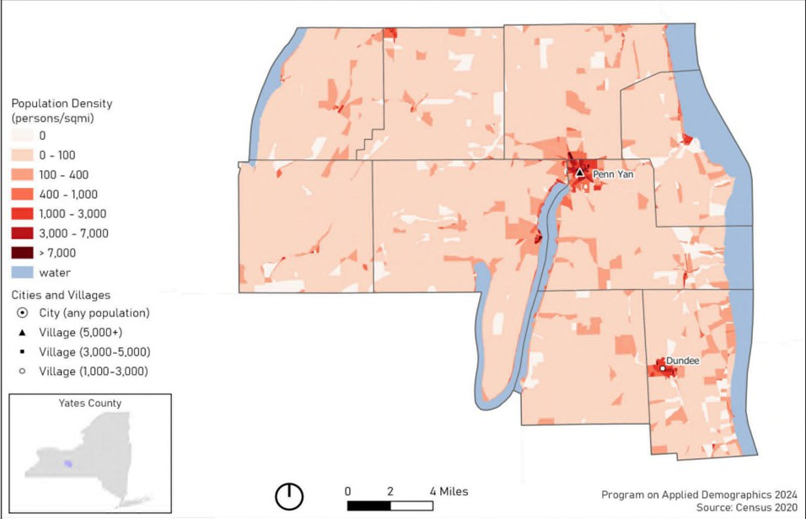
Source: Cornell Program on Applied Demographics 2024; US Census 2020

Figure Y1: Populafion Projecfions- Yates County
Population Projections - Yates County
25,100

25,000

24,900

24,800

24,700

24,600

24,500
Source: Cornell Program on Applied Demographics

³¹ Source: County Health Rankings, U.S. Census

Age and Sex
To befter understand health needs, it is important to know the sex and age make-up of a community. Figure Y2 shows the number of county residents by sex and age. The median age in Yates County is 41.6 years, with one larger populafion group aged 50-79. Sex is relafively evenly split, with females accounfing for 50.7% of the populafion. Individuals idenfifying as LGBTQ+ account for 5.8% of the populafion.
Youth (below 18 years of age) represent 22.7% of the populafion. However, 21.9% of the populafion is 65 years of age or older, with the largest age group of the older populafion being 65 to 74 years old, represenfing 13.4% of the total populafion. Aging populafions often require the ufilizafion of more health services, adding further strain to health infrastructure.

Race and Ethnicity

Figure Y2: Populafion by Age and Sex
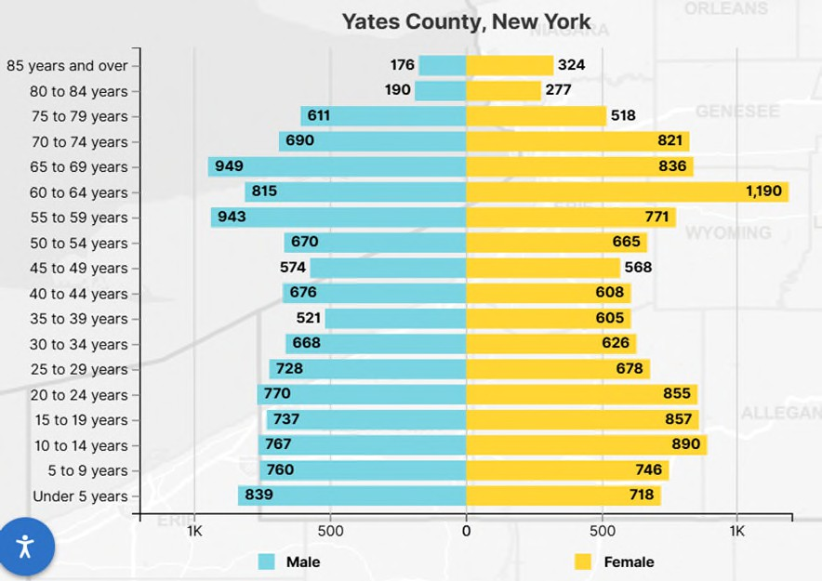
Source: U.S. Census 2020

Census data for Yates County indicate a largely white (93%) populafion followed by Hispanic or Lafino (2.6%), Black or African American (0.7%), Asian (0.3%), and American Indian or Alaska Nafive (0.1%). The regional secfion of this CHA denotes addifional populafion considerafions, including Amish/Mennonite and migrant farmworkers.
There is a large Mennonite community who reside in Yates County. The Groﬀdale Mennonites, commonly known as Horse-and-Buggy Mennonites, seftled in Yates County around 1974, coming from Lancaster County, Pennsylvania. The 2025 Old Groﬀdale and Midwest Horse and Buggy maps show that there are approximately 877 Mennonite households across Ontario, Schuyler, Steuben, and Yates Counfies, with the largest number residing in Yates County. Since 2022, the number of horse-and-buggy households has increased by 97. However, since their seftlement, Mennonites confinued to diversify into Driving Mennonites, expanding households even further around the Finger Lakes Region.
Mennonites make a signiﬁcant contribufion to Yates County’s agriculture and economy. Addifionally, it is important to note the cultural implicafions the populafion can have on local data, such as vaccinafion rates, uninsured rates, prenatal care, educafional aftainment, and unintenfional injuries (e.g.., motor vehicle and farm accidents). The Mennonite community often resorts to homeopathic medicine and relies on experienced community members for health care. Community organizafions and partners collaborate to host inclusive events that integrate Mennonite beliefs and values with evidence-based pracfices, providing the best opportunifies for meaningful learning.

Veterans and People with Disabilifies
Veterans often have disfinct health needs, including higher rates of chronic condifions, mental health challenges, and service-related injuries. The Veteran populafion of Yates County accounts for 7.2% of the total populafion, which is higher than the NYS average (3.9%).³² Of that number 94% are male, and 6% are female.
People with disabilifies may face heightened barriers to care, transportafion, employment, housing, and healthy living. There are approximately 11.1% of the Yates County populafion who live with a disability. Comparafively, there is about 13.5% of the New York State populafion that lives with a disability. The most common disabilifies are cognifive, independent living, and ambulatory diﬃculty.

Language Spoken at Home
In Yates County, according to the U.S. Census, 16.8% of people speak a language other than English at home. This includes: 1.6% who speak Spanish; 14.5% who speak Indo-European languages; 0.8% who speak Asian and Paciﬁc Island languages; and 0.2% percent who speak other languages. The notable share of Indo-European language speakers is likely inﬂuenced by the presence of Amish and Mennonite communifies. Providing language assistance in health care improves the quality of care for all populafions with limited English proﬁciency, thereby opfimizing overall health literacy.

Leading Cause of Death and Life Expectancy
The average number of years a person in Yates County may expect to live is 78.1³³, with variafion throughout the county as seen in Map Y2. This number is lower than the state average of 80.4, but greater than the nafional average of 77.6.³⁴Life expectancy in Yates County is greater than three of its confingent counfies (Steuben 76.6, Seneca 77.5, and Schuyler 75.8) and lower than only the remaining confingent county of Ontario (79.6)^{33.} Life expectancy in Yates County has remained relafively stable since 2018.
Per NYSDOH 2025 data, the leading causes of death in Yates County are cancer, heart disease, and unintenfional injury, respecfively. The leading causes of cancer in the county include prostate, female breast, and lung cancers. At the state level, the leading causes of death are heart disease, cancer and COVID-19. The leading causes of premature death (before age 75) in Yates County are cancer, heart disease, and unintenfional injury, reﬂecfing state trends. The death rates for each indicator are noted in Tables Y1a and Y1b, along with NYS ﬁgures.
The total deaths per 100,000 Yates County residents exceed state rates for both overall death (839.3 vs 679.6 per 100,000) and premature death (334.4 vs 309.3 per 100,000). This is largely due to a substanfial increase in unintenfional injury deaths. At the state level, unintenfional injury accounts for 50.6 per 100,000 deaths and is the fourth leading cause of death. In Yates County, this rises to 86.8 per 100,000 and is the third leading cause of death. Rates of premature death due to unintenfional injury show a

³² Source: U.S. Census, 2023

³⁴ Source: County Health Rankings

similar trend. Statewide, unintenfional injury accounts for 44.8 premature deaths per 100,000 while in
Yates County this ﬁgure jumps to 70.4 per 100,000.
Table Y1a: Causes of Death (measured per 100,000 populafion)

Cause of Death | All Ages, Age-Sex Adjusted Yates  County | All Ages – NYS excluding NYC
Cancer | 142.6 | 129.23
Heart Disease | 141.1 | 159.82
Unintenfional Injury | 86.8 | 50.6
Death Rate | 814.47 | 679.6
Source for Age-Sex Adjusted Leading Causes of Death: Source: NYS DOH Vital Stafisfics, 2022.Analysis by Common Ground Health

Table Y1b: Premature Causes of Death (Before age 75; measured per 100,000 populafion)

Cause of Death | Premature Death rate (Before age  75) Yates County | Premature Death rate (Before age 75) NYS  excluding NYC
Cancer | 61.4 | 67.1
Heart Disease | 46.0 | 57.4
Unintenfional Injury | 70.4 | 44.8
Death Rate | 334.4 | 309.3
Source for Premature Death Rates (before age 75): NYS Leading Causes of Death Dashboard.

Health Disparifies
Health disparifies are the preventable diﬀerences in health outcomes when compared to the overall populafion of an area. Yates County’s rural locafion presents signiﬁcant challenges to health outcomes and access to care. With the densest populafions near the villages of Penn Yan and Dundee, much of the county remains isolated, leaving many residents with limited access to physical and mental health care, inadequate health care infrastructure (e.g., provider shortages), low rates of physical acfivity, and restricted access to healthy food. Having limited availability to these resources can exacerbate chronic disease. Populafions living in rural areas have a higher risk of developing chronic disease when compared to urban counterparts. The county also has a large aging populafion, lower socioeconomic status, and many uninsured individuals who face greater barriers to achieving opfimal health.

Health Status Descripfion

Speciﬁc Methodology
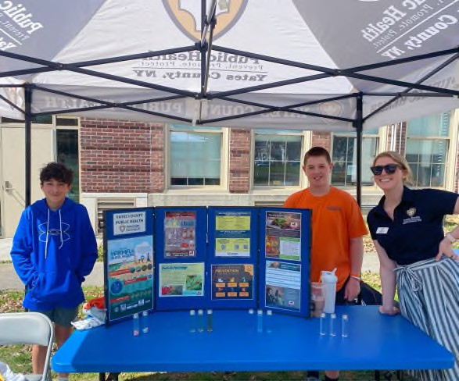
The CHA provides a comprehensive picture of a community’s current health status, including factors that contribute to health risks and challenges, and idenfiﬁes priority health needs by analyzing local data and community input.
Community members and key stakeholders were invited to be part of the CHA by parficipafing in the CHIP steering commiftee, known as Choose Health Yates. Choose Health Yates met monthly in 2025, except in January, May, July, and November.

Data Sources

Yates County’s CHA incorporated a blend of quanfitafive and qualitafive data sources, including secondary data from the NYS Behavioral Risk Factor Surveillance System (BRFSS), County Health Rankings and Roadmaps, the Nafional Center for Health Stafisfics, the American Community Survey, the U.S. Census, the NYS Medicaid Program, and local performance reports.

Penn Yan students, Wilson and Keegan, with Yates County Public Health Educator, Emily End, at the Future Farmers of America (FFA) ﬁeld day event at the Penn Yan Middle School.

Pivital Public Health Partnership assisted in the coordinafion, development, and distribufion of the assessments. The data collected from the assessments were used to tell the community’s story of overall health and well-being.
Community partners played a key role throughout the development of the CHA by complefing three
assessments:
- Community Partner Assessment (CPA): An evaluafion of collecfive community partner systems and capacifies to idenfify partners working in the areas of health inequifies.
- Community Status Assessment (CSA): A compilafion of quanfitafive data from the state and local level to idenfify trends related to the social determinants of health and systems of power and privilege.
- Community Context Assessment (CCA): A collecfion of community voices and qualitafive data to befter understand the lived experience and priorifies of those aﬀected by inequifies.

Community Engagement
Each assessment looked to gather diﬀerent informafion by targefing diﬀerent sectors of the community. The CPA was completed via an online survey plafform and distributed to approximately 22 members of

the Choose Health Yates commiftee in February 2025. The response rate was approximately 46%, and
the results were shared with the group to highlight partner strengths that could assist with the CHIP.
The second assessment, the CCA, was developed in March and conducted between April and May of 2025. During the CCA, a regional survey was developed and distributed to gather community feedback. The quesfions focused on the following categories provided by the MAPP 2.0 CCA assessment toolkit: overall health behaviors and outcomes, community strengths and assets, built environment, and forces of change. Choose Health Yates made it a priority to ensure disproporfionately aﬀected populafions were included in qualitafive data collecfion by choosing various engagement methods. Yates County Public Health, along with various other stakeholders, held focus groups, community dialogues, and interviews/discussions to collect qualitafive data. A total of 11 engagement sessions were conducted throughout the CCA process. Yates County Public Health did aftempt a PhotoVoice with the aging populafion, but due to low aftendance, the session was cancelled.
Overall, the engagement methods were a great success, yielding rich insight from diverse target populafions. Targeted populafions included: aging populafion, low-income neighborhoods, youth, incarcerated individuals, faith-based groups, agricultural workers, and Mennonites. Choose Health Yates methodically idenfiﬁed where these populafions were already meefing, and the agency conducfing the CCA asked to be invited to the gathering to conduct the assessment. The groups provided extensive construcfive feedback that painted a clear picture of community needs and exisfing strengths to build upon. Preliminary data from the CCA were shared at each monthly meefing with Choose Health Yates to gather input from commiftee members.
While the CCA was being conducted, Pivital Public Health Partnership completed the CSA. This was completed by compiling secondary data into scorecards stored in the performance management system, Clear Impact. The scorecards made data easily accessible and shareable among stakeholders and community members, helping review the overall health status of Yates County.
Throughout the assessments, the Choose Health Yates commiftee met regularly to present and discuss ﬁndings from all three assessments. These sessions encouraged quesfions, feedback, and shared interpretafion of the data. The full commiftee collaborafively reviewed and discussed the triangulated results, allowing partners to validate ﬁndings and contribute to idenfifying several cross-cufting themes. These themes included:
- Access to Care/Insurance Stability
- Opportunifies for Acfive Transportafion & Physical Acfivity
- Housing Stability & Aﬀordability
- Mental Wellbeing & Substance Use
- Injuries & Violence
- Opportunifies for Confinued Educafion
The cross-cufting themes were used to develop issue statements for each priority area. The issue statements were used to complete root cause analyses and create issue proﬁles for each health priority. Partners acfively parficipated in analyzing and reviewing these issue proﬁles. The group then completed a priorifizafion matrix process to reﬁne opfions further by systemafically comparing idenfiﬁed issues through selecfion, weighing, and applying a ranking criterion. The ranking criteria included: relevance to the community, magnitude or severity, impact on communifies aﬀected by inequifies, availability and

feasibility of solufions, and availability of resources. This process ensured that shared priorifies reﬂected both data and community voice. Yates County Public Health shared its priorifizafion matrix process with the Choose Health Yates commiftee, which consisted of small group community members.
The ﬁnal CHA will be made available to the public through several plafforms including posfing on the Yates County Public Health website, sharing infographics on social media (Facebook, Instagram), distribufion to the Yates County Legislature and community partners, and discussion on local radio (WFLR).

County Health Rankings
The County Health Rankings & Roadmaps program highlights diﬀerences in community health within and across communifies. This ranking system assesses several variables, including community condifions, populafion health and well-being, social and economic factors, and built environment.
Yates County is ranked above the nafional and state averages for health and well-being (Figure Y3). This measure reﬂects the overall quality of life and the ability to thrive within a community. Variables aﬀecfing physical, mental, spiritual, and social well-being are included in this measure. This ranking signals that Yates County is a community that supports its residents and provides the foundafion for living, growing, and succeeding.
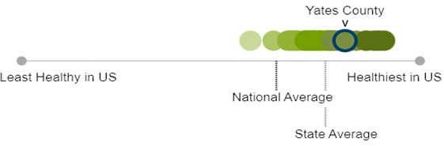
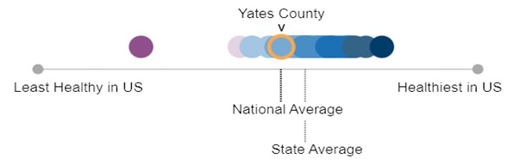
However, rankings of community condifions and the Social Determinants of Health fall below the state average and are roughly comparable to the nafional average (Figure Y4). The Social Determinants of Health refer to the non-medical factors that inﬂuence individual and community health outcomes, including economic stability; access to and quality of educafion; access to and quality of healthcare; neighborhood and built environment; and social and community context. This ranking signiﬁes that, despite the overall quality of life exceeding state and nafional
Figure Y3: Health and Well-Being (2025)

Source: County Health Rankings
Figure Y4: Community Condifions/SDOH (2025)

Source: County Health Rankings
averages, there is sfill work to be done to address underlying factors aﬀecfing community health outcomes.

New York State Prevenfion Agenda 2025-2030
Table Y2 idenfiﬁes the New York State Department of Health (NYSDOH) Prevenfion Agenda domains and priorifies (see Regional Chapter for further informafion). The “Community Partners” column shows the percentage of partners in the CPA who expressed that each domain is either very important or important to address, or who are unsure of its importance. Bolded priorifies are those Yates County has chosen to priorifize during this CHA cycle.
Table Y2: NYS Prevenfion Agenda

Domain | Priorifies | Community Partners
1. Economic Stability | Poverty | 80% very important  10% important  10% unsure
1. Economic Stability | Unemployment | 80% very important  10% important  10% unsure
1. Economic Stability | Nutrifion Security | 80% very important  10% important  10% unsure
1. Economic Stability | Housing Stability and Aﬀordability | 80% very important  10% important  10% unsure
2. Social and Community Context | Anxiety and Stress | 40% very important  40% important  20% unsure
2. Social and Community Context | Suicide | 40% very important  40% important  20% unsure
2. Social and Community Context | Depression | 40% very important  40% important  20% unsure
2. Social and Community Context | Primary Prevenfion, Substance Misuse, and  Overdose Prevenfion | 40% very important  40% important  20% unsure
2. Social and Community Context | Tobacco/ E-cigarefte Use | 40% very important  40% important  20% unsure
2. Social and Community Context | Alcohol Use | 40% very important  40% important  20% unsure
2. Social and Community Context | Adverse Childhood Experiences | 40% very important  40% important  20% unsure
2. Social and Community Context | Healthy Eafing | 40% very important  40% important  20% unsure
3. Neighborhood and Built Environment | Opportunifies for Acfive Transportafion and  Physical Acfivity | 40% very important  40% important  20% unsure
3. Neighborhood and Built Environment | Access to Community Services and Support | 40% very important  40% important  20% unsure
3. Neighborhood and Built Environment | Injuries and Violence | 40% very important  40% important  20% unsure
4. Health Care Access and Quality | Access to and Use of Prenatal Care | 50% very important  40% important  10% unsure
4. Health Care Access and Quality | Prevenfion of Infant and Maternal Mortality | 50% very important  40% important  10% unsure
4. Health Care Access and Quality | Prevenfive Services for Chronic Disease  Prevenfion and Control | 50% very important  40% important  10% unsure
4. Health Care Access and Quality | Oral Health Care | 50% very important  40% important  10% unsure
4. Health Care Access and Quality | Prevenfive Services | 50% very important  40% important  10% unsure
4. Health Care Access and Quality | Early Intervenfion | 50% very important  40% important  10% unsure
4. Health Care Access and Quality | Childhood Behavioral Health | 50% very important  40% important  10% unsure
5. Educafion Access and  Quality | Health and Wellness Promofing Schools | 60% very important  30% important  10% unsure
5. Educafion Access and  Quality | Opportunifies for Confinued Educafion | 60% very important  30% important  10% unsure

Domain: Economic Stability
Economic stability is inﬂuenced by each of the priorifies listed above: poverty, unemployment, nutrifion security, and housing stability and aﬀordability. Socioeconomic disparifies are closely linked to poor health, aﬀecfing physical, mental, and educafional outcomes. Children and older adults are especially vulnerable to these adverse eﬀects.
Unemployment and underemployment contribute to major health inequifies. Unemployed individuals
face greater barriers to health care and experience worsening health as unemployment persists. Employment challenges stem from shifts in the labor market, wage stagnafion, and weakening labor protecfions.
Food insecurity disproporfionately aﬀects low-income households, people with less educafion, and those who are unemployed. Access to aﬀordable, nutrifious food is vital for prevenfing chronic disease and supporfing healthy development. Many communifies, especially rural and low-income communifies, lack full-service grocery stores and rely on costly convenience outlets with limited healthy opfions.
Housing insecurity further undermines health by increasing stress, reducing stability, and increasing exposure to unsafe and/or unhealthy environments. Low-income families and older adults face the greatest housing burdens and associated health risks.

Priority: Poverty
Poverty can strain nearly every aspect of community life, from housing stability to healthcare access, transportafion, and nutrifious food. Families facing ﬁnancial hardship often struggle to meet basic needs, and limited resources can make it diﬃcult for them to ﬁnd sustainable pathways out of poverty.
Map Y2 shows the distribufion of poverty across Yates County. An esfimated 14.1% of residents live in poverty, with the highest concentrafions located in the southern part of the county, parficularly around Dundee, Himrod, and Dresden. Poverty levels in Yates County have been rising steadily since 2018, and by 2022, the county’s rate exceeded the statewide average. Among children under 18, 23% live in poverty, which is above the New York State average of 19% but an improvement from 26% in 2019. For adults age 65 and older, 12.5% live in poverty, just under the state average of 12.7%. However, the poverty rate for older adults has increased signiﬁcantly - up 51% since 2018.

Map Y2: Overall Poverty Rate in Yates County
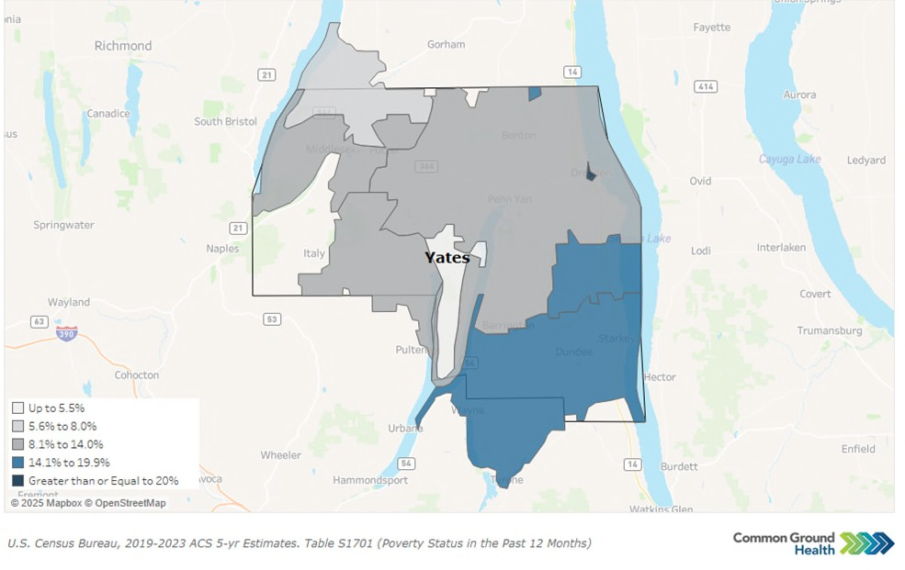

Priority: Unemployment

The unemployment rate in Yates County was 4.5% in April 2025. Figure Y5 notes the trend in unemployment rates recorded each January from 2019 to present.
According to US Census data from 2023, the top three employment sectors in Yates County are (1) educafional services, health care and social assistance (24.7%); (2)
manufacturing (14.5%); and
(3) retail trade (11.9%).
Figure Y5: Unemployment Rate in Yates County as reported in January of each year
6.00%
5.30%
4.80%
5.00%
4.30%
4.50%
4.00%
4.30%
4.00%
3.70%
3.00%

2.00%

1.00%

0.00%
2019
2020
2021
2022
2023
2024
2025
Source: Bureau of Labor Stafisfics

2023 U.S Census data indicate that the median household income in Yates County is $67,521, lower than the state median of $85,820. The gross hourly wage needed for a family of one adult and two children to cover household expenses gradually increased from $38.36 in 2021 to $51.14 in 2024. This ﬁgure

remains lower than the 2024 state value of $61.75 but higher than those of neighboring counfies,
Seneca, Steuben, and Schuyler.

Priority: Nutrifion Security
It is important to note the deﬁnifional diﬀerence between nutrifion and food security for data relevance. The New York State Prevenfion Agenda deﬁnes food security as having access to enough food. When a person reports they are food insecure, they recognize they have limited or uncertain access to food due to limited economic resources. Map Y3 shows the food insecurity rates of Yates and configuous counfies. On the other hand, nutrifion security looks not only at food access, but also at consistent and equitable access to healthy, safe, aﬀordable food. New York State has transifioned to focus on nutrifion insecurity data, but food insecurity data remains relevant to ensure equitable access of food exists across all parts of the state.
Nutrifion and food insecurity can lead to higher rates of chronic disease, poor child development, and overall diminished health and well-being. When families lack consistent access to aﬀordable and nutrifious food as well as community systems, such as healthcare and schools, they may feel the strain of long-term inequifies, resulfing in poorer health outcomes.

Approximately one in four adults (24.9%) in New York State experience food insecurity. Having access to aﬀordable, healthy food helps reduce hunger and prevent chronic disease.
Food and nutrifion security rates may be inﬂuenced by several factors, including income, employment, race/ethnicity, and disability.³⁶ Areas with higher poverty rates (Dundee, Himrod, and Dresden) will likely face greater challenges in accessing healthy, safe, and aﬀordable food.

Addifionally, children are disproporfionately impacted by food insecurity. Feeding America closely monitors annual food insecurity and food costs using real-fime data. In Yates County, approximately 950 children are food-insecure,

³⁶ Source: Healthy People 2030, 2025
Map Y3: Food Insecurity Rate
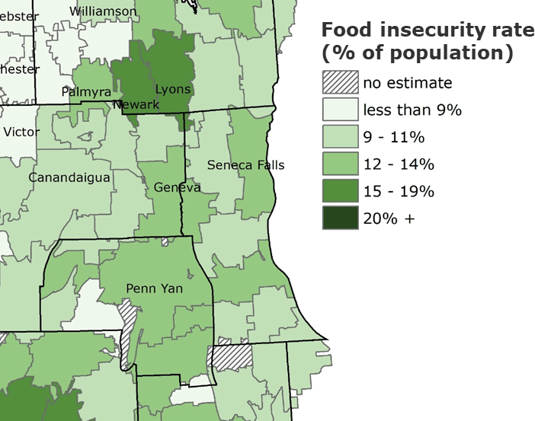
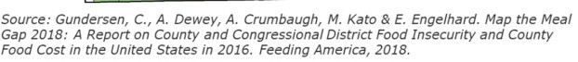

and the overall food insecurity rate for children is 16.9%, which is lower than the New York State rate of 19.0%.³⁷


Picture courtesy of Yates Chambers of Commerce of Windy Acres Farm Market
The Food Environment Index of the USDA Food Environment Atlas measures how easy it is for residents to access healthy, aﬀordable
food, combining rates of food insecurity and the percentage of low-income people living far from a grocery store.
Scores range from 0 (worst) to 10 (best). Yates County’s score decreased from 8.9 in 2018 to 8.8 in 2022 and
is nearly equal to the state average of
8.7. This indicates that, on average, residents face barriers to healthy food access similar to those elsewhere in the state.

Priority: Housing Stability and Aﬀordability
Housing was idenfiﬁed as a top priority aﬀecfing community stability, access to basic needs, and overall health and well-being in Yates County. Housing instability and a lack of aﬀordable opfions can leave families struggling to meet basic needs, often forcing them to choose between housing costs, food, and healthcare. When stable housing is out of reach, communifies experience higher rates of homelessness, overcrowding, and ﬁnancial stress, which can undermine overall health, safety, and economic growth.
In 2021, 13% of households in Yates County experienced at least one of the following major housing problems: overcrowding, high housing costs, and/or lack of kitchen or plumbing facilifies. This is well below the state average of 23% and reﬂects a 13% improvement since 2017. Severe housing cost burden has remained stable since 2021, with only 12% of households spending half or more of their income on housing, compared to 19% statewide. This represents an 8% improvement since 2019, when 13% of households were spending half or more of their income on housing. However, this progress is sfill concerning given that 14% of the populafion lives in poverty, leaving many households with very limited resources to meet basic needs beyond housing.³⁸
A recurring issue raised by focus groups was the increasing use of rental properfies for tourism, which drives up costs and reduces availability for residents. Homeownership rates in the county have decreased from 80% in 2019 to 77% in 2023, indicafing that fewer residents live in owner-occupied residences.³⁹ According to data from the 2023 American Community Survey 5-Year Esfimates, Yates County has a total of 13,143 housing units, of which 4,048 units are vacant. Vacant housing includes

³⁷ Source: Feeding America, 2023: hftps://map.feedingamerica.org/county/2023/child/new-york/county/yates
³⁸ Source: U.S. Census Bureau, 2025
³⁹ Source: County Health Rankings & Roadmaps, 2025

units with no occupants at the fime of the census, temporarily occupied residences such as short-term rentals and vacafion homes, and new units not yet occupied. As of 2025, Yates County has 615 short-term rental properfies (i.e., residences available for rent up to 30 days) registered with the Department of Finance. ⁴⁰
According to the American Community Survey 5-year Esfimates, the 2023 vacancy rates (deﬁned diﬀerently from the census) indicated the housing inventory available for long-term rent or sale were 2% for rental-occupied units and 1% for homeowner-occupied units. Concerns over a shortage of aﬀordable middle-income housing and reasonably priced rental properfies were also discussed in focus groups.
Approximately 26% of renter-occupied households contribute more than 35% of their household's gross income towards rent, indicafing a signiﬁcant cost burden for many residents. Furthermore, the average rent in Yates County was $802 in 2023, which was lower than in neighboring counfies. However, through discussions of lived experiences with focus groups, the cost of rent in 2025 is signiﬁcantly higher than that of 2023.
Residents also raised the issue of lack of local senior housing and assisted living opfions that support aging in place. According to the Pro Acfion Oﬃce for the Aging, Yates County is home to six independent living homes and three higher-level care facilifies for older adults. Admission to these facilifies often involves strict eligibility requirements and higher costs for individuals and families. The ALICE Household Monthly Survival Budget esfimates that a single senior needs $2,770/month to cover basic needs. New York State reports that the average cost of long-term care is between $5,500 and $13,000 per month, a signiﬁcant contrast to what most older adults can aﬀord.⁴¹ As a result, many local seniors are compelled to relocate to more suitable living arrangements elsewhere.
Focus group parficipants expressed a strong connecfion to their community and a desire to remain in Yates County as they age. However, barriers such as lack of in-home assistance, high costs, and transportafion challenges were noted as reasons older adults often seek alternafive living accommodafions. Aging in place is associated with individual and community beneﬁts, including improved life safisfacfion and increased volunteerism.⁴² With nearly a quarter of the populafion aged 65 and older, concerns about the availability of aging in place opfions are likely to grow in the coming years.
Economic Stability Domain Summary: The percent of people living in poverty in Yates County has shown a steady increase since 2018, rising from 11.4% (2018) to 14.1% (2023). This same upward trend in poverty rates can also be seen among populafions who are 65 and older in Yates County. Employment indicators are strong, with lower unemployment, however, the gross hourly wage needed to sustain a family of four remains below the median household income. Nutrifion security has improved, and the county’s overall food environment now aligns with the state average. Homeownership rates have declined, and signiﬁcant cost burdens persist, especially for vulnerable populafions like the aging and low-income residents.

⁴⁰ Source: Yates County Document Center: hftps://www.yatescountyny.gov/DocumentCenter/View/8733/Yates-County-Registered-STR-Properfies?bidId=
⁴¹ Source: New York State Department of Financial Services, 2023
⁴² Source: Rural Health Informafion Hub, 2019

Domain: Social and Community Context
Good mental health is essenfial for daily funcfioning, healthy relafionships, and resilience. Stress and anxiety can harm the body, contribute to condifions like depression and substance misuse, and increase the risk of early death.
Nafionally, suicide remains a major public health concern. Many high school students report suicidal thoughts or aftempts, and death by suicide is sfill a leading cause of death among young people nafionally.
Depression aﬀects more than one in ﬁve New Yorkers each year and signiﬁcantly disrupts daily life. Certain groups face higher risks due to chronic stress, trauma, and systemic inequifies. Many people sfill struggle to access or seek treatment because of sfigma or limited services.
Substance use and overdose deaths confinue to pose serious challenges in the state. Early alcohol and
drug use, high availability of substances, and social norms contribute to risk.
Commercial tobacco use remains a leading cause of preventable illness and death, with signiﬁcant disparifies driven by targeted markefing, especially in low-income and minority communifies. Excessive alcohol use is common and leads to thousands of deaths and billions of dollars in economic costs for New York State each year. Availability, low pricing, and targeted markefing contribute to unequal burdens among certain populafions.
Adverse childhood experiences (ACEs) are events in childhood, such as abuse or neglect, that negafively impact long-term health. These experiences signiﬁcantly increase the risk of chronic disease, mental health problems, and substance misuse later in life.
Healthy eafing is vital for prevenfing chronic disease, yet many New Yorkers fall short of fulﬁlling the
recommended intake of fruits, vegetables, and other nutrients.

Priority: Anxiety and Stress
Data from the BRFSS indicates that the percentage of adults reporfing 14 or more days of poor mental health per month (age-adjusted) increased from 14% in 2018 to 19% in 2022, above the NYS average of 16%. Experiencing 14 or more days of poor mental health in a month is strongly linked to worse overall health outcomes. When this percentage rises, as it has in Yates County, it can signal increasing stress, depression, or anxiety in the community, which may lead to higher rates of chronic disease, substance use, reduced producfivity, and greater demand for mental health and medical services.
When comparing Yates County to New York State as a whole and other counfies, Yates residents reportedly experience poor mental health at a greater rate (see Map Y4). According to County Health Rankings and Roadmaps, Yates County residents, on average, report 6.1 poor mental health days out of the last 30 days. Comparafively, surrounding counfies report only 5.7 poor mental health days out of the last 30. This elevated rate suggests that residents may struggle more with daily funcfioning, decision-

making, and maintaining healthy behaviors, ulfimately aﬀecfing both individual well-being and
community health.⁴³
Map Y4. Poor Mental Health Days in New York
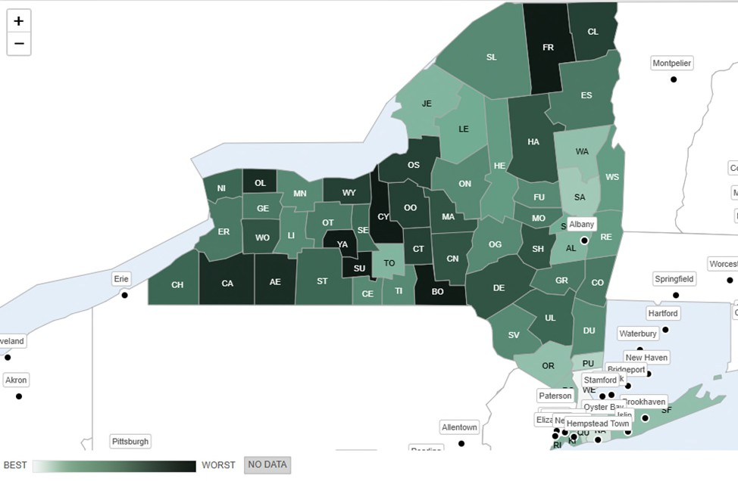
Source County Health Rankings and Roadmaps
Mental health was a common concern across all ages and backgrounds, with many focus group respondents cifing a range of compounding factors. Youth cited bullying and cyberbullying as key contributors, while older adults noted the rural community and social isolafion as important factors. A shortage of mental health providers and ongoing barriers to seeking help, especially for marginalized groups such as older adults and the LGBTQ+ community, were cited as cause for concern. Other suggested root causes include an increased focus on social media and technology, sfigma around receiving mental health care, and the eﬀect of the high cost of living on quality of life.
Residents value organizafions that facilitate social and personal connecfions, such as Pro Acfion Oﬃce for the Aging, community centers, health organizafions, churches, libraries, and The Living Well. Many focus group parficipants commented on the wide range of community supports available and expressed grafitude for their work in the community. Volunteerism and peer support are seen as vital for

⁴³ Source: Strine TW, Balluz L, Chapman DP, Moriarty DG, Owens M, Mokdad AH. Risk behaviors and healthcare coverage among adults by frequent mental distress status, 2001. Am J Prev Med. 2004 Apr;26(3):213-6. doi: 10.1016/j.amepre.2003.11.002. PMID: 15026100.

community outreach and engagement, with many residents expressing a desire for more opportunifies to connect with the various populafions of Yates County.
Despite recognizing opportunifies and a desire to grow community connecfions, isolafion remains a frequent theme, parficularly in the aging community. Beyond social connecfions, residents request more chances for mentorship and regular informafion sharing. There is a desire for more educafional programming on topics such as chronic disease prevenfion and resource awareness. Community members feel that implemenfing such programs may assist in bringing together the community and removing the sense of isolafion to befter support and improve the overall quality of life in the community.

Priority: Suicide
The Nafional Center for Health Stafisfics notes that in 2022 the suicide rate in the county was 15.0 per 100,000 people, nearly double the NYS average of 8 per 100,000 people. This represents a 36% increase in deaths due to suicide since 2018. In contrast, the suicide rate among youth (15-19 years of age) was
0.0 per 100,000 people in 2022, which is lower than the NYS average of 5.6 and has remained unchanged since 2015. The rate of youth suicide remains a bright spot, suggesfing strong protecfive factors and support systems for adolescents in the county. However, the substanfial increase in deaths due to suicide among adults indicates that expanded mental health resources are needed to befter support this populafion.
Rising suicide rates signal worsening mental health and increasing levels of stress, trauma, or unmet behavioral health needs in the community. When the county’s overall suicide rate exceeds the state average, it suggests that residents may face greater barriers to fimely mental health care, social support, or crisis intervenfion. Higher suicide rates also have wide-reaching impacts, causing strain to families, schools, healthcare systems, and communifies. It also potenfially indicates deeper issues such as isolafion, substance use, economic stress, or limited access to mental-health services.⁴⁴

Priority: Depression
In Yates County, the age-adjusted percentage of adults reporfing a depressive disorder in 2021 was 24.3%. This is greater than the NYS rate of 18.7% in the same year and has increased 40% since 2016. Elevated rates of depression are associated with increased risk of chronic diseases, substance use, social isolafion, and suicide, as well as greater demand for mental health services. When the county rate is both higher than the state's average and rising, it indicates that many residents may not be receiving adequate treatment or support, contribufing to long-term health disparifies and strain on local healthcare and social services.⁴⁵
Focus groups idenfiﬁed several root causes of high depression rates in the area. Insights suggested that decreased resiliency, increased reliance on social media and technology, and the lingering mental health impacts of the pandemic have all played signiﬁcant roles. Parficipants also idenfiﬁed broader societal inﬂuences, such as the sfigma around receiving care, the high cost of living, and career burnout, as

⁴⁴ Source: hftps://www.cdc.gov/suicide/facts/index.html
⁴⁵Source: Nafional Insfitute of Mental Health: hftps://www.nimh.nih.gov/health/publicafions/chronic-illness-
mental-health?utm_source=chatgpt.com

addifional inﬂuences on mental health. Focus groups did recognize that the screening process for mental health concerns has greatly improved, potenfially idenfifying a higher number of cases compared to the past. However, it was consistently noted that the infrastructure of mental health care is lacking in the area, contribufing to diﬃculty in receiving care when needed.
The community emphasized that expanding opportunifies for social support and community engagement would improve mental health across the county. It is also understood that geographic factors, such as the rural landscape of Yates County, can increase the risk of social isolafion and contribute to depression rates. Considering this, parficipants stressed the importance of pursuing creafive solufions that build on community strengths to befter support those experiencing mental distress.

Priority: Primary Prevenfion, Substance Misuse, and Overdose Prevenfion
Since 2021, there has been a sharp decrease in overdose deaths involving any drug in Yates County, decreasing from a crude rate of 20 deaths per 100,000 populafion in 2021 to 8.2 deaths per 100,000 in 2022. Yates County also has a lower overdose death rate compared to the Finger Lakes Region as a whole. Opioids, opioid pain relievers, and synthefic opioids other than methadone saw a dramafic decline in overdose deaths. However, overdoses involving cocaine in Yates County have increased from a zero crude rate per 100,000 populafion in 2020 to 8.2 in 2022. This data supports anecdotal informafion from the community regarding a recent shift to increased use of cocaine and methamphetamine.
Focus groups expressed concern about the connecfion between mental health and substance use, remarking that poor access to mental health providers in the area may aﬀect substance use rates. Individuals with lived experience noted the eﬀect that social isolafion has on substance use and mental health, adding that disciplinary acfions such as revoking driver’s licenses intensify feelings of isolafion. Yates County has one mental health provider for every 840 residents, more than three fimes the NYS rafio (260:1), indicafing that Yates County has roughly two-thirds fewer available providers than the state. According to the Substance Abuse and Mental Health Administrafion (SAMHSA), a diagnosis such as anxiety or depression increases an individual’s risk for substance use. With limited access to mental health support, Yates residents with exisfing mental health concerns may be at a higher risk of substance use than those in surrounding counfies.⁴⁶
The community recognized Yates County’s eﬀorts to address the opioid epidemic and the resulfing progress. Since 2023, the county has recorded 269 Naloxone training sessions, 798 individuals trained in Naloxone distribufion, and 495 Naloxone kits distributed. Despite the shifting trends in substance use, maintaining these inifiafives is vital to prevent opioid-related deaths. Furthermore, the growing use of sfimulants presents confinued risks as these substances may be contaminated with high-risk drugs such as fentanyl. People who use substances consequently remain vulnerable to opioid-related injury or death, regardless of the type of substance being used. Ongoing community educafion about overdose prevenfion and substance use risks is crifical in confinuing the posifive trends currently being experienced.

⁴⁶ Source: Substance Abuse and Mental Health Administrafion (SAMHSA)

Priority: Tobacco/E-cigarefte and Alcohol Use
According to data from the BRFSS, the percentage of adults who are current smokers (age-adjusted) has declined slightly since 2018 from 19% to 18% in 2022, which sfill remains above the New York State average of 12%. In contrast, the percentage of adults reporfing binge or heavy drinking quickly rose from 16% (2021) to 22% (2022), higher than the state average of 20%. Data on e-cigarefte use among adults in the county are not available, but rates of vaping by middle and high school students are available. In 2022, 3.9% of middle school students reported vaping within the last 30 days, and 5.3% of high school students reported that they vaped within the last 30 days.⁴⁷
Both smoking and excessive alcohol use are major risk factors for chronic diseases, including heart disease, cancer, liver disease, and respiratory illnesses. Higher rates of these behaviors in the community increase the burden on healthcare systems, contribute to preventable morbidity and mortality, and can reduce quality of life. Persistent smoking above the state average and rising binge or heavy drinking indicate that residents may face elevated long-term health risks and that targeted prevenfion and intervenfion eﬀorts are needed.⁴⁸

Priority: Adverse Childhood Experiences
Adverse Childhood Experiences (ACEs) are the emofional and physical circumstances one experiences before age 18. These may include neglect, sexual abuse, parental divorce, mental illness, and/or substance abuse in the home, and exposure to violence. ACEs impact individuals well into adulthood and may result in long-term physical and mental health problems. The age-adjusted percentage of adults with two or more adverse childhood experiences decreased from 29.4% in 2016 to 24.8% in 2021, below the current NYS average of 40.5%.
ACEs have long-lasfing eﬀects on physical, mental, and behavioral health. Experiencing two or more ACEs increases the risk of chronic diseases, mental health disorders, substance use, and social challenges well into adulthood. Even though the county’s rate of adults with two or more ACEs has decreased to 24.8%, this sfill represents a substanfial porfion of the populafion at higher risk for long-term health problems and increased healthcare and social service needs.⁴⁹

Priority: Healthy Eafing
From 2016 to 2021, the percentage of adults who eat fruits daily (63.4%) increased by 16%, and those who eat vegetables daily (70.2%) decreased by 4%.⁵⁰ An interesfing dichotomy arose in focus groups where some individuals stated it was diﬃcult to incorporate healthy eafing into their roufines, while others said it was very easy. Approximately 1 in 5 NYS adults consume at least one sugar-sweetened

⁴⁷ Source: Yates County Evalumetric Youth Survey Report, 2022
⁴⁸ Source: Kim Y. The eﬀects of smoking, alcohol consumpfion, obesity, and physical inacfivity on healthcare costs: a longitudinal cohort study. BMC Public Health. 2025 Mar 5;25(1):873. doi: 10.1186/s12889-025-22133-4. PMID: 40045251; PMCID: PMC11881326.
⁴⁹ Source: hftps://www.cdc.gov/aces/about/index.html
⁵⁰ Source: Behavior Risk Factor Surveillance System (BRFSS), 2021

beverage daily.⁵¹ In Yates County, the percentage of adults with annual incomes below $25,000 who drink one or more sugar-sweetened beverages has increased from 10.7% in 2016 to 17.1% in 2018.
Low consumpfion of fruits and vegetables and high intake of sugary drinks contribute to poor nutrifion, obesity, diabetes, heart disease, and other chronic condifions. Addressing sugar-sweetened beverage consumpfion is important because studies have found that frequently drinking these beverages is linked to weight gain, tooth decay and cavifies, heart disease, stroke, and type 2 diabetes in adults.⁵² When access to healthy foods is limited, especially for lower-income populafions, residents are more likely to develop diet-related illnesses, increasing healthcare costs and reducing overall community health and quality of life.⁵³
Social and Community Context Domain Summary: Yates County is experiencing signiﬁcant mental and behavioral health challenges. Rates of poor mental health, depression, and suicide all exceed state averages, signaling rising stress, untreated mental health needs, and growing demand for services.
Substance use concerns are also increasing, with sharp rises in overdose deaths involving non-opioid drugs, despite overall rates remaining below the New York State average. Risk behaviors such as smoking and heavy drinking confinue to contribute to preventable health problems, while mixed trends in healthy eafing and persistent impacts of adverse childhood experiences further underscore ongoing vulnerabilifies. Together, these indicators highlight mental health, substance use, and related social factors as crifical priorifies for improving community well-being.

Domain: Neighborhood and Built Environment
Regular physical acfivity oﬀers wide-ranging beneﬁts at every age. It lowers the risk of major chronic diseases, including heart disease, stroke, type 2 diabetes, and several cancers, and supports stronger bones and muscles, befter sleep, improved mental health, and longer life expectancy.
Access to physical acfivity is not equal. Structural barriers such as unsafe neighborhoods, limited accessible facilifies, or environments not designed for diverse needs shape how people can be acfive. Social factors like income, educafion, community support, and cultural aftitudes also inﬂuence acfivity levels. Physical environment features, including parks, safe sidewalks, bike lanes, and walkable neighborhood layouts, also play a major role.
Acfive transportafion, such as walking or biking, to reach daily desfinafions can help integrate physical acfivity into everyday roufines, but it requires safe, well-connected routes and nearby desfinafions.
Injuries are a leading cause of premature death. Motor vehicle crashes, falls, and overdoses are major contributors, with disparifies aﬀecfing racial and ethnic minorifies, older adults, and workers in high-risk occupafions.

Priority: Opportunifies for Acfive Transportafion and Physical Acfivity
Focus groups report mixed experiences related to community amenifies and social infrastructure supporfing health. As of 2024, the percentage of the populafion with adequate access to physical acfivity

⁵¹ Source: Behavior Risk Factor Surveillance System (BRFSS), 2021
⁵² Source: Behavior Risk Factor Surveillance System (BRFSS), 2021
⁵³ Source: hftps://www.cdc.gov/nutrifion/php/about/index.html

locafions is 44%. This has remained stable since 2022 but is well below the NYS average of 93%. Some residents praise the available nature trails and recreafional spaces for opportunifies to maintain health, while others cite a lack of such opportunifies in more rural areas. Many focus group respondents note that the Village of Penn Yan has adequate access to amenifies that promote health, such as the Yates Community Center. Parficipants also observed that agencies such as Yates County Public Health and the Yates Oﬃce for the Aging (OFA), administered by Pro Acfion of Steuben and Yates, Inc., provide ample support to the community as a whole.
However, these posifive experiences are not shared equally throughout the county. Many respondents comment on a lack of health-supporfing community amenifies and social opportunifies. One focus group parficipant noted that “if you live in Dundee...there is nothing to access inside where people can have a social network”. Several other community members supported the nofion that maintaining health outside of larger villages and towns is diﬃcult, parficularly in areas such as Branchport and Pofter, which “need more resources for health”. This is reﬂected in data from 2022, when 27% of adults reported no leisure-fime physical acfivity. This is slightly higher than the NYS average of 25% and an increase of 23% from 2021.⁵⁴ A frequently expressed suggesfion across mulfiple focus groups was the need for a community pool to help address gaps in health-promofing amenifies. The disparity between more populated areas and their more rural counterparts emphasizes an opportunity to support recreafion, social connecfion, and safety measures in less populated communifies.
In addifion to concerns about health-supporfing community amenifies, focus group members repeatedly noted a need for improvements to county-wide built infrastructure. ⁵⁵ Many neighborhoods lack accessible sidewalks, causing pedestrians to walk in the streets. This is reﬂected in a poor Walkability Index (3.67 out of 20).⁵⁶The Nafional Walkability Index accounts for the built environment’s eﬀect on the probability that a person will walk as a mode of transportafion and reﬂects street intersecfion density, proximity to transit stops, and land-use diversity.⁵⁷ The low walkability index in Yates County raises concern for the 13% of residents without access to a vehicle, who may face transportafion challenges.
Residents recognized improvements made, speciﬁcally in Dundee, but would like to see these projects
confinued.
Other concerns, such as speeding, poor signage, and unsafe roads, especially near playgrounds and schools, are widely noted. Road and sidewalk safety are compounded by increased traﬃc during the tourist season and horse-and-buggy use from the large Mennonite community. Many residents express the need for an allofted bike and/or horse and buggy lane to improve safety for all when traveling.
Overall, residents express a strong desire for traﬃc calming, befter signage, and safer pedestrian
environments.
Accessibility for those with mobility diﬀerences and the need for assisfive devices was raised as a concern. Residents noted accessibility is limited by a lack of ramps and safe infrastructure. Several anecdotes were shared about experiences with limited accessibility, especially in downtown Penn Yan. Limited accessibility is compounded by poor lighfing, poorly maintained sidewalks and roads, and a lack

⁵⁴ Sources: U.S. Census, County Health Rankings, EPA Oﬃce of Community Revitalizafion
⁵⁵ Source: EPA Oﬃce of Community Revitalizafion, 2021
⁵⁶ Source: Nafional Walkability Index Methodology and User Guide
⁵⁷ Source: EPA Oﬃce of Community Revitalizafion, 2021

of accessibility buftons for doors. Residents collecfively express a desire for safer, more inclusive, and befter lit areas for acfivity. Access to safe spaces for physical acfivity, transportafion opfions, and walkable environments directly aﬀects residents’ ability to maintain regular exercise. Low physical acfivity is linked to higher risks of obesity, heart disease, diabetes, mental health issues, and overall premature mortality. Limited walkability and inadequate access to acfivity locafions or transportafion can create barriers to healthy lifestyles, contribufing to long-term health disparifies in the community.⁵⁸

Priority: Access to Community Services and Support
The Social Vulnerability Index (SVI) is a composite measure reﬂecfing factors such as poverty, unemployment, housing, disability, minority status, and access to transportafion. It is used to idenfify communifies that may need addifional support during emergencies or public health intervenfions. SVI is measured from 0 to 1, with values closer to zero indicafing less vulnerability. Yates County’s SVI was 0.6066 as measured in 2022, indicafing moderate social vulnerability. This is an improvement from an SVI of 0.7377 in 2014, but a poorer score than the 2018 score of 0.4918. This ﬂuctuafion represents changes in the community, with recent progress in addressing underlying risk factors.
Civic engagement and strong community networks, such as high voter parficipafion and membership in organizafions, help build social cohesion, improve disaster preparedness, and support collecfive acfion during crises. Civic engagement may be measured as vofing, volunteering, and parficipafing in community events. The percentage of the vofing-age populafion who voted in the 2020 presidenfial elecfion was 56.2%. Per the Nafional County Health Rankings, Yates County has 11.9 membership organizafions per 10,000 people, represenfing civic, polifical, religious, sports, and professional organizafions.¹³
Examining the SVI and civic engagement together can help us predict how the community might respond to challenges, such as a disaster or emergency. A community with a higher SVI may face a greater risk of harm and slower recovery, while a community with strong civic engagement may have more community support to respond to the challenges. Yates County’s relafively low SVI and strong civic involvement suggest it has a solid foundafion to respond to community challenges, though vulnerabilifies sfill exist for certain populafions.⁵⁹

Priority: Injuries and Violence
Unintenfional injury death is the third leading cause of death in Yates County. Death resulting from firearms and motor vehicle crashes are above state rates and increasing. Overall, injury and violence-related deaths are a growing threat to community health and safety. Table Y3 details age-adjusted injury and violence death rates per 100,000 populafion.

⁵⁸ Source: hftps://www.who.int/news-room/fact-sheets/detail/physical-acfivity
⁵⁹ Source: County Health Rankings.

Table Y3. Rates of Age-Adjusted Cause of Death (measured per 100,000 populafion)

 | Incidence  Rate (2022) | % change from  2018 | Deﬁnifion
Unintenfional  Injury Death | 80.3 | +267% | Injury resulfing in death that are unplanned and often  preventable (i.e., poisonings, vehicle accidents,  drowning, ﬁres, farm equipment, falls, etc.)
Death due to  Firearms | 9 | No baseline data  available | Death caused by gunshot wound or penetrafing  injury from weapon that uses gun powder
Intenfional  Injury | 79 | +18% | Death caused by physical harm that was  inﬂicted purposefully
Deaths by  suicide (Age-adjusted) | 15 | + 36% | Death caused by injuring oneself with the intent to die
Death due to  Motor vehicle crash | 13 | +44% | Death resulfing from car accident upon impact  or death occurs within 30 days of accident

Rates above state averages and increasing trends indicate rising risk factors, such as unsafe environments, mental health challenges, substance use, and lack of safety intervenfions. High injury and violence-related death rates also strain healthcare systems, emergency services, and social support networks, highlighfing the need for targeted prevenfion, educafion, and community safety inifiafives.⁶⁰
Neighborhood and Built Environment Domain Summary: Residents in Yates County face limited access to physical acfivity spaces, low walkability, and moderate social vulnerability, creafing addifional barriers to healthy living. Although some indicators, such as reduced ACEs and stable youth suicide rates, show progress, the overall paftern highlights signiﬁcant and growing needs across mental health, substance use, injury prevenfion, and community support systems.

Domain: Health Care Access and Quality
Health care access and quality are crifical aspects of community health. Posifive health outcomes are inﬂuenced by access to health promofion and therapeufic intervenfions, which are often limited in rural areas. This includes access to primary care, specialists, and dental care.
Access to prenatal care and health of parents creates the foundafion for posifive health outcomes throughout life. Care is most eﬀecfive when inifiated early and maintained throughout pregnancy. Prenatal care reduces risks such as preterm birth, low birth weight, and maternal and infant mortality.
Roufine immunizafions and screenings help children stay healthy, yet access and uptake remain uneven due to systemic inequifies, transportafion barriers, and historical mistrust. In addifion, poor oral health impacts nutrifion, speech, social development, and overall well-being. Vulnerable populafions, including low-income communifies, face higher rates of untreated dental disease.

⁶⁰ Source: hftps://www.cdc.gov/injury/index.html

Emergency Department Visits and Potenfially Preventable Hospitalizafions
Maps Y5 and Y6 detail emergency department (ED) visits and preventable hospitalizafions (hospital admissions that could have been potenfially avoided with fimely and eﬀecfive outpafient care or disease management) by zip code in Yates County. Table Y4 highlights the diﬀerence in ED visits in Yates County compared with NYS.
Map Y5: ED Visit Rate by Zip Code
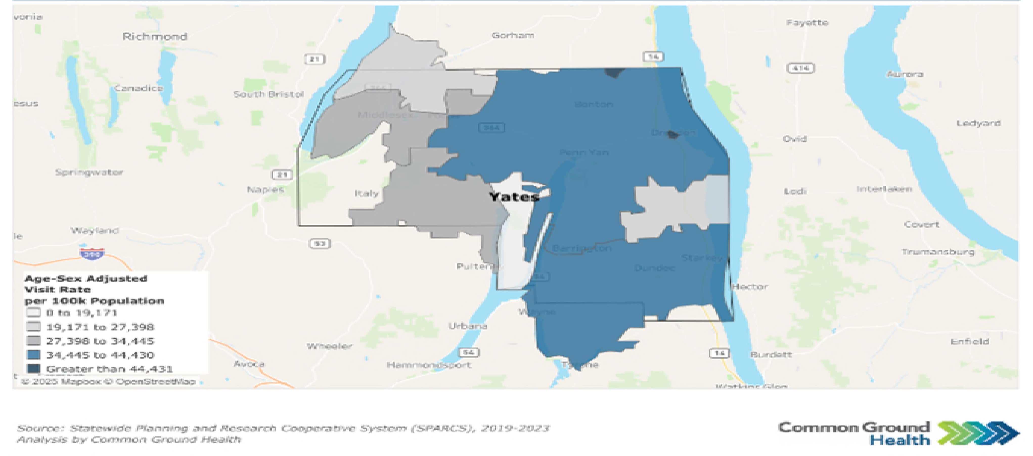

Map Y6: Preventable Hospitalizafions by Zip Code
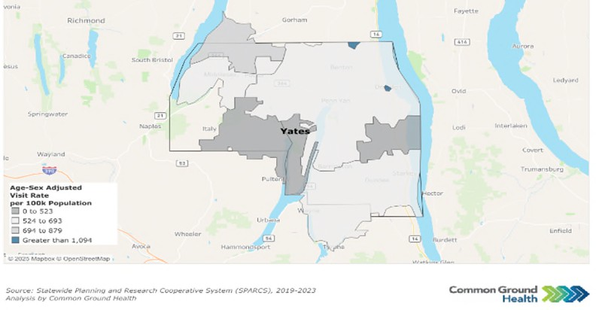

Table Y4: Emergency Department Visits

Issue Yates County Rate NYS Rate Per % Change Per 100,000 100,000 (from 2017)
(2023) (2023)
All ED Visits | 41,443 | 29,809 | +10%
Substance Use Disorder ED Visits | 1,076 | 1,646 | -34%
Intenfional Self Harm ED Visits | 359 | 343 | +2%
Preventable Hospitalizafions  (Overall) | 604 | 808 | -30%
Diabetes Preventable Hospitalizafions | 75 | 181 | -6%
Source: SPARCS
2023 data indicate mixed trends in healthcare ufilizafion in Yates County as compared to 2017. ED visits increased by 10%, suggesfing a reduced usage of primary care providers and a growing demand for urgent care services. In contrast, ED visits related to substance use disorders decreased by 34%, while visits for intenfional self-harm rose slightly by 2%. Preventable hospitalizafions declined by 30%, including a small 6% decrease in diabetes-related hospitalizafions, which may reﬂect improvements in disease management, though ongoing aftenfion to chronic disease prevenfion remains important.

Priority: Access to and Use of Prenatal Care
Receiving early and adequate prenatal care is important for ensuring a healthy pregnancy. Absfinence from smoking, alcohol, and illegal drug use are important indicators of appropriate prenatal care. Since 2018, Yates County has improved in all three indicators. In 2024, the percentage of birthing persons who abstained from alcohol was 100%, an increase of 2%.⁶¹ Absfinence from smoking was 86.1%, an increase of 7%, and absfinence from illegal drug use was 97.8%, an increase of 7%.⁶²
Prenatal care may be addifionally measured by low live birth weights (<2,500 grams or about 5 lbs., 8 oz.) and premature births (live births before 37 weeks). Vital Records data indicate that 12.2% of births (2022 data) were preterm, an increase of 36% from 2013. Live births with low birth weights were 4% (2023 data), a decrease of 20% from 2018 and below the NYS average of 8%.
Breasffeeding infants ensures opfimal nutrifion and provides health beneﬁts to both the breasffeeding parent and the child. The percentage of infants fed breast milk only or both breast milk and formula at the fime of hospital discharge (2024 data) was 91.9%, an increase of 11.4% from 2019. Those who were

⁶¹ Source: Nafional Survey on Drug Use and Health, 2024
⁶² Source: U.S. Department of Health and Human Services, Healthy People 2020, Nafional Center for Health Stafisfics

fed exclusively breast milk in the hospital were 77.4%, a decrease of 1% from 2019, though greater than the NYS average of 46.7%.⁶³ This indicator has shown an upward trend, increasing since 2020.

Priority: Prevenfion of Infant and Maternal Mortality
Prematurity and its related condifions are the leading causes of infant mortality. In 2024, the percentage of preterm births in Yates County was 12.2%, exceeding the NYS target of 9.4% or below. Reducing premature birth rates may directly aﬀect infant mortality rates. Data for this measure in Yates County is unavailable, likely due to the small number of infant deaths in the county.⁶⁴
Encouraging healthy habits during pregnancy can lead to healthier pregnancies and befter outcomes for the child. Yates County has seen confinuously improved rates in absfinence from alcohol and smoking during pregnancy. Smoking absfinence has improved from 82.5% in 2020 to 86.1% in 2024. Alcohol absfinence in pregnancy has held steady between 99% to 100% since 2020.⁶⁵
For Yates County, the maternal mortality rate has remained 0 since the 2013-2015 reporfing period, unfil the most recent reporfing period between 2020-2022, where there was one death reported. This caused a severe increase in the maternal mortality rate, rising to 102.6 per 100,000 live births.

Priority: Prevenfive Services for Chronic Disease Prevenfion and Control
Yates County, like many rural counfies, faces unique challenges in health care access and support. Fewer primary care physicians, denfists, mental health providers, and non-physician health care providers pose signiﬁcant barriers to care. Figure Y6 depicts the rafios of health care providers to one resident in Yates County. These rafios indicate a crifical need for improved healthcare access across all sectors in Yates County.
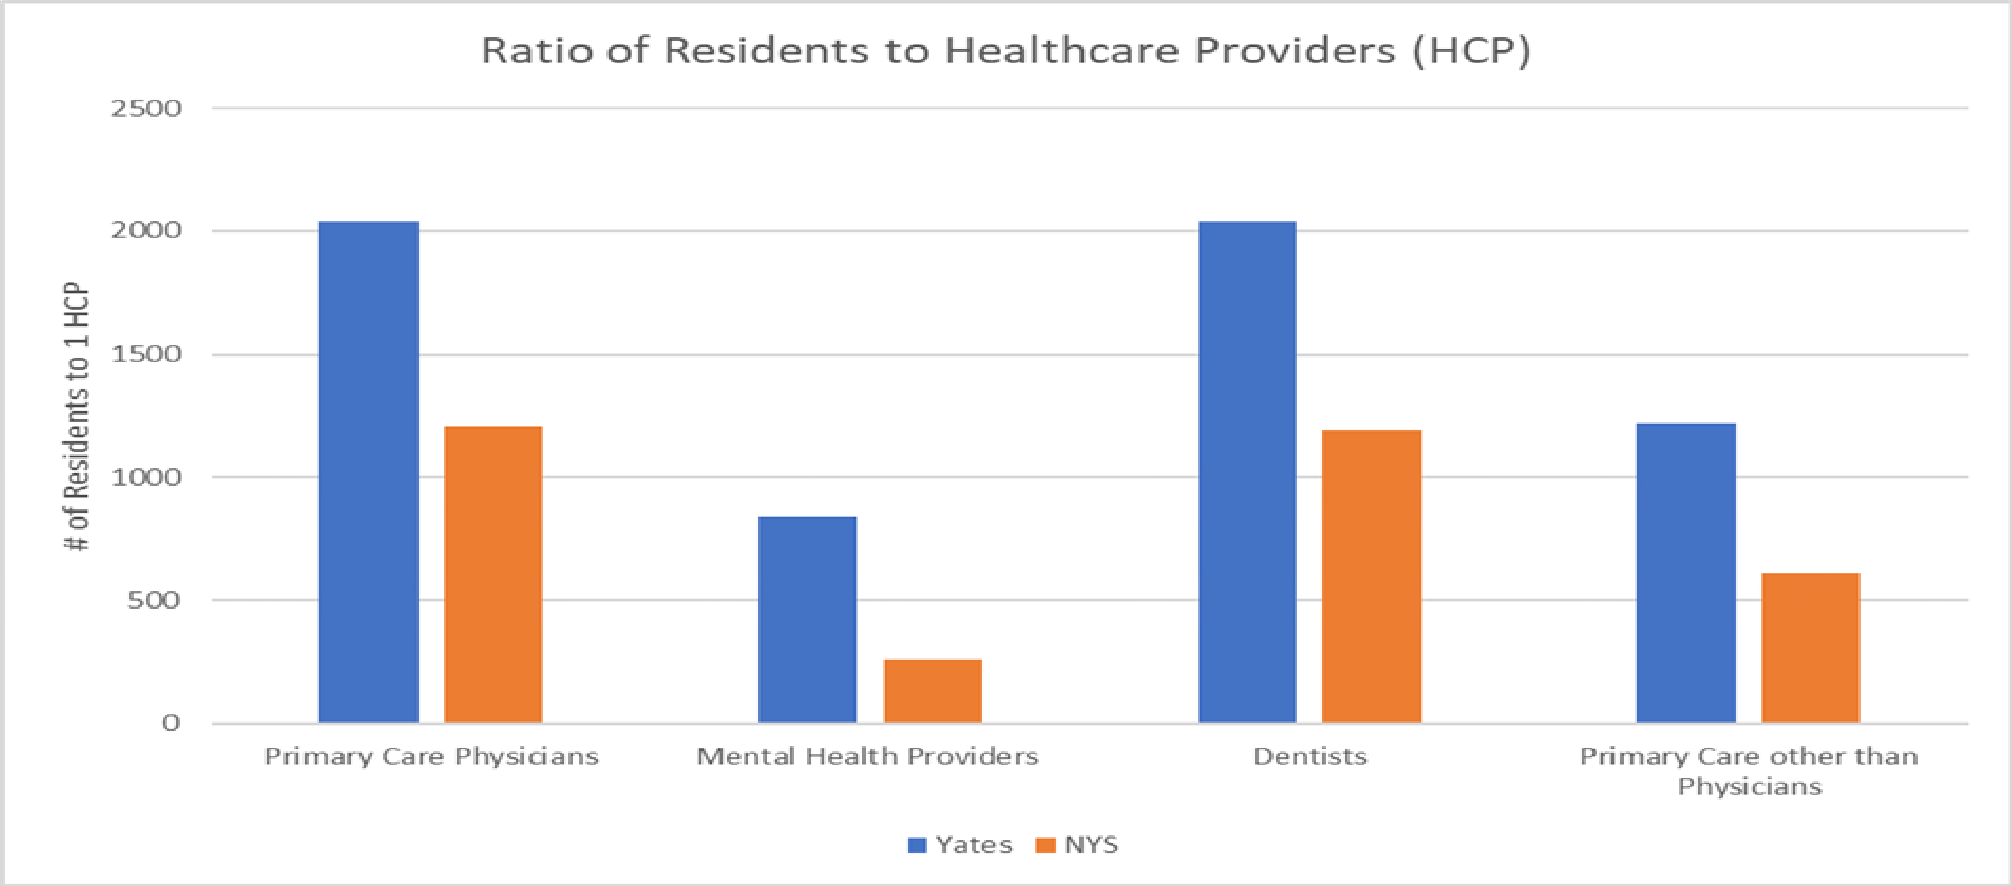
Figure Y6: Resident to Healthcare Provider Rafio
Source: County Health Rankings, Area Health Resource File/American Medical Associafion

⁶³ Source: NYS Prevenfion Agenda, Vital Records
⁶⁴ Source: NYS Prevenfion Agenda, Statewide Perinatal Data System, Vital Records
⁶⁵ Source: Healthy People 2030

Those who are under- or uninsured face addifional obstacles to accessing care. The uninsured rate for Yates County is 10% of the populafion under age 65 (up 25% since 2018) and 8% of children under 19 (up 33% since 2018).⁶⁶ Yates County has a higher percentage of uninsured residents compared to NYS. It is important to note that in Yates County, the Mennonite populafion often chooses not to have health insurance.
The combinafion of high populafion-to-provider rafios and a sizable uninsured populafion creates a signiﬁcant barrier to preventafive care. Consequently, these individuals may not seek prevenfive health care services and instead present to the Emergency Department with potenfially preventable condifions. Yates County residents seek care at the Emergency Department 39% more than the NYS average.⁶⁷ This may further result in increased health care costs and lost workdays, reinforcing the cycle of poverty.
Focus group parficipants consistently expressed concerns about high health care costs and diﬃculty navigafing insurance. They noted that the cost of even basic health care is unaﬀordable for many families and the insurance systems are diﬃcult to navigate.
Limited transportafion and its eﬀect on access to care were common concerns among focus groups. This concern is parficularly true for specialty care services such as cancer and cardiac care - two of the leading causes of death in Yates County.⁶⁸ Many individuals report struggling to get to appointments due to unreliable public transportafion or a lack of personal vehicles. Moreover, many focus group members noted the need to travel an hour or more to access certain specialfies. This again results in addifional fime loss at work and increased personal expenses for the individual.
Despite a nafionwide proliferafion of telehealth and telemedicine services, access to and use of broadband services in Yates County is limited. High-speed, quality internet connecfion enables residents to access essenfial services such as telehealth, online health informafion, appointment scheduling, and remote monitoring - tools that are vital for rural communifies and those with limited transportafion.
Reliable internet also supports health educafion, emergency communicafion, social connecfion, and access to beneﬁts and resources, helping reduce disparifies and improve overall community well-being. Broadband access in Yates County, as measured in the 2025 County Health Rankings, is 78%, while NYS is 90%. The percentage of the populafion with no access to broadband services, meaning broadband is simply not available in their area, is 6.7% in Yates, compared to just 1.3% in NYS as a whole.⁶⁹ This creates an addifional barrier to accessing alternafive means of care in an already underserved area.
In lieu of access challenges, chronic disease prevenfion emerges as a central concern for the county. Prevenfing chronic diseases is essenfial to supporfing a community’s overall health and well-being. In Yates County, condifions such as diabetes and obesity aﬀect a signiﬁcant porfion of residents, including both adults and children. In 2022, the prevalence of adults over age 20 with diagnosed diabetes is 10%; in 2021, the percentage of adults with obesity was 31.8%; and in 2023, the percentage of children and adolescents with obesity was 27.9%. Each of these measures has increased steadily over the past 7–9 years, except for adult obesity, which declined slightly in 2018 before rising again in 2021.

⁶⁶ Source: County Health Rankings & Roadmaps, 2025
⁶⁷ Source: New York State Department of Health Statewide Planning and Research Collaborafive, 2023
⁶⁸ Source: Vital Stafisfics Data, 2024
⁶⁹ Source: County Health Rankings & Roadmaps, 2025

Monitoring and managing risk factors such as high blood sugar and blood pressure is crifical for addressing chronic disease trends in Yates County. The percentage of adults aged 45+ who had a test for high blood sugar or diabetes within the past three years increased from 54.96% (2018) to 69.6% (2021), exceeding the state average of 63.8%. Among adults aged 45+ with a household income below $25,000, the percentage who had the same tests decreased from 58.9% in 2016 to 48.7% in 2018.⁷⁰ The prevalence of high blood pressure in adults 18+ increased 4% from 2017 to 30.1% in 2021.⁷¹ These pafterns underscore the importance of expanding access to preventafive screening for chronic disease risk factors, parficularly for low-income adults who are less likely to receive regular screening.
Mammograms and colorectal cancer screenings have also been shown to be eﬀecfive preventafive care measures. The complefion of prevenfive services shows mixed trends based on 2022 data. Mammogram rates among women ages 50–74 have steadily increased from 73% in 2018 and 74.1% in 2020, to 75.5% currently. The percentage of female Medicare enrollees who receive a mammogram screening has also improved since 2018, increasing from 52% to 55% in 2022. However, the prevalence of colorectal cancer screening among Yates County residents has decreased by 13% from 2020 to 2022, dropping from 72.3% to 63.2%.⁷¹ These trends highlight the need for targeted intervenfions to promote complefion of preventafive measures and reduce long-term health risks.

Priority: Oral Health Care
According to County Health Rankings, Yates County has a denfist-to-populafion rafio of 2,220 to 1. In 2019, 62.6% of adults had a dental visit in the past year, a 5% decrease since 2014 and below the New York State average of 71.3%.
Access to oral health care is even more limited for Medicaid enrollees. The only Medicaid-accepfing dental provider in Yates County is Finger Lakes Community Health, with clinics in Penn Yan and Dundee. The percentage of Medicaid-enrolled adults with at least one dental visit remained above 30% between 2014 and 2019. However, in 2020, this percentage dropped to 25.9%, a 23% diﬀerence from the year prior. Since 2020, the percentage of dental visits for adult Medicaid enrollees has confinued to fall below the state average of 31.1%, underscoring concerns about oral health care availability.
Access to dental care for children is similarly limited. In 2023, Finger Lakes Community Health opened a school-based dental clinic in Penn Yan, providing prevenfive dental care. Trends for Medicaid enrollees aged 2-20 years who had at least one dental visit within the last year are similar to those of adults.
Between 2015 and 2017, this percentage remained above state average, with 49% of Yates County Medicaid enrollees ages 2-20 complefing at least one dental visit in 2018. The rates dropped rapidly in 2020, reaching 36.3%, before slowly increasing to 41.2% in 2023.⁷²

Priority: Prevenfive Services – Immunizafions and Lead
Yates County is classiﬁed as high risk for disease outbreak due to low vaccinafion rates. The complefion rate target value of 4:3:1:3:3:1:4 series (Table Y4) is 80% in NYS. However, in Yates County the percentage of children who have received this immunizafion series by two years of age is 44.8% in 2025, an increase

⁷⁰ Source: Behavior Risk Factor Surveillance System (BRFSS), 2022
⁷¹ Source: Centers for Disease Control and Prevenfion (CDC), 2022
⁷³ Source: U.S. Census and 2023 American Community Survey

of 15% from 2016. The rate of immunizafion complefion remained relafively stable between 2019 and
2025, increasing by only 0.22%.
Table Y5. 4:3:1:3:3:1:4 Schedule

Vaccine Type | Number of Doses
Diphtheria, Tetanus, and Pertussis (DTaP) | 4
Polio (IPV) | 3
Measles, Mumps, Rubella (MMR) | 1
Hepafifis B | 3
Haemophilus infuenzae type B (Hib) | 3
Varicella | 1
Pneumococcal Conjugate Vaccine (PCV) | 4

As of January 1, 2025, Yates County’s MMR (Measles, Mumps, Rubella) vaccinafion rate is the worst in the state with only 55.8% of residence receiving one MMR dose by 2 years of age, compared to the state average of 81.2% and below the 95% threshold to achieve herd immunity. The recommended childhood vaccinafion schedule indicates that the ﬁrst dose of the MMR vaccine be administered between 12 and 15 months and their second dosage between 4 to 6 years, prior to starfing Kindergarten.
Similarly, the number of children who completed the Human Papillomavirus (HPV) vaccine series increased from 15% in 2016 to 21.5% in 2025, but the overall change since 2017 is only 0.5%. HPV immunizafion rates fall below the NYS average of 63.6% and well below the state target value of 80% (Figure Y7).
Figure Y7: Immunizafion Rates (2025)
Immunization Rates
90
80
70
60
50
40
30
20
10
0
HPV
4:3:1:3:3:1:4
MMR
Yates
NYS
Target
Completion Rate (%)

Source: NYSIIP Performance Reports, IAP Baseline Report

Yates County’s low Immunizafion rates are likely aﬀected by the large Mennonite populafion in the community. It is common pracfice for the Mennonite community to remain unvaccinated and seek alternafive, holisfic measures of care. Of note, though, is that Mennonite oﬃce visits for immunizafions at Yates County Public Health increased by 57% since 2024, indicafing a growing interest in this pracfice. Nonetheless, targeted, culturally competent educafion is key to understanding the importance and eﬀecfiveness of vaccinafion and ulfimately improving rates of immunizafion.
Tesfing for blood levels of lead is essenfial in young children as no level of lead in the blood is safe. The CDC indicates that lead poisoning may lead to slowed growth and development, learning and behavior problems, and other long-term health eﬀects. Young children may not show signs and symptoms of lead in the blood and body but can quickly be negafively impacted. Individuals that live or spend fime in buildings built before 1978 or are from low-income households are especially vulnerable. With 18% of children under age 18 living in poverty, it is essenfial to priorifize eﬀorts to improve access to and complefion of lead screening to safeguard long-term health in the county.
Lead screening data from 2024 (Figure Y8) indicate that the percentage of children aged one year who received one lead screening is 40.5%. The percentage of children aged two years who received at least one lead screening was 42.7%. Those who received at least two lead screenings by three years of age were 32.4%. Overall trends are showing a decline in all measures of lead tesfing.
Figure Y8: Prevenfive Services – Lead Screening (2024)
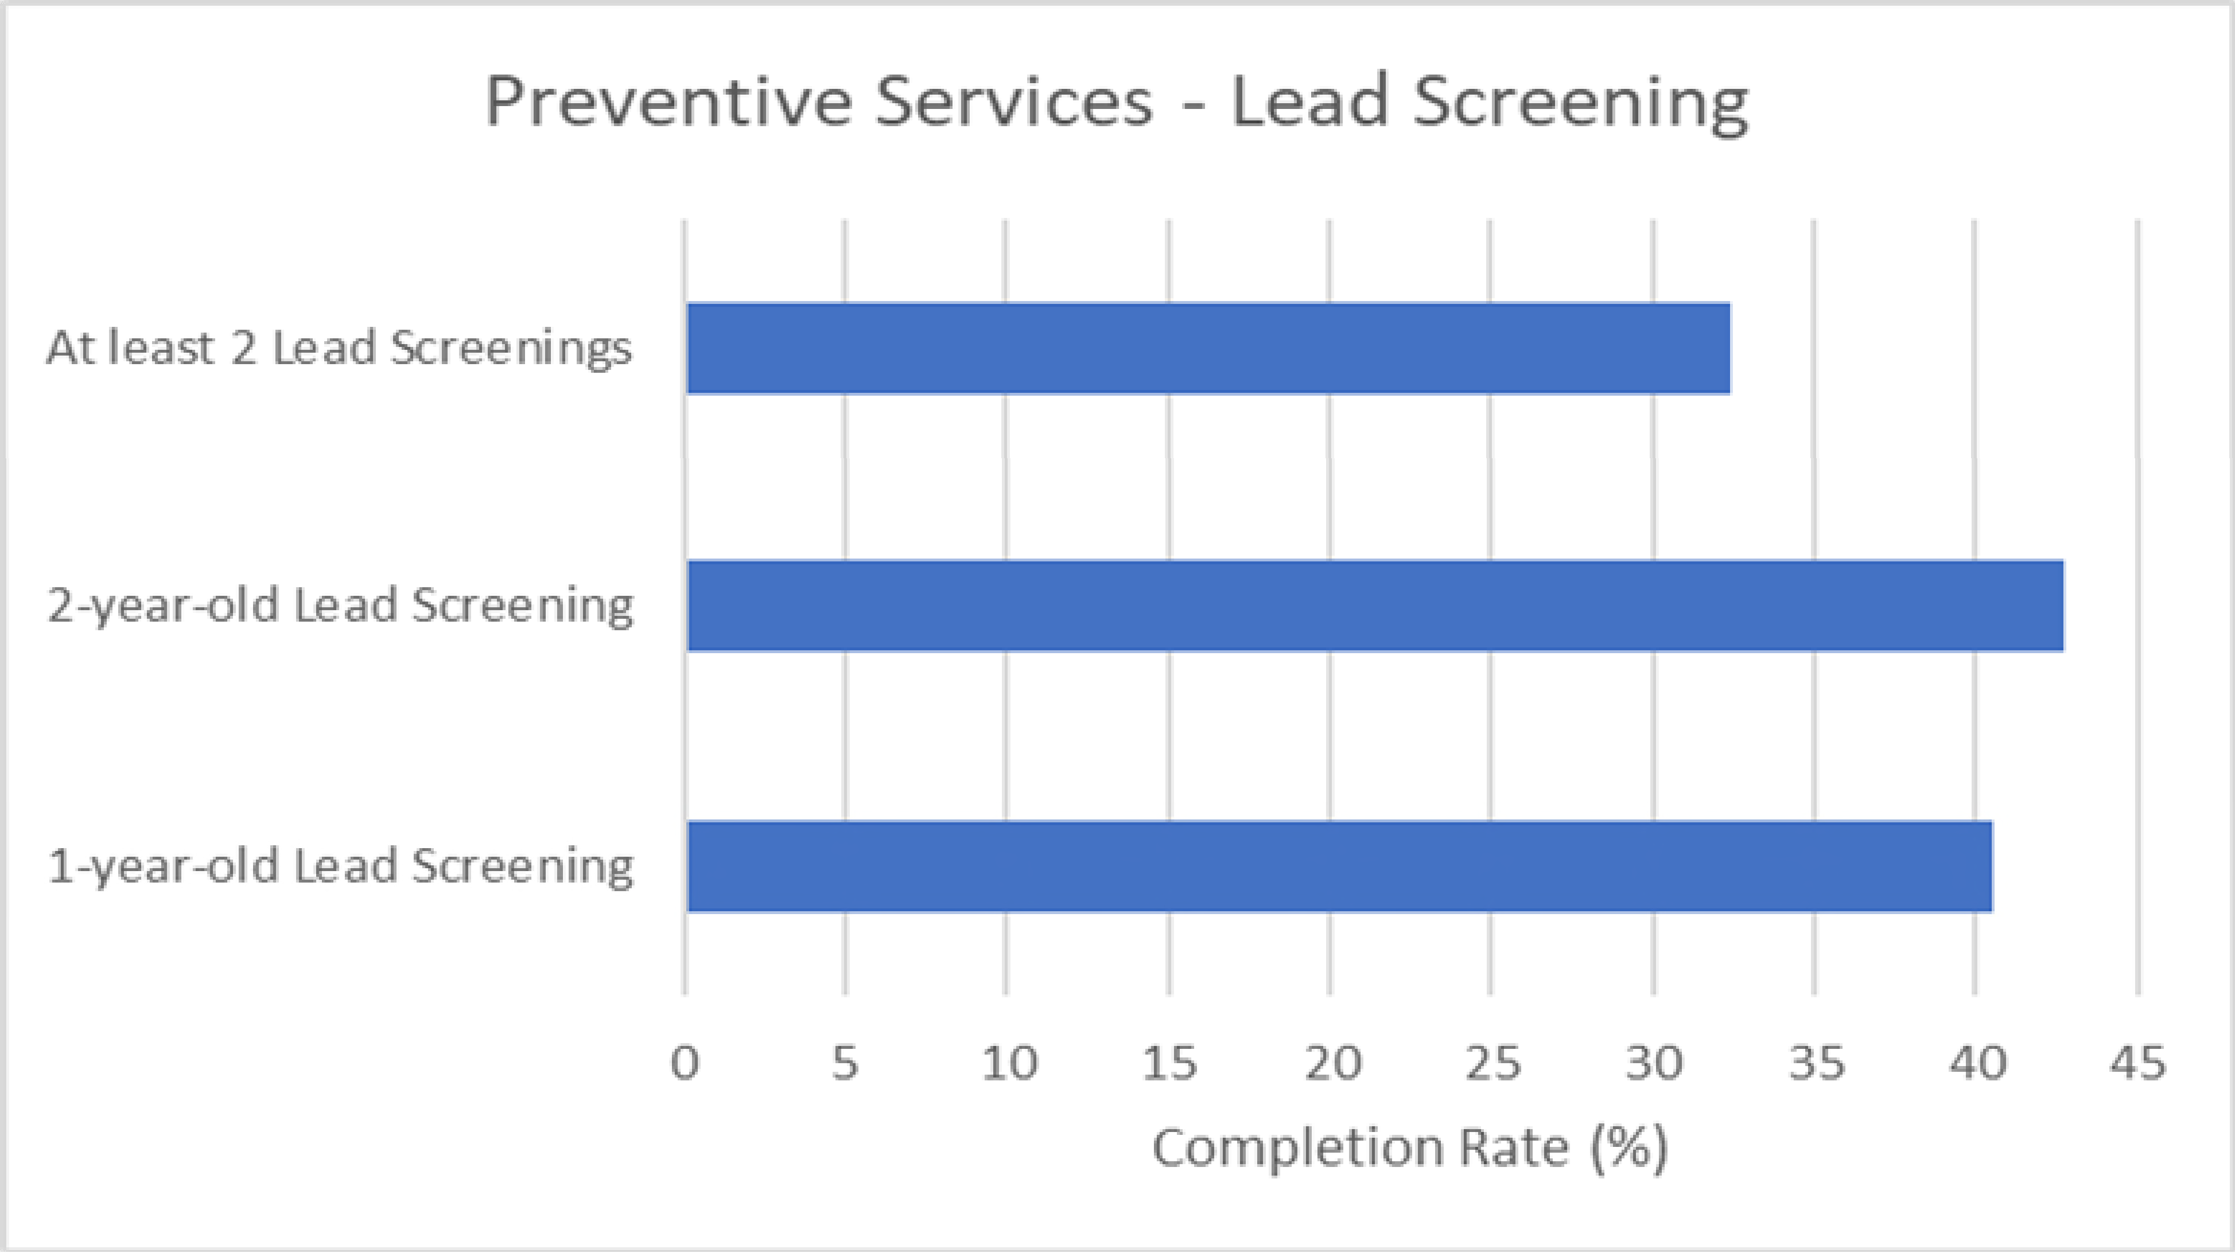
Source: NYSIIP Performance Reports, IAP Baseline Report
Health Care Access and Quality Domain Summary: Yates County shows progress in several maternal and child health indicators, including increased absfinence from smoking, alcohol, and drug use during pregnancy, lower rates of low birthweight, and high breasffeeding rates. However, challenges remain.
Prevenfive care access is strained by provider shortages, declining insurance coverage, transportafion

barriers, and lower prevenfive screening rates among low-income residents. Dental care access, parficularly for Medicaid enrollees, has also declined. Immunizafion and lead-screening rates have declined since 2019. Overall, signiﬁcant gaps in access to prevenfive, oral, and specialty care confinue to aﬀect community health outcomes.

Domain: Educafion Access and Quality
Educafion strongly inﬂuences health. Individuals with more schooling live longer, have fewer chronic diseases, and experience greater economic stability. Chronic absenteeism, deﬁned by the U.S. Department of Educafion as missing at least 10% of the school year for any reason, can interfere with educafional aftainment. Several factors contribute to absenteeism, such as physical and mental health challenges, substance use, unsafe school environments, and low ﬁtness levels.
Chronic absenteeism rose sharply in New York State after the COVID-19 pandemic. In 2022–2023, 26.4% of all students and 34.1% of high school students were chronically absent, far above the pre-pandemic rate of 15.5%. Chronic absenteeism is associated with lower academic achievement, social disengagement, higher dropout risk, and poorer long-term health and economic outcomes. The percentage of students who start ninth grade and graduate in four years was 80% in 2023, lower than the NYS average of 87% and unchanged from the baseline in 2018. The graduafion rate for students classiﬁed as economically disadvantaged was 81% in 2023 versus 82% for NYS, an increase of 6.6% from baseline in 2019.
In Yates County, 73.5% of the school-age populafion is enrolled in kindergarten through 12th grade, with 32.7% in private schools and 67.3% in public schools. The number of students enrolled in school between grades 5 to 8 and grades 9 to 12 drops by approximately 586 students⁷³ (Table Y6). This is likely due to the Mennonite educafional structure which disconfinues schooling after 8th grade.
Table Y6: Enrolled School-Age Populafion

Grade Level | Total Esfimate | Percent Esfimate in  Public School | Percent Esfimate in Private  School
Kindergarten | 210 | 74.3% | 25.7%
Elementary: grade 1 to  grade 4 | 1216 | 55.6% | 44.4%
Elementary: grade 5 to grade 8 | 1395 | 64.1% | 35.9%
High School: grade 9 to grade 12 | 809 | 88.8% | 11.2%
Source: 2023 American Community Survey 5-Year Data
The average gap in dollars between actual and required spending per pupil among public school districts was $9,915 in 2022, compared with $12,745 on average in NYS; an increase of 4.4% from baseline in 2019. The gap between what schools need and what they actually spend is growing. A widening funding gap can strain school resources, limit access to educafional programs and support services, and make it

⁷³ Source: U.S. Census and 2023 American Community Survey

harder for districts to meet student needs. Over fime, this can contribute to disparifies in academic achievement, staﬃng challenges, and fewer opportunifies for students, especially in communifies already facing economic or social disadvantages.
Post-secondary educafion also brings substanfial beneﬁts. Adults with a bachelor’s degree have higher incomes, are less likely to be unemployed, and have befter health and safer working and living condifions than those with only a high school diploma. However, aﬀordability and unequal access to educafional opportunifies remain challenges. The percentage of adults ages 25 and over in Yates County with a high school diploma or equivalent was 84% in 2023, lower than the NYS average of 88% and a decrease of 2% from the baseline in 2019. The percentage of adults aged 25-44 with some post-secondary educafion was 42% in 2023, lower than the NYS average of 71% and a decrease of 22% from the baseline in 2019.
Educafion Access and Quality Domain Summary: Educafional aftainment remains a priority concern: rates of high school complefion, post-secondary educafion, and on-fime graduafion all fall below state averages. Addifionally, the per-pupil spending gap has widened, signaling increasing strain on school resources and the potenfial for growing inequifies in academic opportunifies and student support.

Priority Areas

Yates County idenfiﬁed three priority areas for this CHA. They are:
- Housing Stability and Aﬀordability
- Prevenfive Services for Chronic Disease Prevenfion and Control
- Anxiety and Stress
These priority areas were selected in December 2025 using a ranking systemafic survey to select the above priorifies, in addifion to using secondary data and community feedback.

Housing Stability and Aﬀordability

Although housing cost burden is lower than the state average, community partners and focus groups consistently idenfify housing quality, availability, and aﬀordability as urgent concerns.
Homeownership rates are declining in Yates County while the cost of living confinues to rise.

"People of low income will always be aﬀected the most...as those with adequate funds have choices - where to live, work, spend their money, and where to get their healthcare."
- YCC Focus Group Parficipant

Focus groups in Yates County highlighted signiﬁcant concerns about local housing, nofing a shortage of safe and funcfional homes. Older housing, parficularly pre-1950s structures, often lacks inspecfions for lead and mold, increasing risks for respiratory illnesses, developmental issues, and chronic condifions, as well as injuries from falls in poorly maintained homes.
Further housing assessments are needed in Yates County to befter understand the resources available to
help the community.

Prevenfive Services for Chronic Disease Prevenfion and Control

"I feel that we have to be our own advocate when it comes to healthcare...if I was to menfion health issues between family and friends, there would be too many to state."
- YCC Focus Group Parficipant
Yates County is seeing increased rates of obesity, cancer, diabetes, and heart disease and the county’s top two leading causes of death are associated with chronic disease. Prevenfion, early detecfion, and disease management are important to improving overall quality of life.

However, access to care in Yates County is a widespread barrier, especially for elderly and low-income populafions. There is limited access to primary care locally, and residents are also forced to travel long distances for specialty care. Addifional barriers

include high medical costs, insurance limitafions, scheduling diﬃculfies, lack of transportafion, and poor
broadband access.
Increasing access to care through creafive community solufions and partnerships can reduce the burden
of chronic disease in the community.

Anxiety and Stress
Mental health was noted as a major issue across all focus groups. Youth cited bullying and cyberbullying as
"Older people sfill have skills to be useful and want to be"
-YCC Focus Group Parficipant

factors inﬂuencing mental health while older adults noted isolafion as a key contributor. A shortage of mental health providers and ongoing barriers to seeking help, especially for marginalized groups, was cited as cause for concern.
Declining mental health can signal underlying concerns around rising stress, depression, or anxiety in the community. This may lead to higher rates of chronic disease, substance use, reduced producfivity, and greater demand for mental health and medical services.
Building community support systems focused on resilience-building strategies and social connections can improve community well-being.

Community Assets and Resources

Exisfing and needed community assets and resources supporfing health were idenfiﬁed throughout the Community Health Assessment process. The community partners listed in Appendix 1 provide valuable resources to support posifive health outcomes for Yates County residents.
Pivital Public Health Partnership and Common Ground Health are two agencies that promote and facilitate regional collaborafion. Pivital is a partnership of eight rural health departments in the Finger Lakes Region, focusing on improving the health and well-being of Finger Lakes residents. Common Ground Health covers the same geographic footprint, with the addifion of Monroe County, and focuses on bringing together leaders from all sectors to collaborate on strategies for improving health in the region. Both agencies provide support, collaborafion and resources to improve the health of Yates County residents.
Yates County has broad engagement from nonproﬁts, healthcare systems, school districts, grassroots groups, and faith-based communifies. Agencies like Finger Lakes Area Counseling & Recovery Agency (FLACRA), Cornell Cooperafive Extension, UR Medicine Finger Lakes Health, Pro Acfion provide mental health, substance use, medical, social, and educafional services. Individuals of all ages and backgrounds—including low-income populafions, older adults, those living with disabilifies, LGBTQIA+ community members, immigrants, and racial minorifies— are engaged through support groups, advisory boards, social media, and mulfilingual support. Partners acfively work on policy and advocacy, adapt through regular evaluafion , and use innovafive tools and leadership opportunifies to build resilience and local capacity.

There is also a strong emphasis on community within the county as exempliﬁed by commifted staﬀ, volunteers, and resource sharing (spaces, technology, event support). Social hubs such as libraries, community centers, churches, and schools anchor programming and promote referrals across health/wellness, social, and prevenfive services.
While partnerships and organizafions exist to foster collaborafion in the community, gaps sfill exist that may inhibit growth. Several partners discussed the need to expand community engagement for youth inclusion. Engagement must go beyond social media to include more one-to-one interacfion. Many populafions, especially the older populafion, expressed the desire to mentor youth and foster relafionships.
Addifionally, community partners and businesses must confinue to address organizafional awareness of structural determinants of health. In doing so, creafing more invenfive, comfortable, and accessible meefing and engagement spaces are needed.
Through implementafion of the Community Health Improvement Plan (CHIP), Yates County and its community partners will work to leverage exisfing relafionships, knowledge, and resources. The Yates County CHIP workplan will include a full descripfion of intervenfions and partner roles that will be used to address chosen priorifies and objecfives.
Table Y7 highlights the speciﬁc county partners associated with each priority area and how they may
support Yates County in achieving its goals.
Table Y7: County Resources to Accomplish CHA/CHIP Goals

Priority Area | Sample Assets &  Collaborafive Resources | How They Support Community Health & Well-  being
Housing Stability &  Aﬀordability | Yates County DSS; Keuka Housing Council; Cornell Cooperafive Extension (CCE); Yates County Soil and Water; Geneva District Oﬃce for Environmental Health; LAW of NYS; Housing Consorfium | Ensure basic needs for residents are met (housing, food, safe drinking water, clothing, heat etc.); educafional resources to residents who face environmental hazards within their house; informing residents of their rights as a homeowner; community and governmental collaborafion can help maintain neighborhoods at aﬀordable prices for residents who live and work in the area

Prevenfive Services of Chronic Disease Prevenfion & Control | Cornell Cooperafive Extension (CCE); ProAcfion of Steuben and Yates; Tobacco Acfion Coalifion of the Finger Lakes; Finger Lakes Community Health; Penn Yan Central School District (PYCSD); Dundee Central School District (DCSD); UR Medicine Finger Lakes Health; Dundee Food Pantry-Bapfist Church; The Living Well; Dundee Fresh Grocery, Our Town Rocks; Medical Reserve Corps (MRC); Rochester Regional Health | Providing educafional resources around general health and well-being, nutrifion, and prevenfion/management of chronic disease; primary, emergency, and specialty health care providers; food and nutrifion security; school systems providing primary prevenfion educafion, healthy food opfions, and educafional opportunifies around health and well-being; organizafions oﬀering community support groups and connecfion to resources
Anxiety & Stress | Penn Yan Public Library; Yates County Oﬃce of Emergency Services; ProAcfion of Steuben and Yates; Finger Lakes Area Counseling and Referral Agency (FLACRA); Finger Lakes Community Health; Yates County Sheriﬀ’s Oﬃce (YCSO); Lakeview Health Services; Yates County Correcfional Facility; UR Medicine Finger Lakes Health; The Living Well; Yates County Community Services; Our Town Rocks;  Yates Prevenfion Coalifion | Mental health support and care; emergency response to mental health crises; resources for mental health and general well-being; educafional resources for residents who experience mental health concerns; populafion-speciﬁc resources and community support; social connecfion opportunifies

Appendix 1
Parficipafing Partners and Community Representafion

A diverse coalifion of organizafions and community members parficipated in the Yates County Community Health Assessment process to ensure broad stakeholder input and representafion from populafions experiencing health disparifies. Known as Choose Health Yates, this group serves as the Community Health Improvement Plan (CHIP) steering commiftee for Yates County. The following partners are acfive members of the Choose Health Yates Commiftee:

Organizafion | Sector | Populafion
Penn Yan Public Library | Non-proﬁt organizafion | All populafions, LGBTQ+
Pivital Public Health Partnership | Non-proﬁt organizafion | Finger Lakes region
Chamber of Commerce | Local tourism agency | Yates County residents
Yates County Oﬃce of  Emergency Services | Local government | Yates County residents
Yates County Cornell  Cooperafive Extension | Nonproﬁt educafional system | Agricultural workers, low-income, veterans
ProAcfion of Steuben and Yates | Nonproﬁt agency | Aging populafion, low-income
Yates County Department of Social Services | Local government | Marginalized populafions- low socioeconomic status
Finger Lakes Area Counseling and Referral Agency (FLACRA) | Mental and behavioral health  organizafion | People who use drugs (PWUD),  marginalized populafions
Tobacco Acfion Coalifion of the  Finger Lakes | Nonproﬁt organizafion | Finger Lakes region
Finger Lakes Community Health | Federally Qualiﬁed Health Center  (FQHC ) | Marginalized communifies-migrant/agriculture workers, LGBTQ+, low-income, Medicaid recipients, LEP
Penn Yan Central School District (PYCSD) | Academics | Youth
Yates County Sheriﬀ’s Oﬃce  (YCSO) | Local government | Yates County residents
Lakeview Health Services | Mental and behavioral health services | Finger Lakes Region

Yates County Correcfional  Facility | Local government | Marginalized populafions-incarcerated individuals
University of Rochester Medical Center- Soldiers & Sailors Memorial Hospital | Hospital | All populafions
Dundee Food Pantry- Bapfist  Church | Faith based organizafion | Low-income, aging populafion
The Living Well | Non-proﬁt | Low-income, aging populafion
Yates County Community Services | Local government | Yates County Residents
Dundee Fresh Grocery | Business | All populafions
Our Town Rocks | Nonproﬁt community organizafion | All populafions
Refired Physicians | Community members

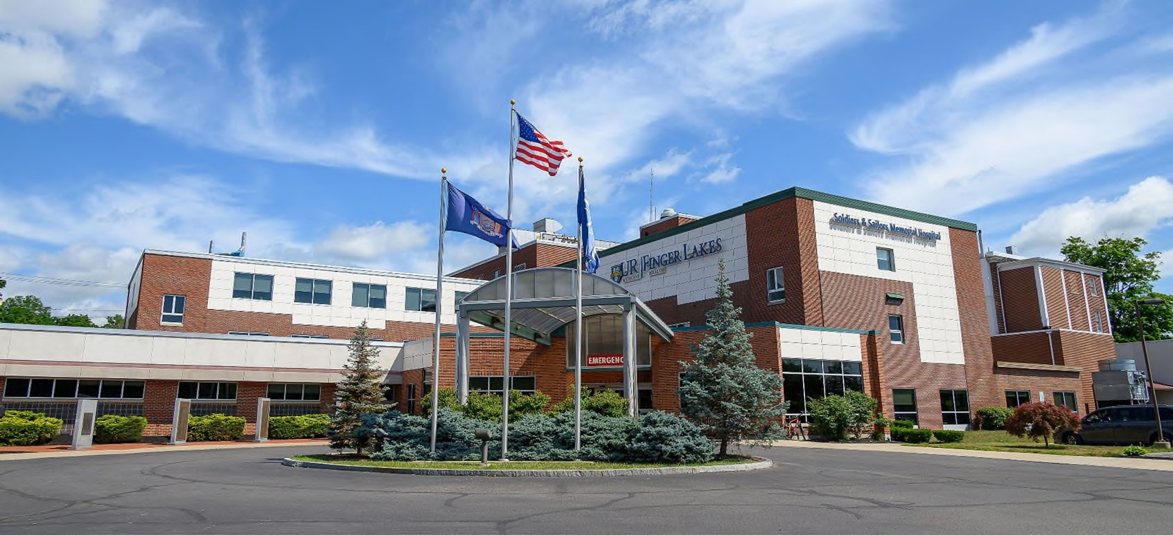
Soldiers and Sailors Memorial Hospital Courtesy of UR Medicine Finger Lakes Health
Courtesy of UR Medicine- Soldiers and Sailors Memorial Hospital

