Courtesy of Yates County Chamber of Commerce

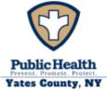 | Community Health Assessment – Yates County | 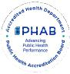

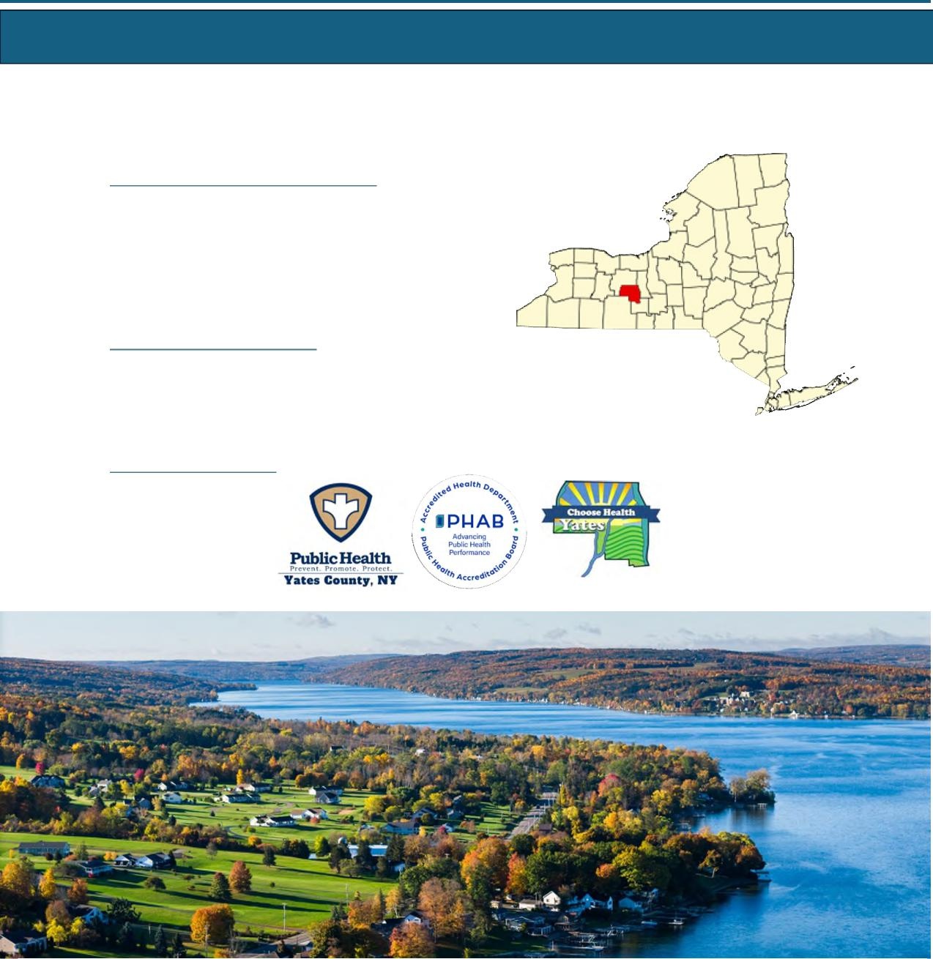
Yates County Public Health
Alyssa Broome-Quissimisse
Director of Public Health
Alyssa.Quissimisse@yatescountyny.gov
315-536-5160
UR Medicine Finger Lakes Health Soldiers and Sailors
Memorial Hospital
Kimberly Ilacqua
Vice President, Community Services
Executive Director, Finger Lakes Health Foundation
Kimberly.Ilacqua@flhealth.org
315-787-4053
Pivital Public Health Partnership Michele Foster
Executive Director MFoster@pivitalphp.org
Yates County
Page 67 Yates County

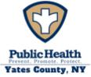 | Community Health Assessment – Yates County | 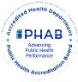

Table of Contents
Executive Summary 69
Community Description | 71
Service Area | 71
Demographic Summary | 71
Health Status Description | 76
Specific Methodology | 76
County Health Rankings | 78
NYS Prevention Agenda | 79
Priority Areas | 103
Community Assets and Resources | 104
Appendix 1: Participating Partners and Community Representation | 107
List of Tables:
Table Y1: Causes of Death | 75
Table Y2: NYS Prevention Agenda 2025-2030 Domains and Priorities | 79
Table Y3: Rates of Age-Adjusted Causes of Death | 93
Table Y4: Emergency Department Visits | 95
Table Y5: 4:3:1:3:3:1:4 Schedule | 99
Table Y6: Enrolled School-Age Population | 101
Table Y7: County Resources to Accomplish CHA/CHIP Goals | 105
List of Maps:
Map Y1: Population Density in Yates County | 72
Map Y2: Overall Poverty Rate in Yates County | 81
Map Y3: Food Insecurity Rate | 82
Map Y4: Poor Mental Health Days | 86
Map Y5: ED Visit Rate by Zip Code | 94
Map Y6: Preventable Hospitalizations by Zip Code | 94
List of Figures:
Figure Y1: Population Projections in Yates County | 72
Figure Y2: Population by Age and Sex | 73
Figure Y3: County Health Rankings Health and Well-Being | 78
Figure Y4: County Health Rankings Community Conditions/SDOH | 78
Figure Y5: Unemployment Rate | 81
Figure Y6: Residents to Healthcare Provider Ratio | 96
Figure Y7: Immunization Rates 2025 | 99
Figure Y8: Preventive Services – Lead Screening | 100

Page 68 Yates County

Yates County has identified three priority areas for this Community Health Assessment (CHA). They are:
 | Community Health Assessment – Yates County | 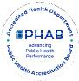

Executive Summary
- Housing Stability and Affordability
- Preventive Services for Chronic Disease Prevention and Control
- Anxiety and Stress
Data Sources
Yates County’s CHA incorporated a blend of quantitative and qualitative data sources, including secondary data from the New York State Behavioral Risk Factor Surveillance System, County Health Rankings and Roadmaps, the National Center for Health Statistics, the American Community Survey, the U.S. Census, the NYS Medicaid Program, and local performance reports.
Partners and Roles
The Choose Health Yates Committee was integral in the development of the CHA, along with the participating partners and community representation listed in Appendix 1. Yates County community members were invited to attend the Choose Health Yates meetings through local radio announcements and meeting dates published on the local health department’s website. During the CHA development, Choose Health Yates met regularly to develop and integrate information collected through use of the MAPP 2.0 framework.
Valuable organizational data and community insights were compiled to create a comprehensive county profile. Gathering this information was completed using three assessments: the Community Partner Assessment (CPA), Community Context Assessment (CCA), and Community Status Assessment (CSA). Throughout the process, partners and community members participated in regular Choose Health Yates meetings where findings from the assessments mentioned above were presented. These sessions encouraged questions, feedback, and shared interpretation of the data. The full committee collaboratively reviewed and discussed the triangulated results of all three assessments, allowing partners to validate findings and identify key health themes, leading to the selection of priorities.
Summary of Findings
Yates County faces a complex mix of social, economic, and health challenges that influence the overall well-being of its residents. Poverty has increased to 14.1%, with the highest concentrations in the southern part of the county, and older adults have experienced a particularly sharp rise in financial hardship. Median household income remains below the state average, and while unemployment is relatively low, wages are not keeping pace with the cost of living, creating economic stress for many families. Even though homeownership rates are high compared to NYS, households have experienced 1 of 4 housing problems (overcrowding, high housing costs, and/or lack of kitchen or plumbing facilities) at higher rates since 2020. Nutrition security appears stable, with most residents having access to healthy food, but gaps in physical activity opportunities, walkable spaces, and community amenities highlight barriers to healthy lifestyles.
Page 69 Yates County

 | Community Health Assessment – Yates County | 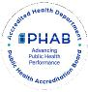

Mental health is a growing concern. Rates of adults reporting poor mental health and depression, along with elevated suicide rates, exceed state averages, signaling rising stress, anxiety, and unmet behavioral health needs. Substance use and overdose trends have decreased, along with the percentage of adults who are current smokers.
Access to healthcare is strained by provider shortages, geographic barriers, and declining insurance coverage for adults and children. Preventive care indicators, including screenings, dental care, immunizations, and lead testing, show lower completion rates among Medicaid enrollees and low-income populations.
High school completion and post-secondary enrollment lag state averages, and the four-year graduation rate is lower than the state average. School funding gaps have slightly worsened, limiting resources and programming that support student success. However, students who are economically disadvantaged have shown a promising upward trend in graduation rates. Civic engagement and social cohesion are moderate, with relatively strong organizational participation and voter turnout, but social vulnerability remains elevated, particularly for those facing economic, transportation, or housing barriers.
Interventions, Strategies, and Disparities
Yates County residents who are older adults, children, of low-income status, and live with a mental health and/or substance use disorder face the greatest health disparities. Yates County Public Health has chosen to submit the Community Health Improvement Plan (CHIP) for June 2026 where more information about specific health disparities will be included. Choose Health Yates and the local hospital, Soldiers and Sailors Memorial Hospital, will continue to work collaboratively in selecting the objectives and interventions for the chosen priorities.
Measures and Evaluation
Choose Health Yates continues to meet regularly to improve the health of Yates residents and to oversee CHIP implementation. Attendees at these meetings will routinely review the progress of the chosen priorities, objectives, and interventions. Once the interventions have been selected, group members will identify and implement mid-course corrections to interventions and processes. These meetings will serve as continued program evaluation and a means to keep the community and partners apprised of the CHIP progress.
Page 70 Yates County

 | Community Health Assessment – Yates County | 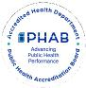

Community Description
Service Area
Yates County is a small, predominantly rural county located in the Finger Lakes region of New York State, covering approximately 376 square miles. The service area encompasses a mix of village centers, lakeside communities, and widely dispersed agricultural areas. With one of the smallest populations in the state, the county is characterized by low population density, limited public transportation, and long travel distances to healthcare and social services. The community includes a growing older-adult population, families living in or near poverty, and several culturally distinct groups, including a sizable Amish and Mennonite population whose health needs, access patterns, and service utilization differ from the general population.
Healthcare services within the county are provided primarily by a small number of clinics, primary care practices, and one critical access hospital, with many residents traveling outside the county for specialty care, behavioral health services, and advanced medical treatment. Economic conditions, geographic isolation, seasonal employment, and transportation barriers all shape the community’s health needs and influence how residents access care.
Overall, the Yates County service area reflects the unique challenges and strengths of a rural community—tight-knit and resourceful, yet facing persistent barriers related to access, affordability, and availability of healthcare and support services.
Demographic Summary
Demographic information is essential in public and community health as it identifies who lives in a community, how their needs differ, and where health disparities exist. By understanding factors such as age, race, income, education, and poverty, organizations can target resources, design effective programs, and allocate funding where it will have the greatest impact. Demographic data provides the foundation for equitable planning, informed decision-making, and improved health outcomes for all community members.
Page 71 Yates County

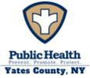 | Community Health Assessment – Yates County

Population
Yates County is in the heart of the Finger Lakes Region and is bordered by Steuben, Seneca, Ontario, and Schuyler counties. While Yates County includes parts of Canandaigua Lake and Seneca Lake, it is home to the popular Keuka Lake. The beautiful scenery, agriculture, and recreational water activities make it an ideal vacation spot for tourists from April to October. There are 24,774 residents across Yates County, with the densest population areas in Penn Yan and Dundee, as shown in Map Y1. The county is considered very rural, with 68.6% of residents living outside population-dense areas.³¹ The population of Yates County is expected to hold relatively steady over the next decade before increasing. (Figure Y1)
Figure Y1: Population Projections- Yates County
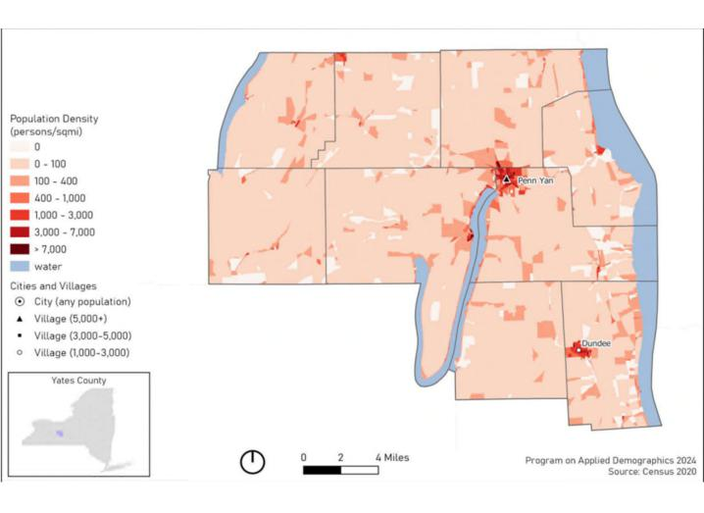
Map Y1: Population Density of Yates County
Source: Cornell Program on Applied Demographics 2024; US Census 2020
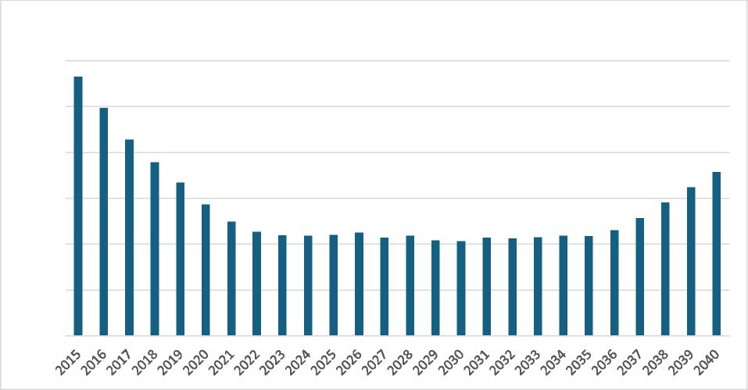
Population Projections - Yates County
25,100
25,000
24,900
24,800
24,700
24,600
24,500
Source: Cornell Program on Applied Demographics
³¹ Source: County Health Rankings, U.S. Census
Page 72 Yates County

Age and Sex
 | Community Health Assessment – Yates County | 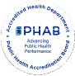

Figure Y2: Population by Age and Sex
To better understand health needs, it is important to know the sex and age make-up of a community. Figure Y2 shows the number of county residents by sex and age. The median age in Yates County is 41.6 years, with one larger population group aged 50-79. Sex is relatively evenly split, with females accounting for 50.7% of the population. Individuals identifying as LGBTQ+ account for 5.8% of the population.  Youth (below 18 years of age) represent 22.7% of the population. However, 21.9% of the population is 65 years of age or older, with the largest age group of the older population being 65 to 74 years old, representing 13.4% of the total population. Aging populations often require the utilization of more health services, adding further strain to health infrastructure.  Race and Ethnicity | 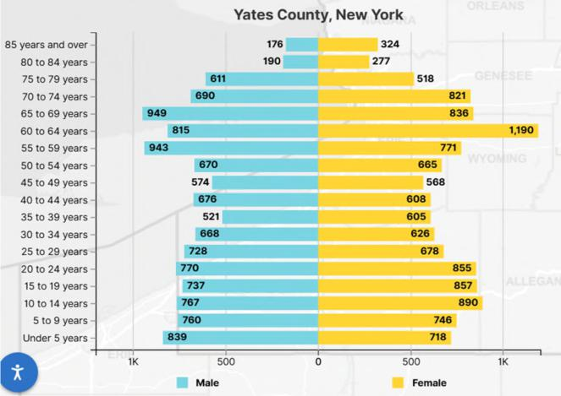
 | Source: U.S. Census 2020

Census data for Yates County indicate a largely white (93%) population followed by Hispanic or Latino (2.6%), Black or African American (0.7%), Asian (0.3%), and American Indian or Alaska Native (0.1%). The regional section of this CHA denotes additional population considerations, including Amish/Mennonite and migrant farmworkers.
There is a large Mennonite community who reside in Yates County. The Groffdale Mennonites, commonly known as Horse-and-Buggy Mennonites, settled in Yates County around 1974, coming from Lancaster County, Pennsylvania. The 2025 Old Groffdale and Midwest Horse and Buggy maps show that there are approximately 877 Mennonite households across Ontario, Schuyler, Steuben, and Yates Counties, with the largest number residing in Yates County. Since 2022, the number of horse-and-buggy households has increased by 97. However, since their settlement, Mennonites continued to diversify into Driving Mennonites, expanding households even further around the Finger Lakes Region.
Mennonites make a significant contribution to Yates County’s agriculture and economy. Additionally, it is important to note the cultural implications the population can have on local data, such as vaccination rates, uninsured rates, prenatal care, educational attainment, and unintentional injuries (e.g.., motor vehicle and farm accidents). The Mennonite community often resorts to homeopathic medicine and relies on experienced community members for health care. Community organizations and partners collaborate to host inclusive events that integrate Mennonite beliefs and values with evidence-based practices, providing the best opportunities for meaningful learning.
Page 73 Yates County

Community Health Assessment – Yates County

Veterans and People with Disabilities
Veterans often have distinct health needs, including higher rates of chronic conditions, mental health challenges, and service-related injuries. The Veteran population of Yates County accounts for 7.2% of the total population, which is higher than the NYS average (3.9%).³² Of that number 94% are male, and 6% are female.
People with disabilities may face heightened barriers to care, transportation, employment, housing, and healthy living. There are approximately 11.1% of the Yates County population who live with a disability. Comparatively, there is about 13.5% of the New York State population that lives with a disability. The most common disabilities are cognitive, independent living, and ambulatory difficulty.
Language Spoken at Home
In Yates County, according to the U.S. Census, 16.8% of people speak a language other than English at home. This includes: 1.6% who speak Spanish; 14.5% who speak Indo-European languages; 0.8% who speak Asian and Pacific Island languages; and 0.2% percent who speak other languages. The notable share of Indo-European language speakers is likely influenced by the presence of Amish and Mennonite communities. Providing language assistance in health care improves the quality of care for all populations with limited English proficiency, thereby optimizing overall health literacy.
Leading Cause of Death and Life Expectancy
The average number of years a person in Yates County may expect to live is 78.1³³, with variation throughout the county as seen in Map Y2. This number is lower than the state average of 80.4, but greater than the national average of 77.6.³³ Life expectancy in Yates County is greater than three of its contingent counties (Steuben 76.6, Seneca 77.5, and Schuyler 75.8) and lower than only the remaining contingent county of Ontario (79.6)^{33.} Life expectancy in Yates County has remained relatively stable since 2018.
Per NYSDOH 2025 data, the leading causes of death in Yates County are cancer, heart disease, and unintentional injury, respectively. The leading causes of cancer in the county include prostate, female breast, and lung cancers. At the state level, the leading causes of death are heart disease, cancer and COVID-19. The leading causes of premature death (before age 75) in Yates County are cancer, heart disease, and unintentional injury, reflecting state trends. The death rates for each indicator are noted in Tables Y1a and Y1b, along with NYS figures.
The total deaths per 100,000 Yates County residents exceed state rates for both overall death (839.3 vs 679.6 per 100,000) and premature death (334.4 vs 309.3 per 100,000). This is largely due to a substantial increase in unintentional injury deaths. At the state level, unintentional injury accounts for 50.6 per 100,000 deaths and is the fourth leading cause of death. In Yates County, this rises to 86.8 per 100,000 and is the third leading cause of death. Rates of premature death due to unintentional injury show a
³² Source: U.S. Census, 2023
³³ Source: University of Wisconsin Population Health Institute. (2025). Life expectancy: Yates County, New York. County Health Rankings & Roadmaps. www.countyhealthrankings.org/health‐data/population‐health‐and‐well‐being/length‐of‐life
Page 74 Yates County

Community Health Assessment – Yates County

similar trend. Statewide, unintentional injury accounts for 44.8 premature deaths per 100,000 while in Yates County this figure jumps to 70.4 per 100,000.
Table Y1a: Causes of Death (measured per 100,000 population)
Cause of Death | All Ages, Age-Sex Adjusted Yates  County | All Ages – NYS excluding NYC
Cancer | 142.6 | 129.23
Heart Disease | 141.1 | 159.82
Unintentional Injury | 86.8 | 50.6
Death Rate | 814.47 | 679.6

Source for Age-Sex Adjusted Leading Causes of Death: Source: NYS DOH Vital Statistics, 2022.Analysis by Common Ground Health
Table Y1b: Premature Causes of Death (Before age 75; measured per 100,000 population)
Cause of Death | Premature Death rate (Before age 75) Yates County | Premature Death rate (Before age 75) NYS excluding NYC
Cancer | 61.4 | 67.1
Heart Disease | 46.0 | 57.4
Unintentional Injury | 70.4 | 44.8
Death Rate | 334.4 | 309.3

Source for Premature Death Rates (before age 75): NYS Leading Causes of Death Dashboard.
Health Disparities
Health disparities are the preventable differences in health outcomes when compared to the overall population of an area. Yates County’s rural location presents significant challenges to health outcomes and access to care. With the densest populations near the villages of Penn Yan and Dundee³⁴, much of the county remains isolated, leaving many residents with limited access to physical and mental health care, inadequate health care infrastructure (e.g., provider shortages), low rates of physical activity, and restricted access to healthy food. Having limited availability to these resources can exacerbate chronic disease. Populations living in rural areas have a higher risk of developing chronic disease when compared to urban counterparts. The county also has a large aging population, lower socioeconomic status, and many uninsured individuals who face greater barriers to achieving optimal health.
³⁴ Source: Cornell University Population Density Maps for NYS Counties, February 2024.
Page 75 Yates County

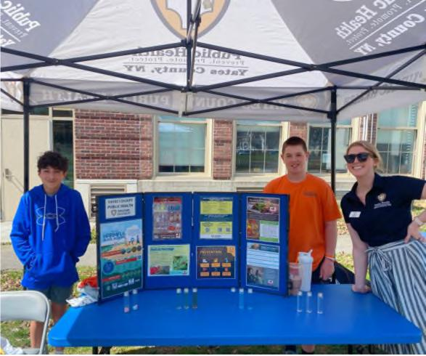
Penn Yan students, Wilson and Keegan, with Yates County Public Health Educator, Emily End, at the Future Farmers of America (FFA) field day event at the Penn Yan Middle School.
Community Health Assessment – Yates County

Health Status Description
Specific Methodology
The CHA provides a comprehensive picture of a community’s current health status, including factors that contribute to health risks and challenges, and identifies priority health needs by analyzing local data and community input. Community members and key stakeholders were invited to be part of the CHA by participating in the CHIP steering committee, known as Choose Health Yates. Choose Health Yates met monthly in 2025, except in January, May, July, and November.
Data Sources
Yates County’s CHA incorporated a blend of quantitative and qualitative data sources, including secondary data from the NYS Behavioral Risk Factor Surveillance System (BRFSS), County Health Rankings and Roadmaps, the National Center for Health Statistics, the American Community Survey, the U.S. Census, the NYS
Medicaid Program, and local performance reports.
Pivital Public Health Partnership assisted in the coordination, development, and distribution of the
assessments. The data collected from the assessments were used to tell the community’s story of overall
health and well-being.
Community partners played a key role throughout the development of the CHA by completing three assessments:
- Community Partner Assessment (CPA): An evaluation of collective community partner systems and capacities to identify partners working in the areas of health inequities.
- Community Status Assessment (CSA): A compilation of quantitative data from the state and local level to identify trends related to the social determinants of health and systems of power and privilege.
- Community Context Assessment (CCA): A collection of community voices and qualitative data to better understand the lived experience and priorities of those affected by inequities.
Community Engagement
Each assessment looked to gather different information by targeting different sectors of the community. The CPA was completed via an online survey platform and distributed to approximately 22 members of
Page 76 Yates County

Community Health Assessment – Yates County

the Choose Health Yates committee in February 2025. The response rate was approximately 46%, and the results were shared with the group to highlight partner strengths that could assist with the CHIP.
The second assessment, the CCA, was developed in March and conducted between April and May of 2025. During the CCA, a regional survey was developed and distributed to gather community feedback. The questions focused on the following categories provided by the MAPP 2.0 CCA assessment toolkit: overall health behaviors and outcomes, community strengths and assets, built environment, and forces of change. Choose Health Yates made it a priority to ensure disproportionately affected populations were included in qualitative data collection by choosing various engagement methods. Yates County Public Health, along with various other stakeholders, held focus groups, community dialogues, and interviews/discussions to collect qualitative data. A total of 11 engagement sessions were conducted throughout the CCA process. Yates County Public Health did attempt a PhotoVoice with the aging population, but due to low attendance, the session was cancelled.
Overall, the engagement methods were a great success, yielding rich insight from diverse target populations. Targeted populations included: aging population, low-income neighborhoods, youth, incarcerated individuals, faith-based groups, agricultural workers, and Mennonites. Choose Health Yates methodically identified where these populations were already meeting, and the agency conducting the CCA asked to be invited to the gathering to conduct the assessment. The groups provided extensive constructive feedback that painted a clear picture of community needs and existing strengths to build upon. Preliminary data from the CCA were shared at each monthly meeting with Choose Health Yates to gather input from committee members.
While the CCA was being conducted, Pivital Public Health Partnership completed the CSA. This was completed by compiling secondary data into scorecards stored in the performance management system, Clear Impact. The scorecards made data easily accessible and shareable among stakeholders and community members, helping review the overall health status of Yates County.
Throughout the assessments, the Choose Health Yates committee met regularly to present and discuss findings from all three assessments. These sessions encouraged questions, feedback, and shared interpretation of the data. The full committee collaboratively reviewed and discussed the triangulated results, allowing partners to validate findings and contribute to identifying several cross-cuffing themes. These themes included:
- Access to Care/Insurance Stability
- Opportunities for Active Transportation & Physical Activity
- Housing Stability & Affordability
- Mental Wellbeing & Substance Use
- Injuries & Violence
- Opportunities for Continued Education
The cross-cuffing themes were used to develop issue statements for each priority area. The issue statements were used to complete root cause analyses and create issue profiles for each health priority. Partners actively participated in analyzing and reviewing these issue profiles. The group then completed a prioritization matrix process to refine options further by systematically comparing identified issues through selection, weighing, and applying a ranking criterion. The ranking criteria included: relevance to the community, magnitude or severity, impact on communities affected by inequities, availability and
Page 77 Yates County

 | Community Health Assessment – Yates County | 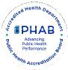

feasibility of solutions, and availability of resources. This process ensured that shared priorities reflected both data and community voice. Yates County Public Health shared its prioritization matrix process with the Choose Health Yates committee, which consisted of small group community members.
The final CHA will be made available to the public through several platforms including posting on the Yates County Public Health website, sharing infographics on social media (Facebook, Instagram), distribution to the Yates County Legislature and community partners, and discussion on local radio (WFLR).
County Health Rankings
The County Health Rankings & Roadmaps program highlights differences in community health within and across communities. This ranking system assesses several variables, including community conditions, population health and well-being, social and economic factors, and built environment.
Yates County is ranked above the national and state averages for health and well-being (Figure Y3). This measure reflects the overall quality of life and the ability to thrive within a community. Variables affecting physical, mental, spiritual, and social well-being are included in this measure. This ranking signals that Yates County is a community that supports its residents and provides the foundation for living, growing, and succeeding.
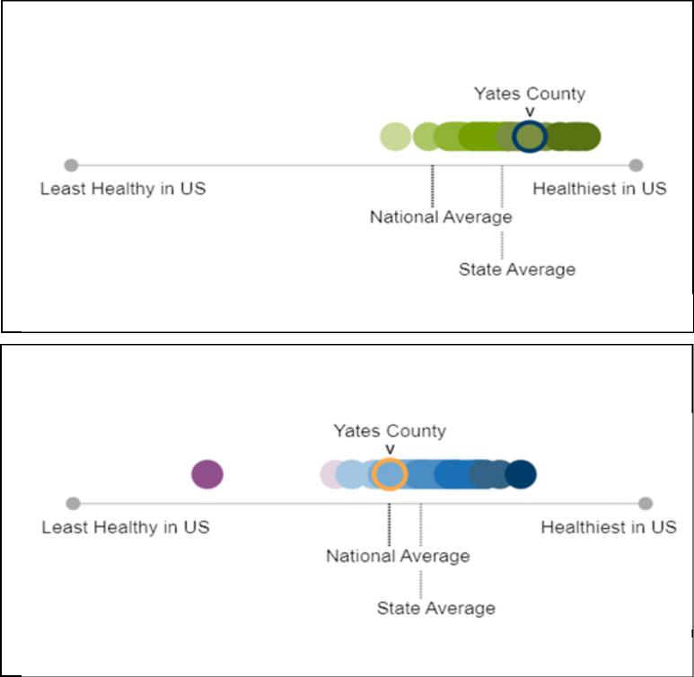
Figure Y3: Health and Well-Being (2025)
Source: County Health Rankings
Figure Y4: Community Condifions/SDOH (2025)
Source: County Health Rankings
However, rankings of community conditions and the Social Determinants of Health fall below the state average and are roughly comparable to the national average (Figure Y4). The Social Determinants of Health refer to the non-medical factors that influence individual and community health outcomes, including economic stability; access to and quality of education; access to and quality of healthcare; neighborhood and built environment; and social and community context. This ranking signifies that, despite the overall quality of life exceeding state and national averages, there is still work to be done to address underlying factors affecting community health outcomes.
Page 78 Yates County

Community Health Assessment – Yates County

New York State Prevention Agenda 2025-2030
Table Y2 identifies the New York State Department of Health (NYSDOH) Prevention Agenda domains and priorities (see Regional Chapter for further information). The “Community Partners” column shows the percentage of partners in the CPA who expressed that each domain is either very important or important to address, or who are unsure of its importance. Bolded priorities are those Yates County has chosen to prioritize during this CHA cycle.
Table Y2: NYS Prevention Agenda
Domain | Priorities | Community Partners
- Economic Stability | Poverty | 80% very important 10% important  10% unsure
- Economic Stability | Unemployment | 80% very important 10% important  10% unsure
- Economic Stability | Nutrition Security | 80% very important 10% important  10% unsure
- Economic Stability | Housing Stability and Affordability | 80% very important 10% important  10% unsure
- Social and Community Context | Anxiety and Stress | 40% very important 40% important 20% unsure
- Social and Community Context | Suicide | 40% very important 40% important 20% unsure
- Social and Community Context | Depression | 40% very important 40% important 20% unsure
- Social and Community Context | Primary Prevention, Substance Misuse, and Overdose Prevention | 40% very important 40% important 20% unsure
- Social and Community Context | Tobacco/ E-cigarette Use | 40% very important 40% important 20% unsure
- Social and Community Context | Alcohol Use | 40% very important 40% important 20% unsure
- Social and Community Context | Adverse Childhood Experiences | 40% very important 40% important 20% unsure
- Social and Community Context | Healthy Eating | 40% very important 40% important 20% unsure
- Neighborhood and Built Environment | Opportunities for Active Transportation and Physical Activity | 40% very important 40% important 20% unsure
- Neighborhood and Built Environment | Access to Community Services and Support | 40% very important 40% important 20% unsure
- Neighborhood and Built Environment | Injuries and Violence | 40% very important 40% important 20% unsure
- Health Care Access and Quality | Access to and Use of Prenatal Care | 50% very important 40% important  10% unsure
- Health Care Access and Quality | Prevention of Infant and Maternal Mortality | 50% very important 40% important  10% unsure
- Health Care Access and Quality | Preventive Services for Chronic Disease Prevention and Control | 50% very important 40% important  10% unsure
- Health Care Access and Quality | Oral Health Care | 50% very important 40% important  10% unsure
- Health Care Access and Quality | Preventive Services | 50% very important 40% important  10% unsure
- Health Care Access and Quality | Early Intervention | 50% very important 40% important  10% unsure
- Health Care Access and Quality | Childhood Behavioral Health | 50% very important 40% important  10% unsure
- Education Access and Quality | Health and Wellness Promoting Schools | 60% very important 30% important  10% unsure
- Education Access and Quality | Opportunities for Continued Education | 60% very important 30% important  10% unsure

Page 79 Yates County

Community Health Assessment – Yates County

Domain: Economic Stability
Economic stability is influenced by each of the priorities listed above: poverty, unemployment, nutrition security, and housing stability and affordability. Socioeconomic disparities are closely linked to poor health, affecting physical, mental, and educational outcomes. Children and older adults are especially vulnerable to these adverse effects.
Unemployment and underemployment contribute to major health inequities. Unemployed individuals face greater barriers to health care and experience worsening health as unemployment persists. Employment challenges stem from shifts in the labor market, wage stagnation, and weakening labor protections.
Food insecurity disproportionately affects low-income households, people with less education, and those who are unemployed. Access to affordable, nutritious food is vital for preventing chronic disease and supporting healthy development. Many communities, especially rural and low-income communities, lack full-service grocery stores and rely on costly convenience outlets with limited healthy options.
Housing insecurity further undermines health by increasing stress, reducing stability, and increasing exposure to unsafe and/or unhealthy environments. Low-income families and older adults face the greatest housing burdens and associated health risks.
Priority: Poverty
Poverty can strain nearly every aspect of community life, from housing stability to healthcare access,
transportation, and nutritious food. Families facing financial hardship often struggle to meet basic needs, and limited resources can make it difficult for them to find sustainable pathways out of poverty.
Map Y2 shows the distribution of poverty across Yates County³⁵. An estimated 14.1% of residents live in poverty, with the highest concentrations located in the southern part of the county, particularly around Dundee, Himrod, and Dresden. Poverty levels in Yates County have been rising steadily since 2018, and by 2022, the county’s rate exceeded the statewide average. Among children under 18, 23% live in
poverty, which is above the New York State average of 19% but an improvement from 26% in 2019. For adults age 65 and older, 12.5% live in poverty, just under the state average of 12.7%. However, the poverty rate for older adults has increased significantly - up 51% since 2018.
³⁵ Source: Common Ground Health, 2024. https://commongroundhealth.org/insights/county‐health‐statistics
Page 80 Yates County

 | Community Health Assessment – Yates County | 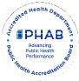

Map Y2: Overall Poverty Rate in Yates County
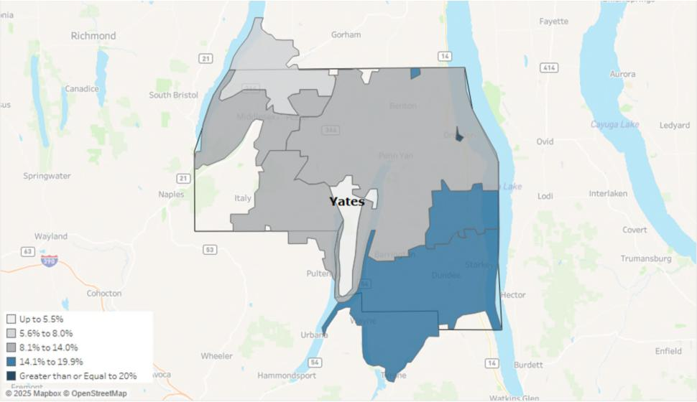
Priority: Unemployment
The unemployment rate in Yates County was 4.5% in April 2025. Figure Y5 notes the trend in unemployment rates recorded each January from 2019 to present. According to US Census data from 2023, the top three employment sectors in Yates County are (1) educational services, health care and social assistance (24.7%); (2) manufacturing (14.5%); and (3) retail trade (11.9%).
Source: Bureau of Labor Statistics
Figure Y5: Unemployment Rate in Yates County as reported in January of each year
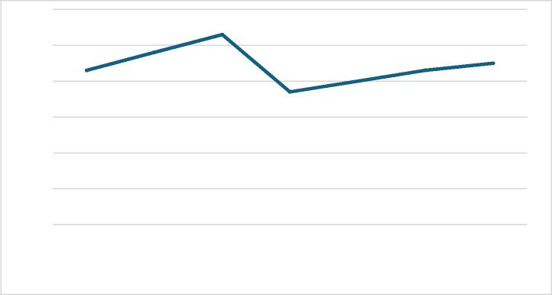
6.00%
5.30%
4.80%
4.30%
4.50%
4.30%
4.00%
3.70%
3.00%
2.00%
1.00%
0.00%
2019 2020 2021 2022 2023 2024 2025
5.00%
4.00%
2023 U.S Census data indicate that the median household income in Yates County is $67,521, lower than the state median of $85,820. The gross hourly wage needed for a family of one adult and two children to cover household expenses gradually increased from $38.36 in 2021 to $51.14 in 2024. This figure
Page 81 Yates County

remains lower than the 2024 state value of $61.75 but higher than those of neighboring counties, Seneca, Steuben, and Schuyler.
Community Health Assessment – Yates County

Priority: Nutrition Security
It is important to note the definitional difference between nutrition and food security for data relevance. The New York State Prevention Agenda defines food security as having access to enough food. When a person reports they are food insecure, they recognize they have limited or uncertain access to food due to limited economic resources. Map Y3 shows the food insecurity rates of Yates and contiguous counties. On the other hand, nutrition security looks not only at food access, but also at consistent and equitable access to healthy, safe, affordable food. New York State has transitioned to focus on nutrition insecurity data, but food insecurity data remains relevant to ensure equitable access of food exists across all parts of the state.
Nutrition and food insecurity can lead to higher rates of chronic disease, poor child development, and overall diminished health and well-being. When families lack consistent access to affordable and nutritious food as well as community systems, such as healthcare and schools, they may feel the strain of long-term inequities, resulting in poorer health outcomes.
Approximately one in four adults (24.9%) in New York State experience food insecurity. Having access to affordable, healthy food helps reduce hunger and prevent chronic disease. Food and nutrition security rates may be influenced by several factors, including income, employment, race/ethnicity, and disability.³⁶ Areas with higher poverty rates (Dundee, Himrod, and Dresden) will likely face greater challenges in accessing healthy, safe, and affordable food.  Additionally, children are disproportionately impacted by food insecurity. Feeding America closely monitors annual food insecurity and food costs using real-time data. In Yates County, approximately 950 children are food-insecure, | Map Y3: Food Insecurity Rate
 | 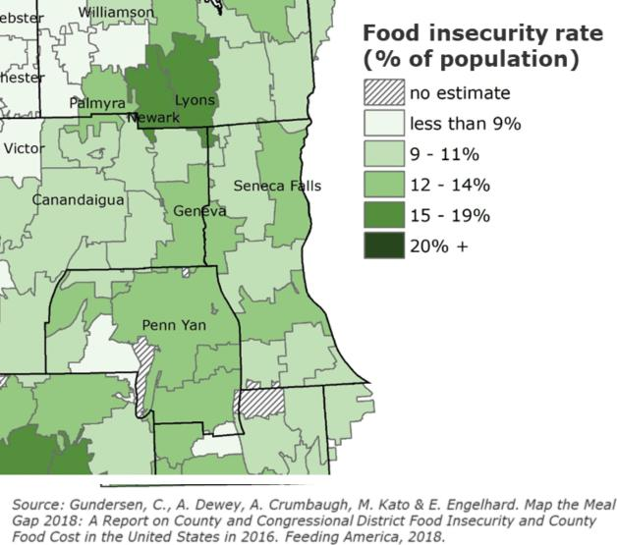

³⁶ Source: Healthy People 2030, 2025
Page 82 Yates County

and the overall food insecurity rate for children is 16.9%, which is lower than the New York State rate of 19.0%.³⁷
 | Community Health Assessment – Yates County | 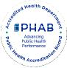

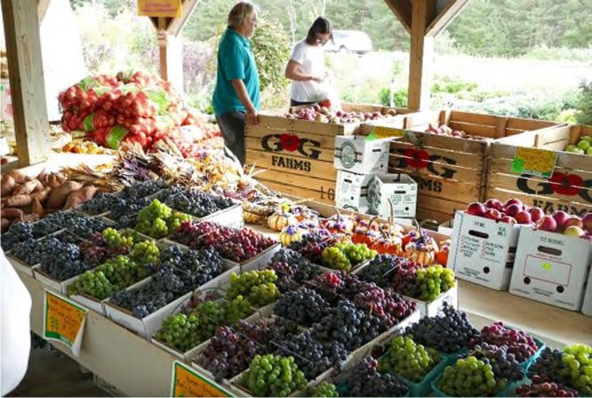 | The Food Environment Index of the  USDA Food Environment Atlas  measures how easy it is for residents to  access healthy, affordable  food, combining rates of food insecurity  and the percentage of low-income  people living far from a grocery store.  Scores range from 0 (worst) to 10  (best). Yates County’s score decreased  from 8.9 in 2018 to 8.8 in 2022 and  is nearly equal to the state average of  8.7. This indicates that, on average,  residents face barriers to healthy food  access similar to those elsewhere in the  state.
Picture courtesy of Yates Chambers of Commerce of Windy Acres Farm Market
Priority: Housing Stability and Affordability

Housing was identified as a top priority affecting community stability, access to basic needs, and overall health and well-being in Yates County. Housing instability and a lack of affordable options can leave families struggling to meet basic needs, often forcing them to choose between housing costs, food, and healthcare. When stable housing is out of reach, communities experience higher rates of homelessness, overcrowding, and financial stress, which can undermine overall health, safety, and economic growth.
In 2021, 13% of households in Yates County experienced at least one of the following major housing problems: overcrowding, high housing costs, and/or lack of kitchen or plumbing facilities. This is well below the state average of 23% and reflects a 13% improvement since 2017. Severe housing cost burden has remained stable since 2021, with only 12% of households spending half or more of their income on housing, compared to 19% statewide. This represents an 8% improvement since 2019, when 13% of households were spending half or more of their income on housing. However, this progress is still concerning given that 14% of the population lives in poverty, leaving many households with very limited resources to meet basic needs beyond housing.³⁸
A recurring issue raised by focus groups was the increasing use of rental properties for tourism, which drives up costs and reduces availability for residents. Homeownership rates in the county have decreased from 80% in 2019 to 77% in 2023, indicating that fewer residents live in owner-occupied residences.³⁹ According to data from the 2023 American Community Survey 5-Year Estimates, Yates County has a total of 13,143 housing units, of which 4,048 units are vacant. Vacant housing includes
³⁷ Source: Feeding America, 2023: https://map.feedingamerica.org/county/2023/child/new-york/county/yates
³⁸ Source: U.S. Census Bureau, 2025
³⁹ Source: County Health Rankings & Roadmaps, 2025
Page 83 Yates County

 | Community Health Assessment – Yates County | 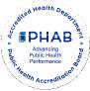

units with no occupants at the time of the census, temporarily occupied residences such as short-term rentals and vacation homes, and new units not yet occupied. As of 2025, Yates County has 615 short-term rental properties (i.e., residences available for rent up to 30 days) registered with the Department of Finance. ⁴⁰
According to the American Community Survey 5-year Estimates, the 2023 vacancy rates (defined differently from the census) indicated the housing inventory available for long-term rent or sale were 2% for rental-occupied units and 1% for homeowner-occupied units. Concerns over a shortage of affordable middle-income housing and reasonably priced rental properties were also discussed in focus groups. Approximately 26% of renter-occupied households contribute more than 35% of their household's gross income towards rent, indicating a significant cost burden for many residents. Furthermore, the average rent in Yates County was $802 in 2023, which was lower than in neighboring counties. However, through discussions of lived experiences with focus groups, the cost of rent in 2025 is significantly higher than that of 2023.
Residents also raised the issue of lack of local senior housing and assisted living options that support aging in place. According to the Pro Action Office for the Aging, Yates County is home to six independent living homes and three higher-level care facilities for older adults. Admission to these facilities often involves strict eligibility requirements and higher costs for individuals and families. The ALICE Household Monthly Survival Budget estimates that a single senior needs $2,770/month to cover basic needs. New York State reports that the average cost of long-term care is between $5,500 and $13,000 per month, a significant contrast to what most older adults can afford.⁴¹ As a result, many local seniors are compelled to relocate to more suitable living arrangements elsewhere.
Focus group participants expressed a strong connection to their community and a desire to remain in Yates County as they age. However, barriers such as lack of in-home assistance, high costs, and transportation challenges were noted as reasons older adults often seek alternative living accommodations. Aging in place is associated with individual and community benefits, including improved life satisfaction and increased volunteerism.⁴² With nearly a quarter of the population aged 65 and older, concerns about the availability of aging in place options are likely to grow in the coming years.
Economic Stability Domain Summary: The percent of people living in poverty in Yates County has shown a steady increase since 2018, rising from 11.4% (2018) to 14.1% (2023). This same upward trend in poverty rates can also be seen among populations who are 65 and older in Yates County. Employment indicators are strong, with lower unemployment, however, the gross hourly wage needed to sustain a family of four remains below the median household income. Nutrition security has improved, and the county’s overall food environment now aligns with the state average. Homeownership rates have declined, and significant cost burdens persist, especially for vulnerable populations like the aging and low-income residents.
⁴⁰ Source: Yates County Document Center: https://www.yatescountyny.gov/DocumentCenter/View/8733/Yates-County-Registered-STR-Properties?bidId=
⁴¹ Source: New York State Department of Financial Services, 2023
⁴² Source: Rural Health Information Hub, 2019
Page 84 Yates County

 | Community Health Assessment – Yates County | 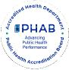

Domain: Social and Community Context
Good mental health is essential for daily functioning, healthy relationships, and resilience. Stress and
anxiety can harm the body, contribute to conditions like depression and substance misuse, and increase the risk of early death.
Nationally, suicide remains a major public health concern. Many high school students report suicidal thoughts or attempts, and death by suicide is still a leading cause of death among young people nationally.
Depression affects more than one in five New Yorkers each year and significantly disrupts daily life.
Certain groups face higher risks due to chronic stress, trauma, and systemic inequities. Many people still struggle to access or seek treatment because of stigma or limited services.
Substance use and overdose deaths continue to pose serious challenges in the state. Early alcohol and drug use, high availability of substances, and social norms contribute to risk.
Commercial tobacco use remains a leading cause of preventable illness and death, with significant disparities driven by targeted marketing, especially in low-income and minority communities. Excessive alcohol use is common and leads to thousands of deaths and billions of dollars in economic costs for New York State each year. Availability, low pricing, and targeted marketing contribute to unequal burdens among certain populations.
Adverse childhood experiences (ACEs) are events in childhood, such as abuse or neglect, that negatively impact long-term health. These experiences significantly increase the risk of chronic disease, mental health problems, and substance misuse later in life.
Healthy eating is vital for preventing chronic disease, yet many New Yorkers fall short of fulfilling the recommended intake of fruits, vegetables, and other nutrients.
Priority: Anxiety and Stress
Data from the BRFSS indicates that the percentage of adults reporting 14 or more days of poor mental health per month (age-adjusted) increased from 14% in 2018 to 19% in 2022, above the NYS average of 16%. Experiencing 14 or more days of poor mental health in a month is strongly linked to worse overall health outcomes. When this percentage rises, as it has in Yates County, it can signal increasing stress, depression, or anxiety in the community, which may lead to higher rates of chronic disease, substance use, reduced productivity, and greater demand for mental health and medical services.
When comparing Yates County to New York State as a whole and other counties, Yates residents reportedly experience poor mental health at a greater rate (see Map Y4). According to County Health Rankings and Roadmaps, Yates County residents, on average, report 6.1 poor mental health days out of the last 30 days. Comparatively, surrounding counties report only 5.7 poor mental health days out of the last 30. This elevated rate suggests that residents may struggle more with daily functioning, decision-
Page 85 Yates County

 | Community Health Assessment – Yates County | 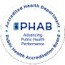

making, and maintaining healthy behaviors, ultimately affecting both individual well-being and community health.⁴³
Map Y4. Poor Mental Health Days in New York
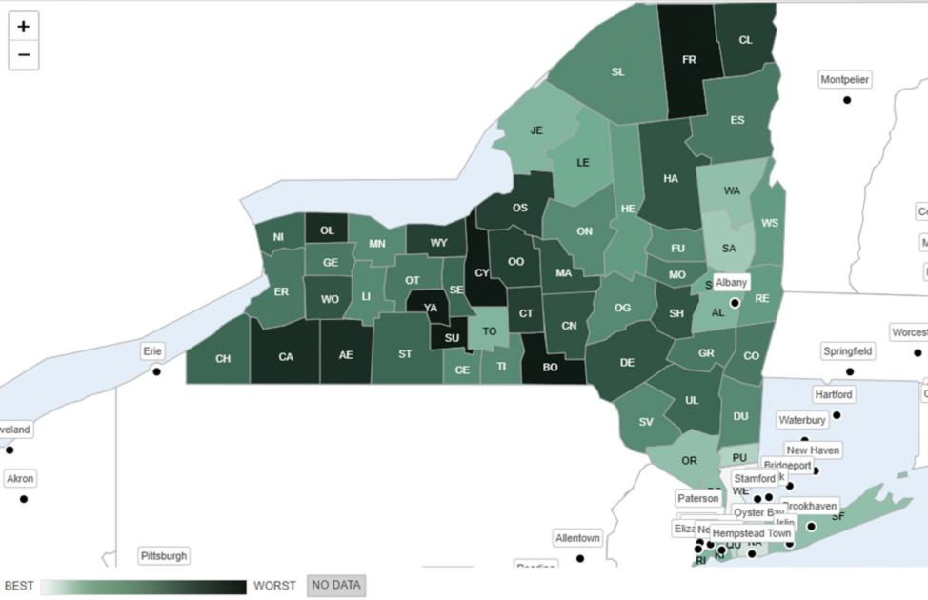
Source County Health Rankings and Roadmaps
Mental health was a common concern across all ages and backgrounds, with many focus group respondents citing a range of compounding factors. Youth cited bullying and cyberbullying as key contributors, while older adults noted the rural community and social isolation as important factors. A shortage of mental health providers and ongoing barriers to seeking help, especially for marginalized groups such as older adults and the LGBTQ+ community, were cited as cause for concern. Other suggested root causes include an increased focus on social media and technology, stigma around receiving mental health care, and the effect of the high cost of living on quality of life.
Residents value organizations that facilitate social and personal connections, such as Pro Action Office for the Aging, community centers, health organizations, churches, libraries, and The Living Well. Many focus group participants commented on the wide range of community supports available and expressed gratitude for their work in the community. Volunteerism and peer support are seen as vital for
⁴³ Source: Strine TW, Balluz L, Chapman DP, Moriarty DG, Owens M, Mokdad AH. Risk behaviors and healthcare coverage among adults by frequent mental distress status, 2001. Am J Prev Med. 2004 Apr;26(3):213-6. doi: 10.1016/j.amepre.2003.11.002. PMID: 15026100.
Page 86 Yates County

Community Health Assessment – Yates County

community outreach and engagement, with many residents expressing a desire for more opportunities to connect with the various populations of Yates County.
Despite recognizing opportunities and a desire to grow community connections, isolation remains a frequent theme, particularly in the aging community. Beyond social connections, residents request more chances for mentorship and regular information sharing. There is a desire for more educational programming on topics such as chronic disease prevention and resource awareness. Community members feel that implementing such programs may assist in bringing together the community and removing the sense of isolation to better support and improve the overall quality of life in the community.
Priority: Suicide
The National Center for Health Statistics notes that in 2022 the suicide rate in the county was 15.0 per 100,000 people, nearly double the NYS average of 8 per 100,000 people. This represents a 36% increase in deaths due to suicide since 2018. In contrast, the suicide rate among youth (15-19 years of age) was 0.0 per 100,000 people in 2022, which is lower than the NYS average of 5.6 and has remained unchanged since 2015. The rate of youth suicide remains a bright spot, suggesting strong protective factors and support systems for adolescents in the county. However, the substantial increase in deaths due to suicide among adults indicates that expanded mental health resources are needed to better support this population.
Rising suicide rates signal worsening mental health and increasing levels of stress, trauma, or unmet behavioral health needs in the community. When the county’s overall suicide rate exceeds the state average, it suggests that residents may face greater barriers to timely mental health care, social support, or crisis intervention. Higher suicide rates also have wide-reaching impacts, causing strain to families, schools, healthcare systems, and communities. It also potentially indicates deeper issues such as isolation, substance use, economic stress, or limited access to mental-health services.⁴⁴
Priority: Depression
In Yates County, the age-adjusted percentage of adults reporting a depressive disorder in 2021 was 24.3%. This is greater than the NYS rate of 18.7% in the same year and has increased 40% since 2016. Elevated rates of depression are associated with increased risk of chronic diseases, substance use, social isolation, and suicide, as well as greater demand for mental health services. When the county rate is both higher than the state's average and rising, it indicates that many residents may not be receiving adequate treatment or support, contributing to long-term health disparities and strain on local healthcare and social services.⁴⁵
Focus groups identified several root causes of high depression rates in the area. Insights suggested that decreased resiliency, increased reliance on social media and technology, and the lingering mental health impacts of the pandemic have all played significant roles. Participants also identified broader societal influences, such as the stigma around receiving care, the high cost of living, and career burnout, as
⁴⁴ Source: https://www.cdc.gov/suicide/facts/index.html
⁴⁵Source: National Institute of Mental Health: https://www.nimh.nih.gov/health/publications/chronic-illness-
mental-health?utm_source=chatgpt.com
Page 87 Yates County

Community Health Assessment – Yates County

additional influences on mental health. Focus groups did recognize that the screening process for mental health concerns has greatly improved, potentially identifying a higher number of cases compared to the past. However, it was consistently noted that the infrastructure of mental health care is lacking in the area, contributing to difficulty in receiving care when needed.
The community emphasized that expanding opportunities for social support and community engagement would improve mental health across the county. It is also understood that geographic factors, such as the rural landscape of Yates County, can increase the risk of social isolation and contribute to depression rates. Considering this, participants stressed the importance of pursuing creative solutions that build on community strengths to better support those experiencing mental distress.
Priority: Primary Prevention, Substance Misuse, and Overdose Prevention
Since 2021, there has been a sharp decrease in overdose deaths involving any drug in Yates County, decreasing from a crude rate of 20 deaths per 100,000 population in 2021 to 8.2 deaths per 100,000 in 2022. Yates County also has a lower overdose death rate compared to the Finger Lakes Region as a whole. Opioids, opioid pain relievers, and synthetic opioids other than methadone saw a dramatic decline in overdose deaths. However, overdoses involving cocaine in Yates County have increased from a zero crude rate per 100,000 population in 2020 to 8.2 in 2022. This data supports anecdotal information from the community regarding a recent shift to increased use of cocaine and methamphetamine.
Focus groups expressed concern about the connection between mental health and substance use, remarking that poor access to mental health providers in the area may affect substance use rates. Individuals with lived experience noted the effect that social isolation has on substance use and mental health, adding that disciplinary actions such as revoking driver’s licenses intensify feelings of isolation. Yates County has one mental health provider for every 840 residents, more than three times the NYS ratio (260:1), indicating that Yates County has roughly two-thirds fewer available providers than the state. According to the Substance Abuse and Mental Health Administration (SAMHSA), a diagnosis such as anxiety or depression increases an individual’s risk for substance use. With limited access to mental health support, Yates residents with existing mental health concerns may be at a higher risk of substance use than those in surrounding counties.⁴⁶
The community recognized Yates County’s efforts to address the opioid epidemic and the resulting progress. Since 2023, the county has recorded 269 Naloxone training sessions, 798 individuals trained in Naloxone distribution, and 495 Naloxone kits distributed. Despite the shifting trends in substance use, maintaining these initiatives is vital to prevent opioid-related deaths. Furthermore, the growing use of stimulants presents continued risks as these substances may be contaminated with high-risk drugs such as fentanyl. People who use substances consequently remain vulnerable to opioid-related injury or death, regardless of the type of substance being used. Ongoing community education about overdose prevention and substance use risks is critical in continuing the positive trends currently being experienced.
⁴⁶ Source: Substance Abuse and Mental Health Administration (SAMHSA)
Page 88 Yates County

Community Health Assessment – Yates County

Priority: Tobacco/E-cigarefte and Alcohol Use
According to data from the BRFSS, the percentage of adults who are current smokers (age-adjusted) has declined slightly since 2018 from 19% to 18% in 2022, which still remains above the New York State average of 12%. In contrast, the percentage of adults reporting binge or heavy drinking quickly rose from 16% (2021) to 22% (2022), higher than the state average of 20%. Data on e-cigarefte use among adults in the county are not available, but rates of vaping by middle and high school students are available. In 2022, 3.9% of middle school students reported vaping within the last 30 days, and 5.3% of high school students reported that they vaped within the last 30 days.⁴⁷
Both smoking and excessive alcohol use are major risk factors for chronic diseases, including heart disease, cancer, liver disease, and respiratory illnesses. Higher rates of these behaviors in the community increase the burden on healthcare systems, contribute to preventable morbidity and mortality, and can reduce quality of life. Persistent smoking above the state average and rising binge or heavy drinking indicate that residents may face elevated long-term health risks and that targeted prevention and intervention efforts are needed.⁴⁸
Priority: Adverse Childhood Experiences
Adverse Childhood Experiences (ACEs) are the emotional and physical circumstances one experiences before age 18. These may include neglect, sexual abuse, parental divorce, mental illness, and/or substance abuse in the home, and exposure to violence. ACEs impact individuals well into adulthood and may result in long-term physical and mental health problems. The age-adjusted percentage of adults with two or more adverse childhood experiences decreased from 29.4% in 2016 to 24.8% in 2021, below the current NYS average of 40.5%.
ACEs have long-lasting effects on physical, mental, and behavioral health. Experiencing two or more ACEs increases the risk of chronic diseases, mental health disorders, substance use, and social challenges well into adulthood. Even though the county’s rate of adults with two or more ACEs has decreased to 24.8%, this still represents a substantial portion of the population at higher risk for long-term health problems and increased healthcare and social service needs.⁴⁹
Priority: Healthy Eating
From 2016 to 2021, the percentage of adults who eat fruits daily (63.4%) increased by 16%, and those who eat vegetables daily (70.2%) decreased by 4%.⁵⁰ An interesting dichotomy arose in focus groups where some individuals stated it was difficult to incorporate healthy eating into their routines, while others said it was very easy. Approximately 1 in 5 NYS adults consume at least one sugar-sweetened
⁴⁷ Source: Yates County Evalumetric Youth Survey Report, 2022
⁴⁸ Source: Kim Y. The effects of smoking, alcohol consumption, obesity, and physical inactivity on healthcare costs: a longitudinal cohort study. BMC Public Health. 2025 Mar 5;25(1):873. doi: 10.1186/s12889-025-22133-4. PMID: 40045251; PMCID: PMC11881326.
⁴⁹ Source: hftps://www.cdc.gov/aces/about/index.html
⁵⁰ Source: Behavior Risk Factor Surveillance System (BRFSS), 2021
Page 89 Yates County

Community Health Assessment – Yates County

beverage daily.⁵¹ In Yates County, the percentage of adults with annual incomes below $25,000 who drink one or more sugar-sweetened beverages has increased from 10.7% in 2016 to 17.1% in 2018.
Low consumption of fruits and vegetables and high intake of sugary drinks contribute to poor nutrition, obesity, diabetes, heart disease, and other chronic conditions. Addressing sugar-sweetened beverage consumption is important because studies have found that frequently drinking these beverages is linked to weight gain, tooth decay and cavities, heart disease, stroke, and type 2 diabetes in adults.⁵² When access to healthy foods is limited, especially for lower-income populations, residents are more likely to develop diet-related illnesses, increasing healthcare costs and reducing overall community health and quality of life.⁵³
Social and Community Context Domain Summary: Yates County is experiencing significant mental and behavioral health challenges. Rates of poor mental health, depression, and suicide all exceed state averages, signaling rising stress, untreated mental health needs, and growing demand for services. Substance use concerns are also increasing, with sharp rises in overdose deaths involving non-opioid drugs, despite overall rates remaining below the New York State average. Risk behaviors such as smoking and heavy drinking continue to contribute to preventable health problems, while mixed trends in healthy eating and persistent impacts of adverse childhood experiences further underscore ongoing vulnerabilities. Together, these indicators highlight mental health, substance use, and related social factors as critical priorities for improving community well-being.
Domain: Neighborhood and Built Environment
Regular physical activity offers wide-ranging benefits at every age. It lowers the risk of major chronic diseases, including heart disease, stroke, type 2 diabetes, and several cancers, and supports stronger bones and muscles, better sleep, improved mental health, and longer life expectancy.
Access to physical activity is not equal. Structural barriers such as unsafe neighborhoods, limited accessible facilities, or environments not designed for diverse needs shape how people can be active. Social factors like income, education, community support, and cultural attitudes also influence activity levels. Physical environment features, including parks, safe sidewalks, bike lanes, and walkable neighborhood layouts, also play a major role.
Active transportation, such as walking or biking, to reach daily destinations can help integrate physical activity into everyday routines, but it requires safe, well-connected routes and nearby destinations.
Injuries are a leading cause of premature death. Motor vehicle crashes, falls, and overdoses are major contributors, with disparities affecting racial and ethnic minorities, older adults, and workers in high-risk occupations.
Priority: Opportunities for Active Transportation and Physical Activity
Focus groups report mixed experiences related to community amenities and social infrastructure
supporting health. As of 2024, the percentage of the population with adequate access to physical activity
⁵¹ Source: Behavior Risk Factor Surveillance System (BRFSS), 2021
⁵² Source: Behavior Risk Factor Surveillance System (BRFSS), 2021
⁵³ Source: https://www.cdc.gov/nutrition/php/about/index.html
Page 90 Yates County

Community Health Assessment – Yates County

locations is 44%. This has remained stable since 2022 but is well below the NYS average of 93%. Some residents praise the available nature trails and recreational spaces for opportunities to maintain health, while others cite a lack of such opportunities in more rural areas. Many focus group respondents note that the Village of Penn Yan has adequate access to amenities that promote health, such as the Yates Community Center. Participants also observed that agencies such as Yates County Public Health and the Yates Office for the Aging (OFA), administered by Pro Action of Steuben and Yates, Inc., provide ample support to the community as a whole.
However, these positive experiences are not shared equally throughout the county. Many respondents comment on a lack of health-supporting community amenities and social opportunities. One focus group participant noted that “if you live in Dundee...there is nothing to access inside where people can have a social network”. Several other community members supported the notion that maintaining health outside of larger villages and towns is difficult, particularly in areas such as Branchport and Potter, which “need more resources for health”. This is reflected in data from 2022, when 27% of adults reported no leisure-time physical activity. This is slightly higher than the NYS average of 25% and an increase of 23% from 2021.⁵⁴ A frequently expressed suggestion across multiple focus groups was the need for a community pool to help address gaps in health-promoting amenities. The disparity between more populated areas and their more rural counterparts emphasizes an opportunity to support recreation, social connection, and safety measures in less populated communities.
In addition to concerns about health-supporting community amenities, focus group members repeatedly noted a need for improvements to county-wide built infrastructure. ⁵⁵ Many neighborhoods lack accessible sidewalks, causing pedestrians to walk in the streets. This is reflected in a poor Walkability Index (3.67 out of 20).⁵⁶The National Walkability Index accounts for the built environment’s effect on the probability that a person will walk as a mode of transportation and reflects street intersection density, proximity to transit stops, and land-use diversity.⁵⁷ The low walkability index in Yates County raises concern for the 13% of residents without access to a vehicle, who may face transportation challenges. Residents recognized improvements made, specifically in Dundee, but would like to see these projects continued.
Other concerns, such as speeding, poor signage, and unsafe roads, especially near playgrounds and schools, are widely noted. Road and sidewalk safety are compounded by increased traffic during the tourist season and horse-and-buggy use from the large Mennonite community. Many residents express the need for an allotted bike and/or horse and buggy lane to improve safety for all when traveling. Overall, residents express a strong desire for traffic calming, better signage, and safer pedestrian environments.
Accessibility for those with mobility differences and the need for assistive devices was raised as a concern. Residents noted accessibility is limited by a lack of ramps and safe infrastructure. Several anecdotes were shared about experiences with limited accessibility, especially in downtown Penn Yan. Limited accessibility is compounded by poor lighting, poorly maintained sidewalks and roads, and a lack
⁵⁴ Sources: U.S. Census, County Health Rankings, EPA Office of Community Revitalization
⁵⁵ Source: EPA Office of Community Revitalization, 2021
⁵⁶ Source: National Walkability Index Methodology and User Guide
⁵⁷ Source: EPA Office of Community Revitalization, 2021
Page 91 Yates County

Community Health Assessment – Yates County

of accessibility buttons for doors. Residents collectively express a desire for safer, more inclusive, and better lit areas for activity. Access to safe spaces for physical activity, transportation options, and walkable environments directly affects residents’ ability to maintain regular exercise. Low physical activity is linked to higher risks of obesity, heart disease, diabetes, mental health issues, and overall premature mortality. Limited walkability and inadequate access to activity locations or transportation can create barriers to healthy lifestyles, contributing to long-term health disparities in the community.⁵⁸
Priority: Access to Community Services and Support
The Social Vulnerability Index (SVI) is a composite measure reflecting factors such as poverty, unemployment, housing, disability, minority status, and access to transportation. It is used to identify communities that may need additional support during emergencies or public health interventions. SVI is measured from 0 to 1, with values closer to zero indicating less vulnerability. Yates County’s SVI was 0.6066 as measured in 2022, indicating moderate social vulnerability. This is an improvement from an SVI of 0.7377 in 2014, but a poorer score than the 2018 score of 0.4918. This fluctuation represents changes in the community, with recent progress in addressing underlying risk factors.
Civic engagement and strong community networks, such as high voter participation and membership in organizations, help build social cohesion, improve disaster preparedness, and support collective action during crises. Civic engagement may be measured as voting, volunteering, and participating in community events. The percentage of the voting-age population who voted in the 2020 presidential election was 56.2%. Per the National County Health Rankings, Yates County has 11.9 membership organizations per 10,000 people, representing civic, political, religious, sports, and professional organizations.¹³
Examining the SVI and civic engagement together can help us predict how the community might respond to challenges, such as a disaster or emergency. A community with a higher SVI may face a greater risk of harm and slower recovery, while a community with strong civic engagement may have more community support to respond to the challenges. Yates County’s relatively low SVI and strong civic involvement suggest it has a solid foundation to respond to community challenges, though vulnerabilities still exist for certain populations.⁵⁹
Priority: Injuries and Violence
Unintentional injury death is the third leading cause of death in Yates County. Death resulting from firearms and motor vehicle crashes are above state rates and increasing. Overall, injury and violence-related deaths are a growing threat to community health and safety. Table Y3 details age-adjusted injury and violence death rates per 100,000 population.
⁵⁸ Source: https://www.who.int/news-room/fact-sheets/detail/physical-activity
⁵⁹ Source: County Health Rankings.
Page 92 Yates County

Community Health Assessment – Yates County

Table Y3. Rates of Age-Adjusted Cause of Death (measured per 100,000 population)
Incidence % change from Definition
Rate (2022) 2018
Unintentional Injury Death | 80.3 | +267% | Injury resulting in death that are unplanned and  often  preventable (i.e., poisonings, vehicle accidents,  drowning, fires, farm equipment, falls, etc.)
Death due to Firearms | 9 | No baseline data  available | Death caused by gunshot wound or penetrating  injury from weapon that uses gun powder
Intentional Injury | 79 | +18% | Death caused by physical harm that was  inflicted purposefully
Deaths by suicide (Age- adjusted) | 15 | + 36% | Death caused by injuring oneself with the  intent to die
Death due to Motor vehicle crash | 13 | +44% | Death resulting from car accident upon impact  or death occurs within 30 days of accident

Rates above state averages and increasing trends indicate rising risk factors, such as unsafe environments, mental health challenges, substance use, and lack of safety interventions. High injury and violence-related death rates also strain healthcare systems, emergency services, and social support networks, highlighting the need for targeted prevention, education, and community safety initiatives.⁶⁰
Neighborhood and Built Environment Domain Summary: Residents in Yates County face limited access to physical activity spaces, low walkability, and moderate social vulnerability, creating additional barriers to healthy living. Although some indicators, such as reduced ACEs and stable youth suicide rates, show progress, the overall pattern highlights significant and growing needs across mental health, substance use, injury prevention, and community support systems.
Domain: Health Care Access and Quality
Health care access and quality are critical aspects of community health. Positive health outcomes are
influenced by access to health promotion and therapeutic interventions, which are often limited in rural areas. This includes access to primary care, specialists, and dental care.
Access to prenatal care and health of parents creates the foundation for positive health outcomes throughout life. Care is most effective when initiated early and maintained throughout pregnancy. Prenatal care reduces risks such as preterm birth, low birth weight, and maternal and infant mortality.
Routine immunizations and screenings help children stay healthy, yet access and uptake remain uneven due to systemic inequities, transportation barriers, and historical mistrust. In addition, poor oral health impacts nutrition, speech, social development, and overall well-being. Vulnerable populations, including low-income communities, face higher rates of untreated dental disease.
⁶⁰ Source: https://www.cdc.gov/injury/index.html
Page 93 Yates County

Community Health Assessment – Yates County

Emergency Department Visits and Potentially Preventable Hospitalizations
Maps Y5 and Y6 detail emergency department (ED) visits and preventable hospitalizations (hospital admissions that could have been potentially avoided with timely and effective outpatient care or disease management) by zip code in Yates County. Table Y4 highlights the difference in ED visits in Yates County compared with NYS.
Map Y5: ED Visit Rate by Zip Code
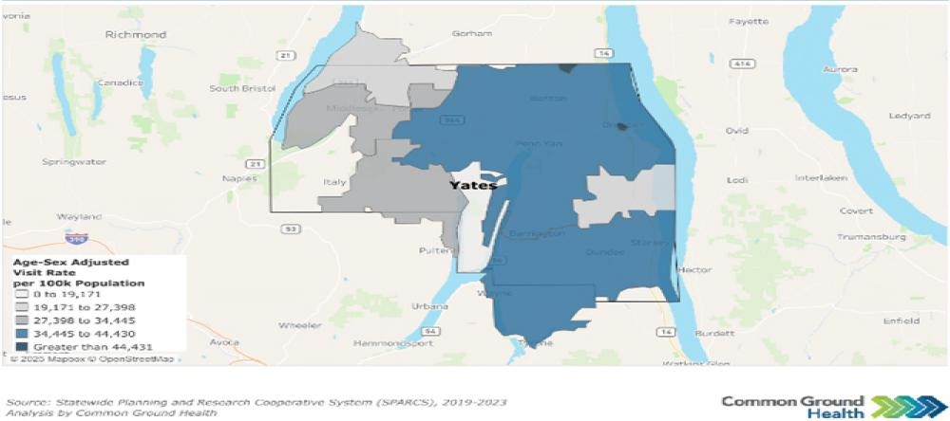
Map Y6: Preventable Hospitalizations by Zip Code
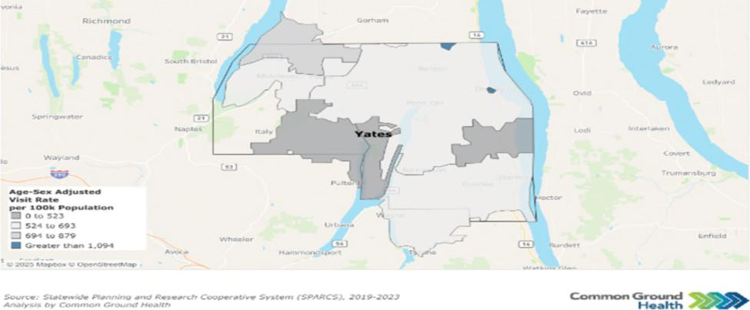
Page 94 Yates County

Community Health Assessment – Yates County

Table Y4: Emergency Department Visits
Yates County Rate NYS Rate Per
Issue % Change
Per 100,000 100,000 (from 2017)
(2023) (2023)
All ED Visits | 41,443 | 29,809 | +10%
Substance Use Disorder ED  Visits | 1,076 | 1,646 | -34%
Intentional Self Harm ED Visits | 359 | 343 | +2%
Preventable Hospitalizations (Overall) | 604 | 808 | -30%
Diabetes  Preventable Hospitalizations | 75 | 181 | -6%

Source: SPARCS
2023 data indicate mixed trends in healthcare utilization in Yates County as compared to 2017. ED visits increased by 10%, suggesting a reduced usage of primary care providers and a growing demand for urgent care services. In contrast, ED visits related to substance use disorders decreased by 34%, while visits for intentional self-harm rose slightly by 2%. Preventable hospitalizations declined by 30%, including a small 6% decrease in diabetes-related hospitalizations, which may reflect improvements in disease management, though ongoing attention to chronic disease prevention remains important.
Priority: Access to and Use of Prenatal Care
Receiving early and adequate prenatal care is important for ensuring a healthy pregnancy. Abstinence from smoking, alcohol, and illegal drug use are important indicators of appropriate prenatal care. Since 2018, Yates County has improved in all three indicators. In 2024, the percentage of birthing persons who abstained from alcohol was 100%, an increase of 2%.⁶¹ Abstinence from smoking was 86.1%, an increase of 7%, and abstinence from illegal drug use was 97.8%, an increase of 7%.⁶²
Prenatal care may be additionally measured by low live birth weights (<2,500 grams or about 5 lbs., 8 oz.) and premature births (live births before 37 weeks). Vital Records data indicate that 12.2% of births (2022 data) were preterm, an increase of 36% from 2013. Live births with low birth weights were 4% (2023 data), a decrease of 20% from 2018 and below the NYS average of 8%.
Breasffeeding infants ensures optimal nutrition and provides health benefits to both the breasffeeding parent and the child. The percentage of infants fed breast milk only or both breast milk and formula at the time of hospital discharge (2024 data) was 91.9%, an increase of 11.4% from 2019. Those who were
⁶¹ Source: National Survey on Drug Use and Health, 2024
⁶² Source: U.S. Department of Health and Human Services, Healthy People 2020, National Center for Health Statistics
Page 95 Yates County

Community Health Assessment – Yates County

fed exclusively breast milk in the hospital were 77.4%, a decrease of 1% from 2019, though greater than the NYS average of 46.7%.⁶³ This indicator has shown an upward trend, increasing since 2020.
Priority: Prevention of Infant and Maternal Mortality
Prematurity and its related conditions are the leading causes of infant mortality. In 2024, the percentage of preterm births in Yates County was 12.2%, exceeding the NYS target of 9.4% or below. Reducing premature birth rates may directly affect infant mortality rates. Data for this measure in Yates County is unavailable, likely due to the small number of infant deaths in the county.⁶⁴
Encouraging healthy habits during pregnancy can lead to healthier pregnancies and better outcomes for the child. Yates County has seen continuously improved rates in abstinence from alcohol and smoking during pregnancy. Smoking abstinence has improved from 82.5% in 2020 to 86.1% in 2024. Alcohol abstinence in pregnancy has held steady between 99% to 100% since 2020.⁶⁵
For Yates County, the maternal mortality rate has remained 0 since the 2013-2015 reporting period, until the most recent reporting period between 2020-2022, where there was one death reported. This caused a severe increase in the maternal mortality rate, rising to 102.6 per 100,000 live births.
Priority: Preventive Services for Chronic Disease Prevention and Control
Yates County, like many rural counties, faces unique challenges in health care access and support. Fewer primary care physicians, dentists, mental health providers, and non-physician health care providers pose significant barriers to care. Figure Y6 depicts the ratios of health care providers to one resident in Yates County. These ratios indicate a critical need for improved healthcare access across all sectors in Yates County.
Figure Y6: Resident to Healthcare Provider Ratio
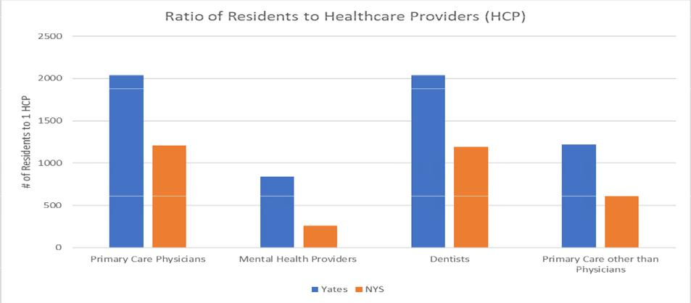
Source: County Health Rankings, Area Health Resource File/American Medical Association
⁶³ Source: NYS Prevention Agenda, Vital Records
⁶⁴ Source: NYS Prevention Agenda, Statewide Perinatal Data System, Vital Records
⁶⁵ Source: Healthy People 2030
Page 96 Yates County

Community Health Assessment – Yates County

Those who are under- or uninsured face additional obstacles to accessing care. The uninsured rate for Yates County is 10% of the population under age 65 (up 25% since 2018) and 8% of children under 19 (up 33% since 2018).⁶⁶ Yates County has a higher percentage of uninsured residents compared to NYS. It is important to note that in Yates County, the Mennonite population often chooses not to have health insurance.
The combination of high population-to-provider ratios and a sizable uninsured population creates a significant barrier to preventative care. Consequently, these individuals may not seek preventive health care services and instead present to the Emergency Department with potentially preventable conditions. Yates County residents seek care at the Emergency Department 39% more than the NYS average.⁶⁷ This may further result in increased health care costs and lost workdays, reinforcing the cycle of poverty.
Focus group participants consistently expressed concerns about high health care costs and difficulty
navigating insurance. They noted that the cost of even basic health care is unaffordable for many families and the insurance systems are difficult to navigate.
Limited transportation and its effect on access to care were common concerns among focus groups. This concern is particularly true for specialty care services such as cancer and cardiac care - two of the leading causes of death in Yates County.⁶⁸ Many individuals report struggling to get to appointments due to unreliable public transportation or a lack of personal vehicles. Moreover, many focus group members noted the need to travel an hour or more to access certain specialties. This again results in additional time loss at work and increased personal expenses for the individual.
Despite a nationwide proliferation of telehealth and telemedicine services, access to and use of broadband services in Yates County is limited. High-speed, quality internet connection enables residents to access essential services such as telehealth, online health information, appointment scheduling, and remote monitoring - tools that are vital for rural communities and those with limited transportation. Reliable internet also supports health education, emergency communication, social connection, and access to benefits and resources, helping reduce disparities and improve overall community well-being. Broadband access in Yates County, as measured in the 2025 County Health Rankings, is 78%, while NYS is 90%. The percentage of the population with no access to broadband services, meaning broadband is simply not available in their area, is 6.7% in Yates, compared to just 1.3% in NYS as a whole.⁶⁹ This creates an additional barrier to accessing alternative means of care in an already underserved area.
In lieu of access challenges, chronic disease prevention emerges as a central concern for the county. Preventing chronic diseases is essential to supporting a community’s overall health and well-being. In Yates County, conditions such as diabetes and obesity affect a significant portion of residents, including both adults and children. In 2022, the prevalence of adults over age 20 with diagnosed diabetes is 10%; in 2021, the percentage of adults with obesity was 31.8%; and in 2023, the percentage of children and adolescents with obesity was 27.9%. Each of these measures has increased steadily over the past 7–9 years, except for adult obesity, which declined slightly in 2018 before rising again in 2021.
⁶⁶ Source: County Health Rankings & Roadmaps, 2025
⁶⁷ Source: New York State Department of Health Statewide Planning and Research Collaborative, 2023
⁶⁸ Source: Vital Statistics Data, 2024
⁶⁹ Source: County Health Rankings & Roadmaps, 2025
Page 97 Yates County

Community Health Assessment – Yates County

Monitoring and managing risk factors such as high blood sugar and blood pressure is critical for addressing chronic disease trends in Yates County. The percentage of adults aged 45+ who had a test for high blood sugar or diabetes within the past three years increased from 54.96% (2018) to 69.6% (2021), exceeding the state average of 63.8%. Among adults aged 45+ with a household income below $25,000, the percentage who had the same tests decreased from 58.9% in 2016 to 48.7% in 2018.⁷⁰ The prevalence of high blood pressure in adults 18+ increased 4% from 2017 to 30.1% in 2021.⁷¹ These patterns underscore the importance of expanding access to preventative screening for chronic disease risk factors, particularly for low-income adults who are less likely to receive regular screening.
Mammograms and colorectal cancer screenings have also been shown to be effective preventative care measures. The completion of preventive services shows mixed trends based on 2022 data. Mammogram rates among women ages 50–74 have steadily increased from 73% in 2018 and 74.1% in 2020, to 75.5% currently. The percentage of female Medicare enrollees who receive a mammogram screening has also improved since 2018, increasing from 52% to 55% in 2022. However, the prevalence of colorectal cancer screening among Yates County residents has decreased by 13% from 2020 to 2022, dropping from 72.3% to 63.2%.⁷¹ These trends highlight the need for targeted interventions to promote completion of preventative measures and reduce long-term health risks.
Priority: Oral Health Care
According to County Health Rankings, Yates County has a dentist-to-population ratio of 2,220 to 1. In 2019, 62.6% of adults had a dental visit in the past year, a 5% decrease since 2014 and below the New York State average of 71.3%.
Access to oral health care is even more limited for Medicaid enrollees. The only Medicaid-accepting dental provider in Yates County is Finger Lakes Community Health, with clinics in Penn Yan and Dundee. The percentage of Medicaid-enrolled adults with at least one dental visit remained above 30% between 2014 and 2019. However, in 2020, this percentage dropped to 25.9%, a 23% difference from the year prior. Since 2020, the percentage of dental visits for adult Medicaid enrollees has continued to fall below the state average of 31.1%, underscoring concerns about oral health care availability.
Access to dental care for children is similarly limited. In 2023, Finger Lakes Community Health opened a school-based dental clinic in Penn Yan, providing preventive dental care. Trends for Medicaid enrollees aged 2-20 years who had at least one dental visit within the last year are similar to those of adults. Between 2015 and 2017, this percentage remained above state average, with 49% of Yates County Medicaid enrollees ages 2-20 completing at least one dental visit in 2018. The rates dropped rapidly in 2020, reaching 36.3%, before slowly increasing to 41.2% in 2023.⁷²
Priority: Preventive Services – Immunizations and Lead
Yates County is classified as high risk for disease outbreak due to low vaccination rates. The completion
rate target value of 4:3:1:3:3:1:4 series (Table Y4) is 80% in NYS. However, in Yates County the percentage of children who have received this immunization series by two years of age is 44.8% in 2025, an increase
⁷⁰ Source: Behavior Risk Factor Surveillance System (BRFSS), 2022
⁷¹ Source: Centers for Disease Control and Prevention (CDC), 2022
⁷³ Source: U.S. Census and 2023 American Community Survey
Page 98 Yates County

Community Health Assessment – Yates County

of 15% from 2016. The rate of immunization completion remained relatively stable between 2019 and 2025, increasing by only 0.22%.
Table Y5. 4:3:1:3:3:1:4 Schedule
Vaccine Type | Number of Doses
Diphtheria, Tetanus, and Pertussis (DTaP) | 4
Polio (IPV) | 3
Measles, Mumps, Rubella (MMR) | 1
Hepatitis B | 3
Haemophilus infuenzae type B (Hib) | 3
Varicella | 1
Pneumococcal Conjugate Vaccine (PCV) | 4

As of January 1, 2025, Yates County’s MMR (Measles, Mumps, Rubella) vaccination rate is the worst in the state with only 55.8% of residence receiving one MMR dose by 2 years of age, compared to the state average of 81.2% and below the 95% threshold to achieve herd immunity. The recommended childhood vaccination schedule indicates that the first dose of the MMR vaccine be administered between 12 and 15 months and their second dosage between 4 to 6 years, prior to starting Kindergarten.
Similarly, the number of children who completed the Human Papillomavirus (HPV) vaccine series increased from 15% in 2016 to 21.5% in 2025, but the overall change since 2017 is only 0.5%. HPV immunization rates fall below the NYS average of 63.6% and well below the state target value of 80% (Figure Y7).
Figure Y7: Immunization Rates (2025)
Source: NYSIIP Performance Reports, IAP Baseline Report
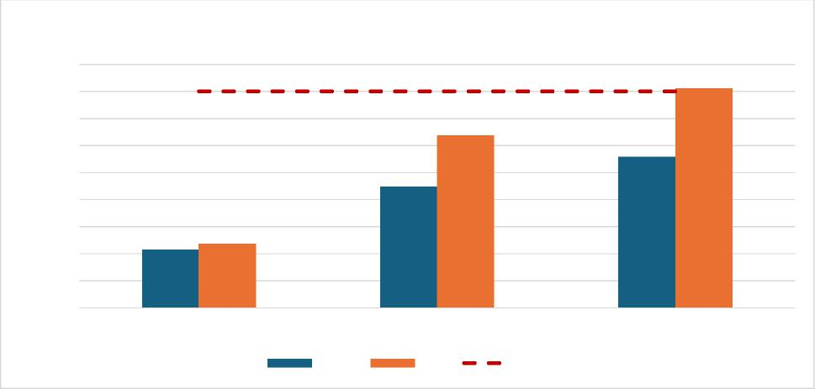
Immunization Rates
90
HPV 4:3:1:3:3:1:4 MMR
Yates NYS Target
Completion Rate (%)
40
80
70
60
50
30
20
10
0
Page 99 Yates County

Community Health Assessment – Yates County

Yates County’s low Immunization rates are likely affected by the large Mennonite population in the community. It is common practice for the Mennonite community to remain unvaccinated and seek alternative, holistic measures of care. Of note, though, is that Mennonite office visits for immunizations at Yates County Public Health increased by 57% since 2024, indicating a growing interest in this practice. Nonetheless, targeted, culturally competent education is key to understanding the importance and effectiveness of vaccination and ultimately improving rates of immunization.
Testing for blood levels of lead is essential in young children as no level of lead in the blood is safe. The CDC indicates that lead poisoning may lead to slowed growth and development, learning and behavior problems, and other long-term health effects. Young children may not show signs and symptoms of lead in the blood and body but can quickly be negatively impacted. Individuals that live or spend time in buildings built before 1978 or are from low-income households are especially vulnerable. With 18% of children under age 18 living in poverty, it is essential to prioritize efforts to improve access to and completion of lead screening to safeguard long-term health in the county.
Lead screening data from 2024 (Figure Y8) indicate that the percentage of children aged one year who received one lead screening is 40.5%. The percentage of children aged two years who received at least one lead screening was 42.7%. Those who received at least two lead screenings by three years of age were 32.4%. Overall trends are showing a decline in all measures of lead testing.
Figure Y8: Preventive Services – Lead Screening (2024)
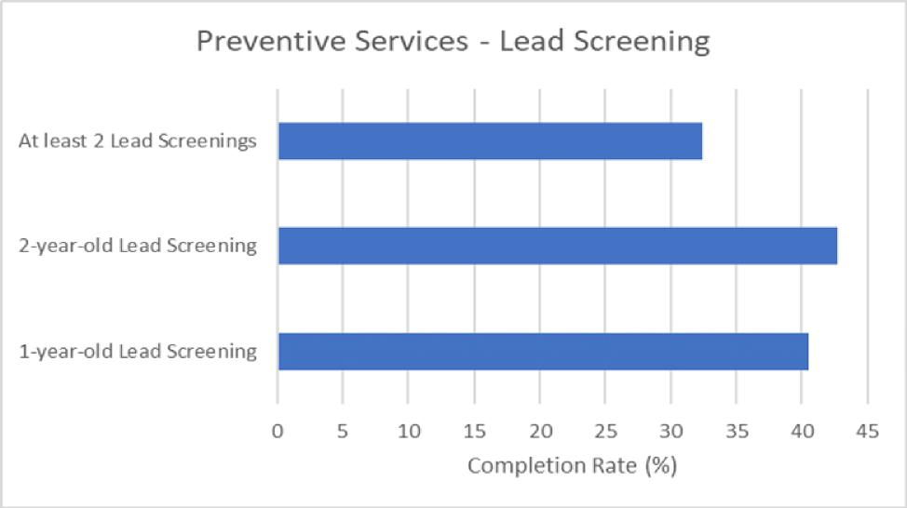
Source: NYSIIP Performance Reports, IAP Baseline Report
Health Care Access and Quality Domain Summary: Yates County shows progress in several maternal and child health indicators, including increased abstinence from smoking, alcohol, and drug use during pregnancy, lower rates of low birthweight, and high breasffeeding rates. However, challenges remain. Preventive care access is strained by provider shortages, declining insurance coverage, transportation
Page 100 Yates County

Community Health Assessment – Yates County

barriers, and lower preventive screening rates among low-income residents. Dental care access, particularly for Medicaid enrollees, has also declined. Immunization and lead-screening rates have declined since 2019. Overall, significant gaps in access to preventive, oral, and specialty care continue to affect community health outcomes.
Domain: Education Access and Quality
Education strongly influences health. Individuals with more schooling live longer, have fewer chronic diseases, and experience greater economic stability. Chronic absenteeism, defined by the U.S. Department of Education as missing at least 10% of the school year for any reason, can interfere with educational attainment. Several factors contribute to absenteeism, such as physical and mental health challenges, substance use, unsafe school environments, and low fitness levels.
Chronic absenteeism rose sharply in New York State after the COVID-19 pandemic. In 2022–2023, 26.4% of all students and 34.1% of high school students were chronically absent, far above the pre-pandemic rate of 15.5%. Chronic absenteeism is associated with lower academic achievement, social disengagement, higher dropout risk, and poorer long-term health and economic outcomes. The percentage of students who start ninth grade and graduate in four years was 80% in 2023, lower than the NYS average of 87% and unchanged from the baseline in 2018. The graduation rate for students classified as economically disadvantaged was 81% in 2023 versus 82% for NYS, an increase of 6.6% from baseline in 2019.
In Yates County, 73.5% of the school-age population is enrolled in kindergarten through 12th grade, with 32.7% in private schools and 67.3% in public schools. The number of students enrolled in school between grades 5 to 8 and grades 9 to 12 drops by approximately 586 students⁷³ (Table Y6). This is likely due to the Mennonite educational structure which discontinues schooling after 8th grade.
Table Y6: Enrolled School-Age Population

Grade Level Total Estimate Percent Estimate in Percent Estimate in Private
Public School School
Kindergarten | 210 | 74.3% | 25.7%
Elementary: grade 1 to grade 4 | 1216 | 55.6% | 44.4%
Elementary: grade 5 to grade 8 | 1395 | 64.1% | 35.9%
High School: grade 9 to grade 12 | 809 | 88.8% | 11.2%

Source: 2023 American Community Survey 5-Year Data
The average gap in dollars between actual and required spending per pupil among public school districts was $9,915 in 2022, compared with $12,745 on average in NYS; an increase of 4.4% from baseline in 2019. The gap between what schools need and what they actually spend is growing. A widening funding gap can strain school resources, limit access to educational programs and support services, and make it
⁷³ Source: U.S. Census and 2023 American Community Survey
Page 101 Yates County

Community Health Assessment – Yates County

harder for districts to meet student needs. Over time, this can contribute to disparities in academic achievement, staffing challenges, and fewer opportunities for students, especially in communities already facing economic or social disadvantages.
Post-secondary education also brings substantial benefits. Adults with a bachelor’s degree have higher incomes, are less likely to be unemployed, and have better health and safer working and living conditions than those with only a high school diploma. However, affordability and unequal access to educational opportunities remain challenges. The percentage of adults ages 25 and over in Yates County with a high school diploma or equivalent was 84% in 2023, lower than the NYS average of 88% and a decrease of 2% from the baseline in 2019. The percentage of adults aged 25-44 with some postsecondary education was 42% in 2023, lower than the NYS average of 71% and a decrease of 22% from the baseline in 2019.
Education Access and Quality Domain Summary: Educational attainment remains a priority concern: rates of high school completion, post-secondary education, and on-time graduation all fall below state averages. Additionally, the per-pupil spending gap has widened, signaling increasing strain on school resources and the potential for growing inequities in academic opportunities and student support.
Page 102 Yates County

Community Health Assessment – Yates County

Priority Areas
Yates County identified three priority areas for this CHA. They are:
- Housing Stability and Affordability
- Preventive Services for Chronic Disease Prevention and Control
- Anxiety and Stress
These priority areas were selected in December 2025 using a ranking systematic survey to select the above priorities, in addition to using secondary data and community feedback.
Housing Stability and Affordability
Although housing cost burden is lower than the state average, community partners and focus groups consistently identify housing quality, availability, and affordability as urgent concerns. Homeownership rates are declining in Yates County while the cost of living continues to rise.
"People of low income will always be affected the most...as those with adequate funds have choices - where to live, work, spend their money, and where to get their healthcare."
- YCC Focus Group Participant
Focus groups in Yates County highlighted significant concerns about local housing, noting a shortage of safe and functional homes. Older housing, particularly pre-1950s structures, often lacks inspections for lead and mold, increasing risks for respiratory illnesses, developmental issues, and chronic conditions, as well as injuries from falls in poorly maintained homes.
Further housing assessments are needed in Yates County to better understand the resources available to help the community.
Preventive Services for Chronic Disease Prevention and Control
Yates County is seeing increased rates of
obesity, cancer, diabetes, and heart disease
and the county’s top two leading causes of
death are associated with chronic disease.
Prevention, early detection, and disease
management are important to improving
overall quality of life.
"I feel that we have to be our own advocate when it comes to healthcare...if I was to mention health issues between family and friends, there would be too many to state."
- YCC Focus Group Participant

However, access to care in Yates County is a
widespread barrier, especially for elderly and low-income populations. There is limited access to primary care locally, and residents are also forced to travel long distances for specialty care. Additional barriers
Page 103 Yates County

include high medical costs, insurance limitations, scheduling difficulties, lack of transportation, and poor broadband access.
Community Health Assessment – Yates County

Increasing access to care through creative community solutions and partnerships can reduce the burden of chronic disease in the community.
Anxiety and Stress "Older people still have skills to be useful and want to be"
Mental health was noted as a major issue across all focus groups. Youth cited bullying and cyberbullying as factors influencing mental health while older adults noted isolation as a key contributor. A shortage of
-YCC Focus Group Participant
mental health providers and ongoing barriers to seeking help, especially for marginalized groups, was
cited as cause for concern.
Declining mental health can signal underlying concerns around rising stress, depression, or anxiety in the community. This may lead to higher rates of chronic disease, substance use, reduced productivity, and greater demand for mental health and medical services.
Building community support systems focused on resilience-building strategies and social connections can improve community well-being.
Existing and needed community assets and resources supporting health were identified throughout the Community Health Assessment process. The community partners listed in Appendix 1 provide valuable resources to support positive health outcomes for Yates County residents.

Community Assets and Resources
Pivital Public Health Partnership and Common Ground Health are two agencies that promote and facilitate regional collaboration. Pivital is a partnership of eight rural health departments in the Finger Lakes Region, focusing on improving the health and well-being of Finger Lakes residents. Common Ground Health covers the same geographic footprint, with the addition of Monroe County, and focuses on bringing together leaders from all sectors to collaborate on strategies for improving health in the region. Both agencies provide support, collaboration and resources to improve the health of Yates County residents.
Yates County has broad engagement from nonprofits, healthcare systems, school districts, grassroots groups, and faith-based communities. Agencies like Finger Lakes Area Counseling & Recovery Agency (FLACRA), Cornell Cooperative Extension, UR Medicine Finger Lakes Health, Pro Action provide mental health, substance use, medical, social, and educational services. Individuals of all ages and backgrounds—including low-income populations, older adults, those living with disabilities, LGBTQIA+ community members, immigrants, and racial minorities— are engaged through support groups, advisory boards, social media, and multilingual support. Partners actively work on policy and advocacy, adapt through regular evaluation , and use innovative tools and leadership opportunities to build resilience and local capacity.
Page 104 Yates County

Community Health Assessment – Yates County

There is also a strong emphasis on community within the county as exemplified by committed staff, volunteers, and resource sharing (spaces, technology, event support). Social hubs such as libraries, community centers, churches, and schools anchor programming and promote referrals across health/wellness, social, and preventive services.
While partnerships and organizations exist to foster collaboration in the community, gaps still exist that may inhibit growth. Several partners discussed the need to expand community engagement for youth inclusion. Engagement must go beyond social media to include more one-to-one interaction. Many populations, especially the older population, expressed the desire to mentor youth and foster relationships.
Additionally, community partners and businesses must continue to address organizational awareness of structural determinants of health. In doing so, creating more inventive, comfortable, and accessible meeting and engagement spaces are needed.
Through implementation of the Community Health Improvement Plan (CHIP), Yates County and its community partners will work to leverage existing relationships, knowledge, and resources. The Yates County CHIP workplan will include a full description of interventions and partner roles that will be used to address chosen priorities and objectives.
Table Y7 highlights the specific county partners associated with each priority area and how they may support Yates County in achieving its goals.
Table Y7: County Resources to Accomplish CHA/CHIP Goals
Priority Area | Sample Assets & Collaborafi ve Resources | How They Support  Community Health & Well-  being
Housing Stability & | Yates County DSS; Keuka | Ensure basic needs for residents are
Affordability | Housing Council; Cornell | met (housing, food, safe drinking
 | Cooperative Extension (CCE); | water, clothing, heat etc.);
 | Yates County Soil and Water; | educational resources to residents
 | Geneva District Office for | who face environmental hazards
 | Environmental Health; LAW of | within their house; informing
 | NYS; Housing Consortium | residents of their rights as a homeowner; community and governmental collaboration can help maintain neighborhoods at affordable prices for residents who live and work in the area

Page 105 Yates County

Community Health Assessment – Yates County

Preventive Services of Chronic Disease Prevention & Control
Anxiety & Stress
Cornell Cooperative Extension (CCE); ProAction of Steuben and Yates; Tobacco Action Coalition of the Finger Lakes; Finger Lakes Community Health; Penn Yan Central School District (PYCSD); Dundee Central School District (DCSD); UR Medicine Finger Lakes Health; Dundee Food Pantry-Baptist Church; The Living Well; Dundee Fresh Grocery, Our Town Rocks; Medical Reserve Corps (MRC); Rochester Regional Health
Penn Yan Public Library; Yates County Office of Emergency Services; ProAction of Steuben and Yates; Finger Lakes Area Counseling and Referral Agency (FLACRA); Finger Lakes Community Health; Yates County Sheriff’s Office (YCSO); Lakeview Health Services; Yates County Correctional Facility; UR Medicine Finger Lakes Health; The Living Well; Yates County Community Services; Our Town Rocks; Yates Prevention Coalition
Providing educational resources around general health and well-being, nutrition, and prevention/management of chronic disease; primary, emergency, and specialty health care providers; food and nutrition security; school systems providing primary prevention education, healthy food options, and educational opportunities around health and well-being; organizations offering community support groups and connection to resources
Mental health support and care; emergency response to mental health crises; resources for mental health and general well-being; educational resources for residents who experience mental health concerns; population-specific resources and community support; social connection opportunities
Page 106 Yates County

Appendix 1
 | Community Health Assessment – Yates County | 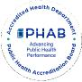

A diverse coalition of organizations and community members participated in the Yates County Community Health Assessment process to ensure broad stakeholder input and representation from populations experiencing health disparities. Known as Choose Health Yates, this group serves as the Community Health Improvement Plan (CHIP) steering committee for Yates County. The following partners are active members of the Choose Health Yates Committee:

Participating Partners and Community Representation
Organization | Sector | Population
Penn Yan Public Library | Non-profit organization | All populations, LGBTQ+
Pivital Public Health  Partnership | Non-profit organization | Finger Lakes region
Chamber of Commerce | Local tourism agency | Yates County residents
Yates County Office of Emergency Services | Local government | Yates County residents
Yates County Cornell  Cooperative Extension | Nonprofit educational system | Agricultural workers, low-income, veterans
ProAction of Steuben and Yates | Nonprofit agency | Aging population, low-income
Yates County Department of Social Services | Local government | Marginalized populations- low socioeconomic status
Finger Lakes Area Counseling and Referral Agency (FLACRA) | Mental and behavioral health organization | People who use drugs (PWUD), marginalized populations
Tobacco Action Coalition of the Finger Lakes | Nonprofit organization | Finger Lakes region
Finger Lakes Community Health | Federally Qualified Health Center (FQHC ) | Marginalized communities-migrant/agriculture workers, LGBTQ+, low-income, Medicaid recipients, LEP
Penn Yan Central School District (PYCSD) | Academics | Youth
Yates County Sheriff’s Office (YCSO) | Local government | Yates County residents
Lakeview Health Services | Mental and behavioral health services | Finger Lakes Region

Page 107 Yates County

Yates County Correctional Facility | Local government | Marginalized populations-incarcerated individuals
University of Rochester Medical Center- Soldiers & Sailors Memorial Hospital | Hospital | All populations
Dundee Food Pantry- Baptist Church | Faith based organization | Low-income, aging population
The Living Well | Non-profit | Low-income, aging population
Yates County Community Services | Local government | Yates County Residents
Dundee Fresh Grocery | Business | All populations
Our Town Rocks | Nonprofit community organization | All populations
Retired Physicians | Community members

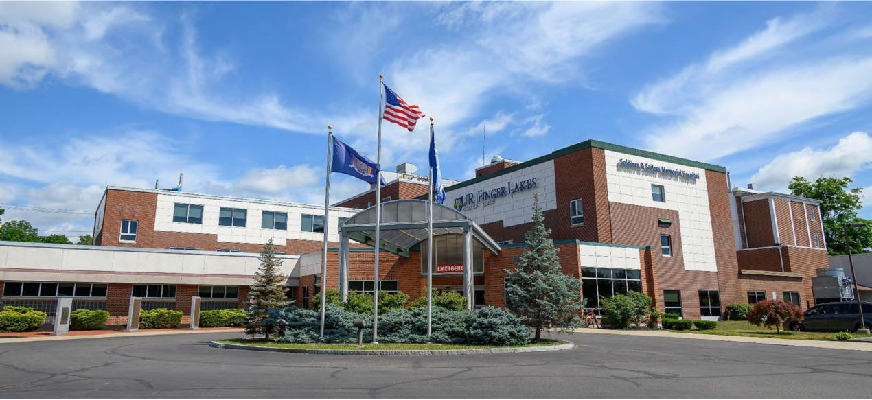
Soldiers and Sailors Memorial Hospital Courtesy of UR Medicine Finger Lakes Health
Courtesy of UR Medicine- Soldiers and Sailors Memorial Hospital
 | Community Health Assessment – Yates County | 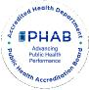

Page 108 Yates County

