
Employee 20
26
Benefits Guide

January 1, 2026–December 31, 2026

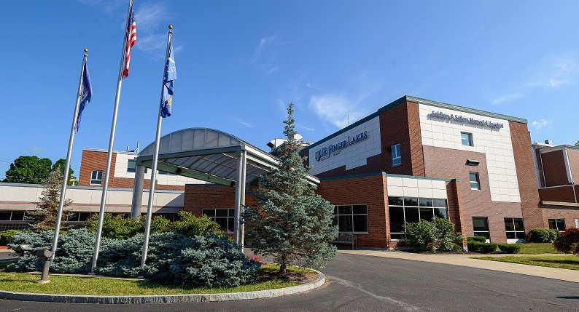




- Employee Resources
- Eligibility
- Contributions
- Medical Highlights
- BCBS Member Account & Mobile App
- Flexible Spending Account
- Health Savings Account (HSA)
- Dental Plan
- Vision Plan
- Life and AD&D Insurance
- Voluntary Life and AD&D Insurance
- Disability Insurance
- Voluntary Benefits
- Identity Theft Protection
- Pet Insurance
- 403(b)
22 Additional Benefits
24 Glossary of Terms

What’s Inside



Finger Lakes Health takes pride in providing a comprehensive employee benefits program, and we recognize the important role employee benefits play as a critical component of your overall compensation. We strive to maintain
a benefits program that is competitive within our industry.

Employee Resources

Plan | Phone Number and Website/Email
FLH Benefits Team | 315-787-4454  benefits@flhealth.org
Medical  Excellus BCBS | 1-877-253-4797  Excellusbcbs.com/flhealth
Dental  Excellus BCBS | 1-800-724-1675  Excellusbcbs.com
Vision  EyeMed | 1-866-9-EYEMED  Eyemed.com
Health Savings Account & Flexible Spending Accounts  LifetimeBenefit Solutions | 1-800-327-7130  Lifetimebenefitsolutions.com
Life and AD&D, Disability, Voluntary Life, Voluntary Benefits  SunLife | 1-800-247-6875  Sunlife.com/US
Retirement Plans  Empower: 403(b) & 457(b) | 1-866-467-7756  Empowermyretirement.com
Identity Theft Protection  LifeLock | 1-800-LifeLock  LifeLock.com
Pet Insurance  Nationwide | 1-877-738-7874  PetsNationwide.com

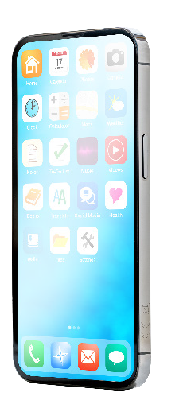

There’s an app for that!
Many of our providers have mobile apps that provide personalized access to your benefits when and where you need it! There are also a variety of FREE health and fitness related apps available. Browse and download apps to your smartphone or tablet from the App Store or Google Play.

Who Is Eligible For Benefits?
All full-time employees regularly scheduled at least 72-80 hours bi-weekly are eligible for benefits. The Affordable Care Act (ACA)defines full-timeemployees as those working 30 or more hours per week. All part-time employees regularly scheduled a minimum of 37.5 hours, but less than 72 hours bi-weekly are eligible for benefits. For new hires, benefits are effective on the first of the month following 30 days of employment.
In addition to enrolling yourself, you may also enroll any eligible dependents. Eligible dependents are defined below:
- Spouse: a person to whom you are legally married to
- Child(ren): Your biological, adopted, or legal dependents up to age 26 regardless of student, financial, and marital status; coverage for a dependent child will terminate at the end of the month in which the child turns age 26

Change-in-Status Events
The benefits plan year runs January 1st through December 31st. Unless you have a qualifying event that impacts your eligibility and the change is allowed under the terms of the insurance contract or plan document, you cannot make changes to the benefits you elect until the next Open Enrollment period. Benefit changes must be consistent with your qualified change-in-status event. Changes must be submitted to Human Resources within 30 days of the event; documentation supporting the change will be required.

Some examples of qualifying event are highlighted below:



Marriage or divorce Birth, adoption, or death



Change in employment, or employment status for you, your spouse, or your dependent child
Change in coverage under another employer plan, such as a change made during your spouse’s Open Enrollment

Eligibility


Don’t understand what a qualified change-in-status event is?
Scan the QR code or visit www. brainshark.com/hilbgroup/ ChangeInStatusEvents to watch a short video.

Contributions

Bi-Weekly
Medical Contributions

Full Time |  |  |  | Part Time
Tier | Excellus Grandfathered | Excellus Premium | Excellus Basic | Excellus Grandfathered | Excellus Premium | Excellus Basic
Employee Only | $181.40 | $63.10 | $32.71 | $269.57 | $152.50 | $59.95
Employee + Spouse | $505.52 | $224.36 | $161.26 | $716.98 | $408.41 | $304.99
Employee + Child(ren) | $393.04 | $203.33 | $136.72 | $623.87 | $359.33 | $275.20
Family | $612.81 | $285.71 | $191.06 | $872.94 | $501.32 | $383.87

ACA Eligible - Medical Contributions

Tier | Excellus Grandfathered | Excellus Premium | Excellus Basic
Employee Only | $678.14 | $384.47 | $55.34
Employee + Spouse | $1,569.60 | $889.88 | $643.16
Employee + Child(ren) | $1,309.11 | $742.20 | $536.42
Family | $1,871.08 | $1.060.81 | $766.71

Dental Contributions

Full Time |  |  | Part Time
Tier | Excellus Basic | Excellus Premium | Excellus Basic | Excellus Premium
Individual | $7.64 | $10.66 | $8.74 | $12.17
Family | $23.76 | $34.11 | $26.52 | $38.06

Vision Contributions

Tier | EyeMed
Employee Only | $2.40
Employee + Spouse | $4.55
Employee + Child(ren) | $4.79
Family | $7.04

Medical Highlights

Contact Info: 1-877-253-4797 Excellusbcbs.com/flhealth

Administered by Excellus BCBS

Grandfathered Plan

Plan Features | FLH Network | URMC | In-Network (Non-URMC) | Out-of-Network
Annual Deductible | $250 individual  $750 family | $1,500 individual  $3,000 family | $3,500 individual  $7,000 family | $15,000 individual  $30,000 family
Annual Out-of-Pocket Maximum | $3,000 individual  $6,000 family | $4,000 individual  $8,000 family | $6,000 individual  $12,000 family | $30,000 individual  $60,000 family
Preventive Services | No charge | No charge | No charge | 40% after deductible
OFFICE VISITS, LABS, AND TESTING
PCP Office Visits | $20 | $35 | 50% after deductible | 50% after deductible
Specialist Office Visits | $35 | $50 | 50% after deductible | 50% after deductible
Rehabilitation Services | $25 | $75 | 50% after deductible | 50% after deductible
Diagnostic Lab | $0 | $40 | 40% after deductible | 40% after deductible
Diagnostic X-rays | $40 | $80 | 40% after deductible | 40% after deductible
High-Tech Imaging | $40 | CT & PET: $300 MRI & ECHO: $500 | 50% after deductible | 50% after deductible
HOSPITAL
Inpatient | 10% after deductible | 20% after deductible | 40% after deductible | 40% after deductible
Outpatient | 10% after deductible | 20% after deductible | 40% after deductible | 40% after deductible
Durable Medical Equipment | 20% after deductible | 20% after deductible | 50% after deductible | 50% after deductible
URGENT AND EMERGENCY CARE
Urgent Care Facility | $35 | $100 | 50% after deductible | 50% after deductible
Emergency Room | $150 | $200 | $250 | $250
PRESCRIPTION DRUGS
Retail Pharmacy, 30-day supply | N/A | $10/$35/$70/$200 | $10/$35/$70/$200 | Not covered
Mail Order, 90-day supply | N/A | $20/$70/$140/NA | $20/$70/$140/NA | Not covered
This chart is intended for comparison purposes only. If there are any discrepancies, the official plan documents will govern.

Medical Highlights

Contact Info: 1-877-253-4797 Excellusbcbs.com/flhealth

Administered by Excellus BCBS

Premium Plan

Plan Features | FLH Network | URMC | In-Network (Non-URMC) | Out-of-Network
Annual Deductible | $100 individual  $300 family | $1,500 individual  $3,000 family | $3,500 individual  $7,000 family | $15,000 individual  $30,000 family
Annual Out-of-Pocket Maximum | $3,000 individual  $6,000 family | $4,000 individual  $8,000 family | $6,000 individual  $12,000 family | $30,000 individual  $60,000 family
Preventive Services | No charge | No charge | No charge | 40% after deductible
OFFICE VISITS, LABS, AND TESTING
PCP Office Visits | $20 after deductible | 20% after deductible | 50% after deductible | 50% after deductible
Specialist Office Visits | $35 after deductible | 20% after deductible | 50% after deductible | 50% after deductible
Rehabilitation Services | $25 after deductible | 30% after deductible | 50% after deductible | 50% after deductible
Diagnostic Lab | $0 after deductible | 20% after deductible | 40% after deductible | 40% after deductible
Diagnostic X-rays | $40 after deductible | 30% after deductible | 40% after deductible | 40% after deductible
High-Tech Imaging | $40 after deductible | 40% after deductible  (PET 30% after deductible) | 50% after deductible | 50% after deductible
HOSPITAL
Inpatient | $300 after deductible | 20% after deductible | 40% after deductible | 40% after deductible
Outpatient | $75 after deductible | 20% after deductible | 40% after deductible | 40% after deductible
Durable Medical Equipment | 20% after deductible | 20% after deductible | 40% after deductible | 40% after deductible
URGENT AND EMERGENCY CARE
Urgent Care Facility | $35 after deductible | 30% after deductible | 50% after deductible | 50% after deductible
Emergency Room | $150 after deductible | 20% after deductible | 30% after deductible | 40% after deductible
PRESCRIPTION DRUGS
Retail Pharmacy, 30-day supply | N/A | $10/$35/$70/$200 | $10/$35/$70/$200 | Not covered
Mail Order, 90-day supply | N/A | $20/$70/$140/NA | $20/$70/$140/NA | Not covered
This chart is intended for comparison purposes only. If there are any discrepancies, the official plan documents will govern.

Medical Highlights

Contact Info: 1-877-253-4797 Excellusbcbs.com/flhealth

Administered by Excellus BCBS

Basic Plan HDHP

Plan Features | FLH Network | URMC | In-Network (Non-URMC) | Out-of-Network
Annual Deductible | $1,700 individual  $3,400 family | $2,600 individual  $5,200 family | $4,500 individual  $9,000 family | $15,000 individual  $30,000 family
Annual Out-of-Pocket Maximum | $3,000 individual  $6,000 family | $4,000 individual  $8,000 family | $6,000 individual  $12,000 family | $30,000 individual  $60,000 family
Preventive Services | No charge | No charge | No charge | 40% after deductible
OFFICE VISITS, LABS, AND TESTING
PCP Office Visits | $20 after deductible | 20% after deductible | 50% after deductible | 50% after deductible
Specialist Office Visits | $35 after deductible | 20% after deductible | 50% after deductible | 50% after deductible
Rehabilitation Services | $25 after deductible | 30% after deductible | 50% after deductible | 50% after deductible
Diagnostic Lab | $0 after deductible | 20% after deductible | 40% after deductible | 40% after deductible
Diagnostic X-rays | $40 after deductible | 30% after deductible | 40% after deductible | 40% after deductible
High-Tech Imaging | $40 after deductible | 40% after deductible  (PET 30% after deductible) | 50% after deductible | 50% after deductible
HOSPITAL
Inpatient | $250 after deductible | 20% after deductible | 40% after deductible | 40% after deductible
Outpatient | $75 after deductible | 20% after deductible | 40% after deductible | 40% after deductible
Durable Medical Equipment | 20% after deductible | 20% after deductible | 40% after deductible | 40% after deductible
URGENT AND EMERGENCY CARE
Urgent Care Facility | $35 after deductible | 30% after deductible | 50% after deductible | 50% after deductible
Emergency Room | $150 after deductible | 20% after deductible | 30% after deductible | 50% after deductible
PRESCRIPTION DRUGS
Retail Pharmacy, 30-day supply | N/A | $10/$35/$70/$200 | $10/$35/$70/$200 | Not covered
Mail Order, 90-day supply | N/A | $20/$70/$140/NA | $20/$70/$140/NA | Not covered
This chart is intended for comparison purposes only. If there are any discrepancies, the official plan documents will govern.
Summary of Benefits and Coverage (SBC)
Choosing a health coverage option is an important decision. To help you make an informed choice, a Summary of Benefits and Coverage (SBC), which summarizes important benefit information in a standard format, is available for review. SBCs for each plan option, benefit summaries and forms can be found via ADP.

Contact Info: 1-877-253-4797 Excellusbcbs.com/flhealth

It’s Your Plan. Get More Out Of It Online.
Making the most of your plan shouldn’t be complicated. When you sign up for an Excellus BlueCross BlueShield online member account, you get instant access to a variety of tools and other resources to make living healthy a little easier.
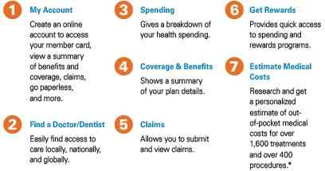
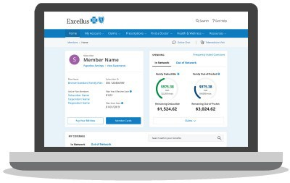

Blue365
As an Excellus BlueCross BlueShield member, you have free access to the industry’s best health and wellness discounts through Blue365.

Blue365 helps you stay healthy for less with exclusive discounts including:
- Discounted gym memberships with access to over 10,000 gyms nationwide from Tivity Fitness Your Wayand Gympass
- Wearable devices from Fitbit, Polar, Garminand more
- Healthy eating discounts (including Jenny Craig and Nutrisystem)
- LASIK eye surgery, hearing aids and much more

Getting Started
Joining Blue365 and redeeming our deals is easy as 1-2-3. Get started with your free registration at Blue365Deals.com/register
- Click the Join or Check Eligibility Button: You’ll find these at the middle and top right ofthe Blue365 home page at Blue365Deals.com
- Enter Your BCBS Member Information: To check your eligibility, simply enter the first 3characters in your member ID card.
- Complete Your Registration: Enter your personal information, accept ourTerms and you are ready to enjoy our deals!

BCBS Member Account & Mobile App

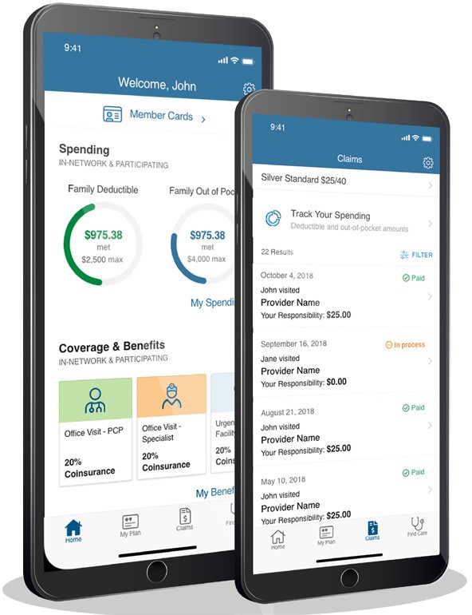
Download the Excellus BCBS Mobile App

Now you can take your health plan with you for on-the-go access 24/7!
  - View your member card
  - Track deductibles and out-of-pocket spending
  - Find a provider or medical facility
  - Access your benefits and claims information


Flexible Spending Account

Contact Info: 1-800-327-7130 lifetimebenefits solutions.com

Administered by Lifetime Benefit Solutions
A Flexible Spending Account (FSA) allows you to reduce your taxable income by setting aside pre-tax dollars to pay for qualified health care and dependent care expenses. The plan is administered through Lifetime Benefit Solutions.

Employees enrolling in a company-sponsored medical plan with a Health Savings Account are NOT eligible to participate in the Health Care FSA, but may participate in the Dependent Care FSA. In order to participate in the FSA, you must enroll each plan year. Your annual contribution stays in effect during the entire plan year.

Using Your FSA
You can use your funds for yourself as well as any of your tax dependents, regardless of whether they are covered by your medical, dental or vision plan. It is important to save all your receipts in the event you are required to document the eligibility of an expense Funds used for non-qualified medical expenses will be taxable as income and also subject to a 20% tax penalty.

Will I lose my money if I don’t use it in a year?
Any remaining funds over $680 in a Health Care FSA and any amount left in your Dependent Care FSA at the end of the plan year will be forfeited. You will have 90 days after the end of the plan year to submit claims incurred during that plan year.

Eligible Expenses
For a listing of eligible expenses, please review the FSA Eligible Expense Guide available online at fsastore.com.

Health Care FSA | Limited Purpose FSA | Dependent Care FSA
$3,400 Plan Year Maximum | $3,400 Plan Year Maximum | $7,500 Plan Year Maximum ($3,750 if married and filing separately)
Copays, deductible expenses, over-the-counter medications and supplies, dental, vision, and hearing  care expenses | Dental cleanings, contact lenses, orthodontics, fillings, eyeglasses, crowns, vision correction | Child care for children under age 13: day care, preschool, after school care, summer day camp and elder car; day care for any physically or mentally incapable dependents.
Note: Dependent Care claims are paid based on your available balance. Please check your balance before using your FSA Card. Daycare services must be incurred before being reimbursed. Claims submitted in advance of services such as summer camps will be held as pending until the services have been incurred.

Contact Info: 1-800-327-7130 lifetimebenefits solutions.com

Administered by Lifetime Benefit Solutions

A Health Savings Account (HSA) allows you to pay for health expenses on a tax-free basis.
- You are eligible for an HSA f you are enrolled in the Basic medical plan
- You are not eligible for an HSA if:
― You are covered by another non-qualified medical plan or a General-Purpose Healthcare FSA set up by you or your spouse
― Enrolled in Medicaid, Medicare, or Tricare
Eligible to be claimed on another person’s tax return
- Funds can be used for yourself, spouse, or tax dependent child(ren)
- Funds cannot be used for children who are no longer IRS tax dependents, even if they are covered under your medical plan
- Funds used for non-qualified healthcare expenses will be taxable as income and also subject to a 20% tax penalty

Using Your HSA Funds
- Employee contributions are deposited from each pay check. You will be able to access the funds after each deposit.
- Employee contributions have to be in the account before they can be used
- Convenient online or mobile app access allows you to pay your providers online and view claims history
- HSA card can be used for qualified medical expenses as permitted under federal tax law
- Expenses include:
― Medical, dental, vision, prescription items
― Deductibles, copayments, coinsurance
― Over-the-Counter items such as diabetic supplies, bandages, crutches, first-aid kits, contact lens solutions, and menstrual care products. Visit www.hsastore.com for full listing of eligible expenses.

Funding your HSA
The IRS establishes a limit that you can contribute each month you are enrolled in a qualifying health plan. The limits are based on whether your qualifying health plan covers just you (individual) or you and others (family). FLH will continue to contribute toward your HSA. Starting in 2026, the employer contribution will be divided evenly across your paychecks throughout the plan year.

You may contribute up to the IRS limit, minus the employer contribution as seen in the illustration below:

 |  | Full Time
 | 2026 Annual Limits | FLH Funding | Employee Maximum Contribution
Individual | $4,400 | $500 | $3,900
Family | $8,750 | $1,000 | $7,750

 |  | Part Time
 | 2026 Annual Limits | FLH Funding | Employee Maximum Contribution
Individual | $4,400 | $250 | $4,150
Family | $8,750 | $500 | $8,250
Individuals age 55 and over may make an additional
“catch-up” contribution of $1,000 per year. Contributions to the account must stop once you are enrolled in Medicare; however, you can still use your HSA funds to pay for eligible medical expenses tax-free.

If you have money left in your HSA at the end of the year, it will simply roll over and grow over time through the accrual of tax-free interest.
What a great way to invest for the future!



Health Savings Account (HSA)
HSA ADVANTAGES
•
•
•
This account belongs to you Funds roll over each year
Employer contributes dollars each quarter that can be used toward qualified expenses
Investment options available
- Triple tax advantage
― Tax-free contribution
― Tax-free earnings from investments
― Tax-free withdrawals
•

Dental Plan

Contact Info: 1-800-724-1675 Excellusbcbs.com

Administered by Excellus BCBS
The features of your dental plan are highlighted in the table below. Please refer to your plan description for full details.

 | Basic Dental Plan | Premier Dental Plan
Plan Features | In-Network - You Pay | In-Network - You Pay
Annual Deductible  Amount you must pay per year before the plan begins to pay benefits | $50 individual  $100 family | $25 individual  $75 family
Annual Benefit Maximum Maximum amount the plan will pay per year | Plan pays $750 per person per plan year | Unlimited
Preventive and Diagnostic Services | No charge—no deductible | No charge—no deductible
Basic Services | Deductible, then 50% | Deductible, then 20%*
Major Services | Deductible, then 50% | Deductible, then 50%*
Orthodontia Services  Children up to age 19 | N/A | 50%—no deductible  $1,000 lifetime maximum per person
Limitations or waiting periods may apply for some benefits; some services may be excluded from your plan. This chart is intended for comparison purposes only. If there are any discrepancies, the plan document will govern.
*Reimbursement is based on the maximum contract allowances and not necessarily each dentist’s submitted fees.



Prevention first!
Make sure you take advantage of your preventive dental visits. Preventive care services are not subject to the deductible and the plan covers 100% of the cost if you visit an in-network provider!

Vision Plan

Contact Info: 1-866-9-EYEMED Eyemed.com

Administered by EyeMed
The features of your vision plan are highlighted in the table below. Please refer to your plan description for full details.

Plan Features | In-Network | Out-of-Network Reimbursement
Vision Exam  Once every 12 months | $10 copay | Up to $40
Eyeglass Frames  Once every 24 months | $0 copay; $130 allowance; 20% off balance | Up to $91
Eyeglass Lenses Once every 12 months Single vision  Lined bifocal Lined trifocal Lenticular | $25 copay  $25 copay  $25 copay  $25 copay | Up to $30 Up to $50 Up to $70 Up to $70
Contact Lenses  Once every 12 months in lieu of eyeglasses  Contact lenses Medically Necessary | $130 allowance; 15% off balance  $0 copay; paid in full | Up to $91 Up to $300
This chart is intended for comparison purposes only. If there are any discrepancies, the plan document will govern. Limitations and exclusions may apply.


Did you know your eyes can tell an eye care provider a lot about you?
Vision insurance can make routine eye care more affordable, especially if you are among the majority of people who wear prescription eyeglasses or contact lenses.
In addition to getting a vision screening, a routine eye exam can help detect signs of serious health conditions like diabetes and high cholesterol. This is important, since you won’t always notice the symptoms yourself and since some of these diseases cause early and irreversible damage.

Life and AD&D Insurance

Contact Info: 1-800-247-6875 Sunlife.com/US

Administered by SunLife
Life insurance helps protect your family from financial risk and sudden loss of income in the event of your death. Accidental death and dismemberment (AD&D) insurance provides an additional benefit if you lose your life, sight, hearing, speech, or limbs in an accident.
- Finger Lakes Health provides you with basic life insurance in the amount of:

Benefit | 1x annual salary to a maximum of $200,000  1.5x annual salary to a maximum of $200,000 (management only) Employees earning over $50,000 can choose flat $50,000
- If you die as a result of an accident, your beneficiary will receive an additional benefit equal to the basic life insurance. For other covered losses, the amount of the benefit is a percentage of the AD&D insurance coverage amount.
- Evidence of good health is not required.
- Benefits begin to reduce at age 70.


During your benefits enrollment, don’t forget to designate a beneficiary!

Voluntary Life and AD&D Insurance

Contact Info: 1-800-247-6875 Sunlife.com/US

Administered by SunLife
Finger Lakes Health provides 100% employee-paid Voluntary Life and AD&D plans for employees, spouses and dependents through SunLife. You must elect coverage for yourself in order to elect coverage for your dependents. The cost is based on the employee’s age and salary.
The cost of each option is calculated in ADP.
Employee

Benefit | Elect up to six times your annual salary, rounded to the next higher $1,000, up to a maximum of $750,000

Spouse

Benefit | Elect 50% up to 2.5x employee’s annual salary, rounded to the next $1,000, not to exceed 50% of employee’s approved benefit

Dependent

Benefit | Age 14 days-6 months: $250 Benefit  Age 6 months to 19 years (25 years for full time student): $10,000 Benefit

Evidence of Insurability (EOI)
SunLife requires you to show that you are in good health before they will agree to provide certain levels of coverage. This is called Evidence of Insurability (EOI).
If you are enrolling for the first time after your initial eligibility period, any amount elected will be subject to EOI. Coverage that requires EOI will not be in effect until you receive approval from SunLife.

Disability Insurance

Contact Info: 1-800-247-6875 Sunlife.com/US

Administered by SunLife

New York State Disability Insurance
The premium for this benefit is largely paid by your employer. Benefits are taxable as income to the extent that the employee did not pay the premium.

Maximum Benefit Period | 26 weeks
Benefit Amount | 50% of an employee’s weekly income
Maximum Benefit | $170/week
Benefit Start Date | 8th day of disabilty

Voluntary Short-Term Disability (STD)
To protect your income in the event of a short-term disability, you can elect Voluntary Short-Term Disabilty coverage through SunLife. This benefit is voluntary and premiums are 100% paid by you.

Maximum Benefit Period | 26 weeks
Benefit Amount | 40% of an employee’s weekly income
Maximum Benefit | $1,000/week
Benefit Start Date | 1st day of accident; 8th day of sickness



Please see the plan summaries for additional information and plan limitations for these coverages. Rates can be found in ADP.

Contact Info: 1-800-247-6875 Sunlife.com/US

Administered by SunLife

Critical Illness Insurance
Critical Illness Insurance provides a lump sum benefit if you are diagnosed with a critical health condition. You can elect coverage for yourself, a spouse, and your dependent children, up to $10,000 guarantee issue. $75 Health Screening benefit included, one per covered person per calendar year.
You will receive a lump sum payment if diagnosed with:

NEW! Accident Insurance
Accident insurance is a supplemental insurance plan that helps cover the costs that arise after an
accidental injury. Medical treatment and ongoing care for an injury can be costly, even with the best medical benefits available. Accident insurance can help offset expenses related to an accidental injury. Coverage includes cash benefits for the following:
- Physical therapy

  - Cancer
  - Benign brain tumor
  - End stage renal failure
  - Heart attack
- Stroke
- Advanced Alzheimer’s
- Coronary Artery Bypass
- Follow-up visits
- Hospitalization
- Surgery
- Anesthesia
- Injury and more

Hospital Indemnity Insurance

Voluntary Benefits
When you’re hospitalized, expenses can add up quickly. Hospital Indemnity insurance helps to ease your mind about handling hospitalization costs. This plan will pay you a fixed benefit amount if you end up spending time in the hospital. The payment may be used to help offset out-of-pocket expenses associated with the hospital admission or other expenses such as deductibles, co-pays, coinsurance, travel, childcare, and loss of income.
* This is not major medical insurance and is not a substitute for major medical insurance.

Hospital Indemnity Features
Maximum Benefit Period | 60 days
Benefit Amount | - Hospital Admission - $1,000 per covered person per year  - Hospital Confinement - $150 per day (up to 60 days)  - ICU Confinement - $100per day (up to 10 days)



Please see the plan summaries for additional information and plan limitations for these coverages. Employees are responsible for the full cost. The cost of the insurance is based on your age. Rates can be found in ADP.

Identity Theft Protection

Contact Info: 1-800-LifeLock LifeLock.com

LifeLock
In today’s world of online shopping, using public Wi-Fi and giving out Social Security numbers as a form of ID, our personal information can be exposed. Unfortunately, free credit monitoring simply alerts you to credit issues. LifeLock not only has proprietary technology to detect a range of identity threats, if you do have an identity theft problem, our U.S.-based team of Identity Restoration Specialists can help fix it. It pays to have the comprehensive protection of LifeLock.

Lifelock Benefit Elite
Only available as a payroll deducted employee benefit. Includes searching millions of transactions per second every day for potential threats to your identity and to financial assets – your 401(k) and investment, checking and savings accounts.
Also includes scanning for misuse of your Social Security number, change of address and court records scanning for use of your identity to commit crimes.

Lifelock Ultimate Plus
Membership provides peace of mind with LifeLock’s comprehensive identity theft protection. Enhanced services include bank account application and takeover alerts, online annual three-bureau credit reports and credit scores plus monthly one-bureau credit score tracking.

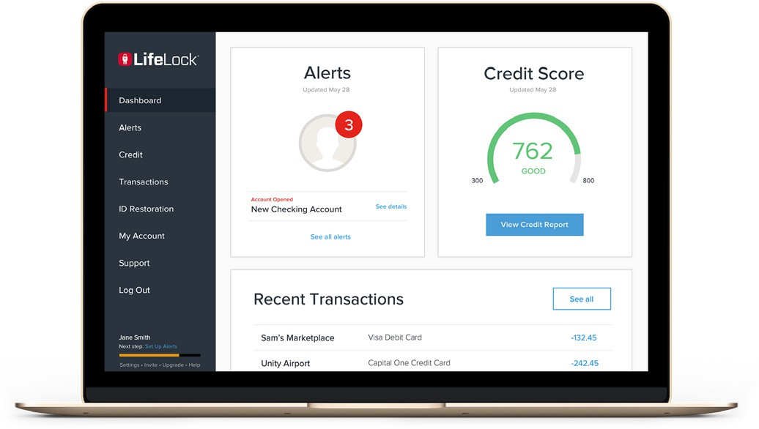
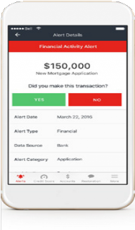
Lifelock Membership
As soon as your membership becomes active, you will receive a welcome email from LifeLock with a link to confirm your identity and set up your member profile. Additionally, any enrolled dependent over 18 years old will also receive a link to set up their own member profile.
Access your member portal at LifeLock.com to:
  - Read alerts & notifications
  - Update contact information
  - Add accounts for transaction monitoring
  - Add info for dark web monitoring
  - Manage account preferences
  - Request assistance
  - Sign up for lost wallet protection


CALCULATE COST and ENROLL
using the ADP Website

Contact Info: 1-855-874-4944 PetsVoluntaryBenefits.com

NEW! - Administered by Nationwide
My Pet Protection Choice from Nationwide comes in your choice of two ready made employee plans or an all new customizable option not previously available.

My Pet Protection Choice includes:
  - Guaranteed issuance
  - Multi pet discounts available
  - Easy payroll payment capability
  - Use any licensed veterinarian
  - Optional wellness coverage available
  - Emergency boarding and kenneling fees
  - Lost pet due to theft or straying
  - Lost pet advertising and reward
  - Mortality benefit

New and Improved Plan Features:
  - Coverage can be dialed up or down by category (accident, illness, hereditary congenital, and wellness)
  - Increased maximum annual benefits as high as
$15,800 (compared with previous $7,500 maximum)
  - More flexible pricing for different budgets and pet needs
  - Wellness coverage for dogs and cats based on benefit schedule
  - Accident only coverage now available



Pet Insurance

How To Enroll
  - Go directly to the dedicated URL we’ve created for your company:
https://partnersolutions.nationwide.com/pet/flhealth
  - Call 1-877-738-7874 and mention that they’re employees of Finger Lakes Health to receive employee pricing
  - Visit PetsNationwide.com and enter your company name


Scan the QR code to learn more about the plan details
Scan the QR code to view FAQ’s

403(b)

Administered by Empower
Whether your retirement is five or fifty years away, the Retirement Savings Plan of Finger Lakes Health System offers a powerful way to enhance your long-term financial well-being. We encourage you to invest in yourself and your future by participating in this plan.
These firms are dedicated to supporting retirement savings plans and focus their resources on giving you the planning tools and guidance you need to achieve your retirement goals.

Plan Provision | Retirement Savings Plan
Enrollment in the Plan | New employees will be auto enrolled at 3%. To change or waive auto enrollment, reach out to Empower directly.
Contributions to the plan*  2026 Annual Maximum = $24,500  2026 Annual Maximum with catch-up for age 50+ = $32,500  2026 Annual Maximum with super catch up for ages  60-63 = $36,000  Secure Act 2.0 goes into effect 1/1/2026 – Retirement plan participants aged 50 years or older who earned more than  $145,000 in FICA wages in the prior year will have to make their contributions on a Roth (post-tax) basis. | Contributory plan: Employees may choose to make pre-tax or Roth after-tax contributions (flat dollar amount or percentage) up to the maximum allowed by law. After one (1) year of service and 1,000 hours worked, the health system  matches 50% of eligible contributions up to a max equal to 3% of salary. You will maximize your employer match by choosing to contribute at least 6% of your salary. Contribution changes can me made throughout the year.  A salary deferral election applies to your regular compensation only. This means your election will not be applied to any supplemental payments you may receive, such as bonuses, temporary assistance program (TAP) payments, supplemental payroll runs or cash outs of used paid time off.  Contact the Human Resources Department, at Ext. 4454, for more information.  *These are the projected rates pending IRS release
Eligibility to participate in the plans | Employees may contribute to the plan upon hire. You are eligible to receive matching contributions from the health system if, on December 31st, you are at least 18 years of age and have completed 1,000 hours of service during the plan year. Physicians and other employees who have waived their eligibility for matching contributions in an employment agreement are not eligible to receive matching contributions from the health system.
Type of plan benefit | Defined contribution: A defined contribution plan means that eligible employees can contribute a portion of their salary to the Retirement Savings Plan. The amount of the benefit payable upon retirement is based on the amount of contributions, asset allocation and investment performance.
Vesting | Employee contributions to the plan are immediately vested. Vesting of the employer matching contribution is based on years of service. The vesting schedule can be found on Docushare (Human Resources/Retirement Plans)
Access to plan funds | Distributions from the plan are not available unless one of the following occurs: Retirement, Termination of employment, Disability or death of plan participan, Approved loan from the plan, Hardship Withdrawal (if eligible), In-Service Distribution (age 62). Penalties may apply.

403(b) Continued

Service Providers | Function
Finger Lakes Health Human Resource Department 315-787-4039 | - Designated Plan Administrator.  - Designs and interprets provisions of plan and its benefits within the guideline of the Employee Retirement Income Security Act (ERISA) and the Internal Revenue Service Code.  - Named fiduciary of the plan. Responsible for plan contribution, allocations to investment options and offering a diverse and sound range of investment choices to participants.  - Maintains Summary Plan Description for employee communication on benefits and Retirement Savings Plan document for specific and legal definition of plan provisions.  - May update and/or change plan to meet regulatory requirements or revise employee benefits. Communicates plan changes to all participants.  - Maintains day-to-day transactions on employee retirement accounts.
TruePlan Benefit and Retirement Advisors 1-800-388-1963 | - Meets individually with employees to enroll in retirement savings plan.  - Virtual meetings with representatives available via zoom.  - Available on-site to employees to provide information regarding:  ― Investment Options  ― Tax Guidelines and implications  ― Group educational meetings and seminars on topics related to retirement planning
Empower 1-866-467-7756  empowermyretirement.com  to register | - Provide record keeping and administrative services.  - Distributions/withdrawals from plan accounts.  - Loan applications and processing.  - Provides toll free customer service and website (my.trsretire.com).  - Provides fund balances and loan information via toll-free phone service.  - Provides quarterly participant account statements to employees.

Work Life Program

Additional Benefits
The program provides free professional consultation, referrals, and short-term counseling for any issue that matters to you and your family. You can call any time, any day. No matter when you call, a qualified professional is available to assess your needs and
connect you to the appropriate resources or short-term counseling. This program assists with:
  - Family and caregiving
  - Everyday living
  - Legal and financial
  - Personal Health
  - Emotional health
  - Work related issues
MyCCAOnline.com (Company Code: FLH) or 800-833-8707 facilitates access to counseling,
well-being support and a comprehensive range of resources.

Child Care Discount
The Jim Dooley Center for Early Learning provides the best in quality childcare for infants through school-age children and assurance to our employees that their children are well cared for. The Center located at the Geneva site is New York State licensed and Nationally accredited. Eligible employees enjoy a discounted rate for the care of their children. Additional information can be found on Docushare.

Tuition Assistance
Finger Lakes Health is dedicated to promoting continuous improvement and professional development through education. Full and Part time employees are eligible to apply after 12-months of employment. Upon approval, full time employees may receive up to $3,000 annually and part time employees may receive up to
$1,500 annually. Please contact Human Resources for additional information about the BSN Educational Support Program ($15,000). Additional information is available on Docushare.

Physical Activity/Wellness Program Activities and Discounts
Please check out the employee wellness file located in DocuShare under Human Resources to find out more about the ongoing Finger Lakes Health onsite fitness classes and discounts at local facilities including:
- Hobart & William Smith Bristol Field House
- Be More Than Fit
- Yates Community Center
- Planet Fitness
- Geneva Fit Club

Cell Phone Service Discount
As an employee of Finger Lakes Health you may be eligible to receive a discount on the phone service portion of your cell phone bill: 24% for AT&T, 23% for Sprint and 23% for Verizon.
Please note: If you are currently receiving the Verizon discount of 23%, this may change to 19% unless you enroll in e-billing. Make sure you enroll in the Verizon e-billing to receive the full discount.

Corporate Shopping
Corporate Shopping connects employees to over 250 top nation retailers offering incredible employee discounts and private offers.
A few popular retailers include: Costco, Sam’s Club, Chase Mortgage, Lands’ End, Avis, Hertz, Budget, Hotels.com, Ralph Lauren, AMC Theatres, Brooks Brothers, 1800Flowers, Walt Disney World, HP Employee Purchase Program, Dell Member Purchase Program & many more!
How to register: Go to
corporateshopping.com/login/flhealth

Tuition Buyback

Additional Benefits Continued
Finger Lakes Health is dedicated to promoting continuous improvement and professional development through education. Eligible employees are full-time employees who have graduated from a program
specific to the job they have been hired for and have a satisfactory work record. The job categories that are eligible for this program are Licensed Practical Nurses (LPNs), Staff Registered Nurses (RNs) and Medical Technologists. Additional information is available on Docushare.

Mini-Storage Rentals Available
Did you know that Finger Lakes Health has mini storage rental units?
The facility is conveniently located at the rear of FLH Commons on Pre- Emption Road in Geneva (behind Ortho/Urgent Care).
Unlike other storage rentals in the area -our facility is temperature controlled. Units vary in size from 5 x 5 feet to 10 x 20 feet. Your rental can be long or short term depending upon your individual needs. We have an electronic gate with coded access and the storage facility itself is well-lit for safety.

Finger Lakes Health employees receive a 10% discount on rental costs.
If you are interested in receiving a quote for your storage needs, please call 315-787-4635.

my Better Benefits
my Better Benefits was created to assist in offering savings on area products and services to its membership. There are over 3,500 local, regional, and national discounts available to you – movies, car
washes, hotels, amusement parks, air fare, zoos, rental cars, cruises, legal services and more. Exclusive savings on traveling productions of Monster Jam, Disney on Ice, Harlem Globetrotters and others.

Utilize this ID #20257250 to access the website at www.mybetterbenefits.org. You may search for discounts alphabetically or by category.

TicketsatWork
Finger Lakes Health is pleased to offer employees access to TicketsatWork, a free program providing exclusive discounts on travel, entertainment, and everyday experiences. Save on theme park tickets, hotels, movie passes, shows, and more!
To get started, visit ticketsatwork.com and click “Become a Member.” Use the company code FLHEAL to unlock your savings!

New York State Smokers’ Quitline
Ready to quit smoking, vaping, or using other tobacco products?
The New York State Smokers’ Quitline offers free, confidential support to help you every step of the way. Connect with trained Quit Coaches for personalized guidance, get access to nicotine replacement therapies (like patches, gum, or lozenges) if eligible, and find resources to stay tobacco-free.
Call 1-866-NY-QUITS (1-866-697-8487) or visit
nysmokefree.com to start your quit journey today.

Commonly used terms and definitions.

These glossary terms and definitions are intended to be educational and may differ from the terms and definitions of your plan. The policy or plan document governs the terms and definitions of your plan.
Uniform Glossary
We know that health care and health insurance terms can be confusing. When you make health decisions, you need information that’s easy to understand. You can find some common terms defined in plain, clear language to help you make informed decisions at https://www.healthcare.gov/SBC-GLOSSARY/.

Allowed Benefit
The allowed benefit, sometimes referred to as the allowed amount, is the maximum amount the insurance company will pay for covered services.
Providers within your plan’s network, also known as in-network providers, agree to accept the allowed amount as payment for a service. You may still owe a copay or coinsurance depending on your plan’s provisions, but the in-network provider agrees not to bill for charges that exceed the allowed amount.

Balance Billing
If you go out-of-network, the provider may charge more than the plan’s allowed benefit, and you may have to pay the difference.

Benefit Maximum
The maximum amount that will be paid on your behalf by the insurance carrier (may also be referred to as an annual benefit maximum).

Coinsurance
The shared cost between the plan and the member for a covered service, calculated as a percentage of the allowed amount for the service.

Copay
A set dollar amount you pay for a covered service, usually paid at the time the service is received.

Deductible
The amount you owe for covered services before your insurance plan begins to pay. Note: the deductible may not apply to all services.

Eligible Expenses
Services that your plan covers.

Evidence of Insurability (EOI)
Some benefits require you to show that you are in good health before the insurance carrier will agree to provide certain levels of coverage. This is called “evidence
of insurability”. Coverage that requires evidence of insurability will not be in effect until you receive approval from the insurance company.

Out-of-Pocket Maximum
The most you pay before your insurance plan begins to pay 100% of the allowed amount. This limit never includes your premium, balance-billed charges, or health care your insurance plan doesn’t cover.


Don’t understand your deductible, coinsurance, or out-of-pocket maximum?

Glossary of Terms
Visit www.brainshark.com/ hilbgroup/MedTerms or scan the QR code to watch a short video.



This guide provides a summary of the benefits available. The company reserves the right to modify, amend, suspend, or terminate any plan at any time, and for any reason without prior notification. The plans described in this guide are governed by insurance contracts and plan documents, which are available for examination upon request. Should there be a discrepancy between this guide and the provisions of the insurance contracts or plan documents, the provisions of the insurance contracts or plan documents will govern. Benefits are not a guarantee of employment.

